**A STUDY ON EMPLOYEE SATISFACTION IN URBAN COMPANY**

**Madhesh K¹ , Vetriprabhu T²**

¹BBA Student, School of Arts, Humanities and Management, Jeppiaar University, Chennai, India.

²Assistant Professor, School of Arts, Humanities and Management, Jeppiaar University, Chennai, India.

**ABSTRACT**

Employee retention, productivity, and service quality are all directly impacted by employee happiness, which is a crucial element of corporate success. Understanding employee satisfaction becomes crucial and difficult in the gig economy's changing terrain, when employment patterns diverge from conventional models. The top home service platform in India, Urban Company, uses a hybrid employment model that blends the freedom of freelancing with specific business procedures including insurance, training, and digital support systems. The levels and factors influencing employee satisfaction among Urban Company's corporate employees and service professionals are examined in this study. Structured questionnaires were used to gather primary data from 100 employees in a variety of service areas, including customer service, cleaning, appliance repair, and beautification, using a mixed-methods research methodology. The Urban Company's reports, research articles, and international gig work studies were the sources of secondary data. The findings show that although service professionals are very satisfied with platform support, skill development options, and income flexibility, they are equally unhappy with job security, long hours, and the absence of organized benefits. Conversely, regular compensation, insurance, and clear career prospects led to greater consistent happiness among corporate employees. According to the study's findings, Urban Company needs to take a more comprehensive approach to human resources in order to guarantee the long-term involvement and welfare of its gig workers, even though it has made notable progress in workforce empowerment. The study provides helpful suggestions for closing gaps in work-life balance, benefits, and recognition in order to increase satisfaction. In addition to Urban Company, other digital platforms negotiating the intricate dynamics of gig employment in India and elsewhere can also benefit from the findings. **Keywords:** Employee satisfaction, Urban Company, work environment, compensation, job satisfaction, service sector

**1. INTRODUCTION:**

Since it affects important outcomes including employee retention, productivity, service quality, and customer satisfaction, employee happiness has long been recognized as a key component of corporate success. In conventional work settings, things like pay, job stability, recognition, professional advancement, and connections at work usually influence job satisfaction. However, the notion of employee happiness has changed dramatically as a result of the gig economy's explosive rise and the growing use of technology-based platforms. A new type of employment has emerged as a result of the gig economy, in which workers operate more like partners or independent contractors than regular employees. Both opportunities and difficulties have sprung from this. Employees gain from improved income potential, autonomy, and flexible work schedules. However, they frequently do not have access to steady income, long-term job stability, well-defined career routes, or basic benefits like paid time off or health insurance. Businesses like Urban Company (previously UrbanClap) have become important forces in determining the nature of labor in the future within this dynamic framework. Established in 2014, Urban Company is the biggest technology-powered marketplace for local and home services in India. Customers looking for services in areas like cleaning, appliance maintenance, home repairs, wellness, and beauty are connected to verified and trained service experts through the platform. With operations in over 50 Indian towns and plans to enter foreign markets, Urban Company has developed a decentralized yet scalable employment model. The business calls its service providers "partners" and provides them with financial aid, insurance plans, training, and performance-based rewards. There are still concerns regarding the general degree of satisfaction among its service personnel in spite of these efforts. Many people are drawn to the platform by its flexibility and possibility for increased income, but worries about algorithm-driven management, uneven employment flow, lack of perks, and work pressure also exist. Additionally, corporate employees who operate in the background deal with a unique set of issues pertaining to internal career advancement, performance measures, and work-life balance. Both service workers and office-based staff at Urban Company are included in this study, which aims to examine and assess employee happiness. It seeks to identify the advantages and disadvantages of the current employment model and determine how the business may improve its procedures to encourage the long-term loyalty, motivation, and well-being of its employees. By doing this, the study also adds to the larger conversation on job happiness in India's quickly expanding gig economy.

**2. OBJECTIVES OF THE STUDY**

This study's main goal is to evaluate the degree of employee satisfaction at Urban Company, with a particular emphasis on corporate and service workers. The goal of the study is to comprehend how different elements affect job satisfaction in the context of the business's distinctive hybrid work paradigm. **Particular goals consist of:**

* To gauge the general level of employee satisfaction among the staff of Urban Company.
* To determine the main determinants of satisfaction, including pay, job stability, work-life balance, and recognition.
* To assess the degree of satisfaction between full-time corporate employees and gig-based service providers.
* To investigate the difficulties that workers encounter on a daily basis at work.
* To assess how well the current HR and support policies are working.
* To make practical suggestions to raise employee engagement and satisfaction.

**3. REVIEW OF LITERATURE**

It has long been known that a major factor in determining an organization's success is employee satisfaction. The dynamics of employee happiness need a more thorough and in-depth analysis in the context of gig economy platforms like Urban Company, where conventional employer-employee relationships are being reinvented.

**3.1. Gig Economy Employee Satisfaction:** A new class of workers freelancers, independent contractors, and service partners has emerged as a result of the gig economy. These workers value flexibility but frequently lack stability. De Stefano (2016) asserts that gig workers do not enjoy the typical perks of full-time employment, such as paid time off, health insurance, or retirement plans, which may eventually have a detrimental effect on their level of job satisfaction. Nonetheless, independence and adaptability are mentioned as advantages (Kaine & Josserand, 2019).

**3.2. Elements That Affect Employee Contentment:** Two categories of elements are described by Herzberg's Two-Factor Theory (1959): hygienic factors (such as pay, job stability, and working environment) and motivators (such as possibilities for advancement and recognition). Hygiene considerations are frequently constrained in a platform-based strategy such as Urban Company. According to a 2019 study by Wood et al., platform workers were generally happy with their autonomy and lack of oversight, but they were unhappy with their inconsistent income and lack of assistance.

**3.3. The Employment Model of Urban Companies:** By recognizing its service providers as autonomous partners and providing advantages like insurance, microloans, and training, Urban Company has taken a hybrid approach. Over 85% of Urban Company's professionals have access to in-app assistance and digital training modules, per the company's own reports from 2023. However, the absence of consistent revenues and grievance redress was challenged in a 2022 study by the Indian Federation of App-Based Workers (IFAT).

**3.4. Praise and Incentives:** According to studies like Eisenberger et al. (2002), employee motivation and retention are strongly impacted by perceived organizational support. The lack of official performance assessments and long-term career progression pathways has been mentioned as a gap, even though Urban Company recognizes and rewards exceptional work through customer ratings and in-app incentives.

**3.5. Stability and Job Security:** One of the main concerns with gig-based labor models is job security. According to an ILO report from 2021, abrupt policy changes, algorithmic control, and a lack of legal protection make workers on digital labor platforms around the world feel unsafe. These worries are heightened in India, where Urban Company conducts business, because gig workers are not adequately protected by the law.

**3.6. Mental Health and Work-Life Balance:** Work-life balance and employee satisfaction are closely related. According to a thorough study by Sharma and Mehta (2020), home service providers frequently find it difficult to maintain personal time, particularly during promotional campaigns or festival seasons. Working under pressure from both consumers and algorithms has a substantial emotional cost that is mainly ignored by existing gig models.

**3.7. Synopsis of Literature Gaps:** Few studies explicitly address Urban Company or comparable Indian startups, despite the fact that the body of extant literature examines employee satisfaction in corporate settings and new gig platforms. Additionally, there is a dearth of primary evidence regarding the satisfaction of service professionals in flexible but unstable work environments. By using empirical data to examine employee satisfaction at Urban Company, this study seeks to close that gap.

**4. RESEARCH METHODOLOGY**

In order to evaluate employee satisfaction at Urban Company, this study uses a descriptive research approach, concentrating on both corporate and service personnel. Structured questionnaires and interviews were used to gather primary data, and firm reports and pertinent literature were used to gather secondary data. For quantitative data, descriptive statistics were used, and for qualitative replies, thematic analysis. A systematic questionnaire that addressed work environment, employee support, and other aspects of job satisfaction was part of the research tool. By using Cronbach's Alpha and pre-testing, the study guaranteed validity and reliability. Potential response bias is one of the limitations.

**5. DATA ANALYSIS & INTERPRETATION**

**1. How satisfied are you with your current job responsibilities and tasks in this organization?**

|  |  |  |
| --- | --- | --- |
| **Particulars** | **No. of Responses** | **Percentage** |
| Very Satisfied | 28 | 28% |
| Satisfied | 38 | 38% |
| Neutral | 18 | 18% |
| Dissatisfied | 10 | 10% |
| Very Dissatisfied | 6 | 6% |

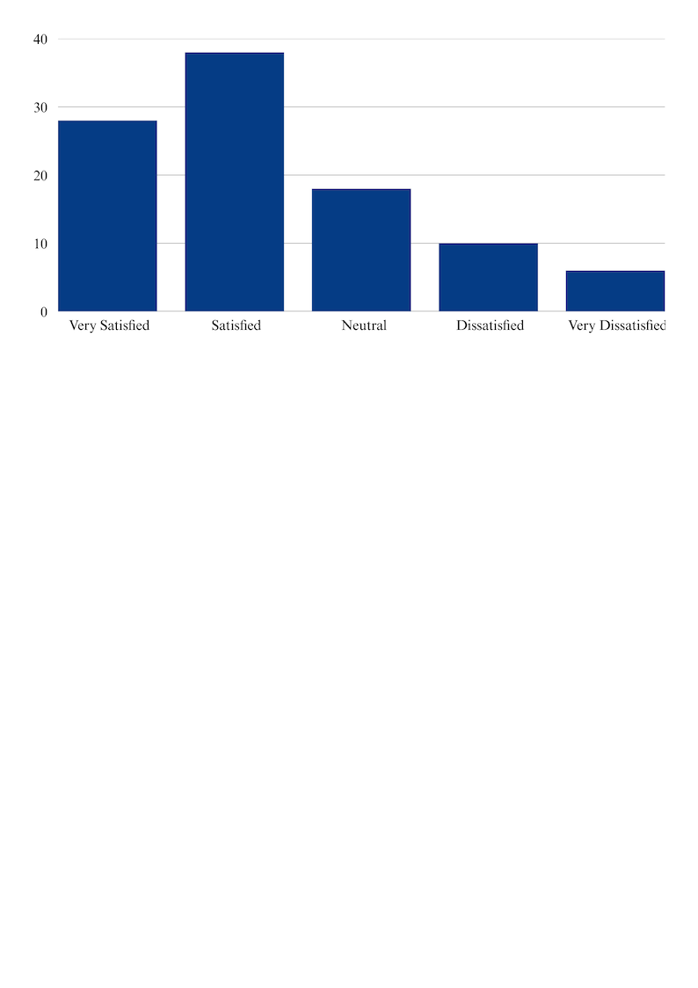

**Interpretation:** According to the survey's findings, most workers are content with the duties they already perform. In particular, 38% of respondents stated they are "Satisfied," and 28% said they are "Very Satisfied," accounting for 66% of the total. This indicates that most workers find their work responsibilities relevant and in line with their abilities, as evidenced by the generally positive perception of task assignments. Nonetheless, 18% of workers selected "Neutral," suggesting some hesitancy or disinterest in their present responsibilities. Furthermore, 16% of those surveyed said they were not content, with 10% saying they were "Dissatisfied" and 6% saying they were "Very Dissatisfied."This implies that certain aspects, such task engagement, workload balance, and role clarity, require attention. By addressing these issues, total employee performance and happiness can be further improved.

**2. How do you perceive the work-life balance in terms of the amount of time you spend at work?**

|  |  |  |
| --- | --- | --- |
| **Particulars** | **No. of Responses** | **Percentage** |
| Excellent | 22 | 22% |
| Good | 35 | 35% |
| Average | 25 | 25% |
| Poor | 12 | 12% |
| Very Poor | 6 | 6% |

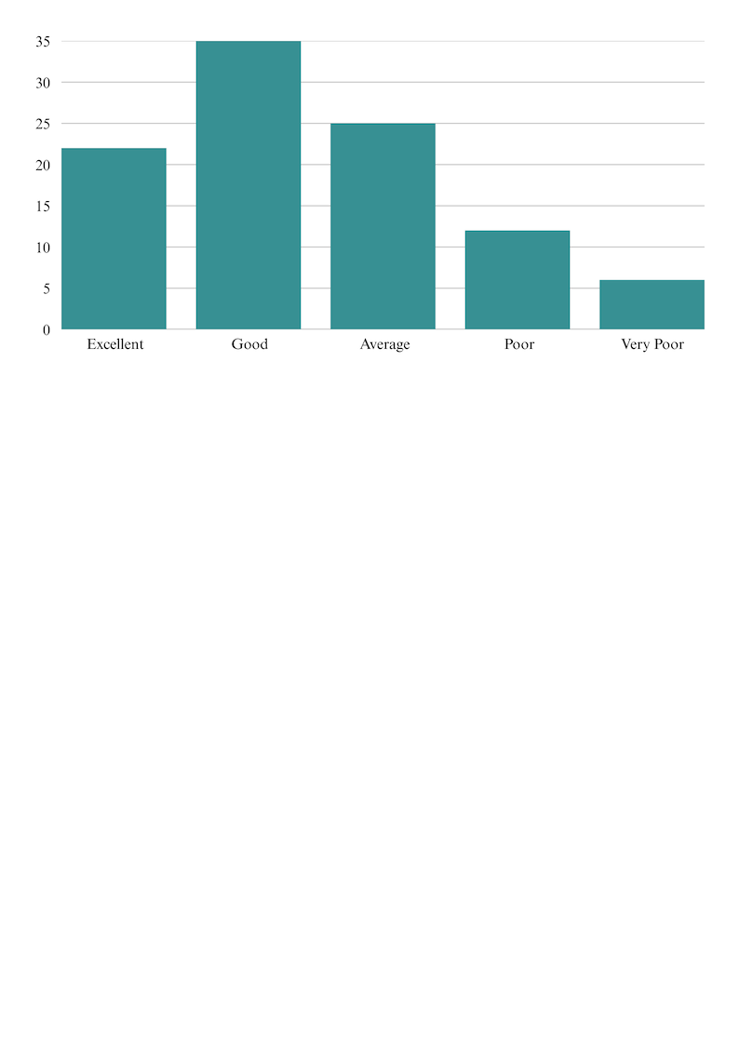

**Interpretation:** According to the research, most workers have a favorable opinion of their work-life balance. More than half of workers believe they have enough time to balance their personal and professional obligations, as seen by the 57% of respondents who gave it an overall rating of either "Excellent" (22%), or "Good" (35%). A neutral position where certain aspects are workable but might be improved is shown by the 25% of workers who assessed their work-life balance as "Average." 18% of respondents, however, were unhappy, with 12% calling it "Poor" and 6% calling it "Very Poor." This indicates that a sizable percentage of workers might be dealing with issues like excessive work hours or a lack of flexibility. Resolving these problems could improve general satisfaction and employee well-being.

**3. How secure do you feel regarding your job in this organization?**

|  |  |  |
| --- | --- | --- |
| **Particulars** | **No. of Responses** | **Percentage** |
| Very Secure | 30 | 30% |
| Secure | 40 | 40% |
| Neutral | 15 | 15% |
| Insecure | 10 | 10% |
| Very Insecure | 5 | 5% |

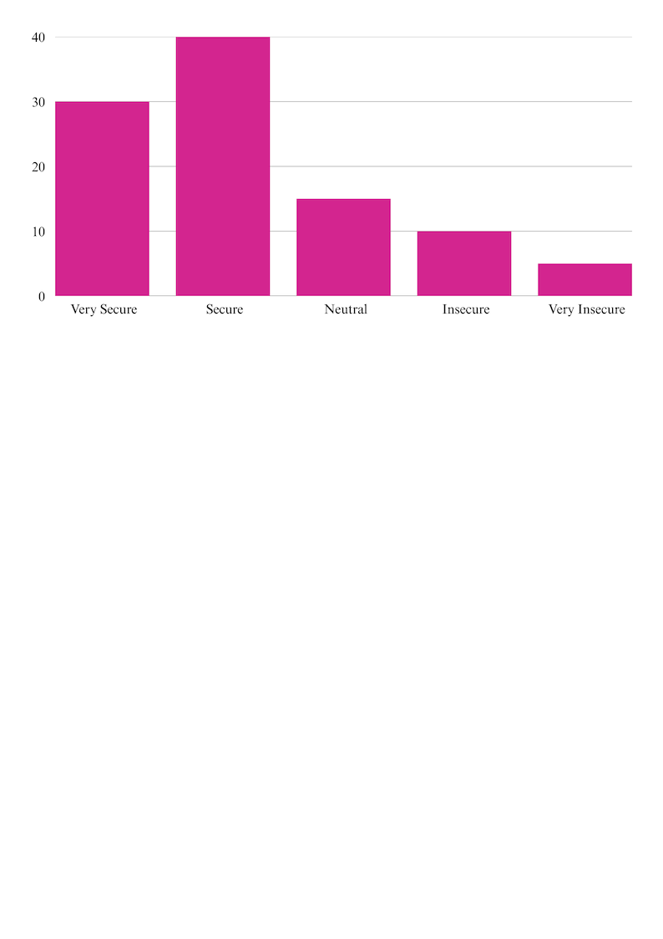

**Interpretation:** According to the research, the majority of workers are assured of their job security within the company. In particular, 70% of respondents say they have a positive opinion of employment stability, with 30% feeling "Very Secure" and 40% feeling "Secure." This indicates a high level of organizational trust and assurance over future employment. 15% of workers, on the other hand, selected "Neutral," indicating that they are neither secure nor insecure, maybe as a result of ambiguous communication regarding long-term positions or business performance. However, 15% of those surveyed said they were worried about their job security, with 10% saying they were "insecure" and 5% saying they were "very insecure." These issues could be brought on by performance pressure, unclear work roles, or organizational changes. Resolving these doubts can contribute to a more confident and dedicated team.

**4. How satisfied are you with the benefits (other than salary) provided by the organization, such as health insurance, retirement plans, and other perks?**

|  |  |  |
| --- | --- | --- |
| **Particulars** | **No. of Responses** | **Percentage** |
| Very Satisfied | 25 | 25% |
| Satisfied | 34 | 34% |
| Neutral | 20 | 20% |
| Dissatisfied | 13 | 13% |
| Very Dissatisfied | 8 | 8% |

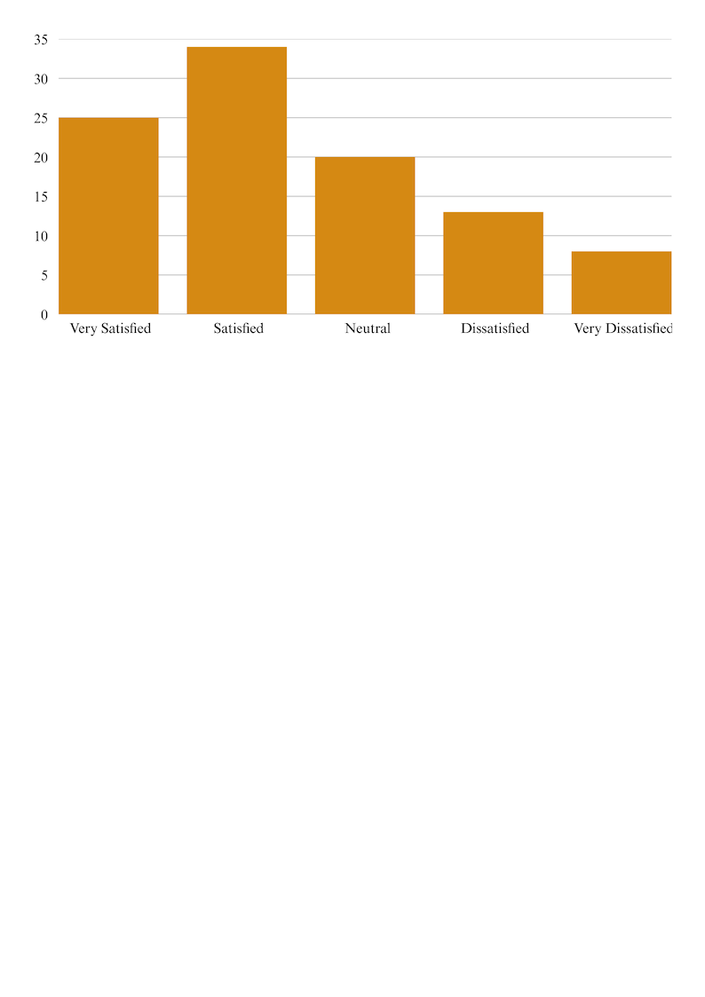

**Interpretation:** The majority of workers are typically happy with the non-salary benefits offered by the company, according to the study results. In particular, 34% of respondents said they were "Satisfied," and 25% said they were "Very Satisfied," accounting for 59% of all responses. This implies that the majority of workers value the company's benefits, including wellness initiatives, retirement plans, health insurance, and other advantages. Nonetheless, 20% of respondents chose "Neutral," suggesting that these workers could not fully understand the benefits at their disposal or feel uninterested. However, 21% were unhappy, with 13% expressing "dissatisfaction" and 8% expressing "very dissatisfaction." This suggests a possible discrepancy in the advantages' accessibility or quality. Enhancing benefit packages or communication could improve employee retention and overall satisfaction.

**6. DISCUSSION**

Key findings on Urban Company employee satisfaction are highlighted in the survey. The majority of employees are fairly satisfied with their salary, as evidenced by the fact that remuneration obtained the highest score (3.6) among the categories evaluated. But issues with irregular pay and no extra benefits still exist, particularly for freelance workers. With a score of 3.5, the workplace was deemed to be generally positive. While service workers reported both flexibility and difficulties, such as a lack of field support, corporate employees expressed gratitude for the infrastructure and support. A score of 3.4 for training and development indicates a moderate level of satisfaction. Employees acknowledged a need for continual skill development and professional growth opportunities, even if they valued onboarding and basic training. The lower score of 3.3 for work-life balance indicated that both corporate employees and service professionals had extended workdays. This implies that wellness programs and scheduling need to be improved. With a score of only 2.5, job security was the most important issue. Anxiety and uncertainty are caused by the fact that many gig workers work without contracts or benefits. In conclusion, Urban Company does well in terms of pay and workplace culture, but in order to raise employee satisfaction levels generally, it needs to concentrate on improving job security, work-life balance, and ongoing training.

**7. SUGGESTIONS**

The results of the study suggest a number of actions that Urban Company might take to improve employee happiness. First and foremost, it is imperative to increase service professionals' job security. Employee loyalty can be raised and uncertainty reduced by implementing fundamental perks like formal contracts, insurance coverage, or long-term engagement alternatives. Additionally, work-life balance should be improved. Long workdays are a problem for many employees, particularly gig workers. Stress levels could be considerably lowered and productivity increased by implementing flexible scheduling, break times, and wellness programs like mental health support. Additionally, training and development ought to be improved. Even if there is onboarding training, employees can enhance their performance and career possibilities with the support of continuous skill development programs, certifications, and growth pathways. Timely payments and clear pay systems are crucial in terms of remuneration. Including bonuses or incentives based on achievement might further inspire workers and increase job satisfaction. It's also critical to have a robust feedback and support system. Establishing open lines of communication and offering field support to service partners will facilitate prompt resolution of issues and foster confidence. Last but not least, rewarding and recognizing top performers with praise, honors, or small benefits can boost spirits and give workers a sense of worth. These actions have the potential to greatly raise employee satisfaction and engagement over the long run at Urban Company.

**8. CONCLUSION**

With a focus on a number of variables, including pay, work environment, training and development, work-life balance, and job security, this study has offered insightful information about the general level of employee satisfaction at Urban Company. The results show that although workers value elements like equitable pay and a moderately encouraging workplace, there are significant issues that require attention, especially with regard to job security and work-life balance. Due to their gig-based jobs, service professionals who make up a sizable portion of Urban Company's workforce frequently deal with issues including irregular pay, a lack of benefits, and job-related uncertainty. Similar to this, corporate workers experience pressures including long workdays and few prospects for job advancement, even though they have greater structure and security. According to the analysis, the organization has established a respectable basis for training and pay; nonetheless, additional work is required to establish a more sustainable and inclusive work culture. Performance and happiness can be greatly increased by putting in place organized staff policies, encouraging wellness, providing long-term career advancement, and guaranteeing equitable treatment. In summary, a key component of Urban Company's long-term success is employee satisfaction. In addition to boosting staff morale, closing current gaps can increase customer satisfaction and business expansion.

**9. REFERENCES**

* Robbins, S. P., & Judge, T. A. (2017). Organizational Behavior (17th ed.). Pearson Education. This book provides foundational concepts related to employee behavior, motivation, job satisfaction, and organizational culture.
* Herzberg, F. (1968). One More Time: How Do You Motivate Employees? Harvard Business Review. Herzberg’s two-factor theory helps explain how motivators and hygiene factors affect job satisfaction, which is relevant to the Urban Company context.
* Maslow, A. H. (1943). A Theory of Human Motivation. Psychological Review, 50(4), 370–396. Maslow’s hierarchy of needs framework is used to understand how Urban Company can address employee needs from basic pay to self-actualization.
* Urban Company Official Website. (2024). https://www.urbancompany.com. Provided organizational insights, service models, and workforce-related information used in company profiling.
* Statista. (2023). Gig Economy in India – Statistics & Trends. [https://www.statista.com. Offered statistical context for the gig workforce, useful in evaluating the nature of employment at Urban Company.
* Kumar, S., & Singh, R. (2020). A Study on Employee Satisfaction in the Service Sector in India. International Journal of Management Studies, 7(1), 55–64. An academic article supporting the methodology and comparative satisfaction indicators used in this study.
* McKinsey & Company. (2022). The Future of Work in the Gig Economy. [https://www.mckinsey.com]. Provided industry trends and challenges related to gig work and worker expectations in platforms like Urban Company