EFFECT OF MUNICIPAL SOLID WASTE INCINERATION WASTE ON CLAYEY SOIL

B. Ashok Reddy 1 Assistant Professor

Vignan's Institute of Information Technology Visakhapatnam, India

B.Mohan Chandra2; G.Sri Harshitha3; V.Sudharshan Rao4;

V.Vijay Kumar 5; S.v.s. Rishitha6 Student

Vignan's Institute of Information Technology Visakhapatnam, India

# Abstract:- Sustainable soil improvement methods play a crucial role in enhancing soil health while ensuring environmental sustainability. Several innovative techniques and stabilizing agents contribute to the engineering properties of soil, making them ideal for road construction projects and other infrastructure developments. In the last few years, waste materials have been used for soil stabilization. Various waste materials, such as fly ash (FA), granulated blast furnace slag (GGBFS), rice husk ash (RHA), cement kiln dust (CKD), Quarry dust, demolished waste, etc. The study aims to assess the effectiveness of MSWIFA as a sustainable and environmentally friendly stabilizer for clayey soil.

# Laboratory tests were conducted to evaluate the impact of different proportions (10 %, 20 %, and 30%) of municipal solid waste (MSW) fly ash on the engineering properties of subgrade clayey soils. Results indicated that the inclusion of MSWIA significantly improved the soil’s behavior, with notable reductions in liquid limit (up to 37.66 %), plasticity index (up to 74.76 %), and Optimum moisture content These findings suggest that MSWIA can serve as sustainable alternatives to traditional soil stabilizers, offering both performance improvements and environmental benefits.

***Keywords:-****MSWI(municipal solid waste incineration ash),Liquid Limit Test, Plastic Limit Test, and Standard Proctor Test.*

# INTRODUCTION

Soil stabilization is the alteration of soil to enhance its physical properties. The process of soil stabilization helps to achieve the required properties in a soil needed for the construction work. Weak soil generally swells and shrinks depending on the presence of moisture content. Stabilization can increase the shear strength of a soil and control the shrinkage properties of a soil and thus improving the load-bearing capacity of a soil. While traditional stabilization methods like lime and cement treatment are effective, they come with substantial environmental drawbacks, including high carbon emissions and significant energy consumption. As a result, there is a growing need to explore more sustainable and eco-friendly alternatives. In this regard, utilizing waste materials in soil stabilization presents a sustainable and cost-effective approach to reducing environmental impact in construction projects. Waste materials such as fly ash, rice husk ash, and palm oil fly ash have been increasingly utilized in soil stabilization, offering a viable alternative to traditional methods like cement and lime production. Many studies recommend the use of MSW fly ash for construction purposes. However, there is no clear evidence, either experimental nor numerical, proving its effectiveness for subgrade soil in the study area. Therefore, this study aims to promote the use of municipal solid waste ash in order to reduce its environmental footprint while promoting sustainable development. Not only do these methods minimize the demand for new resources, but they also contribute to recycling waste materials, thereby lessening negative environmental impacts. Consequently, the use of municipal solid waste ash can also help to reduce construction material costs while improving the strength of weak road pavement subgrade.

A Solid waste fly ash is a fine, powdery byproduct produced during the combustion of coal or other solid fuels in power plants and industrial processes. It is carried by flue gases and collected by pollution control devices. Fly ash contains minerals like silica, alumina, and calcium, and can sometimes include hazardous substances such as heavy metals. If not properly managed, it can pose environmental and health risks. Solid waste fly ash, particularly from municipal solid waste incineration (MSWI), is a fine particulate residue collected from flue gas purification systems during the incineration process, often containing heavy metals, dioxins, and other pollutants, which can be hazardous. Municipal solid waste incineration ash is the outcome/product of bioengineering science.

The incineration or burning of municipal solid waste (MSW) reduces the volume of this biomass by 90%, and the residual ash can be used in several applications. In this study, the potential of municipal solid waste incineration (MSWI) ash waste for the stabilization of expansive soil has been experimentally evaluated.

* *Objective of the study*
* To Analyze the characteristics of clayey soil for different concentration of 0%,10%,20%, and 30%MSWI ash mixed with it.
* To Study the effect of solid wastes, namely MSWI ash, in clayey soil on the variation of index properties and compaction characteristics.
* To Study the outcome of MSWI ash in soil stabilization, in the way to decrease the waste disposal problem, environmental pollution.

**II. LITERATURE REVIEW**

1) Saurabh Kumar, Sneha Gupta (2025). Conducted numerous tests, including consistency limits tests, compaction tests, unconfined compressive strength, California bearing ratio tests, and permeability tests, on various combinations of highly compressible clayey soil and Municipal solid waste incinerated ash and found that adding an 20% of MSWIA bottom ash (20%) had effectively decreased the value of differential free swell and consistency limitations of the soil and the value of UCS increased by more than 146 %.

2) B. Mohan Babu and Gayathri et al. (2023) found that weak soils blended with varying percentages of MSWA (2.5%, 5%, 10%, 12.5%, and 15% improve index properties and compaction values of the soils.

3) Chethan K, Mariyam, et al (2024). Studied the effect of biomedical waste incinerator ash and lime on the weak soils blended with different percentages of 2.5%, 5%, 10%, 12.5%, and 15%. Particle size analysis, Atterberg limits, free swell, compaction, unconfined compression strength, and California bearing ratio tests were performed. and observed improved properties and Compaction values of the soil.

4) Vipin Maddah, Mr. Aman, et al (2022) found that the soil stabilization using burnt municipal solid waste improves the properties of soil and also concluded that the optimum value of ash is 8%, which is desirable to use to stabilize the soil.

5) Shabana Salih K (2021). reviewed the chemical composition and the suitability of MSW incinerator ash in soil stabilization, considering its performance in engineering and sustainability aspects.

6) S. M. Riyad, I. M. Rafizul, et al (2018) investigated the effect of fly ash content on the engineering properties of stabilized soils. The fly ash content of 10, 20, and 30%, the inorganic silt of 10, 20, and 30%, as well as the cement content of 10%, was used to stabilize soils. The results revealed that the optimum content of fly ash was 20% and 30%. The soil with an organic content of 16% showed the highest value of compressive strength, while, soil with an organic content of 12.5% showed the lowest value.

7) Dinesh.A,Gokilavani.S et al (2017). Studied the stabilization of soil using solid waste. To understand the performance of stabilized soil, the Atterberg limits, compaction characteristics, swelling, shear strength, CBR value, and other Index & Engineering properties of soil were analyzed and discussed.

8) Renuka and Shiva Shanker et al (2012) found that the red soils, which are low-expansive having average strength and low bearing capacity mixed with of MSWA with different percentages of 2.5%, 5%, 10%, 12.5%, and 15%, resulted in the improved strength of the soil.

9) Karthik, Ashok Kumar, et al (2014). Conducted CBR tests on soils and soil–ash mixtures prepared at an optimum water content of 9% and concluded that the addition of Fly Ash results in appreciable increase of CBR value of the soil. The increment of the CBR value is used to reduce the thickness of the pavement. And increasing the bearing capacity of soil.

10) Charles H. K. Lam, et al (2010). reviewed the characteristics of municipal solid waste incineration (MSWI) ashes, and also the possible treatment methods for the utilization of ash, namely, separation processes, solidification/stabilization, and thermal processes, are discussed and found that practical use of MSWI ash shows a great contribution to waste minimization as well as resource conservation.

11) Tawrez Sofi, Jamal Ismael et al (2023) Reviewed the key parameters of geotechnical properties of MSW, which are required to utilize in the landfill operations and waste management facilities. Hence, geotechnical properties data of the waste can assist engineers in selecting possible solutions for the extension of the landfill and obtaining prior background data for the evaluation and design of landfills. Because MSW disposal may change the geotechnical properties of soil and also can alter the geotechnical properties of soils may contribute to the physical and physico-chemical interactions between soil and contaminants of the dumping sites.

12) Karanbir Singh Randhawa, Raman Kumar et al (2024) evaluated the potential of municipal solid waste incineration (MSWI) ash and calcium carbide residue (CCR) waste for the stabilization of expansive soils. And determine the best combination of additives to achieve the most favorable technical characteristics of expansive soil. The percentage of expansive soil has been kept fixed at 60% of the total weight of the mix for varying ratios of stabilizing agents

13) Carmen Otilia Rusănescu et al (2023) studied and presented ash treatment methods to reduce the content of heavy metals and salts. And found that addition of certain concentrations of fly ash to degraded soils, the quality, porosity, and texture of the soil are improved; the yield of certain crops increases; the water retention capacity of the soil and soil aeration are improved; the density of the soil bulk; the compactness of the soil is reduced; the pH value is optimized; the electrical conductivity of the soil is increased.

14) Karanbir Singh Randhawaa, Rajiv Chauhan (2021). Reviewed the works carried out by various researchers on the improvement of engineering properties of expansive soils, after the addition of MSWI in varying proportions, and reported that the optimum content of MSWI ash varies between 10% and 30%, for improvement in strength characteristics.

15) Anthony T.C. Goh, Joo-Hwa Tay et al (2021). Reviewed the investigations of physical and engineering properties of the fly ash derived from municipal solid‐waste incineration, concluded that MSWIA can be utilized as a potential source as a fill material, with low compacted density and high strength, and relatively free draining, with permeability of the same order of magnitude as coarse-grained materials. The use of MSWIA as an admixture in the stabilization of a soft marine clay showed improved undrained shear strengths and lower compressive properties.

16) Damtew Tsige Melese, Guta Jida, et al (2024). Evaluated the influence of municipal solid waste fly ash on expansive soils using laboratory tests and finite element methods. The MSW fly ash was used as a stabilizing agent at varying percentages (5 %, 10 %, 15 %, 20 %, 25 %, and 30 % of the dry mass of the soil sample). The laboratory tests showed improvements in the engineering properties of expansive soil when MSW fly ash was mixed. These improvements included a reduction of soaked CBR swelling, free swell index, plasticity index, specific gravity, and optimum moisture content. Additionally, the maximum dry density and soaked CBR values increased.

17) Mohammed Faisal Noaman, M.A. Khan, Kausar Ali, et al (2022). Investigated the effect of fly ash additive on soil characteristics and found that fly ash improved the soil stability, especially in terms of CBR values, the permeability of the soil, and decreased the potential of volumetric soil changes through a series of experimental tests. This is due to the size and shape of particles; in addition to the treated period, volumetric dilation of the ground is reduced.

18) B.R. Phani Kumar, Radhey S. Sharma (2004). Studied the efficiency of fly ash as an additive in improving the engineering characteristics of expansive soils. And evaluated the effect of the fly ash content on the free swell index, swell potential, swelling pressure, plasticity, compaction, strength, and hydraulic conductivity characteristics of expansive soil. The plasticity, hydraulic conductivity, and swelling properties of the blends decreased, and the dry unit weight and strength increased with an increase in fly ash content.

19) M. A. Ansary, M. A. Noor, M. Islam (2006). Investigated the influence of fly ash with lime. The amount of lime was fixed at 3 percent, with the varied amount of fly ash 0, 6, 12, and 18 percent. The results showed that by increasing the amount of fly ash, the strength properties of lime-fly ash stabilized soils also increased. The use of fly ash with lime gave better strength, and it may be more economical. Compared with the untreated samples, flexural strength and modulus increased considerably, depending on the additive content.

20) Vara prasad, Jayaprakash Reddy (2020). The primary objective of this study concerns the reuse of local incinerated ash from municipal solid wastes in soil stabilization. Municipal Solid Waste Incinerated Ash (MSWIA) is blended with soil in various combinations and tested for its Atterberg limits, unconfined compressive strength (UCS), California Bearing Ratio (CBR), and Free Swell Index (FSI). A 1-D Consolidation Test was conducted, and changes in the soil during the test were examined by a scanning electron microscopic (SEM) analysis. The test results showed that there are increments in the UCS and CBR values with the reductions in the FSI, swell pressure, and swell potential of the treated soils.

**III. MATERIALS AND METHODS**

**MATERIALS**

* + - Municipal solid incineration ash
    - Soil.

**MUNICIPAL SOLID WASTE INCINERATION ASH**

Solid waste fly ash is a fine, powdery byproduct produced during the combustion of coal or other solid fuels in power plants and industrial processes. It is carried by flue gases and collected by pollution control devices. Fly ash contains minerals like silica, alumina, and calcium, and can sometimes include hazardous substances such as heavy metals. If not properly managed, it can pose environmental and health risks.

Solid waste fly ash, particularly from municipal solid waste incineration (MSWI), is a fine particulate residue collected from flue gas purification systems during the incineration process, often containing heavy metals, dioxins, and other pollutants, which can be hazardous.

**PROPERTIES OF INCINERATION ASH**

Solid waste Fly ash is a by-product obtained from burning coal or municipal solid waste. It has the following properties:

Physical appearance: solid waste fly ash is a finely divided, typically appears as  grey, spherical, and alkaline-natured powder with micro-sized particles

Chemical composition: Solid waste fly ash often contains silicon dioxide, aluminum oxide, and calcium oxide.

PH: Municipal solid waste fly ash particles tend to be strongly alkaline (pH≥11).

Moisture content: The moisture content of municipal solid waste (MSW) incineration fly ash typically ranges from 0.78% to 16.48%.

Density: The density of MSWI fly ash can be up to 2350 kg/m3.

Pozzolanic Properties: Fly ash contains reactive silica and alumina that can react with calcium hydroxide (Ca (OH)₂) in the presence of water to form compounds with cement-like properties. This makes fly ash useful as an additive in the production of concrete.

**EXTRACTION OF INCINERATION ASH**

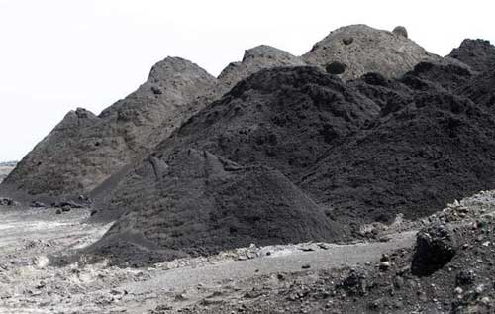

**Figure. 3.1. Extraction of Municipal Solid Waste Ash**

The solid waste incineration ash will be extracted and treated using various methods, including physical separation, chemical leaching, thermal treatment, and solidification/stabilization.

The extraction of Municipal Solid Waste Incineration (MSWI) ash typically refers to the recovery of valuable materials (especially metals) or the treatment of the ash to reduce its environmental impact. MSWI ash is generated as a byproduct of burning municipal solid waste and can beclassified into:

Bottom ash: the non-combustible residue left at the bottom of the incinerator.

Fly ash: the fine particles carried with flue gases, often captured by air pollution control systems.

**COLLECTION OF SOLID WASTE INCINERATION ASH**

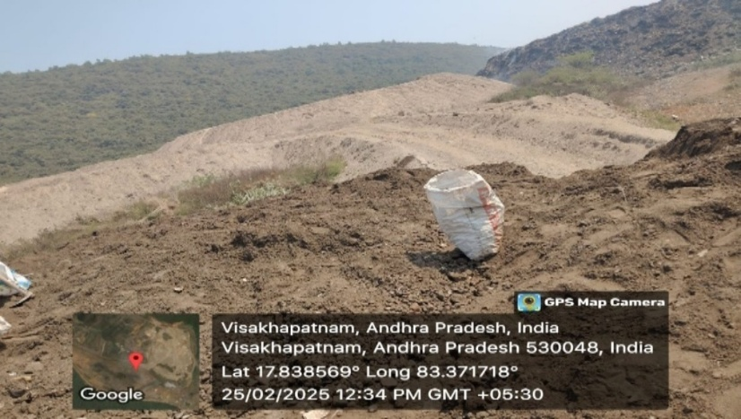

**Figure. 3.2. Collection of Solid Waste Incineration Ash**

The solid waste incineration ash is collected from Marikavalasa Greater Vizag Municipal Corporation (GVMC), where the municipal solid waste is stored and burnt at high temperatures. The resultant ash produced is called the municipal solid incineration ash.

Municipal solid waste incineration ash collection refers to theprocess of gathering the residue remaining after burning household and commercial waste in an incinerator.

**EXTRACTION OF SOIL**

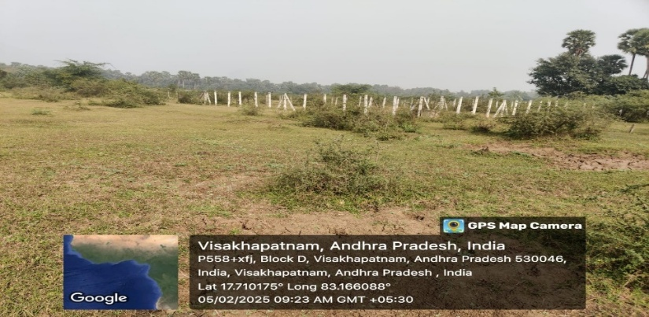

**Figure. 3.3. Extraction of Soil Sample**

The soil is collected at Visakhapatnam, and several laboratory tests were conducted, and identified as a clayey soil.

**COLLECTION OF SOIL**

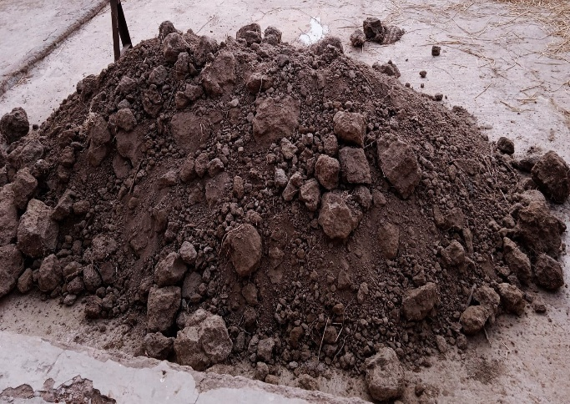

**Figure .3.4. Collection of Soil**

The soil is collected at a depth of 1 meter to avoid organic waste matter, which is present above the soil layer.

**IV. EXPERIMENTAL PROGRAMME**

**GENERAL**

The Highway Research Board (IRB) classifies the soil strata, like black cotton soil and clayey soil, using a suitable sampling technique, such as the Core Cutter Method. To determine the characteristics like Grading by Sieve Analysis, Atterberg’s Limits i.e Liquid limit using Cone Penetration Method and Casagrande Method, Plastic limit by rolling the sample to 3mm diameter thread, Shrinkage limit using Shrinkage apparatus, Optimum Moisture Content and Maximum Dry Density using Standard Proctor Test and also California Bearing Ratio by the determination of the properties such as liquid limit, plastic limit, shrinkage limit, optimum moisture content, maximum dry density, CBR value and shear strength for different concentration of Geo synthetic material with black cotton. The pavement thickness design will be done using pavement design catalogues published by IRC SP:20-2002. The estimation for the road is done by considering items such as Jungle Cutting. Earthwork Excavation for Roadway and Drains, compacting and grading, etc.

Different tests were conducted in order to determine the different characteristics and properties of the soil. The procedure for each of the tests is explained below

**INDEX PROPERTIES:**

**Specific Gravity:**

**Aim:** To determine the specific gravity of soil.

**Materials and equipment needed:**

Pycnometer (clean and dry)

Sample liquid (whose specific gravity needs to be determined)

Distilled water (for reference)

Analytical balance (to measure the mass)

Stopwatch or timer

**Procedure:**

Step 1: Clean and Dry the Pycnometer. Ensure that the pycnometer is clean and dry before starting the test. Any residual liquid or moisture can affect the accuracy of the test results.

Step 2: Weigh the Empty Pycnometer using an analytical balance, weigh the empty and dry pycnometer (W1). Record the mass to the nearest milligram (mg).

Step 3: Fill the Pycnometer with Distilled Water Fill the pycnometer with distilled water up to the calibration mark on the neck of the pycnometer. Avoid any air bubbles in the pycnometer, as they can affect the accuracy of the test results.

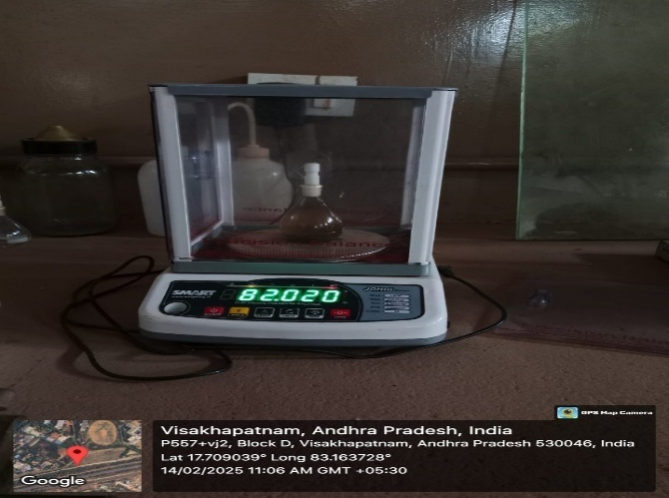

**Figure. 4.1. Pycnometers with soil sample**

Step 4: Weigh the Pycnometer with Water. Weigh the pycnometer filled with distilled water (W2) using the analytical balance. Record the mass to the nearest milligram (mg).

Step 5: Empty the Pycnometer. Empty the pycnometer and rinse it with the sample liquid whose specific gravity needs to be determined. Make sure that the pycnometer is completely clean and free from any residual water or other substances.

Step 6: Fill the Pycnometer with Sample Liquid. Fill the pycnometer with the sample liquid up to the calibration mark on the neck of the pycnometer. Again, avoid any air bubbles in the pycnometer.

Step 7: Weight the Pycnometer with Sample Liquid. Weigh the pycnometer filled with the sample liquid (W3) using the analytical balance. Record the mass to the nearest milligram (mg).

Step 8: Measure the Temperature of the Sample Liquid. Using a thermometer, measure the temperature of the sample liquid in the pycnometer. Record the temperature to the nearest degree Celsius (°C).

Step 9: Calculate the Specific Gravity. Calculate the specific gravity (SG) of the sample liquid using the following formula:

SG = (W3 - W1) / (W2 - W1)

Where:

SG = Specific gravity of the sample liquid,

W1 = Mass of the empty pycnometer

W2 = Mass of the pycnometer filled with distilled water,

W3 = Mass of the pycnometer filled with sample liquid

Step 10: Correct the Specific Gravity for Temperature

If necessary, correct the specific gravity for the temperature of the sample liquid using a reference table or a specific gravity correction calculator, as the density of liquids changes with temperature.

specific gravity correction calculator, as the density of liquids changes with temperature.

**Liquid Limit Test:**

**General**

In order to study the liquid limit of soil Casagrande test was conducted. Liquid limit is generally determined by the mechanical method using Casagrande’s apparatus or the standard liquid limit test apparatus. As per this method, the liquid limit is defined as the moisture content at which 25 blows or drops in standard liquid limit apparatus will just close a groove of standardized dimensions cut in the sample by the grooving tool by a specified amount

**Aim:** To determine the liquid limit of a soil sample.

**Materials:**

Soil sample

Distilled water

Moisture containers or dishes

Sieve with a mesh size of 425 microns

Paper towels or filter paper

Liquid limit device (such as a Casagrande cup)

Mixing spatula or rod

Graduated cylinder or dropper for measuring water

**Equipment:**

Oven for drying soil samples

Balance or scale for weighing soil samples

Stopwatch or timer for measuring time

Measuring cylinder or graduated dropper for measuring drops per second

Cleaning equipment (brushes, towels, etc.) for clean-up

Safety equipment (gloves, goggles, etc.) as required for laboratory safety protocols

**Procedure:**

Step 1: Collect the Sample

Obtain a representative sample of the soil to be tested. The sample should be collected from the field in accordance with standard sampling procedures, ensuring that it is free from any large particles or debris

Step 2: Preparation of Soil Sample

Air dry the soil sample to a constant weight in an oven at a temperature of 105°C (221°F). Crush any lumps or aggregates in the soil sample and pass it through a 425-micron sieve to remove any large particles.

Step 3: Determination of Initial Moisture Content

Weigh out an appropriate amount of the air-dried soil sample (usually between 20-30 grams) and record the weight as W1. Place the soil sample in a moisture container and thoroughly mix it with distilled water to uniformly distribute the moisture. Weigh the container with the moist soil and record the weight as W2. Calculate the initial moisture content using the formula:

Initial Moisture Content = [(W2 - W1)/W1] x 100

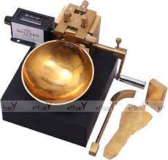.

**Figure. 4.2. Casagrande Apparatus**

Step 4: Preparation of Soil Paste

Add a small amount of distilled water to the moist soil sample in the container and mix it to form a thick paste. Place the paste in the liquid limit device (such as a Casagrande cup) and level it off.

Step 5: Determination of Liquid Limit

Adjust the liquid limit device so that the cup starts moving, and gradually increase the number of drops per second. Allow the cup to move back and forth along the length of the device. The drops from the cup will cause the soil paste to close and form a groove. Keep increasing the drops per second until the groove made by the cup closes for a distance of 13 mm (0.5 inches) along its length. The number of drops per second at this point is the liquid limit of the soil.

Step 6: Calculation of Liquid Limit

Record the number of drops per second at which the groove closes. Repeat the test at least three times and take the average. Use the following formula to calculate the liquid limit:

Liquid Limit (LL) = Average number of drops per second

Step 7: Clean-up

Clean the liquid limit device and other equipment used in the test thoroughly to remove any

residue from the soil sample.

**Plastic Limit Test:**

General

In order to study the Atterberg's limit, it is important to conduct the plastic limit test. Plastic limit (PL) is the water content at which the soil rolled into a thread of the smallest diameter possible starts crumbling and has a diameter of 3 mm

**Aim:** To determine the plastic limit of a soil sample.

**Equipment and Materials:**

Mixing dish or glass plate

Soil Sample

Water source

Spatula or mixing tool

Plastic limit device (e.g, Casagrande’s apparatus)

Oven for drying soil samples

Balance or scale with appropriate accuracy

**Procedure:**

Step 1 Collect a representative soil sample from the field, ensuring it is free from any visible organic matter or debris. Take a sufficient amount of soil to ensure a representative test result.

Step 2. Air-dry the soil sample to remove excess moisture, but do not allow it to become fully dry. The soil should be at or near its natural moisture content before the test.

Step 3.Prepare the plastic limit device by cleaning and assembling it according to the manufacturer's instructions.

Step 4. Weigh an empty mixing dish or glass plate and record its weight as "W1".

Step 5. Take a portion of the air-dried soil sample and break it down into smaller pieces, removing any visible aggregates or clumps.

Step 6. Place a small amount of the soil sample on the mixing dish or glass plate, and using a spatula or mixing tool, add water gradually while thoroughly mixing the soil until it reaches a consistency where it can be easily rolled into a thread without crumbling or cracking. This is the plastic state.

Step 7. Roll a small portion of the soil into a thread with a diameter of approximately 3 mm (1/8 inch) on the mixing dish or glass plate.

Step 8. Use the plastic limit device to cut through the center of the rolled thread, ensuring that the cutting edge just touches the bottom of the dish or plate. Move the two halves of the thread apart by gently lifting the device.

Step 9. Repeat the process with additional portions of the soil sample to obtain at least three threads that meet the criteria for the plastic state.

Step 10. Allow the threads to air dry for a specific time period (typically 24 hours).

Step 11. Once the threads are sufficiently dry, use a spatula or other suitable tool to carefully pick up the threads and try to roll them into threads again. If the threads crumble or crack, they have transitioned from the plastic state to a semi-solid state.

Step 12. Weigh the mixing dish or glass plate with the crumbled threads and record its weight as "W2".

Step 13. Calculate the plastic limit (PL) of the soil using the formula: PL = (W1 - W2) / (W1 - W3) x 100

Where W3 is the weight of the empty dish or plate after the threads are crumbled and removed.

Step 14. Repeat the test with different moisture contents of the soil sample to obtain a range of data points for determining the plastic limit accurately.

Step 15. Clean and dry the equipment thoroughly after each test to prevent contamination and ensure accurate results.

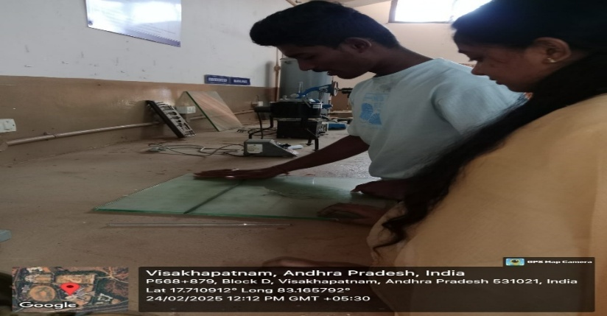

**Figure. 4.3. Plastic Limit test**

**ENGINEERING PROPERTIES :**

**Free Swell Index Test :**

**Aim:** To determine the free swell characteristics of a soil sample.

##### **Equipment and Materials**:

Graduated cylinder or volumetric flask

Soil Sample

Water source

Timer or stopwatch

Stirring rod or a spatula

Balance or scale with appropriate accuracy

**Procedure:**

Step 1. Collect a representative soil sample from the field, ensuring it is free from any visible organic matter or debris. Take a sufficient amount of soil to ensure a representative test result.

Step 2. Air-dry the soil sample to remove excess moisture, but do not allow it to become fully dry. The soil should be at or near its natural moisture content before the test.

Step 3. Prepare a graduated cylinder or volumetric flask of known volume by thoroughly cleaning and drying it. Record its initial volume as "V1".

Step 4. Weigh a known amount of the air-dried soil sample and record its weight as "W1".

Step 5. Place the weighed soil sample in the graduated cylinder or volumetric flask, and add a known amount of water to fully saturate the soil. The water content should be sufficient to allow for swelling, but not excessive to cause over-saturation. Stir the soil-water mixture thoroughly to ensure complete saturation of the soil.

Step 6. Allow the soil-water mixture to stand undisturbed for a specific time period (usually 24 hours) to allow for swelling to occur.

Step 7. After the specified time period has elapsed, carefully measure the volume of the soil-water mixture in the graduated cylinder or volumetric flask and record it as "V2".

Step 8.

Calculate the free swell index (FSI) of the soil using the formula:

FSI = (V2 - V1) / V1 x100

Where V1 is the initial volume of the graduated cylinder or volumetric flask and V2 is the final volume of the soil-water mixture after swelling.

Step 9. Repeat the test with different soil samples or different moisture contents of the same soil sample to obtain a range of data points for determining the free swell characteristics accurately.

Step 10.

Clean and dry the equipment thoroughly after each test to prevent contamination and ensure accurate results.

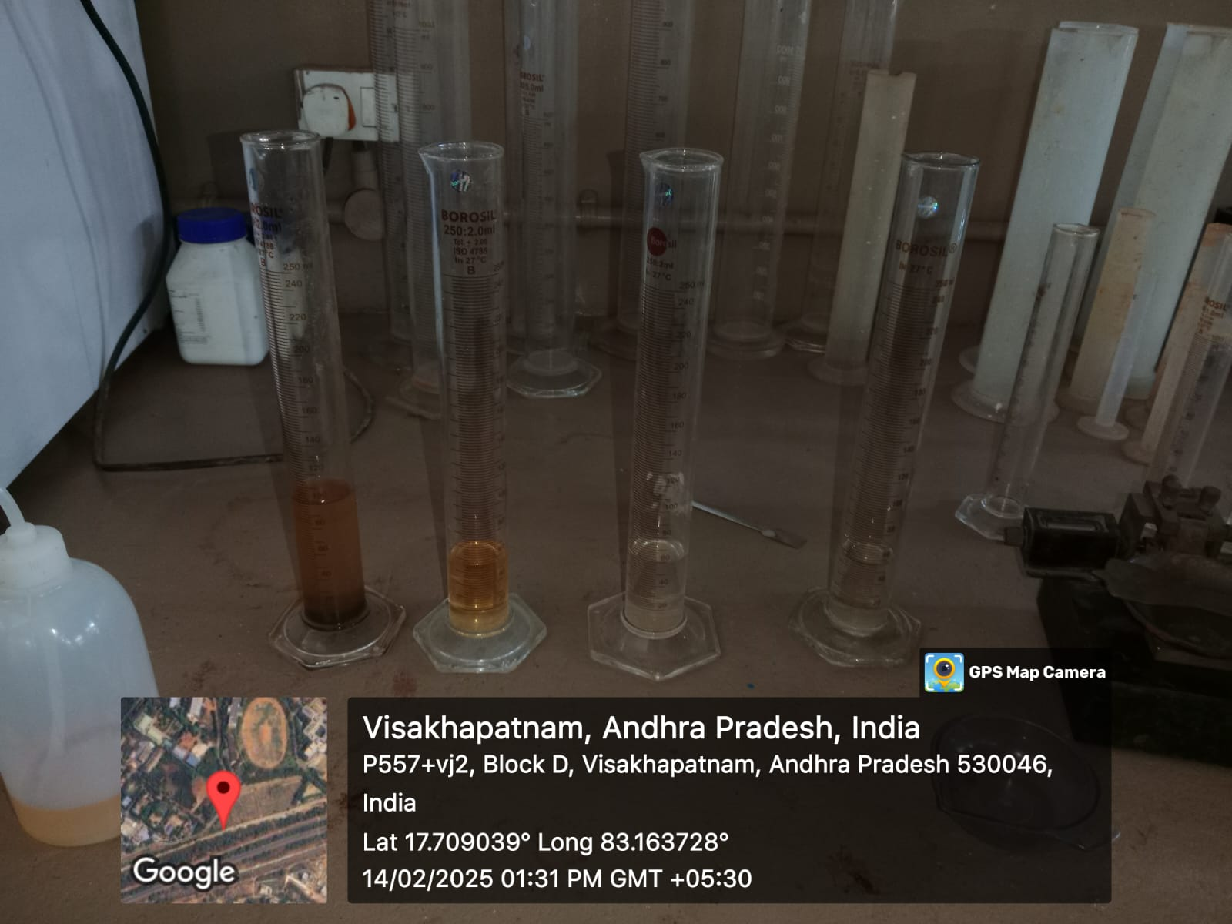

**Figure. 4.4. Measuring jars with a soil sample.**

**Proctor Test**

**General**

The Standard Proctor Test is conducted to study the density of soil and its corresponding optimum moisture content. Compaction of soil is a mechanical process by which the soil particles are constrained to be packed more closely together by reducing the air voids. Soil compaction causes a decrease in air voids and, consequently, an increase in dry density. This may result in an increase in shearing strength

**Aim:** To determine the maximum dry density and optimum moisture content of a soil sample.

##### **Materials and Equipment Required**:

Soil sample

Proctor mold with a volume of 1/30 ft³ or 1 liter

Proctor hammer with a weight of 5.5 lbs or 2.5 kg

Proctor base or compaction pedestal

Balance or scale with a capacity of at least 10 lbs or 5 kg, and accuracy of 0.01 lbs or 5 g

Moisture content can or containers

Mixing tools (e.g., spatula, mixing bowl)

Oven or drying apparatus

Graduated cylinder or similar measuring device

**Procedure:**

Step 1. Obtain a representative soil sample from the project site. The sample should be large enough to provide an adequate amount of soil for testing, typically around 5-10 lbs or 2-5 kg.

Step 2. Remove any organic materials or large particles from the soil sample that may interfere with the test results. Break up any large clumps of soil and remove stones or debris.

Step 3. Determine the initial weight of the Proctor mould with the base and record it.

Step 4. Place the soil sample in a mixing bowl and add water gradually while mixing until the soil reaches the desired moisture content for testing. The moisture content should be within the range of the expected field conditions for compaction.

Step 5. Fill the Proctor mold in three equal layers, each having a height of approximately 1/3 of the mold volume. Compact each layer using 25 blows of the Proctor hammer, uniformly distributed over the surface of the soil.

Step 6. After compacting each layer, trim the excess soil from the top of the mould using a straightedge or spatula, and determine the weight of the compacted soil in the mould, including the mould and base. Record the weight as the wet weight.

Step 7. Remove the compacted soil from the mould carefully and place it in a moisture content can or container. Repeat the compaction process for additional moisture content levels, usually 2-3 more times, to obtain a range of compacted samples with different moisture contents

Step 8. After obtaining all the necessary compacted samples, place them in an oven or drying apparatus to dry at a temperature of 230-250°F (110-120°C) for at least 24 hours, or until the samples reach a constant weight. This constant weight represents the dry weight of the soil.

Step 9. Once the samples are completely dry, remove them from the oven or drying apparatus, allow them to cool to room temperature, and determine the dry weight of each sample using the balance or scale.

Step 10. Calculate the moisture content for each sample using the formula: Moisture Content (%) = [(Wet Weight - Dry Weight)/Dry Weight] x 100

Step 11. Plot a moisture content versus dry density curve using the moisture content and dry density values obtained from the Proctor test.

Step 12. Determine the moisture content and corresponding dry density that yield the maximum dry density from the moisture content versus dry density curve. This moisture content and dry density represent the optimal moisture content and maximum dry density of the soil for compaction.

## 

**Figure. 4.5. Compaction of a soil with a proctor**

**V. RESULTS AND DISCUCCIONS**

**FREE SWELL INDEX TEST:**

1. Free swell index of soil with varying MSWI ash percentages:

**Figure. 5.1. shows free swell index with different % of MSWI ash content**

Table 1: Free swell index

|  |  |  |
| --- | --- | --- |
| S.NO | Percentage of MSWI ash | Percentage of free swell index |
| 1 | 0 | 65 |
| 2 | 10 | 52 |
| 3 | 20 | 42 |
| 4 | 30 | 37 |

* From the above table, we can observe that the clayey soil without adding MSWI ash the percentage of free swell index is 65% by adding MSWI ash, the free swell index is reduced to 52%,42%,37% With addition of 10%,20%and 30% of MSWI ash respectively.

**SPECIFIC GRAVITY TEST:**

**Figure. 5.2. Shows Specific gravity with different % of MSWI ash content**

1. Specific gravity of soil:

Table 2: Specific gravity of soil

|  |  |  |  |  |  |
| --- | --- | --- | --- | --- | --- |
| Trail no | Weight 1(w1) | Weight 2(w2) | Weight 3 (w3) | Weight 4 (w4) | Specific Gravity |
| Trail 1 | 36.88 | 46.9 | 94.41 | 88.56 | 2.4 |
| Trail 2 | 36.92 | 46.57 | 94.4 | 88.56 | 2.38 |
| Trail 3 | 36.88 | 56.88 | 100.24 | 88.92 | 2.3 |
| Trail 4 | 36.94 | 56.94 | 100.27 | 88.75 | 2.35 |

* From Table 2 above, we observe that the specific gravity of soil without adding any MSWI

ash the specific gravity of the soil by taking the average of the trials performed on the specific gravity

of the soil is observed to be 2.35

1. Specific gravity of soil with 10% of MSWI ash:

Table 3 Specific gravity of soil with 10% of MSWI ash

|  |  |  |  |  |  |
| --- | --- | --- | --- | --- | --- |
| Trail.no | Weight1(w1) | Weight 2(w2) | Weight 3 (w3) | Weight 4 (w4) | Specific Gravity |
| Trail 1 | 34.46 | 54.34 | 98.78 | 86.14 | 2.39 |
| Trail 2 | 34.98 | 56.98 | 100.64 | 88.46 | 2.55 |
| Trail 3 | 34.65 | 54.68 | 98.54 | 86.44 | 2.52 |

* From the above table no 3 we observe that the specific gravity of soil with adding 10% of MSWI

ash the specific gravity of the specific gravity of the soil is increased from 2.35 to 2.48 by adding the

10% of MSWI ash to the clayey soil.

1. Specific gravity of soil with 20% of MSWI ash:

Table 4 Specific gravity of soil with 20% of MSWI ash

|  |  |  |  |  |  |
| --- | --- | --- | --- | --- | --- |
| Trail.no | Weight 1(w1) | Weight 2(w2) | Weight 3 (w3) | Weight 4 (w4) | Specific Gravity |
| Trail 1 | 34.46 | 54.5 | 98.7 | 86.24 | 2.64 |
| Trail 2 | 34.69 | 54.74 | 98.94 | 86.49 | 2.63 |
| Trail 3 | 36.92 | 56.92 | 100.53 | 88.41 | 2.53 |

* From the above table no 4 we observe that the specific gravity of soil with adding 20% of MSWI

ash the specific gravity of the specific gravity of the soil is increased from 2.35 to 2.48 by adding the

20% of MSWI ash to the clayey soil.

1. Specific gravity of soil with 30% of MSWI ash:

Table 5 Specific gravity of soil with 30% of MSWI ash

|  |  |  |  |  |  |
| --- | --- | --- | --- | --- | --- |
| S.NO | Weight 1(w1) | Weight 2(w2) | Weight 3 (w3) | Weight 4 (w4) | Specific Gravity |
| Trail 1 | 34.41 | 54.41 | 99.27 | 86.16 | 2.85 |
| Trail 2 | 37.01 | 57.01 | 100.92 | 88.45 | 2.65 |
| Trail 3 | 34.75 | 54.77 | 99.01 | 86.42 | 2.69 |

* From the above table no 4 we observe that the specific gravity of soil with adding 30% of MSWI

ash the specific gravity of the specific gravity of the soil is reduced from 2.6 to 2.73 by adding the

30% of MSWI ash to the clayey soil

* The specific gravity is found to be increased, i.e, the specific gravity of soil is 2.35 by adding the

MSWI ash with different percentages, 10%,20%, and 30%, the specific gravity of the clayey soil is increased to 2.48,2.6,2.73, respectively.

**MODIFIED PROCTOR TEST:**

**Figure. 5.3. Shows the dry density of the soil**

1. Modified proctor test for soil:

Table 6: Dry density of soil

|  |  |
| --- | --- |
| WATER CONTENT (%) | DRYDENSITY kg/m^3 |
| 13.63 | 1.45 |
| 19.04 | 1.46 |
| 21.42 | 1.87 |
| 26.08 | 1.53 |
| 26.92 | 1.47 |

* From Table 6 above, we observe that the dry density of soil without MSWI is the dry density of

The clayey soil is observed as 1.877 g/cc, and the optimum moisture content is noted as 21.42% to the

clayey soil.

1. Modified proctor test for soil with 30% of MSWI ash:

**Figure. 5.4. Shows the dry density of the soil with 30% of MSWI ash**

Table 7: Dry density of soil with 30% of MSWA ash

|  |  |
| --- | --- |
| WATER CONTENT (%) | DRYDENSITY kg/m^3 |
| 16.66 | 1.59 |
| 17.64 | 1.66 |
| 17.85 | 1.67 |
| 18.85 | 1.36 |
| 19.23 | 1.56 |

* From Table 7 above, we observe that the dry density of soil with adding 30% of MSWI ash the dry density of the clayey soil is observed as 1.677 g/cc, and the optimum moisture content is noted as 17.85% for the clayey soil.
* For the modified proctor test, for soil without adding the MSWI ash, the OMC = 21.42%, and the maximum dry density =1.877 g/cc, which are reduced by adding 30% of MSWI ash, the OMC = 17.85 % the maximum dry density =1.674 g/cc.

**ATTERBURG LIMITS FOR SOIL**

**Liquid limit test**:

**Figure. 5.5. Shows the Liquid limit of the soil with different % MSWI ash content**

1. Liquid Limit of soil:

Table 8: Liquid limit of soil

|  |  |  |  |  |  |
| --- | --- | --- | --- | --- | --- |
| Water content | Blows | Weight (w0) | Weight 1(w1) | Weight 2(w2) | Percentage of Liquid limit (%) |
| Amount of water: 40ml | 46 | 53.18 | 60.67 | 58.36 | 44.42% |
| Amount of water: 45ml | 26 | 53.56 | 61.32 | 58.71 | 49.71% |
| Amount of water: 50ml | 10 | 47.2 | 58.87 | 54.77 | 54.16% |

* From Table 8 above, we observe that the liquid limit of the soil without adding the MSWI ash the liquid limit of the soil is found to be 49%.

1. Liquid Limit of soil with 10% of MSWA ash:

Table 9: Liquid limit of soil with 10% of MSWA ash

|  |  |  |  |  |  |
| --- | --- | --- | --- | --- | --- |
| Water content | Blows | Weight (w0) | Weight 1(w1) | Weight 2(w2) | Percentage of Liquid limit (%) |
| Amount of water: 40ml | 30 | 47.26 | 60.57 | 56.64 | 41.89% |
| Amount of water: 45ml | 28 | 54.22 | 69.31 | 64.79 | 42.76% |
| Amount of water: 50ml | 10 | 53.07 | 67.92 | 62.94 | 50.45% |

* From Table 9 above, we observe that the liquid limit of the soil with adding the 10% of MSWI ash the liquid limit of the soil is found to be 45%, which is reduced by 4%.

1. Liquid Limit of soil with 20% of MSWA ash:

Table 10: Liquid limit of soil with 20% of MSWA ash

|  |  |  |  |  |  |
| --- | --- | --- | --- | --- | --- |
| Water content | Blows | Weight (w0) | Weight 1(w1) | Weight 2(w2) | Percentage of Liquid limit (%) |
| Amount of water: 40ml | 35 | 51.49 | 66.87 | 62.55 | 39.05% |
| Amount of water: 45ml | 25 | 51.88 | 68.98 | 63.68 | 44.91% |
| Amount of water: 50ml | 10 | 54.21 | 73.46 | 67.01 | 50.39% |

* From Table 10 above, we observe that the liquid limit of the soil with adding the 20% of MSWI ash the liquid limit of the soil is found to be 44%, which is reduced by 0.09%.

1. Liquid Limit of soil with 30% of MSWA ash:

Table 11: Liquid limit of soil with 30% of MSWA ash

|  |  |  |  |  |  |
| --- | --- | --- | --- | --- | --- |
| Water content | Blows | Weight (w0) | Weight 1(w1) | Weight 2(w2) | Percentage of Liquid limit (%) |
| Amount of water: 40ml | 30 | 51.86 | 68.04 | 63.41 | 40.08% |
| Amount of water: 45ml | 20 | 47.2 | 63.15 | 58.24 | 44.4% |

* From Table 11 above, we observe that the liquid limit of the soil with adding the 30% of MSWI ash the liquid limit of the soil is found to be 42%, which is reduced by 2.91%.
* The liquid limit of the soil was found to decrease with an increase in the MSWA content, i.e, the liquid limit of the soil was found to be 49% by adding the MSWA with different percentages, 10%,20%, and 30% are 45%,44.92%, and 42% respectively.

**Plastic limit test:**

**Figure. 5.6. Shows the plasticity index of the soil with different % MSWI ash content**

1. Plastic Limit of soil:

Table 12: Plastic limit of soil

|  |  |  |  |  |
| --- | --- | --- | --- | --- |
| Trail no | Weight (w0) | Weight1 (w1) | Weight2 (w2) | Percentage of Plastic limit (%) |
| Trail 1 | 51.51 | 55.93 | 55.07 | 24.15% |
| Trail 2 | 47.21 | 49.71 | 49.18 | 26.90% |

From Table 12 above, we observe that plastic limit of the soil without adding the MSWI ash the plastic limit of the soil is found to be 26.9%.

2)Plati Limit of soil with 10% of MSWI ash:

**Table 13: Plastic limit of soil with 10% of MSWI ash**

|  |  |  |  |  |
| --- | --- | --- | --- | --- |
| Trail no | Weight (w0) | Weight1 (w1) | Weight2 (w2) | Percentage of Plastic limit (%) |
| Trail 1 | 51.50 | 53.17 | 53.36 | 25.5% |
| Trail 2 | 51.83 | 53.67 | 53.36 | 20.2% |
| Trail 3 | 47.22 | 58.2 | 57.54 | 23.4% |

* From Table 13 above, we observe that the plastic limit of the soil with adding 10% of MSWI ash the plastic limit of the soil is found to be 25.5%, which is reduced by 1.4%.

3) Plastic Limit of soil with 20% of MSWI ash:

Table 14: Plastic limit of soil with 20% of MSWI ash

|  |  |  |  |  |
| --- | --- | --- | --- | --- |
| Trail no | Weight (w0) | Weight1 (w1) | Weight2 (w2) | Percentage of Plastic limit (%) |
| Trail 1 | 51.86 | 54.35 | 53.86 | 24.50% |
| Trail 2 | 51.54 | 52.61 | 52.39 | 25.88% |
| Trail 3 | 47.22 | 50.08 | 49.24 | 27.67% |

* From Table 14 above, we observe that the plastic limit of the soil with adding 20% of MSWI ash the plastic limit of the soil is found to be 27.67%, which is increased by 2.17 %.

4) Plastic Limit of soil with 30% of MSWI ash:

Table 15: Plastic limit of soil with 30% of MSWI ash

|  |  |  |  |  |
| --- | --- | --- | --- | --- |
|  | Weight (w0) | Weight1 (w1) | Weight2 (w2) | Percentage of Plastic limit (%) |
| Trail 1 | 53.57 | 54.73 | 54.46 | 29.5% |
| Trail 2 | 54.73 | 56.67 | 56.24 | 28.4% |

* From Table 15 above, we observe that the plastic limit of the soil with adding 30% of MSWI ash the plastic limit of the soil is found to be 29.5%, which is increased by 1.83 %.
* The plasticity index of the soil is found to be 22.1%. by adding the MSWA with different percentages, 10%,20%, and 30%, which are 19.5%,17.24% %, and 13.5%, which means the plasticity index of soil is decreasing with the addition of MSWA content. This indicates that the soil is becoming less prone to swelling, shrinking, and deformation, which are all problems associated with high plasticity.

# VI. CONCLUSION

The study aimed to determine the improvement of the index and engineering properties of clayey soil by conducting a series of geotechnical tests, which include the Free Swell Index test, the Specific gravity test, the consistency limits of the soil, including a liquid and plastic limit of the soil, and also the standard proctor test. The results have provided a comprehensive understanding of the physical and engineering properties of clayey soil, which are useful for foundation design problems and construction decisions.

# REFERENCES

[1]. Saurabh Kumar, Sneha Gupta “Engineering Behavior of Municipal Solid Waste Incinerated Ash with Compressible Soil” Mechanics of Advanced Composite Structures 12 (2025), Serial Number 24, 85 – 96.

[2]. Chethan K, Mariyam Aleena Mahin 1’’ Stabilization of expansive soil using incinerated waste ash ” ICEST_CV-012(2024).

[3]. Vipin Madadh, Mr. Aman Bathla, Dr. Gurcharan Singh “Soil stabilization using burnt municipal solid waste “Volume 7, Issue 6 | ISSN: 2456-3315,2023

[4]. B. Mohan Babu, Adimulam Gayathri “A study on soil stabilization by using municipal solid waste incineration ash” Journal of Engineering Sciences Vol 14 Issue 02,2023

[5]. A. S. M. Riyad1, I. M. Rafizul, “Effect of Fly Ash Content on the Engineering Properties of Stabilized Soil at Southwestern Region of Bangladesh Journal of Energy and Environment 9 (3): 216-226, 2018.

[6]. Dinesh. A Gokilavani,” Stabilization of soil by using solid waste “© 2017 IJEDR Volume 5, Issue 3 | ISSN: 2321-9939.

[7]. P Renuka, Shivashanker,” A study on soil stabilization by using municipal solid waste incineration ash” Journal Volume 11, Issue 08, 2022.

[8]. Karthik, Ashok Kumar” Soil Stabilization By Using Fly Ash “e-ISSN: 2278-1684,p-ISSN: 2320- 334X, Volume 10, Issue 6 (Jan. 2014), PP 20-26.

[9]. Charles H. K. Lam, Alvin W. M. Ip,” Use of Incineration MSW Ash”, ISSN 2071-1050(2010).

[10]. Tawrez Shaaban Sofi, Jamal Ismael Kakrasul, and Sherwan Sharif Qurtas” Assessment of the Geotechnical Properties of Municipal Solid Waste and Its Effect on the Surrounding Soil”.

[11]. Karanbir Singh Randhawa, Raman Kumar, Hamad Alkaabi,” Bioengineering solutions for expansive soil stabilization using waste materials” AIP Advances 14, 055308 (2024).

[12]. Carmen Otilia Rusănescu and Marin Rusănescu ” Application of Fly Ash Obtained from the Incineration of Municipal Solid Waste in Agriculture” Appl. Sci. 2023, 13, 3246

[13]. K. Aditya Sainath, Sangeeta Das” study on municipal solid waste management in india”© 2021 IJCRT | Volume 9, Issue 2 February 2021 | ISSN: 2320-2882.

[14]. Byoung Hooi Cho, BooHyun Nam, Jinwoo An, and Heejung Youn “Municipal Solid Waste Incineration (MSWI) Ashes as Construction Materials” Materials 2020, 13, 3143.

[15]. Bharti Shinde, Anuja Sangale, Maile Pranita, Jyotsna Sanagle, “Utilization of waste materials for soil stabilization” Progress in Engineering Science 1 (2024) 100009.

[16]. Cristina Marieta 1, Alexander Martín-Garin, Iñigo Leon 2” Municipal Solid Waste Incineration Fly Ash” Materials 2023, 16, 2538.

[17]. Karanbir Singh Randhawaa, Rajiv Chauhanb “Stabilizing black cotton soil in subgrade with municipal solid waste incineration ash for lowering greenhouse gas emission” [Volume 50, Part 5](https://www.sciencedirect.com/journal/materials-today-proceedings/vol/50/part/P5), 2022, Pages 1145-1151.

[18]. Preetpal Singh, Amardeep Boora, and Ashok Kumar Gupta “A Review on Utilizing Municipal Solid Waste Incineration (MSWIA) in Construction Activities” IOP Conf. Series: Earth and Environmental Science 1110 (2023) 012042.

[19]. Yuying Zhang W.Tsang, Lei Wang, Liang Chen” Treatment of municipal solid waste incineration fly ash” journal of Hazardous Materials411(2021)125132.

[20]. Tanaya Deb, Sujit Kumar Pal” Effect of fly ash on geotechnical properties of local soil-fly ash mixed samples.