Fertilizers Selling and Suggesting Website

|  |  |  |
| --- | --- | --- |
| Mr. Nikhil Jahagirdar | Mr. Arjun Mali | Mr. Kunal Khairnar |
| *Information technology* | *Information technology* | *Information technology* |
| *MET’s Institute of Technology* | *MET’s Institute of Technology* | *MET’s Institute of Technology* |
| *Polytechnic, Bhujbal Knowledge City* | *Polytechnic, Bhujbal Knowledge City* | *Polytechnic, Bhujbal Knowledge City* |
| *Nashik, Maharashtra ,India* | *Nashik, Maharashtra ,India* | *Nashik, Maharashtra ,India* |
| [nikhiljahagirdar38@gmail.com](mailto:nikhiljahagirdar38@gmail.com) | [arjunmali2006@gmail.com](mailto:arjunmali2006@gmail.com) | [kunalkhairnar607@gmail.com](mailto:kunalkhairnar607@gmail.com) |

### A.A.Ugale

*Project Guide Information Technology*

*Met’s Institute of Technology Polytechnic, Bhujbal Knowledge City, Adgaon, Nashik, Maharashtra, India* [Email:aboliu_iot@bkc.met.edu](mailto:srgaidhani1@gmail.com)

### Sanjeev.B.Patil

*HOD,*

*Dept. of Information Technology*

*Met’s Institute of Technology Polytechnic, Bhujbal Knowledge City, Adgaon, Nashik,*

*Maharashtra, India*

[Email:sanjeevp_iot@bkc.met.edu](mailto:sanjeevp_iot@bkc.met.edu)

##### *Abstract -* In recent years, the agriculture area has visible a sizable shift toward digital structures that provide green answers for farmers and gardening fans. This paper explores the layout and implementation of a web fertilizer selling and recommendation internet site, aimed toward bridging the distance between purchasers and tailored agricultural merchandise. The platform integrates user-pleasant features inclusive of personalized fertilizer pointers based on soil conditions, plant sorts, and regional climate elements. By using superior algorithms and a robust database of fertilizer types and their respective advantages, the internet site gives precise tips to optimize crop increase and soil health. Additionally, the platform streamlines the shopping process, imparting a huge variety of fertilizers and related products with the benefit of domestic transport. The paper discusses the technical framework, person enjoy layout, and the potential impact of this kind of platform in promoting sustainable agricultural practices and growing accessibility to incredible fertilizers. Through case studies and user remarks, we compare the effectiveness of the website in meeting the desires of cutting- edge-day farmers and hobbyists alike.

***Keywords: Fertilizer recommendation system, agricultural e- commerce, personal fertilizer proposal, adaptation of soil health.***

# INTRODUCTION

The global agricultural sector undergoes a change inspired by technological progress, where the Internet plays an important role in reducing the difference between farmers, consumers and agricultural products. One of the biggest challenges in modern agriculture is the choice of proper fertilizer, which corresponds to specific soil conditions, plant types and environmental factors. This challenge often results in disabilities and crops of crops, as farmers lack access to the right tools to meet personal recommendations and their unique needs.

The emergence of fertilizer sales and recommendations represents an important opportunity to solve these challenges.

These platforms can provide accurate fertilizer solutions for

farmers, gardeners and hobbies by combining advanced algorithms, data-driven recommendations and e-commerce

functions that increase crop productivity and support permanent agricultural practices.

# SYSTEM DESIGN

The method of designing coding to design a fertilizer and suggesting website is done to complete the information for a system for a system for HTML5, CSS5, JavaScript and boot straps. System module description:

* + Coding (HTML, Bootstrap, PHP, CSS, JavaScript, SQL)
  + Methodology
  + Software architecture
  + Data Design Model

##### Html

Hyper Text Markup Language (HTML) stands as the foundation stone for web development, offering a standard, user -friendly language to create websites. This simplifies the process of organizing and presenting information about browsers by providing a versatile structure. Through HTML, developers can integrate various elements such as images, texts, videos, hyperlinks, buttons, search boxes, moldings and checkout route on a web page. The simple learning and essential functionalities presented HTML inevitable for anyone involved in web development, as it makes it possible to create dynamic and interactive web pages. Originally conceived by Tim Burner Lee in 1980, HTML achieved standardization of Internet Engineering Task Force (IETF) in 1993. The syntax consists mainly of different types of materials and documents that act as containers, opening and closing. For example, a section is encapsulated in an opening and closure code, which has materials that live between them. In short, HTML simplicity and strong abilities make it a basic skill to create web pages, and shape the digital landscape that we know.

##### Bootstrap

Bootstrap is a widely used front and framework designed to create responsible and mobile-first sites and webapper. Developed by Twitter, Bootstrap developers, including grids, navigation line, buttons and forms, provide HTML, CSS and JavaScript before style with a wide set of components, enabling them to construct

constant and visually attractive user interface quickly and visually. The web system facilitates the preparation of responsible layouts as originally adapted to different screen sizes and equipment, while the wide library with customization components and uses classes provides simple prototypes and customization. With its strong functions, flexibility and active social support, Bootstrap has become a favorite alternative for developers to create modern, responsible and user -friendly web projects.

#### PHP

PHP which stands for Hypertext Preprosper, is a widely used script language on the servers side mainly designed for grid development, but is also suitable for general programming. Use in various platforms and operating systems is known for ease of use, flexibility and extensive support, enables PHP developers to create dynamic and interactive web pages and applications. With its extensive libraries and frames, such as larvae, symphony and codes, offer powerful tools to effectively create scalable and strong web solutions for PHP developers. In addition, PHP is initially integrated with databases such as MySQL, which makes it ideal for creating dynamic material-powered websites and e-commerce platforms. Its open source, giant social support and continuous development have strengthened PHP status as one of the most popular and versatile programming languages for web development.

#### CSS

Cascading Style Sheet (CSS) is a basic web development tool, adding color, animation and layout to HTML content enriches the visual presentation of web pages. In addition to aesthetics, the CSS also distinguishes the presentation from the material, which enables code clarity and access to code clarification, and enables continuous styles on multiple pages when using separate .CSS files. This modular approach not only strengthens the development, but also improves the performance of the site by customizing the side load time through information about cache styling. In short, css -stable HTML transforms the structures visually attractive and user -friendly websites, making it an essential language to create an online experience.

##### JavaScript

Java Script is often abbreviated as JS, it is an object oriented, is high-level programming language. It has curly-bracket syntax and includes dynamic typing and first-class functions. It is a programming language used both on the client-side and serverside that allows you to make web pages interactive. Every browser has an embedded engine which is also called a JavaScript virtual machine. Different engines have different “codenames”. For example, V8 – in Chrome and Opera. Spider Monkey – in Firefox. Java Script was initially called type script.

#### SQL

SQL (Structured Query Language) plays an important role in e- commerce sites by managing and managing data in the database. This enables storage, recovery and manipulation of large versions of structured data, such as customer information, product description, order and transaction. In an e-commerce context, SQL is used to perform questions that receive information about the product, manage stock levels, process orders and generate reports for analysis. In addition, SQL ensures data integrity and security through facilities such as transactions, obstacles and permits, protects sensitive customers and transaction data. With its ability to handle complex issues effectively and manage a relationship database, SQL acts as a spine in e-commerce sites, facilitates spontaneous operations and provides a reliable basis for business-

matured tasks.

## COMPONENTS IN Fertilizer Selling and Suggesting Website

1. **Innovative Technologies in Fertilizer Selling and Suggesting:** In recent years, technology has largely impressed the way fertilizer is sold and suggested both online and offline. These innovations not only improve the efficiency of selling fertilizers, but also provide better recommendations to customers, and ensure that they receive the most appropriate product for their needs.
2. **Content Quality and Accuracy:** When selling fertilizers online, the quality and accuracy of the material supplied on your site is important. The exact, reliable and well -prepared material not only helps to inform customers, but also creates self -confidence and reliability. Poor content or misleading information can cause dissatisfaction with the customer, financial loss and damage to the brand's reputation.
3. **Social Media Integration and Marketing:** The literature acknowledges the role of social media in real estate marketing. Integrating social media platforms into websites and utilizing them for promotional activities are seen as effective strategies to reach a broader audience.
4. **Competitive Landscape and Industry Trends:** The fertilizer market is very competitive, focusing on different segments such as traditional, organic and innovative fertilizers with diverse mix of global players, regional suppliers and new entrance. The competing landscape is influenced by factors such as technological progress, regulatory environment, pricing strategies and consumer preferences..

# RESULTS AND DISCUSSION

## Quantitative Analysis:

Quantitative analysis reveals the necessary insight into the technical performance of the property site. Page load provides a quantitative foundation for evaluating the efficiency of the site, such as responsibility in devices, liability in devices and the speed of the overall site.

## User Feedback Surveys:

For user survey, a qualitative approach provides users' experiences. Participants' reactions shed light on content, content satisfaction and general satisfaction with the site. Common topics and specific user problems are identified for intensive analysis.

1. **Usability Testing:** Proper test results highlight the areas of the site that users find comfortable or challenging. During these sessions, observational users provide valuable insights into interactions, alerts to increase the overall user experiences.
2. **Comparative Analysis:** Comparative analysis Benchmark's real estate site against industry standards and best practices identified in the literature survey. The relative strength and weaknesses are identified with the participants, and help to understand the competing status of the site.

## Agile Model

The flexible model was mainly designed to help adapt a project quickly to change the requests. So the main goal of the flexible model is to offer the facility to complete the Quick Project. To complete this task, agility is required. The project is achieved by mounting the process and removing activities that may not be necessary for a specific project. In addition, all that is wasted time and effort is avoided. The flexible model refers to a group of development processes. These processes have some basic properties, but there are some subtle differences between.

1. **Collection of the requirement:-** At this stage, the development team should gather requirements by interacting with the customer. The development team will plan the time and effort required to build the project. Based on this information, you can evaluate technical and affordable feasibility.
2. **Design requirements:** -In this stage, the growth team will use high -level user flow or UML diagrams to display the work on new features and show how they will apply to existing software. Wireframaing and design of user interfaces are done in this phase
3. **Construction / repetition:-** In this step, the members of the development team begin to work on their project, with a view to distributing a work product.
4. **Testing / quality assurance:-** Testing includes unit testing, integration tests and system testing.
5. 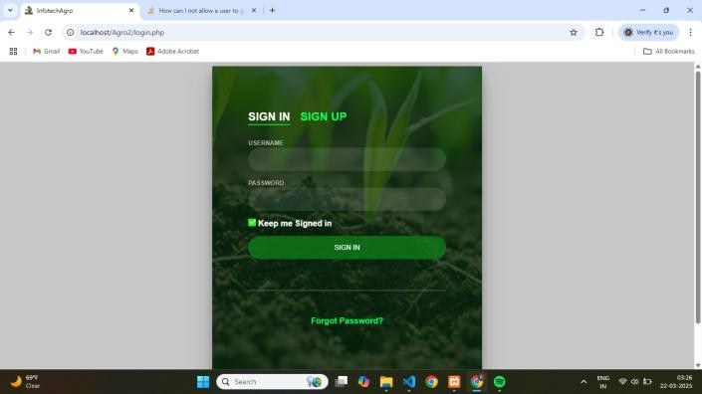**Integration test:-** Integration test is used to identify and solve any problem that can occur when different software units are combined.
6. **Answer:-** This is the final phase of the flexible model. In this, the team receives feedback on the product and is working to correct the errors based on the reaction given by the customer.

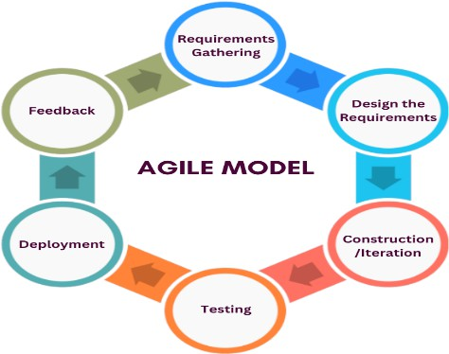

# RESULT

## Index.php

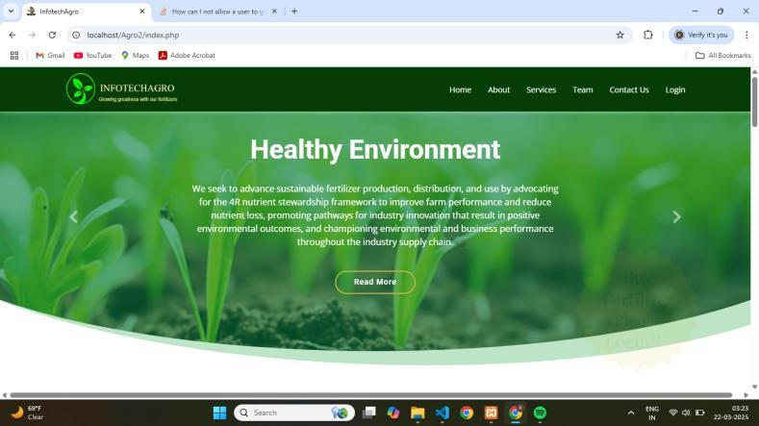

1. **Login Page**
2. **Admin Dashboard**

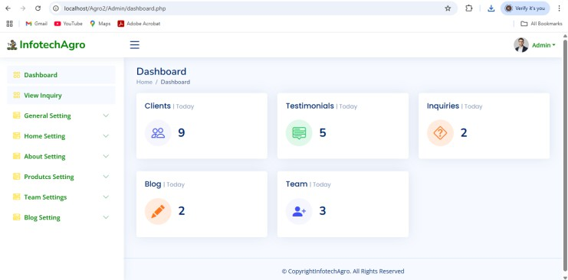

1. **Product**

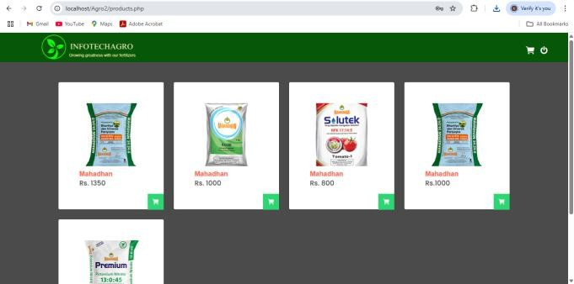

# CONCLUSION

The global fertilizer market undergoes significant changes, which is inspired by the progression of technology, data analysis and increasing significance of stability. Fertilizer sites, which have been integrated into the agricultural supply chain, develop to meet the different requirements for farmers in different fields. Either through e-commerce platforms, accurate agricultural equipment or stability initiatives, these sites redefine how fertilizers are sold, marketed and implemented globally.

# REFERENCES

1. International Fertilizer Industry Association (IFA). (2021). The Global Fertilizer Outlook 2021
2. Food and Agriculture Organization (FAO). (2020). Fertilizer Use by Crop: Global Review. Palm, R., & Reagans, R. (2013)..
3. European Commission. (2020). EU Fertilizer Regulation and Sustainability
4. European Commission. (2021). Digital Technologies for Precision Agriculture.