SMART CITY ROAD DEVELOPMENT: UPGRADING URBAN ROADS THROUGH COMPLETE STREET STRATEGIES
Mr. Sourabh Kala, Prof Ashish Waghmare², Prof Gaurav Vispute³
^{1,2,3} Department of Civil Engineering, AJEENKYA D Y Patil School of Engineering, Pune, Maharashtra- 412105, India.
Abstract:-
The evolution of urban mobility requires infrastructure that prioritizes not just vehicles, but people, sustainability, and smart technology. This paper explores the development and improvement of urban road networks under the Smart City initiative, emphasizing the adoption of Complete Street strategies. These strategies promote inclusive road design that accommodates all users—pedestrians, cyclists, public transport, and vehicles—while enhancing safety, accessibility, and environmental performance.
The study focuses on selected project road stretches identified for upgradation. Existing road conditions were assessed in detail, including geometry, traffic flow, pedestrian movement, and utility constraints. Based on this analysis, multiple improvement schemes were proposed, reviewed for feasibility, and refined into a comprehensive conceptual design aligned with Smart City objectives. The proposed upgrades integrate smart infrastructure, efficient drainage, green corridors, and non-motorized transport facilities, ultimately transforming traditional roads into vibrant, multi-functional public spaces. This paper highlights how Complete Streets can play a pivotal role in sustainable urban development and contribute to more livable, resilient cities.
Key Words: - Smart City, Urban Road Development, Complete Streets, Sustainable Mobility, Infrastructure Upgradation, Road Safety
1. Introduction:-
This paper is focused on Upgradation and improvement of road under Smart City Project. Project road stretch sections have been identified for upgradation and improvement under the Smart City Project. The existing features of the project stretch have been analysed to come up with suitable solutions for upgrading the existing road with complete street components. Initial feasibility of improvement schemes for this road sections has been discussed, reviewed and a final concept has been arrived to upgrade the road as per scope of work. Jmmu & Kashmir also known as “Paradise on Earth” is known all over the world for its scenic splendour. Srinagar, the summer capital of Jammu & Kashmir Union Territory (UT) is one the prominent tourist destination in northern India. The city is situated at an elevation of 1586 meters (5200 feet) along the banks of Jhelum River in the Vale of Kashmir. The city despite having water available in plenty is confronted with acute shortage of potable water supply and non-revenue water is as high as 89% in some of the pumping stations. Similarly, there are large deficiencies in amenities/ facilities and other sectors have begun to impose serious constraints on the orderly and planned development.
The area constituting the metropolitan and its environs are becoming more and more critical with the increase in population and deterioration in existing level of services. The problems are assuming serious propositions in all aspect of urban living and are extremely critical in major sectors of traffic, transportation, sewerage, solid waste management, drainage, housing for urban poor, and conservation of natural or cultural heritage. For instance, traffic and transportation problems have begun to impose serious constraints on orderly development and mobility. At present major sewerage generated in the city is directly draining into Jhelum River. Rising cost of land and construction has put lower incomes out of housing market.
Srinagar is the northernmost city of India & it is the first Metropolis and fastest growing city of UT Jammu and Kashmir. It is located in the heart of the Valley on both banks of River Jhelum. It is known for its rich historical past with bountiful natural heritage. Srinagar city due to its centrality has recorded extensive growth in spatial spread and population over last three decades which has generated a number of problems including stress and strain on infrastructure, traffic and transportation, environmental, housing, and mushrooming of urban poor colonies, widespread inorganic and haphazard growth.

2. Survey and Investigation:-
Survey and investigations play significant role in planning and design of infrastructure projects. The SSCL carried out various field studies, engineering surveys and investigations to collect the necessary data for the project. The investigations were carried out to generate adequate supportive database for preparing the most appropriate proposal to meet the functional and structural efficiency and safety requirements.
The field studies, engineering surveys and necessary data available with SSCL was collected for planning and design of infrastructure components. As the details available were limited, the design was carried out based on secondary data and experiences.
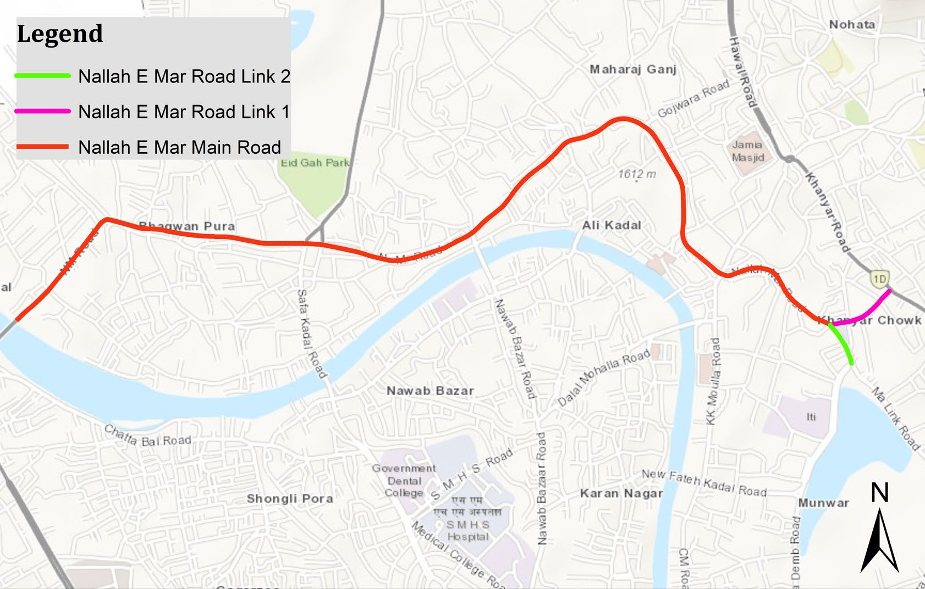
Existing features of the road. The existing condition assessment of the stretch of around 4.3 km. of the Nallah-i-Mar road, which is under consideration for upgradation and improvement, is discussed in this section. The road considered is from Khanyar Police station to Noor Jahan bridge.
Figure01: Location of Nallah-I-Mar Road
2.1 Carriageway:
The Nallah-i-Mar road from Khanyar Police station to Noor Jahan bridge is majorly 2- lane carriageway with carriageway width varying from 6m to 7m. The RoW varies between around 17m to 43m along Nallah-i-Mar main road and 20m-30m along Link roads.
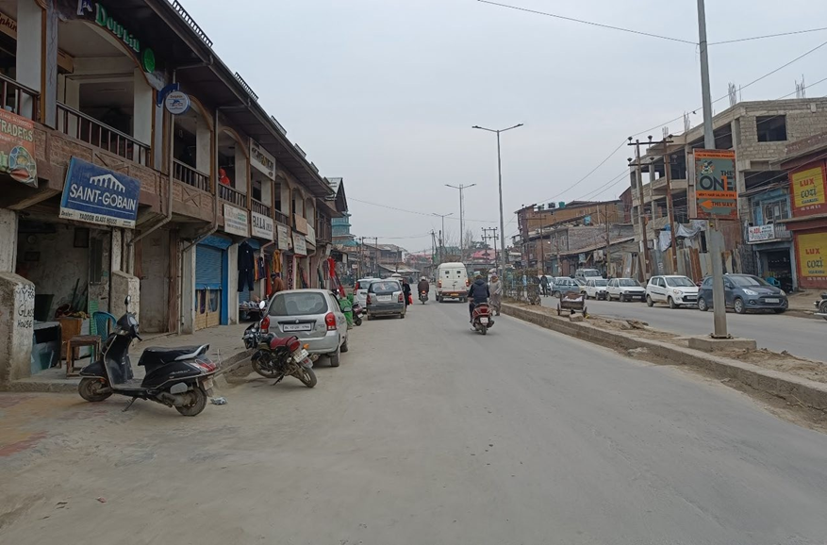
Figure:02 Carriageway of Nallah-i-Mar Road

2.1 Median:-
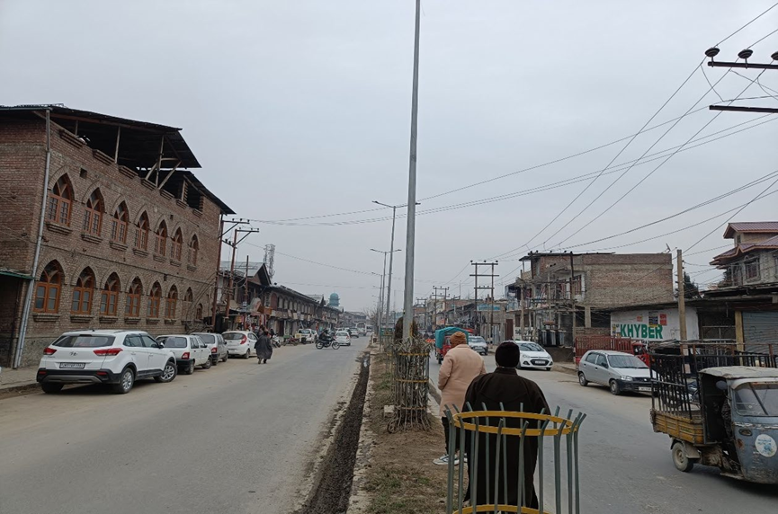
Figure 0-3 Median on Nallah-i-Mar road
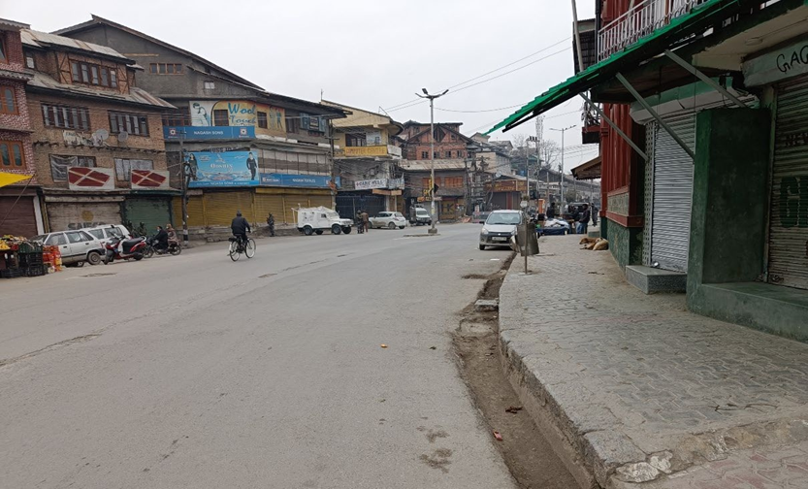
Figure 0-4 Nallah-i-Mar Road stretch without raised median

The median present in some of the stretches along the road varies in width along the downtown road from 1-2 meters.

2.2 Footpath:-
Footpath is provided on both the side on Nallah-i-Mar Road. Footpath on Nallah-i-Mar road varies from 1.0m to 4.2m. Mainly the footpaths are occupied by hawkers and shopkeepers on the road. Footpath is paved with concrete paver blocks.
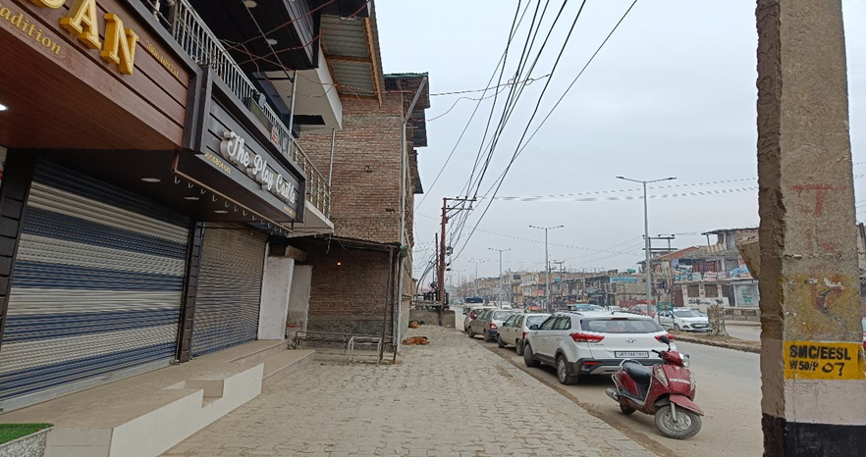
Figure 0-5 Footpath on Nallah-i-Mar Road

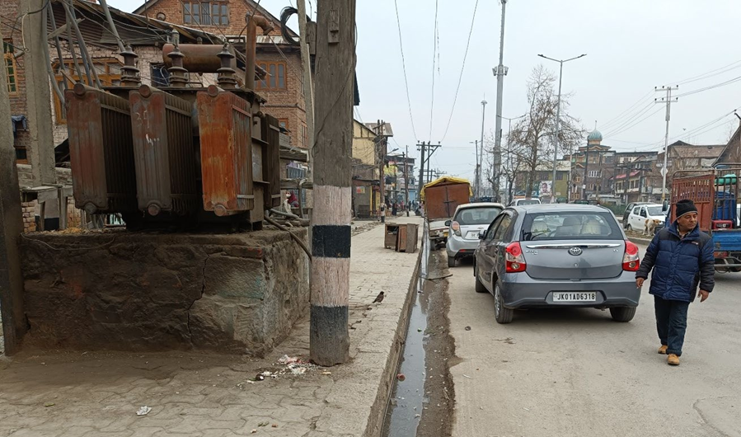
Figure 0-6 Electrical utilities on existing footpath
3. Major junction:-
Major junction on Nallah-i-Mar road (Khanyar Police station to Noor Jahan bridge) are listed below:
S.no. | Junction Name | Chainage
1 | Baba Demb ( Gousia Hospital) | 0+000
2 | Bohri kadal chowk | 0+500
3 | Rajori Kadal Chowk | 1+150
4 | Nawakadal chowk | 1+950
5 | Sekidafar Chowk | 2+600
6 | Qamarwari chowk | 3+840

3.1 Existing public building
There are several public buildings and parks located along the project roads. Prominent buildings attract lot of vehicular traffic during the peak hours & cause congestion hence it is important to study the locations of these buildings and upgrade the roads as per future requirement.
Table 0-1 important public building and institutions
S.no. | Buildings
1 | Ranger Masjid
2 | Jamia Masjid
3 | Budshah Tomb
4 | S.R Gunj Post office
5 | Mirwaiz manzil
6 | Jammu and Kashmir bank Rajori kadal
7 | Syed Mohd Habibullah Sarkhabi shrine
8 | Eidgah Park
9 | Shaheen public school
10 | Public Playground

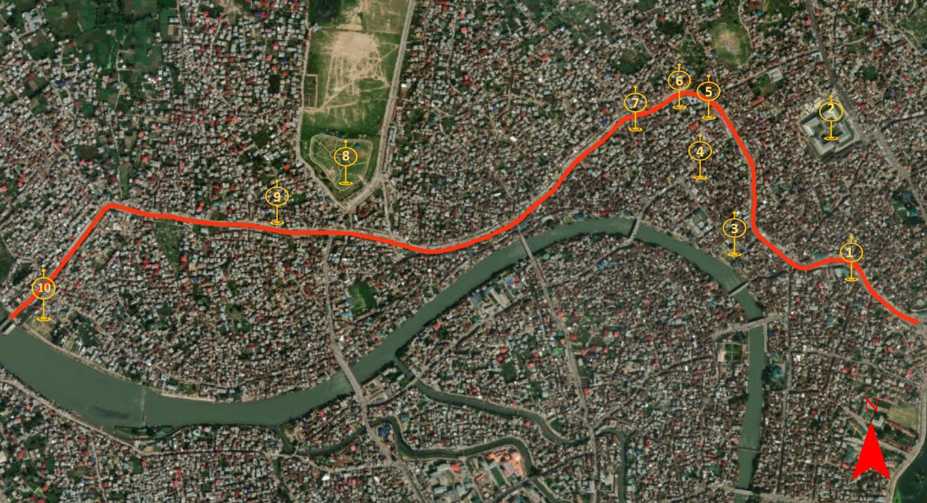
Figure 0-7 Existing important public building and institutions along Nallah-i-Mar Road

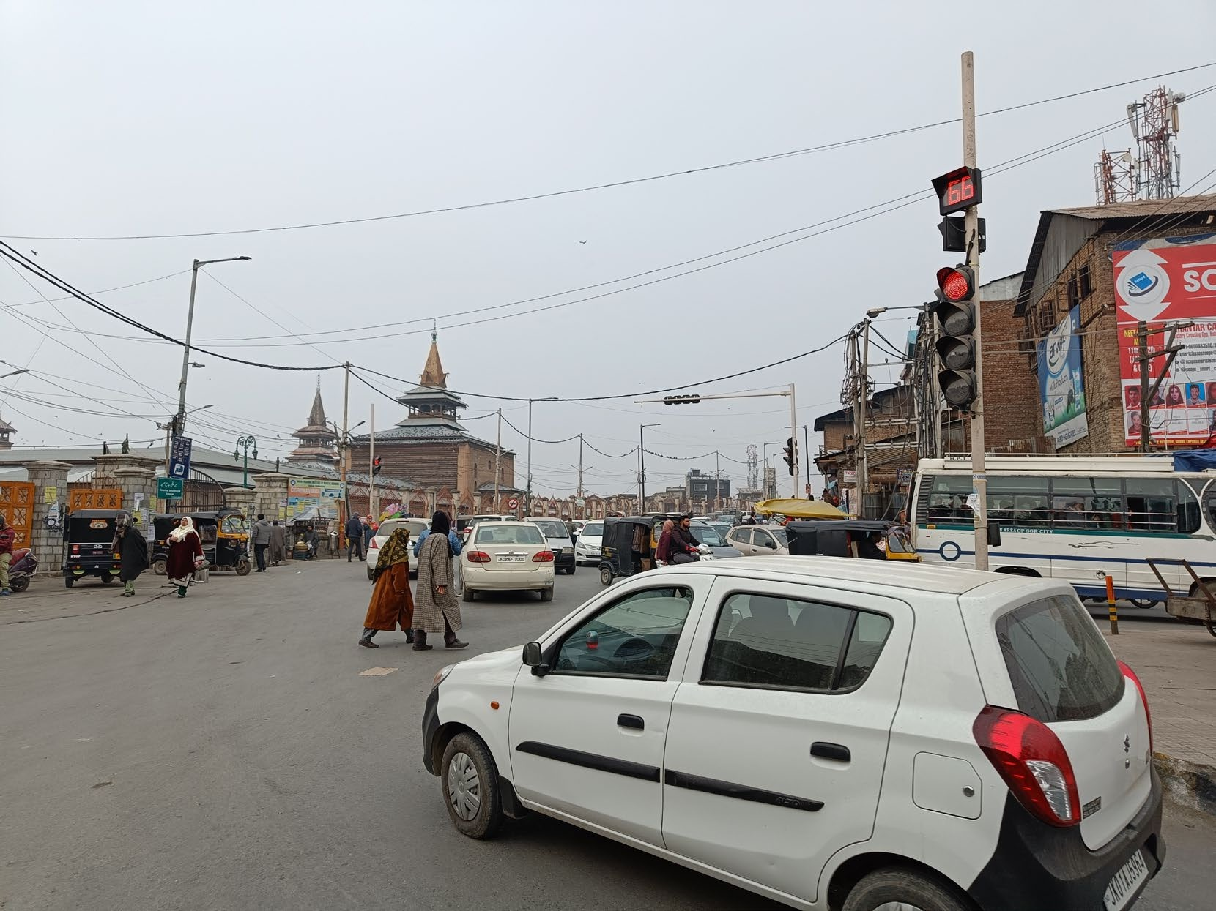
Figure 0-8 Nowhatta Chowk

4: Development Plan:

4.1 Introduction
Old city parts of Srinagar city are connected through Nallah-i-Mar road, which houses many commercial establishments along it. It also connects the old town with new uptowns of Srinagar city across the Jhelum river.
The main objective of proposed development is to ease the congestions on the road and upgrading the existing infrastructure. Creating friendly road for pedestrians and motorists. Providing & improving footpath, stormwater drain, illumination facilities, junction improvements & other utilities will help in improving the road.

4.2 Development Proposal:
Following activities are considered under development proposal –
1. Overlaying over the existing carriageway as per the SSCL planning proposal.
2. After the carriageway development of footpath & stormwater drain is proposed on along both the sides of the road.
3. In some of the stretch’s on street parking provision has been proposed.
4. Realignment of electrical utilities, provision of street lights, overhead gantry, signages have been proposed.
5. Provision of bus Bays & bus stops.
6. Junction improvement is also proposed.

4.3 Proposed RoW details:
Assessment of proposed ROW is done on the basis of topographical Survey data, Site conditions and in accordance with instructions of SSCL and R&B (PWD) Kmr. Srinagar. Table 0-1 Contains details of proposed ROW Nallah-i-Mar Road with details. The TCS as applicable at their respective chainage points are mentioned as well. All drawings of TCS and the respective Estimates of each project component are attached under Estimation & Costing Section of DPR.

4.4 Design Basis:

4.4.1 Introduction
The development and improvement of project road of length around 4.3 km. is proposed in integrated manner. Before starting design, complete available data has been checked, confirmed and verified after series of site visits. Based on approved concept plan following infrastructure components are proposed.
- Overlaying of Pavement
- Footpath development
- Storm Water Drainage provision
- Illumination through street lights
- Realignment of electrical poles & utilities
- Junction Improvement
- Bus Bays, Bus stops, On Street Parking
- Overhead gantry and Signages
It is majorly 2-lane urban road, but design and standard for detailed design of the project road will be adopted based on the guidelines set out by client, Manual of specification and standard for 4-lane IRC SP 84-2019 and IRC 86-2018 by Indian Roads Congress. The design and plan proposed are provisional & may vary at execution stage as per direction/instruction of SSCL.

4.4.2 Geometric design considerations.
4.4.2.1 Design Speed: - The IRC standard recommends design speed based on the functional classification and terrain. In general, the ruling design speed shall be adopted, minimum design speed shall be adopted only on-site constraint.
Design speed is related to the function of a road, keeping in view the type of functions expected of each class of the urban road system, the design speeds given in Table 6-1 are recommended for adoption.
Table: Design Speed classification
Classification | Design Speed (km/h)
Arterial road | 80
Sub Arterial Road | 60
Collectorate road | 40
Local street | 30
(Source IRC 86-1983)
4.4.2.2 Typical Cross section: -
The typical cross section has been prepared as per the understanding of requirement, study of existing infrastructure and instruction & directions of SSCL. The Width of different segment are shown in Table.
Table: Cross sectional Width Detailed for Nallah-I-Mar Road
S. No. | Description | Width (plain and Rolling terrain)
1 | Raised Median | 2 m
2 | Main Carriageway | Varies
3 | Kerb shyness | 0.25m
4 | Footpath | Varies
5 | Stormwater Drain | Pipe Drain with RCC Gully Trap

4.4.2.3 Cross slope: - The cross slope of main carriageway and footpath are as per the table

Table: Camber slope details
S.no | Description | Design slope | Remark
1 | Main carriageway | 2.5 % | IRC 86-1983
2. | Footpath | 2.5 to 3 % | IRC 103-2012

4.4.2.4 Median Width: -
The Width of the median shall be as per the Typical Cross section; it varies from 2m including shyness.

4.4.3 Footpath/Sidewalk: - The dedicated footpath shall be provided both side of the project road the minimum width of footpath should be 1.8m. they should have well maintained surface with cross fall 2.5 to 3 %, but for comfort point of view and according to SSCL planning instruction footpath slopes may varies from 1% to 2.5%, the project road footpath width varies which is shown in typical cross section
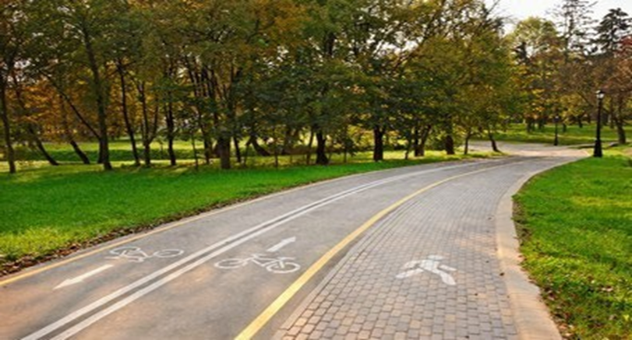
Figure: Footpath along the road

4.4.4 Parking lane: -
The parking lane has been provided on the project road in the business and shopping area. In the project road the width of 2-5.5m for parking is proposed.
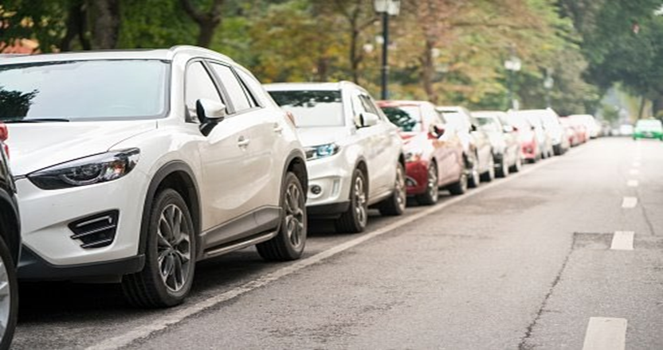
Figure: Parking space along the road
4.4.5 Illumination: -
Illumination is particularly necessary for pedestrian crossing, public transport facilities and for car parking. Concentrated lighting especially for required location such as congregation of pedestrian is expected, bus stop near crosswalks near street furniture. Illumination shall be accentuated at all intersection and Hazard prone location.

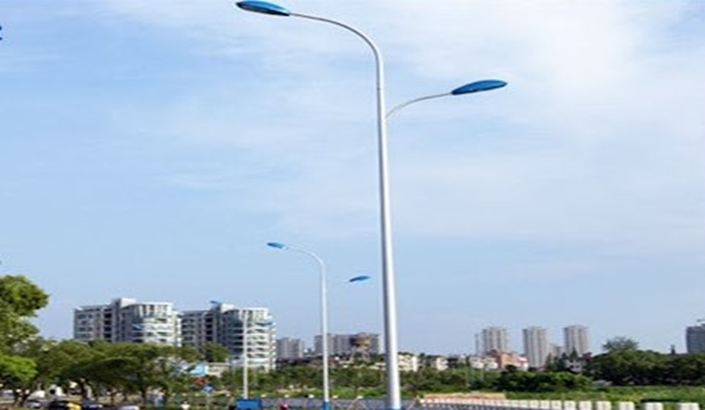
Figure: Street light
4.4.6 Intersection:-
Major and minor intersections shall be designed as per the provisions of IRC: SP-41 and Manual of Specifications and Standards for four laning of Highways (IRC: SP: 84-2019).
The following Item, necessary for traffic safety, road furniture shall be provided as per the standard and specification.
- Road Signs shall be provided as per Clause 9.2 of the IRC: SP: 84-2019 and IRC: 67-2012.
- Road Markings shall be provided as per the IRC: SP: 84-2019. and IRC: 35-2015.
- Road Delineators shall be provided as of the IRC SP: 84-2018 and IRC:79.

4.4.7 Strom Water Drain:-
As the proposed road development includes utilities laying such as storm drain, but in the absence of details of existing storm drain network laid by concerned department, RCC drain of Gully Trap with Pipe connections of size 500mm×450mm x 500 is proposed on the both side of the main carriageway and Link road 1 and 2. Pipe drains of dia. 450mm for connection of existing drain are proposed for Nallah-i-Mar main road stretches, with manhole proposed at 30m c/c.

4.4.8 Water Distribution Network:-
Providing good and safe drinking water is worldwide considered a fundamental issue for public health protection. As per site visit and investigations, it is observed that water supply pipelines are running along Nallah-i-Mar road suitable care should be taken while execution and in case of any damage items are taken in estimates for their repair therefor it is duty of construction agency to repair any damage caused by them.

4.4.9 Sewerage Collection Network:-
Sewerage collection network is not in scope of this DPR. Concerned administrative department will undertake the sewerage related works.
4.4.9 Electrical Infrastructure:-
Realignment of existing electrical infrastructure has been proposed along the project road. The provision of cost has been considered in this DPR.

5. Assumptions and Considerations:
As the engineering surveys and investigations are not in scope of DPR consultant, the design is based on limited data. Some of the assumptions considered in the preparation of DPR are listed below:
- Due to unavailability and lack of data, the design has been carried out based on SSCL instructions, secondary data and experiences of similar work.
- A detailed design based on site investigation and engineering survey as per prevailing standards before execution shall be done.
- Proper ground preparation before construction of road is required.
- The depth of the manhole for storm network is kept 1.5m but it will vary as per the proposal of concerned department for the project area.
- The execution of project works shall be subject to prior permission to be sought from the concerned department.
6. Conclusion:-
The preparation of the Detailed Project Report (DPR) has been undertaken with the best available secondary data, guidance from SSCL, and insights drawn from similar past projects, due to the unavailability of site-specific engineering surveys and investigations within the current scope. As a result, several assumptions have been made to progress the conceptual and preliminary design stages. These include provisional dimensions, ground conditions, and utility placements, all of which will require validation through comprehensive field investigations before execution.
It is crucial that a detailed engineering survey and geotechnical assessment be carried out in accordance with prevailing standards prior to the implementation phase. Ground preparation must be ensured to provide a stable base for road construction, and specific components—such as manhole depths—will need to be finalized in coordination with the respective departments. Furthermore, all proposed works are contingent on obtaining necessary approvals from relevant authorities.
while the current DPR serves as a strategic framework for upgrading urban roads under the Smart City initiative, its successful implementation will depend on thorough site validation, inter-departmental coordination, and adaptive execution practices aligned with actual field conditions. smart cities are the future of sustainable urban living. By adopting a multidisciplinary and participatory approach, cities can not only respond to current urban challenges but also anticipate and evolve with future demands—building smarter, greener, and more livable communities for generations to come.

References:-
- Albino, V., Berardi, U., & Dangelico, R. M. (2015). Smart cities: Definitions, dimensions, performance, and initiatives. Journal of Urban Technology, 22(1), 3–21.
- Batty, M., Axhausen, K. W., Giannotti, F., & Pozdnoukhov, A. (2012). Smart cities of the future. The European Physical Journal Special Topics, 214(1), 481–518.
- Caragliu, A., Del Bo, C., & Nijkamp, P. (2011). Smart cities in Europe. Journal of Urban Technology, 18(2), 65–82. Analyzes smart city growth and innovation in European contexts.
- Giffinger, R., & Gudrun, H. (2010). Smart cities ranking: An effective instrument for the positioning of cities? ACE: Architecture, City and Environment, 4(12), 7–25. Introduces a ranking framework for evaluating smart city performance.
- Komninos, N. (2013). Smart cities and the future internet: Innovation ecosystems of smart cities. Journal of Smart Cities. Explores how smart cities operate as innovation ecosystems using the Internet of Things.
- Kitchin, R. (2014). The real-time city? Big data and smart urbanism. GeoJournal, 79(1), 1–14. Examines the role of big data in enabling smart governance and infrastructure.
- Nam, T., & Pardo, T. A. (2011). Conceptualizing smart city with dimensions of technology, people, and institutions. 12th Annual International Conference on Digital Government Research. Emphasizes the socio-technical and institutional elements of smart cities.
- United Nations ESCAP. (2019). Smart Cities: Regional Policy Framework. Offers policy guidance for Asia-Pacific nations on inclusive and sustainable urbanization.
- Ministry of Housing and Urban Affairs (India). (2015). Smart Cities Mission Guidelines. Framework for developing smart cities in India, including funding and implementation strategies.
- ISO 37120:2018. Sustainable cities and communities – Indicators for city services and quality of life. Establishes measurable indicators for evaluating urban performance.
- McKinsey Global Institute. (2018). Smart Cities: Digital Solutions for a More Livable Future. Discusses how data-driven technology improves city life and infrastructure efficiency.
- Deloitte. (2015). Smart Cities: Realizing the Urban Future. Offers strategies for public-private partnerships and innovation in urban development.
- IBM Institute for Business Value. (2012). Smarter Cities for Smarter Growth. Advocates data integration and analytics as a foundation for smart city success.

