**A STUDY ON CAPITAL STRUCTURE AND FINANCIAL LEVERAGE ANALYSIS OF SEPC LIMITED**

**LIBICA S *1, S V PRAVEEN*2**

*1 MBA Student, Jerusalem College of Engineering, Chennai, Tamil Nadu, India

*2 Assistant Professor, MBA, Jerusalem College of Engineering, Chennai, Tamil Nadu, India

**ABSTRACT**

This study examines the determinants of Capital Structure of SEPC Ltd in Comparison with its Peers.To conduct this study, the data has been taken from the year 2019 – 2024. It focused on factors such as liquidity, profitability, growth, tangibility, and size to understand their influence on the capital structure. The study utilized correlation analysis, multiple regression analysis, and descriptive analysis. The ratios of long-term solvency and short-term liquidity are effective indicators for evaluating capital structure.

1. **INTRODUCTION**

The capital structure of a company plays a crucial role in determining its financial stability, profitability, and overall growth. A well-balanced capital structure ensures that the company maximizes shareholder value while maintaining financial flexibility and minimizing risks. Financial leverage, on the other hand, measures the extent to which a company utilizes borrowed funds to enhance returns for shareholders. However, excessive reliance on debt can increase financial risk and impact the company's solvency. This study focuses on the capital structure and financial leverage analysis of SEPC Limited, a company engaged in infrastructure development and engineering services. By analyzing key financial ratios such as debt-to-equity ratio, interest coverage ratio, and return on equity (ROE), this research aims to provide valuable insights into the company’s risk-return profile and its ability to sustain financial obligations. Furthermore, the study compares SEPC Limited’s capital structure with industry standards to understand its competitive standing. It also identifies challenges related to debt financing and suggests strategies for optimizing financial leverage.

**II. METHODOLOGY**

The data was collected from secondary data. (2019-2024) The study relies on financial statements, including Balance sheets, Profit and loss statements, and Annual reports of SEPC Limited.

**Tools For Analysis**: This study uses Ratio Analysis as a primary tool: Current Ratio, Return on Equity, Debt Equity Ratio, Capital gearing ratio, Proprietary ratio.

**Data Analysis and Interpretation:**

**Current Ratio Formula: Current Ratio = Total Current Assets /Total Current Liabilities**

|  |  |  |  |  |
| --- | --- | --- | --- | --- |
| **YEAR** |  | **TOTAL CURRENT LIABILITY** | **TOTAL CURRENT ASSEST** | **CURRENT RATIO** |
| **2019 - 2020** |  | **84,224.73** | **148,060.40** | **1.75** |
| **2020 - 2021** |  | **97,818.55** | **134630.25** | **1.37** |
| **2021 - 2022** |  | **1,07385.14** | **1,23,885.41** | **1.15** |
| **2022 - 2023** |  | **44150.45** | **1,13268.85** | **2.56** |
| **2023- 2024** |  | **46,745.31** | **1,32,776.14** | **2.84** |

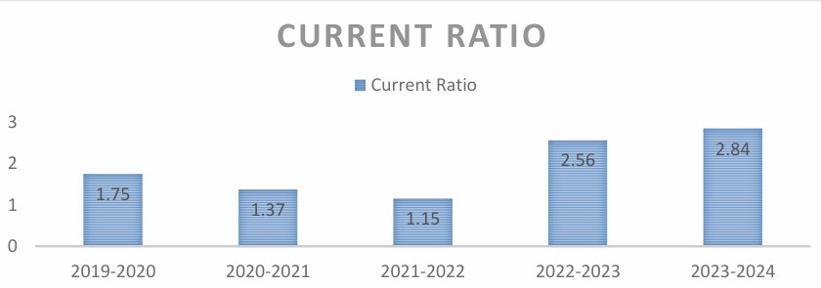

**INFERENCE:**

From the above table and chart, it is observed that the company's liquidity position declined from 1.75 in 2019-2020 to 1.15 in 2021-2022, indicating increased financial strain. A significant improvement was observed in 2022-2023 (2.56) and 2023-2024 (2.84), reflecting better working capital management. The recent rise suggests a strong ability to meet short-term obligations and improved financial stability.

**Return on equity Formula: Return on equity = Profit After Tax/ Total Equity**

|  |  |  |  |
| --- | --- | --- | --- |
| YEAR | PROFIT AFTER TAX | TOTAL EQUITY | RETURN ON EQUITY |
| 2019 - 2020 | 8099 | 117719.9 | 0.07 |
| 2020 - 2021 | 18289 | 99451.02 | 0.18 |
| 2021 - 2022 | 24,901.02 | 74,604.62 | 0.33 |
| 2022 -2023 | 1,132.24 | 108404.21 | 0.01 |
| 2023 - 2024 | 2,267.13 | 120739.12 | 0.02 |

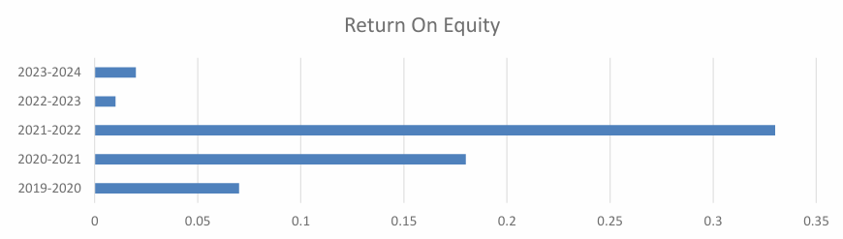

**INFERENCE:**

ROE improved from 7% in 2019-2020 to a peak of 33% in 2021 2022, indicating strong profitability. A sharp decline followed in 2022-2023 (1%) and 2023-2024 (2%), reflecting reduced efficiency in generating returns. Despite an increase in equity, the company’s recent performance shows lower returns for shareholders. The company experienced fluctuating profitability, with a notable decline in recent years.

**Debt Equity Ratio Formula: Debt equity ratio = Total debts /** **Total equity**

|  |  |  |  |
| --- | --- | --- | --- |
| FINANCIAL YEAR | DEBT | TOTAL EQUITY | DEBT EQUITY RATIO |
| 2020 | 68,410.12 | 117,719.90 | 0.58 |
| 2021 | 83,588.65 | 99,451.02 | 0.84 |
| 2022 | 97,827.44 | 74,604.62 | 1.31 |
| 2023 | 40,583.22 | 1,08,404.21 | 0.37 |
| 2024 | 45,213.91 | 1,20,739.12 | 0.37 |

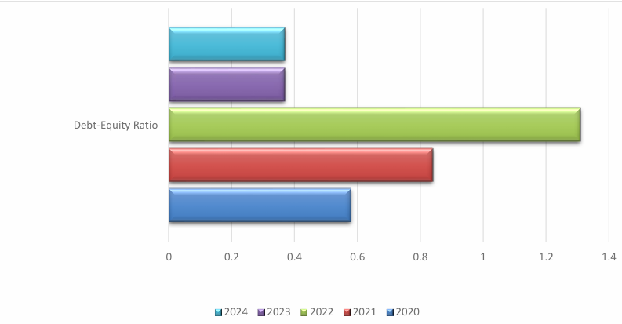

**INFERENCE:**

The debt-equity ratio increased from 0.58 in 2020 to a peak of 1.31 in 2022, indicating higher financial risk. A significant reduction occurred in 2023, reflecting improved financial stability. The ratio remained stable at 0.37 in 2024, suggesting a balanced and low-risk capital structure**.**

**Capital Gearing Ratio**

**Capital Gearing=Debt with Fixed Charges /Equity Shareholders’ Funds**

|  |  |  |  |
| --- | --- | --- | --- |
| YEAR | DEBT | TOTAL SHARES | CAPITAL GEARING RATIO |
| 2020 | 148,060.40 | 84224.73 | 63835.67 |
| 2021 | 134630.25 | 97818.55 | 36811.70 |
| 2022 | 123885.41 | 107385.14 | 16500.27 |
| 2023 | 113268.85 | 44150.45 | 69118.40 |
| 2024 | 132776.14 | 46745.31 | 86030.83 |

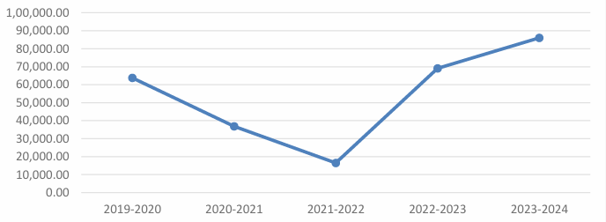

**INFERENCE :**

CGR declined from ₹63,835.67 lakhs in 2019–20 to ₹16,500.27 lakhs in 2021–22, indicating reduced liquidity and potential short-term financial strain. From 2022–23 onward, there was a strong recovery in CGR, reaching ₹86,030.83 lakhs in 2023–24 due to a significant drop in current liabilities. The CGR in recent years reflects improved liquidity and a stronger ability to meet short-term obligations.

**Proprietary Ratio**

**Proprietary Ratio=Shareholders funds / total assets.**

|  |  |  |  |
| --- | --- | --- | --- |
| YEAR | DEBT | TOTAL | PROPRIETARY RATIO |
| 2020 | 68105.2 | 63835.67 | 1.07 |
| 2021 | 53193.33 | 36811.70 | 1044 |
| 2022 | 30278.64 | 16500.27 | 1084 |
| 2023 | 37884.66 | 69118.40 | 0.55 |
| 2024 | 56,098.28 | 86,030.83 | 0.65 |

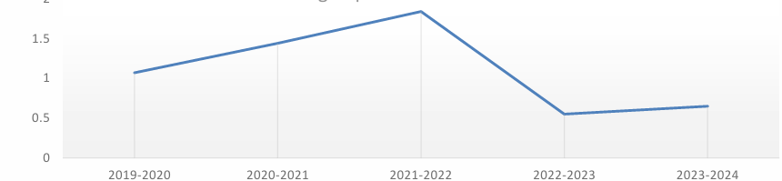

**INFERENCE:**

The ratio improved from 1.07 in 2019-2020 to a peak of 1.84 in 2021-2022, reflecting better utilization of working capital. A sharp decline occurred in 2022-2023 (0.55), indicating reduced efficiency in generating sales. The ratio remained low at 0.65 in 2023-2024, suggesting continued underutilization of working capital**.**

1. **FINDINGS:**

**The current ratio showed a decline from 1.75 in 2019-2020 to 1.15 in 2021-2022, indicating increasing liquidity stress. However, it significantly improved to 2.56 in 2022-2023 and further increased to 2.84 in 2023-2024, reflecting a strong position to meet short-term liabilities. The return on equity improved from 0.07 in 2019-2020 to 0.33 in 2021-2022, indicating better shareholder returns. However, it sharply declined to 0.01 in 2022-2023, with only a slight recovery to 0.02 in 2023-2024, reflecting continued low profitability. The debt equity ratio increased from 0.58 in 2019-2020 to 1.31 in 2021 2022, indicating higher dependency on debt financing. However, it significantly dropped to 0.37 in 2022-2023 and remained stable at that level in 2023-2024, reflecting reduced financial risk. The CGR declined from 2019–20 to 2021–22, indicating liquidity stress during that period. A strong recovery was observed from 2022–23 onwards, mainly due to a sharp reduction in current liabilities. This improvement reflects better short-term financial management. The proprietary ratio improved from 1.07 in 2019-2020 to 1.84 in 2021-2022, indicating optimal use . However, it sharply declined to 0.55 in 2022-2023 and slightly improved to 0.65 in 2023-2024, reflecting continued inefficiency .**

1. **SUGGESTIONS :**

**SEPC should aim for a healthy debt-to-equity ratio to ensure sustainable financing without excessive risk. Regularly monitoring this ratio is crucial for maintaining investor confidence and financial stability. Closely monitor the relationship between short-term liquidity and long-term solvency. Adjusting financial decisions based on this relationship will enhance SEPC's ability to navigate market uncertainties. SEPC should prioritize factors like liquidity, tangibility, growth, and size while making capital structure decisions. And focusing on these key determinants will optimize SEPC's capital structure and financial performance.**

1. **REFERENCES**
2. Akomeah, E., Bentil, P., & Musah, A. (2018). The Impact of Capital Structure Decisions on Firm Performance: The Case of Listed Non Financial Institutions in Ghana. International Journal of Academic Research in Accounting, Finance and Management Sciences, 8(4).
3. Bhole, L. M., & Mahakud, J. (2004). Trends and determinants of corporate capital structure in India: A panel data analysis. Finance India, 18(2), 37–55.
4. Chinaemerem, O. C., & Anthony, O. (2012). Impact of capital structure on the financial performance of Nigerian firms. Arabian Journal of Business and Management Review,1(12), 43–61.
5. Jayiddin Nur, F., Jamil, A., & Mat, R. S. (2017). Capital Structure Influence on Construction Firm Performance. 00025.