**Pros and Cons of Post Office Savings Schemes- A Study**

**Mr.Iranna R Hondappannavar\***

**Dr. S. B. Akash\*\***

**Abstract**

Post office savings is common in developed societies. It is important for ruralalso urban households' socioeconomic development. Different income groups save differently.Raising the household's income and increasing the number of breadwinners are two key components in fostering a more thrifty mindset. To create their conclusion, the writers of "Pros and Cons of Post Office Savings Schemes: A Study." consulted both primary and secondary materials. Poor growth in Belagavi post office savings was noted in the survey.A broad awareness campaign, financial literacy, updated Post Office goods and services, fostering mutual understanding and trust, and generating more revenue through income-generating schemes might create a charming atmosphere which has been created in the Belagavi Post office.

**Keywords:** Post office, financial literacy, Income generating, Civilized societies

**Introduction**

Saving money at the post office is traditional in India. It began in India around 1880 A.D., when organized savings methods were unavailable. In India, the largest savings bank has 154,725 locations. Modern banking services are frequently unavailable at rural post offices. The "Pros and Cons of Post Office Savings Schemes—A Study" research looks at the ways people save money at the post office through experiments.

This study set out to identify potential opportunities and risks to the Belagavi District's post office savings. Current study was also to establish the feasibility of post office savings at various income classes in Belagavi District.

**Review of Literature**

The researcher has immersed themselves in the world of Post Office savings. The following research papers are pertinent::

**M. Indhu Bala et. al.(2014)** Discovered that Kanyakumari District post office savings programs are crucial for comfort and safety. Additionally, they discovered that customer feedback is significant for Post Office offerings.

**Devidas B. Bharati et. al. (2003)** Their research on middle-class savings systems in Pune, found that middle-class Pune residents save a lot yet another half population in the rural areas had not thought of saving.

**B. Saranya****et. al. (2014)** examined investor behavior in Post Office savings plans and found that various age groups chose different investments. Age can affect investors' goals. Bank savings, for example, may appeal to investors over the age of 50 because of their perceived safety.

**C. S. Tembhurnikar et. al. (1988)**examined the past and future of India's postal savings system. The research stressed the Post Office Savings Bank's significance in development planning through savings mobilization. In order for the Savings Bank to run well and everyone to be satisfied, the Post Office needs complete independence.

**C. Shanbagavalli et. al. (2002)**negotiated savings bonds for Salem District Post Office. The Postal Service should implement the better plan, according to studies. Most depositors want short-term plans. Post Office should offer minimum-maturity savings products.

**Prof. Ujwala Bairagi et. al. (NA)** analyzed a Pune-based family saving and investment preference survey. They discovered a boom in middle-class families, doubling income and working women. Women investors should be attracted by offering accurate information about investment opportunities.

**K. Sethilkumaret. al. (2012)** investigated the views of rural investors on postal investments. Investors prioritize safety and high returns, per their claim. High yields and security attract Post Office Time Deposit investors.

**OBJECTIVES OF THE STUDY**

The main aim of this particular empirical study is to undertake recent trends which are happening in the saving account schemes of post office located in Belagavi District. In addition to these broad goals, there are more detailed targets, such as:

1. In order to gauge how well-informed investors are about the various investment opportunities available at post offices.
2. To analyze the pros and cons of investors in post office.

**METHODOLOGY**

For the Post Office Savings study to be possible and useful, the researcher focused on approaches and instruments.

**i)Scope of Study**

Present study covers Belagavi district.

**ii)Sources of Data**

The study used a standardized questionnaire to collect primary data from 188 families in various income brackets, including employees, housewives, and businessmen. The data came from a variety of secondary sources, including National and the Directorate of Small Savings.

**RESULTS AND DISCUSSIONS**

Results and interpretations derived from household respondents' structured questionnaires are as follows:

**Age level of respondents:**

According to Table 1, 69% of respondents are under 15 to 30 years old, 21% are 31–45 years old, 7% are 46–60 years old, and 3% are over 60. Respondents under the age of 1530 make up the bulk of the household.

**Table No.1 Age group**

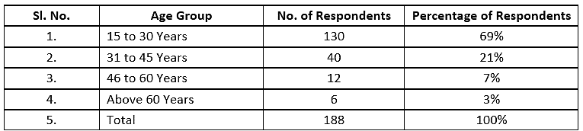

Source: Field Survey

**Gender group of respondents**:

According to Table 2, 61% of the participants are men and 39% are female.

**Table No.2 Analysis of Respondents by Gender**

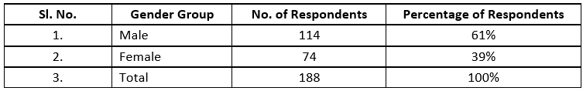

Source: Field Survey

**Place of Residence:**

Place of residence: 62% live in rural areas, 16% in semi-urban areas, and 22% in metropolitan areas (Table No. 3).

**Table No.3 Place of Residence**

|  |  |  |  |
| --- | --- | --- | --- |
| **Sl. No.** | **Place of Residence** | **No. of Respondents** | **Percentage of Respondents** |
| 1. | Rural | 116 | 62% |
| 2. | Semi urban | 30 | 16% |
| 3. | urban | 42 | 22% |
|  | Total | 188 | 100% |

Source: Field Survey

**Educational qualification of respondents:**

Only 11% of respondents have Ph.D. scholars, 53% have post graduates, 19% have under graduates, 12% have PUC education, 1% have SSLC education, and 4% are illiterate, according to Table 3. Graduated degree holders are the majority of percentage of respondents.

**Table No.4 Educational Qualification of Respondents**

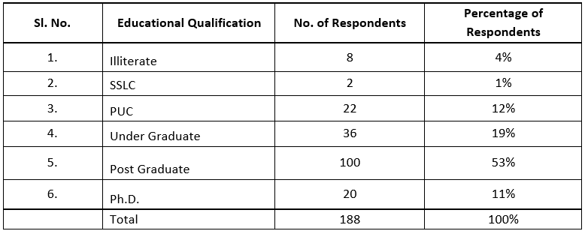Source: Field Survey

**Occupational Statuses of respondents:**

The respondents' occupations are divided into 8 categories. Table 4 shows that 3% of respondents are farmers, 4% in business, 18% in government services, 5% are housewives, 8% are professionals, 28% are Pvt Employees, 29% are students and research scholars, and 5% are unemployed.

**Table No.5 Occupation of Respondents**

|  |  |  |  |
| --- | --- | --- | --- |
| **Sl. No.** | **Occupational Statuses** | **No. of Respondents** | **Percentage of Respondents** |
| 1. | Agriculture | 6 | 3% |
| 2. | Business | 8 | 4% |
| 3. | Govt Employee | 34 | 18% |
| 4. | House Wife | 10 | 5% |
| 5. | Professionals | 14 | 8% |
| 6. | Pvt Employee | 52 | 28% |
| 7. | Students/Ph.D. | 54 | 29% |
| 8. | Unemployed | 10 | 5% |
|  | Total | 188 | 100% |

Source: Field Survey

**Monthly family income of respondents:**

35% of respondents have a monthly household income of less than 10,000 rupees, 18% between 10,000 and 20,000, and 13% between 20,000 and 50,000. 34% of families earn over Rs. 50,000 monthly.

**Table No.6 Respondents' Monthly Family Income**

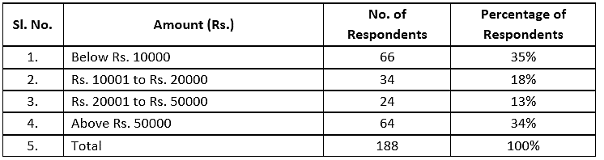

Source: Field Survey

**Pension Benefits of Respondents**

Table 6 shows that 19% of respondents receive pension and 81% do not.

**Table No.7 Pension Benefits of Respondents**

|  |  |  |  |
| --- | --- | --- | --- |
| **Sl. No.** | **Pension Benefits** | **No. of Respondents** | **Percentage of Respondents** |
| 1. | Yes | 36 | 19% |
| 2. | No | 152 | 81% |
| 3. | Total | 188 | 100% |

Source: Field Survey

**Saving purpose of Respondents**

Saving goals are divided into 7 categories. 20% of respondents are saving for house construction, 13.8% for tax benefits, 14.5% for medical emergencies, 11.7% for children's prosperity, 16.6% for schooling, 3.2% for marriage, and 20.2% for a stable return.

**Table No.8 saving purpose of Respondents**

|  |  |
| --- | --- |
| **Purpose of your saving** | **Percentage of Respondents** |
| House Construction | 20% |
| Tax Benefit | 13.8% |
| To meet medical emergency | 14.5% |
| Children's prosperity | 11.7% |
| Children's education | 16.6% |
| Children's marriage | 3.2% |
| Stable return | 20.2% |
| Total | 100% |

Source: Field Survey

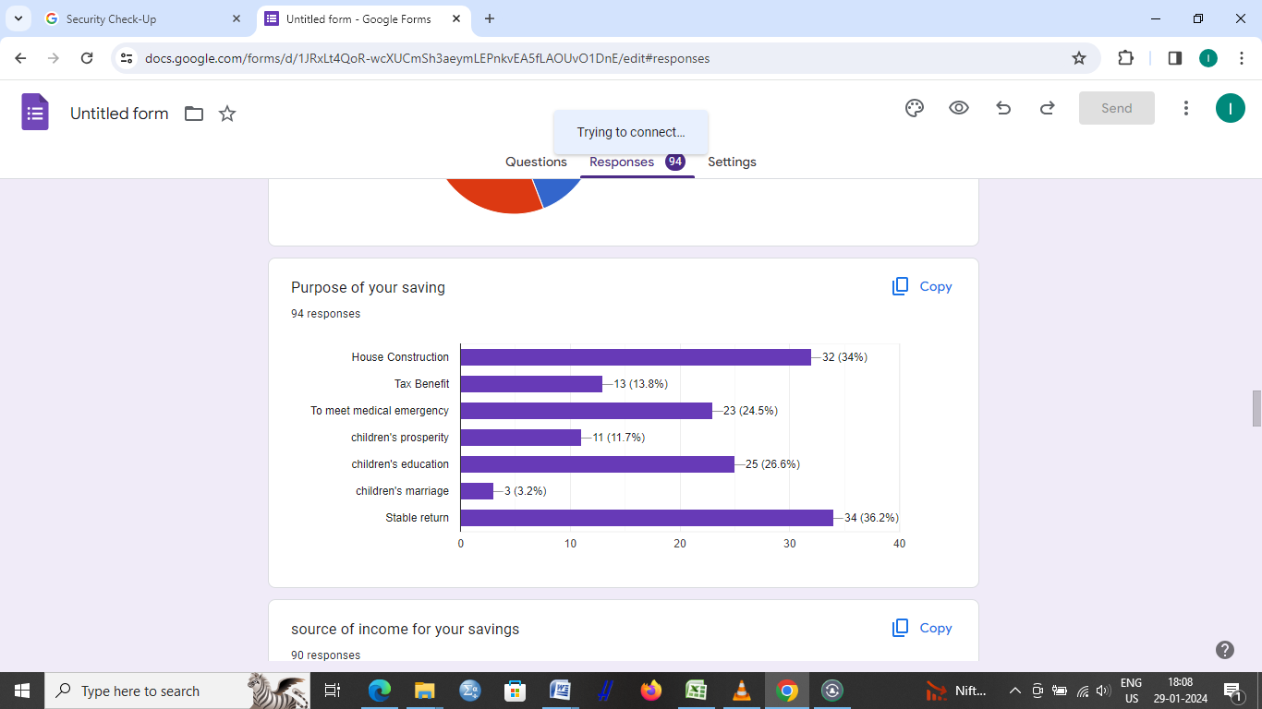

**Source of income**

We classified the respondents' sources of income into five main groups. Table 8 indicates that 9% of respondents earn agriculture income, 10% company revenue, 4% pension, 57% salary income, and 20% scholarships and stipends

**Table No.9 source of income of Respondents**

|  |  |  |
| --- | --- | --- |
| **source of income** | **No. of Respondents** | **Percentage of Respondents** |
| Agriculture income | 16 | 9% |
| Business income | 18 | 10% |
| Pension | 8 | 4% |
| Salary income | 108 | 57% |
| scholarships or stipend | 38 | 20% |
| Total | 188 | 100% |

Source: Field Survey

**Monthly Savings of respondents:**

According to Table 7, nearly half of the respondents (44%) had monthly savings of less than 1000 Rs., a quarter (25%) had between 1,000 and 3,000 Rs., and a third (31%) had 3,000 or more Rs.

**Table No.10 Money Respondents Save Each Month**

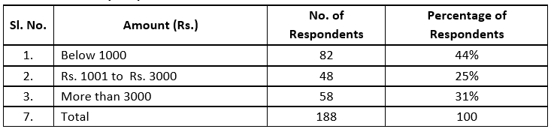

Source: Field Survey

**Source of available saving account in post office**

Four broad categories describe the respondents' information sources. According to Table 10, 8 percent of people who took the survey got their information from ads., 9% from agents, 57% from friends and family, and 26% from post office staff.

**Table No.11Information Source Regarding Postal Savings Programs**

|  |  |  |  |
| --- | --- | --- | --- |
| **Sl. No.** | **Source of available saving account in post office** | **No. of Respondents** | **Percentage of Respondents** |
| 1. | Advertisement | 16 | 8% |
| 2. | Agents | 16 | 9% |
| 3. | Friends/Relatives | 108 | 57% |
| 4. | Post Office Employees | 48 | 26% |
|  | Total | 188 | 100% |

Source: Field Survey

**Deposits Schemes**

From the below Table No.12,Clearly, a considerable number of participants have set aside money in different savings accounts.: 30% to RD, 15% to TD, 5% to PPF, 9% to national saving certificates, 8% to KVP, 4% goes to the senior savings plan, 9% to SSY, and 14% to postal life insurance.

**Table No.12 Schemes of deposits of Respondents**

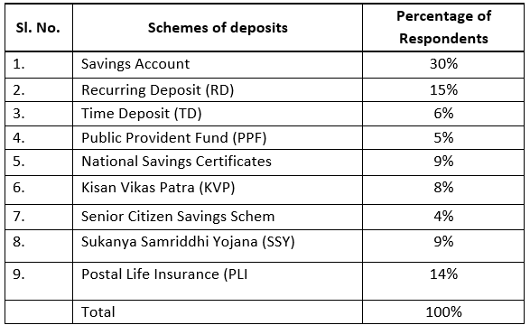

Source: Field Survey

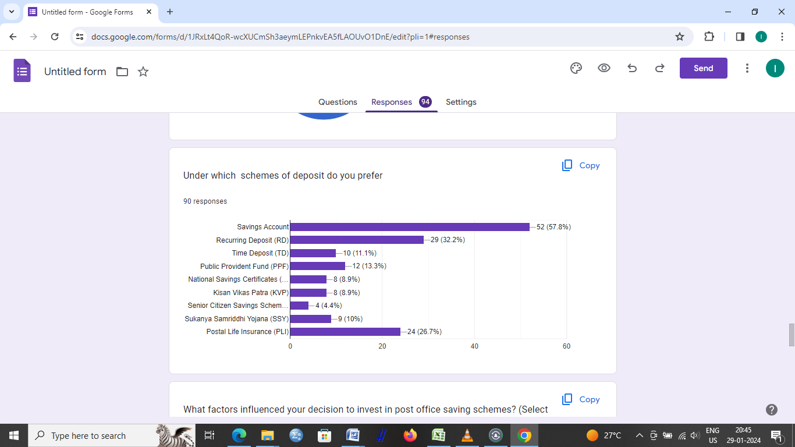

**A number of things affected the amount you invested in the post office savings scheme.**

**Table No.13 Schemes of deposits of Respondents**

|  |  |  |
| --- | --- | --- |
| **Sl. No.** | **Factors** | **Percentage of Respondents** |
| 1. | Attractive interest rates | 25% |
| 2. | Tax benefits | 12% |
| 3. | Government-backed security | 14% |
| 4. | Ease of investment | 20% |
| 5. | Flexible tenure options | 6% |
| 6. | Familiarity and trust in the post | 12% |
| 7. | Recommendation from friends | 4% |
| 8. | Others (Please specify) | 7% |
|  | Total | 100% |

Source: Field Survey

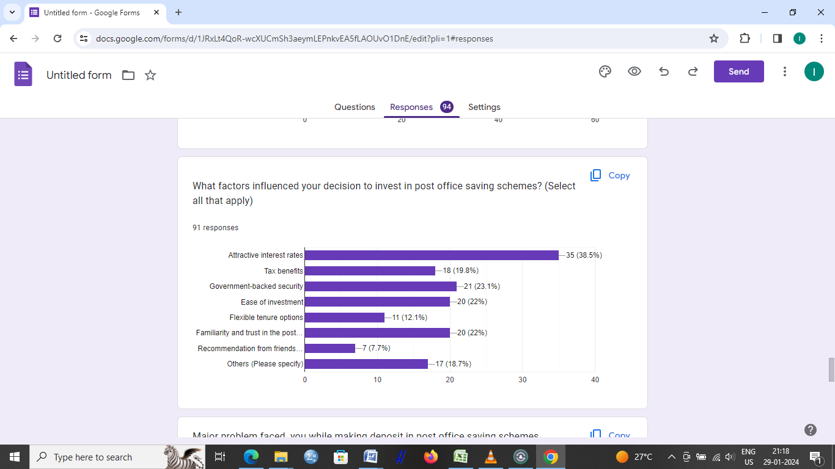**Corns of post office saving schemes**

Processing delays affect 25% of respondents, low interest affects 24%, customer-friendly issues affect 21%, hefty penal fees affect 4%, information lack affects 20%, and insecurity affects 6%, according to Table 14.

**Table No.14 Schemes of deposits of Respondents**

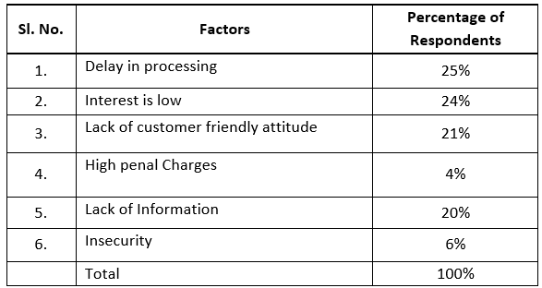

Source: Field Survey

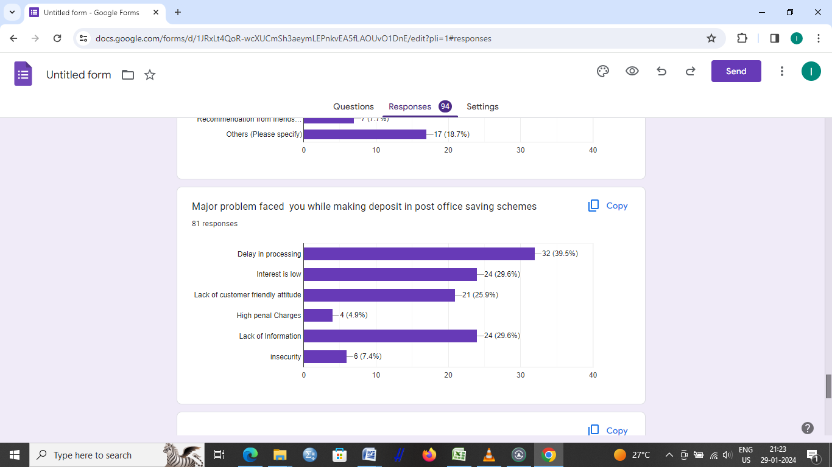

**Suggestion**

1. Both the state and central governments may implement a good prize or incentive programme to motivate post office agents.
2. In their efforts to enhance district and state-wide post-office savings initiatives, state and union governments may pay greater attention to social media, which is an essential component of modern life.
3. Post Office Savings Schemes do not offer daily or weekly savings options. Programs like these might be implemented by the Union government to assist the most vulnerable citizens.
4. The agent needs formal training if the post office wants to boost the amount of money customers save.
5. An increase in post office savings might be the outcome of a large-scale education campaign regarding post office savings schemes.
6. Commissions for post office agents are extremely modest. The post-office savings climate in the Belagavi district and India as a whole might improve if it rises to a reasonable level.
7. For customers who need access to funds quickly, the Post Office offers an ATM service that is available around the clock.

**Conclusion:**

It is possible for the Post Office's savings programs to reach the homes of the poorest individuals. As a savings strategy, it could be better than what the country is doing now. Modern technology and cost-cutting strategies can help the Postal Service save even more money. Following through on its proposal to transform the Post Office into a bank, the Union Government may ensure that even the most impoverished individuals residing in rural areas have access to banking services. Belagavi District post office savings are inadequate, according to this investigation.There are a number of things that could benefit the Belagavi district's post office savings, including a larger awareness campaign, better training for post office personnel, more literacy, better comprehension, and a more efficient management structure.

**REFERENCE**

1. Aggarwal, R. (2012). Identifying Factors influencing preference towards Post Office Saving Schemes. IRACST- International Journal of Research in Management and Technology (IJRMT), 2 (6), PP. 550- 559.
2. Aportela, F. (1999). Effects of Financial Access on Savings by Low-income People. Banco de Mexico.
3. Bairagi, U., and Rastogi, C. (2013). An emperical study of saving pattern and investment preferences of individual household with reference to pune city. Asm's International E-Journal of Ongoing Research in Management And IT, PP. 1-11.
4. Bala, M. I., and Murugan, S. (2014). A Study On Post Office Savings Schemes In Kanyakumari District. Tirunelveli: Women's Cristian College, Nager Coil.
5. Bandiera, O., Jr., G. C., Honohan, P., and Schiantarelli, F. (1998). Does Financial Reform Raise or Reduce Savings?
6. Baxter, M., and Crucini, M. J. (1993). Explaining Saving-Investment Correlations. The American Economic Review.
7. Bharati, D. B., and Rao, A. B. (2003). A Study of the Different Schemes of savings among the middle classes in pune district.” (1991-2000). Pune: Brihan Maharasta College of Commerce, Pune.
8. BORDOLOI, S. (2005). Family resource management and saving habits of women - a study of dispur assembly constituency. gauhati: gauhati university.
9. Budhedeo, S. H., and Bansal, S. N. (2007). Dynamics of indian savings: behaviour, determinants and policy optlon. Vadodara: The M.S. University of Baroda.
10. Chandrasekhar, B. (2016). A Study on Micro-savings and Saving Behavior of the Poor: Hurdles and Opportunities. Prasanthi Nilayam: Sri Sathya Sai Institute of Higher Learning. Attri, R. (2012). Spending and savings habits of youth in the city of Indore. Bauddhik, 3 (2), P. 8-15.
11. Chanu, W. S. (2014). Small Savings and Investment in Manipur. Imphal, Manipur: Manipur University.
12. Chaturvedi, M., and Khare, S. (2012). Study of Savings Pattern and Investment Preferences of Individual Household in India. International Journal of Research in commerce and Management, Vol. 3, Issue No. 5 (May), pp. 115-121.
13. Cronqvist, H., and Siegely, S. (2010). The Origins of Savings Behavior. Singapore: Singapore International Conference on Finance.
14. Cruce, A. (2001). A History of Progressive- Era School Savings Banking 1870 to 1930. Center for Social Development, Washington University, 1-31.
15. Dalakoti, C., and Pathak, P. K. (2010). A Study of Impact of Household Savings and Investment Behaviour on the Economic Development of Uttarakhand. Baluwakote: Kumaun University.