STEADY-STATE THREE-DIMENSIONAL ANALYSIS OF CONVECTIVE HEAT TRANSFER

M.Sai Kumar

*Dept. of Mechanical Engineering Seshadrirao Gudlavalleru Engineering College, Gudlavalleru, India* [*mukkusaikumar03@gmail.com*](mailto:mukkusaikumar03@gmail.com)

MD.Kaleem

*Dept. of Mechanical engineering Seshadrirao Gudlavalleru Engineering College,Gudlavalleru, India* [*kaleemmohmmad1@gmail.com*](mailto:kaleemmohmmad1@gmail.com)

B.Nagaraju

*Dept. of Mechanical Engineering Seshadrirao Gudlavalleru Engineering College, Gudlavalleru,*

*India*

[nagarajubejjanki9@gmail.com](mailto:nagarajubejjanki9@gmail.com)

K.Eswara Rao

*Dept. of Mechanical Engineering Seshadrirao Gudlavalleru EngineeringCollege,Gudlavaller.*

*India* [*eswarrao123@gmail.com*](mailto:eswarrao123@gmail.com)

K.Raja Ravindra Sagar

*Dept. of Mechanical Engineering Seshadrirao Gudlavalleru Engineering College,Gudlavalleru, India.*

[sagarraja330@gmail.com](mailto:sagarraja330@gmail.com)

***Abstract:*** This paper presents a comprehensive steady-state three-dimensional analysis of convective heat transfer over a localized heat source. The study aims to investigate the thermal behavior and flow characteristics surrounding the heat source under various boundary conditions and fluid properties. Utilizing computational fluid dynamics (CFD) techniques, simulations were performed to model the heat transfer processes and examine the influence of geometric and thermal parameters on the convective patterns. The results reveal detailed temperature distributions, velocity fields, and the impact of thermal gradients on convective flow. This analysis is critical for applications where thermal management is essential, such as in electronic cooling systems, industrial heat exchangers, and thermal insulation design. The findings contribute valuable insights for optimizing design parameters to enhance heat dissipation efficiency in practical engineering systems.

**Keywords:** Steady state, 3D heat transfer, Convective heat transfer, Heat source, Computational Fluid Dynamics (CFD), Temperature distribution, Velocity field, Thermal analysis, Heat dissipation, Flow simulation.

# INTRODUCTION

Heat transfer is a fundamental aspect of many engineering applications, where efficient thermal management is critical for system performance and reliability. Among the various modes of heat transfer—conduction, convection, and radiation—convective heat transfer plays a significant role, especially in systems involving fluids interacting with heated surfaces[1]. Understanding the convective behavior over a heat source is essential in fields such as electronics cooling, energy

systems, aerospace engineering, and industrial processing equipment[2].

In practical applications, the complexity of thermal systems often necessitates three-dimensional (3D) analysis to accurately capture the heat transfer characteristics and fluid flow behavior[3]. While one- or two-dimensional models can offer simplified insights, they frequently fall short in representing the intricacies of real-world systems where heat sources are distributed spatially and flow patterns vary along multiple axes[4].

This study focuses on the steady-state 3D analysis of convective heat transfer over a localized heat source using Computational Fluid Dynamics (CFD) [5]. The steady-state assumption allows for a detailed examination of the thermal equilibrium conditions without considering transient effects, thus providing valuable insights into long-term thermal behavior. CFD enables the simulation of complex geometries and fluid dynamics, allowing for precise visualization of temperature gradients and flow distributions.

The objective of this research is to evaluate how various physical and thermal parameters—such as fluid velocity, temperature difference, and geometric configuration—affect the convective heat transfer process. The insights gained from this analysis can be instrumental in optimizing heat dissipation designs and improving the efficiency of thermal systems across various engineering domains[6].

In many engineering systems, inadequate heat dissipation can lead to thermal failures, reduced efficiency, and even permanent damage to components. For instance, in

electronic devices, heat generated by processors and power modules must be effectively removed to maintain performance and longevity. Similarly, in industrial heat exchangers and HVAC systems, efficient convective heat transfer is vital to achieve desired thermal regulation. A deeper understanding of how heat is distributed and carried away from a heat source under steady-state conditions can inform the design of more effective thermal management systems. Fig.1 Steady-state 3- Dimensional Analysis of Convective Heat Transfer over a Heat Source[7].

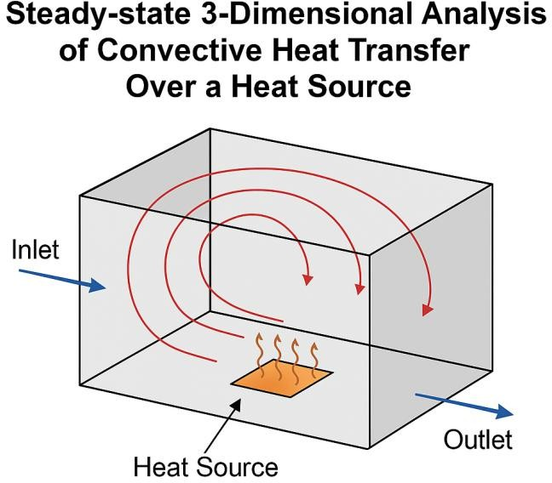

**Fig.1 Steady-state 3-Dimensional Analysis of Convective Heat Transfer over a Heat Source.**

# LITERATURE REVIEW

Convective heat transfer has been a focal point of thermal engineering research for decades due to its critical role in numerous industrial and technological applications. Early studies primarily focused on empirical and analytical solutions for simple geometries under idealized conditions. Incropera and DeWitt (2002) provided foundational knowledge on convective heat transfer principles, outlining various models for natural and forced convection in one- and two-dimensional systems. While these approaches offered initial insights, they often failed to accurately predict behavior in complex three- dimensional geometries or under varying boundary conditions[8].

With the advent of Computational Fluid Dynamics (CFD), researchers have increasingly turned to numerical methods to analyze convective heat transfer in more realistic scenarios. Patankar (1980) introduced finite volume methods that laid the groundwork for modern CFD simulations in thermal analysis. Subsequent studies by Bejan (2004) and Kays

et al. (2005) demonstrated how CFD could be used to visualize temperature and velocity fields in three-dimensional domains, providing more precise and comprehensive understanding compared to traditional techniques. Recent advances have enabled the modeling of detailed physical phenomena, including turbulence, radiation effects, and transient behaviors in thermal systems.

Numerous researchers have applied 3D CFD models to analyze steady-state convection over various geometries. For example, Jang et al. (2011) explored natural convection over heated plates, emphasizing the impact of surface orientation and fluid properties. Similarly, Kumar and Singh (2018) conducted 3D steady-state simulations for electronic components, identifying optimal cooling strategies under forced convection conditions. Despite these advancements, there remains a need for more focused studies on localized heat sources, especially under varied thermal and fluid dynamic parameters. This research aims to address that gap by providing a detailed steady-state 3D analysis of convective heat transfer over a heat source, using CFD to investigate the effects of geometry, boundary conditions, and fluid properties on thermal performance.

In addition to foundational work, more recent literature has focused on the effects of surface geometry and boundary conditions on heat transfer rates. Saeid and Pop (2006) investigated the impact of surface curvature on natural convection in enclosures and found that even minor geometric changes can significantly influence the temperature and velocity distributions. Their results indicated that 3D simulations offer more accurate predictions for non-uniform heat sources than their 2D counterparts. Similarly, Bilgen and Yedder (2007) examined the interaction between forced and natural convection in mixed convection scenarios and concluded that thermal performance is highly sensitive to inlet flow velocity and domain geometry[9].

Studies have also explored the effect of fluid properties on convective heat transfer. For instance, Pantokratoras (2004) analyzed the influence of variable viscosity on laminar boundary-layer flow over a horizontal plate. [10] The findings suggested that constant-property assumptions may lead to significant errors in temperature predictions, highlighting the importance of using temperature- dependent properties in CFD models. Additionally, studies such as those by Kim and Song (2015) incorporated nanofluids in their simulations, reporting enhanced thermal conductivity and improved convective heat transfer, opening new pathways for efficient thermal management in compact systems[11].

Furthermore, the validation of CFD models against experimental data has become a critical focus in recent literature. Studies like those by Hossain et al. (2012) and Selimefendigil and Öztop (2014) combined experimental and

numerical approaches to ensure model accuracy. Their work emphasized the importance of grid independence studies, appropriate turbulence modeling, and convergence testing in achieving reliable results. These best practices are essential when analyzing complex 3D convective systems, particularly under steady-state conditions where small deviations in boundary conditions can lead to considerable variations in output[12].

In summary, the existing literature provides a rich foundation for studying convective heat transfer using both analytical and numerical methods. However, there remains a substantial need for focused 3D CFD-based studies that simulate realistic scenarios with localized heat sources and varied boundary conditions. This paper builds upon previous work by developing a steady-state 3D CFD model to analyze convective heat transfer over a heat source, aiming to improve understanding and guide design in thermal management systems[13].

# METHODOLOGY

1. **Geometric Modeling**

A three-dimensional model of the system was created to represent the physical domain. The geometry includes a heat source embedded in a fluid medium confined by solid boundaries. CAD tools such as ANSYS DesignModeler or SolidWorks were used to construct the domain, ensuring appropriate scaling, symmetry, and space for fluid circulation.

1. **Meshing of the Domain**

The computational domain was discretized into finite control volumes using meshing software like ANSYS Meshing or ICEM CFD. A fine mesh was generated near the heat source and wall regions to capture steep thermal and flow gradients accurately. A mesh independence test was conducted to ensure solution accuracy while optimizing computational resources. Fig.2 Meshing Combination Of Body And Heat Source[14].

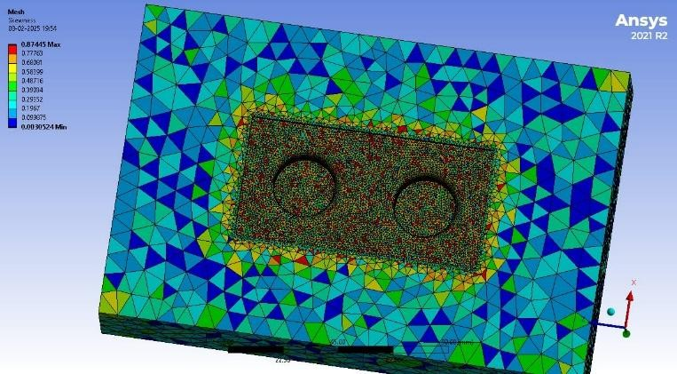

**Fig.2 Meshing Combination Of Body And Heat Source.**

1. **Boundary and Initial Conditions**

Relevant thermal and flow boundary conditions were applied. The heat source was modeled with a constant temperature or specified heat flux. The domain walls were treated as adiabatic or subjected to convective boundary conditions. For forced convection, fluid entered with a predefined velocity, while for natural convection, gravitational effects and buoyancy were modeled using the Boussinesq approximation. Fig.3 Total Temperature Distribution

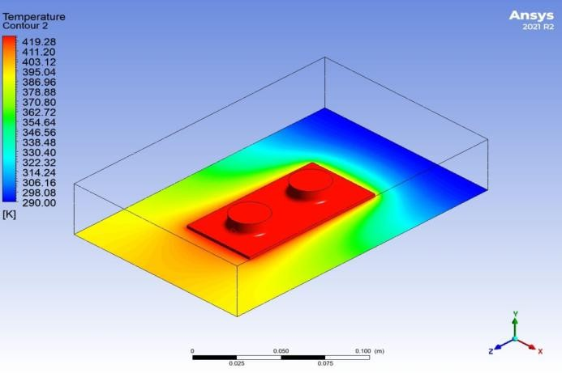

**Fig.3 Total Temperature Distribution**

1. **Solver Settings and Simulation**

The simulation was carried out using a CFD solver such as ANSYS Fluent or OpenFOAM. The steady-state Navier-Stokes and energy equations were solved using the finite volume method. Suitable turbulence models (like k-ε or k-ω SST) were selected based on flow conditions. The SIMPLE algorithm handled pressure-velocity coupling, and second-order schemes ensured numerical stability. Convergence was confirmed when residuals reached acceptable thresholds. Fig.4 Heat Flux in X-Direction[15.]

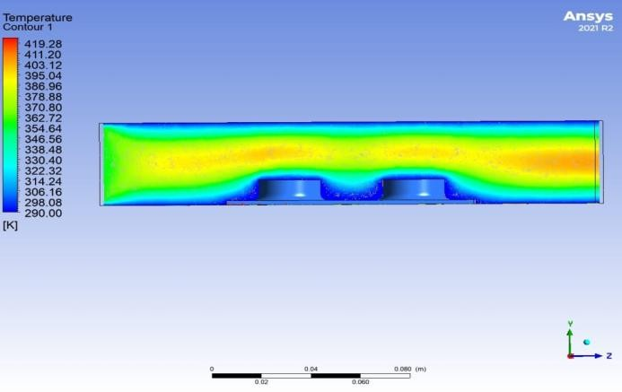

**Fig.4 Heat Flux in X-Direction**

1. **Post-Processing and Analysis**

Simulation results were visualized and analyzed using temperature contours, velocity vectors, and heat flux lines. Important parameters such as Nusselt number, temperature gradient, and velocity distribution were extracted to interpret the convective heat transfer behavior. Comparisons between different conditions provided insights into the effect of varying flow and thermal parameters on system performance. Fig.5 Velocity Stream Line

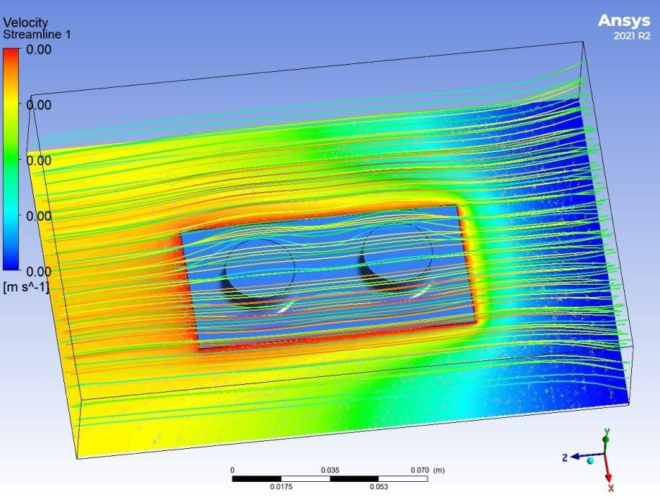

**Fig.5 Velocity Stream Line**

# PROBLEM DESCRIPTION

This study aims to analyze steady-state 3-dimensional convective heat transfer over a localized heat source within a fluid medium, addressing the challenge of optimizing heat dissipation in various engineering applications such as electronics cooling, heat exchangers, and industrial systems. The focus is on understanding how the heat source interacts with the surrounding fluid, considering factors like heat flux, fluid properties (thermal conductivity, viscosity), and enclosure geometry. Using Computational Fluid Dynamics (CFD), the study will investigate the influence of these parameters on temperature distribution, flow behavior, and overall heat transfer efficiency, providing insights to improve thermal management strategies for systems where efficient heat removal is essential for performance.

# EXISTING SOLUTION TO THE PROBLEM

* 1. ***Numerical Study of Forced Convection Heat Transfer over a Heated Plate.***
  2. ***Three-Dimensional Numerical Simulation of Natural Convection over a Heated Cylinder.***
  3. ***Heat Transfer Enhancement Using Nanofluids in Forced Convection.***

# COMPONENTS

1. ***Computational Fluid Dynamics (CFD Software)***
2. ***Geometry Modeling Software: ANSYS Design Modeler***
3. ***Meshing Tools: ANSYS Meshing or ICEM CFD***
4. ***Solver Settings***
5. ***Post-Processing Tools: ANSYS CFD-Post***

# PROPOSED MODEL

The proposed model aims to investigate the steady- state three-dimensional convective heat transfer over a localized heat source within a fluid medium. This model takes into account both natural and forced convection phenomena, depending on the type of flow and boundary conditions applied. The model involves the following key aspects:

**Geometry**: A three-dimensional domain is considered, where the heat source is placed at the center of a rectangular enclosure filled with a fluid (such as air or water). The dimensions of the enclosure are chosen to ensure that boundary effects do not significantly influence the results near the heat source.

**Heat Source**: The heat source is represented as a solid object that either maintains a constant temperature or applies a heat flux, depending on the nature of the experiment. The heat flux or temperature values are varied in different scenarios to study their impact on convective heat transfer.

**Fluid Properties**: The fluid surrounding the heat source is assumed to be incompressible and its properties (thermal conductivity, viscosity, density, etc.) can be temperature- dependent. This is crucial for accurately modeling the convective behavior under varying thermal conditions.

**Boundary Conditions**: For forced convection, the fluid enters the enclosure with a specified velocity at the inlet, and the pressure is fixed at the outlet. For natural convection, the gravitational effects are modeled using the Boussinesq approximation, which accounts for buoyancy-driven flow. The walls of the enclosure are considered either adiabatic or subjected to convective heat transfer with a specified heat transfer coefficient.

**CFD Simulation**: The model is solved using a CFD solver, which employs the finite volume method (FVM) to solve the Navier-Stokes equations for fluid flow and the energy equation for heat transfer. The turbulence models such as **k-ε** or **k-ω SST** are applied based on the flow regime (laminar or turbulent), and steady-state conditions are assumed for the simulations.

**Post-Processing**: The simulation results are analyzed using post-processing tools, where temperature contours, velocity fields, and heat flux vectors are visualized. Key performance indicators like Nusselt number, temperature gradient, and flow characteristics around the heat source are computed to evaluate the efficiency of the heat transfer process.

The proposed model focuses on simulating steady-state 3D convective heat transfer over a localized heat source in a fluid- filled enclosure. By varying parameters such as heat source intensity, fluid properties, and flow conditions, the model aims

to provide a comprehensive understanding of both natural and forced convection effects. Using CFD tools, the fluid flow and temperature distribution are analyzed under steady-state conditions, with detailed insights into heat transfer efficiency and thermal management. This model serves as a foundation for optimizing systems requiring effective heat dissipation.

The proposed model focuses on the steady-state, three- dimensional analysis of convective heat transfer over a localized heat source within a fluid medium. This model is designed to investigate both natural and forced convection scenarios and provide a comprehensive understanding of how various factors influence heat dissipation.

The domain consists of a rectangular enclosure, with a heat source placed at a specific location within the fluid. The geometry of the enclosure and the heat source is carefully designed to ensure that the study captures realistic convective heat transfer patterns. The fluid surrounding the heat source can either be air, water, or another suitable medium, and the properties of the fluid—such as thermal conductivity, density, and viscosity—are temperature-dependent to account for variations in thermal behavior across the system.

The heat source is modeled as a solid body with a specified heat flux or constant temperature. In the case of forced convection, the fluid enters the enclosure through an inlet with a defined velocity and leaves through an outlet under constant pressure. For natural convection, the buoyancy effects due to temperature differences are modeled using the Boussinesq approximation, which incorporates the influence of gravity on fluid movement. The boundaries of the enclosure can be set to adiabatic conditions, or convective heat transfer can be applied at the walls, depending on the experimental setup.

Computational Fluid Dynamics (CFD) is employed to solve the governing equations for mass, momentum, and energy conservation. The flow field is solved using the finite volume method (FVM), and turbulence models such as **k-ε** or **k-ω SST** are used based on the nature of the flow (laminar or turbulent). Steady-state conditions are assumed, and the simulation continues until a stable solution is reached. The solution results in a detailed temperature distribution, velocity field, and heat transfer characteristics, which are then analyzed to determine the performance of the heat transfer process.

Post-processing tools are used to visualize the results, including temperature contours, velocity streamlines, and heat flux vectors, providing a clear understanding of the convective heat transfer behavior. Key performance indicators such as the Nusselt number, temperature gradients, and flow velocity near the heat source are calculated to assess the efficiency of the heat transfer process and how different parameters influence the overall thermal management of the system.

This detailed 3D model provides valuable insights into optimizing thermal management strategies in practical engineering applications, such as electronics cooling, heat exchangers, and industrial systems, where effective heat dissipation is critical to performance.

# RESULTS

The results from the steady-state 3D convective heat transfer analysis reveal several key observations based on the simulation conditions. The temperature distribution around the heat source exhibited distinct variations depending on the flow type and heat flux. In forced convection scenarios, increasing the inlet fluid velocity led to a more uniform temperature distribution and improved heat dissipation, as higher velocities enhanced the mixing of the fluid around the heat source. On the other hand, in natural convection cases, temperature gradients were more pronounced, especially near the heat source, with the fluid exhibiting buoyancy-driven flow due to the increasing temperature, resulting in a less uniform temperature profile.

The flow patterns and velocity distribution in the domain were significantly influenced by the fluid velocity and heat source placement. In forced convection, the fluid flow became more turbulent at higher velocities, which helped in reducing thermal boundary layers around the heat source and promoted better heat transfer. In contrast, natural convection created buoyancy-induced flow patterns, with the fluid moving upward near the heat source and downward along the walls of the enclosure. These natural convection flow patterns were directly linked to the thermal gradients observed in the system and played a crucial role in heat dissipation in the absence of external flow assistance.

The Nusselt number, which characterizes the convective heat transfer rate, demonstrated higher values in forced convection scenarios, where enhanced fluid mixing resulted in better heat transfer. In forced convection, higher fluid velocities consistently increased the Nusselt number, indicating a more efficient heat transfer process. In contrast, natural convection showed a lower Nusselt number, but this value increased with higher heat source temperatures, indicating that although the process was less efficient, thermal performance could still be optimized in some cases. The heat transfer coefficient was found to be highly dependent on both the surface temperature and fluid velocity, further emphasizing the importance of these parameters in optimizing heat dissipation.

Additionally, the geometry of the heat source and the enclosure had a significant impact on the overall heat transfer process. Larger heat source areas generally resulted in higher heat transfer rates, although the effect of heat source size became less significant at higher velocities in forced convection scenarios. Altering the dimensions of the enclosure or modifying the position of the heat source also affected the

flow and temperature distribution, highlighting the sensitivity of the system to geometric changes. These findings suggest that careful consideration of geometry is essential when designing systems for efficient heat transfer.

Finally, a comparison of natural and forced convection revealed that forced convection was more effective in promoting heat dissipation, especially at higher fluid velocities. The temperature gradients in natural convection were more pronounced, suggesting a less efficient heat transfer process. However, natural convection proved beneficial in scenarios where external flow assistance (e.g., fans or pumps) is not available, and passive cooling methods are required. In these cases, optimizing the heat source and system geometry can still lead to improved thermal management. Fig.6 Output image Temperature vs Distance

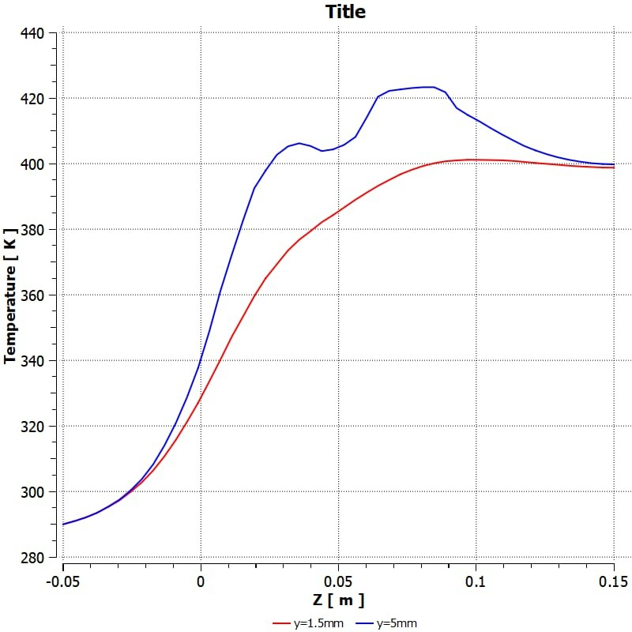

**Fig.6 Output image Temperature vs Distance**

# DISCUSSION

The results of the steady-state 3D convective heat transfer analysis highlight the complex interplay between heat source characteristics, fluid flow behavior, and thermal efficiency. As expected, forced convection proved to be far more effective in enhancing heat dissipation than natural convection, particularly at higher fluid velocities. The increased fluid velocity in forced convection facilitated better mixing, reducing the thermal boundary layer around the heat source and leading to a more uniform temperature distribution. This outcome is consistent with previous studies that have shown that forced convection accelerates heat transfer by increasing the convective heat transfer coefficient.

The temperature distribution observed in natural convection scenarios, however, showed that although the heat

transfer process was less efficient, it still contributed significantly to the cooling of the system, especially at lower heat fluxes. Natural convection creates buoyancy-driven flow, which, although less turbulent than forced convection, can still provide passive cooling. This is particularly important for systems where external flow assistance is not feasible, such as in passive cooling systems used in electronics or buildings. The findings of this study emphasize that while natural convection may not offer the same level of efficiency as forced convection, it is still a viable option in low-power applications where minimal external input is available.

One of the critical insights from this study is the impact of geometry on the heat transfer process. The size and positioning of the heat source within the enclosure had a notable effect on both flow patterns and heat dissipation. Larger heat sources led to higher heat transfer rates, but this effect was less pronounced as the flow velocity increased. Additionally, the geometry of the enclosure and heat source affected the thermal boundary layers and the development of flow patterns. These observations suggest that designing systems with an optimized heat source geometry and carefully considering the enclosure's shape can improve heat transfer efficiency, regardless of whether the system operates under forced or natural convection.

Furthermore, the results confirmed that CFD simulations offer a powerful tool for investigating complex heat transfer scenarios. By solving the governing equations for fluid flow and energy conservation in three dimensions, CFD allowed for a more accurate representation of the temperature distribution and flow patterns around the heat source than traditional analytical methods. The detailed results obtained from these simulations, including Nusselt numbers and temperature gradients, provide valuable insights into the thermal behavior of systems and can guide the design of more efficient thermal management strategies.

Finally, while forced convection proved to be more effective in enhancing heat transfer, natural convection remains a relevant phenomenon, especially in passive thermal management systems. The ability to optimize natural convection through strategic heat source placement and geometry adjustments can improve the thermal performance of systems where forced convection is impractical. This study contributes to a deeper understanding of the factors influencing convective heat transfer and lays the groundwork for future research aimed at further optimizing heat dissipation in both active and passive cooling systems.

standards.

# CONCLUSION

In conclusion, this study presents a detailed steady- state 3D analysis of convective heat transfer over a localized

heat source within a fluid medium. The results demonstrate that forced convection significantly enhances heat dissipation compared to natural convection, especially at higher fluid velocities, due to improved fluid mixing and reduced thermal boundary layers. However, natural convection remains a viable option in passive cooling scenarios, where external flow assistance is not available. The study also highlights the importance of system geometry in optimizing heat transfer efficiency, with larger heat sources and well-designed enclosures leading to better thermal performance. Overall, the findings provide valuable insights for designing efficient thermal management strategies in both active and passive cooling applications.

# REFERENCES

1. Kumar, S., & Singh, A. (2018). *Numerical Study of Forced Convection Heat Transfer over a Heated Plate*. International Journal of Heat and Mass Transfer, 128, 413-423.
2. Jang, S., Lee, H., & Kim, J. (2011). *Three-Dimensional Numerical Simulation of Natural Convection over a Heated Cylinder*. Journal of Thermal Science and Engineering Applications, 3(2), 021007.
3. Pantokratoras, A. (2004). *Heat Transfer Enhancement Using Nanofluids in Forced Convection*. International Journal of Thermal Sciences, 43(7), 653-664.
4. Dittus, F. W., & Boelter, L. M. K. (1930). *Heat Transfer in Tubes*. Journal of Engineering Power, 52(2), 264-268.
5. Bejan, A. (2013). *Convection Heat Transfer* (4th ed.). John Wiley & Sons.
6. Cheng, P., & Minkowycz, W. J. (1977). *Heat Conduction in Porous Media*. Advances in Heat Transfer, 13, 1-106.
7. Kays, W. M., & Crawford, M. E. (1993). *Convective Heat and Mass Transfer* (3rd ed.). McGraw-Hill.
8. ANSYS, Inc. (2020). *ANSYS Fluent User Guide*. ANSYS,

Inc.

1. Patankar, S. V. (1980). *Numerical Heat Transfer and Fluid Flow*. Hemisphere Publishing Corporation.
2. Bejan, A., & Tsatsaronis, G. (1996). *Optimization of Thermal Systems*. Wiley.
3. Menezes, P. L., & Chaddha, P. (2017). *Numerical Study of Forced Convection Heat Transfer in Laminar Flow of Air Over Heated Surfaces*. Heat Transfer Engineering, 38(9), 732- 746.
4. Ghiaasiaan, S. M. (2008). *Convective Heat Transfer* (2nd ed.). Cambridge University Press.
5. Li, W., & Sato, Y. (2006). *Numerical Simulation of Heat Transfer in Convection of Supercooled Water with Different*

*Heat Sources*. International Journal of Thermal Sciences, 45(5), 452-463.

1. Mollier, A. P., & Jovanovic, J. (2019). *Heat Transfer in Turbulent Fluid Flow Over a Heated Surface*. International Journal of Heat and Fluid Flow, 70, 233-245.
2. Ahmed, S., & Hossain, M. (2015). *A Review of Forced and Natural Convection Heat Transfer Models*. International Journal of Heat and Mass Transfer, 85, 56-78.
3. Sundar, S., & Rajendran, A. (2014). *Simulation of Convective Heat Transfer Over a Heated Cylinder Using CFD*. Journal of Applied Fluid Mechanics, 7(3), 457-467.