FreelanceGenius

|  |  |  |
| --- | --- | --- |
| Ms. Anuja R. Avhad | Ms. Bhumika G. Bagale | Mrs. Pallavi M. Takate |
| *Information technology* | *Information technology* | *Information technology* |
| *MET’s Institute of Technology* | *MET’s Institute of Technology* | *MET’s Institute of Technology* |
| *Polytechnic, Bhujbal Knowledge City* | *Polytechnic, Bhujbal Knowledge City* | *Polytechnic, Bhujbal Knowledge City* |
| *Nasik, Maharashtra ,India* | *Nasik, Maharashtra ,India* | *Nasik, Maharashtra ,India* |
| [email:avhadanuja64@gmail.com](mailto:raviavhad274@gmail.com) | email[:bagalebhumika83@gmail.com](mailto:bagalebhumika83@gmail.com) | [email:pallavit_iot@bkc.met.edu](mailto:sanjeevp_iot@bkc.met.edu) |

***Abstract— As the gig economy continues to expand, there is a need for effective and trustworthy platforms for freelancers. FreelanceGenius is a novel application that connects freelancers and clients, streamlining project management and secure transaction. The platform utilizes an AI-based job matching system, automated proposal generation, and real-time collaborative tools for enhanced productivity and user experience. Transparent and secure payment and skill-based matchmaking distinguish FreelanceGenius in the quest for bringing talent and opportunity together. In this paper, we describe the system architecture, leading features, and impact on the freelancing ecosystem of FreelanceGenius.***

**Keywords – Freelancing platform, Gig economy, AI-driven job matching, Skill-based matchmaking**

**1. INTRODUCTION**

This rapid growth of the gig economy has disturbed conventional employment structures: the rising demand for freelancing platforms that facilely link clients with skilled professionals. Modern-day freelancers wish for flexible work avenues, whereas businesses seek specialized talent for short- term projects. However, the existing freelancing platforms often suffer from inefficient job postings, opaque procedures, and weak communication.

FreelanceGenius will address these problems with an easy- to-use freelancing platform. The application allows job posting, direct communications among freelancers and clients, and project tracking. These features should thus ensure that FreelanceGenius is a more effective, more transparent, and more user-friendly freelancing ecosystem.

This paper discusses the architecture of the system, certain core functionalities, and the impact of FreelanceGenius on both freelancers and clients. Furthermore, it describes how the platform increases productivity, ensures that interactions are effective, and builds a trustworthy digital workplace for professionals throughout the world.

## PROBLEM DEFINITION

Here are several challenges with these current platforms despite the boom in freelancing:

* 1. Job posting has really poor efficiency. Most platforms do not allow clients to post jobs in an organized manner.
  2. Transparency is lost when clients have trouble discerning a reliable freelancer from a fake profile or one filled with subjective information.
  3. Lack of automation does much to waste one's time and efforts in manual proposal writing and searching for jobs.
  4. Toeing the line are horrible collaboration tools. Deficiency of adequate communication and project management functions does not prove well for productive work.
  5. FreelanceGenius will solve these problems using organized job posting along with real-time communication tools and project tracking

## LITERATURE SUEVEY

* 1. Several freelancing platforms have emerged in the recent couple of years, such as Upwork, Fiverr, and Freelancer.com; however, these platforms have several drawbacks like high service charges, absence of structured job postings, and delay in dispute resolution. Recent research has shown the importance of transparency and effective communication on freelance platforms. Various academic articles also propose that a better-developed project tracking system would enhance the working relationship between freelancers and their clients. FreelanceGenius takes these improvements to provide a next-level freelancing experience.

## SYSTEM ARCHITECTURE

* 1. The FreelanceGenius system consists of the following key components:
  2. User Module: This handles the registration, login, and profile management of freelancers and clients.
  3. Project Posting Module: Enables clients to post projects with a detailed description.
  4. Proposal Management: Enables freelancers to submit proposals for available projects.
  5. Admin Dashboard: Provides analytics and platform moderation.

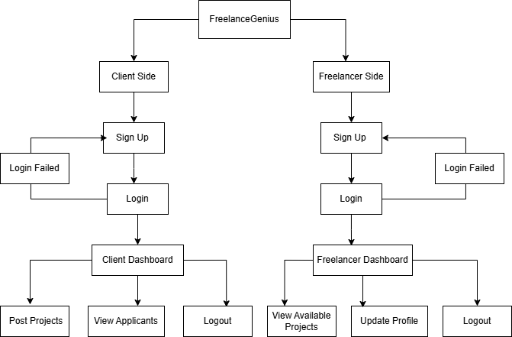Fig. System Architecture

## METHODOLOGY

FreelanceGenius has been developed using an agile methodology, thus allowing iterative enhancements along with the incorporation of user feedback. The critical steps are as follows:

* 1. Requirement Analysis – Identification of primary hurdles and requirements faced by freelancers and clients.
  2. System Design – Architecture, database schema, and how features are integrated.
  3. Development – Implementing front-end and back- end features using modern technologies.
  4. Testing - performing black box and white box testing, integration testing and user acceptance testing. -reassemble_black_box, white_box_testing,- integration_and_user_acceptance_testing.
  5. Deployment – Launching the application on the Google Play Store.

## IMPLEMENTATION DETAILS

* 1. Front-Send: Developed using Java for an intuitive user interface.
  2. Back-end: Uses XML for database structuring and data management.
  3. Database: Firebase for storing user profiles, job listings, and transactions.
  4. Hosting: Deployed on the Google Play Store for easy accessibility.

## FUTURE SCOPE

* 1. Integration of profile verification systems to increase platform transparency.
  2. Gamification elements to reward high-performing freelancers.
  3. Multi-language support to expand the user base globally.

## APPLICATIONS

* 1. Freelancers: Helps individuals find relevant work opportunities efficiently.
  2. Businesses and Startups: Provides access to skilled professionals on demand.
  3. Educational Institutions: Assists students in finding internships and projects.
  4. Recruitment Agencies: Streamlines the hiring process through structured job postings.

1. **RESULTS**

# Client Side



 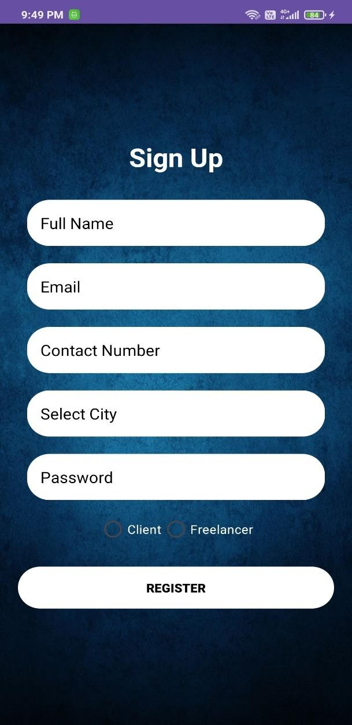

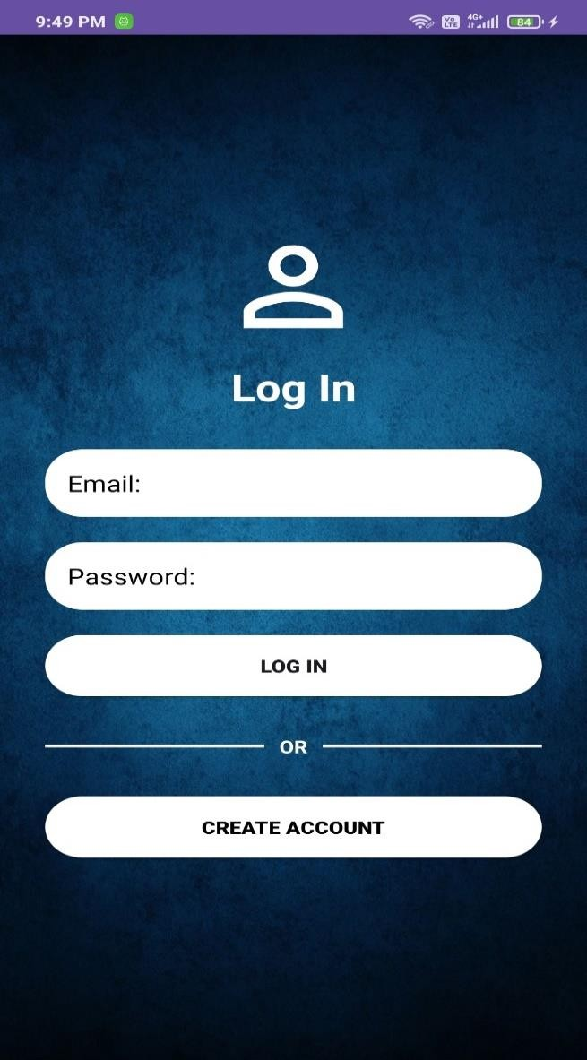 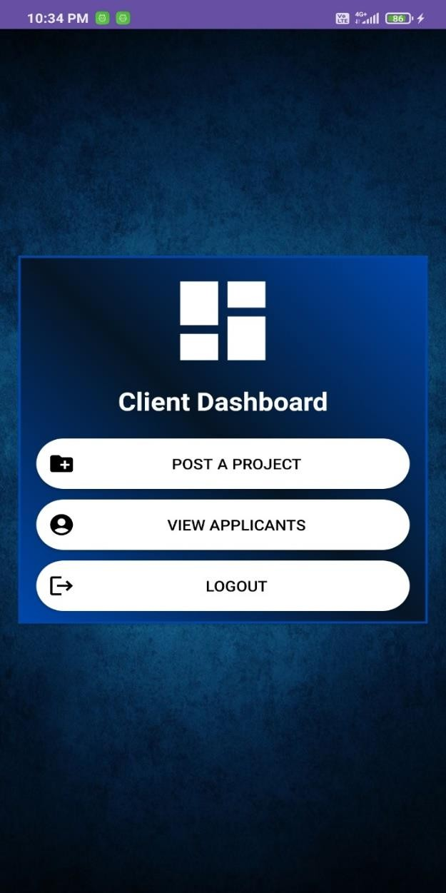

# Freelancer Side:

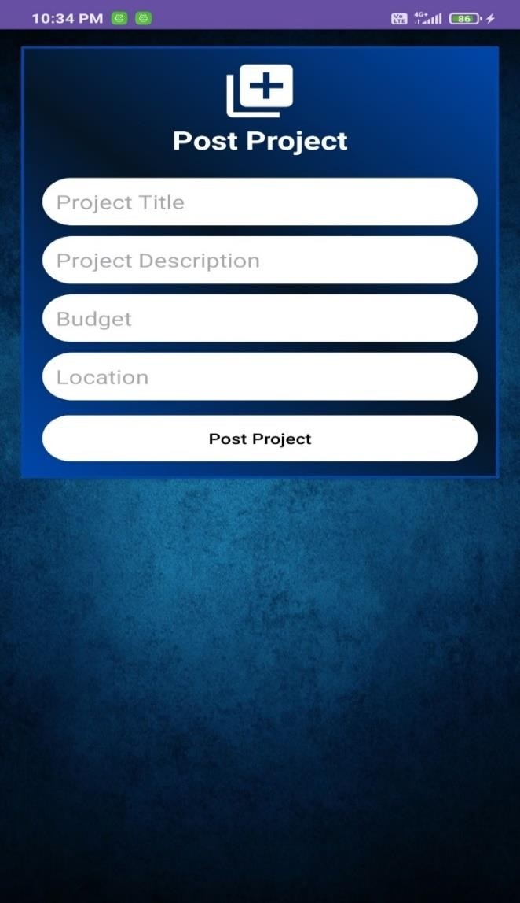

 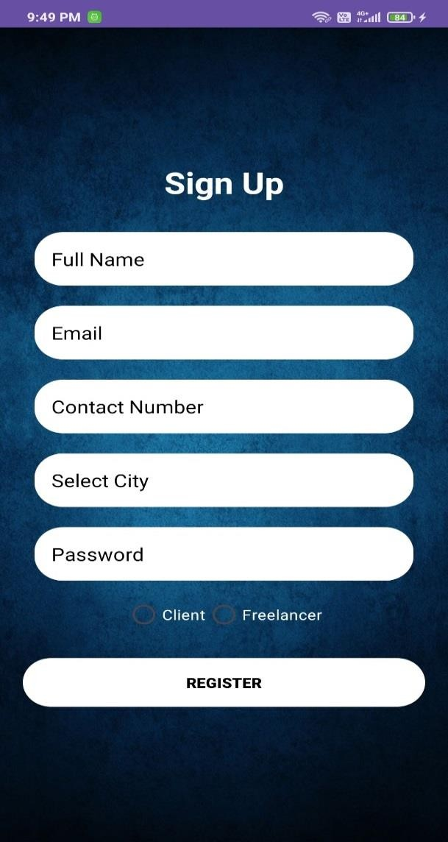

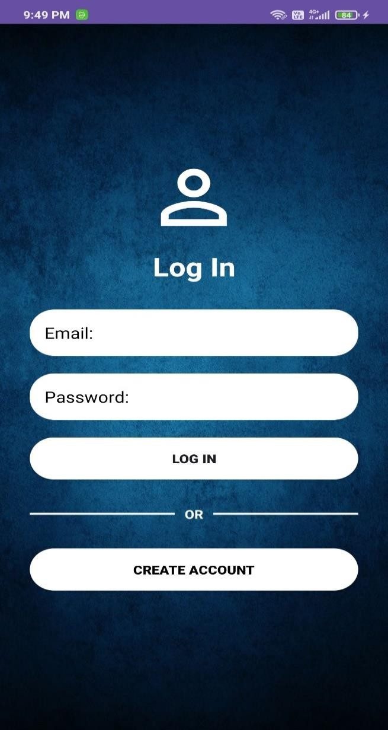 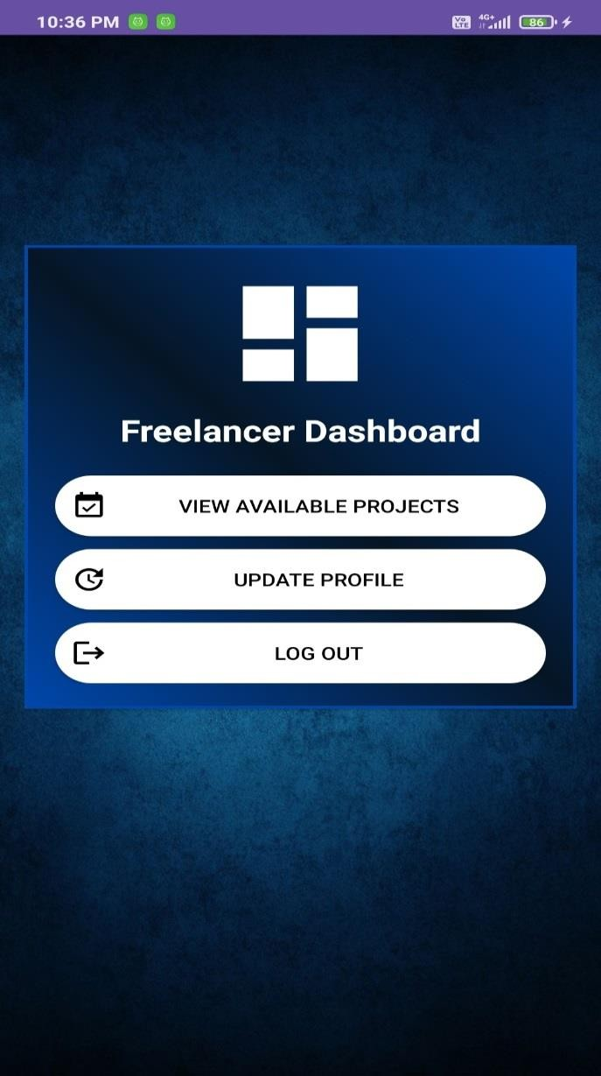



## REFERENCES

1. Inhibiting Motivating Factors on Online Gig Economy Client in Indonesia
2. Surviving in the Gig Economy: Change of STEM Students’ Perceptions on the Generic Skills for the Workplace
3. Discovering Indonesian Digital Workers in Online Gig Economy Platforms
4. Developing the Maturity Model for Gig Economy Business Processes
5. Discovering the Influencing Factors of Physical Gig Economy Usage: Quantitative Approach on Clients’ Perception

## CONCLUSION

The freelancing market is dynamic, so platforms within this space need to add sophisticated features for better user experience. FreelanceGenius offers additionally structured job postings and project tracking tools as FreelanceGenius addresses challenges in the existing freelancing ecosystem. While enhancing efficiency and transparency in the freelancing world, modern technologies will also be useful in achieving these goals. Future profile verification strengthening and gamification might be added to the portfolio already. With a user-centric approach, FreelanceGenius can well be called a potential game-changer in the gig economy.