**Understanding Customer Preferences and Predictive Sales Trends in the Automobile Sector: An Analytical Study with Power BI**

**Gokulraj P.M1 , Dr.D.kotteswaran2**

**PGStudent1, Assistant Professor2**

II MBA Student, Department of Management studies1

Vel Tech Rangarajan Dr. Sagunthala R&D Institute of science and Technology, Avadi, Chennai, India.

Assistant Professor, Department of Management studies2

Vel Tech Rangarajan Dr. Sagunthala R&D Institute of science and Technology, Avadi, Chennai, India.

**[gokulraj20155@gmail.com](mailto:gokulraj20155@gmail.com1,)[1](mailto:gokulraj20155@gmail.com1,) [,](mailto:gokulraj20155@gmail.com1,)**

**koteeswarand@veltech.edu.in2**

**Abstract:**

**In the rapidly evolving auto industry today, knowing the customer's preference is crucial for forecasting future car sales trends and creating business strategies. With this research study, it concentrates on detecting consumer preference and foretelling car sales with Power BI, a contemporary business intelligence platform for data analysis and visualization.The main objective of this study is to examine existing customer trends and predict sales patterns based on survey information. The research also seeks to determine the most desired car models and options, investigate the effect of customer demographics including age, income, and lifestyle, and approximate future demand for electric and hybrid cars. It also investigates the effect of variables such as price sensitivity, fuel efficiency, safety, and smart technology on car purchases.Surveys were conducted using a standardized questionnaire that captured multiple sides of customer behavior, such as preferred vehicle types, price point, fuel type, importance of sophisticated features, and future buying plans. Power BI was used to analyze the responses and reveal latent patterns and visual trends through bar charts, pie charts, filters, slicers, and forecasting models.The findings of the study indicate high customer demand for fuel efficiency, safety features, and technology integration. It also shows increased awareness and interest in electric vehicles, particularly among environmentally aware and younger buyers. Power BI's interactive dashboards offered greater insights by graphically mapping customer segments and sales trends.This study illustrates the effective utilization of business intelligence tools such as Power BI in assisting data-driven decision-making within the automobile sector. Knowing what drives customer choices helps car manufacturers and dealers plan for better marketing, enhance inventory control, and provide products that more closely meet consumers' expectations. This study, in general, provides valuable information on how to align business processes with customer needs in a fast-changing market.**

**Keywords:** PowerBI, Car Sales Prediction, Customer preference analysis, Business Intelligence, Automobile Industry**.**

**Introduction:**

The automotive industry is one of the fast going sector , where consumer preferences and market trends are ever-evolving. Given how fiercely competitive the market is these days, knowing what customers want is essential to increasing sales and building solid business plans. When purchasing a car, buyers now consider a wide range of criteria, such as price, brand name, comfort, security, mileage, fuel, and smart features like AI help and connectivity.

This research concentrates on examining customer preferences and forecasting car sale trends utilizing Power BI, a business analytics program recognized for its data visualization and forecasting capabilities. Through the examination of consumer decision-making and behavior, the project seeks to provide automobile firms, marketers, and car dealers with improved information-based decisions.

The main aim of this study is to determine existing customer preferences and apply them to predict future automobile sales. It also investigates secondary topics like determining the most popular car models and options, examining how demographics (age, income, lifestyle) of customers affect purchasing decisions, and predicting demand for electric and hybrid cars. It also investigates how price sensitivity, fuel efficiency, and technology affect purchasing decisions.

The data was gathered via a formal questionnaire that addressed essential areas such as car type, fuel preference, budget, preferred features, and buying intention. Power BI was used to analyze the responses, enabling the development of interactive dashboards with graphs, filters, and charts. These visualizations allowed for easy identification of trends and drawing of conclusions from the data.

Power BI forecasting functions also enabled the study to make predictions on sales trends in the future based on customers' interests.

Findings indicate increasing popularity of electric cars, growing desire for fuel efficiency, and high influence of price and technology on purchase decisions. This study demonstrates how business intelligence software such as Power BI can streamline intricate data and aid in decision-making within the automobile industry. With improved understanding of what consumers desire, companies can enhance product development, marketing strategies, and inventory management, thereby leading to improved business growth.

**Review of literature:**

### Customer Preferences and Buying Behavior in the Automobile Industry, Sharma, P., & Gupta, S. (2019)This paper studies how different factors like price, fuel efficiency, and safety features influence car-buying behavior in India. It highlights that customer preference is highly influenced by fuel prices and brand image. The paper suggests that demographics like age and income have a direct impact on purchase decisions.

### Role of Business Intelligence in Automotive Industry,Kumar, R. (2021).This paper explores the growing role of BI tools such as Power BI in analyzing consumer data. It explains how visual dashboards help companies understand customer behavior and make faster, data-driven decisions. The author emphasizes BI's use in forecasting sales and improving operational planning.

### Impact of Demographic Factors on Car Purchasing Decisions****:**** Mehta, A., & Singh, R. (2018) The study investigates how age, income, occupation, and residential location affect customer choices. It concludes that younger buyers prefer technology-rich cars, while older customers focus on durability and brand trust. Demographics are key to segmenting markets effectively.

### Predictive Analytics in the Automotive Sector Johnson, L. (2020) This paper discusses how predictive models can estimate future demand for specific car types. It explores tools like Power BI and Tableau for creating data visuals that assist managers in sales planning. The author also touches on integrating ML algorithms with BI.

### A Study on Consumer Behavior towards Electric Vehicles Patel, N. (2022)This paper analyzes why some customers choose EVs over conventional cars. It identifies environmental concerns, lower maintenance, and government subsidies as major drivers. It also notes that awareness and affordability are still challenges for EV adoption.

### Using Power BI for Visual Data Analysis in Business Thomas, D. (2021)The paper showcases Power BI as a user-friendly tool for handling complex datasets. It explains how slicers, filters, and real-time dashboards improve data understanding. The study demonstrates real-world use cases including sales forecasting and customer segmentation.

### The Influence of Fuel Efficiency on Consumer Buying BehaviorRao, M. & Verma, S. (2017) This research reveals that mileage is one of the most important factors for Indian consumers. It notes that even high-end buyers look at fuel savings over time. The study concludes that fuel efficiency can be a deciding factor in a highly price-sensitive market.

### Technology Features and Car Buying PreferencesIyer, S. (2020) This paper discusses the importance of smart features like AI dashboards, lane assist, and connectivity in attracting modern buyers. It finds that tech-savvy customers are more likely to choose brands offering innovative features. It also notes that digital influence affects decision-making.

### Automobile Sales Using Visualization Tools****:**** George, A. (2021) This study uses Power BI to create visual forecasts for vehicle sales based on historical data. It demonstrates how trends can be visualized using charts and forecasting tools. The findings support the use of BI tools for better planning and strategy alignment.

### Business Intelligence as a Tool for Competitive AdvantageChatterjee, D. (2022) This paper explains how BI tools help companies gain competitive edge by turning raw data into actionable insights. It highlights the usefulness of dashboards in various industries, including automobile. The author argues that BI adoption leads to more customer-focused strategies.

**Objectives of the study**

* The primary objective: To use Power BI to forecast future trends in auto sales and analyze present client preferences.
* Secondary objective: To determine the most popular vehicle models and important characteristics that affect consumers' decisions to buy.
* To examine how trends in car sales are impacted by demographic variables including age, income, and lifestyle.
* To forecast future demand for hybrid and electric cars by taking into account changing consumer preferences.
* To investigate how pricing, fuel economy, and technology developments influence consumer purchasing decisions.
* To use Power BI's forecasting and analytical capabilities to display and analyze sales trends in order to make better decisions.

**Scope of study**

This study focuses on understanding customer preferences and analyzing sales trends in the automobile sector using Power BI, a modern business intelligence and data visualization tool. The research aims to explore the key factors that influence customer decisions when purchasing a car, such as price, fuel efficiency, design, brand trust, and advanced technology features.

The study also looks at how consumer variables like age, region, employment status, and income level influence purchasing decisions. In order to facilitate better business decision-making and make it simpler to predict future patterns in automobile sales, the research uses Power BI to show this data using dashboards and forecasting tools. All things considered, the study offers a data-driven method for predicting sales and comprehending consumer behavior in the ever-changing automotive sector.

**Research Methodology**

This study uses a quantitative research methodology, emphasizing factual analysis and numerical data to comprehend consumer preferences and predict future trends in auto sales. Data from a structured questionnaire is used to drive the research, and Power BI, a business intelligence and visualization tool, is used for analysis.

**Data Collection Technique**  
Primary data was gathered via a survey using a Google Form.The questionnaire was given to prospective existing and potential car customers. It contained both closed-ended and Likert scale questions about expectations for technology, budget, fuel type, preferred car models, and anticipated purchase dates. This methodology guaranteed that the answers were quantifiable and appropriate for examination.

**Data Modeling**   
A single structured table containing the cleansed dataset was loaded into Power BI. Relationship modeling was not necessary because the survey data was flat and non-relational. In order to segment replies, extract insights, and enable forecasting logic—such as projecting intended purchase plans to future periods—new DAX columns were developed.

**Data Visualization**

Interactive dashboards and visualizations were created using Power BI to showcase the data's findings. Bar graphs, pie charts, treemaps, KPI cards, and forecasting lines were among the charts that were used to:

* Show patterns in consumer preferences
* Examine demand for various car models and attributes.
* Evaluate fuel choices and price sensitivity.
* Estimate prospective future sales based on consumers' intents to buy.

These graphics aided in the identification of new trends and simplified the interpretation of the data.

**Research Design**

The research design used in this study is both descriptive and analytical. Because it examines the kinds of cars that consumers favor, the characteristics they find valuable, and the ways in which demographics affect decisions, it is descriptive. It is analytical since it investigates the possibility of using these preferences to forecast future trends in auto sales.

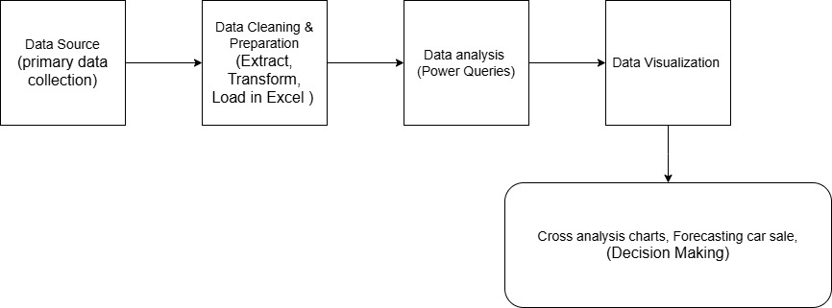**Research model:**

### ****Sampling Method****

### Convenience sampling, a non-probability sampling technique, is used in this study. Information was gathered from those who were willing and able to be reached. Google Forms was used to distribute the online poll in order to swiftly reach those who were considering buying a car. Respondents were pertinent to the study's goal since they were chosen based on their interest in or knowledge of purchasing an automobile.

### ****Sample Size****

### Total of 236 respondents took part in the survey .The sample size is sufficient for the purpose of this study, which is to use Power BI to forecast sales trends and examine customer preferences. The responses offer sufficient information to spot significant trends and insights, even though they are not meant to be representative of the broader population.

**Data Analysis and Interpretation**

**Chart 1: Age group Vs preferred car type**

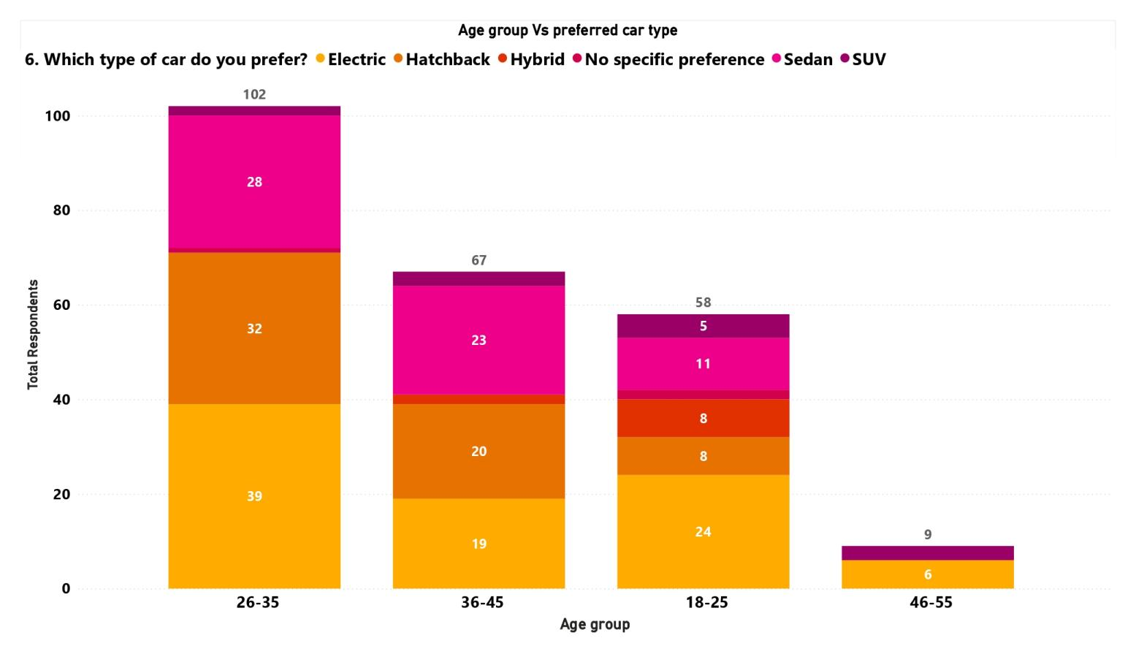

**Interpretation**

The above visual chart show age group of 26 to 35 is the most active, according to the data, and they have a strong preference for SUVs, followed by hatchbacks and no preference at all. SUVs and hatchbacks are likewise preferred by the 36–45 age bracket, demonstrating a pragmatic purchasing habit. Today's tastes are reflected in the 18–25 age group's preference for SUVs but also their interest in sedans, hybrids, and electric vehicles. There are fewer people in the 46–55 age range, but they tend to buy SUVs. SUVs are the most popular vehicle type overall, regardless of age, and younger consumers are becoming more interested in environmentally friendly option

**Chart 2: Salary level Vs Willing to spend new car**

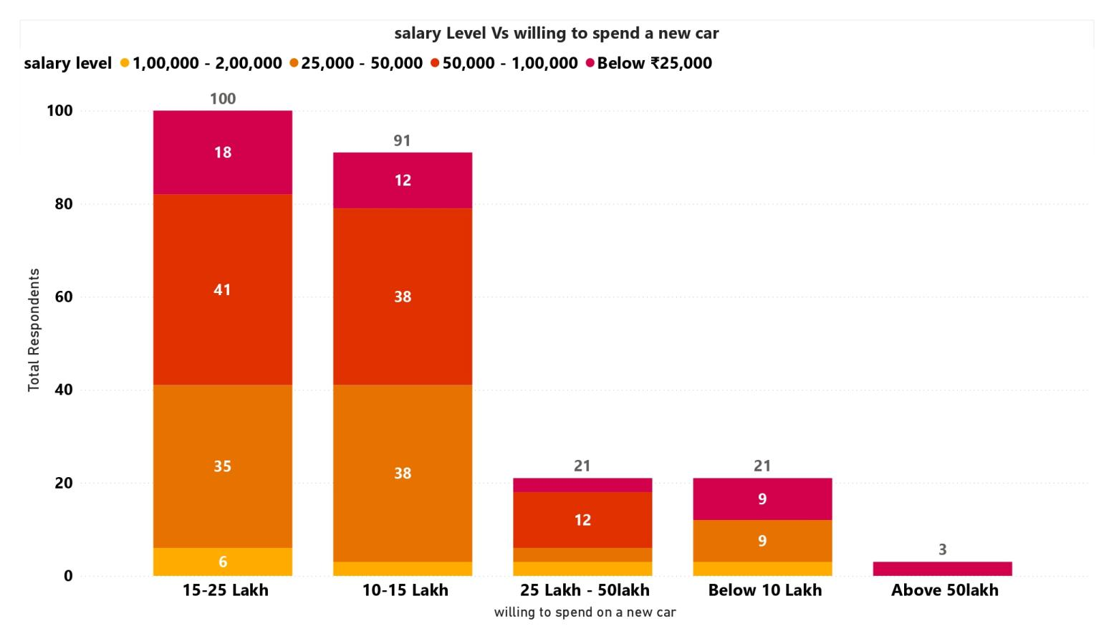

**Interpretation**

The above visual show For a new car, the majority of respondents who make between ₹50,000 and ₹2,00,000 are willing to pay between ₹10 and ₹25 lakhs. In particular, the budget of ₹15–25 Lakh has the greatest number of buyers (100), closely followed by the budget of ₹10–15 Lakh (91), suggesting a strong preference for mid-range expenditure. Buyers with smaller incomes (less than ₹25,000) typically look for possibilities under ₹10 Lakh or between ₹15 and 25 Lakh. Due to financial limitations, very few respondents (only 3) are willing to pay more than ₹50 lakh. The trend emphasizes how important affordability is when making selections about what to buy.

**Chart 3: Purchase Timeline Vs Interest in EV vehicles**

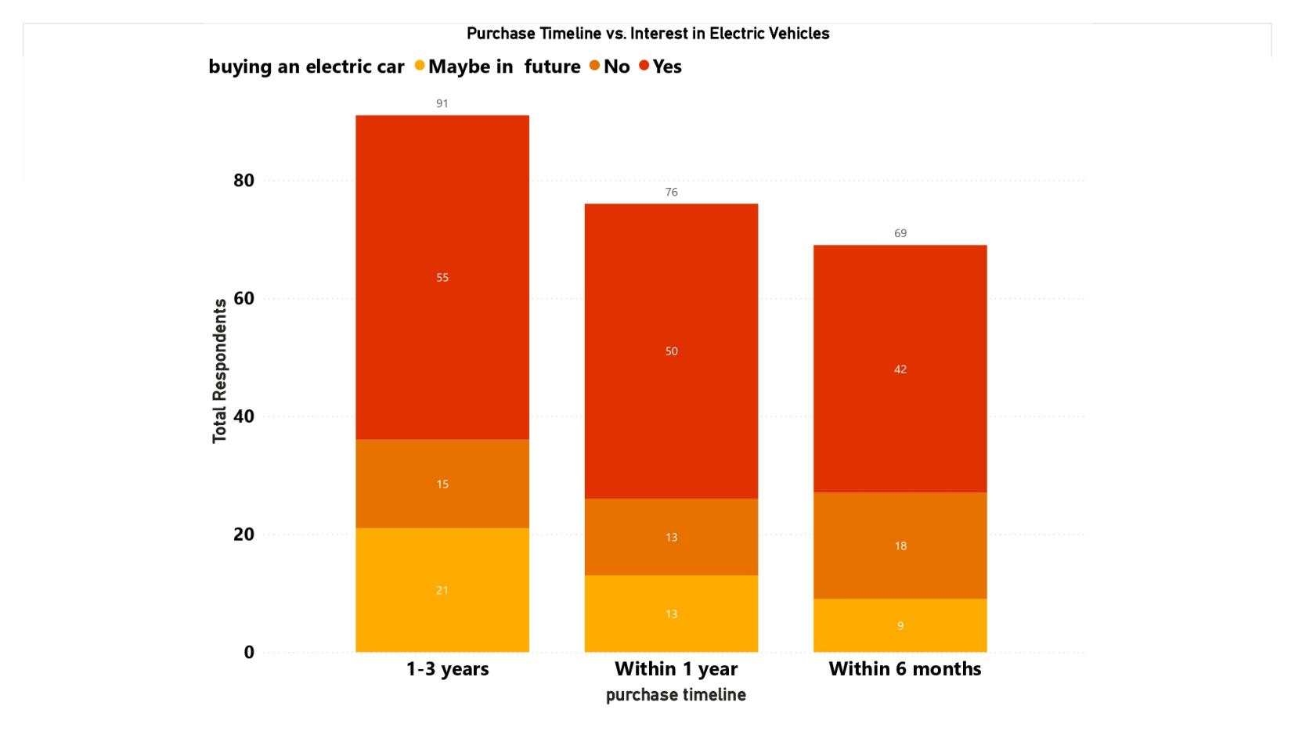

Interpretation

The above visual show across all purchase timescales, the majority of respondents are not now interested in purchasing an electric vehicle, particularly those who want to do so within the next one to three years (55 out of 91) and within a year (50 out of 76). However, there is a tiny but significant market for EVs in the future, especially in the 1–3 year range. Currently, only a small percentage of buyers—21, 13, and 9 respondents in the corresponding timelines—showed a high interest in EVs. This implies that even if awareness is rising, there is still a lack of immediate adoption and that most consumers may put off buying EVs until later.

**Chart 4: AI Tech features importance by Age Group**

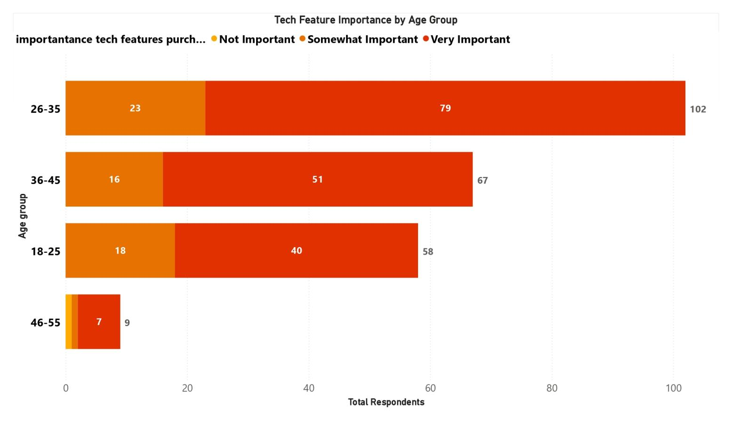

**Interpretation**

This chart indicates When buying a car, the majority of respondents across all age groups rank technological features as "Very Important." 79 out of 102 people in the 26–35 age range place the highest value on it, which is particularly high. The following age groups—36–45 and 18–25—show that younger and middle-aged customers are very tech informed. It's interesting to note that, despite their smaller numbers, most people in the 46–55 age range still view technology as somewhat or extremely significant. This illustrates the rising desire, particularly among millennials and Gen Z, for technology-driven amenities in contemporary automobiles.

**Chart 5: Customer interest willing to purchase tech features cars**

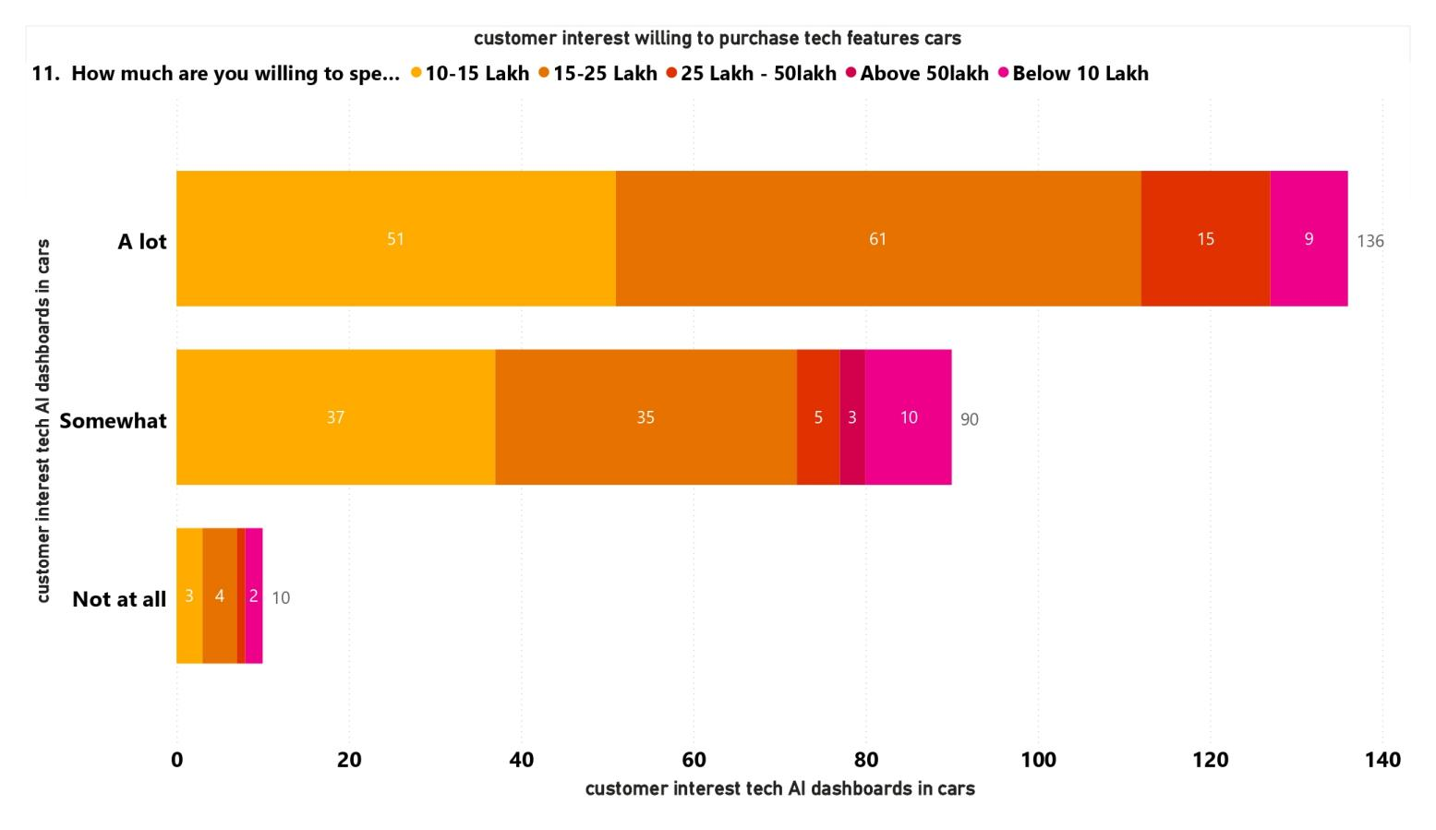

**Interpretation**

There is a substantial correlation between higher spending intentions and high tech interest.The majority of customers who express a high level of interest in tech/AI dashboards in cars ("A lot") are in the ₹15–25 lakh (61 replies) and ₹10–15 lakh (51 responses) expenditure ranges, suggesting that tech-savvy consumers are willing to pay more for the more sophisticated capabilities. However, individuals spending less than ₹10 lakh are more likely to have minor tech interest ("Not at all"), which may indicate that budget purchasers are price sensitive or don't see high-end technology as having as much value. This pattern demonstrates a direct link between investment readiness in mid-to-premium auto sectors and tech enthusiasm.

**Chart 6: Forcast purchase timeline by year, quarter, month**

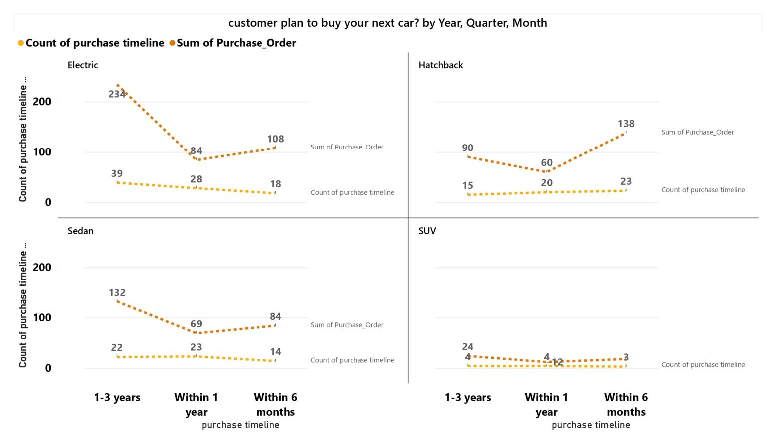

**Interpretation**

Future automotive tastes are dominated by electric and hatchback vehicles. Customers who intend to buy within the next one to three years are strongly drawn to electric (234 orders) and sedan (132 orders) vehicles, demonstrating a forward-thinking interest in eco-friendly and useful alternatives. However, hatchbacks (138 orders) and electric cars (108 orders) are the most popular choices for short-term purchasing plans (within 6 months), indicating a growing confidence and willingness to quickly adopt small and environmentally friendly vehicles. Conversely, SUVs continue to be the least popular option throughout all historical periods, which may be due to consumer preference for smaller and greener vehicles or financial limitations.

**Findings and Recommendations:**

* Marketing should highlight feature-rich SUVs and hatchbacks with flexible financing and customization options in order to appeal to the very active 26–35 age group. Emphasize practicality, fuel efficiency, and long-term value for the 36–45 age range. Targeting the 18–25 age group with eco-friendly advertising and youth-focused offers is important given their growing interest in EVs, hybrids, and sedans. SUVs ought to be promoted as multipurpose lifestyle cars since they are well-liked by people of all ages. Stress comfort, safety, and low-maintenance characteristics for people aged 46 to 55.
* Given the clear presence mid-range budgets (₹10–25 Lakh) are clearly preferred, manufacturers and dealers should concentrate on providing value-packed vehicles in this price range with flexible EMI plans and appealing amenities. Adding affordable models under ₹10 Lakh with necessary technological and safety features might increase reach because pricing influences decisions, particularly for buyers with lower incomes. Selective marketing is necessary for high-end models costing more than ₹50 lakh, focusing on niche premium consumers with unique perks and a luxurious image. In general, maximizing conversions requires matching product offerings with income-driven affordability.
* Even with increased knowledge, there is still little immediate interest in electric vehicles across all timeframes, particularly among those who want to purchase within the next 12 months. This implies that long-term EV awareness programs emphasizing advantages like cost savings and environmental friendliness are necessary. To lessen hesitancy, manufacturers and dealers should spend money on government incentive programs, test drives, and instructional materials. Pre-launch offers and flexible EV financing tailored to the 1–3 year buying group can foster early adopters and create demand that is ready for the future.
* Car manufacturers should give priority to smart versions with AI dashboards, connected infotainment, and safety technology because most age groups, particularly those between the ages of 26 and 35, place a high value on technological features. While older groups choose technology that increases comfort and security, younger buyers are more interested in innovation and convenience. Meeting the expectations of today's consumers requires promoting technology as a fundamental component.
* Higher spending capacity and enthusiasm for technology are clearly related. Customers in the ₹10–25 lakh category are very interested in cutting-edge features like AI dashboards, which suggests that they are more prepared to spend money on intelligent, technologically advanced cars. People in the ₹10 lakh range, on the other hand, show little interest in technology, which is indicative of their tight budgets and low opinion of the worth of high-end equipment. This demonstrates that the mid-to-premium car category is where tech-focused marketing works best.
* Since electric and hatchback vehicles are highly sought after for both short-term and medium-term purchases, manufacturers ought to give them top priority. For consumers who want to purchase within the next six months, electric cars and hatchbacks should be advertised with an emphasis on their affordability and environmental friendliness, whereas electric cars and sedans should be advertised for those who expect to purchase within the next one to three years. The lack of appeal in the SUV market points to the need for more reasonably priced or hybrid electric SUV alternatives. Adoption may increase if people are informed about the economic advantages of electric automobiles. Future car designs will be able to adapt to the demand for economical and environmentally friendly solutions with the support of ongoing customer preference monitoring.

**Conclusion:**

Using Power BI, this study effectively examined consumer preferences and forecasted future trends in auto sales, providing insightful information for the automotive industry's decision-making. According to the report, younger consumers are becoming more interested in electric and hybrid cars, while the 26–35 age group is the most active car-buying market, with a strong preference for SUVs and hatchbacks. Spending capacity was found to be influenced by income levels, with mid-range budgets (₹10–25 lakh) being the most common.

All age groups place a high value on technological features, but internet-savvy millennials especially do, and there is a direct link between greater willingness to spend and digital enthusiasm. Despite the low level of interest in EVs at the moment, demand for them is expected to grow in the future, particularly in the one to three year purchase period, suggesting a shift in consumer behavior toward more environmentally friendly purchases.  
Power BI turned out to be a useful tool for anticipating sales trends, segmenting consumer behavior, and displaying patterns. The study illustrates how business intelligence technologies may improve strategic planning in marketing, inventory management, and product positioning using interactive dashboards and data-driven insights.

Overall, the results highlight how automakers and dealers must prioritize affordability, intelligent features, fuel economy, and environmentally friendly models in order to match their product offerings with consumer expectations. Remaining competitive in the ever changing automotive sector will require ongoing customer preference monitoring using analytics solutions like Power BI.

**Reference:**

* A. Kumar and P. Sharma, Consumer Behaviour in Automobile Industry, New Delhi, India: Sage Publications, 2018, pp. 112–120.
* N. Gupta, Data Visualization Techniques using Power BI, Mumbai, India: TechPress, 2020, ch. 5.
* ] S. Mehta, “Understanding millennial car buying preferences in India,” Auto Market Research Journal, vol. 14, no. 3, pp. 42–49, Jul. 2021.
* R. Patel, “A predictive analysis on electric vehicle adoption,” Int. J. Sustainable Mobility, to be published.
* L. Thomas, “Integrating Business Intelligence in Automotive Marketing (Submitted for publication),” IEEE Trans. Ind. Informatics, submitted for publication.
* V. Krishnan, Personal communication, Automobile Customer Behavior Survey, Chennai, India, Mar. 2025.
* M. Ramesh, R. Iyer, and D. Nair, “Power BI-based dashboards for customer segmentation,” IEEE Transl. J. Data Sci. Visual., vol. 5, Jan. 2022, pp. 88–91.
* A. Singh, Modern Trends in Automobile Marketing, 2nd ed. Pune, India: Wheels Press, 2019.
* S. Roy. (2023, Oct. 12). Forecasting Car Sales Using Power BI and AI [Online]. Available: https://www.automobileinsights.com/pbi-car-sales
* T. Joseph. (2022, Feb. 5). Understanding Customer Purchase Behavior in the EV Segment [Online]. Available: https://www.evmarketresearch.org/behavioral-study