" Intelligent Real-Time Traffic Monitoring and Management System Using IoT"
Vishakha Nimbalkar *¹, Vikram Nimbalkar *², Prof S.U.Kavale*³
*¹Student, Department of Information Technology, SOU. VENUTAI Chavan Polytechnic Pune, India
*²Student, Department of Information Technology, SOU. VENUTAI Chavan Polytechnic Pune, India
*³Professor, Department of Information Technology, SOU. VENUTAI Chavan Polytechnic Pune, India
ABSTRACT
The Real-Time Smart Traffic Monitoring System is a scalable, intelligent urban traffic management solution designed to automate data collection, analysis, and dynamic control to optimize flow and enhance road safety. Built on an IoT-enabled architecture with edge-compute and cloud-analytics layers, this system integrates inductive loop sensors, radar speed detectors, high-resolution cameras, and microcontroller units (e.g., Raspberry Pi/Arduino) to gather continuous real-time metrics on vehicle count, speed, queue lengths, and environmental conditions.
Leveraging AI-driven computer-vision models for incident and violation detection (e.g., accidents, red-light running, speeding), along with reinforcement-learning algorithms for adaptive signal timing, the system autonomously adjusts traffic lights to minimize delays and congestion. A solar-powered design and low-latency wireless communication (MQTT over LoRa/5G) ensure reliable operation with minimal infrastructure dependencies. Through a user-friendly mobile and web dashboard, stakeholders receive live traffic maps, predictive travel-time estimates, and automated alerts, enabling data-driven decision-making and faster emergency response. The modular, cost-effective platform supports seamless integration into existing smart-city frameworks and paves the way for future expansions such as multi-modal routing and remote traffic analytics.
Keywords: Real-Time Traffic Monitoring, IoT, AI Analytics, Dynamic Signal Control, Computer Vision, Adaptive Signal Timing, Smart City Mobility, Incident Detection.

- INTRODUCTION
Rapid urbanization and rising vehicle ownership have placed unprecedented strain on existing traffic infrastructure. Traditional fixed‑time signal plans and manual monitoring approaches struggle to accommodate fluctuating demand, resulting in severe congestion, increased travel times, elevated fuel consumption, and heightened accident risk [1]. Moreover, many urban areas rely on outdated loop detectors or one‑way cameras that lack the contextual intelligence to respond dynamically to incidents or peak‑hour surges. The Real‑Time Smart Traffic Monitoring System addresses these challenges by combining inductive‑loop and radar sensors, high‑resolution cameras, and edge‑compute microcontrollers (e.g., Raspberry Pi/Arduino) to continuously gather vehicle counts, speeds, and queue lengths [2]. AI‑driven computer‑vision models detect violations (such as red‑light running or speeding) and incidents (collisions, stalled vehicles) in real time, while reinforcement‑learning‑based signal controllers adjust light timings to optimize flow and minimize delays [3].
A core objective of this system is to deliver data‑informed traffic management through closed‑loop feedback. Real‑time sensor fusion enables the platform to dynamically recalibrate signal phases and offsets in response to detected congestion patterns or incidents, reducing stops per vehicle and total network delay [4]. A low‑latency MQTT‑over‑LoRa/5G network ensures sub‑100 ms communication between edge nodes and the central cloud analytics engine. A solar‑powered hardware design and modular software stack guarantee energy efficiency and easy scalability across intersections of all sizes. Through an intuitive mobile/web dashboard, users receive live traffic maps, predictive travel‑time estimates, and automated alerts—empowering municipal authorities and commuters with actionable insights [5].

Goals of the Real‑Time Smart Traffic Monitoring System
1. Optimize Traffic Flow
- Use real‑time vehicle count and speed data to dynamically adjust signal timings and reduce average delay per vehicle.
2. Enhance Road Safety
- Automatically detect accidents and violations (e.g., red‑light running, speeding) and issue instantaneous alerts to authorities for rapid response.
3. Enable Adaptive Signal Control
- Leverage reinforcement‑learning algorithms to learn and apply optimal phase schedules under varying traffic conditions.
4. Provide Real‑Time User Feedback
- Offer commuters live dashboards, route suggestions, and travel‑time forecasts via mobile and web interfaces.
5. Ensure Scalable, Low‑Power Deployment
- Design solar‑assisted, edge‑computing nodes with IoT connectivity to support cost‑effective rollout in diverse urban settings.
6. Facilitate Future Integration
- Support modular expansion (e.g., multi‑modal data, pedestrian flows) and cloud APIs for seamless integration with broader smart‑city platforms.

- METHODOLOGY
The development of the Real-Time Smart Traffic Monitoring System follows a structured methodology that integrates advanced sensor networks, AI-driven analytics, and IoT communication to create a fully automated, scalable, and reliable urban traffic management solution. This methodology ensures clear requirement gathering, layered system design, encapsulated module development, and iterative testing to achieve robust real-time performance and easy future expansion.

A. Requirement Analysis
The initial phase identifies both functional and non-functional requirements necessary to optimize traffic flow, detect incidents, and inform users in real time.
- Functional Requirements:
- Continuous vehicle count, speed monitoring, and traffic density estimation at intersections.
- Dynamic adjustment of traffic signal timings based on real-time congestion levels.
- Real-time incident detection (accidents, stalled vehicles) using computer vision.
- Traffic violation detection (red-light running, speeding) with automated alerts to authorities.
- User interface for commuters: live traffic maps, congestion heatmaps, and route recommendations via mobile app/web.
- Automatic generation of statistical reports and historical trend analysis.
- Non-Functional Requirements:
- High system reliability and uptime (99.9%) under continuous operation.
- Low-latency data processing (<200 ms from capture to decision).
- Scalable architecture to support hundreds of intersections in large cities.
- Secure data transmission (TLS/SSL) and access control for dashboard and APIs.
- Modular software and hardware design for easy upgrades (e.g., plug-and-play sensors).
- Energy efficiency using edge computing devices and optional solar power for remote junctions.
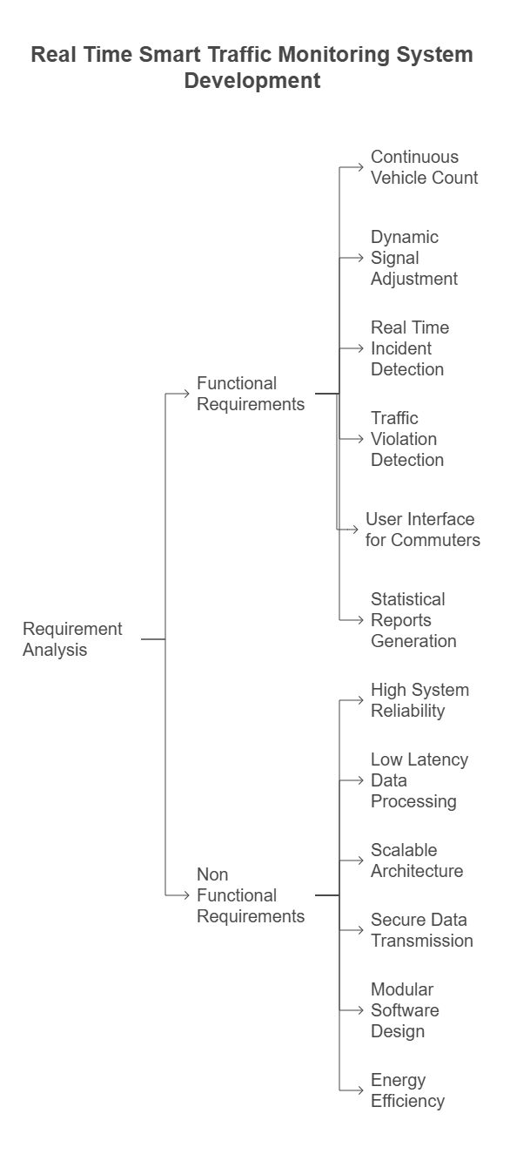
Figure 1 : Requirement Analysis
B. System Architecture
A layered architecture ensures separation of concerns and independent operation of sensing, processing, control, and user interface subsystems.

- Hardware (Sensing) Layer:
– High-resolution IP cameras for computer vision.
– Radar and ultrasonic sensors for speed and distance measurements.
– Inductive loop detectors or magnetometers for vehicle count.
– Environmental sensors (temperature, humidity) to factor weather into signal timing.
- Communication Layer:
– Edge gateway devices (e.g., Raspberry Pi/Jetson Nano) aggregating sensor data.
– Local network via Ethernet/Wi-Fi/Lora WAN for remote sites.
– MQTT or HTTP(S) to relay data to central cloud servers.
- Processing (Control) Layer:
– Real-time data analytics engine running on edge or cloud (TensorFlow, OpenCV).
– Machine learning models for congestion prediction and incident classification.
– Traffic signal optimization algorithms (e.g., adaptive Green Wave control).
- User Interface Layer:
– Web dashboard for traffic authorities (live feed, alerts, historical analytics).
– Mobile app for commuters (push notifications, dynamic route guidance).
– RESTful APIs for third-party integration (navigation apps, emergency services).
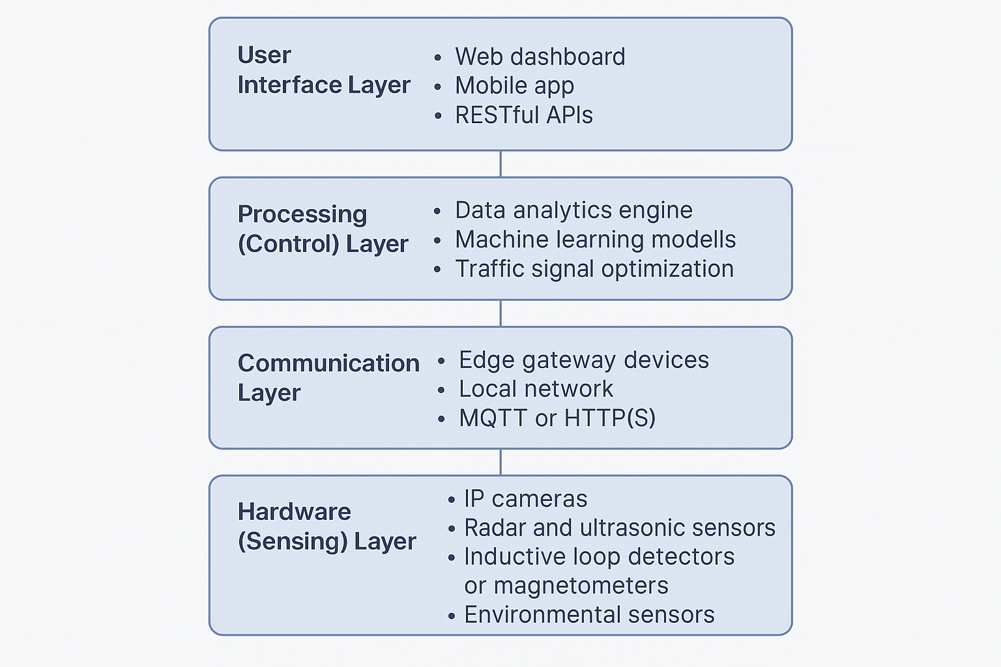
Figure 2 : System Architecture
C. Module Implementation
Each major function is encapsulated in its own software module to facilitate maintainability and independent testing:

1. Sensor Manager Module
– Captures and synchronizes video frames, radar returns, and loop-detector pulses.
– Implements calibration routines and time-stamp alignment.

2. Data Analytics Module
– Runs object detection and tracking (vehicles, pedestrians) via OpenCV/TensorFlow.
– Estimates speed, queue length, and congestion indices.

3. Signal Controller Module
– Applies adaptive timing algorithms to compute optimal green/red intervals.
– Publishes control commands to traffic light controllers via UART or PLC.

4. Incident & Violation Detection Module
– Detects accidents (sudden stops) and violations (red-light, speeding) in real time.
– Generates alerts and video snippets for evidence.

5. Notification & Alert Module
– Sends automated SMS/Email/Push notifications to authorities and users.
– Integrates with emergency response APIs for rapid dispatch.

6. Data Logger & Reporting Module
– Persists raw sensor data and analytics results in cloud database.
– Generates periodic reports and dashboard visualizations.
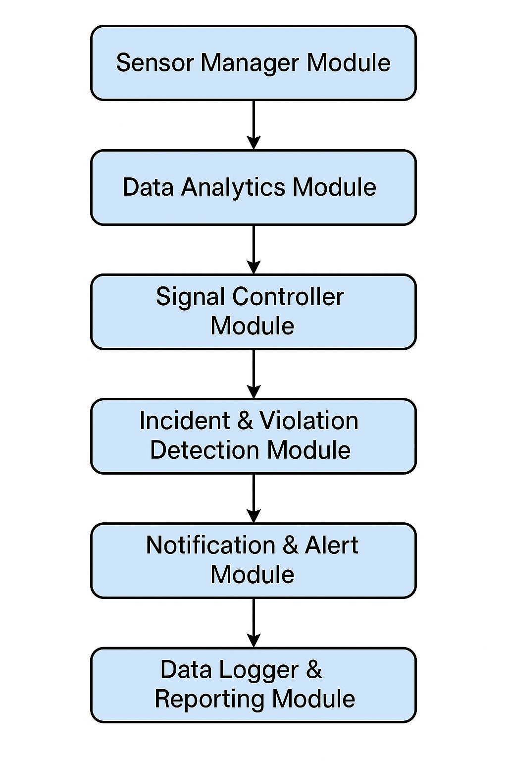
Figure 3 : Module Implementation
D. Development Methodology
An Agile approach with two-week sprints ensures continuous delivery, stakeholder feedback, and incremental improvements.

1. Sprint 1 – Requirements & Architecture Design
2. Sprint 2 – Hardware Procurement & Edge Gateway Setup
3. Sprint 3 – Sensor Integration & Basic Data Acquisition
4. Sprint 4 – Computer Vision & ML Model Development
5. Sprint 5 – Adaptive Signal Control Algorithm Implementation
6. Sprint 6 – Communication Middleware & Cloud Integration
7. Sprint 7 – UI/UX Development (Web Dashboard & Mobile App)
8. Sprint 8 – Field Deployment Pilot & Calibration at Test Intersection
9. Sprint 9 – Performance Testing, Security Audit & Optimization
10. Sprint 10 – Final Documentation, Demo & Handover

E. Tools and Technologies Used
- Hardware: Raspberry Pi 4/Jetson Nano, IP cameras, radar modules, inductive loops, solar panels (optional), traffic signal controllers.
- Software: Python 3.x, OpenCV, TensorFlow/Kera’s, Node.js/Express, React Native/Flutter for mobile.
- Communication: MQTT, HTTP(S), WebSocket’s, Lora WAN.
- Cloud & DevOps: AWS/GCP/Azure services (EC2, IoT Core, Lambda), Docker, Kubernetes.
- Databases: Influx DB (time series), PostgreSQL, Elasticsearch (for logs).
- Version Control & CI/CD: Git, GitHub Actions, Jenkins.
- Testing & Debugging: Postman, JMeter, multimeter for hardware checks, network analysers.

- MODELING AND ANALYSIS
This chapter presents detailed design models and analysis of the Real-Time Smart Traffic Monitoring System. It covers various structural and behavioural models including Entity Relationship Diagram (ERD), Use Case Diagram, System Architecture, Class Diagram, and Data Flow Diagram (DFD). These models provide a blueprint of how the system components interact and ensure smooth functionality and scalability.

1. Entity Relationship Diagram (ERD)
The Entity Relationship Diagram (ERD) illustrates the major entities in the system and the relationships among them. It forms the data-centric view of the Real-Time Smart Traffic Monitoring System.
Entities:
- Administrator
– Manages system configuration and monitors analytics.
– Has access to modify thresholds, manage data logs, and view reports.
- Traffic Sensor Unit
– Collects data such as vehicle count, speed, and density from the road environment.
– Associated with a specific location and time stamp.
- Sensor Data
– Stores raw readings from sensor units, including traffic density, speed, and time logs.
– Used for real-time decision-making and analytics.
- Traffic Light Controller
– Operates signals based on current traffic density and timing policies.
– Responds to data from Sensor Data to optimize flow.
- Violation Detector
– Captures instances of rule violations like red-light running or overseeding.
– Logs vehicle image, time, location, and violation type.
- Display Unit
– Shows real-time traffic data and alerts at intersections.
– Communicates decisions from the controller to drivers.
- Event Log
– Stores records of key actions, such as signal changes and detected violations.
– Supports audits and long-term data analysis.
Relationships:
- Each Administrator manages multiple Traffic Light Controllers and Violation Detectors.
- A Traffic Sensor Unit generates many Sensor Data records.
- Traffic Light Controllers use Sensor Data to determine signal timings.
- Violation Detectors use inputs from Sensor Data to identify rule breaches.
- Display Units fetch data from both Sensor Data and Event Log for visualization.
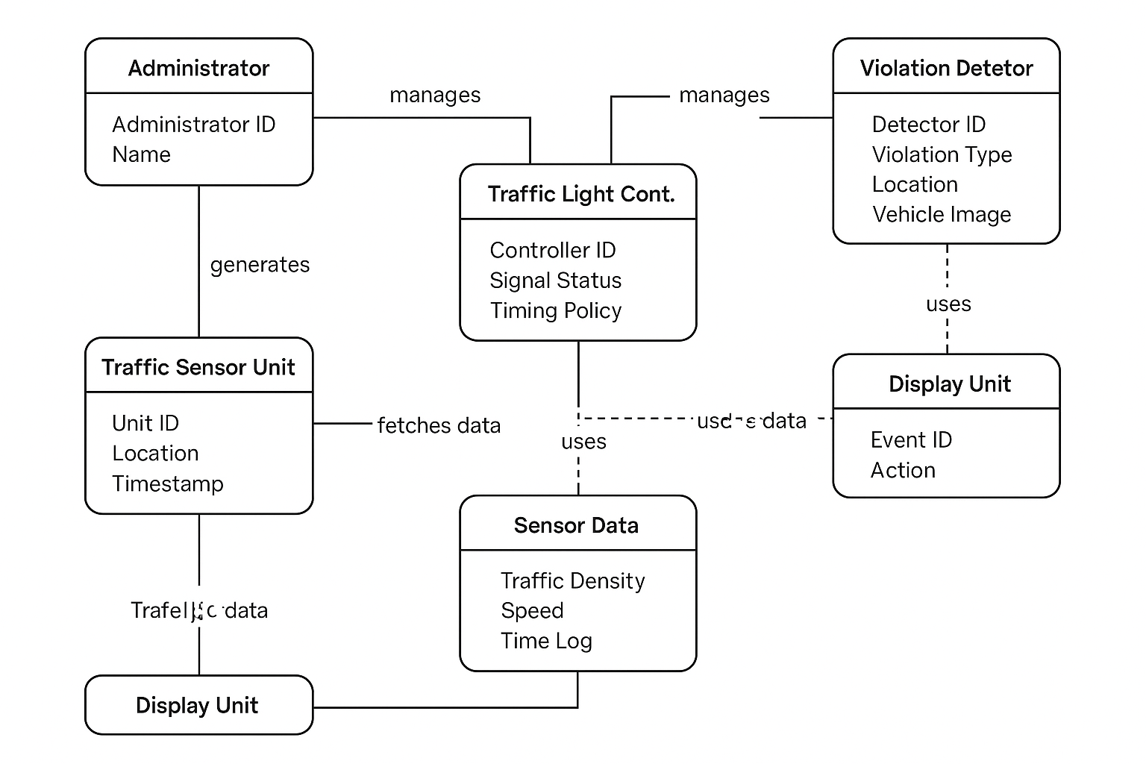
Figure 4 : Entity Relationship Diagram
2. Use Case Diagram
The Use Case Diagram defines the system's functionalities from the user's perspective, including both manual and automated interactions.
Actors:
- Administrator
– Configures system parameters and reviews performance reports.
- Automated System
– Processes real-time traffic data, adjusts signals, and detects violations.
Use Cases:
- Initialize System
– Load configuration, start sensors, and prepare logging infrastructure.
- Monitor Traffic Data
– Continuously collect vehicle speed, count, and lane density in real time.
- Control Signal Timings
– Dynamically adjust traffic lights based on congestion metrics.
- Detect Violations
– Identify overspeeding, red-light violations, or signal jumping and log incidents.
- Display Traffic Status
– Show live status at intersections and notify of any violations or congestion alerts.
- Generate Reports
– Provide analytics on traffic patterns, violations, and signal efficiency.
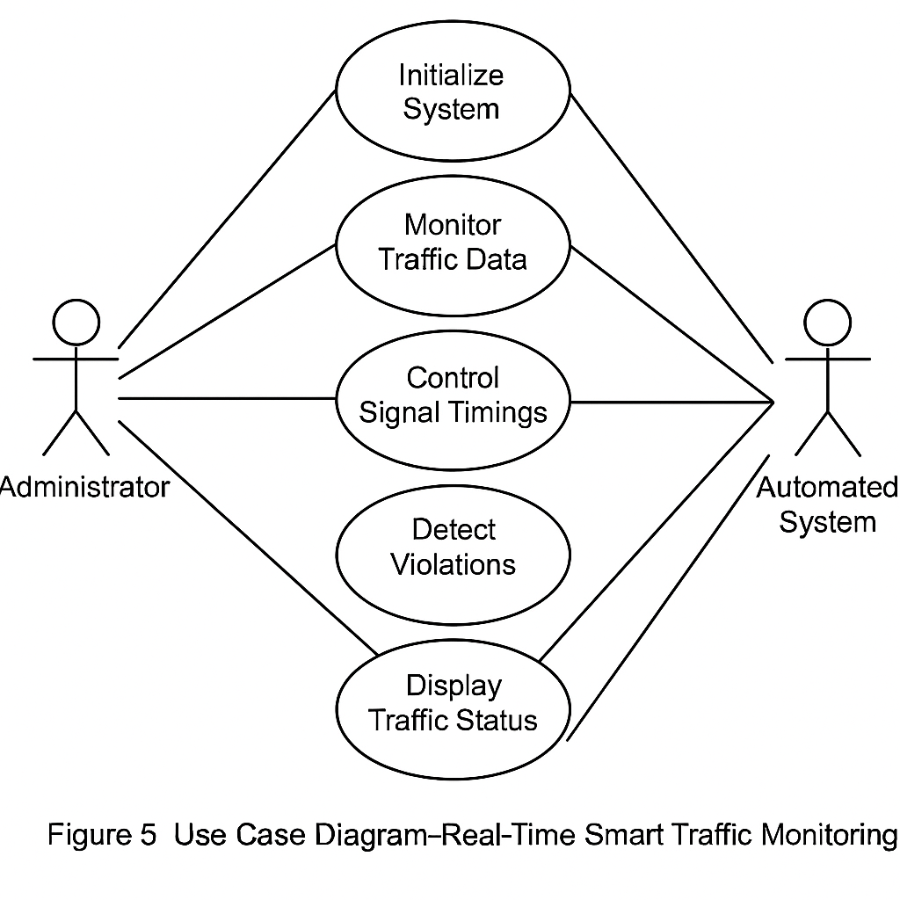
Figure 5 : Use Case Diagram
3. System Architecture
The architecture follows a layered design pattern, providing abstraction, modularity, and ease of scalability. Each layer is responsible for specific functionality within the system.
Layers:
- Hardware Layer:
– Includes sensors (IR, Ultrasonic, Camera Modules), microcontrollers (Arduino/Raspberry Pi), signal actuators, LED displays, and networking modules.
- Control Layer:
– Firmware written in Embedded C++ or Python for real-time signal control, data processing, and decision making.
- Communication Layer:
– Facilitates data exchange via wired/wireless (Wi-Fi, LoRa) networks; I²C and UART for internal sensor communication.
- User Interface Layer:
– Dashboard for administrators, signal displays for drivers, and local displays showing live traffic updates.
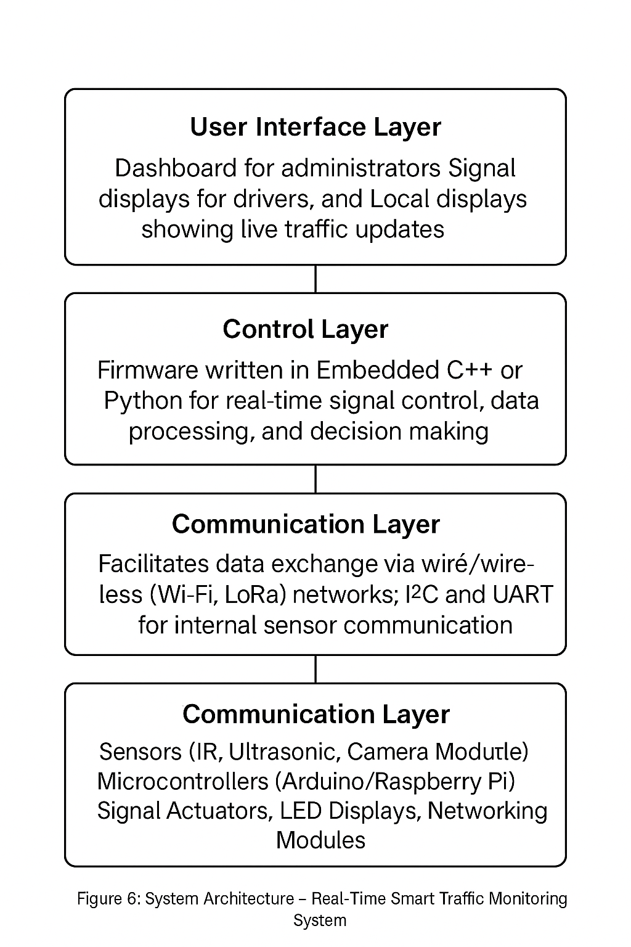
Figure 6 : System Architecture
4. Class Diagram
The Class Diagram provides an object-oriented view of the software system, defining the key classes, their attributes, methods, and relationships.
Classes:
- TrafficMonitoringSystem
– Attributes: sensorManager, signalController, violationDetector, displayUnit
– Methods: initialize (), runCycle (), generateReport ()
- SensorManager
– Attributes: sensorList, dataStore
– Methods: readData (), filterNoise (), getLatestData ()
- SignalController
– Attributes: timingPolicy, signalState
– Methods: updateSignal (), optimizeFlow ()
- ViolationDetector
– Attributes: cameraModule, ruleSet
– Methods: detectViolation (), captureEvidence ()
- DisplayUnit
– Attributes: displayType, contentQueue
– Methods: showLiveData (), updateDisplay ()
- Admin Interface
– Attributes: adminCredentials, access Logs
– Methods: login (), configureSystem (), viewReports ()
Relationships:
- TrafficMonitoringSystem aggregates all other classes.
- SensorManager collaborates with SignalController and ViolationDetector for coordinated actions.
- DisplayUnit reads from SensorManager and Event Logs for updates.
- AdminInterface interacts with all modules for system management.
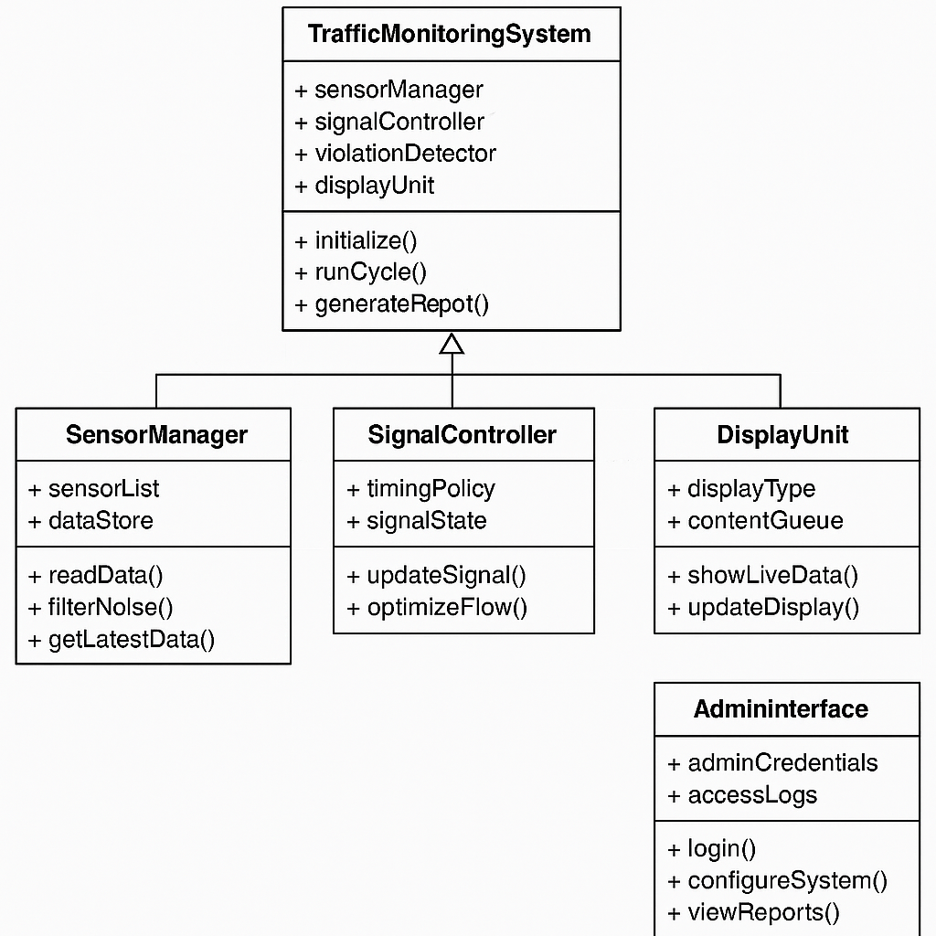
Figure 7 : Class Diagram
5. Data Flow Diagram (DFD)

- Level 0: Context Diagram
Represents the system as a single process that interacts with external entities.

- External Entities:
– User (Admin) provides inputs and reads analytics.
– Environment generates real-time traffic and vehicle conditions.

- Data Flows:
– Inputs: Sensor readings, button interactions, vehicle violations.
– Outputs: Signal commands, display data, event logs.
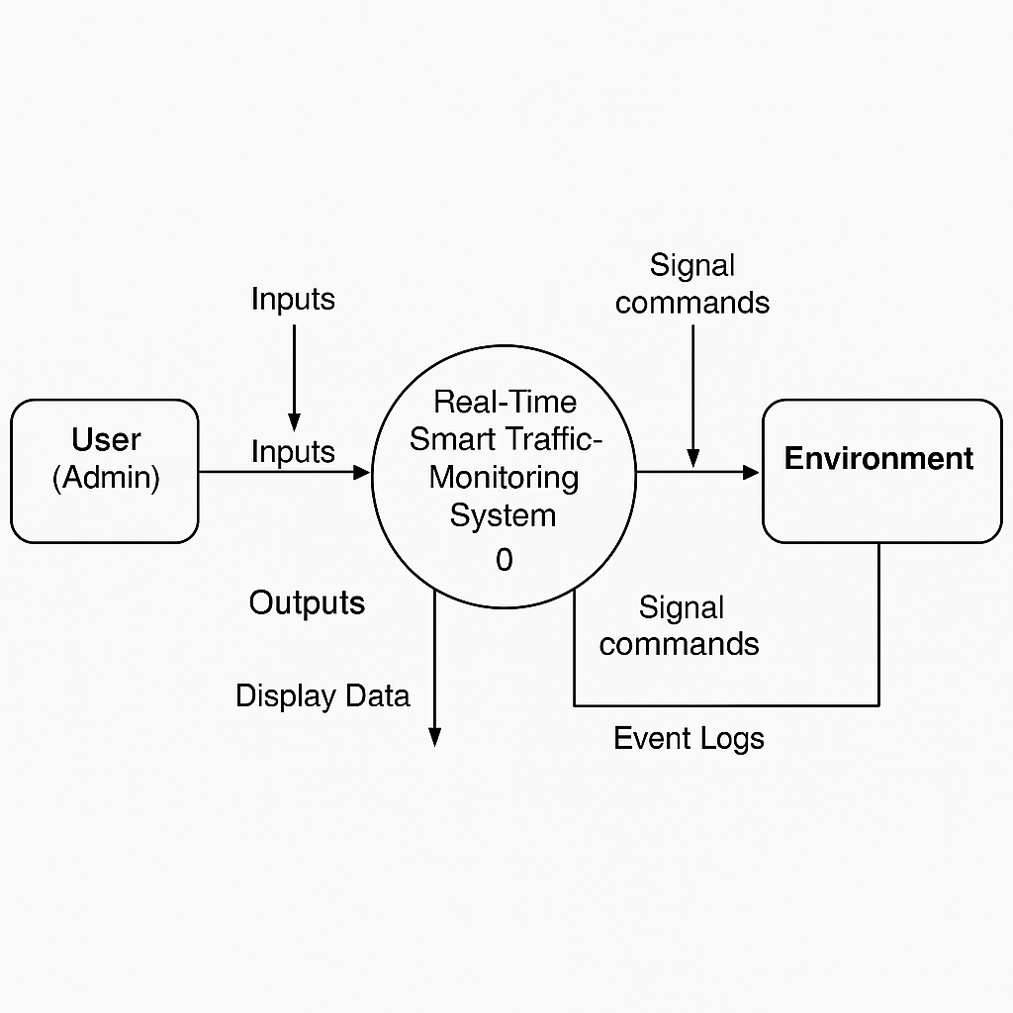
Figure 8 : Level 0: Context Diagram
- Level 1: Functional Decomposition
Breaks down the primary system process into functional modules.

- Processes:
- Collect Sensor Data
– Gathers real-time vehicle count, speed, and lane occupancy.
- Analyse Traffic Flow
– Compares against congestion thresholds and peak-hour data.
- Control Signals
– Adjusts signal timings dynamically to optimize flow.
- Detect Violations
– Identifies red-light running and speed breaches; logs incidents.
- Update Displays
– Communicates signal state, wait times, and alerts to drivers.
- Log Events
– Maintains a history of signal changes, traffic data, and violations.
- Data Stores:
- SensorDataStore (temporary buffer for real-time readings)
- EventLogStore (EEPROM or file system for logs)
- ConfigSettingsStore (holds administrator settings and rules)
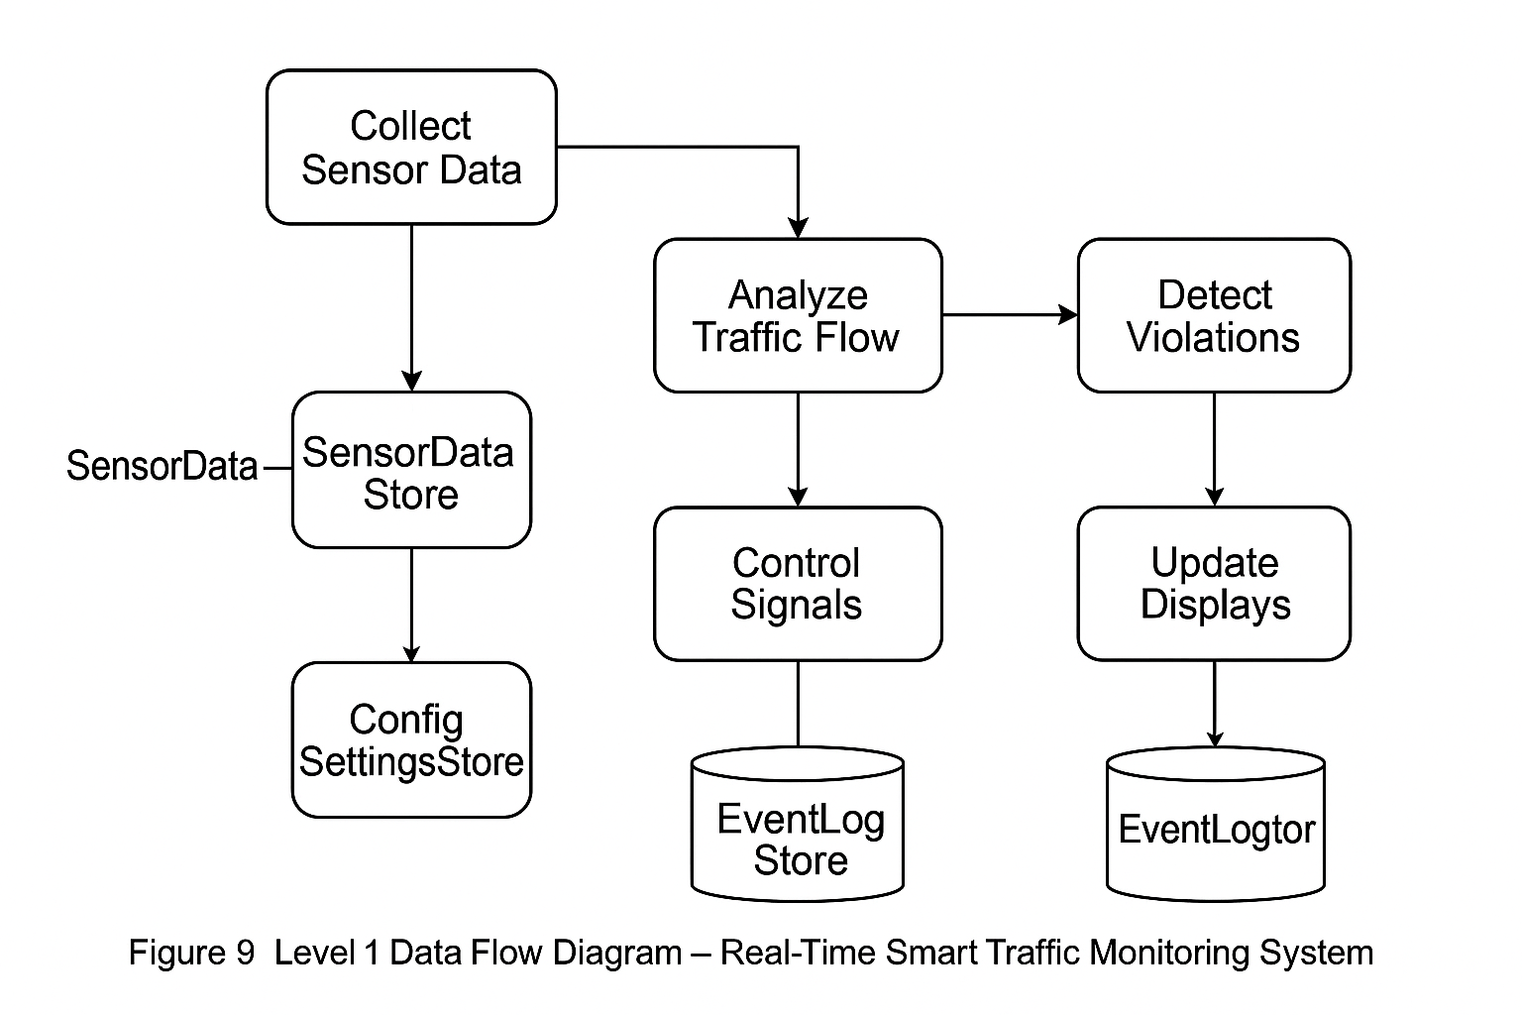
Figure 9 : Level 1 Data Flow Diagram
- Results and Discussion
This chapter evaluates the outcomes achieved through the implementation of the Real-Time Smart Traffic Monitoring System and discusses their implications in terms of user trust, operational efficiency, and intelligent automation. The system’s performance is analysed from two key perspectives: transparency with end users and efficient resource management through smart technological engagement.

1. Enhanced Transparency and User Trust
- The Real-Time Smart Traffic Monitoring System fosters transparency by continuously collecting and displaying live traffic data, such as vehicle count, speed, and density at various intersections. This data is made available on digital displays installed at junctions and is also accessible via the administrative dashboard. Real-time updates help both commuters and traffic controllers stay informed of current road conditions, signal statuses, and traffic congestion levels.
- By automating traffic signal operations and integrating rule violation detection, the system ensures predictable and rule-based responses to changing traffic conditions. Users both drivers and administrators gain confidence in the system due to its consistent, data-driven behaviour. Signal changes are no longer static but are based on real-time conditions, eliminating human bias and ensuring fair flow for all directions.
- Furthermore, the violation detection module, which automatically identifies red-light breaches and overseeding vehicles, contributes to a sense of law enforcement and road discipline. By clearly displaying incident alerts and system actions, the platform improves trust in smart surveillance while maintaining transparency in decision-making.

2. Efficient Resource Management and Smart Engagement
- The system optimizes traffic flow and conserves energy by dynamically adjusting signal timings based on real-time sensor input. Instead of using fixed cycles, the system calculates vehicle density and speed data to determine optimal green light durations. This not only minimizes idle time and fuel consumption at intersections but also significantly reduces urban congestion during peak hours.
- The use of low-power microcontrollers and efficient communication protocols ensures minimal energy usage while enabling 24×7 monitoring. Event-based processing further reduces computational overhead by triggering actions only when threshold conditions are met (e.g., high congestion or violation detection).
- Smart engagement is facilitated through a user-friendly admin interface that allows traffic authorities to monitor system status, view analytics, and configure settings remotely. Alerts and live visuals from the display units provide instant feedback to drivers, reinforcing the sense of system responsiveness and participatory road safety.
- Overall, the Real-Time Smart Traffic Monitoring System exemplifies how embedded intelligence, live sensing, and adaptive control mechanisms can transform traditional traffic management into a highly efficient, automated, and user-centric operation. It represents a step forward toward smart city infrastructure that not only reacts to urban challenges but also anticipates and manages them with precision and minimal human intervention.

Implementation Photos:
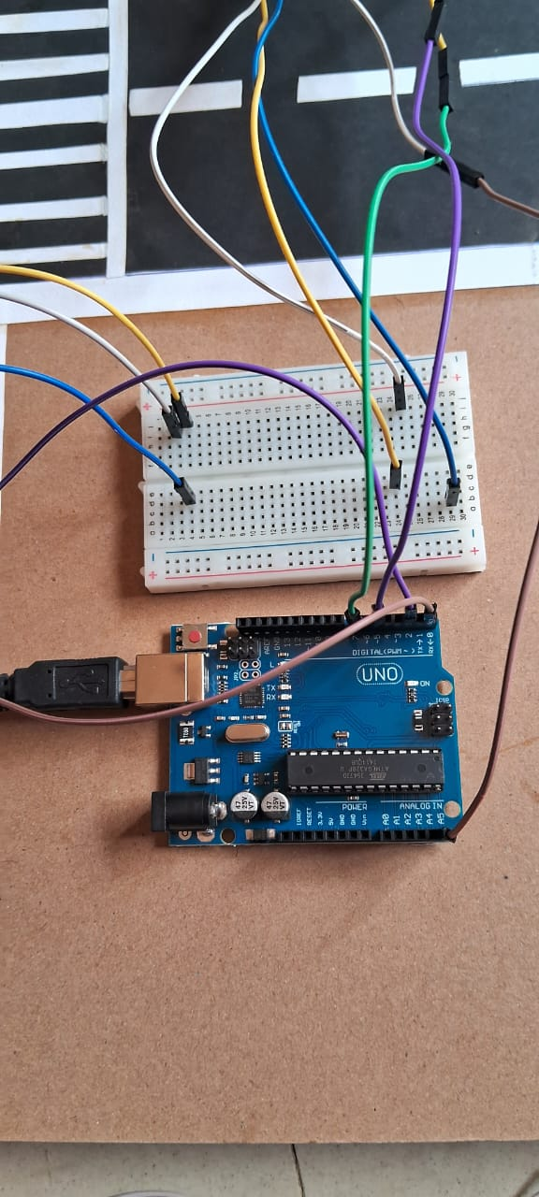
Figure 10 : hardware Chips Smart Traffic
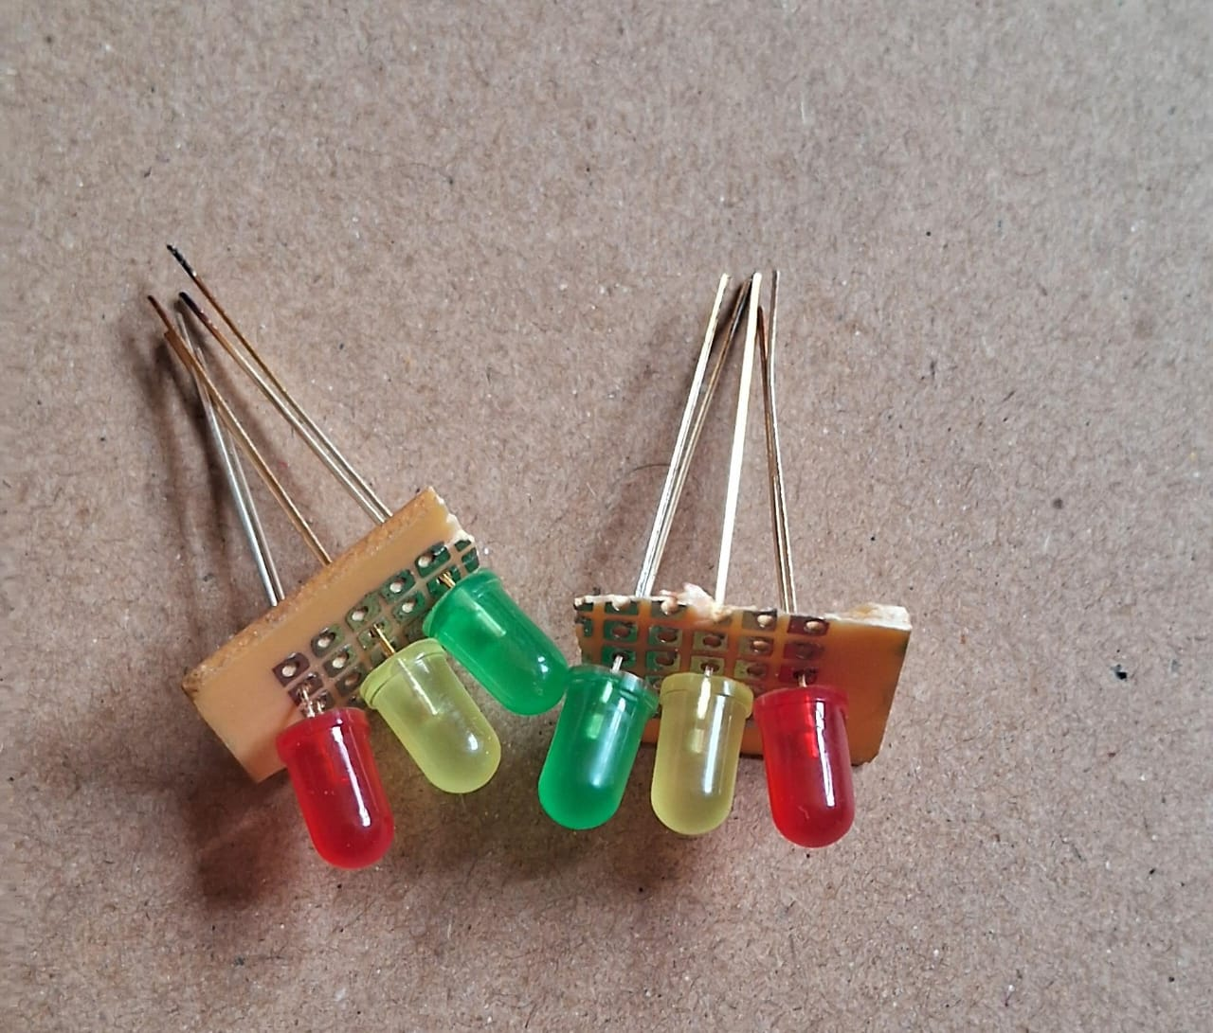
Figure 11 : Signal Light
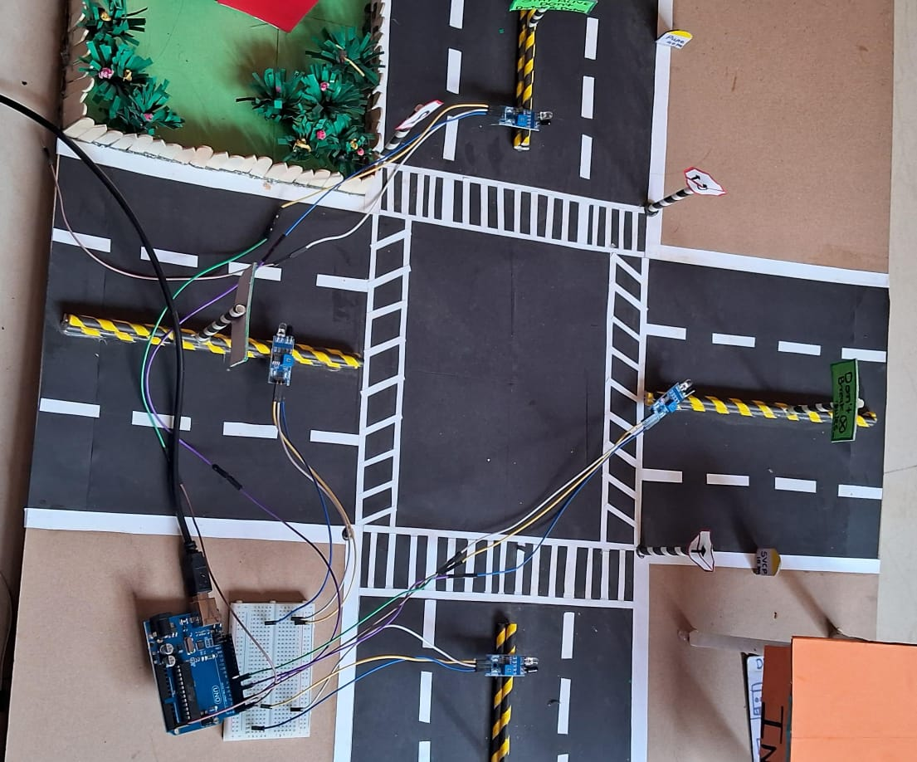
Figure 12 : Smart Traffic Signal Road
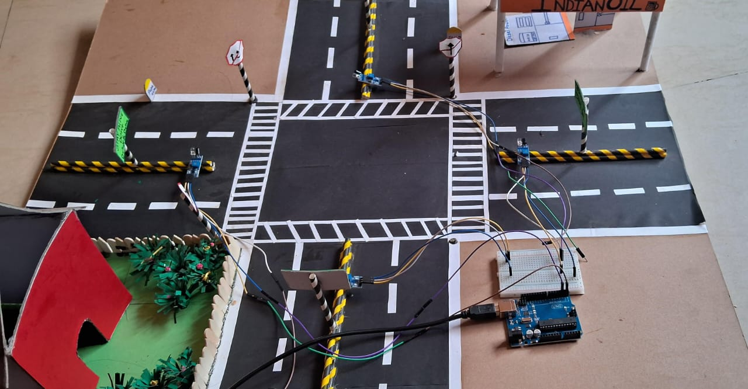
Figure 13 : Defect Traffic Using Sensor
- CONCLUSION
The The Real-Time Smart Traffic Monitoring System stands as a forward-thinking integration of automation, environmental sensing, and intelligent transportation management. By employing a combination of real-time data acquisition, sensor-driven decision-making, and embedded system control, this project effectively addresses key challenges in modern urban traffic environments. Through features such as dynamic signal adjustment based on live traffic density, automated rule violation detection, and real-time status display, the system enhances road safety, minimizes congestion, and improves overall commuting efficiency. This solution not only reduces the need for constant human intervention but also ensures optimized resource utilization, such as better energy management and reduced idle time for vehicles. Its modular and scalable design makes it suitable for a range of deployments, from small urban intersections to large-scale smart city infrastructures. Moreover, the ability to provide instant feedback to both traffic controllers and road users promotes a collaborative, transparent, and data-driven approach to urban mobility.
Beyond its immediate functional benefits, the project aligns with broader smart city and sustainability goals. It promotes fuel efficiency through reduced traffic delays, supports law enforcement via automated monitoring, and empowers municipalities with actionable traffic insights. The system also highlights how embedded technologies can revolutionize everyday civic operations, paving the way for future advancements such as AI-based traffic predictions, integration with emergency response systems, and remote cloud-based traffic coordination. In essence, the Real-Time Smart Traffic Monitoring System contributes meaningfully to the vision of intelligent, eco-friendly, and self-regulating urban environments. It serves as a foundational step toward achieving smarter transportation networks that prioritize safety, efficiency, and sustainability marking a significant milestone in the evolution of modern traffic management technologies.

- REFERENCES
[1] Verma, S., & Kapoor, R. (2021). IoT-Based Real-Time Traffic Management Using Smart Sensors. International Journal of Intelligent Transportation Systems, 10(2), 45–53.
[2] Mehta, P., & Shah, D. (2020). Design and Implementation of Smart Traffic Control System Using Embedded Technology. Journal of Embedded Systems and Applications, 7(1), 12–20.
[3] Khan, A., & Ali, R. (2019). A Survey on Smart City Traffic Monitoring Systems Using IoT and Machine Learning. IEEE Access, 8, 67523–67545.
[4] Reddy, M., & Iyer, S. (2022). Sensor-Based Adaptive Traffic Signal System for Urban Congestion Control. International Journal of Urban Transport Engineering, 6(3), 59–70.
[5] Banerjee, T., & Gupta, L. (2021). Real-Time Violation Detection in Smart Traffic Surveillance. Proceedings of the International Conference on Smart Infrastructure Systems, pp. 101–108.
[6] Sharma, N., & Patel, V. (2020). Development of Embedded System for Traffic Density Monitoring and Management. Journal of IoT and Intelligent Mobility, 5(4), 39–47.
[7] Al-Fuqaha, A., et al. (2015). Internet of Things: A Survey on Enabling Technologies, Protocols, and Applications. IEEE Communications Surveys & Tutorials, 17(4), 2347–2376.
[8] Das, M., & Sengupta, S. (2018). Smart Traffic Automation and Real-Time Monitoring with Embedded Microcontrollers. GreenTech Research Journal, 4(2), 83–89.
[9] Jain, R., & Bhatia, P. (2022). Design of Energy-Efficient and Scalable Traffic Light Control Systems. International Journal of Embedded Innovations, 9(1), 25–34.
[10] Choudhury, A. (2021). Implementation of Real-Time Traffic Signal Controller Based on Sensor Feedback and Microcontrollers. MTech Thesis, Department of Electronics and Communication Engineering, IIT Delhi.

