SWIFTHIRE

CONNECTING TALENT AND OPPORTUNITES

1. Vrushali Gangawane , Zeal Polytechnic, Pune, India.
2. Krishna Karande , Zeal Polytechnic, Pune, India.
3. Shravani Mozar , Zeal Polytechnic, Pune, India.
4. Sakshi hande , Zeal Polytechnic, Pune, India.

Guide : Prof. Vijay.B.Mohite

# Abstract

**The food service industry has seen rapid evolution with the emergence of on-demand platforms. SwiftHire is a mobile application designed to bridge the gap between professional chefs and individuals seeking personalized culinary experiences at home. This paper discusses the motivation, system architecture, user interface, functionality, and potential societal impact of SwiftHire, while also highlighting challenges faced during development and future enhancements.**

# Introduction

The rising demand for personalized dining experiences and the shift in lifestyle patterns have prompted the need for innovative solutions. SwiftHire aims to provide users with an easy-to-use platform to book certified chefs, either for events or home-cooked meals. The application also supports food delivery services managed by individual chefs or culinary partners.

# Problem Statement

While food delivery apps are common, few provide a platform specifically for hiring chefs. Consumers face challenges such as trust issues, lack of customization, and impersonal service. SwiftHire addresses these by enabling verified chefs to offer tailored experiences, bringing a human element back to food services.

# Objectives

Enable real-time booking and scheduling. Ensure safety and verification protocols. Provide an integrated chat and feedback system. Allow chefs to manage menus and orders dynamically.

# 4.Methodology

SwiftHire was developed using Flutter for cross-platform compatibility, backed by Firebase for authentication, real-time database, and storage. The team followed Agile development with iterative testing and feedback loops. UI/UX designs were created with a focus on simplicity and accessibility, using Figma and Adobe XD for wireframes and mockups.

# 5.System Architecture

**Gantt Chart**

|  |  |  |  |  |  |  |
| --- | --- | --- | --- | --- | --- | --- |
| Test Case ID | Test Case | Precondition | Steps | Expected Result | Actual Result | Status |
| TC01 | Validate Job Search Feature | User has a valid login and access to the platform. | 1. Log in to the platform.  <br> 2.  Enter keywords for hospitality job search.<br> 3.  Click on the search button | Relevant hospitality job results should appear based on the entered keywords. | Same as expected | PASS |
| TC02 | Test candidate matching algorithm | The system contains candidate profiles and job postings. | 1.Log in as a recruiter.<br> 2.Post a new job requirement.  <b> 3. Wait for the system to match candidates.<br>  4.Verify the list if matched candidates. | The system should display a list of candidates whose profiles match the job requirements, ranked by relevance. | Same as expected | PASS |
| TC03 | Check skill assessm ent tool | User has a valid login and access to the skill assessment tool. | 1.Log in to the platform.<br> 2.Navigates to the “skill assessment” section.<br> 3. Select a skill test and complete it. | The test should be completed without errors, and the user should receive instant result with performance feedback. | Same as expected | PASS |
| TC04 | Verify interview tips resources | User has access to the “Resources” section. <br>  3.Open the “Interview Tips”article. | 1.Log in to the platform. <br> 2. Navigate to the “Resources” section.<br> 3. Open the “Interview Tips” article. | The interview tips article should load correctly, with actionable and well- structured content to assist the user in interview preparation. | Same as expected | PASS |

**Test case for login process**

|  |  |  |  |  |  |  |
| --- | --- | --- | --- | --- | --- | --- |
| Test Case ID | Test Case | Precondition | Steps | Expected Result | Actual Result | Status |
| TC001 | Validate Login Feature | User has a valid username and password. | 1. Open the login page.<br> 2. Enter valid credentials.<br> 3. Click on “Login”. | User should be redirected to their dashboard without errors. | Same as expected | PASS |
| TC002 | Verify Login error message | User has invalid credentials. | 1. Open the login page.<br> 2. Enter incorrect credentials.   <br> 3. Click on “Login”. | System should display an error messages: “Invalid username or password” | Same as expected | PASS |
| TC003 | Check Blank Login Fields | Login page is accessible. | 1.Open the login page.<br> 2. Leave both fields blank. <br> 3. Click on “login”. | System should prompt the user to fill in the required fields. | Same as expected | PASS |

**Architecture Diagram: User Interface**

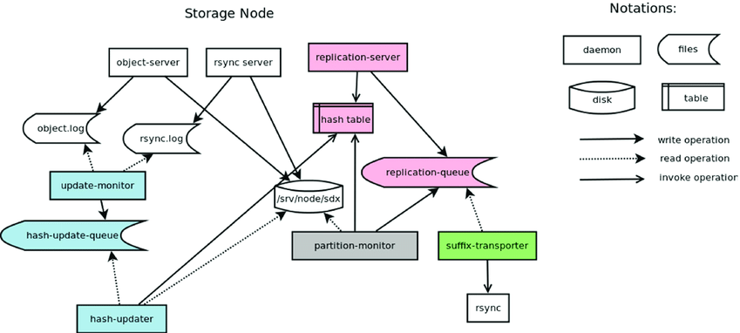

Figure 1. User Interface

**ER Diagran**

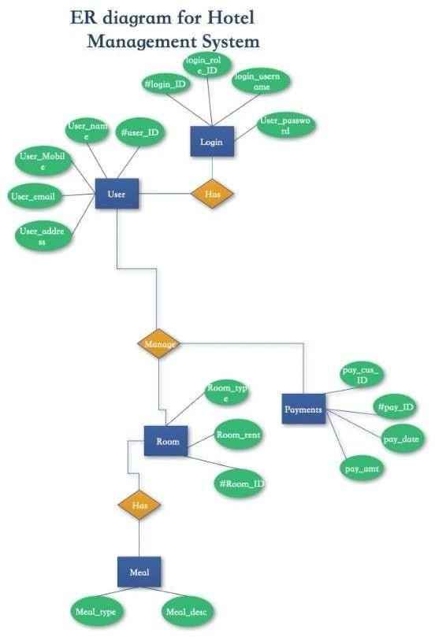Figure 2. ER Diagram

**Use case diagram**

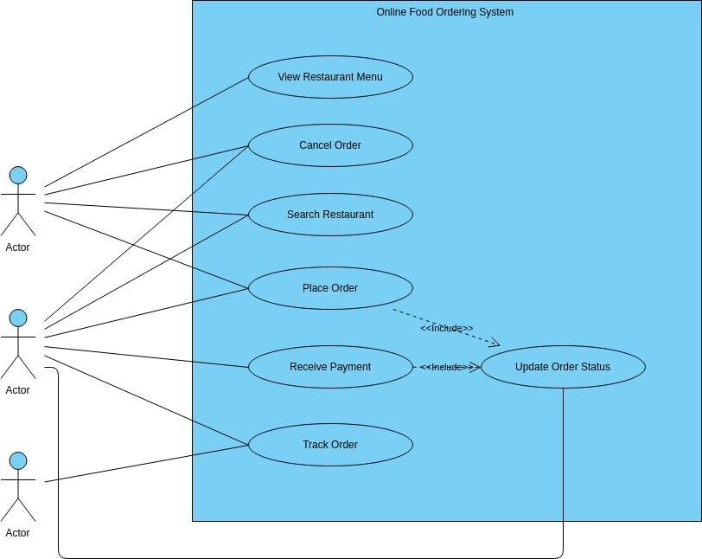

The DFD outlines the Job Seeker Registration and interaction process on the platform. It starts with the Job Seeker providing personal information to complete the registration, followed by Role-Based Authentication to verify their identity and allow access to the system. Once authenticated, the job seeker can log in and utilize the platform's features.

One key feature is the ability to Upload Resumes,1 where job seekers can add and store their resumes,

Fig: 3 Use Case Diagram

**Activity diagram**

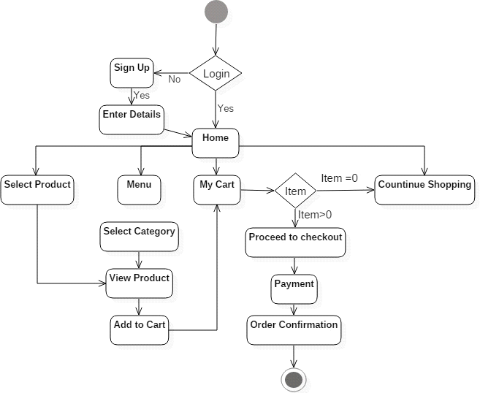

Fig: 4 Use Case Diagram

**Sequence Diagram**

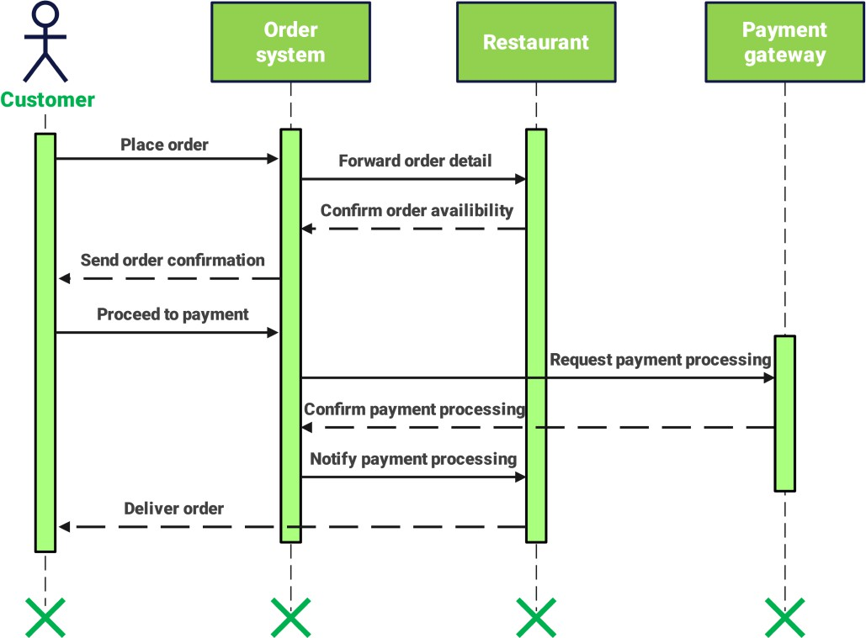

Fig: 5 Sequence Diagram

**RESULT**

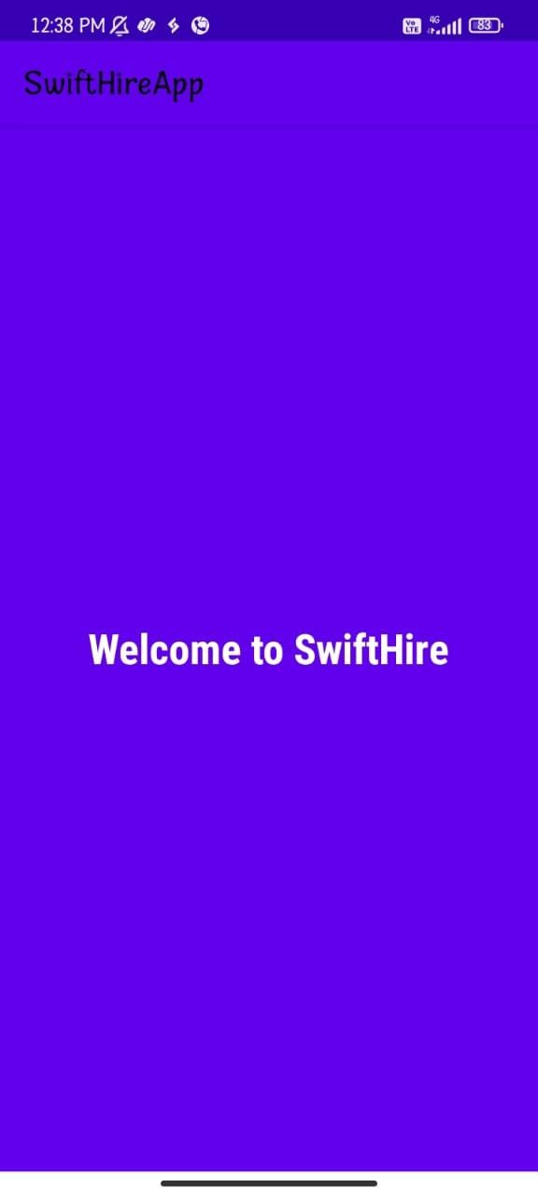

This is the welcome screen of the SwiftHire app. It shows a message "Welcome to SwiftHire" to the user. From here, the user can move to the login screen to access the app.

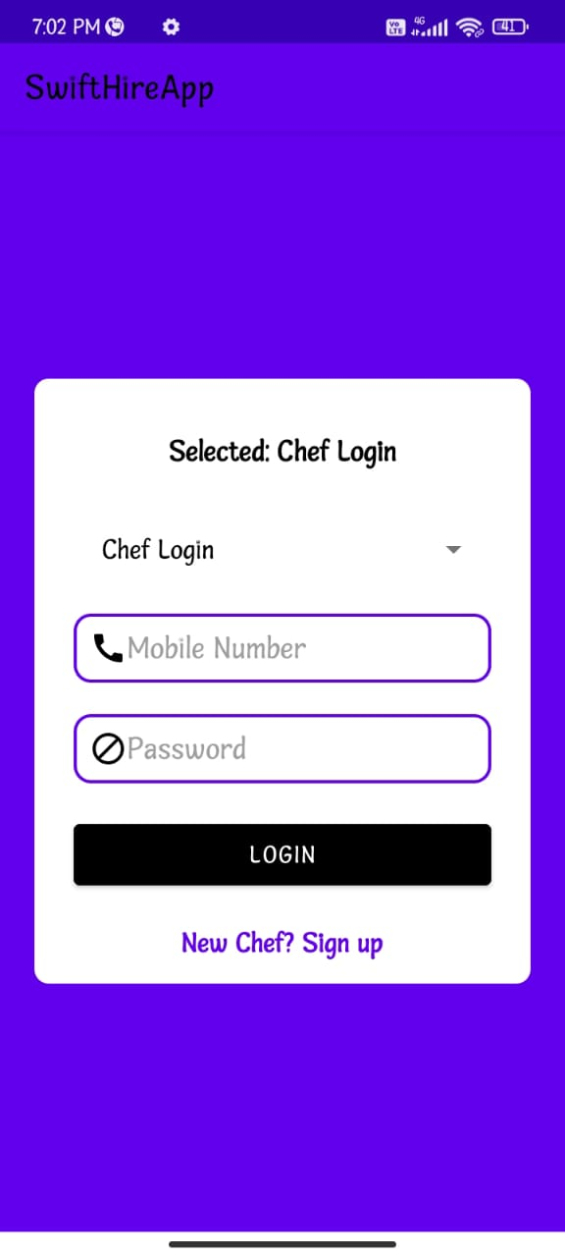

This is the Chef Login screen of the SwiftHire app.It allows chefs to log in using their mobile number and password. There is also an option for new chefs to sign up and create an account

# 

This is the Chef Registration screen of the SwiftHire app. It allows chefs to enter their personal details like name, email, phone number, address, and food specialty (Veg/Non-Veg) to register on the platform.

# 

This is the Chef Profile screen in the SwiftHire app.

It displays the chef's personal information and provides two main options: to view order history or to log out from the app.

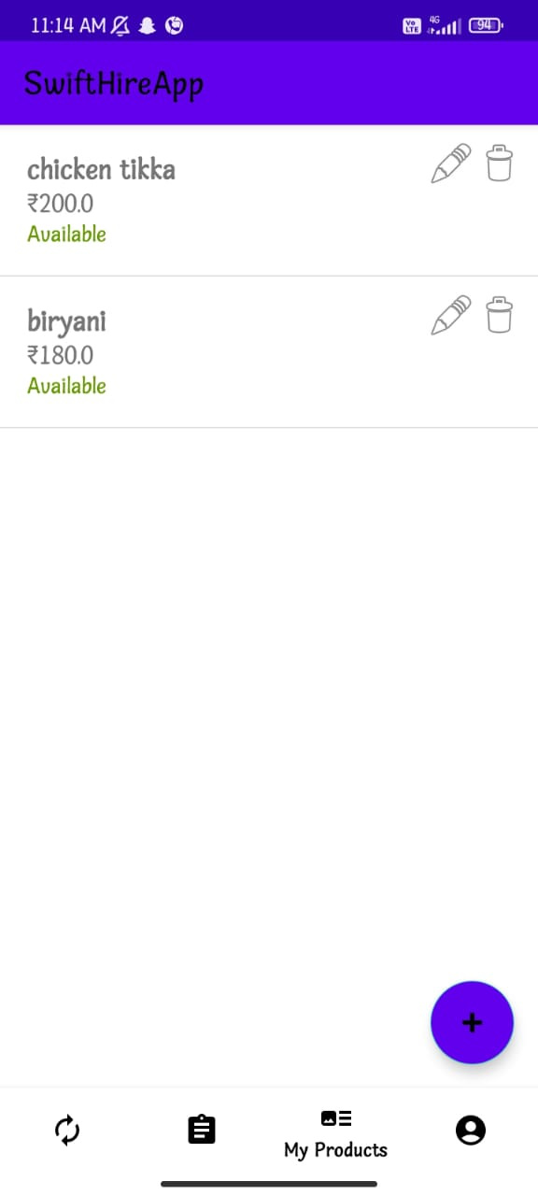

This screen shows the product management interface of the SwiftHireApp. It lists food items (chicken tikka and biryani) along with their prices and availability status. Each item includes options to edit or delete. At the bottom, a navigation bar highlights “My Products,” with a floating "+" button to add new items.

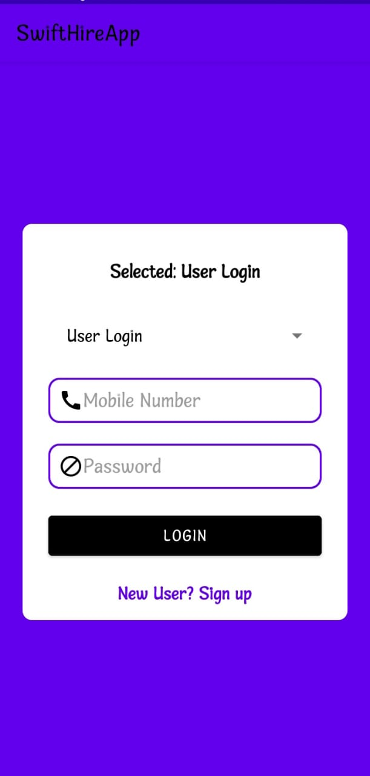

This screen displays the user login interface of the SwiftHireApp. It includes fields for mobile number and password, a login button, and a link for new users to sign up. The design features a clean layout with a focus on user authentication

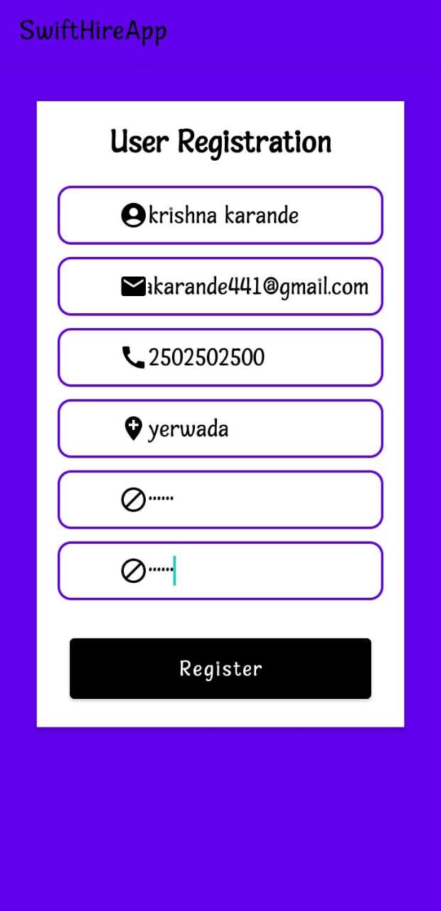

This screen illustrates the user registration form in the SwiftHireApp. It includes fields for entering the user's name, email, mobile number, address, and password. The interface is designed to capture essential details for account creation, with a prominent Register button at the bottom.

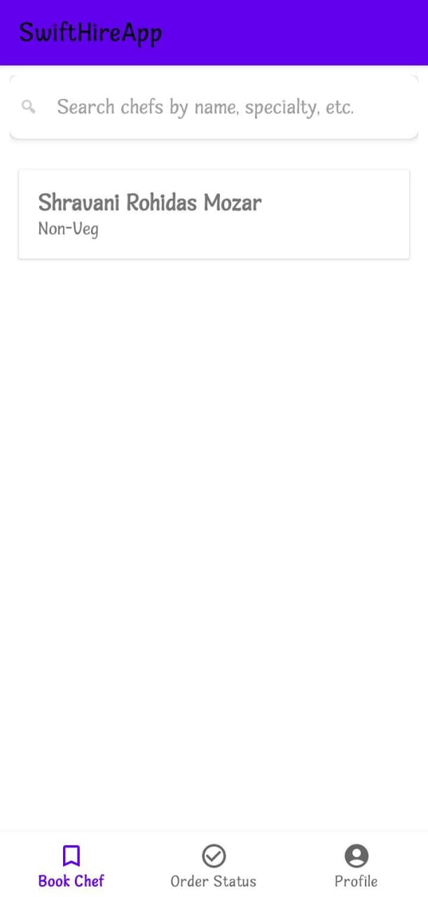

This screen shows the chef search feature in the SwiftHireApp. Users can search for chefs by name, specialty, etc. A result is displayed for "Shravani Rohidas Mozar" with a tag indicating "Non-Veg". The bottom navigation includes options for booking a chef, order status, and user profile.

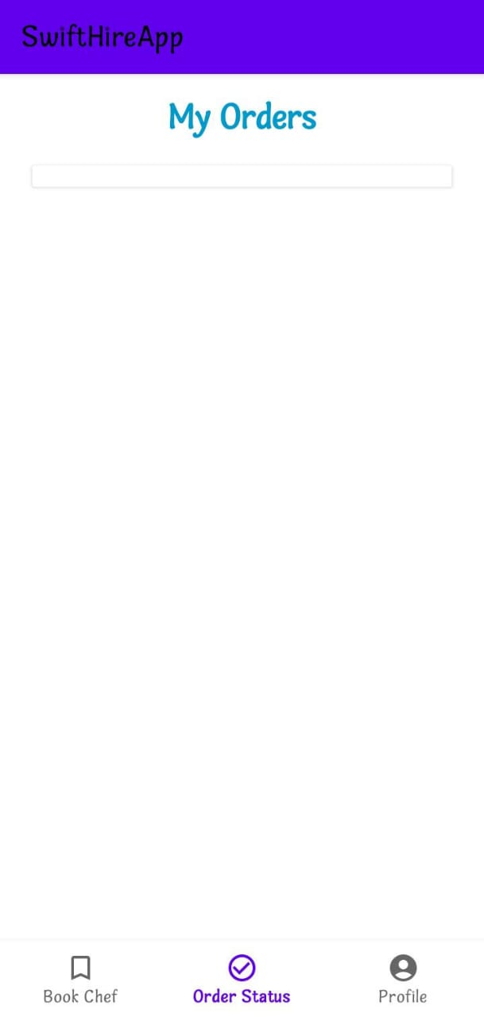

### This screen displays the "My Orders" section of the SwiftHireApp, where users can view the status of their bookings or food orders. The navigation bar at the bottom provides access to "Book Chef", "Order Status", and "Profile" sections.

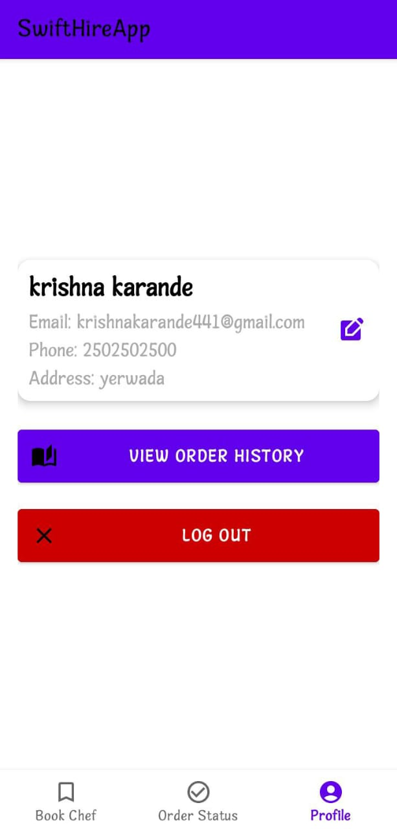

This screen displays the user profile in the SwiftHireApp. It shows personal details such as name, email, phone number, and address. Users can edit their information, view order history, or log out. The bottom navigation bar allows easy access to other features like "Book Chef" and "Order Status".

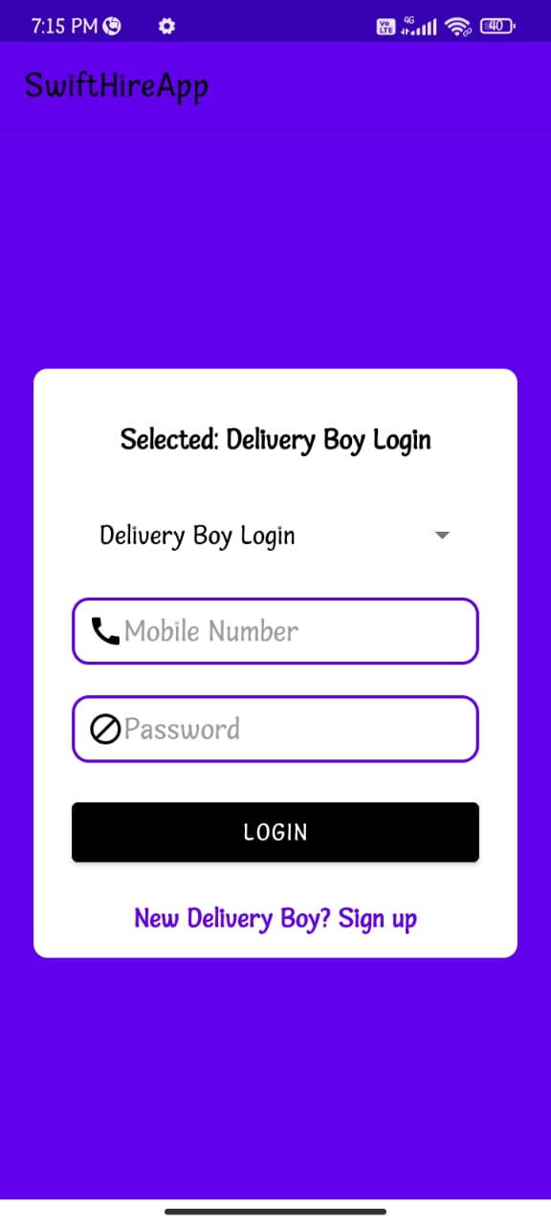

### This screen allows delivery personnel to log in using their registered mobile number and password. It features input fields for credentials, a login button, and a link for new delivery personnel to sign up. The user interface is simple and intuitive, designed for quick access.

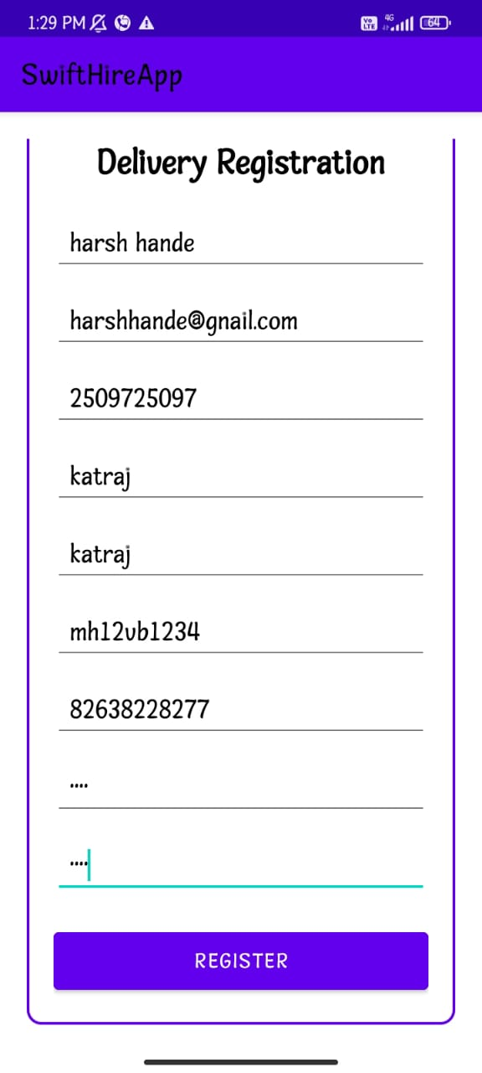

This screen allows new delivery personnel to register by providing their name, email, phone number, area, vehicle number, and Aadhar number. It features a clean form layout with a "REGISTER" button for easy submission. The interface supports quick onboarding of delivery agents.

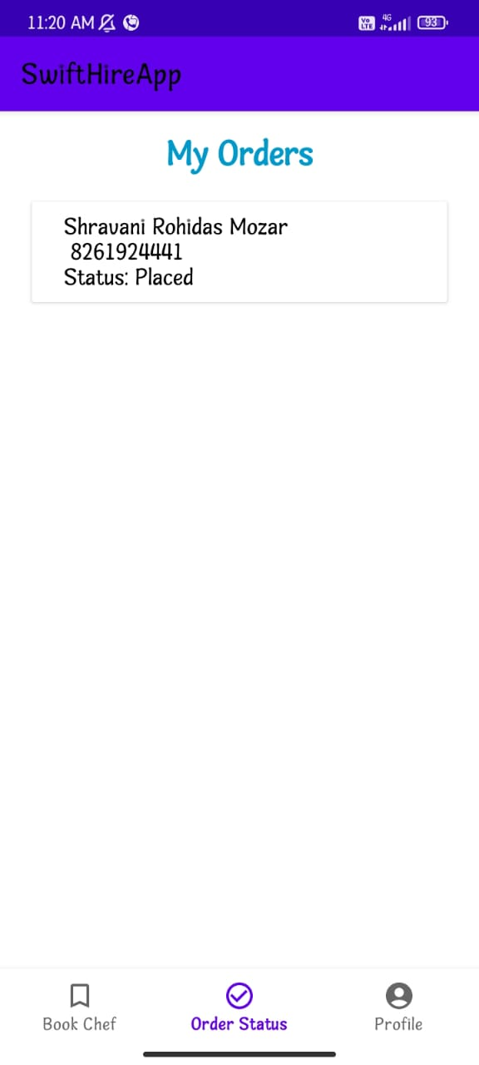

This screen displays the user's order details, including the customer's name (Shravani Rohidas Mozar), contact number, and current order status ("Placed"). It provides a clear summary under the "Order Status" tab with a simple and user-friendly interface.

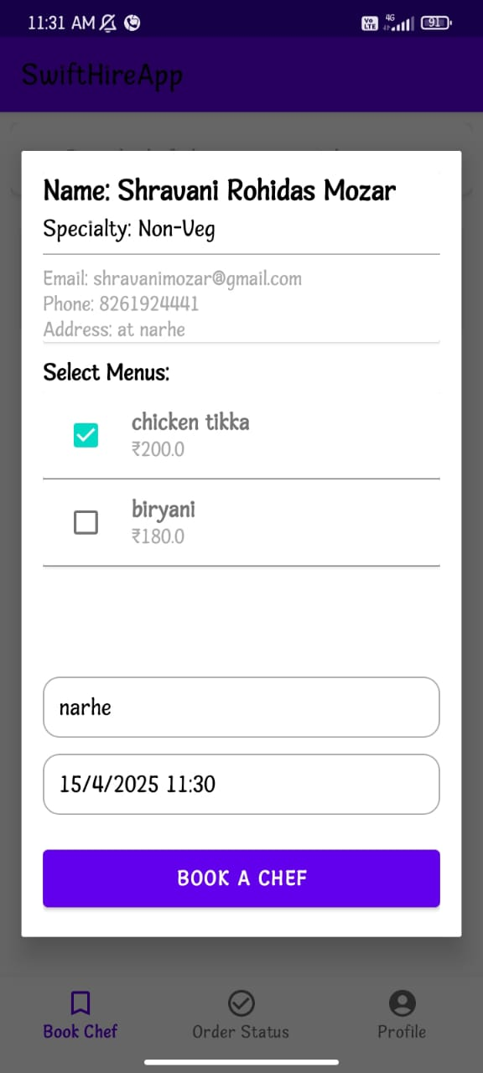

This screen allows users to book a chef by selecting a dish from the menu (e.g., Chicken Tikka or Biryani), entering the address, and choosing a date and time. It displays the chef's name, contact details, and specialty (Non-Veg). The "Book a Chef" button confirms the order.

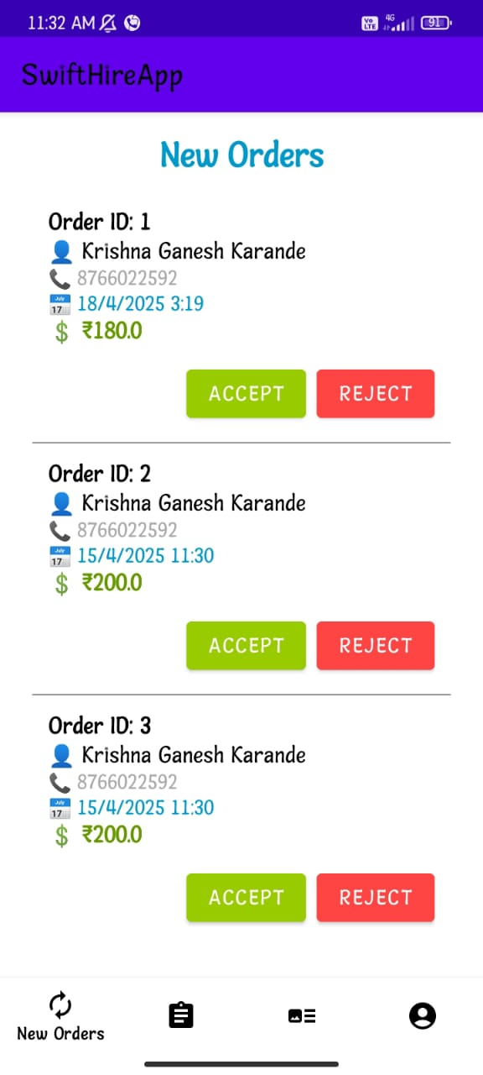

This screen displays a list of new incoming orders for the chef or delivery personnel. Each order includes the Order ID, customer's name, phone number, scheduled time, and total cost. Users can either Accept or Reject the orders using the respective buttons provided for each entry.

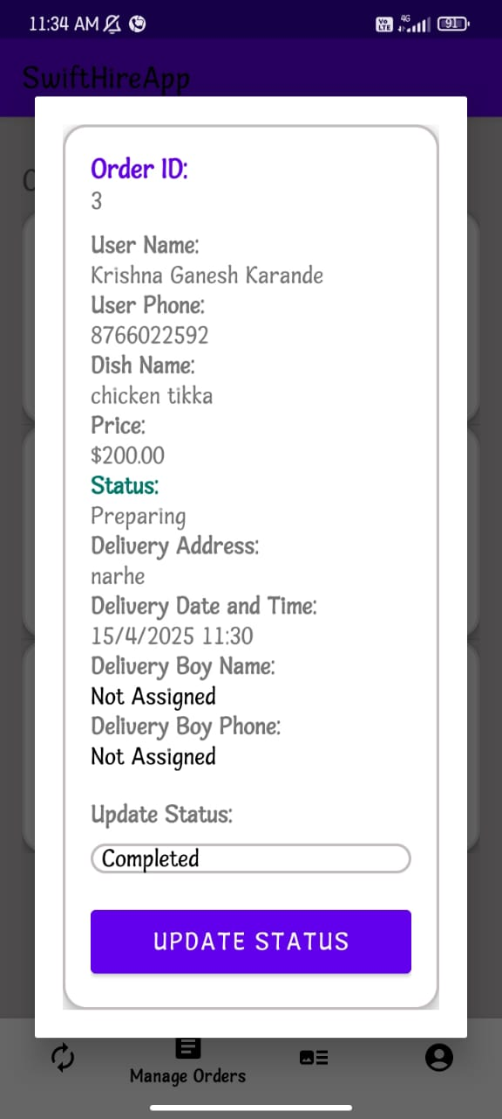

This screen provides detailed information for a specific order. It includes Order ID, user details, dish name and price, order status, delivery address, scheduled delivery time, and delivery personnel (if assigned). The status can be updated (e.g., to “Completed”) using the Update Status button.

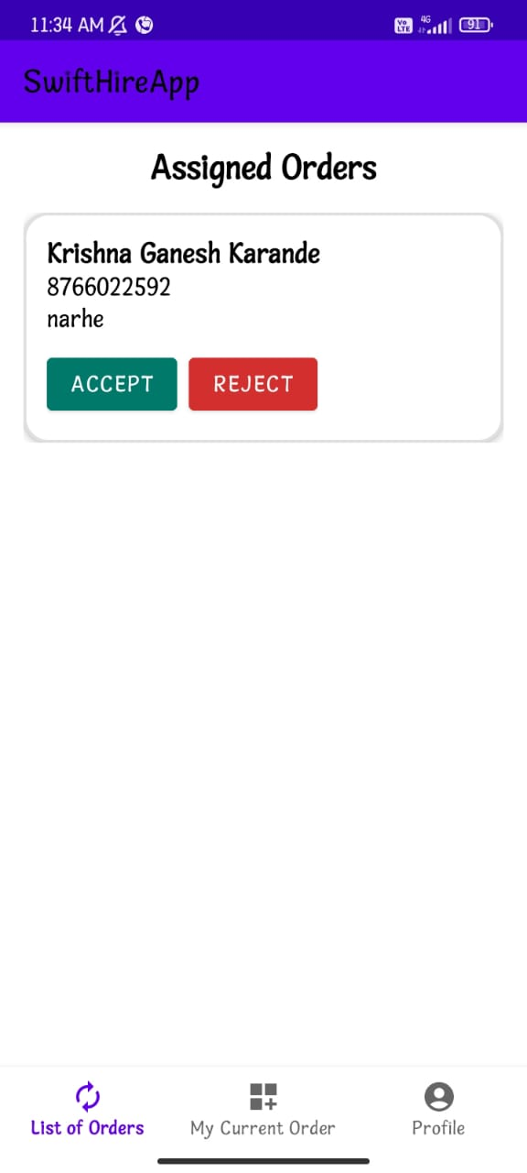

This screen shows orders that have been assigned to a delivery person. It displays the customer's name, contact number, and delivery location. Two options are provided: ACCEPT to confirm delivery or REJECT to decline the assignment.

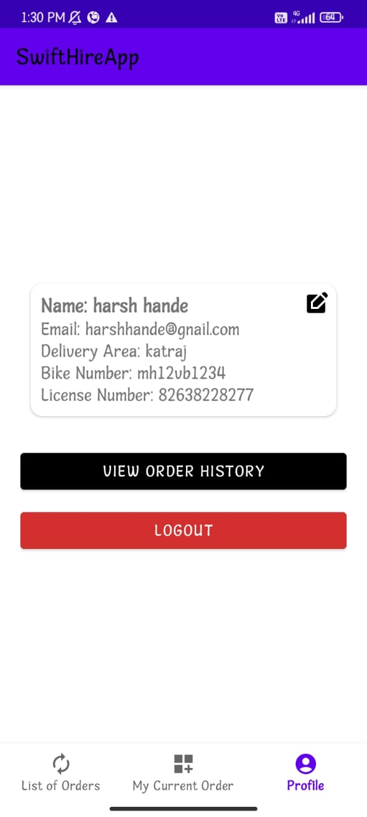

This screen displays the profile details of the delivery partner, including name, email, delivery area, bike number, and license number. Options available are to View Order History or Logout. There's also an edit icon to update profile information.

**Conclusion**

# This paper aims to enhance the functionality of SwiftHire by integrating essential features tailored to the needs of various roles within the hospitality industry. By streamlining operations, improving error handling, and supporting localization, SwiftHire positions itself as a critical tool for small and medium- sized businesses looking to boost efficiency and adaptability in a competitive landscape. SwiftHire offers a comprehensive solution that enables a more holistic management approach, supporting varied roles and enhancing the overall efficiency of hotel and hospitality operations

**Future Scope**

The future scope of SwiftHire - Streamlining Hospitality is vast and holds immense potential to revolutionize the hospitality industry. As technology advances, SwiftHire can integrate more innovative features to enhance its usability and effectiveness. For example, Artificial Intelligence and Machine Learning algorithms could be further developed to predict industry trends, allowing users to stay ahead of the curve. With these advancements, SwiftHire could not only analyze current requirements but also anticipate future demands, giving both students and businesses an edge in planning their strategies. SwiftHire can also embrace sustainability by promoting eco-friendly practices in the hospitality industry. It could highlight job opportunities in sustainable tourism and advocate for green certifications for hotels and businesses.

# Reference

1. Teoh Ern Sheng & Hazaruddin Harun Design and Development of An Inventory Management Mobile Application International Journal of Research in Engineering and Science (IJRES) Volume11 Issue 9 ǁ September 2023.
2. Hakan Koyuncu, Baki Koyuncu| Intelligent Front Desk Hotel Management, International Journal of Artificial Intelligence and Agent Technology Vol 3|issue 2|Sep. 2015.
3. Hemant Kumar, Muskan Jain, Manpreet Singh Bajwa Online Food Delivery App „Foodie‟ Journal of University of Shanghai for Science and Technology Volume 23, Issue 7, July - 2021.