Improving Evaluation Of Safety And Wear In Mechanical Component Design Using Fuzzy –Neuro Controller)

UdehUbasinachi Osmond, Okwara Maurice & Chukwuagu M. Ifeanyi

Caritas University Amorij-Nike, Emene, Enugu State Nigeria

Corresponding author E mail: ubaudeh @ gmail.com

Abstract

The evaluation of safety and wear in mechanical component design is critical to ensuring system reliability, durability, and operational efficiency. Traditional methods often face challenges in addressing nonlinearities, uncertainties, and complex interactions inherent in mechanical systems. This study explores the application of a fuzzy-neuro controller, which combines the rule-based reasoning of fuzzy logic with the adaptive learning capabilities of artificial neural networks, to improve the evaluation process. The proposed approach effectively models and analyzes wear dynamics and safety parameters, offering enhanced predictive accuracy and real-time adaptability. It handles complex variables and provides optimized design parameters that minimize wear and improve safety margins. Simulation results demonstrate the system's ability to outperform conventional methods in identifying potential risks, reducing material fatigue, and extending component lifespan. This innovative methodology paves the way for more intelligent and robust mechanical component designs, ensuring compliance with safety standards and reducing maintenance costs. The findings highlight the potential of integrating fuzzy-neuro controllers into industrial applications, marking a significant step toward the advancement of intelligent mechanical engineering systems.

Keywords; Improving, evaluation, safety, wear, mechanical, component, design, fuzzy –neuro, controller

**1. 0 Introduction**

The evaluation of safety and wear in mechanical components is a critical aspect of engineering design, as these factors significantly impact the performance, reliability, and lifespan of machinery. Conventional evaluation methods often rely on deterministic models, which may not adequately account for the uncertainties and nonlinearities inherent in mechanical systems (Yin et al., 2020). This limitation necessitates the adoption of more intelligent and adaptive approaches to ensure accurate predictions and improved design outcomes. Fuzzy logic and neural networks have emerged as powerful tools for addressing the complexities in mechanical component evaluation. Fuzzy logic is effective in managing imprecision and uncertainty by simulating human reasoning through linguistic variables (Zadeh, 1965). Meanwhile, neural networks provide robust learning capabilities, enabling systems to adapt to dynamic conditions and improve predictive accuracy over time (Haykin, 2009). By integrating these two techniques, fuzzy-neuro controllers combine the strengths of both methods, offering a hybrid solution for more effective decision-making in safety and wear evaluation. Recent studies have highlighted the potential of fuzzy-neuro systems in optimizing mechanical designs by reducing wear rates and enhancing operational safety (Jiang et al., 2021). These systems facilitate real-time monitoring and adaptive control, making them invaluable for modern engineering applications. Moreover, the ability of fuzzy-neuro controllers to learn from historical data and adapt to new conditions offers significant advantages in addressing the challenges posed by varying load conditions, material properties, and environmental factors. The importance of improving safety and wear evaluation is further underscored by the growing demand for sustainable and efficient mechanical systems. Enhanced evaluation techniques contribute to better resource utilization, reduced maintenance costs, and prolonged equipment life cycles (Kumar & Singh, 2019). Thus, the development and application of fuzzy-neuro controllers represent a significant step toward achieving these objectives, fostering innovation in mechanical component design.

1. Methodology

To characterize and establish the causes of failure in evaluation of safety and wear in mechanical component design

Table 1 characterized and established causes of failure in evaluation of safety and wear in mechanical component design

|  |  |  |
| --- | --- | --- |
| **Cause of Failure** | **Description** | **Estimated Percentage (%)** |
| **Inadequate Material Selection** | Use of materials that are not suitable for specific operational conditions, leading to premature wear. | 25% |
| **Improper Load Analysis** | Failure to accurately assess and account for the stresses and loads during operation. | 20% |
| **Environmental Factors** | Neglecting the effects of temperature, humidity, corrosion, and other environmental conditions. | 15% |
| **Design Complexity** | Overly complicated designs that are difficult to evaluate or predict wear and safety accurately. | 10% |
| **Insufficient Predictive Models** | Lack of advanced modeling techniques to anticipate wear and safety issues under dynamic conditions. | 15% |
| **Human Error** | Errors in testing, design interpretation, or maintenance processes. | 10% |
| **Inconsistent Testing Standards** | Variation in testing protocols leading to inaccurate evaluation of safety and wear. | 5% |

This distribution is approximate and may vary depending on specific industries, components, and operational conditions.

To design a conventional SIMULINK model for evaluation of safety and wear in mechanical component design



Fig 1 design a conventional SIMULINK model for evaluation of safety and wear in mechanical component design

The results obtained were as shown in figures 9 and 10

To develop a rule base that will automatically reduce the causes **of** failure in evaluation of safety and wear in mechanical component design

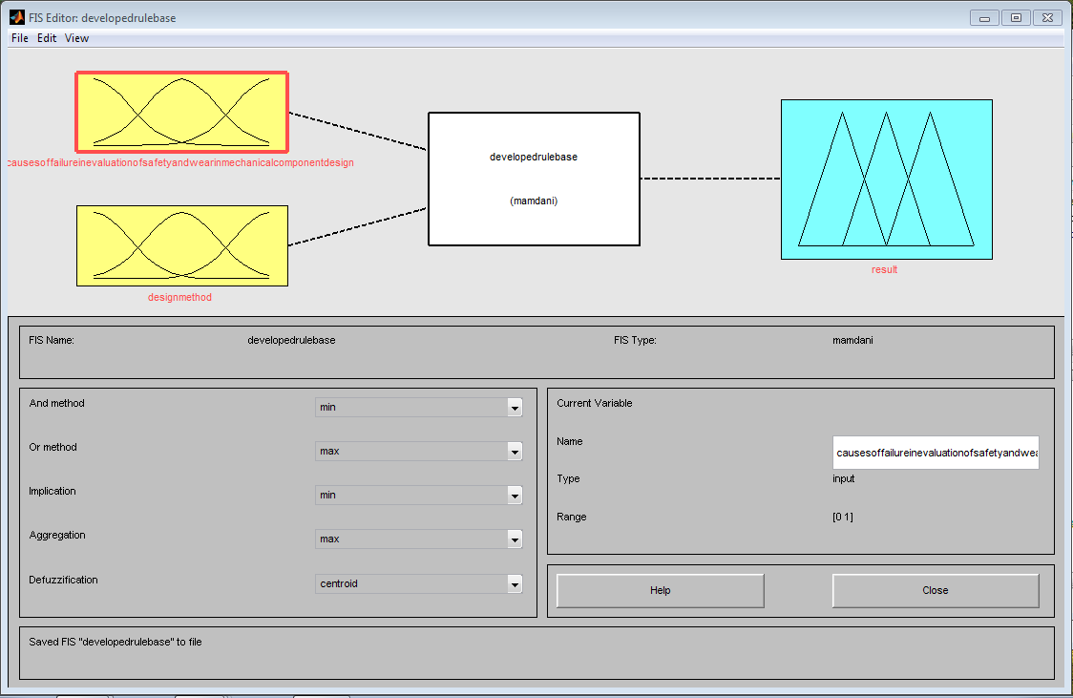

Fig 2 develop a fuzzy inference system that will automatically reduce the causes **of** failure in evaluation of safety and wear in mechanical component design

This had two inputs of causes **of** failure in evaluation of safety and wears in mechanical component design and design method. It equally had an out put of result.

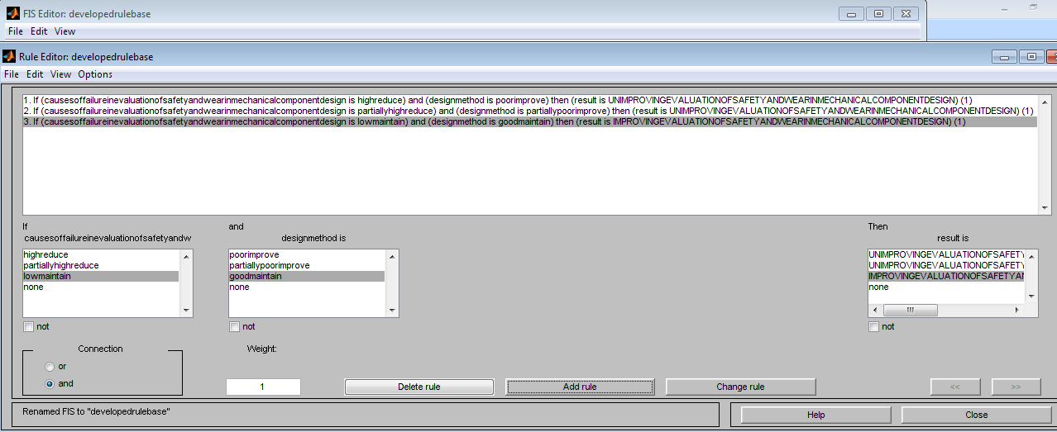

Fig 3 developed rule base that will automatically reduce the causes **of** failure in evaluation of safety and wear in mechanical component design

This was comprehensively detailed in table 2.

Table 2 comprehensive developed rule base that will automatically reduce the causes **of** failure in evaluation of safety and wear in mechanical component design

|  |  |  |
| --- | --- | --- |
| IF CAUSES **OF** FAILURE IN EVALUATION OF SAFETY AND WEAR IN MECHANICAL COMPONENT DESIGN IS HIGH REDUCE | AND DESIGN METHOD IS POOR IMPROVE | THEN RESULT IS UNIMPROVING EVALUATION OF SAFETY AND WEAR IN MECHANICAL COMPONENT DESIGN |
| IF CAUSES **OF** FAILURE IN EVALUATION OF SAFETY AND WEAR IN MECHANICAL COMPONENT DESIGN IS PARTIALLY HIGH REDUCE | AND DESIGN METHOD IS PARTIALLY POOR IMPROVE | THEN RESULT IS UNIMPROVING EVALUATION OF SAFETY AND WEAR IN MECHANICAL COMPONENT DESIGN |
| IF CAUSES **OF** FAILURE IN EVALUATION OF SAFETY AND WEAR IN MECHANICAL COMPONENT DESIGN IS LOW MAINTAIN | AND DESIGN METHOD IS GOOD MAINTAIN | THEN RESULT IS IMPROVING EVALUATION OF SAFETY AND WEAR IN MECHANICAL COMPONENT DESIGN |



Fig 4 the operational mechanism of the rules

**To train ANN in those rules for effective reduction of the causes of** failure in evaluation of safety and wear in mechanical component design

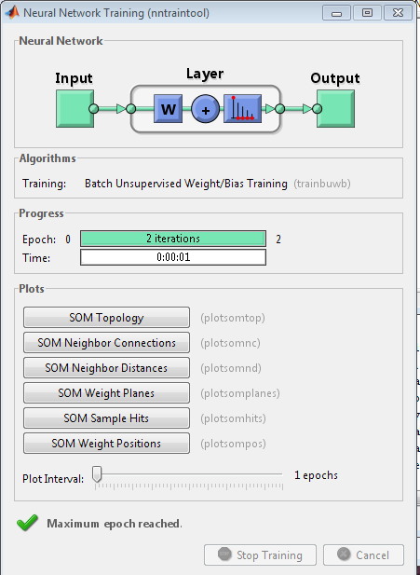

**Fig 5 training tools**

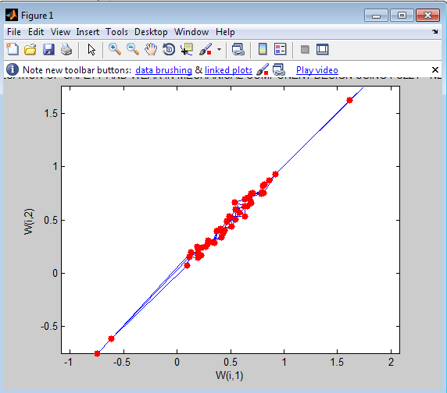

**Fig 6 trained ANN in those rules for effective reduction of the causes of** failure in evaluation of safety and wear in mechanical component design

The three rules were trained twenty times 3 x 20 = 60 to have sixty neurons that looks like human brain,



**Fig 7 result obtained during the training**

**To develop an algorithm that will implement the process**

1. characterize and establish the causes of failure in evaluation of safety and wear in mechanical component design
2. identify **Inadequate Material Selection**
3. **Identify Improper Load Analysis**
4. **Identify Environmental Factors**
5. **Identify Design Complexity**
6. **Identify Insufficient Predictive Models**
7. **Identify Human Error**
8. **Identify Inconsistent Testing Standards**
9. **design a conventional SIMULINK model for** evaluation of safety and wear in mechanical component design and incorporate 2 through 8
10. **develop a rule base that will automatically reduce the causes of** failure in evaluation of safety and wear in mechanical component design
11. **train ANN in those rules for effective reduction of the causes of** failure in
12. **Integrate 10 and 11.**
13. **Integrate 12 into 9**
14. **Did the causes of failure** in evaluation of safety and wear in mechanical component design reduce when 12 was integrated into 9
15. **IF NO go to 13**
16. **IF YES go to 17**
17. improved evaluation of safety and wear in mechanical component design
18. stop
19. End.

**To design a SIMULINK model for** improving evaluation of safety and wear in mechanical component design using fuzzy –NEURO CONTROLLER



Fig 8 **designed SIMULINK model for** improving evaluation of safety and wear in mechanical component design using fuzzy –NEURO CONTROLLER

The results obtained were as shown in figures 9 and 10

To validate and justify the percentage improvement in the reduction of the causes of failure in evaluation of safety and wear in mechanical component design with and without fuzzy –NEURO CONTROLLER

To find the percentage improvement in the reduction of Inadequate Material Selection causes of failure in evaluation of safety and wear in mechanical component design with fuzzy –NEURO CONTROLLER

Conventional Inadequate Material Selection =25%

Fuzzy –NEURO CONTROLLER Inadequate Material Selection =21.7%

% improvement in the reduction of Inadequate Material Selection causes of failure in evaluation of safety and wear in mechanical component design with fuzzy –NEURO CONTROLLER=

Conventional Inadequate Material Selection - Fuzzy –NEURO CONTROLLER Inadequate Material Selection

% improvement in the reduction of Inadequate Material Selection causes of failure in evaluation of safety and wear in mechanical component design with fuzzy –NEURO CONTROLLER=25% - 21.7%

% improvement in the reduction of InadequateMaterial Selection causes of failure in evaluation of safety and wear in mechanical component design with fuzzy –NEURO CONTROLLER=3.3%

To find the percentage improvement in the reduction of **Insufficient Predictive Models** causes of failure in evaluation of safety and wear in mechanical component design with fuzzy –NEURO CONTROLLER

Conventional **Insufficient Predictive Models** =15%

Fuzzy –NEURO CONTROLLER **Insufficient Predictive Models** 13%

% improvement in the reduction of **Insufficient Predictive Models** causes of failure in evaluation of safety and wear in mechanical component design with fuzzy –NEURO CONTROLLER=

Conventional **Insufficient Predictive Models** - Fuzzy –NEURO CONTROLLER **Insufficient Predictive Models**

% improvement in the reduction of **Insufficient Predictive Models** causes of failure in evaluation of safety and wear in mechanical component design with fuzzy –NEURO CONTROLLER=15% - 13%

% improvement in the reduction of **Insufficient Predictive Models** causes of failure in evaluation of safety and wear in mechanical component design with fuzzy –NEURO CONTROLLER=2%

1. **Results and Discussion**

Table 3 comparison of conventional and Fuzzy –NEURO CONTROLLER Inadequate Material Selection causes of failure in evaluation of safety and wear in mechanical component design

|  |  |  |
| --- | --- | --- |
| **Time(s)** | Conventional Inadequate Material Selection causes of failure in evaluation of safety and wear in mechanical component design(%) | Fuzzy –NEURO CONTROLLER Inadequate Material Selection causes of failure in evaluation of safety and wear in mechanical component design(%) |
| **1** | 25 | 21.7 |
| **2** | 25 | 21.7 |
| **3** | 25 | 21.7 |
| **4** | 25 | 21.7 |
| **10** | 25 | 21.7 |



Fig 9 comparison of conventional and Fuzzy –NEURO CONTROLLER Inadequate Material Selection causes of failure in evaluation of safety and wear in mechanical component design

The conventional Inadequate Material Selection causes of failure in evaluation of safety and wear in mechanical component design was 25%. On the other hand, when Fuzzy –NEURO CONTROLLER was integrated in the system, it drastically reduced to 21.7%

Table 4 comparison of conventional and Fuzzy –NEURO CONTROLLER **Insufficient Predictive Models** causes of failure in evaluation of safety and wear in mechanical component design

|  |  |  |
| --- | --- | --- |
| **Time(s)** | Conventional **Insufficient Predictive Models** causes of failure in evaluation of safety and wear in mechanical component design(%) | Fuzzy –NEURO CONTROLLER **Insufficient Predictive Models** causes of failure in evaluation of safety and wear in mechanical component design(%) |
| **1** | 15 | 13 |
| **2** | 15 | 13 |
| **3** | 15 | 13 |
| **4** | 15 | 13 |
| **10** | 15 | 13 |



Fig 10 comparison of conventional and Fuzzy –NEURO CONTROLLER **Insufficient Predictive Models** causes of failure in evaluation of safety and wear in mechanical component design

The conventional **Insufficient Predictive Models** causes of failure in evaluation of safety and wear in mechanical component design was 15%. Mean while when Fuzzy –NEURO CONTROLLER was imbibed in the system, it automatically reduced to13%. With these results obtained, it definitely applied that the percentage improvement in evaluation of safety and wear in mechanical component design was2%.

**4.0** Conclusion

The integration of fuzzy-neuro controllers in the evaluation of safety and wear in mechanical component design presents a significant advancement in modern engineering practices. By combining the strengths of fuzzy logic's rule-based decision-making with neural networks' adaptive learning capabilities, this approach offers a more robust, accurate, and efficient means of assessing the safety and longevity of mechanical components. The fuzzy-neuro system effectively handles uncertainties and nonlinearities inherent in wear and safety evaluations, providing insights that traditional methods may overlook. This enhances predictive accuracy, optimizes design parameters, and ensures compliance with safety standards while reducing the risk of premature failures. Moreover, the intelligent system's adaptability allows for real-time monitoring and decision-making, enabling proactive maintenance and extending the service life of components. This innovation not only improves the reliability of mechanical systems but also reduces operational costs and downtime, making it a practical and sustainable solution for industries. In conclusion, the application of fuzzy-neuro controllers marks a transformative step in mechanical component design, fostering the development of safer, more durable, and efficient systems. Future research should focus on refining these models further, integrating them with advanced IOT and AI technologies to achieve even higher levels of precision and automation in mechanical engineering. The conventional **Insufficient Predictive Models** causes of failure in evaluation of safety and wear in mechanical component design was 15%. Mean while when Fuzzy –NEURO CONTROLLER was imbibed in the system, it automatically reduced to13%. With these results obtained, it definitely applied that the percentage improvement in evaluation of safety and wear in mechanical component design was2%.

**References**

1.Haykin, S. (2009). *Neural networks and learning machines* (3rd ed.). Pearson Education.

2.Jiang, W., Zhang, L., & Gao, Y. (2021). Enhancing mechanical system reliability through intelligent control techniques: A review. *Mechanical Systems and Signal Processing, 145*, 106922. https://doi.org/10.1016/j.ymssp.2020.106922

3.Kumar, R., & Singh, S. P. (2019). Evaluation of wear in mechanical components using intelligent systems: A comprehensive review. *Journal of Materials Research and Technology, 8*(4), 5011-5023. https://doi.org/10.1016/j.jmrt.2019.08.017

4.Yin, H., Wang, Q., & Li, X. (2020). Advanced methodologies in wear analysis for mechanical components. *Engineering Fracture Mechanics, 231*, 107043. https://doi.org/10.1016/j.engfracmech.2020.107043

5.Zadeh, L. A. (1965). Fuzzy sets. *Information and Control, 8*(3), 338–353. https://doi.org/10.1016/S0019-9958(65)90241-X