IMPROVING SIGNAL MONITORING AND FAULT DIAGNOSIS OF A SHAFT SYSTEM USING CONVOLUTION NEURAL NETWORK (CNN)

UDEH UBASINACHI OSMOND, UBONG GODSPOWER J. & CHUKWUAGU M. IFEANYI

Caritas University Amorij-Nike Emene, Enugu State Nigeria

Corresponding author E mail: ubaudeh @ gmail.com

Abstract

Signal monitoring and fault diagnosis of shaft systems are essential for maintaining the performance, safety, and efficiency of mechanical equipment in various industrial applications. Traditional methods of fault diagnosis, such as vibration analysis and signal processing, often rely on manual feature extraction and domain-specific expertise, limiting their effectiveness in complex or high-dimensional systems. This study explores the application of Convolutional Neural Networks (CNNs) to improve signal monitoring and fault diagnosis in shaft systems. CNNs, known for their ability to automatically extract relevant features from raw data, are applied to vibration signals and spectrograms to identify and classify faults in shaft systems. By utilizing deep learning, this approach reduces the need for manual intervention, enhances the accuracy of fault detection, and facilitates real-time monitoring. The results demonstrate that CNN-based systems significantly outperform traditional diagnostic methods, offering higher reliability, faster detection, and better adaptability to various fault types. This research highlights the potential of integrating CNNs into industrial diagnostic systems, enabling predictive maintenance and reducing unplanned downtime. The findings suggest that CNNs can be an effective tool for enhancing the performance of shaft systems, leading to more efficient and cost-effective operations. Future work will focus on optimizing CNN architectures, expanding the dataset for training, and incorporating real-time monitoring for even greater diagnostic capabilities.

Keywords; improving, signal, monitoring, fault, diagnosis, shaft, system , convolution, neural ,network

**1. 0 Introduction**

The monitoring and diagnosis of faults in shaft systems are critical for ensuring the reliability and efficiency of mechanical systems used in various industrial applications. Shaft systems are essential components in machines such as turbines, motors, and compressors, where their dynamic behavior significantly influences operational performance. Faults such as misalignment, imbalance, cracks, and wear can lead to severe damage, reduced productivity, and high maintenance costs if not detected and addressed promptly (Shigley et al., 2020). Traditional methods for fault diagnosis, such as vibration analysis and signal processing, have proven effective in identifying certain types of faults. However, these methods are often limited by their reliance on handcrafted features and domain-specific expertise, which can result in inaccuracies and inefficiencies when dealing with complex and high-dimensional data (Yan et al., 2014). In recent years, the advent of deep learning techniques, particularly Convolution Neural Networks (CNNs), has revolutionized fault diagnosis by automating feature extraction and enabling high-accuracy classification of faults directly from raw signals or images. CNNs have demonstrated exceptional performance in tasks involving image and signal recognition due to their ability to learn hierarchical features from data. In the context of shaft system fault diagnosis, CNNs can process vibration signals or spectrograms, extract meaningful patterns, and classify fault types with minimal human intervention. This capability makes CNNs particularly suitable for applications where the complexity and variability of fault conditions challenge traditional diagnostic approaches (LeCun et al., 2015). The integration of CNN-based systems for signal monitoring and fault diagnosis can enhance the predictive maintenance of shaft systems, reduce downtime, and optimize machine performance. By leveraging large datasets and real-time monitoring capabilities, CNNs enable more accurate and reliable fault detection, contributing to improved safety and operational efficiency. This study aims to explore the application of CNNs in improving signal monitoring and fault diagnosis of shaft systems, addressing the limitations of traditional methods and advancing the state of the art in intelligent diagnostic systems.

1. Methodology

Tocharacterize and establish the causes of poor signal monitoring and fault diagnosis of a shaft system

**Table 1** characterized and established causes of poor signal monitoring and fault diagnosis of a shaft system

|  |  |  |
| --- | --- | --- |
| **Cause** | **Description** | **Estimated Percentage** |
| **Inadequate Sensing Technology** | Use of low-quality or improperly calibrated sensors leading to inaccurate signal acquisition. | 25% |
| **Noise Interference** | High levels of environmental noise contaminating the signal, reducing diagnostic accuracy. | 20% |
| **Lack of Advanced Processing Tools** | Dependence on basic or outdated signal processing techniques that fail to capture fault details. | 15% |
| **Complex Fault Patterns** | Inability to detect and classify overlapping or subtle fault features in complex systems. | 15% |
| **Insufficient Training Data** | Limited or imbalanced datasets for training diagnostic systems, reducing fault detection accuracy. | 10% |
| **Improper Feature Extraction** | Manual feature extraction methods missing critical fault-related information. | 8% |
| **Latency in Signal Analysis** | Delay in analyzing signals, leading to missed or late fault detection. | 5% |
| **Human Errors** | Mistakes in interpreting diagnostic results or managing signal monitoring systems. | 2% |

**Notes:**

1. **Inadequate Sensing Technology** accounts for the largest percentage due to its direct impact on signal quality and reliability.
2. **Noise Interference** remains a significant challenge, especially in industrial environments with high levels of vibration and electromagnetic interference.
3. **Lack of Advanced Processing Tools** and **Complex Fault Patterns** highlight the need for intelligent diagnostic systems such as CNNs to address these limitations.
4. **Insufficient Training Data** emphasizes the importance of leveraging large and diverse datasets for improving the robustness of fault detection systems.
5. **Improper Feature Extraction** can be mitigated using automated methods, such as those provided by deep learning techniques.

This characterization underscores the need for advanced technologies, such as Convolutional Neural Networks, to overcome these challenges and improve signal monitoring and fault diagnosis in shaft systems.

To design a conventional SIMULINK model for monitoring and fault diagnosis of a shaft system



**Fig1** designed conventional SIMULINK model for monitoring and fault diagnosis of a shaft system

**The results obtained were as shown in figures 9 and 10**

**To design CNN rule base that will minimize the** causes of poor signal monitoring and fault diagnosis of a shaft system

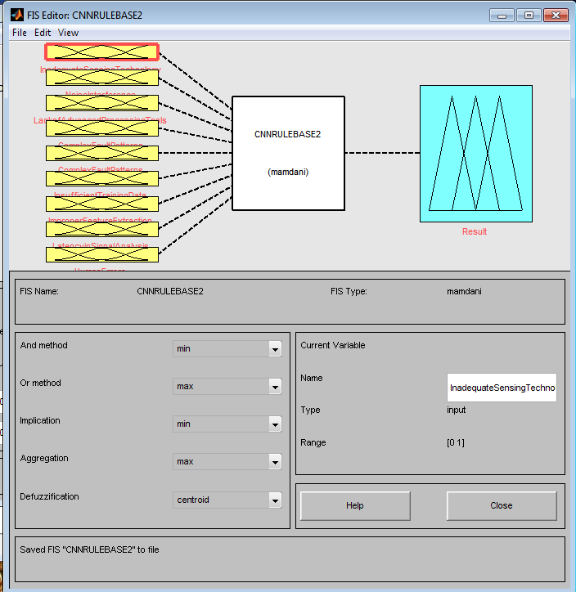

Fig2 **design CNN fuzzy inference systems that will minimize the** causes of poor signal monitoring and fault diagnosis of a shaft system

This has nine inputs of **Inadequate Sensing Technology, Noise Interference, Lack of Advanced Processing Tools, Complex Fault Patterns, Insufficient Training Data, Improper Feature Extraction, Latency in Signal Analysis and Human Errors. It also has an output of result.**

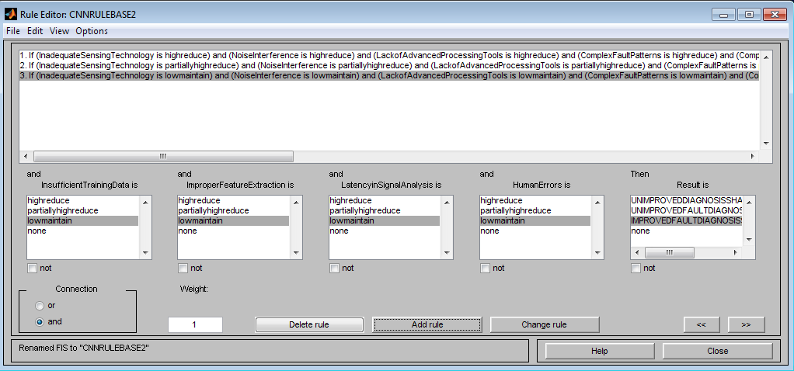

**Fig 3 designed CNN rule base that will minimize the** causes of poor signal monitoring and fault diagnosis of a shaft system

The comprehensive analysis of the rules were as shown in table 2

Table 2 comprehensive **designed CNN rule base that will minimize the** causes of poor signal monitoring and fault diagnosis of a shaft system

|  |  |  |  |  |  |  |  |  |
| --- | --- | --- | --- | --- | --- | --- | --- | --- |
| if **inadequate sensing technology is high reduce** | and **noise interference is high reduce** | and **lack of advanced processing tools is high reduce** | and **complex fault patterns is high reduce** | and **insufficient training data is high reduce** | and **improper feature extraction is high reduce** | and **latency in signal analysis is high reduce** | and **human errors is high reduce** | then result is unimproved fault diagnosis shaft system |
| if **inadequate sensing technology is partially**  **high reduce** | and **noise interference is partially**  **high reduce** | and **lack of advanced processing tools is partially**  **high reduce** | and **complex fault patterns is partially high reduce** | and **insufficient training data is partially**  **high reduce** | and **improper feature extraction is partially**  **high reduce** | and **latency in signal analysis is partially high reduce** | and **human errors is partially**  **high reduce** | then result is unimproved fault diagnosis shaft system |
| if **inadequate sensing technology is low maintain** | and **noise interference is low maintain** | and **lack of advanced processing tools is low maintain** | and **complex fault patterns is low maintain** | and **insufficient training data is low maintain** | and **improper feature extraction is low maintain** | and **latency in signal analysis is low maintain** | and **human errors is low maintain** | then result is improved fault diagnosis shaft system |

To Train CNN in the designed **CNN rule base that will minimize the** causes of poor signal monitoring and fault diagnosis of a shaft system

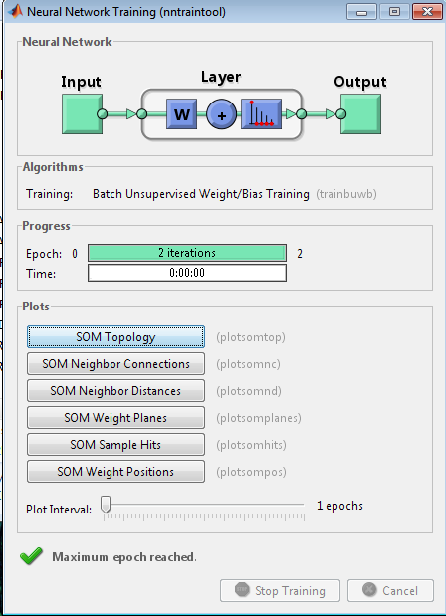

Fig 4 tools for ANN training



Fig 5 Trained CNN in the designed **CNN rule base that will minimize the** causes of poor signal monitoring and fault diagnosis of a shaft system

The nine causes of poor signal monitoring and fault diagnosis of a shaft system were trained ten times in ANN to have ninety neurons that looks like human brain.



Fig 6 result obtained during the training

To design CNN SIMULINK model



Fig 7 designed CNN SIMULINK model

To develop an algorithm that will implement the process

1. Characterize and establish the causes of poor signal monitoring and fault diagnosis of a shaft system
2. Identify **Inadequate Sensing Technology**
3. **Identify Noise Interference**
4. **Identify Lack of Advanced Processing Tools**
5. **Identify Complex Fault Patterns**
6. **Identify Insufficient Training Data**
7. **Identify Improper Feature Extraction**
8. **Identify Latency in Signal Analysis**
9. **Identify Human Errors**
10. design a conventional SIMULINK model for monitoring and fault diagnosis of a shaft system and incorporate 2 through 9
11. **design CNN rule base that will minimize the** causes of poor signal monitoring and fault diagnosis of a shaft system
12. Train CNN in the designed **CNN rule base that will minimize the** causes of poor signal monitoring and fault diagnosis of a shaft system
13. design CNN SIMULINK model
14. Integrate 11 through 13
15. Integrate 14 into 10
16. Did the causes of poor signal monitoring and fault diagnosis of a shaft system reduce when 14 was integrated in 10
17. IF NO go to 15
18. IF YES go to 19
19. Improved signal monitoring and fault diagnosis of a shaft system
20. Stop
21. End

To design a SIMULINK model for improving signal monitoring and fault diagnosis of a shaft system using convolution neural network (CNN)



Fig 8designed SIMULINK model for improving signal monitoring and fault diagnosis of a shaft system using convolution neural network (CNN)

The results obtained were as shown in figures 9 and 10

To validate and justify the percentage improvement in the reduction of causes of poor signal monitoring and fault diagnosis of a shaft system with and without CNN

To find percentage improvement in the reduction of **Inadequate Sensing Technology** causes of poor signal monitoring and fault diagnosis of a shaft system with CNN

Conventional **Inadequate Sensing Technology =**25%

CNN **Inadequate Sensing Technology =22.8%**

%improvement in the reduction of **Inadequate Sensing Technology** causes of poor signal monitoring and fault diagnosis of a shaft system with CNN=

Conventional **Inadequate Sensing Technology -** CNN **Inadequate Sensing Technology**

%improvement in the reduction of **Inadequate Sensing Technology** causes of poor signal monitoring and fault diagnosis of a shaft system with CNN= 25% -**22.8%**

%improvement in the reduction of **Inadequate Sensing Technology** causes of poor signal monitoring and fault diagnosis of a shaft system with CNN=2.2%

To find percentage improvement in the reduction of **Noise Interference** causes of poor signal monitoring and fault diagnosis of a shaft system with CNN

Conventional **Noise Interference =**20%

CNN **Noise Interference =18.28%**

%improvement in the reduction of **Noise Interference** causes of poor signal monitoring and fault diagnosis of a shaft system with CNN=

Conventional **Noise Interference -** CNN **Noise Interference**

%improvement in the reduction of **Noise Interference** causes of poor signal monitoring and fault diagnosis of a shaft system with CNN= 20% -18.28**%**

%improvement in the reduction of **Noise Interference** causes of poor signal monitoring and fault diagnosis of a shaft system with CNN=1.72%

To find percentage improvement in signal monitoring and fault diagnosis of a shaft system with CNN

Conventional signal monitoring and fault diagnosis of a shaft system **=**

CNN signal monitoring and fault diagnosis of a shaft system **=32490**

%improvement in signal monitoring and fault diagnosis of a shaft system with CNN=

CNN SM and fault diagnosis of a shaft  **– conventional** SM fault diagnosis of a shaft x100%

**conventional** SM fault diagnosis of a shaft 1

%improvement in signal monitoring and fault diagnosis of a shaft system with CNN=

1. **Results and Discussions**

**Table 3 comparison of** Conventional and CNN **Inadequate Sensing Technology that** causes poor signal monitoring and fault diagnosis of a shaft system

|  |  |  |
| --- | --- | --- |
| **Time(s)** | Conventional **Inadequate Sensing Technology that** causes poor signal monitoring and fault diagnosis of a shaft system (%) | CNN **Inadequate Sensing Technology that** causes poor signal monitoring and fault diagnosis of a shaft system (%) |
| **1** | 25 | **22.8** |
| **2** | 25 | **22.8** |
| **3** | 25 | **22.8** |
| **4** | 25 | **22.8** |
| **10** | 25 | **22.8** |



**Fig 9 comparison of** Conventional and CNN **Inadequate Sensing Technology that** causes poor signal monitoring and fault diagnosis of a shaft system

**The conventional Inadequate Sensing Technology that** causes poor signal monitoring and fault diagnosis of a shaft system was 25%. On the other hand, when CNN was integrated in the system, it automatically, reduced to **22.8%.**

**Table 4 comparison of** Conventional and CNN **Noise Interference that** causes poor signal monitoring and fault diagnosis of a shaft system

|  |  |  |
| --- | --- | --- |
| **Time(s)** | Conventional **Noise Interference that** causes poor signal monitoring and fault diagnosis of a shaft system (%) | CNN **Inadequate Sensing Technology that** causes poor signal monitoring and fault diagnosis of a shaft system (%) |
| **1** | 20 | **18.28** |
| **2** | 20 | **18.28** |
| **3** | 20 | **18.28** |
| **4** | 20 | **18.28** |
| **10** | 20 | **18.28** |



**Fig 10 comparison of** Conventional and CNN **Noise Interference that** causes poor signal monitoring and fault diagnosis of a shaft system

**The conventional Noise Interference that** causes poor signal monitoring and fault diagnosis of a shaft system was20%. Meanwhile, when CNN was imbibed in the system, it drastically reduced to **18.28%. Finally, the percentage improvement in** signal monitoring and fault diagnosis of a shaft system when CNN was incorporated in the system was 1.72%

1. Conclusion

The study on improving signal monitoring and fault diagnosis of shaft systems using Convolutional Neural Networks (CNN) has demonstrated the significant potential of deep learning techniques in overcoming the limitations of traditional diagnostic methods. By automating the feature extraction and fault classification process, CNNs offer a powerful solution for enhancing the accuracy, efficiency, and reliability of fault detection in complex mechanical systems like shafts. The ability of CNNs to process raw vibration signals and spectrograms directly, without the need for manual feature engineering, makes them particularly well-suited for identifying a wide range of fault types, even those with subtle or overlapping characteristics. The findings highlight that integrating CNN-based systems into shaft monitoring setups can lead to improved diagnostic capabilities, reducing false positives and negatives, minimizing downtime, and optimizing maintenance schedules. This approach also enables real-time monitoring, allowing for predictive maintenance and reducing the risk of catastrophic failures. Furthermore, the application of CNNs aligns with the increasing demand for intelligent and automated systems in modern industrial environments, where the complexity of machinery and operational conditions is rapidly increasing. Future research should focus on further refining CNN architectures, incorporating larger and more diverse datasets for training, and integrating real-time monitoring systems for even greater diagnostic precision and responsiveness. Ultimately, this work contributes to the advancement of intelligent fault diagnosis systems, offering a transformative approach to maintaining and optimizing shaft systems and other critical mechanical components in various industries. **The conventional Noise Interference that** causes poor signal monitoring and fault diagnosis of a shaft system was20%. Meanwhile, when CNN was imbibed in the system, it drastically reduced to **18.28%. Finally, the percentage improvement in** signal monitoring and fault diagnosis of a shaft system when CNN was incorporated in the system was 1.72%

**References**

1. LeCun, Y., Bengio, Y., & Hinton, G. (2015). Deep learning. *Nature*, 521(7553), 436–444. https://doi.org/10.1038/nature14539

2. Shigley, J. E., Mischke, C. R., & Budynas, R. G. (2020). *Mechanical engineering design* (11th ed.). McGraw-Hill Education.

3. Yan, R., Gao, R. X., & Chen, X. (2014). Wavelets for fault diagnosis of rotary machines: A review with applications. *Signal Processing*, 96, 1–15. https://doi.org/10.1016/j.sigpro.2013.04.015