**A STUDY ON RECRUITMENT AND SELECTION PROCESS WITH
SPECIAL REFERENCE YENMIN COMMUNICATION**

**Lavanya P¹ , Mohammed Saif N²**

¹B.Com Student, School of Arts, Humanities and Management, Jeppiaar University, Chennai, India.

²Assistant Professor, School of Arts, Humanities and Management, Jeppiaar University, Chennai, India.

**ABSTRACT**

One essential human resource management task that has a direct impact on an organization's success and productivity is the hiring and selection process. The objective of this research is to assess the hiring and selection practices of Yenmin Communication, a developing company in the digital and telecommunications industries. Hiring the proper talent has grown more difficult yet crucial in an increasingly competitive business climate. This study examines the effectiveness of Yenmin Communication's existing recruitment tactics, resources, and selection procedures in drawing in, choosing, and keeping skilled workers. Both primary and secondary data sources, such as employee surveys and HR staff interviews, served as the foundation for the study. It highlights important issues like gaps in onboarding procedures and the absence of automation in hiring. Suggestions are offered to improve the hiring process's general effectiveness, openness, and applicant experience. HR professionals and corporate decision-makers looking to maximize human capital development and talent acquisition will find this study useful. **Keywords:** Talent acquisition, Recruitment, Selection, Human Resources, Hiring Procedure, and The Telecom Industry

**1. INTRODUCTION:**

Two of the most crucial aspects of human resource management are recruitment and selection. They are essential in making sure that the appropriate individuals are employed for the appropriate positions. While selection entails picking the best applicant from a pool of candidates, recruitment is the process of locating and luring job searchers. Organizations need to have an efficient hiring procedure in place to draw in qualified and talented candidates in the competitive employment market of today. An effective hiring and selection process lowers turnover, boosts employee performance, and saves businesses money and time. A rising force in the telecom sector, Yenmin Communication depends on its staff to provide high-quality services and expand its operations. Having a robust recruitment and selection process becomes even more crucial as the business grows. Understanding Yenmin Communication's hiring and selection procedures, the phases involved, and their efficacy are the main goals of this study. This study's primary goal is to evaluate the business's hiring procedures and offer suggestions for how to make them more effective and employee-friendly.

**2. OBJECTIVES OF THE STUDY**

This study's primary goal is to comprehend and assess Yenmin Communication's hiring and selecting procedure. Hiring the appropriate individuals is crucial to reaching objectives and ensuring seamless operations in any firm. The purpose of this study is to investigate how the organization recruits, chooses, and evaluates individuals.

**The following are the study's specific goals:**

* **To research Yenmin Communication's hiring and selection procedure:** Recognize the procedures for recruiting, vetting, and choosing individuals.
* **To determine the different sources of hiring that the business uses:** Examine the company's use of college placements, referrals, job sites, and other sources.
* **To assess how well the selection procedures worked:** Analyze how well the methods of selection (tests, interviews, etc.) aid in selecting qualified applicants.
* **To learn about the difficulties encountered in the hiring and selecting process:** Determine any challenges that candidates or HR encountered during the hiring process.
* **To offer recommendations for enhancing the hiring and selection procedure:** Make suggestions for actions the business may take to improve the effectiveness, equity, and applicant experience of its hiring process.

**3. REVIEW OF LITERATURE**

Understanding previous studies, hypotheses, and research findings on the subject is aided by the literature review. It lays the groundwork for the current investigation and aids in locating knowledge gaps. Numerous scholars have examined hiring and selection procedures across a range of industries. The main ideas from those studies are emphasized in this section along with their relevance to the current investigation.

**3.1. Review of Concepts:** The process of locating and motivating possible applicants to submit job applications is known as recruitment. Job portals, recommendations, job ads, and other sources are included. The process of selecting the best applicant through assessments, examinations, and interviews is known as selection. Gary Dessler (2017) asserts that hiring and selection are crucial HR tasks that affect both the caliber of workers and the organization's overall performance.

**3.2. Review of Theory:** Benjamin Schneider's "Attraction-Selection-Attrition (ASA) Framework" describes how companies seek for applicants who suit their culture, choose those who do, and eventually let go of those who don't. This approach clarifies the significance of selecting the best applicants for the company culture as well as their skills. Because people are the organization's most important assets, the Human Capital Theory also supports the notion that making investments in efficient recruiting and selection has long-term benefits.

**3.3. Review of the Research:** A 2019 study by Sharma & Mehta examined hiring procedures in telecom firms. They discovered that although digital hiring via LinkedIn and job portals has grown in popularity, businesses continue to face difficulties in retaining and engaging candidates. In his 2020 study on the hiring procedure in mid-sized businesses, Ravi Kumar found that written exams and organized interviews decreased employee attrition. The significance of onboarding as an extension of the selection process was underlined by Preeti Singh (2021). She discovered that businesses with an effective onboarding approach had reduced attrition rates and higher employee satisfaction.

**3.4. Research Deficit:** There is little research on how small and medium-sized businesses (SMEs) like Yenmin Communication handle their hiring and selection procedures, with the majority of earlier studies concentrating on big or international corporations. By carefully analyzing the procedures of a developing telecom company and making useful recommendations, this study seeks to close that gap.

**4. RECRUITMENT AND SELECTION PROCESS AT YENMIN COMMUNICATION**

**4.1 Recruitment Sources:**

* Online job boards (like LinkedIn and Naukri)
* Internal hiring (transfers and promotions)
* Referrals from employees
* Recruitment on campus
* Employment agencies

**4.2 The Selection Process Steps:**

* Posting Jobs and Receiving Applications
* Resuming the screening
* Pre-interview over the phone or online
* Technical Interview
* Interview with HR
* Verification of Documents and Offer Distribution
* Orientation

**5. RESEARCH METHODOLOGY**

The methodical procedure used to gather, examine, and evaluate data for a study is known as research methodology. It offers a precise structure that contributes to the accuracy, dependability, and relevance of the research. A descriptive research design is used in this study to analyze and assess Yenmin Communication's hiring and selection procedure.

**5.1. Research Type:** Because it describes Yenmin Communication's present recruitment and selection procedures, this study is descriptive in nature. It seeks to offer comprehensive knowledge based on observation and analysis rather than conducting tests.

**5.2. Data Sources:** Both primary and secondary data were gathered in order to finish this study: Primary Data: Structured questionnaires and in-person interviews were used to gather primary data directly from Yenmin Communication's employees and HR personnel. Secondary Data: Company manuals, HR policy documents, research papers, internet articles, and textbooks pertaining to hiring and human resource management were the sources of secondary data.

**5.3. Method of Sampling:** Convenience sampling was employed. This indicates that information was gathered from readily available and cooperative participants, including HR personnel and recently hired staff members.

**5.4. The size of the sample:** Twenty-five respondents in all took part in the study. This includes team leaders, HR managers, and recently hired staff members from various Yenmin Communication departments.

**5.5. Data Collection Instruments: S**tructured survey with both closed-ended and open-ended inquiries Individual interviews An examination of the hiring procedure.

**5.6. Data Analysis Instruments:** Simple statistical methods and percentage analysis were used to examine the gathered data. For easier comprehension and interpretation, the results are displayed as tables and charts.

**6. DATA ANALYSIS & INTERPRETATION**

An essential component of any research activity is data analysis. Understanding the respondents' thoughts, experiences, and recommendations is beneficial. Data for this study was gathered from 25 respondents, including Yenmin Communication's HR staff and freshly employed staff members. Tables and charts are used to display the findings of the percentage analysis that was performed on the gathered data.

**1. The source that the company uses for hiring**

|  |  |  |
| --- | --- | --- |
| **Sources of Recruitment** | **No. of Respondents** | **Percentage** |
| Online Job Portals | 11 | 44% |
| Employee Referrals | 7 | 28% |
| Campus Recruitment | 3 | 12% |
| Internal Recruitment | 2 | 8% |
| Recruitment Agencies | 2 | 8% |

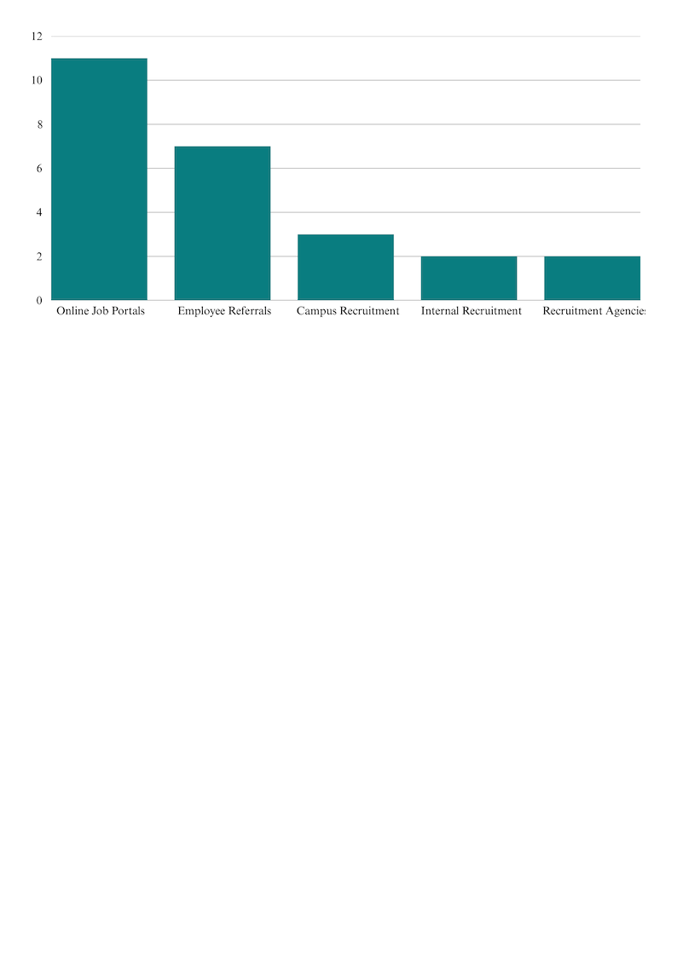

**Interpretation:** The majority of respondents (44%) said that the organization hires through online job boards like LinkedIn and Naukri. Referrals from employees are also frequently used. Internal promotions and campus recruitment are employed less frequently.

**2. Satisfaction with Recruitment Process**

|  |  |  |
| --- | --- | --- |
| **Satisfaction Level** | **No. of Respondents** | **Percentage** |
| Highly Satisfied | 5 | 20% |
| Satisfied | 12 | 48% |
| Neutral | 6 | 24% |
| Dissatisfied | 2 | 8% |
| Highly Dissatisfied | 0 | 0% |

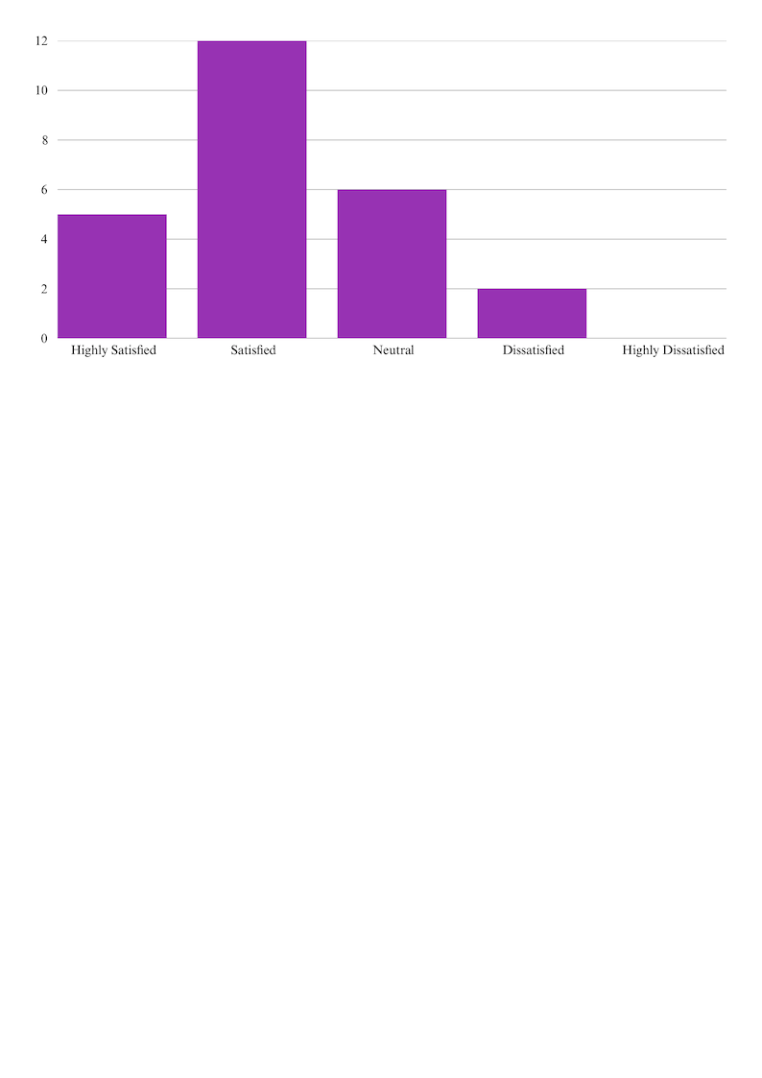

**Interpretation:** The majority of workers (48%) expressed satisfaction with the hiring procedure. Few people expressed dissatisfaction, suggesting that while the procedure is typically well-received, it may be made better.

**3. Duration of the Recruiting Process**

|  |  |  |
| --- | --- | --- |
| **Duration** | **No. of Respondents** | **Percentage** |
| Less than 1 Week | 5 | 20% |
| 1 to 2 Weeks | 14 | 56% |
| 2 to 4 Weeks | 6 | 24% |
| More than 4 Weeks | 0 | 0% |

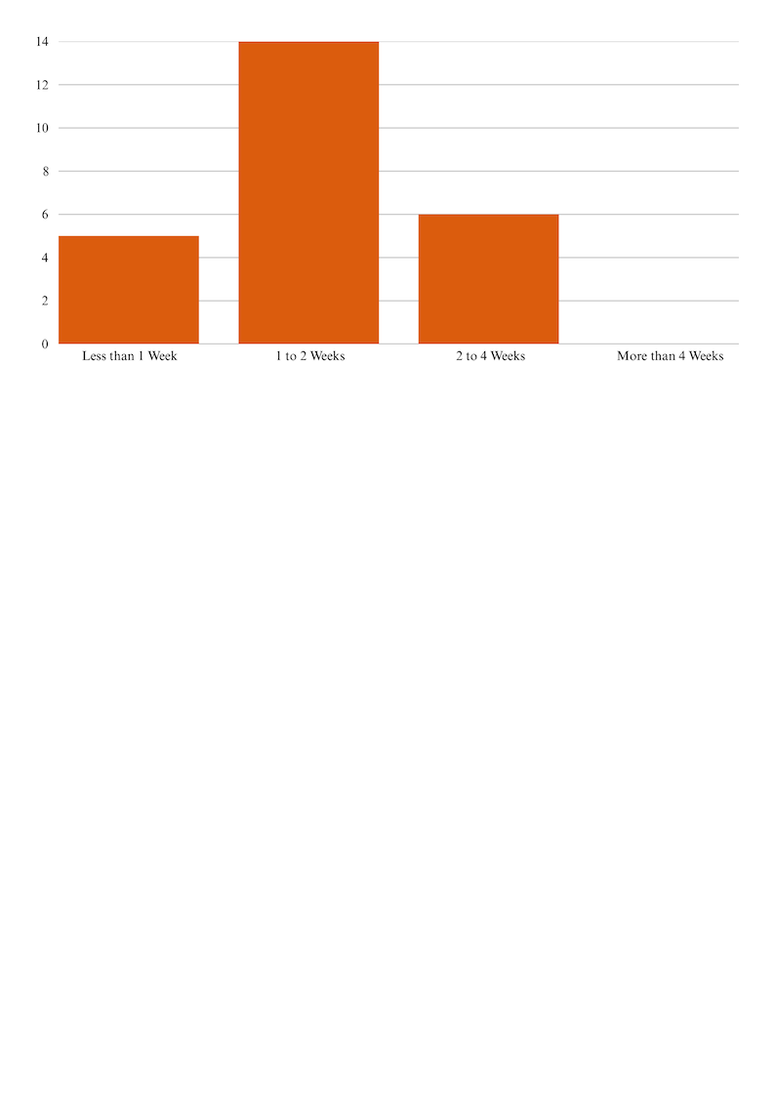

**Interpretation:** Most respondents stated that the procedure took one to two weeks, indicating that the business processes applications and completes the selection steps somewhat quickly.

**4. Opinion on Selection Methods Used (e.g., Interviews, Tests)**

|  |  |  |
| --- | --- | --- |
| **Opinion** | **No. of Responses** | **Percentage** |
| Very Effective | 7 | 28% |
| Effective | 10 | 40% |
| Average | 6 | 24% |
| Not Effective | 2 | 8% |

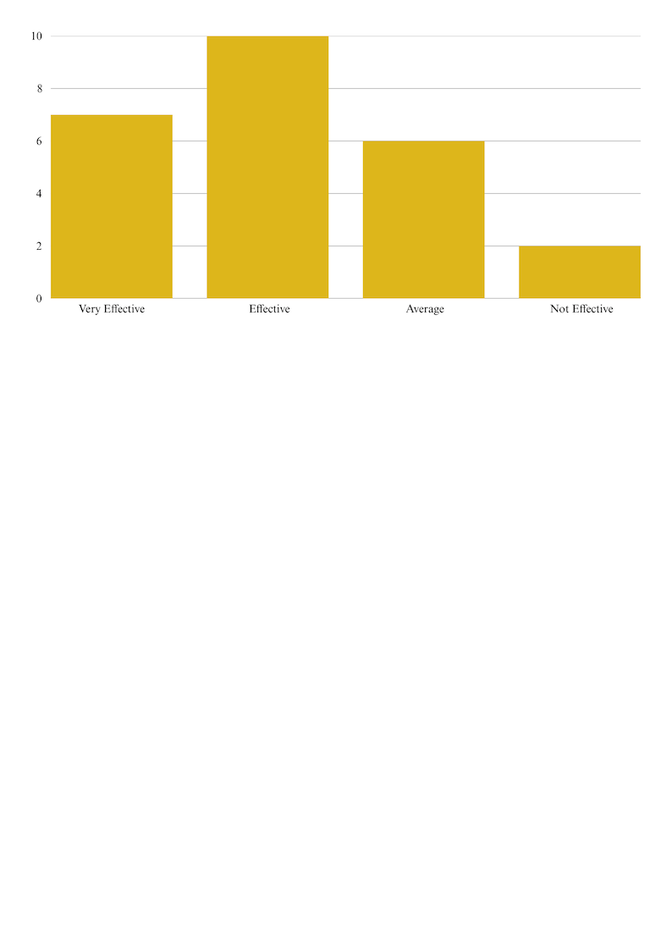

**Interpretation:** According to 68% of respondents, the selection procedures are successful. However, some workers believe that there is space for improvement, particularly in the ways that testing and assessment are conducted.

**6.1. Ideas for Enhancement (Recurring Themes):**

* Using an Applicant Tracking System (ATS) online
* Using rating scales in structured interviews
* Improved correspondence and follow-up with applicants
* Better onboarding following selection

**6.2. General Interpretation:** According to the data, Yenmin Communication's hiring and selection procedure is both practical and somewhat successful. The primary sources are online resources and recommendations. The majority of workers are content, but in order to increase productivity and the candidate experience, it is obvious that technology adoption and improved engagement strategies are needed.

**7. FINDINGS OF THE STUDY**

The investigation has discovered a number of important conclusions regarding Yenmin Communication's hiring and selection procedures based on the data gathered and examined. Employee experiences, current trends, and the general efficacy of the business's hiring procedure are all reflected in these findings.

**The Most Popular Source of Hiring is Online Job Portals:** According to the majority of respondents, the organization mostly sources people from job portals like Indeed, Naukri, and LinkedIn. This indicates a move toward quicker and easier digital hiring practices.

**Referrals from Employees Are Also Frequently Used:** The second most popular recruitment strategy is employee referrals. In addition to saving the business time, this guarantees a certain degree of reliability and caliber in the applicants being recommended.

**The hiring procedure is reasonably quick:** Yenmin Communication maintains a reasonably efficient hiring timeline, as evidenced by the fact that over half of the respondents said the recruitment process took one to two weeks.

**The majority of workers are happy with the hiring procedure:** The majority of respondents said they were satisfied with the hiring process as a whole. This implies that the employment process used by the organization is methodical and somewhat well-structured.

**Methods of Selection Are Seen as Effective:** The majority of respondents said that the tests and interviews conducted during the selection process were pertinent and helpful in assessing applicants. Some, however, recommended including more organized instruments, such as personality or skill tests.

**There is room for improvement in communication:** Lack of prompt communication during the hiring process was brought up by a few respondents. This includes post-interview updates and feedback delays, which may cause candidates to become confused or frustrated.

**Strengthening Post-Selection and Onboarding Support:** A few workers thought that although the hiring process went well, stronger orientation programs and direction would have enhanced the onboarding process once they joined the organization.

**Limited Technology Use in Hiring:** Advanced HR solutions like AI-based screening and applicant tracking systems (ATS) are rarely used. The process might become more data-driven and efficient with the use of such tools.

**In brief:** The hiring and selection process at Yenmin Communication is generally efficient, especially when it comes to fairness and speed. Onboarding, communication, and the use of contemporary technology to assist the hiring process are some areas that could use better, though.

**8. SUGGESTIONS**

A number of enhancements are recommended to improve Yenmin Communication's hiring and selection procedure in light of the findings. An Applicant Tracking System (ATS) should be put in place by the business to effectively manage and streamline applications. It should be a top priority to communicate clearly with candidates, particularly with the results and updates of the interview. Candidates can be evaluated more impartially with the use of skill-based tests and structured interviews. To guarantee a more seamless transfer for new hires, the onboarding procedure needs to be improved. Talent acquisition can be enhanced by increasing campus recruitment and preserving a talent pool for upcoming hiring requirements. Lastly, in order to stay abreast of industry developments and enhance the process's overall efficacy, the HR department should regularly evaluate hiring procedures.

**9. CONCLUSION**

According to the study on Yenmin Communication's hiring and selection procedure, the business has a reasonably efficient and organized hiring system. The majority of workers are happy with current procedures, particularly the utilization of online job boards and short hiring turnaround times. Onboarding, communication, and the utilization of contemporary recruitment techniques are a few areas that still require work. The selection process can be made more accurate and equitable by using skill-based tests and structured interviews. Efficiency and transparency can be increased by putting technology like an applicant tracking system into place. All things considered, a carefully thought out and frequently evaluated hiring strategy can not only draw in top talent but also enhance organizational performance and employee retention. Long-term growth requires these procedures to be continuously improved.

**10. REFERENCES**

1. Dessler, G. (2017). Human Resource Management (15th ed.). Pearson Education. A foundational textbook covering HR practices, including recruitment and selection.

2. Robbins, S. P., & Coulter, M. (2018). Management (14th ed.). Pearson. Provides insights into management functions with a focus on staffing and employee selection.

3. Sharma, R., & Mehta, M. (2019). “Recruitment Practices in the Telecom Sector: A Comparative Study.” International Journal of Human Resource Studies, 9(2), 45–56. Highlights modern trends in telecom recruitment strategies.

4. Kumar, R. (2020). “Effectiveness of Selection Methods in Mid-Sized Firms.” Journal of Management Research and Analysis, 7(1), 23–29. Discusses structured interviews and assessments in hiring.

5. Singh, P. (2021). “Importance of Onboarding in Employee Retention.” International Journal of Business and Administration Research Review, 9(5), 18–24. Emphasizes the connection between selection and onboarding.

6. Schneider, B. (1987). “The People Make the Place.” Personnel Psychology, 40(3), 437–453. Introduces the ASA (Attraction-Selection-Attrition) framework.

7. Naukri.com. (2024). “Current Hiring Trends in Indian Telecom Industry.” Retrieved from https://www.naukri.com Provides data on job portals and their use in modern recruitment.

8. Indeed.com. (2024). “How Companies Use Skill Assessments in Hiring.” Retrieved from https://www.indeed.com