**Digital Identity Verification – A Blockchain-based System for Verifying and Managing Digital Identities**

***Shraddha Dinesh Gawade1****, Computer Engineering, Zeal Polytechnic, Pune, India.*

***Shrestha Suresh Makne2****, Computer Engineering, Zeal Polytechnic, Pune, India.*

***Apeksha Ashruba Pawar 3****, Computer Engineering, Zeal Polytechnic, Pune, India.*

***Aarti Sunil Shirsath4****, Computer Engineering, Zeal Polytechnic, Pune, India.*

***Prof. laxman.lande5****, Computer Engineering, Zeal Polytechnic, Pune, India.*

***Abstract:*** *Classifying restaurant review sentiment involves analyzing customer feedback to determine whether the sentiment expressed is positive, negative, or neutral. Using natural language processing (NLP) techniques, such as text preprocessing, feature extraction, and machine learning models, the reviews are transformed into data that can be categorized based on sentiment. Common approaches include employing methods like Bag of Words, TF-IDF, or more advanced models like deep learning for sentiment classification. This process helps restaurants gain insights into customer satisfaction, allowing businesses to respond to feedback effectively, improve service quality, and make informed decisions based on customer sentiment trends. Ultimately, sentiment classification of reviews provides valuable feedback that enhances customer experience and drives operational improvements*

***Keywords:*** *Sentiment Analysis, Natural Language Processing (NLP), Text Classification, Feature Extraction, Bag of Words (BoW), TF-IDF, Word Embeddings, Machine Learning, Sentiment Labels, Data Preprocessing, Tokenization, Deep Learning, Model Evaluation, Customer Feedback, Opinion Mining, Accuracy Metrics, Review Categorization, Customer Satisfaction*

1. **INTRODUCTION**

The Classifying Restaurant Review Sentiment project aims to utilize natural language processing (NLP) and machine learning techniques to analyze and classify customer reviews of restaurants into sentiment categories—positive, negative, or neutral. With the rise of online reviews, businesses can gain valuable insights into customer satisfaction and improve their services based on direct feedback. The project involves gathering a dataset of restaurant reviews, preprocessing the text data, and applying various machine learning algorithms to automatically categorize the sentiment of each review. By utilizing methods like Bag of Words (BoW), TF-IDF, and deep learning models, this project helps automate sentiment analysis at scale. The outcomes provide actionable insights for restaurant managers to understand customer experiences, identify areas for improvement, and tailor marketing strategies. Ultimately, this project combines data science and business intelligence to enhance customer engagement and improve restaurant performance.

1. **OBJECTIVES**

The objective of the Classifying Restaurant Review Sentiment project is to develop an automated system that can analyze and categorize restaurant reviews based on sentiment (positive, negative, or neutral) using natural language processing (NLP) and machine learning techniques. The key goals include:

1. Data Collection and Preprocessing: Gather a large dataset of restaurant reviews and clean the text data by removing noise, such as stop words and special characters, to prepare it for analysis.
2. Feature Extraction: Extract relevant features from the review text using methods like Bag of Words (BoW), TF-IDF, or Word Embeddings to represent the data numerically.
3. Model Development: Train machine learning models (e.g., Logistic Regression, Naive Bayes, or deep learning models like LSTM) to classify the sentiment of the reviews accurately.
4. Sentiment Categorization: Develop a system that can classify the sentiment of new, unseen restaurant reviews into positive, negative, or neutral categories.
5. Model Evaluation and Optimization: Evaluate the performance of the model using metrics like accuracy, precision, recall, and F1-score, and optimize it to achieve better accuracy.
6. Business Insights: Provide actionable insights for restaurant businesses to understand customer sentiment, improve customer satisfaction, and enhance decision-making based on feedback.

**BACKGROUND:**

The Classifying Restaurant Review Sentiment project is built on the increasing importance of online customer feedback and the need for businesses to quickly analyze large volumes of reviews to gain actionable insights. With the proliferation of platforms like Yelp, TripAdvisor, and Google Reviews, restaurant owners are presented with a wealth of customer opinions that can influence their operations, marketing strategies, and customer satisfaction efforts. However, manually going through these reviews is time-consuming and inefficient.

Sentiment analysis, a branch of natural language processing (NLP), allows for the automation of this process by identifying and classifying the sentiment expressed in textual data. By leveraging machine learning algorithms and NLP techniques, it's possible to categorize reviews as positive, negative, or neutral based on the words, phrases, and context in the text.

Historically, sentiment analysis was applied to simpler use cases, such as social media posts and product reviews, but its application to restaurant reviews presents a unique challenge due to the varied language, slang, and nuances customers may use. This project addresses the need to develop effective models capable of understanding these subtleties and providing restaurant businesses with timely, actionable insights.

In recent years, advancements in machine learning, such as deep learning and transformer models (e.g., BERT, GPT), have significantly improved the accuracy and scalability of sentiment analysis systems. By incorporating these technologies, the Classifying Restaurant Review Sentiment project aims to provide an efficient and scalable solution for analyzing large datasets of restaurant reviews, enabling businesses to better understand customer sentiment and improve overall service quality. This background sets the stage for creating a robust, automated system that not only saves time but also enhances decision-making in the competitive restaurant industry.

1. **LITERATURE SURVEY**

Sentiment analysis of restaurant reviews has become an essential tool for understanding customer feedback, enabling businesses to improve their services based on customer sentiment. Various techniques have been used to classify sentiment in restaurant reviews, including traditional machine learning approaches and more recent deep learning methods.

1. Traditional Machine Learning Models: Early sentiment analysis of restaurant reviews utilized models like Naive Bayes, Support Vector Machines (SVM), and Logistic Regression, often using Bag of Words (BoW) or TF-IDF for feature extraction. These models, as discussed by Pang et al. (2002), laid the groundwork for text classification but struggled with complex language nuances in reviews.
2. Deep Learning Models: More recent studies have leveraged deep learning models such as Recurrent Neural Networks (RNNs) and Long Short-Term Memory (LSTM) networks. These models, as shown by Zhang et al. (2018), significantly improve sentiment classification accuracy by capturing the context and sequence of words, providing better understanding of mixed sentiments.
3. Transformer Models: The introduction of transformer-based models like BERT (Devlin et al., 2019) has further advanced sentiment analysis by improving contextual understanding. These models outperform traditional approaches by learning contextual word embeddings, which help to better handle complex phrases, sarcasm, and mixed sentiment.
4. Aspect-Based Sentiment Analysis: In addition to overall sentiment classification, research has also focused on aspect-based sentiment analysis, where specific aspects of a restaurant, such as food quality or service, are analyzed separately. This allows for a more granular understanding of customer sentiment, as seen in the work by Pontiki et al. (2016).
5. Challenges: Challenges in classifying restaurant review sentiment include handling ambiguity, sarcasm, and the need for models to adapt to different cultural contexts and languages, especially with datasets like Yelp and TripAdvisor, which feature reviews from diverse regions.
6. **GAPS IDENTIFIED IN EXISTING SYSTEM**

While significant progress has been made in the field of sentiment analysis for restaurant reviews, there are still several gaps in existing systems that hinder their effectiveness and applicability. These gaps are crucial to address for developing more accurate and robust sentiment classification models. Below are some of the key gaps identified in current systems: .

1. Handling Mixed Sentiments

Many restaurant reviews contain a combination of positive and negative sentiments, making it challenging to classify reviews accurately. For instance, a review might praise the food but criticize the service, creating a mixed sentiment. Existing systems often struggle to properly detect and classify such reviews into specific sentiment categories or fail to capture the nuances of different aspects within the same review.

1. . Sarcasm and Irony Detection

Sarcasm and irony are often used in customer reviews, and traditional sentiment analysis models tend to misclassify these reviews. For example, a review that says, "The food was great, but I’m sure the chef was a magician to make it taste this bad" could be misinterpreted by a basic sentiment analysis model. Although recent advances in deep learning and transformers (e.g., BERT) have made strides in this area, sarcasm remains an underexplored challenge, particularly for restaurant reviews where tone plays a critical role.

**Solutions to Identified Gaps:**

1. Mixed Sentiments:

Solution: Implement fine-grained sentiment analysis techniques that can detect and classify multiple sentiments within a single review. Multi-class classification or aspect-based sentiment analysis (ABSA) can help identify different sentiment polarities for specific aspects of the review (e.g., food, service).

Example: Use models like BERT for capturing contextual nuances and sentiment dependencies, allowing for more accurate detection of mixed sentiments.

2 Sarcasm and Irony Detection:

Solution: Leverage advanced models that are specifically trained to detect sarcasm and irony in text, such as sarcasm detection algorithms or transformer-based models with additional sarcasm datasets.

Example: Incorporate pre-trained transformers like BERT with additional layers or fine-tuning focused on sarcasm detection, or use hybrid models combining sentiment classifiers with sarcasm-detection tools.

1. **PROPOSED SYSTEM**
   1. **System overview:**

The Classifying Restaurant Review Sentiment system is designed to automatically analyze customer feedback from restaurant review platforms like Yelp, TripAdvisor, and Zomato to determine the sentiment expressed in the reviews. The system utilizes advanced natural language processing (NLP) and machine learning models to classify sentiments as positive, negative, or neutral, and also performs aspect-based sentiment analysis to evaluate specific aspects such as food, service, and ambiance. It incorporates deep learning techniques like BERT and LSTM to accurately capture contextual information and handle complexities like sarcasm or mixed sentiments. Additionally, the system supports multilingual reviews, enabling it to process global customer feedback. Real-time sentiment analysis, scalability through cloud-based platforms, and intuitive visualizations help restaurant managers make data-driven decisions quickly. The system also includes explainability features, offering transparent insights into how sentiment predictions are made. Overall, this system empowers businesses with actionable insights to improve customer experience and adapt to changing customer preferences.

* 1. **Features:**

**Sentiment Classification**:

Automatically classifies restaurant reviews as positive, negative, or neutral based on the overall tone of the review, providing a quick sentiment overview.

**Aspect-Based Sentiment Analysis (ABSA):**

Breaks down the reviews to assess sentiment for specific aspects of the restaurant, such as food quality, service, ambiance, and price. This allows businesses to gain insights into specific areas of improvement.

**Multilingual Support:**

Handles reviews in multiple languages (e.g., English, Spanish, French) using multilingual models like mBERT or XLM-R, making the system suitable for global applications.

**Real-Time Sentiment Analysis:**

Analyzes incoming reviews in real-time, providing immediate feedback on customer sentiment. This feature allows businesses to track customer opinions as they are posted, enabling prompt responses.

* 1. **Modules:**

**Data Collection Module**: To gather restaurant reviews from various sources such as Yelp, TripAdvisor, and Zomato.

.**Text Preprocessing Module**:Clean and normalize the review text to make it ready for analysis.

* 1. **System Architecture:**

The System Architecture for the Classifying Restaurant Review Sentiment project is structured in layers to efficiently process and analyze customer reviews. It begins with the Data Collection Layer, where reviews are gathered from platforms like Yelp and TripAdvisor. The Data Preprocessing Layer cleans and normalizes the text. In the Sentiment Analysis Layer, machine learning models like BERT and LSTM classify the overall sentiment and perform aspect-based analysis. The system supports real-time processing using cloud platforms, while the Visualization Layer displays actionable insights through dashboards. Additionally, feedback loops and model retraining ensure continuous improvement, and APIs enable seamless integration with external systems. This modular architecture ensures scalability, real-time insights, and adaptability.

.

* 1. **Activity flow:**

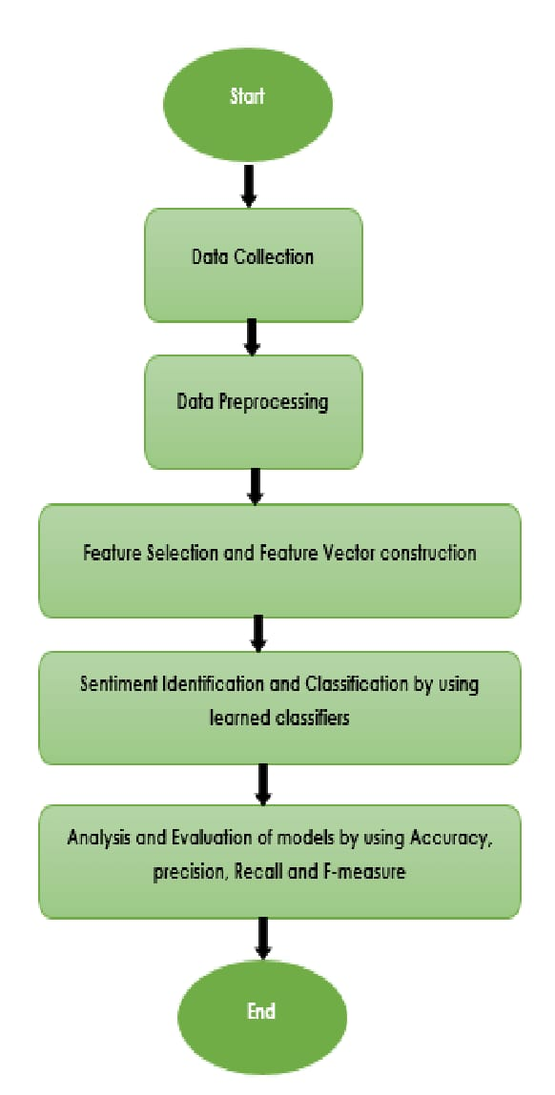

**Fig 1**. Activity diagram

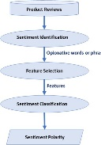

**Fig 2**. Use Case Diagram

1. **IMPLEMENTATION**

**6.1. Algorithm for Implementing a Blockchain-based Decentralized Identity System:**

To implement a sentiment classifier for restaurant reviews, you can use Natural Language Processing (NLP) techniques combined with machine learning algorithms. Below is a basic outline of how you can approach this problem using Python:

Steps to Implement Sentiment Classification for Restaurant Reviews

**Collect the Data**:

You will need a dataset containing restaurant reviews with sentiment labels. Sentiment can be classified as positive, negative, or neutral.

You can use datasets like the Restaurant Review Dataset from Kaggle or create your own by scraping restaurant review sites (e.g., Yelp).

**Preprocess the Data**:

Clean the text data to remove noise.

Tokenization: Split the review text into words.

Remove stopwords: Words that do not carry significant meaning (e.g., "the", "is", etc.).

Lemmatization or stemming: Reduce words to their root form (e.g., "running" → "run").

**Feature Extraction**:

Convert the cleaned text into numerical format.

TF-IDF (Term Frequency-Inverse Document Frequency): A popular technique to convert text into numerical features.

Word Embeddings (Word2Vec, GloVe): More advanced methods for capturing the semantic meaning of words.

**Model Selection**:

Choose a machine learning model. You can start with simpler models and later explore more advanced ones:

Logistic Regression

Naive Bayes

Support Vector Machine (SVM)

Deep Learning Models (RNNs, LSTMs, or Transformers)

**Train the Model**:

Split your dataset into training and testing sets.

Train the selected model on the training set and evaluate performance using the testing set.

**Evaluation**:

Measure the model’s performance using metrics like accuracy, precision, recall, F1 score, or confusion matrix.

**Deploy**:

Once you have a trained and evaluated model, you can deploy it as an API or integrate it into an application.

**6.2. Tools and Technology:**

1. Programming Language:

Popular for NLP and ML tasks.

2. NLP Libraries:

spaCy, NLTK, TextBlob: For text processing (tokenization, lemmatization).

Transformers (Hugging Face): For advanced models like BERT, GPT.

3. Feature Extraction:

TF-IDF, Word2Vec, GloVe: Convert text into numerical representations.

4. Machine Learning Frameworks:

scikit-learn: For models like Logistic Regression, Naive Bayes.

XGBoost, LightGBM: For gradient boosting.

1. **CONCLUSION**

In conclusion, classifying restaurant review sentiment is a powerful application of Natural Language Processing (NLP) and Machine Learning (ML) that enables businesses to understand customer feedback at scale. By analyzing reviews, sentiment classification models can categorize sentiments as positive, negative, or neutral, offering insights into customer satisfaction and areas for improvement.

Key steps involve data collection (e.g., scraping reviews from Yelp or TripAdvisor), text preprocessing (such as tokenization, lemmatization, and removing stopwords), feature extraction (using techniques like TF-IDF or word embeddings), and training models (such as Logistic Regression, Naive Bayes, or deep learning models like LSTM and BERT).

Tools like Python, spaCy, scikit-learn, TensorFlow, and Hugging Face’s Transformers, alongside cloud services like Google Cloud NLP and AWS Comprehend, provide the necessary infrastructure to build, train, and deploy these models effectively.

Ultimately, sentiment classification enhances a restaurant’s ability to improve customer experience by turning qualitative feedback into actionable data, offering businesses a competitive edge in understanding and responding to customer sentiment.

.

1. **REFERENCES**

[1] Aydoğan, Ebru, and M. Ali Akcayol. "A comprehensive survey for sentiment analysis tasks using machine

learning techniques." In 2016 international symposium on innovations in intelligent systems and applications

(INISTA), pp. 1-7. IEEE, 2016.

[2] Raza, Hassan, M. Faizan, Ahsan Hamza, Mushtaq Ahmed, and Naeem Akhtar. "Scientific text sentiment

analysis using machine learning techniques." International Journal of Advanced Computer Science and

Applications 10, no. 12 (2019).

[3] Isah, Haruna, Daniel Neagu, and Paul Trundle. "Bipartite network model for inferring hidden ties in crime

data." In Proceedings of the 2015 IEEE/ACM international conference on advances in social networks analysis

and mining 2015, pp. 994-1001. 2015.

[4] Naithani, Kanchan, and Yadav Prasad Raiwani. "Realization of natural language processing and machine

learning approaches for text‐based sentiment analysis." Expert Systems (2022): e13114..