**AI RESUME BUILDER**

**Uzzam Ansari *1, Ali Asgar Devjani *2, Ahmed Raza Khan*3, Maaviya Maktabay *4, Owais Mukri *5**

*1MSBTE (Maharashtra State Board of Technical Education), M.H. SABOO SIDDIK POLYTECHNIC, Department of Information Technology, Mumbai, Maharashtra, India

*2MSBTE (Maharashtra State Board of Technical Education), M.H. SABOO SIDDIK POLYTECHNIC, Department of Information Technology, Mumbai, Maharashtra, India

*3MSBTE (Maharashtra State Board of Technical Education), M.H. SABOO SIDDIK POLYTECHNIC, Department of Information Technology, Mumbai, Maharashtra, India

*4MSBTE (Maharashtra State Board of Technical Education), M.H. SABOO SIDDIK POLYTECHNIC, Department of Information Technology, Mumbai, Maharashtra, India

*5MSBTE (Maharashtra State Board of Technical Education), M.H. SABOO SIDDIK POLYTECHNIC, Department of Information Technology, Mumbai, Maharashtra, India

**ABSTRACT**

The AI Resume Builder is an intelligent web-based application designed to assist users in creating professional, tailored resumes with minimal effort. Leveraging Natural Language Processing (NLP) and machine learning algorithms, the system guides users through an intuitive interface, dynamically generating content suggestions and optimizing resume sections such as summaries, skills, experiences, and achievements. The tool ensures the final output adheres to industry standards and is customized for specific job roles or sectors. By automating the resume-building process, this AI-powered solution significantly enhances user efficiency, reduces errors, and increases the chances of job seekers securing interviews.

**Keywords:** AI Resume Builder, Resume Optimization, Web Application, Smart Resume Assistant, Automated Resume Generation.

1. **INTRODUCTION**

An AI resume builder is a software application designed to simplify the process of creating a resume for individuals. The system leverages artificial intelligence to generate professional looking resumes efficiently. It offers an intuitive interface that helps users design resumes tailored to their qualifications and career goals without the hassle of manual formatting.

1. **METHODOLOGY**

The AI Resume Builder Website helps job seekers create professional and well-structured resumes quickly and easily. Using artificial intelligence, it suggests the best content, formats, and keywords to match specific job roles and industries. The platform offers easy editing tools, and ATS-friendly designs to improve job application success. It also helps with job suggestions making resume creation simple for everyone—from fresh graduates to experienced professionals. With just a few clicks, users can build, customize, and download a standout resume that increases their chances of getting hired.

**ALGORITHM**

Step 1: User Input Collection

1. User registers or logs in.

2. Collect personal details (name, contact, education, work experience, skills, etc.).

3. (Optional) Upload an existing resume for analysis.

Step 2: AI-Powered Resume Generation

1. AI analyzes user input and job role requirements.

2. Suggests optimized content (e.g., summary, skills, experience descriptions) using NLP (Natural Language Processing).

3. Ensures ATS-friendly formatting by structuring resume sections properly.

Step 3: Customization & Editing

1. User edits and customizes the suggested resume (layout, fonts, colors, sections).

2. AI provides real-time feedback and keyword recommendations.

3. (Optional) Generate a tailored cover letter based on the resume.

Step 4: Download & Sharing

1. User previews the final resume.

2. Downloads it in preferred formats (PDF, Word, etc.).

3. (Optional) Shares directly via email, LinkedIn, or job portals.

Step 5: Additional Features (Future Enhancements)

1. AI suggests relevant job openings based on resume content.

2. User can save and update resumes for future use.

3. Monetization options (freemium features, expert resume reviews, premium templates).

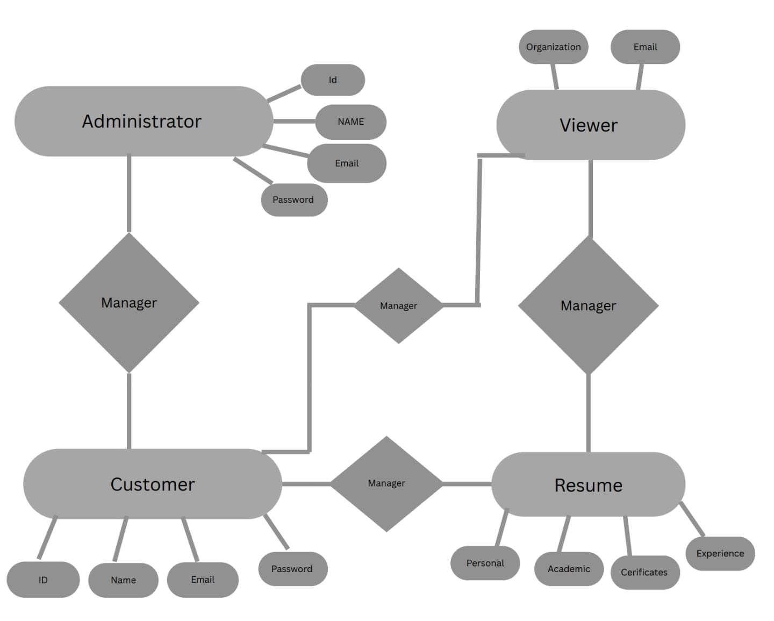**SYSTEM FLOW CHART**

**Fig 1:** Flow Chart of AI resume Builder

1. **MODELING AND ANALYSIS**

The AI Resume Builder simplifies resume creation through a user-friendly form, generating professional resumes with minimal effort. Built using the Incremental Build Model, the system is developed and delivered in phases, ensuring flexibility and early usability. It emphasizes efficient deployment, stakeholder collaboration, clear requirement analysis, and strong documentation to support smooth development and user adoption.

**Figure 2:** Increment Model

1. **RESULTS AND DISCUSSION**

The AI Resume Builder successfully generated a structured and professional resume based on user inputs. The system guided the user through a form covering personal details, educational background, skills, and interests. Based on the responses, the application produced a polished resume in the selected format. The outcome highlights the effectiveness of the tool in simplifying resume creation. Compared to manual preparation, the AI-based approach reduced user effort and ensured proper formatting. The generated resume met standard professional requirements, confirming that the system is both user-friendly and efficient.

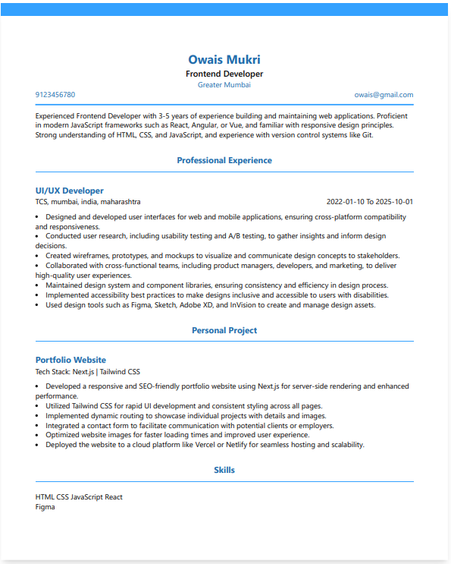

**Figure 3:** Example of Generated Resume

1. **CONCLUSION**

The AI Resume Builder simplifies and enhances resume creation by automating formatting, keyword optimization, and personalization. It saves time, improves ATS compatibility, and helps users stand out. Future updates aim to make it a complete job search companion.

1. **REFERENCES**
2. H. B. Aladi, "Automatic Resume Generator," Cloud-based Resume System, [Online].
3. S. Biswas, "Stress-Free Resume Builder."
4. S. Biswas, "Web Service for Online Resume Making."
5. B. Kungwani, A. Manglani, N. Dembal, H. Hirani, and L. Sawlani, "Resume Manufacturer."
6. FARIS Technology Institute, Ethiopia, "Resume/CV SystemSpam Detection."
7. FARIS Technology Institute, "Resume Application."
8. R. Gunkar, "Automated Resume Builder."
9. A. Ayudhyay, "Geeks-for-Geeks Online Resume Builder."
10. S. Biswas and M. Agar, "APP for CV Making."