AI – Mental Health Campanion

### Ishwari Jadhav Rutika khillari

*Information technology Information technology MET’s Institute of Technology MET’s Institute of Technology*

*Polytechnic, Bhujbal Knowledge City Polytechnic, Bhujbal Knowledge City Nashik, Maharashtra ,India Nashik, Maharashtra ,India*

### [Ishwarijadhav2006@gmail.com](mailto:Ishwarijadhav2006@gmail.com) khillarirutika07@gamil.com

Shaunak.R.Gaidhani *Project Co-ordinator Information Technology*

*Met’s Institute of Technology Polytechnic, Bhujbal Knowledge City, Adgaon, Nashik, Maharashtra, India* [Email:srgaidhani1@gmail.com](mailto:srgaidhani1@gmail.com)

### Sanjeev.B.Patil

*HOD,*

*Project Guide*

*Dept. of Information Technology*

*Met’s Institute of Technology Polytechnic, Bhujbal Knowledge City, Adgaon, Nashik,*

*Maharashtra, India*

[Email:sanjeevp_iot@bkc.met.edu](mailto:sanjeevp_iot@bkc.met.edu)

***Abstract—***

### MindMate is an AI-powered mental health companion designed to provide personalized emotional support, coping strategies, and mental health resources to users. Leveraging the advanced natural language processing capabilities of the Gemini LLM, MindMate offers a safe, non-judgmental space for users to express their thoughts, feelings, and concerns. The system is designed to adapt to individual needs, providing tailored responses, mindfulness exercises, and actionable advice to help users manage stress, anxiety, and other mental health challenges.

**Keywords – AI therapy, Mental health support, Emotional wellness, AI counseling, Digital therapist.**

## INTRODUCTION

An AI mental health companion is a digital tool designed to provide personalized emotional support and mental wellness resources. Using advanced AI, it offers 24/7 assistance for managing stress, anxiety, and other mental health concerns through techniques like mood tracking, mindfulness exercises, and therapeutic strategies. Accessible, non-judgmental, and always available, it empowers users to take control of their mental well-being, offering a valuable supplement to traditional therapy or as a standalone resource.

## REVIEW OF LITERATURE

A review of literature on AI mental health companions reveals significant advancements in the integration of artificial intelligence to support mental well-being. Studies highlight the potential of AI-driven tools to provide personalized, scalable mental health interventions, particularly through chatbots and virtual assistants. Research emphasizes the effectiveness of AI in delivering Cognitive Behavioral Therapy (CBT), mood tracking, and stress management techniques. AI companions have been shown to reduce barriers to

traditional mental health care, such as cost, stigma, and accessibility. They are especially beneficial for users seeking immediate support, offering 24/7 availability and confidentiality. However, challenges remain regarding user trust, the need for accurate emotional assessments, and the limitations of AI in fully replicating human empathy and clinical expertise.

## SYSTEM DESIGN

To design an E-commerce website the method of shaping the coding is done in Pyton,Streamlit for designs, interfaces and information for a system to satisfy mere needs. System Module Description:

* + Coding (,)
  + Methodology
  + Software Architecture
  + Data Design Model

#### PYTHON

Python is a versatile, high-level programming language that's widely used for its simplicity and readability. Known for its extensive libraries and community support, Python excels in various applications, such as web development, data analysis, machine learning, automation, and more. Its syntax is easy to learn, making it a popular choice for both beginners and experienced developers. Python's motto, "batteries included," reflects its comprehensive standard library that provides tools for almost any programming task.

**Streamlit**

**Streamlit** is an open-source framework designed for building and sharing custom web apps, primarily for data science and machine learning projects. Its simplicity allows users to create interactive and visually appealing apps using pure Python, without needing any front- end development skills. Streamlit automatically handles layout, widgets, and updates, making it ideal for quick prototyping and sharing of data-driven applications. With its user-friendly syntax, it enables seamless integration of charts, tables, and controls to visualize insights effectively.

## COMPONENTS IN E-COMMERCE

#### User Interface (UI) / Frontend

**Mobile/Web Interface**: This is the user-facing platform, either as a mobile app or a web interface, where users interact with the health companion.

**Personalized Dashboards**: A visual representation of the user's health data, progress, and recommendations, designed with easy navigation and quick access to critical information.

**Chatbot / Virtual Assistant**: An AI-driven interface where users can ask health-related questions, get recommendations, and receive personalized insights in real-time.

#### User Authentication & Profile Management

**Sign-up/Log-in System**: Secure authentication system (with email, social logins, biometric data) for users to register and sign in.

**Health Profile Creation**: Users can enter personal details, medical history, health goals, and preferences that are then used to personalize their experience and recommendations.

#### AI/ML Algorithms for Personalization

**Health Risk Prediction**: AI models analyze user data (age, gender, activity level, etc.) to predict potential health risks, like diabetes, hypertension, etc.

**Personalized Recommendations**: Machine learning algorithms suggest personalized products, services, or lifestyle changes based on the user's profile, goals, and historical data.

**Natural Language Processing (NLP)**: NLP models allow the AI to understand and respond to health queries or provide recommendations through text or voice interaction.

#### E-commerce Integration

**Product Recommendations**: Based on the user's health data, preferences, and behavior, the AI system recommends relevant health products (vitamins, supplements, fitness equipment, etc.).

**Product Search & Discovery**: Users can search for products related to health, wellness, fitness, and more. The system should include filtering and sorting features for a personalized shopping experience.

**Transaction Management**: Secure payment gateways, shopping carts, order management, and delivery tracking are integrated into the platform for a seamless purchasing process.

#### Healthcare Data Integration

**Electronic Health Records (EHR) Integration**: AI can pull relevant information from users' EHRs (with consent) to offer accurate insights, reminders, or treatment suggestions.

**Wearable Device Integration**: Data from fitness trackers or health-monitoring devices (like heart rate, steps, sleep patterns) can be integrated into the health companion for real-time health analysis.

**Telemedicine**: Users can have virtual consultations with healthcare professionals through the platform, using video calls or messages.

#### Data Privacy & Security

**Compliance with Health Regulations**: Ensuring the system adheres to health privacy laws such as HIPAA (Health Insurance Portability and Accountability Act) in the U.S., GDPR in Europe, and other regional

regulations.

**Data Encryption**: All sensitive health data must be encrypted to ensure user privacy and security.

**Consent Management**: Obtaining proper consent from users for using their data for AI predictions, personalized recommendations, and third-party integrations.

#### Communication Channels

**Push Notifications**: Real-time updates about health goals, product recommendations, discounts, or reminders to encourage continuous user engagement.

**Email/Message Alerts**: Automated emails or messages for new health tips, important product updates, or reminders for health check-ups and appointments.

#### Analytics & Insights

**User Health Monitoring**: Track users’ health journey, monitor progress, and give actionable feedback to improve their health outcomes.

**Sales Analytics**: Analyze purchasing behavior, popular products, and trends to adjust product offerings, recommendations, and marketing strategies.

**AI-driven Predictive Analytics**: Use user data to predict future health issues or needs, providing proactive recommendations before a problem arises.

#### Customer Support

**AI Chatbots for Support**: Provide 24/7 support to users by answering health-related questions, troubleshooting e- commerce issues, or resolving product-related queries.

**Human Support Integration**: For more complex issues, users can escalate their concerns to human customer service representatives.

#### Supply Chain & Inventory Management

**Product Stock Tracking**: Real-time monitoring of product availability, ensuring the right products are in stock.

**Order Fulfillment**: Efficient systems for managing orders, from purchase to delivery, ensuring customers receive their products on time.

**Supplier Integration**: Work with suppliers for timely delivery, product availability, and inventory management.

#### Marketing and Customer Retention

**Targeted Advertising**: AI-driven ads and promotions tailored to user health data, shopping behavior, and preferences.

**Loyalty Programs**: Reward users with points, discounts, or exclusive offers based on their purchases and engagement with the platform.

**Referral Programs**: Encourage users to refer others with incentives such as discounts or credits towards future purchases.

## AGILE MODEL

1. Requirements Gathering: The team gathers high- level requirements and prepares for iteration planning.
2. Iteration Planning The team plans the work for a specific iteration (usually 1-4 weeks).
3. Design and Development: Developers work on creating and implementing the features based on the iteration's requirements.
4. Testing: Testing is done continuously throughout the development process to ensure quality.
5. Review: At the end of each iteration, there is a review meeting where progress is discussed, and feedback is gathered.
6. Deployment: Working software is deployed to users after each iteration.
7. *Feedback and Adjustments: Stakeholder feedback is collected and used to adjust priorities and processes for the next iteration.

SYSTEM ARCHITECTURE:

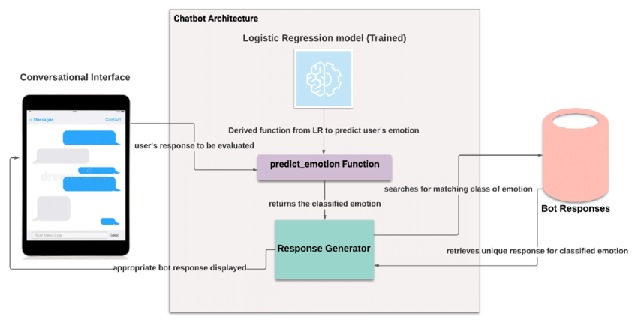

**|**

#### METHODOLOGY

The methodology for developing an AI-driven mental health companion involves several key stages:

1. **Problem Definition**: Establish goals, target audience, and ensure compliance with ethical and legal standards (e.g., GDPR, HIPAA).
2. **Data Collection**: Gather user data (mood, behavior), clinical data, and conversational data to train AI models. Use sentiment analysis and behavioral tracking to identify mental health indicators.
3. **AI/ML Model Development**: Implement Natural Language Processing (NLP) for emotion detection, personalized interactions, and therapeutic techniques like Cognitive Behavioral Therapy (CBT). Use machine learning to track symptoms and provide tailored advice.
4. **User Interaction**: Design a conversational interface for empathetic, personalized support. Provide real-time feedback and nudges to encourage positive behaviors.
5. **Privacy & Security**: Ensure strong encryption, user control over data, and compliance with data privacy regulations.
6. **Human Support Integration**: Enable escalation to mental health professionals when necessary, and provide access to emergency resources.
7. **Continuous Improvement**: Collect user feedback, retrain AI models, and implement A/B testing for continuous optimization.
8. **Scalability & Accessibility**: Make the system available across platforms, ensure cultural sensitivity, and offer accessibility for diverse user groups.
9. **Ethical Considerations**: Ensure transparency, bias mitigation, and compassionate, non-judgmental interactions.
10. **Monitoring & Evaluation**: Assess effectiveness through user outcomes, retention rates, and feedback to refine the system over time.

.

**1. RESULT**

**Index.AI mental health companion**

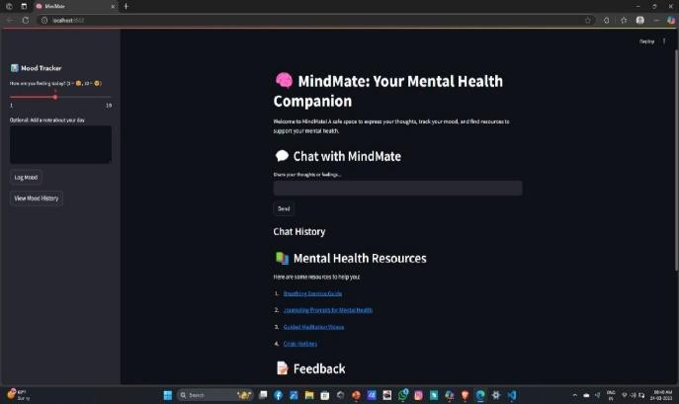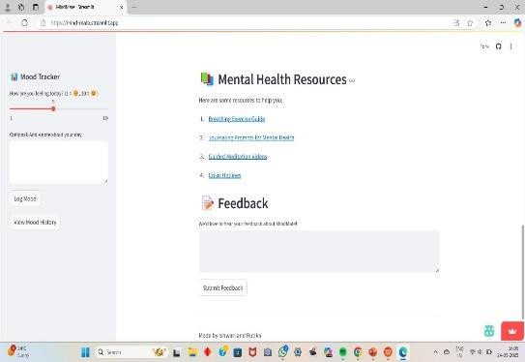**FIG.1**

**FIG.2**

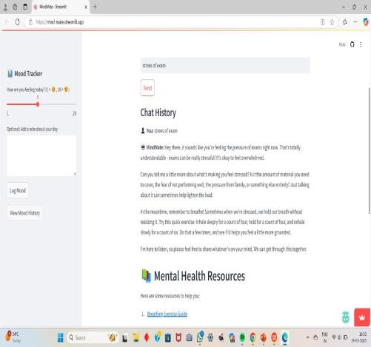**FIG.3**

1. 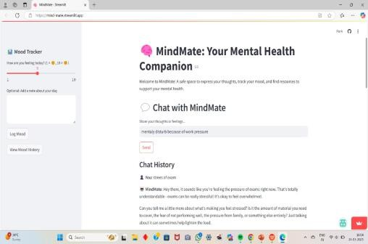**CONCLUSION**

# AI-powered mental health companions have the potential to provide accessible, round-the-clock support for individuals facing emotional distress, anxiety, or loneliness. By leveraging natural language processing, personalized responses, and therapeutic techniques, these digital assistants can complement traditional mental health services, offering users guidance, coping strategies, and a sense of companionship However, while AI can be a valuable tool, it should not replace professional therapy or medical interventions, especially for severe mental health conditions. Ethical considerations such as privacy, bias, and the limitations of AI in understanding complex human emotions must also be carefully managed.In the future, advancements in AI and human-AI interaction could enhance the effectiveness of mental health companions, making them more empathetic, responsive, and beneficial to users. As technology evolves, a balanced approach that integrates AI support with human care will be key to improving mental well-being on a broader scale.

## REFERENCES

1. Fiske, A., Henningsen, P., & Buyx, A. (2019). "Your Robot Therapist Will See You Now: Ethical Implications of Embodied Artificial Intelligence in Psychiatry, Psychology, and Psychotherapy." *Journal of Medical Internet Research, 21*(5), e13216. <https://doi.org/10.2196/13216>

# Miner, A. S., Milstein, A., & Hancock, J. T. (2017). "Talking to Machines About Personal Mental Health Problems: Ethical Considerations and Future Directions." *AI & Society, 32*(4), 511–523.

1. Gaur, M., Li, J., Seneviratne, O., & Zadeh, A. (2022). "AI and Mental Health: A Systematic *Proceedings of the 36th AAAI Conference on Artificial Intelligence.*
2. Bailey, S., & Parry, M. (2021). "Artificial Intelligence Chatbots and Mental Health: Examining the Ethical and Practical Implications." *Digital Health, 7*, 205520762110334.