STUDENT GUIDE MANAGEMENT APP

Prof. Meghna Garud 1, Vaibhavi P. Salve2, Shreya S. Shinde3, Isha S. Shivarkar4, Samiksha A. Tonde5

*1, 2, 3, 4, 5 Computer Engineering, Zeal Polytechnic, Pune, Maharashtra, India.

***ABSTRACT:. The Student Guide Management Application is an Android-based platform designed to enhance the accessibility and management of college-related information for students, faculty, and administrators. The application provides a Student Portal that offers a virtual tour of the college, access to academic details, faculty information, admission guidelines, and administrative services. Additionally, it integrates an AI-powered college guide bot to assist students with queries, ensuring a seamless experience. The Faculty Portal enables faculty members to manage their courses, track student attendance, assign coursework, and share course materials efficiently. On the administrative side, the Admin Portal plays a crucial role in user and course management, handling announcements, and overseeing virtual tour management to keep institutional operations running smoothly. The application is developed using Java for the backend and leverages Firebase as the database, providing a scalable and real-time data management system. With its structured design, the system aims to enhance communication and accessibility, ensuring that students, faculty, and administrators can easily access and manage essential college-related services in a more efficient and organized manner***

**KEYWORDS:** AStudent Portal, Faculty Portal, Admin Portal, Course Management, User Management, Attendance System, Assignment Tracking, Virtual Tour, Academic Resources, Firebase Database, Java Backend, AI College Guide, Student Login

1. **Introduction:**

The Student Guide Management Application is an Android-based platform designed to provide students, faculty, and administrators with a seamless and efficient way to access and manage college-related information. In educational institutions, students often face challenges in navigating academic resources, faculty details, and administrative processes. Similarly, faculty members require an organized system to manage courses, attendance, and assignments, while administrators need tools for user and course management. This project aims to bridge these gaps by offering a centralized application that streamlines information access and enhances communication between

students, faculty, and administration.

### Literature Survey:

Several academic institutions have implemented digital solutions to improve student engagement and administrative efficiency. Existing systems like **LMS (Learning Management Systems)** and **college portals** primarily focus on academic content and faculty-student interaction but often lack a holistic approach to integrating administrative functionalities, virtual guidance, and AI-powered assistance. Some applications provide individual solutions such as virtual tours or attendance tracking, but a **comprehensive system** combining these features into a single platform remains limited. Our project differentiates itself by **integrating a virtual tour, AI**

**chatbot assistance, faculty course management, and administrative controls within one unified system**, leveraging **Firebase for real-time database management** and **Java for backend development** to ensure smooth and responsive performance.

### Problem statement:

The primary purpose of the **Student Guide Management Application** is to provide a **centralized platform** that enhances the student experience, streamlines faculty management, and improves administrative efficiency within an educational institution. In traditional college settings, students often struggle to find relevant academic and administrative information, leading to confusion and inefficiencies. Faculty members require an organized system to manage courses, attendance, and assignments, while administrators need tools to oversee user management, course administration, and announcements. This application bridges these gaps by integrating a virtual tour, AI- powered assistance, faculty course management, and administrative controls into a **single, unified platform**. By leveraging **Java for backend development** and **Firebase for real-time data management**, the system ensures quick access to essential college- related services, reducing manual workload and enhancing communication among students, faculty, and administrators.

Furthermore, the application aims to provide a **user-friendly interface** that requires minimal training for users. The implementation of an AI- powered chatbot will assist students

in resolving queries efficiently, eliminating the need for excessive administrative intervention. Additionally, by offering real-time updates and notifications, the platform ensures that students and faculty members stay informed about important announcements, deadlines, and academic schedules. The system also aims to create a paperless environment, reducing the dependency on physical documentation and enhancing eco- friendly institutional practices. Overall, the **Student Guide Management Application** aims to improve the overall productivity and digital experience of educational institutions.

### Key Features and Functionalities

**User Authentication:** Secure login and authentication for students, faculty, and administrators using Firebase Authentication.

**VirtualTour:**A comprehensive, interactive virtual tour of the institution, allowing students to explore different campus areas.

**AI Chatbot:** An AI-driven chatbot integrated into the application to answer student queries regarding academics, faculty, and administration.

**Course Management:** Faculty members can create, update, and manage courses while students can access course-related materials.

**AttendanceManagement:** Faculty can mark attendance digitally, reducing paperwork

and improving record-keeping accuracy.

**AssignmentSubmission:** Students can submit assignments online, and faculty can evaluate and provide feedback.

**AnnouncementSystem:** Admins can post institutional updates, ensuring effective communication.

**UserManagement:** Admins can add, remove, or modify user access permissions and roles.

### 2.3.2Non-Functional Requirements

Non-functional requirements define the system’s performance and operational constraints, including:

**Scalability:** The system must support a growing number of students, faculty, and administrative users without performance degradation.

**Security:** Data security is ensured through Firebase authentication, encrypted communication, and role-based access control.

**Usability:** The user interface should be intuitive, allowing easy navigation and accessibility for all users.

**Availability:** The system must be accessible 24/7, ensuring continuous availability of educational resources and administrative tools.

**Performance:** The application should provide quick response times, ensuring smooth interactions even under heavy usage.

**Maintainability:** The system should

be modular, allowing easy updates and integration of additional features as needed

### System Architecture

The The **system architecture** of the Student Guide Management Application follows a **three-tier model**, consisting of the **presentation layer** (Android front-end for students, faculty, and admin), the **application layer** (Java-based backend handling logic and processes), and the **data layer** (Firebase for real-time database and authentication). Each user type interacts with the system through their dedicated portal, ensuring smooth

At the top, the **Presentation Layer** serves as the user interface for students, faculty, and administrators. This is where users interact with the system through the Android application. Below it, the **Application Layer** handles the core functionalities of the system, divided into three main portals: **Student Portal**, **Faculty Portal**, and **Admin Portal**. Each portal is tailored to specific user roles and manages their respective operations.

1. The  **Presentation Layer** This is the front-end interface of the app, accessed by students, faculty, and admins. It provides a user-friendly experience on Android devices.

Each user type sees different options based on their role. It ensures smooth navigation and interaction with system features.

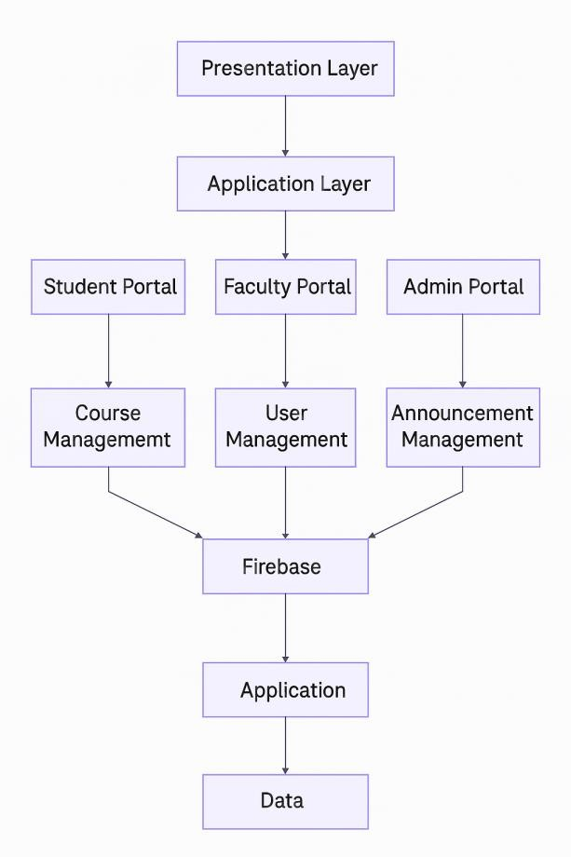

2.

**Application Layer**

This layer handles all the business logic and internal processes of the app.

It connects the user interface with the backend database.

It manages requests from different user portals and processes them accordingly. It ensures role-based access and secure handling of data operations.

# Student Portal

Students can log in to view course details, academic info, and a virtual tour.

They can access faculty details, admission info, and an AI college guide bot.

The portal is designed for easy access to essential student services.

It personalizes information based on the student’s data.

# Faculty Portal

Faculty members manage courses, take attendance, and upload materials.

They can track student progress and share assignments.

The portal offers tools for classroom and academic management.

It helps faculty stay organized and connected with students.

# Admin Portal

Admins control overall system settings and

manage user roles.

They can add/edit/delete students, faculty, and course info.

Admins also post announcements and handle virtual tour content.

This portal ensures the smooth operation of the entire application.

1. Course/User/Announcement Management These are internal modules handling specific operations.

Course management links students and faculty to relevant subjects.

User management handles login credentials and profiles.

Announcement management lets admins post important updates.

1. • Data Layer (Firebase)

Firebase serves as the real-time backend database for the app.

It stores all user data, courses, attendance, and announcements.

The system fetches and updates data instantly for all users.

It ensures security, synchronization, and

scalability of the application

# Conclusion:

**Student Guide Management Application** provides an efficient and centralized platform for managing key academic and administrative activities within an educational institution. By incorporating dedicated portals for students, faculty, and admins, it ensures role-based access, smooth communication, and real-time data

# Result: Student Portal -

handling through Firebase. The system simplifies tasks such as course enrollment, attendance tracking, assignment distribution, and announcement sharing, making processes more transparent and accessible. With its Java-based backend and Android front- end, the application supports mobility, scalability, and ease of use, ultimately contributing to a smarter, more connected campus environment.

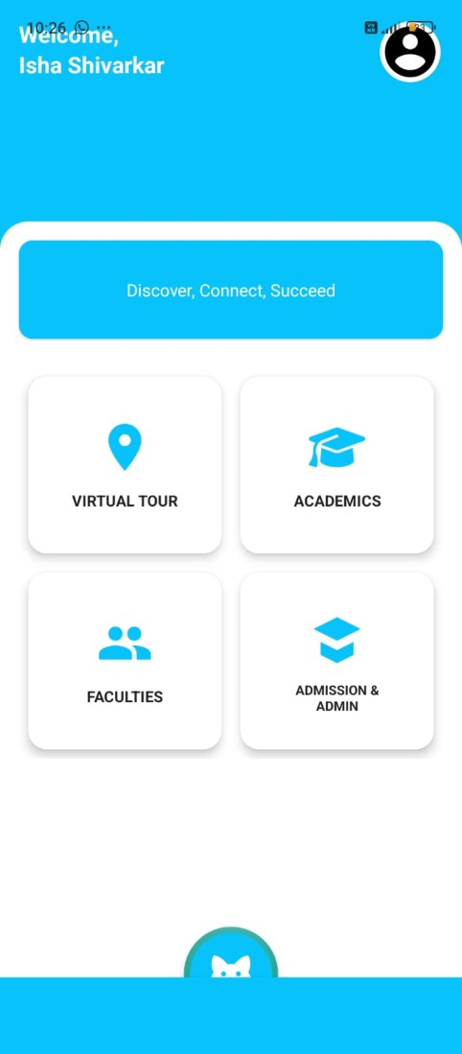 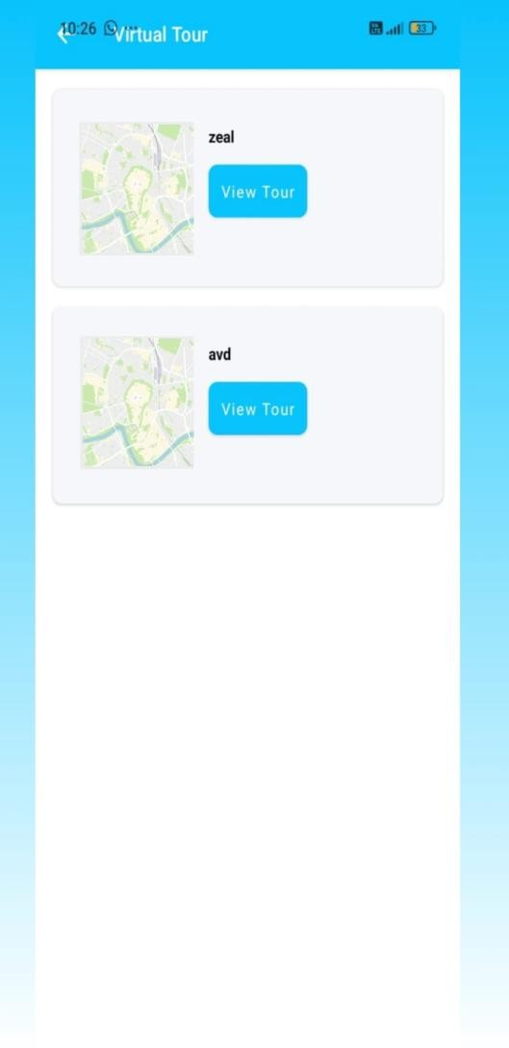

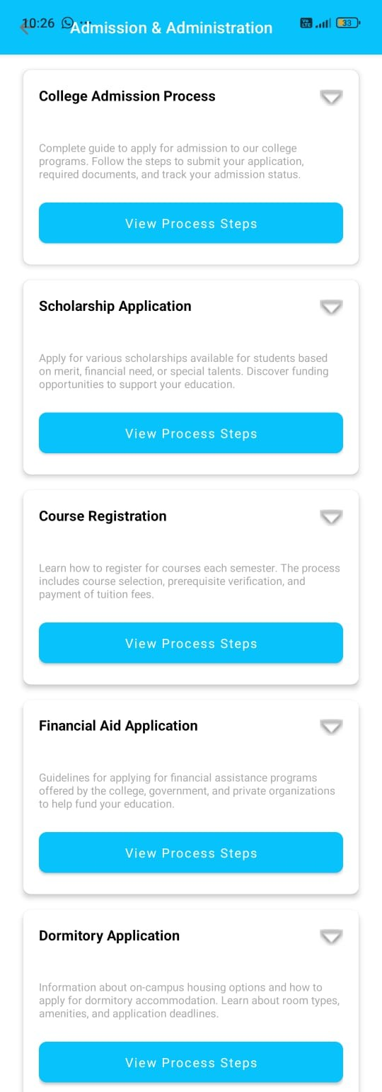 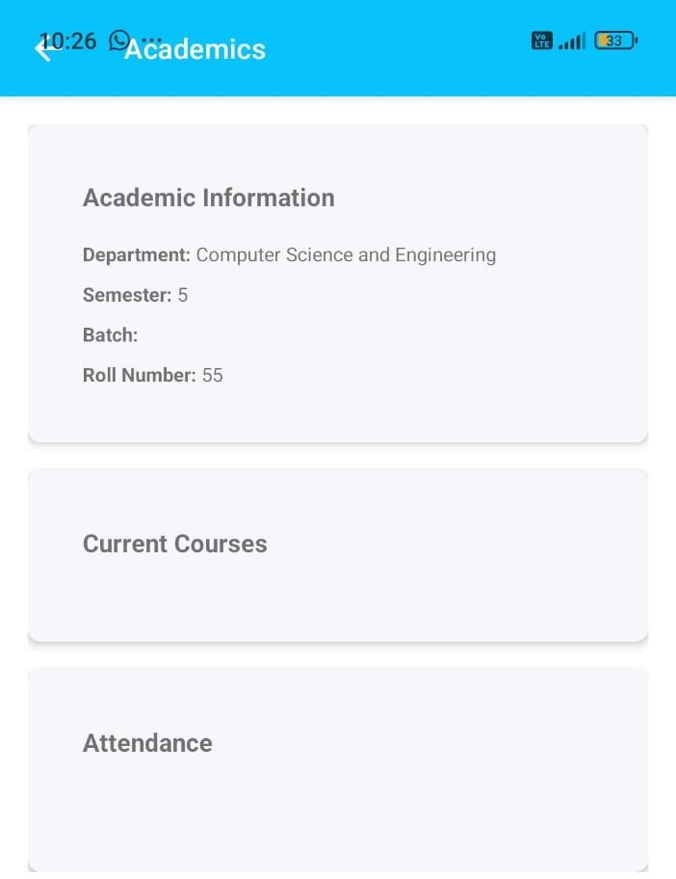

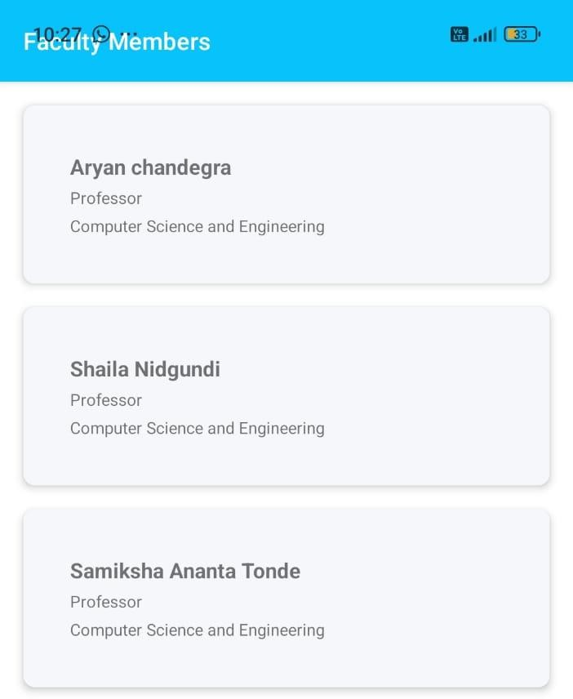 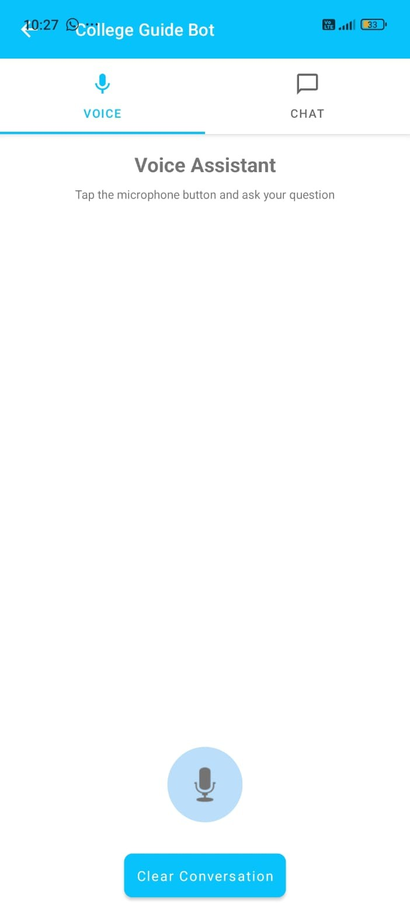

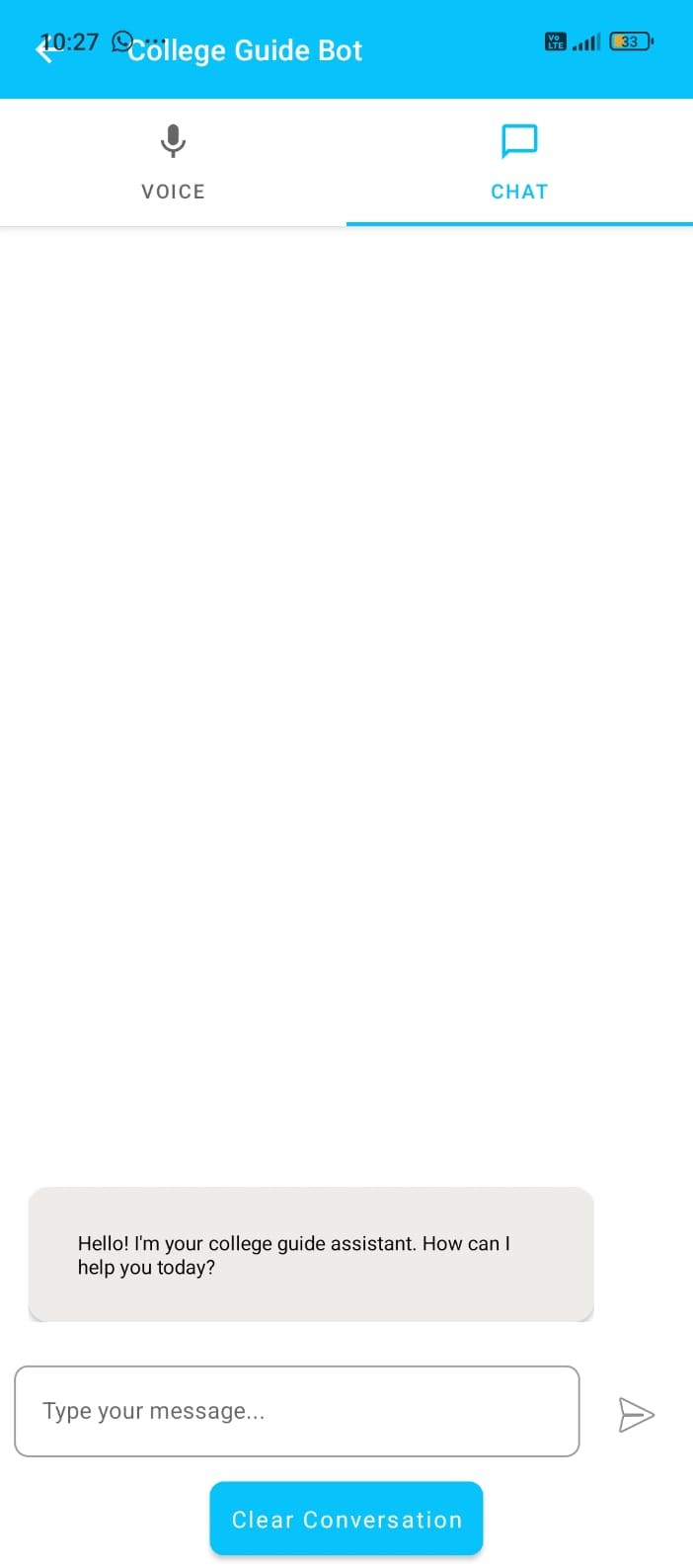 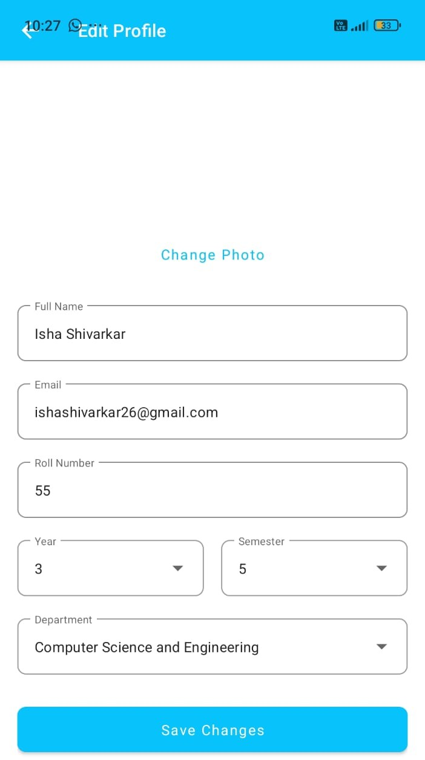

# Faculty Portal-

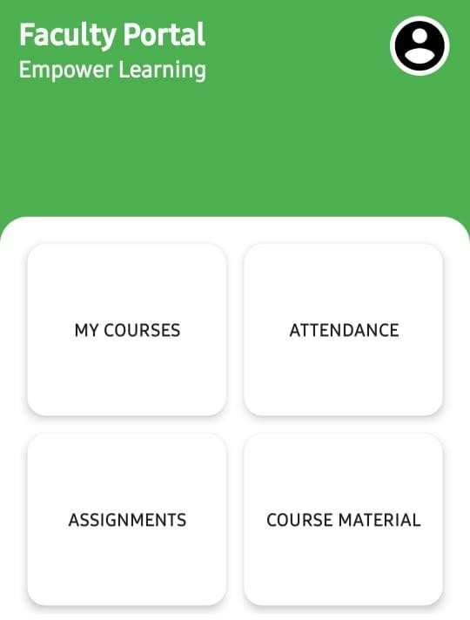 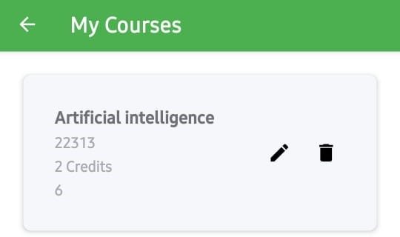

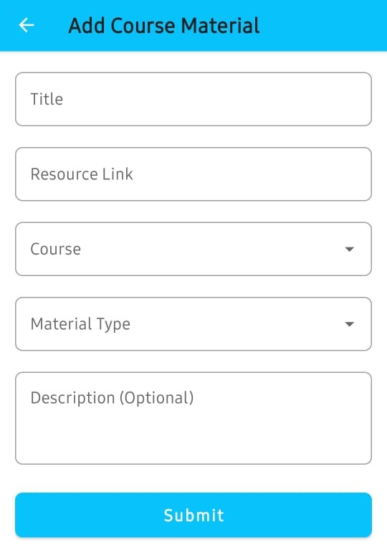 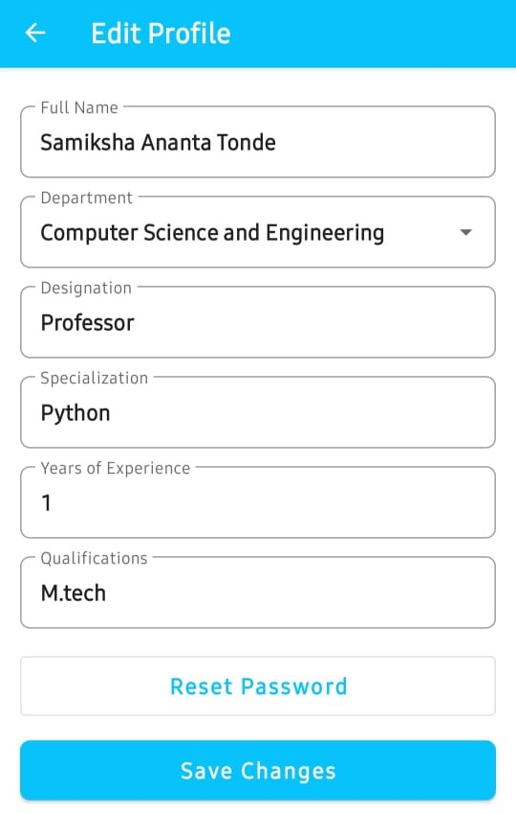

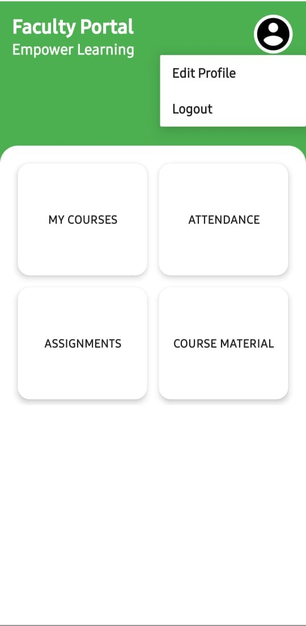

# Admin Portal-

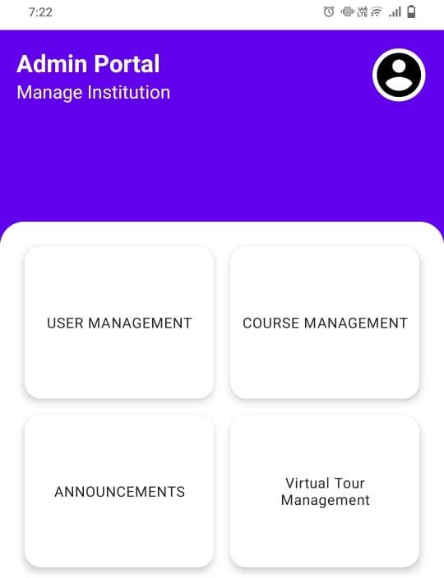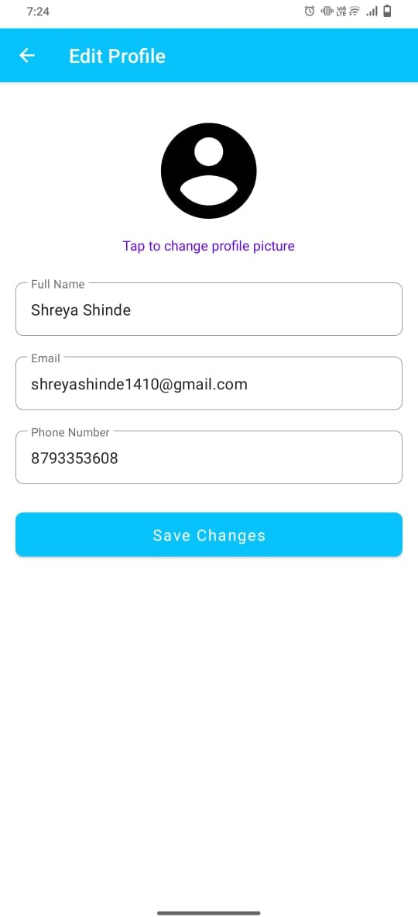

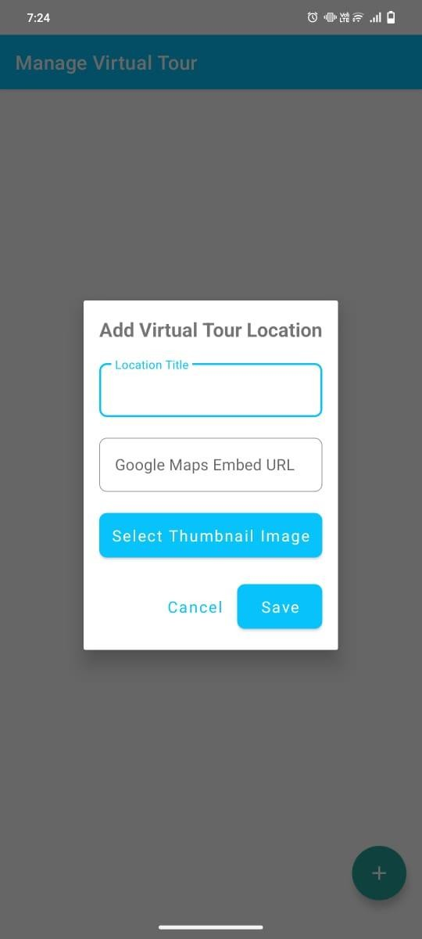 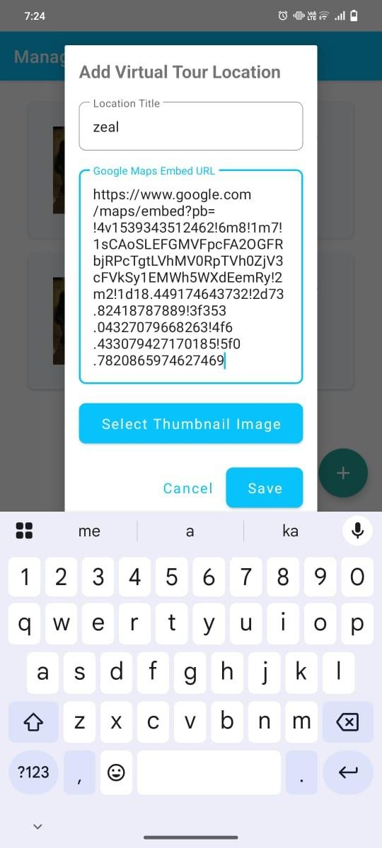

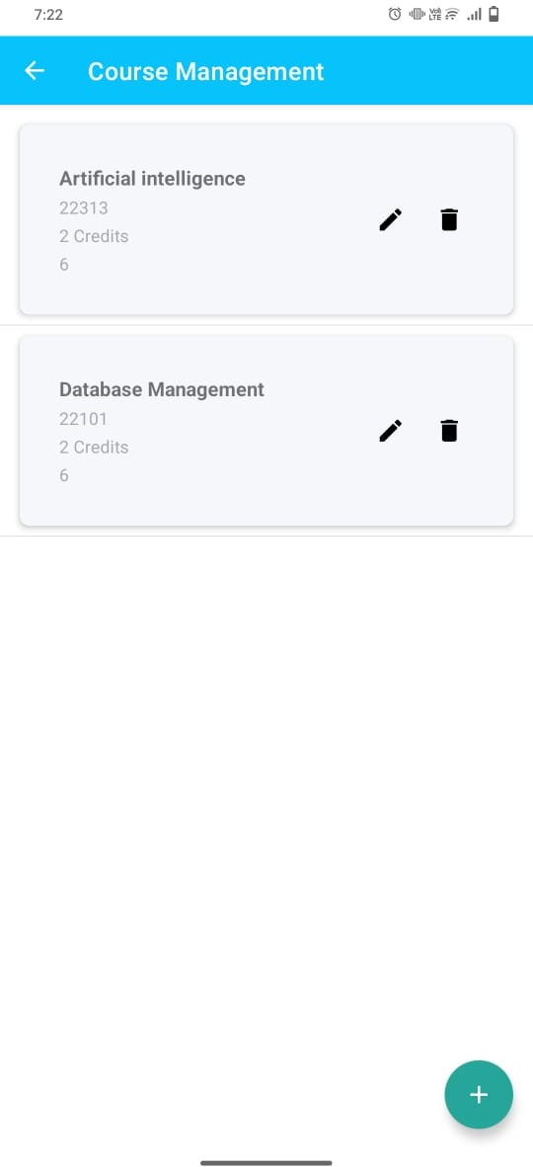 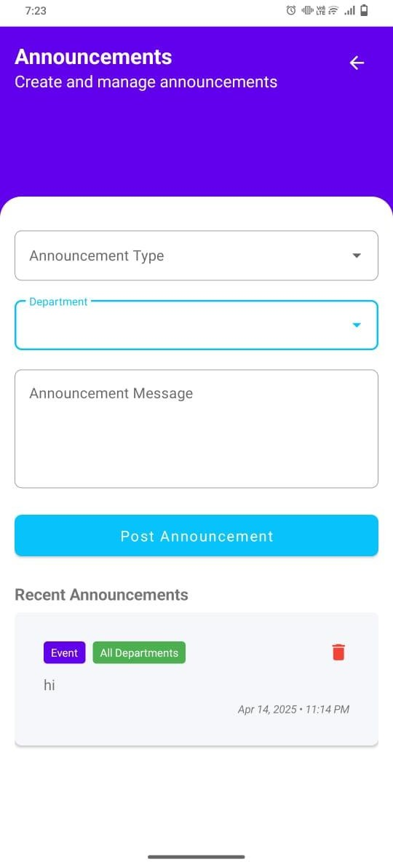

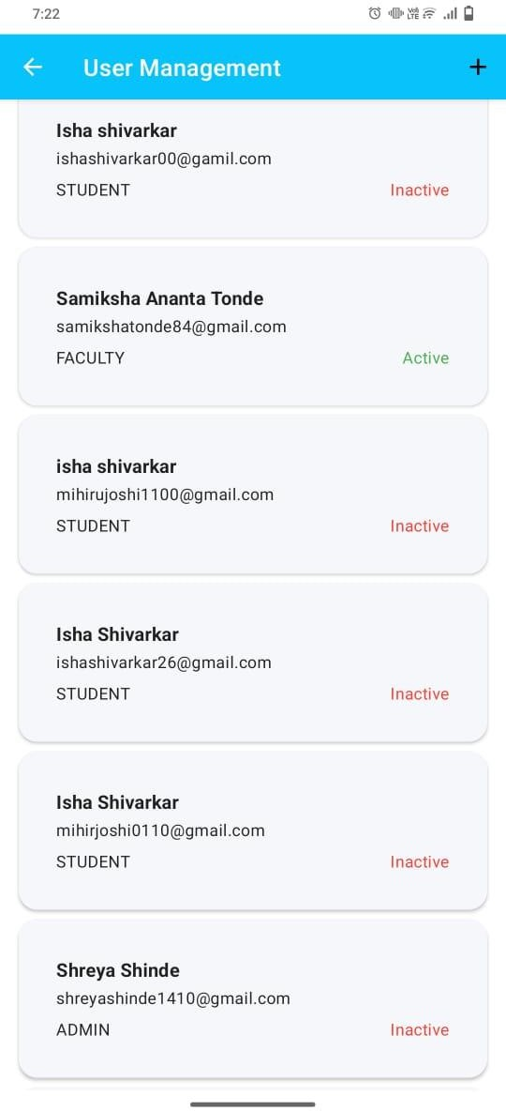

# References:

1. *(N.d.-a). * *N.d.-a). Student Guide Management System. IJIRMPS. Retrieved October 21, 2024, from* [*https://www.ijirmps.org/research-*](https://www.ijirmps.org/research-paper.php?id=230350)[*paper.php?id=230350*](https://www.ijirmps.org/research-paper.php?id=230350)
2. *N.d.-b). Donation Management System. ResearchGate. Retrieved October 21, 2024, from* [*https://www.researchgate.net/publication/37*](https://www.researchgate.net/publication/370403656_Donation_Management_System)[*0403656_Donation_Management_System*](https://www.researchgate.net/publication/370403656_Donation_Management_System)
3. ** *N.d.-c). Development of a Web-Based Charity Organizations and Donation Management System: A Case Study. ResearchGate. Retrieved October 21, 2024, from* [*https://www.researchgate.net/publication/37*](https://www.researchgate.net/publication/371575052_Development_of_a_Web-Based_Charity_Organizations_and_Donation_Management_System_A_Case_Study)[*1575052_Development_of_a_Web-*](https://www.researchgate.net/publication/371575052_Development_of_a_Web-Based_Charity_Organizations_and_Donation_Management_System_A_Case_Study)[*Based_Charity_Organizations_and_Donati*](https://www.researchgate.net/publication/371575052_Development_of_a_Web-Based_Charity_Organizations_and_Donation_Management_System_A_Case_Study)[*on_Management_System_A_Case_Study*](https://www.researchgate.net/publication/371575052_Development_of_a_Web-Based_Charity_Organizations_and_Donation_Management_System_A_Case_Study)
4. ** *N.d.-d). Implementation of Web-Based Information Systems for College Management.* [*https://doi.org/10.30880/aitcs.2023.04.02.09*](https://doi.org/10.30880/aitcs.2023.04.02.091)[*1*](https://doi.org/10.30880/aitcs.2023.04.02.091)

## N.d.-e). Educational Management System for Colleges. SSRN. Retrieved October 21, 2024, from

[*https://papers.ssrn.com/sol3/papers.cfm?abs*](https://papers.ssrn.com/sol3/papers.cfm?abstract_id=4045680)[*tract_id=4045680*](https://papers.ssrn.com/sol3/papers.cfm?abstract_id=4045680)

1. *N.d.-f). Design and Development of an Academic Information System. JINITA – PNC. Retrieved October 21, 2024, from* [*https://ejournal.pnc.ac.id/index.php/jinita/ar*](https://ejournal.pnc.ac.id/index.php/jinita/article/view/2257)[*ticle/view/2257*](https://ejournal.pnc.ac.id/index.php/jinita/article/view/2257)