Interior Design Using AI Android App

**Kaif Ansari1, Ansari Hassan2, Ansari Saad3, Ansari Zain4**

1,2,3,4Student, Department of Artificial Intelligence and Machine Learning, M.H Saboo Siddik Polytechnic, Mumbai, India.

# ABSTRACT

In the age of digital transformation, interior design is no longer confined to traditional consultations; it has embraced smart technology and artificial intelligence to offer personalized design experiences. This project presents an AI-powered Android application for interior design, developed using Java/XML and integrated with Firebase Authentication and Firebase Realtime Database for secure, real-time functionality. The app enables users to upload room images, which are then analyzed by a Generative AI model that provides tailored design suggestions, including furniture arrangements and color schemes, based on the room’s layout and lighting. An integrated NLP-based chatbot enhances user engagement by offering conversational assistance on home aesthetics and spatial optimization. Additionally, the app includes educational video tutorials that empower users with creative insights and DIY techniques. By merging Generative AI, image analysis, and interactive mobile design tools, the application offers a comprehensive and intuitive platform for reimagining interior spaces through a smartphone.

**Keywords:** Interior Design, Android App, Artificial Intelligence, Generative AI, NLP Chatbot, Firebase Realtime Database, Image Processing, UI/UX, Java, Mobile Application, Smart Home Design.

# INTRODUCTION

Interior design has significantly evolved with advancements in mobile technology and artificial intelligence. This project introduces an innovative Android application that leverages AI to assist users in designing and enhancing their living spaces. Built using Java/XML and supported by Firebase, the app allows users to upload images of their rooms, which are then analyzed by a Generative AI model to suggest personalized design ideas. With additional features like an AI-powered chatbot for real-time guidance and a video section for tutorials and inspirations, the app aims to make interior design more accessible, interactive, and user-friendly.

## PROBLEM STATEMENT

In the modern world, interior design is no longer limited to luxury—it has become a necessity for optimizing living spaces, improving aesthetics, and enhancing comfort. However, traditional interior design approaches are often expensive, time-consuming, and inaccessible to many due to the need for professional consultants and physical site visits. Additionally, individuals without a background in design struggle to visualize or plan their room layouts effectively. There is also a lack of integrated tools that combine real-time design assistance, AI-driven suggestions, and educational content in a single platform.

To address these challenges, this project proposes the development of an AI-powered Android application that simplifies the interior design process. The app allows users to upload images of their rooms, receive personalized design recommendations through Generative AI, interact with an NLP-based chatbot for expert guidance, and access tutorial videos for DIY inspiration. This all-in-one solution aims to make interior design more accessible, cost-effective, and engaging for users of all backgrounds.

# IMPELEMNTATION PLAN

## The implementation of the *Interior Design Using AI Android App* is carried out in a structured and modular approach to ensure clarity, scalability, and user-centric development. Below is the step-by-step implementation plan:

## 1. Requirement Analysis and Planning

## Description: Identify core functionalities such as image upload, AI design suggestions, chatbot integration, video tutorials, and user authentication.

## Outcome: Defined project scope, technology stack, and resource allocation.

## 2. UI/UX Design

## Description: Design wireframes and user interface using XML in Android Studio to ensure a smooth, intuitive experience.

## Outcome: User-friendly layouts for home screen, image upload section, chatbot interface, and video tutorials.

## 3. Firebase Integration

## Description: Set up Firebase Authentication for secure user login and registration, and use Firebase Realtime Database for storing user data, design history, and chat interactions.

## Outcome: Real-time sync and data storage for personalized user experience.

## 4. Image Upload & Processing Module

## Description: Enable users to upload room images from gallery or camera. These images are pre-processed and sent to a Generative AI model for design analysis.

## Outcome: Input-ready image for AI-based design suggestion.

## 5. Generative AI Model Integration

## Description: Integrate a pre-trained Generative AI model (hosted locally or via API) to provide furniture arrangement, wall decor, and color theme suggestions based on the room image.

## Outcome: Automated, personalized design outputs for the user.

## 6. NLP Chatbot Integration

## Description: Develop or integrate a chatbot using a natural language processing engine (e.g., Gemini API or Dialogflow) that answers interior design queries.

## Outcome: Real-time conversational support on design-related topics.

## 7. Video Tutorials and Learning Hub

## Description: Create a section within the app to showcase interior design tutorials, expert walkthroughs, and DIY tips using Firebase Cloud Storage or YouTube integration.

## Outcome: Visual learning resources for user inspiration and skill enhancement.

## 8. Testing and Debugging

## Description: Perform unit testing, UI testing, and end-to-end testing to ensure smooth functionality, performance, and compatibility across devices.

## Outcome: Bug-free and stable application ready for deployment.

## 9. Deployment and User Feedback

## Description: Publish the app on the Google Play Store and gather user feedback for continuous improvement.

## Outcome: Live application with real-time user data and enhancement plan.

## 10. Maintenance and Future Updates

## Description: Regularly update the app with improved AI models, new features, and updated tutorials based on user feedback.

## Outcome: Scalable and future-proof mobile application.

# SYSTEM DESIGN

The Interior Design Using AI Android app offers a seamless and intelligent platform for users to enhance their living spaces using artificial intelligence. After a secure login via Firebase Authentication, users can upload an image of their room directly through the app. This image is sent to a third-party Generative AI API, which analyzes the room’s layout, lighting, and structure to provide personalized interior design suggestions, such as furniture placement and color themes.

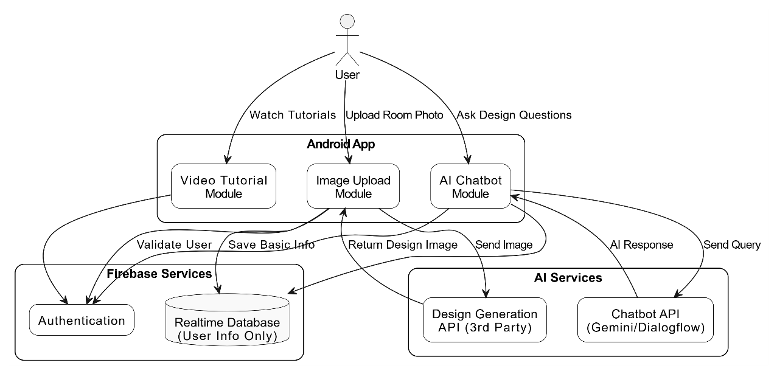

**Fig.1**: Block Diagram for Student Stress Detection System

Users can also interact with an integrated AI chatbot, powered by NLP services like Gemini or Dialogflow, to receive conversational guidance on topics like space optimization and home aesthetics. Additionally, the app features a video tutorial section where users can explore expert walkthroughs and DIY design tips. While images and responses are not stored, essential user data and session details are managed through Firebase Realtime Database to maintain personalization. The app effectively combines AI, cloud services, and intuitive UI to deliver a modern, accessible, and engaging interior design experience.

# FUTURE SCOPE

The future scope of the Interior Design Using AI Android app is vast and promising, with multiple avenues for enhancement and scalability. In the coming iterations, the app can integrate augmented reality (AR) features to allow users to virtually place furniture and decor items in their actual room environment for a more immersive experience. The AI model can also be continuously improved to offer more accurate and diverse design suggestions tailored to different cultural and architectural styles. Additionally, integration with e-commerce platforms could enable users to directly purchase recommended items, transforming the app into a complete design-to-purchase solution. Multi-language support and regional customization can further expand its accessibility to a global audience.

# CONCLUSION

In conclusion, the Interior Design Using AI Android app offers an innovative and user-friendly solution for modern interior design needs. By combining AI-powered image analysis, interactive chatbot support, and educational video content, the app simplifies the design process and empowers users to transform their spaces with ease. With its seamless integration of technology and design, the app bridges the gap between imagination and execution, making interior design more accessible, personalized, and efficient.

# REFERENCES

[1] H. Zhang, X. Li, J. Wang, and S. Hu, "AI-Based Interior Design Recommendation System Using Deep Learning," IEEE Access, vol. 9, pp. 131245–131256, 2021.

[2] S. Wang, Y. Liu, and M. Chen, "Furniture Layout Planning via Reinforcement Learning in Interior Design," in Proc. IEEE Int. Conf. Artificial Intelligence Circuits and Systems (AICAS), pp. 1–4, 2022.

[3] M. Tanaka and H. Yamaguchi, "A Personalized Interior Design Support System Using Style Transfer and GANs," in Proc. IEEE Conf. Consumer Electronics (ICCE), pp. 1–6, 2023.

[4] P. Roy and S. Biswas, "Smart Interior Design Assistance Using Image-to-Image Translation Models," IEEE Trans. Multimedia, vol. 25, no. 4, pp. 1056–1064, Apr. 2023.

[5] Y. Lee, K. Kim, and D. Han, "Mobile AI Applications for Real-Time Room Styling," in Proc. IEEE Global Conf. Artificial Intelligence (GCAI), pp. 89–94, 2022.

[6] A. Mehta and V. Gupta, "Real-Time Interior Design Visualization Using Cloud-based Generative Networks," IEEE Cloud Computing, vol. 9, no. 1, pp. 60–67, 2022.

[7] T. Li, J. Zhang, and Q. Zhou, "DesignNet: A Deep Neural Network for Interior Style Prediction and Suggestion," IEEE Access, vol. 10, pp. 14256–14265, 2022.

[8] R. J. Ng and Y. Tang, "AI Chatbots for Interactive Design Guidance: A NLP-Based Approach," in Proc. IEEE Conf. Natural Language Processing and Knowledge Engineering (NLP-KE), pp. 301–307, 2021.

[9] M. Kaur and R. Sharma, "Generative AI Models for Interior Visualization in Mobile Environments," in Proc. IEEE Int. Conf. Mobile Services (MS), pp. 55–62, 2023.

[10] L. Xu, C. Li, and A. Zhao, "Context-Aware Smart Home Design via AI-Powered Mobile Apps," IEEE Internet of Things Journal, vol. 10, no. 2, pp. 789–798, Jan. 2023.

[11] B. Singh and K. Arora, "Semantic Segmentation for Interior Image Understanding in Design Applications," in Proc. IEEE Conf. Computer Vision and Pattern Recognition Workshops (CVPRW), pp. 345–352, 2021.

[12] Z. Huang, W. Sun, and H. Luo, "Interactive AI Chatbots in Architecture and Design Education," IEEE Trans. Learning Technologies, vol. 16, no. 1, pp. 74–83, 2023.

[13] D. Patel and N. Kumar, "Deploying Deep Learning in Mobile Apps for Home Interior Customization," IEEE Software, vol. 39, no. 3, pp. 58–65, May-June 2022.

[14] Y. Chen, M. Park, and E. Lee, "Edge AI for Personalized Room Design Suggestions," in Proc. IEEE Int. Conf. Edge Computing (EDGE), pp. 99–106, 2022.

[15] F. Rahman and S. Jain, "A Survey on AI-Driven Interior Design Tools and Applications," in Proc. IEEE Int. Conf. Smart Applications (ICSA), pp. 220–227, 2021.

1. S. Kumari et al., "Enhancing College Chat Bot Assistant with the Help of Richer Human Computer Interaction and Speech Recognition," 2020 International Conference on Electronics and Sustainable Communication Systems (ICESC), pp. 427-433, 2020, doi: 10.1109/ICESC48915.2020.9155951.
2. N. P. Patel et al., "AI and Web-Based Human-Like Interactive University Chatbot (UNIBOT)," 2019 3rd International conference on Electronics, Communication and Aerospace Technology (ICECA), pp. 148-150, 2019, doi: 10.1109/ICECA.2019.8822176.
3. V. Singh et al., "ChatBot using Python Flask," 2023 7th International Conference on Intelligent Computing and Control Systems (ICICCS), pp. 1182-1185, 2023, doi: 10.1109/ICICCS56967.2023.10142484.
4. L. Tunstall et al., "Natural Language Processing with Transformers: Building Language Applications with Hugging Face," O'Reilly Media, 2022.
5. R. Arumugam et al., "Hands-On Natural Language Processing with Python," Packt Publishing, 2018.
6. S. Kublik et al., "GPT-3: Building Innovative NLP Products using OpenAI's Powerful Language Model," Independently published, 2021.
7. OpenAI Developer Channel, "OpenAI API Quickstart - Build Your First GPT-3 App," YouTube.
8. Tech With Tim, "Creating AI Chatbots Using OpenAI and GPT-3," YouTube.
9. OpenAI Blog, "OpenAI API GPT-3 Use Cases," OpenAI, 2023.
10. Towards Data Science, "How to Build a Chatbot with GPT-3," Towards Data Science, 2023.
11. Hugging Face Blog, "Building NLP Applications with Transformers," Hugging Face, 2023.
12. Analytics Vidhya, "Develop Your First AI Chatbot with Python and NLP," Analytics Vidhya, 2023.
13. LangChain Blog, "Building a GPT-powered Chatbot with LangChain," LangChain, 2023.
14. Shivam et al., "Chatbot for College Website," 2018.
15. S. Rohan et al., "Design and Development of College Chatbot," 2020.