**Leveraging Computer Vision, Recommender Systems, and AI Agents for Intelligent Pet Ecosystems**

**Udit Kumar Sharma1, Rahil Khan Zeldar2,**

**Gaurav Kumar Lakhera3, Dr. Budesh Kanwer4**

Poornima Institute of Engineering and Technology, Jaipur

[2021pietadudit053@poornima.org](mailto:2021pietadudit053@poornima.org) , [2021pietadrahil037@poornima.org](mailto:2021pietadrahil037@poornima.org) , [2021pietadgaurav062@poornima.org](mailto:2021pietadgaurav062@poornima.org) , [budesh.kanwar@poornima.org](mailto:budesh.kanwar@poornima.org)

*Abstract:*

Over the past few years, Artificial Intelligence has integrated itself into pet care and adoption services to bring forth new possibilities when it comes to human-animal interaction. PetSphere AI is a comprehensive and intelligent platform that aims to enhance the adoption and care of your pets using AI powered solutions that this paper will present. The system uses a computer vision to recognize and interpret pet movements and behavioural signs as a non-verbal interaction layer between pets and humans. In addition to this, there is a recommendation engine embedded in the platform that allows users to receive personalized recommendations for pet products, services and adoption matches based on their user preference and pet data. An AI agent is further integrated which helps in service bookings, answer user queries and provides intelligent assistance to further improve engagement of the users. The idea behind the proposed system is to fill the gap of communication between pets and humans, and to do this representatively in a centralized platform for all pet related needs. The system architecture, components, component implementation strategies and their possible effect to pet care and adoption ecosystem is described in this paper.

Keyword:

Artificial Intelligence, Computer Vision, Recommendation engine, AI Agents, Movement and Sign Detection, Intelligent Assistance, Pet Ecosystem, Human Pet Interaction etc.

1. Introduction

In today’s economically active and digitally driven world, the more you focus on providing products and building metrics of health, the less Artificial there'll ever be. Many aspects of our life have been reshaped by intelligence (AI) including how human life interacts with animals. With the growing number of pet owners and the increasing demand for intelligent pet care AI technologies are now used to builds the communication gap between humans and their pets.

It monitors and uses computer vision based on the movements of pets interpret enabling a nonverbal form of communication. Additionally, it incorporates a personalized recommendation system that suggests, or adoption matches based or services or products on user preferences and pet profiles. An AI agent is to offer automated assistance it was also integrated. These manage service requests and support across. the platform.

They are technologies that this paper explores behind. How recommendation works based on my pet’s personality was the focus of PetSphere AI.

2. How Recommendation Systems Work

Algorithms called recommendation systems provide

user choices are used for item or content proposals

behavioural patterns as well as matching users to one

another. These recommendation systems serve

in multiple platforms like Netflix and Amazon

are currently being used by and on Spotify.

smart services such as PetSphere AI. The main

concept involves selecting and forecasting

appropriate information items for individual users

among extensive databases. Recommendation

User profiles are analysed by the engines, both

it also takes direct interaction data and rating scores as well. System record of clicks and user search activities together with contextual information.

The main concept involves selecting and forecasting appropriate information items for individual users among extensive databases. Recommendation engines interpret user profiles by analysing both direct interaction data and rating scores as well as system record of clicks and user search activities together with contextual information. The system generates suggestions for products and services and content according to the data it has constructed from the user profile. Through its recommendation engine PetSphere AI proposes a collection of suitable services for pets including grooming sessions training sessions vet appointments along with food products pet accessories and potential adoption options which results in enhanced user experience and efficiency.

3. Types of Recommendation Systems

3.1 Content-Based Filtering

Figure 1: Content Based Filtering

The recommendation system retrieves items like what the user has used in the past through item attributes and individual preference records. The system will recommend new products to users who buy organic dog food by suggesting items with matching ingredients that also belong to the same brands. A user profile gathers information which new items must match to receive recommendations. Content-based filtering demonstrates its best application in recommending personal suggestions through analysis of individual user behaviour patterns.

3.2 Collaborative Filtering

Collaborative filtering relies on the concept of “wisdom of the crowd.” The system detects regular patterns among many users' behaviours to deliver recommendation services relying on liked experiences from comparable users. Item-feature detail is not necessary in this recommendation system because it only requires user-system interactions recorded with ratings or clicks. The system encounters a major drawback known as the cold-start problem because its inability to provide recommendations for both new users and items with insufficient historical data.

Figure 2: Collaborative Filtering

3.3 Hybrid Models

Recommendation systems that utilize hybrid models create a solution by integrating the optimal features from content-based and collaborative filtering systems to address their respective weaknesses. The systems employ dual algorithms that activate their specific mode according to the current scenario.

Figure 3: Hybrid Models

4. Computer Vision

Machines gain understanding of visual information through the technology of computer vision while operating in the world. The program extracts important data points from pictures or videos through the combination of picture processing technology alongside machine learning and deep learning approaches.

The detection and analysis of animal movements and behavioural patterns and gestures through PetSphere AI happens through its implemented computer vision capabilities. The system functions as an effective tool for identifying nutrition signals and playful conduct and tiredness symptoms and anxiety indications through its trained models that process animal movement varieties.

Non-verbal communication serves innovative functions for pet care by helping novice pet owners read their animals better.

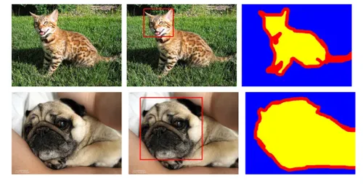

Figure 4: Computer Vision

4.1 Application in PetSphere AI

PetSphere AI's core utility relies on computer vision technology that identifies pet body changes at side behaviour indicators. The system identifies live camera feeds or video recordings through real-time monitoring for gesture detection with tail movement and ear position alongside body stance and face expression. The system translates such monitored observations into actions and emotions for creating personalized suggestions and notices.

4.2 Movement and Behaviour Recognition

A pet movement detection process begins by acquiring images which are then processed through preventive measures before identifying objects which subsequently leads to classification phases. The pre-processed video frames go through evaluation from a trained convolutional neural network for identifying pet species detection and key movement analysis in the images. The nervous state of a pet becomes evident when it performs repetitive paw movements while calm eye behaviour conveys its need for interaction. The acquired information enables the development of specific communication outputs together with recommendation proposals.

4.3 Image Acquisition and Preprocessing

The PetSphere AI system performs image acquisition using a combination of live cameras and phone feeds for acquiring images and video frames of the pets. The raw images are exposed to numerous challenges resulting from noise interference, irrelevant background information, changing illumination, and camera motion blur. Preprocessing is an obligatory practice before analysis since it improves the quality of the input data before initiating standardization processes.

The very first steps of image processing are comprised of three traditional techniques starting with the grayscale transformation as a process to ease computations, followed by median filtering or Gaussian blur to suppress noise and supplemented with normalization to offer uniform scaling of pixels. Sufficient preprocessing results in better model performance and supports faster and uniform detection of pet movement.

4.4 Feature Extraction

Feature extraction is the process of identifying significant visual elements from an image that contribute to distinguishing pet actions or behaviours. In PetSphere AI, this involves detecting and tracking body landmarks. Techniques like edge detection, key point identification e.g., using Media Pipe and CNN embeddings are employed to extract these features effectively.

The features extracted are the foundation of the underlying classification of individual gestures or behaviours, thus allowing the system to provide correct and contextually appropriate responses or service recommendations.

4.3 Challenges and Limitations

The detection system is wrong if animals move rapidly from one zone of cameras to another and if more than one pet overlaps the camera field of view simultaneously. Acquiring appropriate animal datasets is a principal challenge since effective identification systems must be developed, despite playing a vital part in correct gesture analysis.

Recognition accuracy is affected by the presence of different pet breeds, size variations, texture differences in fur, and the influence of ambient light conditions.

5. AI Agents

An AI agent acts autonomously while also serving in parts as a service that translate environmental data into interpretation to meet its declared goals.

The sense-think-act paradigm provides a working framework for AI systems to learn sensory input before they can perform intelligent operations for generating appropriate actions.

Software agents utilize their structural design to gain complete functionality which enables them to address multiple tasks from answering elaborate customer inquiries to making merchandise suggestions and performing time-sensitive process sequences.

Technology companies use their agents to operate in four main business domains including customer service and healthcare institutions as well as personal assistance systems and the PetSphere AI smart pet platform.

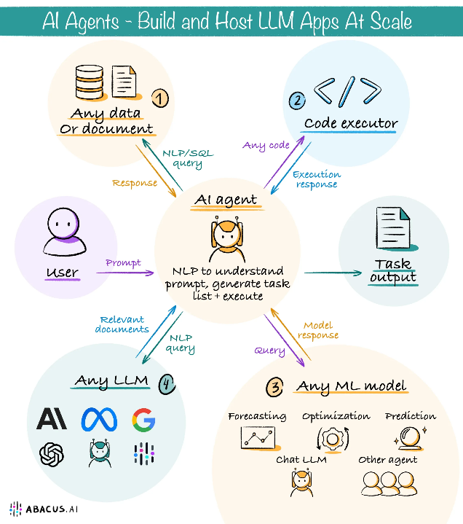

Figure 5: AI Agent

5.1 Integration of AI Agents in PetSphere AI

The decision-making capabilities and intelligent adjustments in PetSphere AI function because of its employed AI agents. These system elements operate as user guides in the services to provide booking functions for pet care, veterinary procedures and behavioural evaluations.

The user needs to understand the reason behind their cat making constant vocalization. AI provides modified results by processing information from databases in combination with behavioural data at each specific time.

5.2 Use of LangChain and LLM-Powered Agents

Through LangChain users can effortlessly unite large language models (LLMs) with dynamic real-time information and external application programming interfaces (APIs) and choice trees.

PetSphere makes use of LangChain agents to perform three functions: The application provides answers to user questions regarding animal behaviour patterns.

The system generates recommendations which derive from user preferences and computer vision outputs.

• Guide users to relevant services or professionals.

The system enables agents to conduct separate operations through modular conversations which allows them to execute diverse functions like providing recommendations and emotional support and planning daily activities.

5.3 Benefits and Limitations

AI agents build better engagement with customers through automated personalization of the system. The models perform with precision, yet their effectiveness depends on the input training sets and they might sometimes fail to understand intents or specific domain terminology adequately.

6. Methodology

Machine learning capabilities integrated with intelligent agents and computer vision operate within Petsphere AI systems to execute pet operations that produce recommendation results through gesture recognition. The system functions through connecting separate individual components that operate as processing pipelines for continuous execution of PET care procedures.

6.1 Data Acquisition

Real-time pet images and videos get collected through the combination of surveillance cameras and mobile devices as well as pre-recorded video inputs. The system uses visual data as an entry point for performing behaviour analysis. Organizational databases store user-provided information about pet breed together with age along with health conditions and preferences to enable personalized recommendations.

6.2 Preprocessing and Feature Extraction

The visual data collection process applies preprocessing via grayscale conversion and resizing and normalization and denoising to achieve appropriate data quality. Identifying body movements through key point detection and motion tracking features extracts information about tail wagging and changes in posture and ear tilts and facial expressions.

6.3 Behaviour Classification and Interpretation

The system detects pet behaviours through pre-trained deep learning analysis (for instance CNNs and pose estimation frameworks) which generates categories such as hunger-related actions and signs of anxiety and playfulness and discomfort signals. The system interprets predicted results by comparing them to established historical patterns to maintain accuracies.

6.4 Recommendation System Pipeline

The recommendation engine generates suitable actions such as feeding schedules, veterinary guidance and toy recommendations and relaxation techniques through a combination of detected behaviour and saved pet file information.

6.5 AI Agent Interaction Layer

LangChain serves as an AI agent to provide communication functionality that connects the system with end users. The system first understands verbal requests then analyses live video feeds and finally retrieves results from the recommendation system. Resource distribution through this mechanism allows users to communicate while obtaining personalized assistance.

6.6 System Architecture

The complete pipeline implements a microservices architecture so that vision, recommendation, and agent interface modules operate separately from one another. The design enables the system to scale while also promoting maintainability combined with simplified update procedures. APIs establish a smooth exchange of data between individual system parts.

7. Conclusion:

The unique technology PetSphere AI bridges visuals with recommendation platforms and AI agents which have been specifically developed for pets and their owners. This system develops real-time behavioural insights from visual evidence to match them up with custom service recommendations with the purpose of connecting pets to their owners.

The utilization of agents powered by large language models enables users to have meaningful natural interactions which simplifies operations such as behavioural analysis and service acquisition and health tracking. The design of PetSphere AI enables future development toward a complete smart assistant system for pet care operations.

Enhanced performance and practical usage of the current prototype will be achieved through future developments involving many pet recognition capabilities alongside emotion detection systems and expanded integration with IoT devices for pets. The conducted research enables the development of advanced robotic ecosystems for pets that utilize artificial intelligence systems.

8. References:

1. *He, K., Zhang, X., Ren, S., & Sun, J. (2016). Deep Residual Learning for Image Recognition. In Proceedings of the IEEE Conference on Computer Vision and Pattern Recognition (CVPR), pp. 770–778.*
2. *Redmon, J., & Farhadi, A. (2018). YOLOv3: An Incremental Improvement. arXiv preprint arXiv:1804.02767.*
3. *Zhang, Y., Gong, Y., Zhang, Z., & Xiao, J. (2021). Vision-based Animal Behaviour Recognition: A Review. Computers and Electronics in Agriculture, 189, 106367.*
4. *Burke, R. (2002). Hybrid Recommender Systems: Survey and Experiments. User Modelling and User-Adapted Interaction, 12(4), 331–370.*
5. *Ricci, F., Rokach, L., & Shapira, B. (2011). Introduction to Recommender Systems Handbook. Springer.*