Holographic Display With Real Time Interaction

17.Gaurav Bobade 57.Anandi Mahanad

Project Guide: Mr. U. S. Shirshetti


ABSTRACT: This project, titled "Holographic Display with Real-Time Interaction," explores a new way of interacting with digital content—by bringing it into the air, right in front of you. Instead of looking at flat images on a screen, this system creates 3D holograms that appear to float in mid-air, no special glasses needed. What makes it even more exciting is the ability to interact with these visuals in real time. Using hand gestures, you can rotate, zoom, or move the holograms, almost like reaching into the air and grabbing the content. This is made possible by combining gesture sensors like Leap Motion or Kinect with microcontrollers such as Arduino or Raspberry Pi. The whole setup is powered by familiar components and software, making it relatively affordable and easy to build. Whether it's used in classrooms to explain complex subjects, in hospitals to visualize medical scans, or in product demos and gaming, this holographic system offers a futuristic, hands-free experience that feels intuitive and exciting.

1. INTRODUCTION

This project, "Holographic Display with Real-Time Interaction," reimagines how we interact with digital content by bringing 3D visuals into the air—no screens or special glasses needed.

Using gesture sensors like Leap Motion or Kinect, users can control these floating images with simple hand movements. Built with affordable components like Arduino or Raspberry Pi, the system offers an intuitive, touchless experience that's perfect for education, design, healthcare, or just exploring new ways of visual interaction.

2. WORKING OF GESTURES

The gesture control system lets users interact with the holographic display using simple hand movements—no need for a mouse or touch screen. Sensors like Leap Motion or Kinect track the position and motion of the user's hands in real time. These gestures are then converted into commands, such as rotating,

zooming, or switching between holograms. The data is processed by a microcontroller or computer, which updates the display instantly, creating a smooth and responsive interaction that feels natural and intuitive.

3.HARDWARE COMPONENTS

o | Transparent | Display
 | Surface:(e.g., acrylic glass or
 | holographic | pyramid) | –
 | creates the 3D visual effect.
o | Gesture |  | Sensor:
 | tracks hand movements for real-
 | time interaction.

o Microcontroller or Processor: (Arduino or Raspberry Pi) – processes input and controls display behavior.

o Display Device: (Smartphone, tablet, or monitor) – projects the holographic visuals.

- Power Supply:

(USB power or battery pack) – provides power to the components.

- Cables & Connectors:

For connecting sensors, display, and microcontroller.

  - Support Frame/Stand:

Holds the entire setup at the correct angle for optimal holographic projection.

- BLOCK DIAGRAM
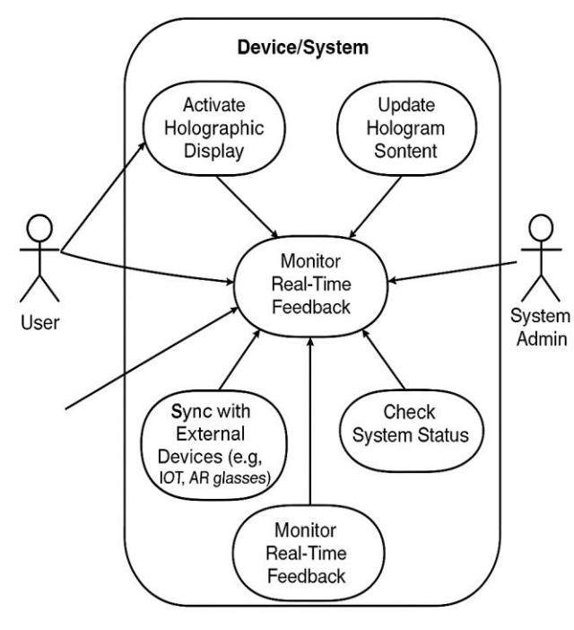

5.WORKING
The "Holographic Display with Real-Time Interaction (Garry)" project aims to create an immersive experience by allowing users to interact with 3D holograms in real-time. Imagine being able to touch and manipulate a hologram floating in mid-air, just like in science fiction. This project blends cutting-edge technology to project holographic images while tracking your gestures, movements, or touch. By using tools like motion sensors and augmented reality, the system lets you engage with these virtual objects as if they were physically present. The possibilities are vast— whether for gaming, education, or design, this project brings a whole new level of interaction, making technology feel more intuitive and hands-on.

6.APPLICATIONS

The "Holographic Display with Real-Time Interaction (Garry)" project has diverse applications, including in education, where it can visualize complex concepts for interactive learning. In gaming, it offers immersive experiences by allowing players to interact with holographic environments. For design, it helps professionals visualize and prototype in 3D. In healthcare, it aids in diagnosis and surgery planning using 3D scans. It also enhances virtual collaboration by allowing teams to work together in shared holographic spaces, and in retail, it enables customers to interact with 3D product models before purchasing. This project transforms digital interaction across various fields.

1

7. CONCLUSION

In conclusion, the "Holographic Display with Real-Time Interaction (Garry)" project represents a groundbreaking step in how we interact with digital content. By merging holographic technology with real-time user interaction, it opens up new possibilities across education, gaming, design, healthcare, and beyond. This technology not only enhances user engagement but also offers practical solutions for a variety of industries, making digital experiences more intuitive, immersive, and impactful. As the project continues to evolve, it has the potential to revolutionize the way we engage with information and collaborate in the digital world.

REFERENCES:

The "Holographic Display with Real-Time Interaction (Garry)" project also builds on the foundation laid by pioneers in human-computer interaction (HCI), where advancements in intuitive user interfaces have focused on making digital systems more accessible and engaging. The work of researchers like S. K. H. Xie (2018) on multi-touch and gesture-based interactions provides a framework for developing natural methods of controlling holograms in real-time. Moreover, the field of depth sensing, as explored in studies by S. L. Leprince and R. W. Zeldman (2020), has significantly advanced the capability to capture and interpret 3D gestures, making it possible to create seamless interactions between users and holographic projections. Real-time computing systems and algorithms, such as those utilized in cloud-based rendering services (e.g., Amazon Web Services’ EC2 and Google Cloud), offer scalable solutions for processing and delivering high-quality holographic content on-demand, ensuring smooth and responsive user experiences.

The integration of augmented reality (AR) technologies has been further enhanced by contributions from institutions like MIT and Stanford, where AR and mixed reality (MR) platforms have continuously evolved, allowing for more immersive and interactive digital experiences. The HoloLens, developed by Microsoft, is one of the flagship products that has advanced the development of holographic displays, offering a blend of AR and 3D visualization to bring virtual elements into the real world, thus providing inspiration for this

2

project’s real-time interactive elements. Similarly, technologies like Light Field Displays (as studied by R. L. Jacobsen et al., 2020) have helped push the limits of 3D visualization by offering more natural and convincing holographic effects.

In the healthcare sector, the use of 3D models and holograms for training and surgery is supported by extensive studies such as those by J. P. Khusainov et al. (2021), where holographic systems were tested for use in surgery simulation, providing precise anatomical visualizations that aid medical professionals in understanding complex structures. Additionally, the application of holograms in retail, as examined in research by A. M. W. Zhou et al.

(2022), suggests that such technology can enhance consumer interaction with products, making online shopping experiences more tangible and engaging.

The collective insights from these various fields converge in this project, offering an integrated approach that leverages the latest developments in holography, real-time computing, interactive design, and spatial computing to create an

innovative and immersive experience. As more industries begin to explore and adopt this technology, it promises to significantly impact fields such as education, healthcare,

design, and entertainment, transforming how we interact with both virtual and physical worlds.

