Home-Nest (Client Management, Service Tracking, Appointment Scheduling)

***Sushant Vishwas Palkar1,*** *Zeal Polytechnic, Pune, India.* ***Pranav Devidas Sukhadeve2,*** *Zeal Polytechnic, Pune,India* ***Omkar Pratap Pandarkar3,*** *Zeal Polytechnic, Pune, India.* ***Rajvardhan Sandeep Rajale4,*** *Zeal Polytechnic, Pune,India.* ***Prof. Savita Biradar5,*** *Zeal Polytechnic, Pune, India.*

***Abstract:*** *Normally associated with smart homes, HomeNest is the solution for upgrades to the Android platform. You can improve your home living space with the latest automation gadgets, or you can seek expert assistance in setting it up. Instead, HomeNest has everything on a single platform. No more hopping from one website to another or calling for services saying: Tap- Browse-and Make your Dream Smart Home Living Reality.Finding products, scheduling installations, tracking orders: HomeNest does all so that you don't have to. It goes further to provide timely reminders for your bookings, confirm them, and gives you all that is going on until the task is done. You save time, energy, and a whole lot of hassle.There's room in HomeNest for everyone. Homeowners can surf across an array of home automation products, book unique services with professionals, and be greeted with real-time updates—all through a smooth, intuitive app. Meanwhile, they also receive a dashboard feature to manage appointments, track progress, and most importantly stay organized while on the go.Homeowners and managers can avail themselves of powerful tools to view sales, track inventory, analyze customer requests, and better understand insights into scaling the business, all from a single place.HomeNest provides you with protected cloud storage, an in-house CRM, and instant payment gateway facilities. It keeps your data secured and makes your experience smooth for you.*

# INTRODUCTION:

With HomeNest, you are talking to your comforting smart home partner-an easy-to - use e-commerce app with a complete home automation product and service at your finger tips. Buying that latest model or gadget does not bother you because at HomeNest, the whole process is made easy and stress-free.

HomeNest is your one-stop shop for innovative products, and even more, professional installations; no longer do you need to look through websites or have technicians running

around trying to find what you need-an exclusive all-in-one place. You can browse through categories, compare, read reviews, book your service, and track orders all from your phone.

Well, it is not an app for shopping alone; it is for control. App pushes timely updates, reminders, and confirmations keeping you in the loop at all times. Plus, intelligent automation takes care of all mundane routine things such as service follow-ups, inventory checks, saving you time and effort.

In addition to offering an exclusive space for service providers themselves and their technicians for proper management of appointments, tracking progress, and keeping up with their daily tasks, HomeNest also makes it easy for business owners to keep track of

performance, check sales, manage stocks, and provide insights to help grow their business.

Whether you're upgrading in a single room or constructing a fully connected smart home, HomeNest has you covered when it comes to building a smarter lifestyle-in comfort, ease, and confidence. Smart living made easy, isn't it

Proceeding here, the designers of HomeNest enable the general public to experience comfort living involved with smart homes while allowing businesses to provide outstanding service, thus maintaining a conducive working atmosphere with fully motivated employees through streamlined day-to-day operations and the automation of routine processe

# OBJECTIVE:

* + **Central management for home appliance:**

Users would have an easy time using a single smart technology solution for light, security, entertainment, and energy systems-hassle experience-free.

# Updates and Notifications at Live Time:

Create real-time updates and notification services regarding the in-device energy consumption or unusual activities, keeping users constantly informed and controlling to their homes.

# Smart Scheduling & Automation:

Makes it possible for users to easily set their routines and automate simple tasks like turning on lights, running appliances, and locking doors, saving time, energy, and effort.

# Enhanced User Experience Customization:

Offer an extremely personalized dashboard attuned to each individual's lifestyle, customized settings from voice control to dedicated app integrations, for a truly enriching living experience.

# Addressing Current Market Gaps:

In the present fast-changing smart technology, there are still bastions of most users trying to juggle several apps or clunky legacies that do not marry into the system. HomeNest comes on being all-in-one, scalable, and easily reliable and will be ready for the future.

House service businesses often suffer confusion, double bookings, and delayed schedules due to juggling multiple tools and manual systems. With increased expectations from homeowners and rising competition, it has become apparent that a smart all-in-one digital platform to keep everything in order is needed now more than ever.

HomeNest was built for this specific need— real-time updates, easy co-ordination of staff, and an uncomplicated way of service tracking. Basically, it is safe to say that it is not only a time saver: it improves customer relationships, aligns teams, and minimizes stress when it comes to daily operations

1. **BACKGROUND :** Home

automation services are increasingly finding their place in the main stream where increasing income is becoming the order of the day. Daily operation management with respect to product purchases, service bookings, technician dispatch schedules can therefore become crazy for such businesses. A lot of them still cling on to the old form of handwritten logs, spreadsheets, or even a cocktail of separate application solutions when it comes to keeping things running. These have probably worked once but fade into obsolescence once you put them into perspective against today's fast-moving, customer-first world which requires real-time updates, efficient coordination, and smooth communication as an inevitable part of daily operations. And without one single source of truth, it happens: Double-booking, she doesn't arrive to install the appliance, and nothing gets communicated back from customer service. This is how service managers and providers get really unhappy- not what is mentioned earlier, but the customer experience at large. HomeNest was built to cater to these needs. It is an out-of-the-box solution platform designed specifically for the home automation industry- as a simplified operations solution,

transparency boost, as well as bringing teams and customers to the same platform. Whether booking a service, managing staff schedules, or tracking order status, HomeNest pulls it all into one seamless, easy-to-use system.

# LITERATURE SURVEY:

1. **The home maintenance management systems**
   * Overview : the mapping of home service management systems is the total online solutions for service bookings, customer data handling, technician scheduling, inventory tracking, and billing provisions. It enables businesses to work smartly and improve workflow through increased productivity in customer experience delivery.
   * Related Studies: According to M. S. Anwar et al. (2019), a cloud-based service management platform in which the business owner can manage appointments-set, customer data, and service performance of the whole application-is presented.

* HomeNest Centralized platform for customer and technician data.
* Scalability and remote control cloud enabled architecture.
* Having built-in features for job scleheduled and for customer relationship tracking.

# Appointment Planning and Customer Engagement Systems. :

* + Overview: These systems enable scheduling of client appointments, allotment of technicians, and maintenance of records concerning technicians' availability-all without double bookings and missed appointments. They also retain customers' preferences and history for a personalized experience.
  + Relevant Studies:R. Kumar et al. (2018) defined a real-time mobile-based appointment system with updates instantly sent to the customer and technician.
* **Seamless online booking and rescheduling to reduce wait times.**
* **Smart notifications for confirmations, reminders, and changes.**
* **Preference-based matching to boost customer satisfaction and loyalty.**

1. **Technician and Work Force Management Platforms:**

* Overview these have to do with facilitating businesses in service work force management-everything from task delegation and shift following to payroll and performance analysis are covered in this kind of process of managing. A well-structured team is likely to give faster and more perfect service delivery.
* Relevant Studies: The task scheduling and performance tracking systems were defined by V. Bhargavi et al. (2017) for technician assignment and payroll calculation, which have been made easy and manageable for lesser backend workload.
* Real-time attendance tracking and shift planning for better coordination. Task assignments with status tracking and notifications. Employee performance analytics to improve productivity and team morale**.**

# Point of Sale (POS) and Billing Systems

* Overview: In the home service space, POS and billing systems are the backbone of financial operations. They handle everything from processing payments and generating invoices to syncing with inventory and expense tracking. A reliable billing system ensures transparent, seamless transactions for both clients and service providers.
* Relevant Studies: S. Mehta & D. Sharma (2019) developed an integrated POS system that allowed salons to manage real-time sales, generate invoices, and monitor inventory simultaneously.
* Integration with secure, multi-channel payment gateways for smooth transactions.
* Auto-generated invoices for each completed service, with optional digital delivery.
* Flexible billing models to support different service packages, discounts, and promotions.

# Inventory and Product Management Systems :

* + Overview: For home service businesses, keeping tabs on tools, spare parts, and cleaning or repair supplies is crucial. Inventory systems help track product usage, send restock alerts, and ensure technicians are always equipped to get the job done without delays.
  + Relevant Studies:K. N. Gupta & A. Kumar (2018) explored how automated inventory tools in salons helped reduce shortages and overstocking by generating real-time reminders and purchase orders.
* Smart alerts when essential items are running low, helping prevent last-minute scrambles.
* Automated reordering systems linked to suppliers for restocking efficiency.
* Real-time inventory updates after each service to maintain accurate product logs.

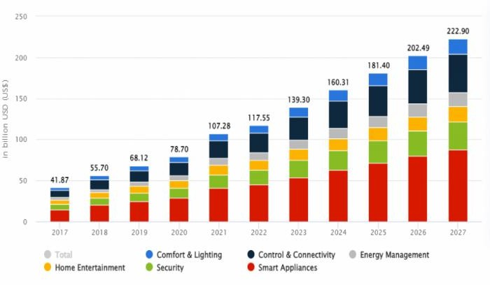

Fig. 4.1 Things used in Home Automation in Industry & Household

1. **FEATURES AND WORKING :**
   1. **Registration page :**

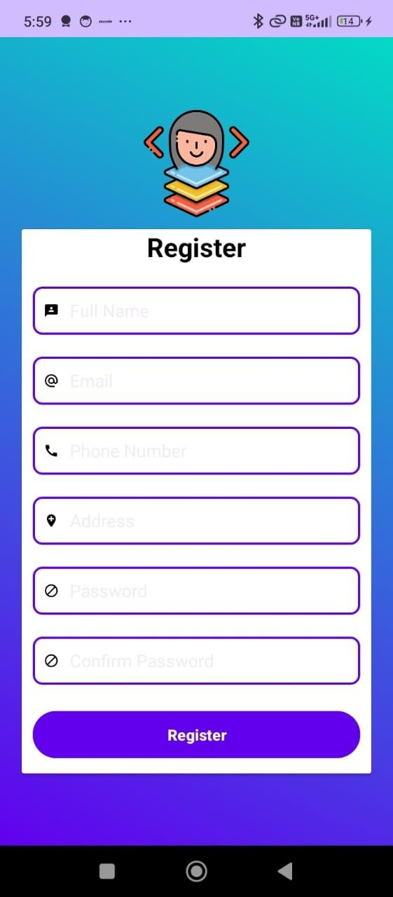

**Fig. 5.1 Register Page**

* With the incorporation of input validation, some social login options may be made available for easy sign-up.
* Once the data has been submitted or filled in by the user, it is checked and securely stored in the system. This usually entails sending out a confirmation e-mail or SMS for account verification.

# Product Page :

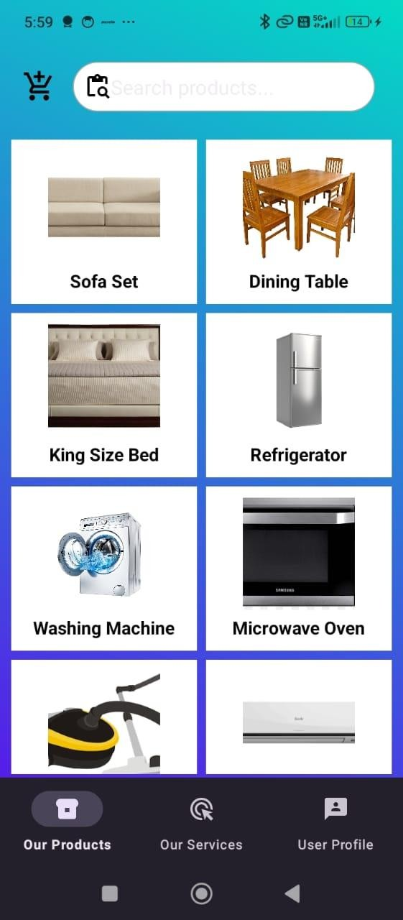

**Fig. 5.2 Product Page**

* Products of home automation are displayed on this page together with detailed information such as images, descriptions, pricing, and customer reviews.
* Customers are allowed to choose options for the product and put some in the cart, along with helping to explore related products. comparative layout as well as a wishlist option are supported

# Services Page:

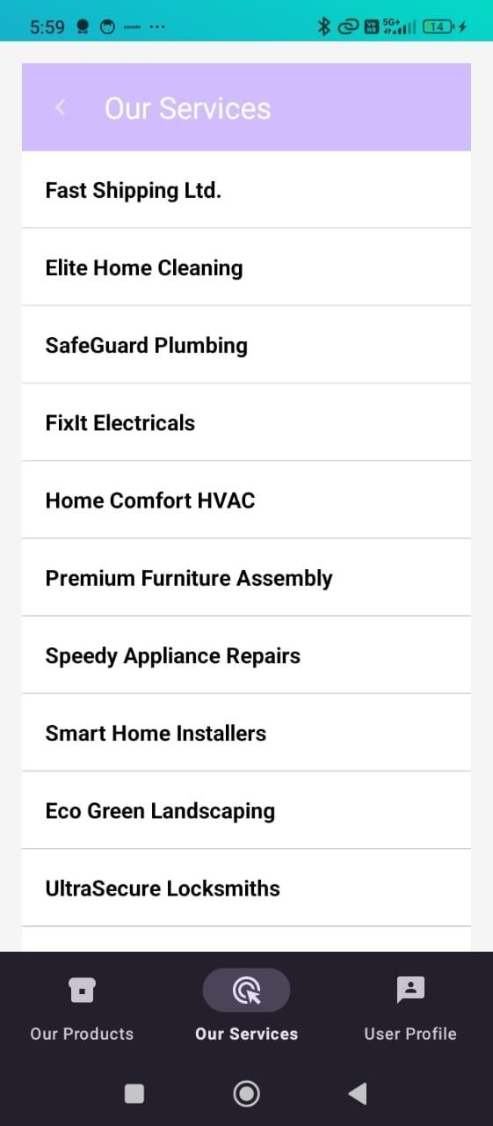

**Fig. 5.3 Services page**

* + - Home automation services include installations, upgrades, or custom

setups, along with pricing and service specifications used to obtain these respective services.

* + - This service allows users to book for these services straight. They can select the date and time for either delivery or installation before they proceed with payment, where applicable

# Shopping Cart Page :

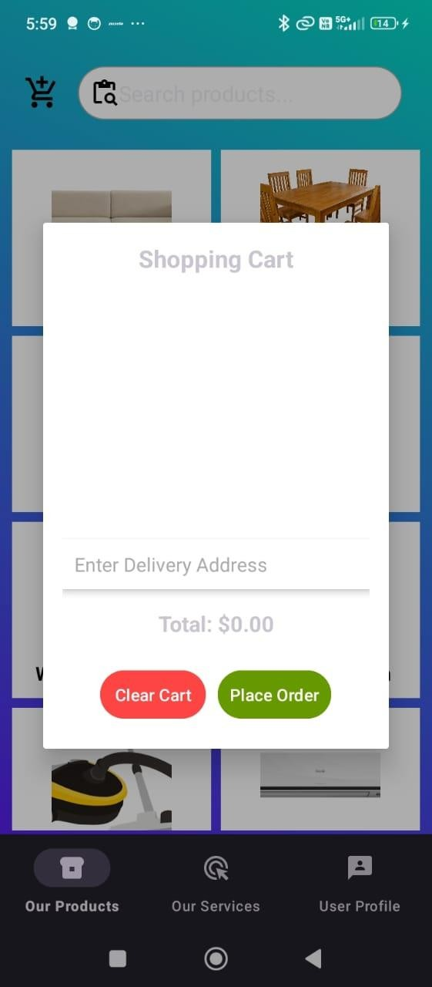

**Fig. 5.4 Shopping Cart Page**

* + - Items on the user's cart page are displayed, detailing products, quantity, and total amount. The user can change the quantity of products or remove some.
    - Promo codes can still be applied here, and they can proceed to checkout, where they'll provide their payment information and shipping details. The price breakdown with tax is shown.

# Order History Page :

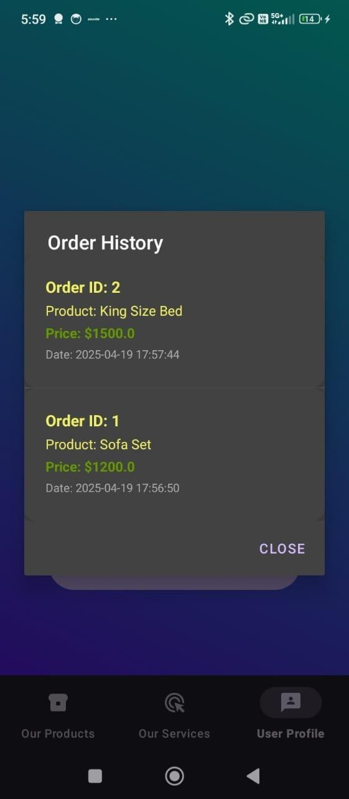

**Fig. 5.5 Order History Page**

* + - This page gives users the ability to view all of their previous orders, including respective order states, with indications for Pending, Shipped, or Delivered.
    - Users can even see order summaries and have the option to reorder the same items or download their invoices**.**

# User Profile Page :

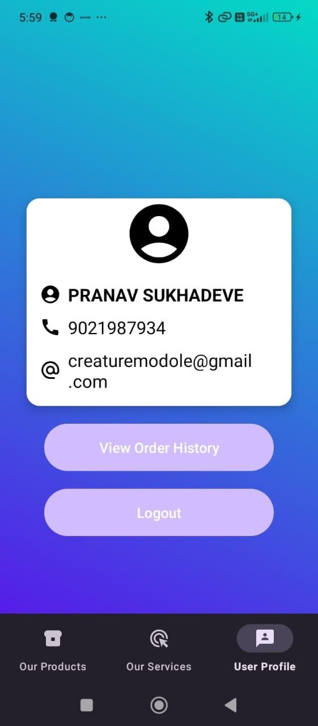

**Fig. 5.6 User Profile Page**

* + - A user profile captures personal data consisting of the name, email, shipping address, and contact number, which can actually be modified any time.
    - Also offers saved payment methods and service choices and gives access to manage account settings or order history.

# Search Product Page

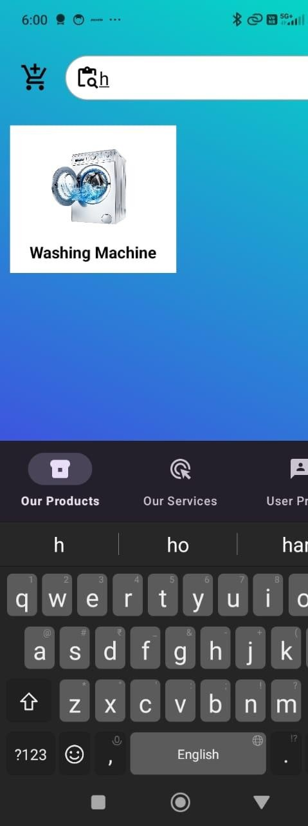

**Fig. 5.7 Search product Page**

* + - The search page enables users to easily find products by inputting keywords relevant to product names, brands, or categories.
    - Filters assist the customer in narrow results by price range, ratings, and features, helping to discover the product.

# PROPOSED SYSTEM:

The envisioned Home Automation E-commerce System proposes to be an all-encompassing digital platform to assist in the sales of smart home products, service bookings, and customer engagement. The automation of various aspects, such as product management, service scheduling, user profiling, and communication, adds to the great efficiency that this system derives. The core features include the following:

# Online Product & Service Booking

* + Customers can browse and book smart home services such as installation or setup and order products via mobile apps or web portals.
  + Availability status for services and delivery slots is monitored in real-time to avoid conflicts and provide flexibility in bookings.

# Customer Profile Management

* + The system holds detailed customer profiles that include contact details, order history, preferred products, and saved addresses.
  + Profiles assist in making personalized recommendations for smart devices and promotions targeted toward smart product advertisements**.**

# Technician & Service Scheduling

* + The admin creates schedules for home visits for installations or maintenance, assigning technicians based on skill and availability.
  + In addition, technicians would be able to see assigned jobs, thereby eliminating confusion and improving service delivery.

# Inventory & Device Stock Control

* + Automatically updating product inventories when goods are being purchased by customers or a service is in use.
  + Low stock or out-of-stock alerts trigger timely restocking action to prevent disruption in supply.

# Billing and Invoicing

* + Automatically generates invoices for products and services purchased.
  + Supports payment through card, UPI, net banking, and wallets, keeping all secure recorded transactions for future reference.

# Browse Smart Home Products

* + Users can browse a wide range of smart home devices such as smart bulbs, cameras, sensors, and hubs.
  + Every product comes with a complete description indicating price, availability, and use guide; optional cart and buy now options available.

# Reminders & Notifications

* + Customers receive automatic alerts concerning their upcoming services, which include servicevisits, deliveries of placed orders, and restocks of products.
  + Notifications will be provided to confirm bookings, cancellations, promotions, and follow-up service feedback.

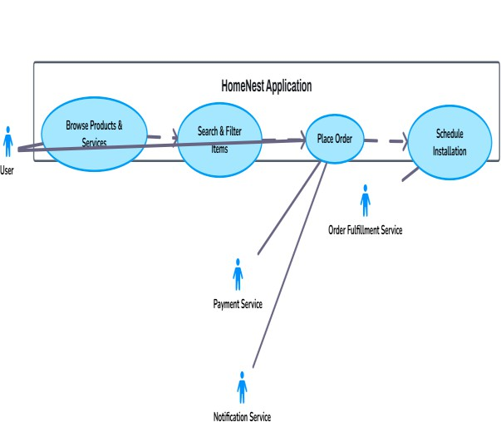

# Fig. 6. 1 Flowchart

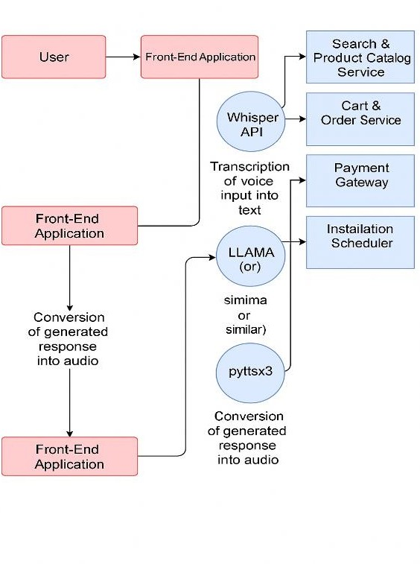

# User Interaction Flow :

The data flow diagram starts with user interaction, with activities such as registering, logging in, browsing for products and services, and placing orders generating data that flow into the system for processing.

# Processing Units :

Core processes such as "User Authentication," "Product Management," "Order Handling," and "Cart Operations" receive input data, process it, and disseminate the output into a database or back to the UI.

# Data Storage Points

Data is flowing to and from several central storage points, such as the User Database, Product Catalog, Order History, and Cart Storage, thus allowing a structured data management and retrieval mechanism.

* **External Entities & Flow Direction** External entities, such as Payment Gateway, Shipping Partner APIs, and Admin Panel, interface with the system through these defined data exchanges, ensuring smooth integration and consistent data updates across modules.

# System Requirements:

The prospective HomeNest Home Automation E-commerce Application shall be developed as a mobile-based platform optimized for Android. It will utilize cutting-edge cloud technologies, along with AI tools toward a smooth user experience with intelligent shopping automation, scheduling, and user interaction. The detailed system requirements are given as follows:

# Platform:

* Operating System: Supporting Android 5.0 (Lollipop) and later
* Device Support: Optimized for smartphone and tablet use
* Development Tools: Using Android Studio along with Java/Kotlin in the frontend

# Backend:

* Cloud Backend: The Firebase Realtime Database or Firebase Firestore are to be employed for real-time data handling of application changing elements
* Authentication: User authentication and role-based access control will be performed by Firebase Authentication.
* APIs: For backend functions like order processing, notifications, and analytics that keep large orders in control, we will use Firebase Cloud Functions.

# AI Tools:

TensorFlow Lite: It provides the support for integration of on-device ML models for smart product suggestions and analysis of usage pattern behavior, and provides predictive maintenance recommendations.

* + Google's Gemini API: For conversational AI features such as voice-assisted search, customer support chatbot, and smart order assistance.

# Storage: (Cloud Based)

* + Firebase Cloud Storage is used to store customer profiles, product images, invoices, service records, and installation videos.
  + It ensures availability, scalability, and secure access from any authenticated device.
  + Integrates with analytics and AI modules to personalize experience and protect behind-the- scenes backup

# Conclusion :

The HomeNest Home Automation E-Commerce App has been designed to make things simple and contemporary regarding the way people use home automation goods and services with a smart and friendly digital offering. It has in it everything a user might need, like product browsing, service booking, shopping cart controls, order tracking, user profiles, and billing-all in one place.

Built with very robust Android frameworks with Firebase as backend base, and enhanced by AI tools such as TensorFlow Lite and Google's Gemini API, HomeNest makes sure its performance is optimally speedy, intelligent automation, and really personalizes the shopping experience. Also all user- product data is kept using cloud storage for real-time access and easy scaling with the increase in user demand.

All smart home users, ultimately, would leverage HomeNest seamlessly, while all businesses would spend less on operational errors and time while providing customers with a more professional experience. In fact, their effort would move to

ensuring that homeowners enjoy more comfort, security, and smart living while growing the brand in a highly competive digital marketplace .

# Refrences

1. **Android Developers Documentation**

Google. (2025). Official Android Development Guide for Mobile Applications. Retrieved from https://developer.android.com

# Firebase Documentation

Google. (2025). Firebase: Tools for Real- Time Databases, Authentication, and Cloud Functions. Retrieved from https://firebase.google.com/docs

# TensorFlow Lite Documentation

TensorFlow. (2025). TensorFlow Lite: Machine Learning for Mobile and Edge Devices. Retrieved from https:/[/www.tensorflow.org/lite](http://www.tensorflow.org/lite)

# Google Gemini API Documentation

Google. (2025). Gemini API: Powering Conversational AI for Smarter Applications. Retrieved from https://developers.google.com

# Smart Home E-commerce Platforms – Research Paper

John, A., & Smith, B. (2023). Building Intelligent E-commerce Systems for Home Automation. Journal of Digital Retailing, 11(2).

|  |  |  |
| --- | --- | --- |
| **6. AI-Powered** |  | **Product** |
| **Recommendations** | **in** | **Home** |
| **Automation** |  |  |

Patel, M. (2024). Personalizing the Smart Home Experience through AI Tools. HomeTech Journal, 7(1).

# Cloud Solutions for E-commerce Apps

Chandra, P. (2024). Cloud-Based Infrastructure for Scalable Retail Applications. TechBusiness Insights, 9(2).

# Home Automation Devices & Tools

HomeNest Resources. (2025). Trusted Devices and Integrations in HomeNest’s Product Line. Retrieved from https:/[/www.homenest.in](http://www.homenest.in/)