**Design and Implementation of a Fire Alarm System Using Arduino UNO**

**T.P Deshmukh 1, Purva S. Jagtap2, Sanskruti Kadam3 , Shruti V. Kandekar**⁴**, Samidha Katore**⁵**, Samiksha Landge**⁶

1Assistant Profesor, AIDS , Guru Gobind Singh College of Engineering and Research Centre, Nashik, Maharashtra, India

2Student, AIDS, Guru Gobind Singh College of Engineering and Research Centre, Nashik, Maharashtra, India

3Student, AIDS, Guru Gobind Singh College of Engineering and Research Centre, Nashik, Maharashtra, India

⁴Student, AIDS, Guru Gobind Singh College of Engineering and Research Centre, Nashik, Maharashtra, India

⁵Student, AIDS, Guru Gobind Singh College of Engineering and Research Centre, Nashik, Maharashtra, India

⁶Student, AIDS, Guru Gobind Singh College of Engineering and Research Centre, Nashik, Maharashtra, India

**ABSTRACT**

This project presents a low-cost, efficient fire alarm system utilizing an Arduino microcontroller. The system is designed to detect fire hazards by monitoring environmental temperature and smoke levels through sensors such as the DHT11 (temperature) and MQ-2 (smoke) sensors. When the sensor readings cross predefined thresholds, the Arduino triggers an alarm using a buzzer or activates further safety measures like alert notifications or turning on exhaust fans. This compact and reliable system is ideal for residential, commercial, and industrial safety applications. It demonstrates how embedded systems and sensors can be integrated to provide a real-time, automated fire detection solution.

**Keywords:** Arduino, Fire Alarm, Smoke Sensor, Temperature Sensor, MQ-2, DHT11, Embedded System, Safety System, Real-time Monitoring, Automation.

1. **INTRODUCTION**

Fire hazards pose a significant risk to property and human life. Traditional fire alarm systems are often expensive and lack flexibility. The proposed system leverages Arduino technology to provide an affordable and customizable solution. This paper outlines the components, circuit design, and operation of an Arduino-based fire alarm system.

Circuit Design: The system is constructed using the connections illustrated in the image provided. The MQ-2 sensor is connected to the analog input A0 of the Arduino, while the TMP36 temperature sensor connects to A1. The 16x2 LCD is interfaced using digital pins 7, 6, 5, 4, 3, and 2. The buzzer is connected to digital pin 8, and LEDs to pins 9, 10, and 11, respectively. A potentiometer is used to control the contrast of the LCD.

1. **METHODOLOGY**

The MQ-2 sensor detects the presence of smoke, while the TMP36 sensor monitors the ambient temperature. The Arduino continuously reads data from these sensors. When the smoke level or temperature exceeds a predefined threshold, the system activates the buzzer and lights up the red LED. Simultaneously, the LCD displays a fire alert message. If the readings are within safe limits, the green LED remains on and the system remains in standby mode.

**2.1 Hardware Setup :**

The system hardware was assembled on a breadboard for prototyping. The sensors, LCD, LEDs, and buzzer were connected to the Arduino UNO as per the designed circuit diagram. Each component was tested individually before integration to ensure functionality.

**2.2 Software Development**

The Arduino was programmed using the Arduino IDE. Libraries for the LCD and sensor handling were imported. The code includes sensor calibration, threshold comparisons, and control logic for activating alerts. Serial monitoring was used during development for debugging and validation.

1. **MODELING AND ANALYSIS**

The fire detection model is based on threshold values for smoke (from MQ-2) and temperature (from TMP36). The system was analyzed under different environmental conditions by simulating smoke and heat to observe the system’s response. Data readings were recorded and evaluated to ensure accuracy and consistency in detection. The results confirmed the model's

ability to reliably trigger alerts when hazardous conditions were present.

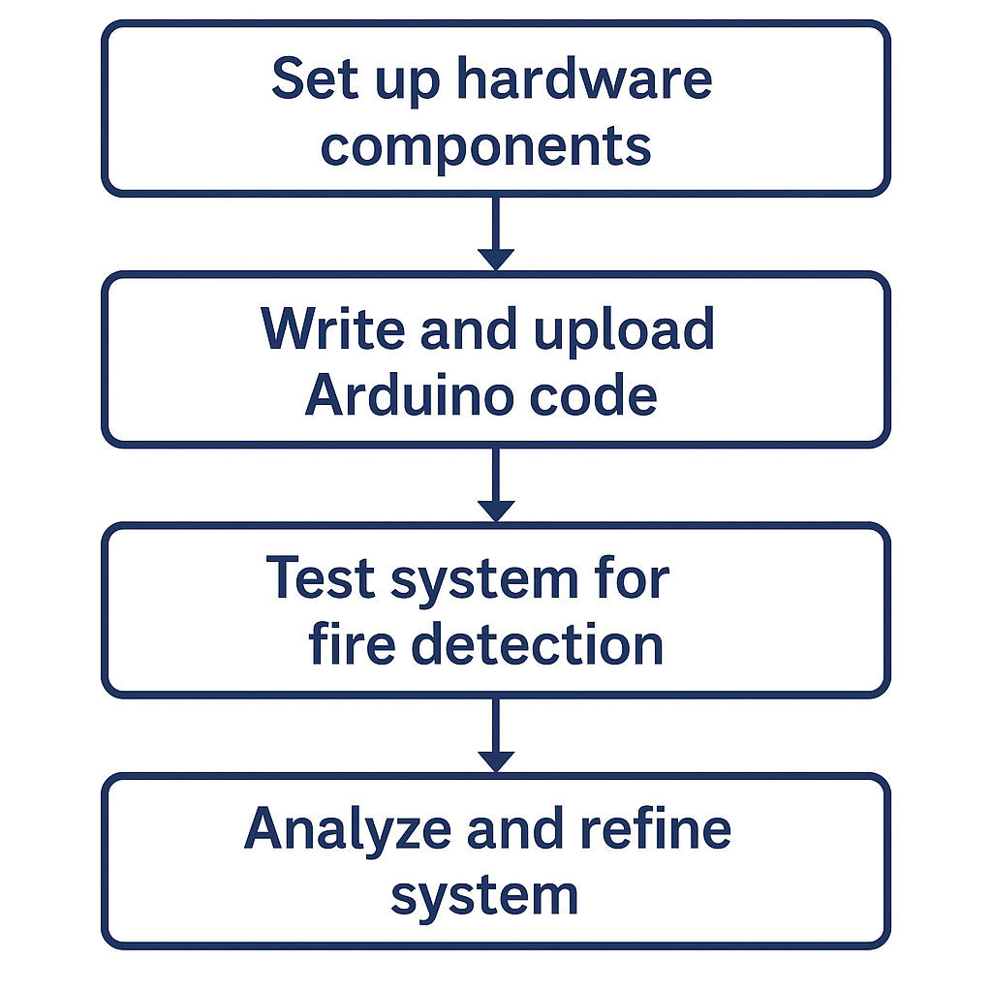**Ardiuno code implementation :**

#include <LiquidCrystal.h>

LiquidCrystal lcd(12, 11, 5, 4, 3, 2);

int cel; //for converting the voltage of tmp36 into Celsius

void setup() {

//pinmode setup

pinMode(A0,INPUT);

pinMode(A2,INPUT);

pinMode(7,OUTPUT);

pinMode(10,OUTPUT);

pinMode(9,OUTPUT);

Serial.begin(9600);

lcd.begin(16,2);

}

void loop() {

cel = map(((analogRead(A0) - 20) * 3.04), 0, 1023, -40, 125);

// Convert voltage values to temperature in Celsius

int gas_indi = analogRead(A2);

digitalWrite(10,HIGH);

digitalWrite(9,LOW);

if (gas_indi > 100 || cel >= 58) { // 58 used for fire detection

digitalWrite(10,LOW);

digitalWrite(9,HIGH);

lcd.clear();

lcd.setCursor(0,0);

if (gas_indi > 100) {

lcd.print("Nearby gas");

lcd.setCursor(0,1);

lcd.print("detected!");

delay(1000);

lcd.clear();

lcd.print("Take Precautions!");

delay(1000);

tone(7,400,1000);

}

if (cel >= 58) {

lcd.clear();

lcd.setCursor(0,0);

lcd.print("EMERGENCY!");

delay(1000);

lcd.setCursor(0,1);

lcd.print("TAKE CAUTION!");

delay(1000);

tone(7,400,1000);

}

delay(500);

} else {

digitalWrite(10,HIGH);

lcd.clear();

lcd.setCursor(0,0);

lcd.print("ALL CLEAR");

delay(1000);

lcd.setCursor(0,1);

lcd.print("No fire nearby");

delay(1000);

}

}

1. **RESULTS AND DISCUSSION**

The prototype successfully detects smoke and heat. When smoke is introduced or the temperature rises beyond the threshold, the buzzer sounds and the red LED illuminates. The LCD shows real-time temperature and alerts. This confirms the system's reliability in identifying potential fire hazards.

**Table 1.** Sample Comparison

|  |  |  |  |
| --- | --- | --- | --- |
| Criteria | Traditional system | Arduino based system | Smart (IOT based ) system |
| Cost | Hight | Low | High |
| Ease of installation | Moderate | Easy | Complex |
| Customization | Limited | High | Moderate |
| Smoke detection | Yes | Yes (MQ-2 sensor) | Yes |
| Temperature detection | Rare | Yes (TMP36 sensor) | Yes |
| User Interface | Siren only | LCD display + Buzzer | Mobile app + Siren |
| Remote Monitoring | No | No (can be added) | Yes |

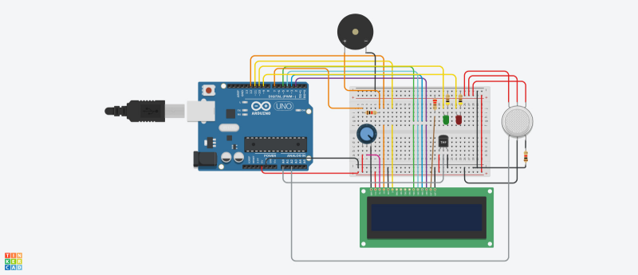

**Figure :** Arduino Board

1. **CONCLUSION**

This Arduino-based fire alarm system provides an effective and low-cost method for early fire detection. It is ideal for home and small business use, and can be enhanced with GSM modules for SMS alerts or IoT integration for remote monitoring.

1. **REFERENCES**

1. Arduino UNO Datasheet

Arduino.cc. (n.d.). Arduino UNO Rev3 — Technical specifications. Retrieved from:

<https://store.arduino.cc/products/arduino-uno-rev3>

2. MQ-2 Gas Sensor Datasheet

Hanwei Electronics. (n.d.). MQ-2 Semiconductor Sensor for Combustible Gas. Retrieved from:

<https://www.sparkfun.com/datasheets/Sensors/Biometric/MQ-2.pdf>

3. TMP36 Temperature Sensor Datasheet

Analog Devices. (2004). TMP35/TMP36/TMP37 Low Voltage Temperature Sensors. Retrieved from:

<https://www.analog.com/media/en/technical-documentation/data-sheets/TMP35_36_37.pdf>

4. Arduino Official Documentation

Arduino.cc. (n.d.). Arduino Software (IDE) — Guide and Reference. Retrieved from:

https://www.arduino.cc/en/software

5. Tinkercad Circuits Simulator

Autodesk Inc. (n.d.). Tinkercad Circuits - Online Circuit Design and Simulation Tool. Retrieved from:

https://www.tinkercad.com/circuits