# Cryptocurrency Prediction Using Python and Binance API

Payal B. Satpute1, Sakshi .S.Walunjakar2, Shraddha.S.Gaikwad3, Sakshi.S.Khomane4 Shravani.S.Raut,5 , Prof. Bhargavi Gorde6

*1, 2, 3, 4,5 Computer Engineering, Zeal Polytechnic, Pune, Maharashtra, India.

*ABSTRACT: This project focuses on predicting cryptocurrency prices by applying machine learning models to historical price data, mar- ket trends, social media sentiment, and blockchain metrics. It aims to provide reliable forecasts in the highly volatile cryptocurrency mar- ket by utilizing techniques such as Long Short-Term Memory (LSTM) networks and sentiment analysis. The results are intended to support investors, traders, and researchers in making informed decisions and understanding the dynamics of emerging financial systems.*

KEYWORDS: Cryptocurrency, price prediction, machine learning, historical data, market trends, sentiment analysis, blockchain metrics, volatility, LSTM networks, financial analytics.

**INTRODUCTION**: Cryptocurrency markets are known for their extreme volatility, influenced by factors such as market trends, public sentiment, and technological developments. Pre- dicting cryptocurrency prices is a challenging yet crucial task for investors and traders who aim to make informed decisions. This project explores the potential of machine learning techniques to analyze historical price data, market trends, social media senti- ment, and blockchain metrics to forecast cryptocurrency prices. By leveraging advanced algorithms, the project seeks to address the complexities of cryptocurrency markets and provide reliable predictions that could enhance financial decision-making in emerging financial systems

**OBJECTIVES**: Cryptocurrency prediction using Python and Binance API is often aimed at achieving specific objectives. Here are some common goals for such projects:

1. **Price Prediction**: Developing models to predict future prices of cryptocurrencies based on historical data.
2. **Market Analysis**: Analyzing trends and patterns in the cryptocurrency market to identify potential opportuni- ties for investment or trading.
3. **Trade Automation**: Creating bots that execute trades based on predefined strategies or predictions generated by machine learning models.
4. **Volatility Analysis**: Measuring and predicting the volatility of cryptocurrencies to manage risk in trading strategies.
5. **Sentiment Analysis**: Incorporating data from social media, news, or forums to understand public sentiment and its impact on cryptocurrency prices.
6. **Portfolio Optimization**: Using predictions to construct a diversified and optimized portfolio of cryptocurren- cies.
7. **Custom Indicators**: Developing personalized indica- tors using Binance API data to enhance prediction ac- curacy.
8. **Risk Management**: Identifying high-risk scenarios and creating safeguards to minimize potential losses.
9. • **Liquidity Analysis**: Assessing the liquidity of vari- ous cryptocurrencies to identify assets that are easier to trade and less prone to price manipulation.
10. **Pattern Recognition**: Detecting recurring patterns in market movements to predict future trends and capital- ize on trading opportunities.
11. **Real-Time Alerts**: Implementing systems to monitor Binance data and send real-time notifications for poten- tial trading opportunities or significant market changes.

**Current Market Needs and Problems**: The cryptocurrency market today has critical needs and challenges that shape its evolution. Regulatory clarity is essential for creating a trustwor- thy and stable environment for businesses and investors. Scala- bility is crucial as networks must handle increasing transaction loads efficiently to support growing adoption. Enhanced security measures are required to tackle the persistent threat of hacks and cyberattacks. Simplified, user-friendly platforms can help make cryptocurrency accessible to a wider audience. Interoperability between blockchain networks is needed for seamless operations across ecosystems. Sustainability remains a concern, with grow- ing calls for environmentally conscious mining practices.

## BACKGROUND:

Cryptocurrency price prediction using Python is an innova- tive approach that blends financial data analysis with ma- chine learning techniques. By collecting historical price data, preprocessing it to ensure accuracy, and using features like moving averages or market trends, Python-based mod- els attempt to forecast future price movements. Advanced models, such as Long Short-Term Memory (LSTM) net- works, are especially effective for analyzing time-series data and capturing complex patterns. Python's rich ecosys- tem of libraries, including Pandas, Scikit-learn, and Ten- sorFlow, empowers developers to create predictive models that cater to the volatile nature of cryptocurrencies. This approach not only helps traders and investors make in- formed decisions but also highlights the potential of tech- nology in reshaping financial forecasting.

## LITERATURE SURVEY:

1. **Deep Learning Models:** Research has shown that deep learning techniques, such as feedforward neural net- works and ensemble learning algorithms, are effective in handling the complexities of cryptocurrency data. These models are used to predict closing prices and de- tect anomalies in market trend.
2. **Machine Learning Frameworks**: Studies have inte- grated machine learning models like Random Forest and Gradient Boosting to forecast cryptocurrency pric- es. These models demonstrate high precision and relia- bility in predicting price movements.
3. **Time Series Forecasting:** Libraries like Facebook Prophet are employed for time series forecasting of cryptocurrency prices. This involves analyzing histori- cal data to predict future trend
4. **Binance API Utilization:** The Binance API is widely used for retrieving historical price data and building predictive models. It supports data preparation, visuali- zation, and model building using Python libraries such as pandas, numpy, and matplotlib.

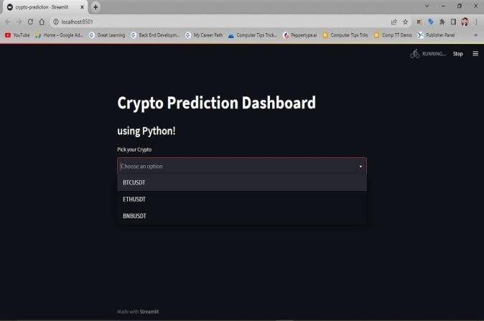

### Dashboard Overview

From the screenshots, your dashboard has a clean, struc- tured layout built with Streamlit, offering real-time crypto insights:

Main Components Identified:

Dropdown Selection for cryptocurrency pairs (BTCUSDT, ETHUSDT, BNBUSDT)

Volume Chart showing trading activity over time Prediction Signal Chart showing buy/sell/hold recommen- dations

Line Plots or Bar Charts with date-based x-axes

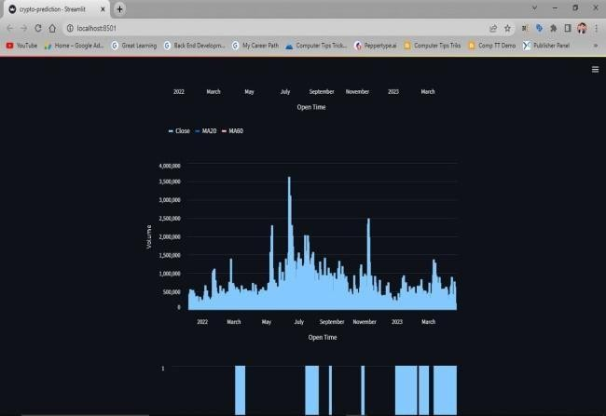

### Visual Elements Breakdown

Screenshot 1 – Volume Over Time

Bar chart titled “Volume vs Open Time”

X-axis: Time (labeled “Open Time”, spans 2022–2023) Y-axis: Volume

Chart Style: Bars in light blue

Interpretation: Displays historical trading volume trends

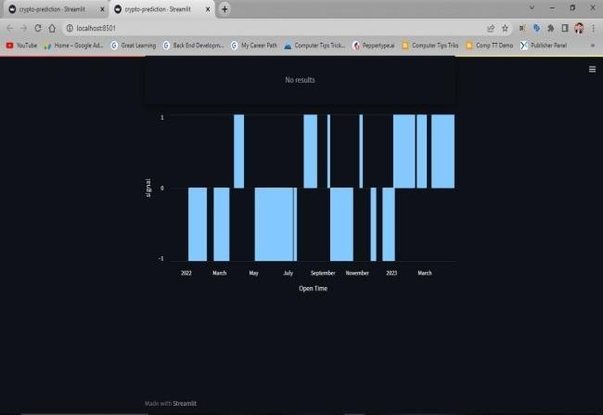

### Prediction Signals

Bar chart titled “Predicted Signal vs Open Time” Y-axis Values:

1 = Buy

0 = Hold

-1 = Sell

Color: Light blue bars

Purpose: Indicates when the model predicts trade actions

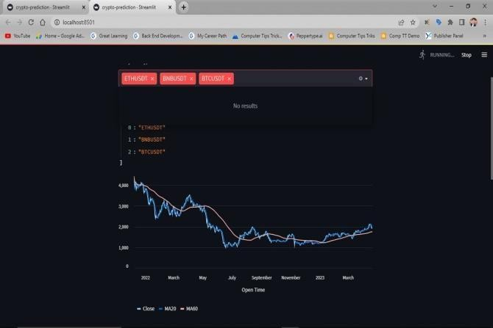

A dropdown to select the crypto (ETHUSDT is selected). A line chart showing:

Close price

20-day moving average (MA20) 60-day moving average (MA60)

It visualizes Ethereum's price decline in 2022, consolidation mid-year, and a recovery trend into 2023.

This dashboard visualizes Ethereum (ETHUSDT) price trends using Python and Streamlit. It features interactive crypto selection and shows a line chart with historical clos- ing prices alongside two technical indicators—20-day and 60-day moving averages—to help identify market trends and potential trading signals.

### Technical Challenges:

* Learning Binance API and handling authentication
* Processing large and volatile crypto dataset
* Building effective prediction models, starting sim- ple.

### Data Challenges:

* Ensuring data quality and managing gaps.
* Incorporating real-time data using webSockets.

### Conceptual Challenges:

* + understanding crypto market dynamics
  + preventing overfitting in your prediction mod- els

### Ethical Challenges:

* Avoiding misleading results in predictions
* Safeguarding API keys and sensitive data

### Practical Tips:

* start with historical data analysis
* use python library like pandas, Numpy, ccxt and visual- ization
* experiment with statistical models first

## FEATURES:

### Technical Features:

* + **API Acces**s:Enables retrieval of real-time and his- torical crypto data.
  + **Python Libraries**: Integration with libraries like Pandas, NumPy, and Scikit-learn for data analysis and machine learning.
  + **Real-Time Updates**: Use of WebSockets for live market data.

### Analytical Features:

* + **Predictive Models**: Build statistical and machine learning models for forecasting trends.
  + **Data Visualization**: Tools like Matplotlib and Seaborn for visual representation of trends and in- sights.

### Security Features:

* + **API Key Management:** Secure handling of API keys to ensure safe operations.
  + **Environment Variables**: Protect sensitive creden- tials and data.

### Practical Features:

* + **Automation:** Automate trading decisions based on prediction models.
  + **Customizable Scripts**: Create scripts tailored to specific cryptocurrencies and market strategies.

### Analytical Features:

* + **Time-Series Analysis:** Analyze patterns in historical data to understand market trends and price cycles.
  + **Sentiment Analysis:** Incorporate news and social me- dia data to gauge market sentiment and its impact on prices.
  + **Feature Engineering:** Create custom data features (e.g., moving averages, volatility indicators) for better predictions.

### Automation Features:

* + **Trading Bot Integration:** Link predictive models with trading bots to automate buy/sell decisions.
  + **Custom Alerts:** Set up triggers based on model predic- tions for price thresholds or market events.

### Optimization Features:

* + **Parameter Tuning:** Fine-tune machine learning model parameters to enhance prediction accuracy.
  + **Backtesting:** Test prediction models on historical data to evaluate their effectiveness.

### Research and Development Features:

* + **Experimentation:** Explore various machine learning algorithms (e.g., Decision Trees, LSTMs, SVMs).
  + **Scalability:** Work with cloud services like AWS or Google Cloud for handling large-scale data analysis.

### User-Friendly Features:

* + **Interactive Dashboards:** Build dashboards to visual- ize predictions and market trends.
  + **Documentation:** Provide clear documentation of the code and methods used for future reference.

### Scalability Features:

* + **Cloud Integration:** Utilize cloud platforms like AWS, Google Cloud, or Azure to process large-scale datasets, deploy models, and handle high computational de- mands. This makes your project more robust and capa- ble of managing growing data or traffic.

## WORKING:

Cryptocurrency prediction involves analyzing historical and real-time data to forecast price movements. Python, with its rich ecosystem of libraries, serves as an ideal language for implementing these models. Binance API provides access to a plethora of market data that can be utilized for building ef- fective prediction systems.

### Key Phases of Working on Cryptocurrency Prediction

1. **Data Collection**
   * **Historical Data:** Fetch data from the Binance API re- garding past cryptocurrency prices, volumes, and other market indicators.
   * **Real-Time Data:** Utilize the Binance WebSocket API for receiving live updates of trades, prices, and market movements, allowing for dynamic analysis.

### Data Preprocessing

* + **Data Cleaning:** Remove null or missing values and en- sure the dataset is structured properly.
  + **Feature Extraction:** Create meaningful features, such as moving averages, volatility indices, and momentum indicators, which are crucial for predictions.
  + **Normalization:** Scale the data to avoid bias toward high-value variables in your models.

### Exploratory Data Analysis (EDA)

* + Use visualization tools like Matplotlib and Seaborn to understand patterns in the data.
  + Identify trends, correlations, and anomalies in crypto- currency price movements.

### Model Building

* + **Statistical Models:** Employ models like moving aver- ages or ARIMA (AutoRegressive Integrated Moving Average) for basic trend analysis.
  + **Machine Learning Models:** Implement algorithms such as Random Forest, Gradient Boosting, or Neural Networks for more sophisticated predictions.
  + **Deep Learning Models:** Use architectures like LSTMs (Long Short-Term Memory networks) to capture se- quential dependencies in time-series data.

### Model Training and Evaluation

* + Split the dataset into training and testing sets to ensure the model learns effectively while providing unbiased evaluations.
  + Optimize hyperparameters to enhance model accuracy.
  + Use performance metrics like Mean Squared Error (MSE) or R-squared to evaluate the prediction quality.

### Incorporating Real-Time Predictions

* + Integrate models with real-time data streams to provide up-to-date predictions.
  + Deploy WebSocket connections for live market data and automate updates to your predictions.

### Backtesting and Risk Analysis

* + Test the predictive models on historical data to ensure reliability and accuracy.
  + Perform risk analysis by assessing market volatility and setting trading parameters to minimize financial losses.

### Automation and Deployment

* + Automate trading strategies by linking predictions with decision-making scripts.
  + Use cloud platforms for hosting and scaling your model to accommodate growing data and computational needs.

### Ethical Considerations

* + Clearly communicate limitations of your model to avoid misleading predictions.
  + Secure sensitive data such as API keys and ensure pri- vacy compliance.

### Benefits of This Approach

* + Access to real-time data ensures dynamic modeling and up-to-date predictions.
  + Python’s robust libraries enable efficient data pro- cessing and model creation.
  + Insights derived from prediction models can aid in in- formed decision-making and strategy formulation.

## TECHNOLOGIES:

### Programming Language:

Python: Provides simplicity, extensive libraries, and flexi- bility for data analysis, machine learning, and API interac- tion.

### Data Libraries:

Pandas:For data manipulation and cleaning.

NumPy: For numerical computations and matrix operations.

### Machine Learning Libraries:

Scikit-Learn: Useful for building traditional ML models like linear regression or Random Forest.

TensorFlow / PyTorch: Used for creating complex neural networks, especially for time-series forecasting models.

XGBoost: Efficient for gradient boosting in supervised learning tasks.

### Data Visualization Tools:

Matplotlib & Seaborn: For visualizing data trends and in- sights.

Plotly: To create interactive dashboards and charts.

### API & Data Integration:

Binance API (`ccxt`): For accessing historical and real-time cryptocurrency data.

WebSockets: For live streaming market data directly from Binance.

### Cloud Services:

AWS / Google Cloud / Azure: Useful for deploying models, managing large datasets, and scaling up computations.

### Time-Series Analysis:

Statsmodels: For statistical modeling and time-series analy- sis (e.g., ARIMA models).

### Automation & Deployment:

Docker:For containerizing your application for seamless deployment.

Flask/Django: For building APIs or web interfaces to access prediction outputs.

Streamlit: Create interactive, user-friendly dashboards and applications.

# GANTT CHART

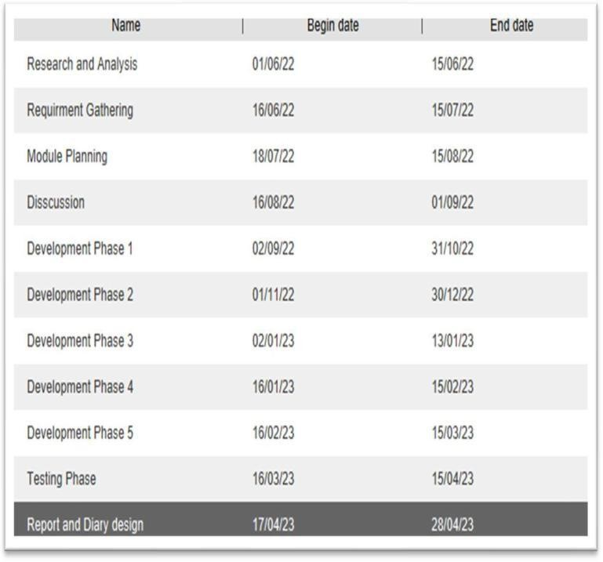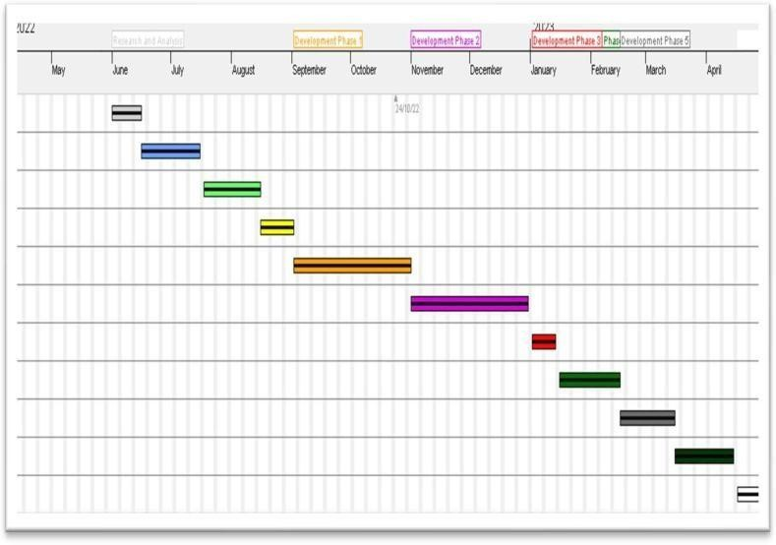

Development phase 2

**FLOW FOR PROPOSED SYSTEM:**

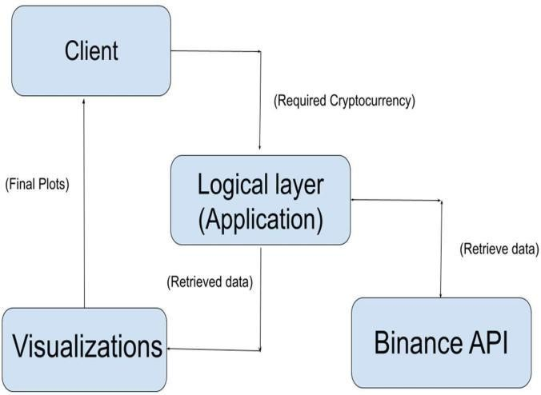

**USE CASE DIAGRAM**



Authenticate API Access

Fetch Live Access Data

Predict Price Move- ment

Visualize Prediction

USER

Store Data

Receive Alerts

Fetch Historical Data

**CONCLUSION**:

The combination of Python's versatile programming capa- bilities and the Binance API's access to real-time cryptocur- rency data opens up opportunities for predictive analysis and algorithmic trading. By leveraging Python libraries like pandas, numpy, and machine learning frameworks, you can preprocess data, analyze trends, and develop forecasting models. Integrating these predictions with Binance API allows for automated trading strategies based on market insights. These tools together create a robust platform for exploring cryptocurrency forecasting and trading.

## REFERENCES:

* [GitHub-ASG0007/Crypto-currency-Price-](https://github.com/ASG0007/Crypto-currency-Price-Prediction-using-Binance-API) [Prediction-using-Binance-API: This project aims](https://github.com/ASG0007/Crypto-currency-Price-Prediction-using-Binance-API) [to](https://github.com/ASG0007/Crypto-currency-Price-Prediction-using-Binance-API) [analyze historical Cryptocurrency price data (](https://github.com/ASG0007/Crypto-currency-Price-Prediction-using-Binance-API) [here](https://github.com/ASG0007/Crypto-currency-Price-Prediction-using-Binance-API) [Bitcoin is taken as example ) and build pre-](https://github.com/ASG0007/Crypto-currency-Price-Prediction-using-Binance-API) [dictive](https://github.com/ASG0007/Crypto-currency-Price-Prediction-using-Binance-API) [models for forecasting future price move-](https://github.com/ASG0007/Crypto-currency-Price-Prediction-using-Binance-API) [ments.](https://github.com/ASG0007/Crypto-currency-Price-Prediction-using-Binance-API)
* [GitHub-onur-duman/Indicator-Signal-Bot-with-](https://github.com/onur-duman/Indicator-Signal-Bot-with-Binance-API) [Binance-API: Cryptocurrency Signal Bot](https://github.com/onur-duman/Indicator-Signal-Bot-with-Binance-API)
* [GitHub AbdulkareemAlman-](https://github.com/AbdulkareemAlmansoori/BinanceCryptoPricePredictor) [soori/BinanceCryptoPricePredictor: Predict any](https://github.com/AbdulkareemAlmansoori/BinanceCryptoPricePredictor) [cryptocurrency with any pair](https://github.com/AbdulkareemAlmansoori/BinanceCryptoPricePredictor) [(USDT/ETH/BTC/BNB/ETC) on Binance through](https://github.com/AbdulkareemAlmansoori/BinanceCryptoPricePredictor) [Deep Learning (commonly known as Artificial In-](https://github.com/AbdulkareemAlmansoori/BinanceCryptoPricePredictor) [telligence for those who do not know the differ-](https://github.com/AbdulkareemAlmansoori/BinanceCryptoPricePredictor) [ence between AI/Ml/Dl).](https://github.com/AbdulkareemAlmansoori/BinanceCryptoPricePredictor)