**A STUDY ON EFFECT OF REWARD MANAGEMENT ON EMPLOYEE ENGAGEMENT**

Jefna S Y1,Dr. Nagalakshmi M2,

1MBA Student, School of Arts, Humanities and Management, Jeppiaar University, Chennai, India.

2Associate Professor, School of Arts, Humanities and Management, Jeppiaar University, Chennai, India.

1***syjefna@gmail.com,***

2***nagaishu124gmail.com*,**

**ABSTRACT**

Employee engagement's effects on output, retention, and overall workplace morale have emerged as a crucial component in a company's success. This study intends to investigate the intricate relationship between reward management and employee engagement in order to ascertain how different reward systems impact employee engagement. The findings demonstrate that an effective incentive management system significantly raises employee engagement by satisfying both internal and extrinsic motivating objectives. Monetary incentives like bonuses and pay raises were found to boost short-term engagement, whereas non-monetary incentives like recognition and opportunities for professional advancement were found to boost long-term commitment and loyalty.In order to maintain high levels of engagement, the study also highlights the importance of a strategic approach to reward management, enabling customized and transparent incentive processes.

**INTRODUCTION**

Employee engagement is the degree to which a person is dedicated to their work and the company's goals. In addition to being content in their positions, engaged employees are highly motivated, enthusiastic, and prepared to go above and beyond to support the objectives of the business. They radiate dedication and a sense of ownership that goes beyond the scope of their job designations. Today's workplace is rapidly evolving due to shifts in employee expectations, technology, and demographics. Consequently, the importance of employee engagement has grown. To create an engaging culture that fits with the diverse needs and preferences of their workforce, businesses must adapt their strategies and practices.

Employee engagement is more than simply an HR initiative or catchphrase for contemporary businesses looking to unlock the full potential of their staff, foster sustainable growth, and ensure long-term success in today's competitive business environment. By supporting employee engagement initiatives, organizations can create a win-win environment where employees feel valued, motivated, and empowered to give their all. In the end, this will be advantageous to the individual and the business overall.

**REVIEW OF LITERATURE**

1. Paul Turner (2019). Employee engagement, a branch of organizational practice that was formerly limited to the study of people or HR management, is now being observed in a broader organizational context due to its positive impacts on a range of commercial, service, or operational outcomes. Both cognitive and emotional components are covered in its descriptions, including zeal, passion, fulfillment, self-assurance, empowerment, and optimistic outlooks.
2. B.C. Sinha (2021). The phrase "employee engagement" refers to a worker's highest level of commitment, involvement, and loyalty to the company's vision, mission, and objectives.
3. Zeidan, S. and Itani, N. (2020). Engaged employees are stated to work harder, be more willing to go above and beyond, and be more passionate about the work they do and the quality they give in order to produce better results that support corporate success.
4. Chanchai Bunchapattanasakda and Li Sun (2019). Employee engagement and both individual and organizational success are positively correlated, according to research.
5. Duncan Brown (2014). The concept of "total rewards" is becoming increasingly out of date in our post-recession economy, which is austere and uneven.
6. Smith, I. (1993). Rewards management is another example of a new wine in an old bottle. investigates the development of the concept of reward management between the 1960s and the 1990s, taking into account the impact of governmental regulations as well as other ostensibly creative approaches to pay.

**OBJECTIVES OF RESEARCH**

1. To look into how different organizational elements affect worker engagement
2. To understand how important a motivated workforce is to an organization's long-term viability.
3. To look into how different techniques and reward systems affect work satisfaction, employee motivation, and organizational performance.
4. To evaluate how non-cash incentives like praise, chances for professional advancement, and work-life balance programs contribute to worker happiness and motivation

**SCOPE OF THE STUDY**

1. Employee Engagement Determinants: Look at the factors that influence employee engagement, including as pay policies, work-life balance, leadership ideologies, workplace cultures, and job designs.
2. Impact on Organizational Outcomes: Examine the relationship between employee engagement and key organizational outcomes, such as staff retention, financial performance, customer satisfaction, creativity, and productivity. Analyze how changing involvement levels affect these outcomes over the long run.
3. Effectiveness of Different Reward Systems: Analyze the effects of different incentive programs on employee engagement, including intrinsic, non-extrinsic, financial, and non-financial.
4. Employee Engagement and Retention: Analyze the effects of reward management tactics on workers' levels of engagement and motivation to stick with the organization. Analyze the effects of incentives on staff retention and the creation of a supportive work environment.

**RESEARCH METHODOLOGY**

1. Sources Of Data
2. **Primary Source Of Data**

Considering that the survey was conducted online using a Google questionnaire with several study-related items that was given to the respondents. As a result, a variety of response formats were seen, such as multiple-choice questions and answers expressed as ratios and percentages. We also collected data through observation and unofficial interviews.

1. **Secondary Sources of Data:**

Secondary data is collected from earlier research and published publications in order to finish the study. The following methods were used to collect secondary data:

* Articles
* Scholarly publications
* An online database containing additional web resources

1. **Sample design**

The dissemination of the questionnaire was carried out throughout the day for convenience. Respondents were approached, briefed on the purpose of the survey, and given the questionnaire before it was handed to them. The link to the web-based survey was shared via social media sites like Instagram, Twitter, and Whats App. Participants in the survey included homemakers, business people, teachers, students, retirees, and members of the military services. Four age groups were identified: those aged 18 to 25, those aged 25 to 30, those aged 30 to 35, and those above 35. The total sample size was between 50 and 100 individuals.

1. **Sampling Method**

A straightforward sampling technique that guarantees each member of the target population has an equal probability of being chosen for the study is simple random sampling. Every member of a population has an equal probability of being chosen for a sample using the statistical technique known as simple random sampling.

1. **Data Collection Method**

The data was collected using Google questionnaire forms that I created. Google's questionnaires asked on demographics, information sources, reasons for self-medication, and other subjects. The forms were distributed in a random sequence to the study's target group. An ethical clearance was obtained before to collecting this data from the population.

1. **Data Analysis And Interpretation**

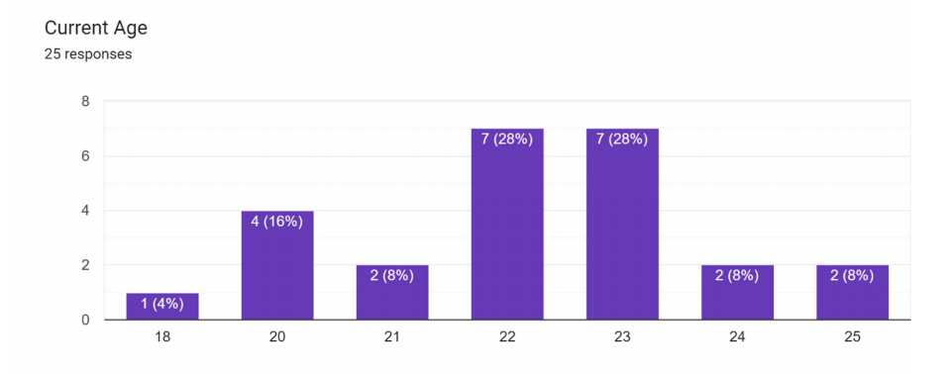

|  |  |  |
| --- | --- | --- |
| **RESPONSES** | **FREQUENCY** | **PERCENTAGE** |
| 18-24 | 23 | 92 |
| 25-34 | 2 | 8 |
| TOTAL | 25 | 100 |

**Analysis-** From the above graph and table, it is observed that out of the total responses 25, 23 responders are from the age group 18-24, 02 responders are from the age group of 25-34.

**Interpretation:** It is observed that most of the responders are among the age group of 18-24 years and the least number of responders belongs to the age group 25-34.

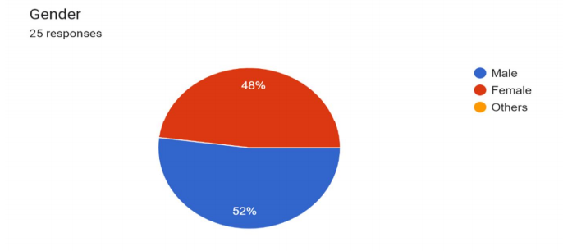

|  |  |  |
| --- | --- | --- |
| **RESPONSES** | **FREQUENCY** | **PERCENTAGE** |
| Female | 12 | 48 |
| Male | 13 | 52 |
| TOTAL | 25 | 100 |

**Analysis-** From the above graph, it is observed that out of the total responses 25, 12 responders are Females, 13 responders are Males.

**Interpretation-** It is observed that most of the responders are males and the least number of responders are females.

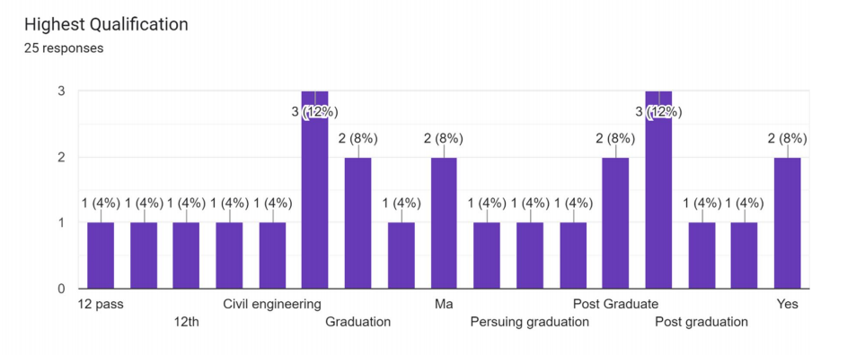

|  |  |  |
| --- | --- | --- |
| **RESPONSES** | **FREQUENCY** | **PERCENTAGE** |
| High school | 5 | 20 |
| Bachelor’s | 7 | 28 |
| Master’s | 13 | 52 |
| TOTAL | 25 | 100 |

**Analysis-** From the above graph and table, it is observed that out of the total responses 25, 05 responders from the high school, 07 responders are from the bachelor’s and 13 responders from the masters.

**Interpretation:** It is observed that most of the responders are from the master’s and the lowest from the High School

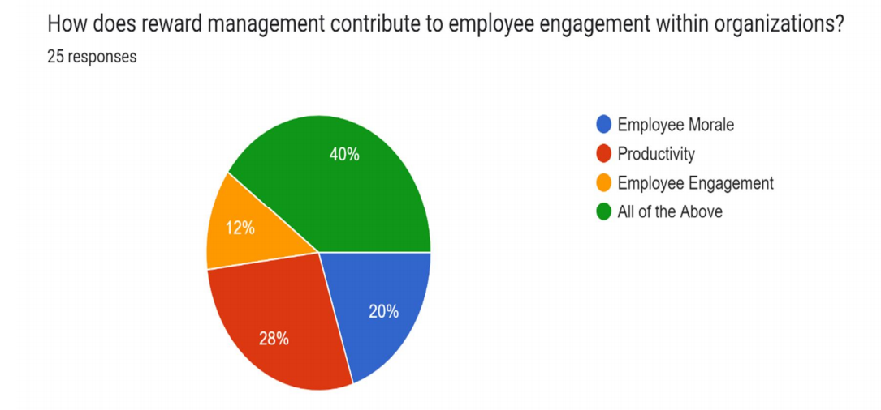

|  |  |  |
| --- | --- | --- |
| **RESPONSES** | **FREQUENCY** | **PERCENTAGE** |
| Employee Morale | 5 | 20 |
| Productivity | 7 | 28 |
| Employee Engagement | 3 | 12 |
| All of the above | 10 | 40 |
| TOTAL | 25 | 100 |

**Analysis-** From the above graph and table, it is observed that out of the total responses 25, 05 responders selected Employee Morale, 07 responders selected Productivity, 03 responders selected Employee Engagement, and 10 responders selected All of the above.

**Interpretation:** It is observed that 10 responders selected All of the above which was the maximum and 05 responders selected Employee engagement which was the minimum.

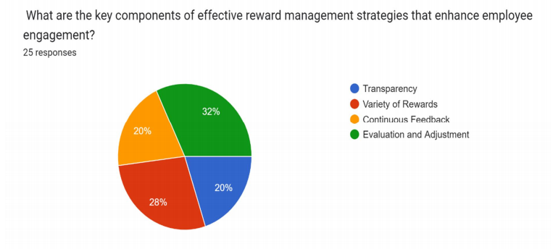

|  |  |  |
| --- | --- | --- |
| **RESPONSES** | **FREQUENCY** | **PERCENTAGE** |
| Transparency | 5 | 20 |
| Variety of Rewards | 7 | 28 |
| Continuous Feedback | 5 | 20 |
| Evaluation and adjustment | 8 | 32 |
| TOTAL | 25 | 100 |

**Analysis-** From the above graph and table, it is observed that out of the total responses 25, 05 responders selected Transparency, 07 responders selected Variety of Rewards, 05 responders selected continuous feedback, and 08 responders selected Evaluation and adjustment.

**Interpretation:** It is observed that 08 responders selected Evaluation and adjustment which was the maximum and 05 responders selected Transparency as well as continuous feedback which was the minimum.

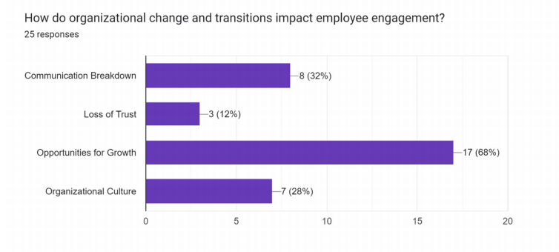

|  |  |  |
| --- | --- | --- |
| **RESPONSES** | **FREQUENCY** | **PERCENTAGE** |
| Communication Breakdown | 8 | 32 |
| Loss of trust | 3 | 12 |
| Opportunities for growth | 17 | 17 |
| Organizational Culture | 7 | 28 |
| TOTAL | 25 | 100 |

**Analysis-** From the above graph and table, it is observed that out of the total responses 25, 08 responders selected Communication breakdown, 03 responders selected Loss of trust, 17 responders selected Opportunities for growth, and 07 responders selected Organizational culture.

**Interpretation:** It is observed that 08 responders selected Communication breakdown, 03 responders selected Loss of trust, 17 responders selected Opportunities for growth, and 07 responders selected Organizational culture.

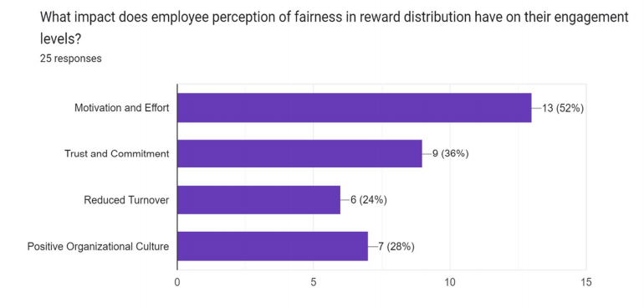

|  |  |  |
| --- | --- | --- |
| **RESPONSES** | **FREQUENCY** | **PERCENTAGE** |
| Motivation and effort | 13 | 52 |
| Trust and commitment | 9 | 36 |
| Reduced turnover | 6 | 24 |
| Positive organizational culture | 7 | 28 |
| TOTAL | 25 | 100 |

**Analysis-** From the above graph and table, it is observed that out of the total responses 25, 13 responders selected Motivation and effort, 09 responders selected Trust and commitment, 06 responders selected Reduced turnover, and 07 responders selected Positive organizational culture.

**Interpretation:** It is observed that 13 responders selected Motivation and effort which was the maximum and 06 responders selected Reduced turnover which was the minimum.

**FINDINGS**

Following the observations and data analysis, the following issues emerged, along with all of the study's conclusions:

1. The age group of 18 to 24 years old had the highest number of respondents, while the age group of 25 to 34 years old had the lowest number.
2. According to the qualification, the majority of respondents were high school graduates, while the greatest number of students were master's and bachelor's degree holders.
3. It is noted that men make up the majority of replies, while women make up the smallest percentage.
4. It can be seen that 05 respondents chose transparency and constant feedback, which was the minimum, and 8 respondents chose evaluation and modification, which was the maximum.
5. It can be seen that eight respondents chose "communication breakdown," three chose "loss of trust," seventeen chose "opportunities for growth," and seven chose "organizational culture."
6. It can be seen that six respondents chose reduced turnover, which was the smallest, and thirteen respondents chose motivation and effort, which was the maximum.

**CONCLUSION**

Following the observations and data analysis, the following issues emerged, along with all of the study's conclusions: It has been noted that ten people concur that employee engagement at work is largely influenced by production and morale. Five respondents chose transparency and ongoing input, which was the least, while eight respondents chose evaluation and adjustment, which was the highest. The majority of respondents discovered that offering both monetary and non-monetary rewards increases employee motivation, and more engaged employees are more productive. It can be seen that eight respondents chose "communication breakdown," three chose "loss of trust," seventeen chose "opportunities for growth," and seven chose "organizational culture."

It can be seen that six respondents chose reduced turnover, which was the smallest, and thirteen respondents chose motivation and effort, which was the maximum. The majority of responders are between the ages of 18 and 24, and the majority of students who meet the requirements are in master's programs, with the lowest percentage of respondents being in high school. As can be seen, there are a minimum of 12 female respondents and a maximum of 13 male respondents.

**REFERENCES**

1. Journal by Paul Turner, (2019) <https://doi.org/10.1007/978-3-030-36387-1_2>

[2] Journal by B.C. Sinha, (2021) <https://doi.org/10.4018/978-1-7998-7951-0.ch008>

[3] Journal by S. Zeidan, (2020) <https://doi.org/10.7206/cemj.2658-0845.18>

[4] Journal by Li Sun, (2019) <https://doi.org/10.5296/IJHRS.V9I1.14167>

[5] Journal by Duncan Brown, (2014) <https://doi.org/10.1177/0886368714549303>

[6] Journal by I. Smith, (1993) <https://doi.org/10.1108/01425459310038915>