**A STUDY ON ACCOUNTS PAYABLE PROCESS IN CHOLAMANDALAM INVESTMENT AND FINANCE COMPANY LIMITED**

**DHAARANI.E**, MBA student Jerusalem College of Engineering, Chennai Tamil Nadu, India

Guide: **Sivakanni S**, Assistant Professor, Jerusalem College of Engineering, Chennai, Tamil Nadu, India

**ABSTRACT**

The accounts payable process plays a crucial role in managing an organization’s cash flow, maintaining supplier relationships, and ensuring regulatory compliance. This study explores the effectiveness and efficiency of the accounts payable system ina leading non-banking financial company (NBFC) in India. The primary objective is to evaluate the current practices, identify process bottlenecks, and recommend improvements to enhance operational performance. The research methodology involves both qualitative and quantitative approaches, including analysis of financial documents, process flow evaluations, and interviews with finance department personnel. Key findings reveal that while CIFCL maintains a structured and technology-driven accounts payable framework, challenges persist in areas such as invoice processing time, vendor communication, and reconciliation delays. The study suggests leveraging automation tools, refining approval hierarchies, and improving vendor engagement strategies to streamline the accounts payable process. This research contributes to a better understanding of financial process optimization within NBFCs and supports strategic decision-making for improved financial management.

**Keywords:** Accounts Payable, Cholamandalam, NBFC, Financial Process, Invoice Management, Automation, Financial Efficiency.

**INTRODUCION:**

The accounts payable process is a vital component of financial management, ensuring timely payments to vendors and maintaining healthy cash flow. In organizations like Cholamandalam Investment and Finance Company Limited (CIFCL), an efficient AP system is crucial due to the high volume of financial transactions involved in their operations. This study focuses on analyzing the current accounts payable process at CIFCL to identify inefficiencies and suggest improvements. The objective is to enhance operational effectiveness and support better financial control within the organization.

**REVIEW OF LITERATURE:**

#### **“Digital Transformation in Accounts Payable: A Review of Technologies and Implementation Strategies” Rebecca Johnson (2023)**

The role of digital transformation in revolutionizing accounts payable processes within finance companies. It explores various technologies such as robotic process automation (RPA), artificial intelligence (AI), and blockchain, and their impact on streamlining invoice processing, enhancing accuracy, and reducing costs. The review also discusses implementation strategies, including change management, stakeholder engagement, and integration with existing systems. Furthermore, it evaluates the benefits of digital transformation, such as improved efficiency, better decision-making, and enhanced compliance.

#### **Supplier Diversity in Accounts Payable: A Review of Strategies and Implications” Sarah Roberts (2023)**

The integration of supplier diversity initiatives into accounts payable processes within finance companies. It discusses the importance of supplier diversity for promoting inclusion, driving innovation, and mitigating risks associated with supplier concentration. The review explores strategies for implementing supplier diversity programs, including supplier outreach, certification requirements, and performance monitoring. Additionally, it evaluates the impact of supplier diversity on supplier relationships, brand reputation, and competitive advantage. The findings offer insights for finance professionals seeking to leverage supplier diversity to enhance their accounts payable practices.

#### **“Continuous Improvement in Accounts Payable: A Review of Strategies and Best Practices” Sophia Roberts (2023)**

The strategies for implementing continuous improvement initiatives in accounts payable processes within finance companies. It discusses the importance of aculture of continuous improvement for driving efficiency, reducing costs, and enhancing stakeholder satisfaction in accounts payable operations.

#### **“Continuous Improvement in Accounts Payable’’**

A Review of Strategies and Best Practices” Sophia Roberts (2023) The strategies for implementing continuous improvement initiatives in accounts payable processes within finance companies. It discusses the importance of aculture of continuous improvement for driving efficiency, reducing costs, and enhancing stakeholder satisfaction in accounts payable operations. The review evaluates methodologies such as Lean Six Sigma, Total Quality Management (TQM), and Kaizen for identifying process bottlenecks, eliminating waste, and optimizing workflow in accounts payable. Additionally, it explores best 21 practices such as performance benchmarking, cross- functional collaboration, and employee empowerment. The findings provide insights for finance professionals seeking to establish a framework for ongoing improvement in their accounts payable functions.

# 

#### **“Ethical considerations in accounts payable’’**

a review of challenges and solutions” Sophia Adams (2022) The ethical considerations in accounts payable processes within finance companies. It discusses common ethical dilemmas faced by accounts payable professionals, such as vendor favoritism, conflicts of interest, and fraudulent activities. The review explores ethical frameworks and guidelines for promoting integrity and transparency in accounts payable operations. Additionally, it discusses the role of organizational culture, leadership, and training in fostering ethical behavior among accounts payable staff. The findings provide insights for finance professionals seeking to uphold ethical standards and mitigate risks in the accounts payable function.

**NEED OF STUDY**

**Ensuring Financial Efficiency** – A well-structured accounts payable process helps in timely payments, avoiding penalties, and managing cash flows efficiently. Understanding Chola’s AP system will provide insights into how the company optimizes its working capital.

**Identifying Challenges in the AP Process** – Every organization faces challenges like delayed payments, reconciliation errors, fraudulent transactions, or inefficiencies in vendor management. This study aims to analyze the key pain points and suggest improvements

**Enhancing Vendor Relationships** – Timely payments and efficient AP management contribute to strong vendor relationships, which are vital for the smooth operation of financial services. This study will evaluate how Chola maintains trust and efficiency with its suppliers.

**SCOPE OF STUDY**

**Overview of the Accounts Payable Function**:

* Exploration of the purpose and significance of the AP process within Cholamandalam Investment and Finance Company.
* Understanding the relationship between AP and the company’s overall financial operations.

**Internal Controls and Compliance**:

* Analysis of the internal control mechanisms in place to ensure accuracy, prevent fraud, and comply with company policies and legal requirements.

**LIMITATIONS OF STUDY**

* The project will be limited to a specific time frame and location, excluding informal or unstructured training methods.

**OBJECTIVES OF STUDY**

**PRIMARY OBJECTIVE:**

* To Study the Accounts Payable Process in Cholamandalam Investment and Finance Company Limited.

**SECONDARY OBJCTIVE:**

* To analyze the role of technology in streaming the accounts payable process.
* To identify challenges in the accounts payable process.
* To assess the relationship with suppliers and vendors.

**METHODOLOGY:**

The study aims to explore the characteristics and interrelationships among key variables, including employee relationship management, communication, motivation, and employee satisfaction, focusing on understanding how these factors collectively influence employee relations. A descriptive research design was adopted, which is suited for outlining the characteristics and behaviours within a population, providing a comprehensive view of the target group. To gather data, questionnaires were employed as the primary tool, allowing the study to capture nuanced insights about employee experiences and perspectives. Data collection was conducted through this systematic approach, utilizing structured questionnaires designed to elicit detailed information on ERM factors and their impact on employee satisfaction. This method offers a robust way to quantify perceptions and attitudes, creating a clearer picture of employee relationship dynamics for analysis.

**DATA ANALYSIS AND INTERPRETATION:**

**PERCENTAGE ANALYSIS FOR AGE OF THE RESPONDENTS**

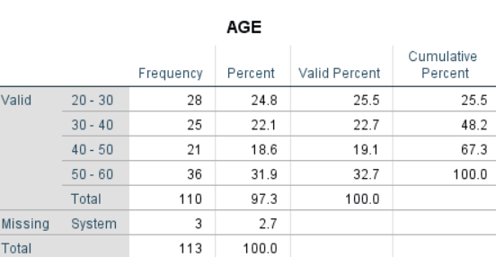

**INTREPRETATION**

#### From the above table it shows that out of 110 respondents 24.8% are between 20 TO 30 years22.1 are 30 TO 40years ,18.6% are 40 TO 50years , 31.9% are 50 TO 60 years.

**PERCENTAGE ANALYSIS FOR GENDER OF RESPONDENTS**

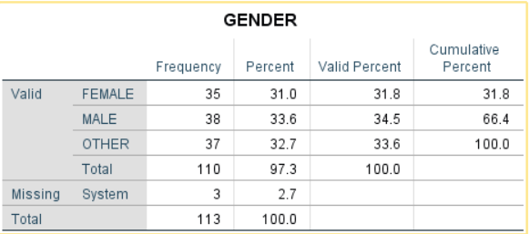

#### **INTREPRETATION:**

FROM THE ABOVE TABLE ITS SHOW THAT OUT OF 110 RESPONDANT 31% ARE

FEMALE,38% ARE MALE AND 37% ARE OTHER

**PERCENTAGE ANALYSIS FOR EXPERIENCE IN ACCOUNTS PAYABLE** 

**INTREPRETATION**

From the above table with the largest group (27.3%) having over 5 years of experience. Around 46% have more than 4 years, indicating a strong presence of seasoned professionals. Meanwhile, about 37% have less than 3 years of experience, suggesting a mix of both new and experienced individuals. This balance can support a collaborative environment with opportunities for mentorship and growth.

**CORRELATION**

HO: There is no significant relationship between the tech benefit and dispute handling.

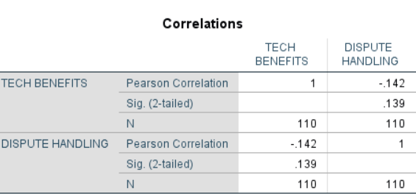H1: There is a significant relationship between the tech benefit and dispute handling.

**INTERPRETATION:**

The calculated significant value is 0.139 is greater than the significant value 0.05(0.139>0.05). Hence H0 is accepted and H1is rejected. There is no significant relationship between tech benefits and dispute handling.

**ANOVA**

HO: There is no significance difference between the common accounting treatment for accounts and documents verifies of goods and service in payables process.

H1: There is a significance difference between the common accounting treatment for accounts and documents verifies of goods and service in payables process.

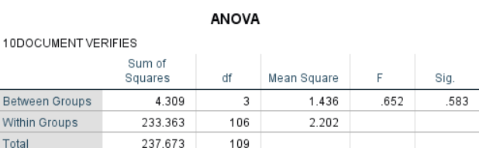

#### **INTERPRETATION:**

The results indicate that the difference between groups is not statistically significant, as evidenced by an F-value of 0.652 and a corresponding p-value (Sig.) of 0.583. Since the p-value is greater than the commonly accepted significance level of 0.05, we fail to reject the null hypothesis.

**FINDINGS**

* From the above table it shows that out of 110 respondents 24.8% are between 20 TO 30 years 22.1 are 30 TO 40years ,18.6% are 40 TO 50years , 31.9% are 50 TO 60 years.
* From the above table its show that out of 110 respondant 31% are female,38% are male and 37% are other
* From the above table and chart it is observed that out of 110 respondents, 21.2% of the respondents are belongs to the diploma, 20.4% of the respondents are belongs to the undergraduate, 37.2% of the respondents are belongs to the postgraduate are the major respondents of this study.
* From the above table with the largest group (27.3%) having over 5 years of experience.

**SUGGESTIONS**

* Increase adoption of ERP systems and automated invoice processing tools to reduce errors and improve efficiency.
* Use centralized platforms for **invoice tracking**, **payment scheduling**, and **dispute resolution** to eliminate delays and promote transparency.
* Integrate AI-based tools for smart invoice recognition and fraud detection.
* Expand the use of ERP and AI tools to reduce manual errors and processing delays.
* Address staffing issues through continuous training to boost efficiency and reduce bottlenecks.

**REFERENCES**

* **García-Teruel, P. J., & Martínez-Solano,**. (2010). A dynamic perspective on the determinants of accounts payable. *Review of quantitative finance and accounting*, *34*, 439-457.
* **Schaeffer, M. S.** (2002). *Essentials of accounts payable*. John Wiley & Sons.
* **Ilter, C.** (2020). A discussion paper on accounts payable ratio. *Acta Oeconomica Pragensia*, *27*(3), 85-94.
* **Burnie, D. A., & Ridder, A. D**. (2023). Accounts payable management. In *Working capital management: Concepts and strategies* (pp. 283-307)