##### NEWS PORTAL

##### **Aarti Bhilavekar, Neha Yadav, Harshita Mehta, Prof. RAJ Kumar Verma**

Department of Computer Science and Engineering, Thakur Shiv Kumar Singh Memorial Engineering College

**ABSTRACT**

The News Portal Website serves as a digital platform designed to deliver real-time news updates across various categories, including politics, sports, entertainment, business, and technology. This system facilitates efficient browsing, searching, and reading of news articles, enabling journalists and administrators to dynamically publish and update content. Users are empowered to engage with articles through features that allow liking, commenting, and sharing on social media. Additionally, a robust search functionality and personalized recommendations enhance the overall user experience. The website is underpinned by a secure database that ensures efficient storage and retrieval of news. The overarching goal of the News Portal Website is to provide users with accurate, timely, and easily accessible news, thereby fostering informed engagement with current events.

**INTRODUCTION**

The news portal project using PHP and MySQL is an online app. Is a dynamic system. Can be easily maintained and modified because it is based on the database. Contains websites created in real-time. These sites include the

online scenario code, as a PHP. Completely is completely secure from the unauthorized approach. In a word, can mean that our online news site is an online website to create the software, we have worked with all possible codes It is attended to conceive principles first in PHP, CSS and HTML. background pattern especially in particular on a particular online programming language ​​as pHp, mysql, javascript, CSC.The News having three modules i.e. Admin Sub-Admin User.

**LITERATURE REVIEW**

Recent academic discourse highlights the fragmentation of news consumption and the rise of issue-based journalism. Portals like 'The Ken' (business), 'Gaon Connection' (rural news), and 'Alt News' (fact-checking) exemplify how targeted journalism has gained momentum. Studies show that audiences now prefer content that aligns with their interests and values, creating space for specialized news services.

**RESULT**

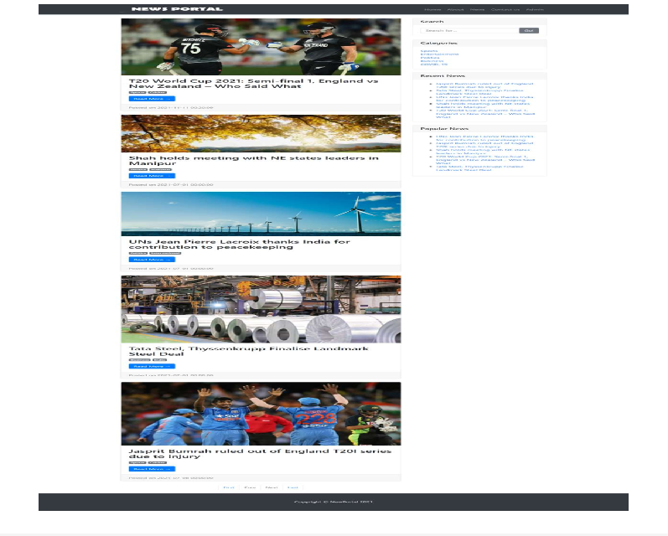

**Fig 1.1 Home Page Of News Portal**

**APPLICATIONS**

* The app shows the latest news in categories like Sports, Politics, and Entertainment.
* It has an easy-to-use design that works on both computers and phones.
* Users can search for specific news articles.
* Admins can easily add and manage news content.
* Users can interact by liking, sharing, or commenting on articles

**LIMITATIONS**

There are some limitations for the current system to which solutions can be provided as a future development:

• The website requires an internet connection to access content.

• We don’t manage news reporting system.

• Advertisements may clutter the user experience.

• High website traffic can slow down performance or cause crashes.

• Limited customization for users in terms of news preferences.

• User engagement might be low if the site lacks interactive features.

• Limited offline access to articles or features.

• Security breaches could expose user data if not properly protected.

• Maintaining real-time updates may be challenging with limited resources.

**FUTURE SCOPE**

The future scope of our project is valuable. Our project time duration was only one years .In this time interval we developed our project. It was very difficult to complete project within this time duration. In future if we get chance we will develop this website for large volume.

As for other future developments, the following can be done:

• We will manage news reporting system.

• We can make video conferencing system.

• We update our database.

• Sensibility level could add be added.

**CONCLUSION**

In our project work, an attempt has been made to develop News or information based web site.

We develop this project that helps the people and make them aware so that they can know any news. To establish this website we use various methodologies. To develop this project we have faced many problem but we hardly tried to develop this project. Our supervisor helps us by giving his valuable opinion, decision and time.

**REFERENCE**

For PHP

* <https://www.w3schools.com/php/default.asp>
* <https://www.sitepoint.com/php/>
* <https://www.php.net/>

For MySQL

* https://www.mysql.com/
* <http://www.mysqltutorial.org>

For XAMPP

* <https://www.apachefriends.org/download.html>
* Digital News Report 2024 (Reuters Institute)
* IAMAI Digital Media Report 2024
* Interviews with digital journalists from The Ken and Alt News
* Various online sources and analytics platforms