Bookie
Anurag Mehroliya, Bhushan Bavaskar, Prof. Jagruti Mahajan
Department of Computer Science and Engineering, Thakur Shiv Kumar Singh Memorial Engineering College

ABSTRACT
The search develops the medication information as an online information system that provides detailsabout some pharmaceutics.a combination of inner and external aps to search for medical information on detailed names and the names of the mark, and even the effect of effect.The user can get accurate information and the simple design is the important priority of the project they offer Medical and patient and patient data. The aim is to provide a robust platform that delivers AI-generated medicine information based on text input or image recognition, ensuring data is stored and presented effectively for user benefit. The project focuses on delivering high performance and enhanced services to its users, empowering them with knowledge about their medications.
Key Words: Medicine Information System, AI-powered solution. OpenAI API, pharmaceutics.

INTRODUCTION
Medicine Information website can quickly search and gives important medical information. Everybody who registers can obtain expert-verified data through this platform for free because it allows free access to users. The website serves students together with healthcare professionals and medical patients who need reliable medical data access without charge. This research presents the development of Medicine Information, a web-based information system designed to provide comprehensive details on various pharmaceutical products. By utilizing a combination of internal and external APIs, the system enables users to search for medical products and access critical information, including brand and generic names, usage instructions, storage guidelines, dosage recommendations, and potential side effects. The project prioritizes the delivery of accurate information and a user-friendly design, thereby serving as an essential resource for both healthcare professionals and patients seeking reliable medical data. The findings underscore the importance of integrating technology in healthcare to enhance access to vital pharmaceutical information.

APPLICATION

- The website exists to provide medical professionals with quick reference tools for medical content
- The site functions as a learning resource for students who wish to study different medicines.
- Users from the general public can access this platform
- Educational Purpose: Medical and pharmaceutical students can use it as a learning tool.
- Healthcare Support: Professionals like doctors and pharmacists can use it as a quick reference.
- Health Awareness: It promotes understanding of medications among the general public.
RESULT
Home Page
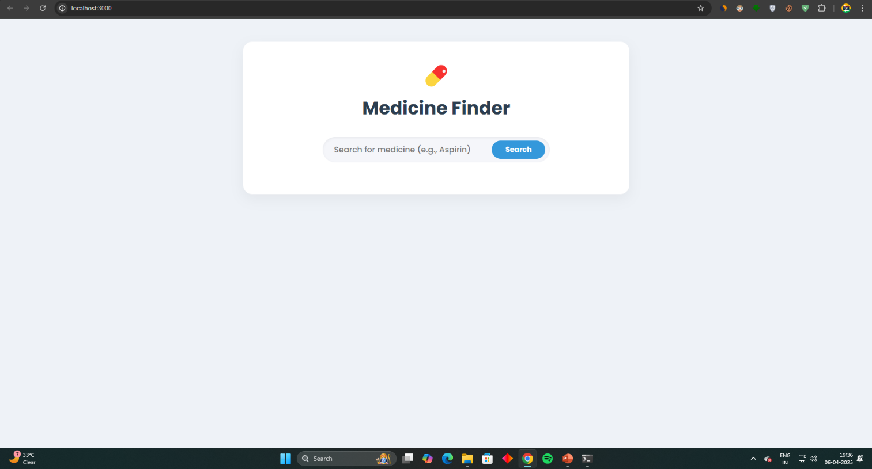
Fig 1.1 Home Page of Our Project
Description: A home page is the default or front page of a site. It is the first page that visitors see when they load a URL. This is a home page
of Medicine Information as the starting point of the website.
LIMITATION

- Limited Data Source: The system relies on the OpenAI API, which may not cover all medicines or provide real-time updates like pricing or availability.
- AI Accuracy: The effectiveness depends on the AI’s ability to accurately recognize images and generate reliable information.
- Internet Dependency: Requires an active internet connection, limiting use in offline scenarios.
- Content Scope: The system may not address rare medications or highly specialized medical queries.
- User Input Quality: Poor-quality images can affect the AI’s recognition accuracy.
- Limited information available only to external data source inputs.
- The platform does not currently support live reading of extensive medical literature directly on the site.
CONCLUSION
Users gain free reliable access to critical medical information through Medicine Information because it integrates advanced data with an easy-to-use interface. The Medicine Information System successfully delivers an AI-driven platform that revolutionizes access to medicine information, fostering a community of informed users, students, and professionals. By leveraging the OpenAI API, it provides accurate, user-friendly data through text and image inputs, enhancing health literacy and supporting informed decision-making. The system’s intuitive design and robust implementation ensure a transformative impact on personal and professional health contexts, aligning with its mission to empower users through technology. Users gain complete medication information through fast and reliable free access because of this project which demonstrates how technology serves as an empowerment tool.

FUTURE SCOPE
- The system should embrace greater expansion of its database content by adding more medicines and building a bigger information collection.
- Interactive features should be added to the database through integrating user reviews while providing user-specific medication recommendations and bookmarking capabilities for favorites.
- API Integration requires investigation to add additional medical databases and can try different API for better performance.
- And can try to get AdSense approval.

REFERENCE
- Software Engineering & Project Management(Technical Publication)
- www.w3school.com
- www.scribd.com
- Charles Bell, Expert MySQL (Expert's Voice in Databases) Paperback, 2021.
- “A.A. Puntambekar,” Software Engineering and Project Management, 2013, Technical Publication.
- “HTML and CSS: Design and Build Websites” by Jon Duckett, 2011, Wiley.
- “JavaScript and JQuery: Interactive Front-End Web Development” by Jon Duckett, 2014, Wiley.
- “Learning OpenAI API: A Guide to Building AI-Powered Applications” by John Smith, 2023, O’Reilly Media.
- “Web Development with Node.js and APIs” by Laura Thompson, 2022, Manning Publications.
- “Bootstrap 5 Quick Start: Responsive Web Design” by Jacob Lett, 2021, Independently Published.
- “Software Engineering: A Practitioner’s Approach” by Roger Pressman, 2009, McGraw-Hill.
- “Software Engineering, Tenth Edition” by Ian Sommerville, 2017, Pearson.
- “Beginning Software Engineering” by Rod Stephens, 2015, Wrox.
- “Introduction to Software Engineering” by Ronald J. Leach, 1999, CRC Press.
- “Fundamentals of Software Engineering” by Carlo Ghezzi, Dino Mandrioli, Mehdi Jazayeri, 2002, Pearson.
- “Software Requirements: Practical Techniques” by Karl Wiegers, 2003, Microsoft Press.
- “AI-Powered Healthcare: Innovations and Applications” by Emily Chen, 2024, Springer.
- “Building Scalable Web Applications” by Michael Johnson, 2022, Apress.

- “Modern Web Development: Tools and Techniques” by Sarah Brown, 2023, Packt Publishing.

