**BANANA TRADE**

**Akshay Mahajan, Jay Mahajan, Abhishek Gour,**  **Prof. Vardan Gupta**

Department of Computer Science and Engineering, Thakur Shiv Kumar Singh Memorial Engineering College Burhanpur(MP)

**ABSTRACT**

This research paper addresses the challenges faced by farmers in India due to the prevalence of mediators in the crop selling process, which often leads to significant profit loss for the farmers. With mediators taking over 75% of the profits, farmers are left with limited control over pricing and customer choice. The proposed solution is a progressive web application designed to empower farmers and retailers by facilitating direct transactions for buying and selling crops. The application incorporates a predictive pricing feature that provides insights into current and future market prices, enabling farmers to identify profitable crops and set fair selling prices. Recognizing the linguistic diversity among users, the application supports over 18 languages, making it accessible for a broader audience. This innovative approach not only promotes financial independence for farmers but also streamlines the agricultural supply chain.

**INTRODUCTION**

The Banana Buying and Selling Project is designed to support farmers by creating a reliable and profitable market for their banana produce. Bananas are one of the most widely consumed fruits in the world, offering high nutritional value and consistent market demand. However, many farmers face challenges in accessing fair prices, reliable buyers, and efficient distribution channels.

This project aims to bridge the gap between banana growers and buyers by setting up a structured system that ensures quality, timely payments, and better price negotiation. By connecting farmers directly with markets—whether local, regional, or export-based—we help reduce dependency on middlemen, minimize post-harvest losses, and improve farmers’ income. Additionally, the system aims to eliminate the need for mediators, ensuring that farmers receive their rightful profits. To enhance usability, the application includes uninterrupted location services for transportation and 24/7 customer support, with offline maps for navigation in low-signal areas.

**APPLICATION**

The Tech Academy is an Educational Website which will-

1. This web app can be used by any User in all over the World.
2. This web app can be handling by the admin for Updating content.
3. Admin can monitor the activities of User.
4. User can manage their content in one particular session.
5. This web app can reduce the time and effort of User.
6. This web app provide easy interface to User.
7. It reduces pen-paper effort.
8. **B2B and B2C Supply Chain Platform**.
9. **B2C (Business to Consumer)**: Selling bananas directly to consumers.
10. **B2B (Business to Business)**: Connecting farms with restaurants, supermarkets, or exporters

**LIMITATION**

1. **Limited Product Scope**

* **Only bananas**: Focusing on a single product limits customer interest and reduces repeat visits.
* **No variety**: If the site doesn’t offer types (e.g., Cavendish, Red bananas, Plantains), users may lose interest.

**2. Geographic Limitations**

* **Delivery constraints**: Fresh produce like bananas has a short shelf life, limiting how far it can be shipped.
* **Limited sellers**: A small seller base means fewer options for buyers.

**3. Payment System Limitations**

* **No support for local payment methods** in certain regions.
* **Lack of security** or **trust** in the system can stop users from transacting.

**RESULT**

**Description:** A home page is the default or front page of a site. It is the first page that visitors see when they load a URL. This is a home page of BANANA TRADE as the starting point of the website.

The home page is the main landing screen after login. It usually displays key features, user-specific information, and navigation links to other parts of the app.

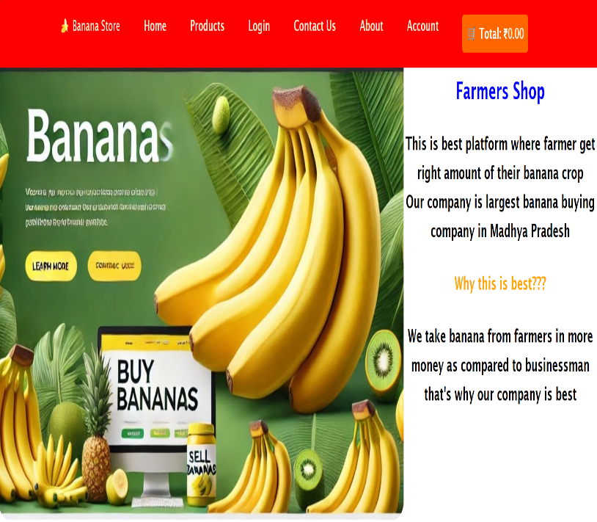

Fig 1.1 **BANANA TRADE HOME PAGE**

**FUTURE SCOPE:**

* In future we are using some new technologies for farmers from that farmers can demand for increasing of their crop amount if they have good crop also we are introducing some new Things like they can take advanced money from our management for crop growing.

Then can gave money to our team later

* **Expanding Marketplaces:**
* **Global Reach:** Crop buying and selling platforms can bridge the gap between local farmers and international buyers. By expanding the reach, farmers can get better prices, and buyers can source crops from different regions with ease.
* **E-commerce Integration:** More seamless e-commerce options will be integrated into these platforms, allowing for easier payment methods, financing options, and subscription models

**CONCLUSION**

We've found this may be the best site for users to access the purchase and selling content in a secure access country. This website is complete anyway on current market price, etc. limit this project is that the user is not able to pay the amount online. Meanwhile, the farmer ecosystem facilitates sharing of views and experiences by consumers in multiple ways .

**REFERENCE**

* Software Engineering & Project Management(Technical Publication)
* [www.w3school.com](http://www.w3school.com/)
* [www.scribd.com](http://www.scribd.com/)
* [www.google.com](http://www.google.com/)
* [www.wikipedia.com](http://www.wikipedia.com/)
* [www.youtube.com](http://www.youtube.com/)
* Charles Bell, Expert MySQL (Expert's Voice in Databases) Paperback, 2021.
* M Kuhrmann, Tell-IEEE journal on Software Development Risks, 2021
* I Abudani, M Alenezi-IEEE journal of Web Applications, 2021.
* P Kyriakakis, A Chatzigeorgiou-IEEE PHP Web Application, 2019.
* Ronald J. Leach, Introduction to Software Engineering, 2017.
* C Severance-IEEE Project Management journal, 2018.