**A Implementation on Gesture Controlled Virtual Mouse**

Assistant Prof. Sudha Shende, Department of Computer Science Engineering (Data Science), Abha Gaikwad

Patil College Of Engineering And Technology, Mohgaon, Wardha Road, Nagpur, Maharashtra, India

Krutika Meshram1, Priti Nagwanshi2, Avinsah Narwade3, Kunal Kamble4, Ashish Yadav5

ABSTRACT

The rapid evolution of human-computer interaction (HCI) has led to the development of alternative input methods beyond traditional devices like the keyboard and mouse. One such innovation is the gesture-controlled virtual mouse, which offers a more intuitive and hands-free interaction experience. This research proposes the design and implementation of a gesture-controlled virtual mouse that uses computer vision and machine learning algorithms to track and interpret hand movements. The system captures gestures through a standard webcam, processes the motion data, and translates it into corresponding mouse actions such as movement, clicks, and scrolling. The study explores the effectiveness and accuracy of gesture recognition in various real-world conditions, including different lighting, distances, and hand orientations. Results indicate that the proposed system provides a viable and efficient alternative to conventional mouse-based input devices, with potential applications in accessibility, gaming, and interactive media. Future work will focus on refining gesture recognition algorithms to improve reliability and expanding the range of supported gestures for broader application use cases.

Keywords: Gesture Controlled technology, hand gesture, movement recognition, gesture controlled virtual mouse system

I. INTRODUCTION

In the era of Human-Computer Interaction (HCI), traditional input devices like mice and keyboards are being enhanced or replaced by more intuitive and immersive technologies. A Gesture Controlled Virtual Mouse leverages computer vision and machine learning to interpret hand movements and gestures, allowing users to interact with a computer without physical contact.

This system typically utilizes a webcam or depth sensor to capture hand motions, which are then processed using algorithms such as MediaPipe, OpenCV, and deep learning models. Various gestures, such as finger movements, hand tilts, and clicks, are mapped to standard mouse functions like cursor movement, clicking, and scrolling.

The primary advantages of a virtual mouse include enhanced accessibility, improved hygiene, and a futuristic user experience, making it particularly useful in touchless environments, gaming, and assistive technologies. However, challenges such as accuracy, latency, and adaptability to different lighting conditions remain areas of ongoing research and development.

This paper explores the design, implementation, and applications of a Gesture Controlled Virtual Mouse while addressing its limitations and future advancements. With the rapid advancement of Human-Computer Interaction (HCI), traditional input devices such as physical mice and keyboards are evolving to provide users with more intuitive and seamless interaction methods. A Gesture Controlled Virtual Mouse is an innovative system that enables users to control a computer’s cursor using hand gestures instead of conventional hardware peripherals.

This system relies on computer vision, deep learning, and artificial intelligence (AI) to detect and interpret hand movements in real-time. Technologies such as OpenCV, MediaPipe, TensorFlow, and machine learning algorithms are commonly used to track hand landmarks and recognize predefined gestures. These gestures are then mapped to mouse functions such as cursor movement, clicking, scrolling, and dragging, eliminating the need for physical contact.

The demand for touchless interaction methods has grown significantly, especially in contexts where hygiene is a priority, such as **medical environments, public kiosks, and industrial applications.** Additionally, gesture-based control enhances **accessibility for individuals with physical disabilities** and offers an immersive experience in fields like **gaming, augmented reality (AR), and virtual reality (VR).**

A Gesture Controlled Virtual Mouse functions by utilizing a **camera (webcam or depth sensor)** to capture real-time hand movements. These captured frames are processed using **image processing techniques and deep learning models** to identify the user’s hand position, detect finger gestures, and translate them into cursor movements and mouse actions. Commonly used frameworks for implementation include **OpenCV, MediaPipe, TensorFlow, and PyTorch.**

The Gesture Controlled Virtual Mouse is an innovative human-computer interaction (HCI) system that allows users to control a computer's cursor and perform mouse functions using hand gestures instead of a traditional physical mouse. This technology leverages computer vision, artificial intelligence (AI), and machine learning to interpret hand movements and translate them into corresponding actions, such as cursor movement, clicking, scrolling, and dragging.

With the increasing demand for contactless and intuitive interaction methods, gesture-based control systems have gained popularity in various domains, including healthcare, gaming, smart environments, and assistive technology. Unlike traditional input devices, which require physical contact, a gesture-controlled virtual mouse enhances hygiene, accessibility, and user convenience, making it an ideal solution for touchless interactions.

The Gesture Controlled Virtual Mouse is a touchless human-computer interaction (HCI) system that enables users to control a computer’s cursor and perform mouse functions using hand gestures instead of a physical mouse. It utilizes computer vision, artificial intelligence (AI), and deep learning to detect and interpret hand movements in real-time. By using a webcam or depth sensor, the system tracks hand motions and maps them to standard mouse operations, such as cursor movement, clicking, scrolling, and dragging. Technologies like OpenCV, MediaPipe, and TensorFlow are commonly used to implement gesture recognition.

The Gesture Controlled Virtual Mouse is a revolutionary advancement in Human-Computer Interaction (HCI) that enables users to interact with a computer system using hand gestures instead of a physical mouse. This technology eliminates the need for traditional input devices by leveraging computer vision, artificial intelligence (AI), and machine learning to detect and interpret real-time hand movements. As touchless interaction gains prominence in various fields such as healthcare, gaming, smart environments, and assistive technology, a gesture-controlled virtual mouse provides a more intuitive, accessible, and hygienic alternative to conventional mouse devices. By using a webcam or depth sensor, the system captures hand movements, processes them using image processing algorithms, and translates them into corresponding mouse actions, such as cursor movement, clicking, scrolling, and dragging. The Gesture Controlled Virtual Mouse is an advanced Human-Computer Interaction (HCI) technology that allows users to control a computer’s cursor and perform mouse functions using hand gestures instead of a physical mouse. By utilizing computer vision, artificial intelligence (AI), and machine learning, the system detects and interprets hand movements in real-time, enabling cursor movement, clicking, scrolling, and dragging without physical contact.

**Ⅱ**. LITERATURE REVIEW

Quality of life (QoL) is a multidimensional concept encompassing physical, cognitive, social, psychological, and sensory well-being. Virtual reality (VR) and augmented reality (AR) have gained significant attention as innovative tools that can enhance these aspects of life for older adults. Research has highlighted numerous benefits of VR and AR in improving various QoL domains, particularly in healthcare, rehabilitation, fall prevention, cognitive stimulation, and entertainment. However, while many studies explore these applications, there remains a lack of clarity regarding the most effective technology for addressing social well-being. Additionally, existing reviews have often focused on specific aspects of VR and AR, such as digital games, exergames, or rehabilitation, without providing a comprehensive perspective on their broader impact on multiple QoL dimensions. Given the importance of maintaining a balance across physical, cognitive, psychological, and social well-being for healthy aging, further exploration is needed to guide researchers, developers, and practitioners in leveraging these technologies effectively.

Technological advancements, decreasing device costs, and widespread internet access have significantly contributed to the growing use of VR and AR. These tools offer older adults a secure and controlled environment for engaging in activities that might otherwise pose risks in the real world. AR enhances interactions with the physical environment by overlaying digital content, while VR provides immersive experiences that allow users to explore virtual settings beyond their physical limitations. VR systems vary in their level of immersion, ranging from fully immersive experiences using head-mounted displays (HMDs) to semi-immersive systems where digital content is displayed on screens. Similarly, AR applications can be accessed through various devices, including smartphones, tablets, and specialized AR glasses.

Both game-based and non-game-based applications of VR have gained popularity in research on aging. Game-based VR, particularly exergames, combines physical activity with interactive gaming elements to promote engagement and enjoyment. These applications can be customized in terms of intensity, duration, and feedback to suit individual needs. On the other hand, non-game-based VR applications aim to replicate real-world experiences, such as mobility training and rehabilitation exercises, often integrating additional technologies like motion sensors, treadmills, or wearable devices to enhance feedback and interaction. AR-based games and applications similarly offer engaging experiences that can improve cognitive function and physical activity while maintaining a level of real-world interaction.

Despite the promising potential of VR and AR in improving the QoL of older adults, several challenges remain. One major issue is the frequent conflation of VR and AR in research, leading to inconsistencies in findings and a lack of clarity regarding their unique benefits. Many studies discuss these technologies interchangeably, making it difficult to determine their specific contributions to different QoL domains. Additionally, while research suggests that VR and AR can help maintain and improve cognitive, physical, psychological, and social abilities, there is no clear framework outlining their optimal use for older adults.

To address these gaps, it is essential to explore the diverse subcategories of VR and AR and their specific impact on different QoL aspects. This review aims to provide a comprehensive overview of existing research on VR and AR applications for older adults, emphasizing their relevance in rehabilitation, training, and healthcare. Unlike previous systematic reviews that focus on a single domain or application, this mapping review seeks to offer a broader perspective on how these technologies contribute to healthy aging. By synthesizing current findings, this study aims to assist researchers, technology developers, and healthcare professionals in identifying the most effective applications of VR and AR to enhance the overall well-being of older adults.

In the current virtual mouse control system, a hand recognition mechanism is used to perform basic mouse functions such as moving the pointer, left and right clicking, and dragging. However, the reliance on hand recognition may not be a viable approach in the future. Various hand recognition methods exist, but the system in use primarily relies on static hand recognition. This technique identifies specific hand shapes and assigns predefined actions to each shape. However, this approach is restricted to a limited set of recognized gestures, which can lead to confusion and inaccuracies in execution. The primary goal of the proposed AI-powered virtual mouse system is to provide an alternative to traditional mouse control by enabling hands-free interaction

Ⅲ. METHODOLOGY

3.1 Finger Capturing: -

The system works by scanning the unique patterns and ridges of an individual's fingertips, processing the captured image to extract distinctive features, and creating a template that can be matched against stored templates in a database to verify identity. With applications in security, access control, identity verification, and biometric authentication, Finger Capturing Systems offer a convenient, secure, and accurate means of identification, leveraging the uniqueness of fingerprints to provide a high level of authentication and authorization.

3.2 Fingertip Detect: -

Using advanced computer vision and machine learning algorithms, the system captures and processes video images of the fingertips to identify specific gestures, movements, and patterns. This information is then used to control digital devices, such as computers, smartphones, and gaming consoles, allowing users to interact with them in a natural and intuitive way. With

applications in fields like human-computer interaction, gaming, and assistive technology, Fingertip Detect systems offer a innovative and engaging way to interact with digital devices, enhancing user experience and accessibility.

3.3 Process the Codes: -

This system utilizes advanced algorithms and machine learning techniques to recognize and process coded patterns, such as gestures, voice commands, or keyboard inputs. Once the coded input is detected, the system translates it into a corresponding action, allowing users to interact with digital devices, control applications, or access specific functions. With applications in fields like human-computer interaction, automation, and accessibility, Process Codes systems offer a flexible and efficient way to interact with technology, enhancing user experience and streamlining complex tasks.

3.4 Gesture Extracting: -

These detected gestures are then converted into digital instructions, enabling users to seamlessly control electronic devices, engage with software applications, and access various features. By harnessing this innovative technology, Gesture Extracting systems provide a fluid and instinctive means of interacting with technology, thereby enriching the user experience and promoting greater accessibility across diverse fields, including human-computer interaction, gaming, and assistive technology.

3.5 Image Recognition: -

A cutting-edge technology that enables computers to identify and classify images into predefined categories. Using advanced machine learning algorithms and deep learning techniques, the system analyzes visual data from images, detecting patterns, shapes, and features to recognize specific objects, people, or scenes. With applications in fields like security surveillance, healthcare, self-driving cars, and social media, Image Recognition systems offer a powerful tool for automating image analysis, enhancing user experience, and driving business innovation. By accurately identifying and interpreting visual data, Image Recognition systems unlock new possibilities for image-based applications, enabling faster, more accurate, and more efficient decision-making.

3.6 Image Processing: -

Through the utilization of advanced algorithms and computer vision techniques, the system acquires, processes, and interprets image data to augment its quality, extract pertinent information, or prepare it for subsequent analysis. The applications of Image Processing systems are diverse, encompassing fields such as medical imaging, security surveillance, photography, and autonomous vehicles, where tasks including image filtering, object detection, segmentation, and recognition are performed.

The system supports various commands, including "click" gestures, such as tapping or pinching, to simulate left or right mouse button clicks. "Drag" gestures, like moving the hand or finger while maintaining contact, enable users to drag and drop virtual objects. "Scroll" gestures, such as moving the hand or finger up or down, allow users to scroll through documents or web pages. Additionally, "zoom" gestures, like spreading or pinching fingers, enable users to zoom in or out of virtual environments. By leveraging these intuitive gestures, users can effortlessly interact with virtual interfaces, enhancing their overall computing experience.

The process commences with the acquisition of a hand image through "Finger Capturing." Subsequently, the system identifies the precise locations of the fingertips in the "Fingertip Detect" phase. The captured data is then subjected to processing in the "Process the Codes" step, which involves the extraction of pertinent information. The system then progresses to the "Gesture Extracting" stage, where it scrutinizes hand gestures to discern the user's intended commands. This is succeeded by the "Image Recognition" phase, where the system recognizes patterns within the detected gestures. To enhance accuracy, the system performs "Image Processing" on the recognized gestures. OpenCV plays a vital role in facilitating image recognition and processing tasks, thereby optimizing the virtual mouse system's performance. Ultimately, the processed information is translated into executable commands, enabling users to navigate and interact with the virtual mouse using intuitive hand gestures.

Finger Capturing

Fingertip Detect

Process the Codes

Gesture Extracting

Image Recognition

OpenCV

Image Processing

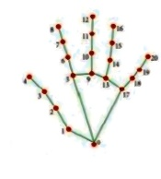

Fig. 3.1 Flow Chart of Virtual Mouse Using OpenCV

1. IV. MODULES

* No alteration or movement is made on the screen

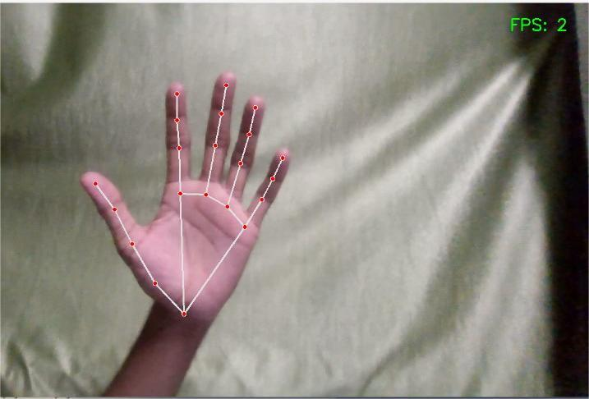

Fig.4.1 Inactive gesture.

* Perform a mouse drag operation, or Click-and-drag action.

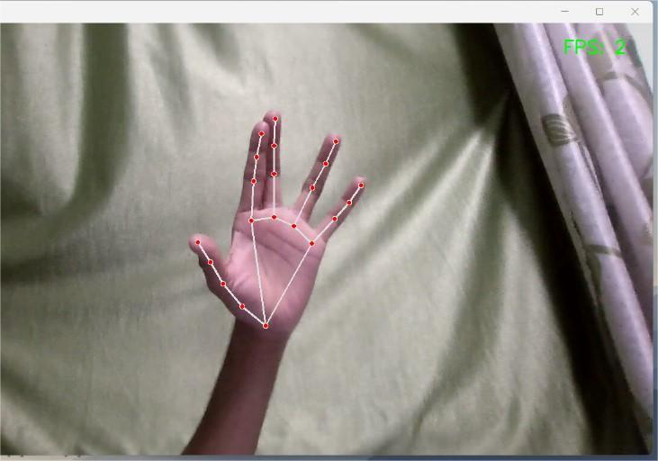

Fig.4.2 Grab-and-move.

* Simulate a left mouse button press or Execute a left-click action.

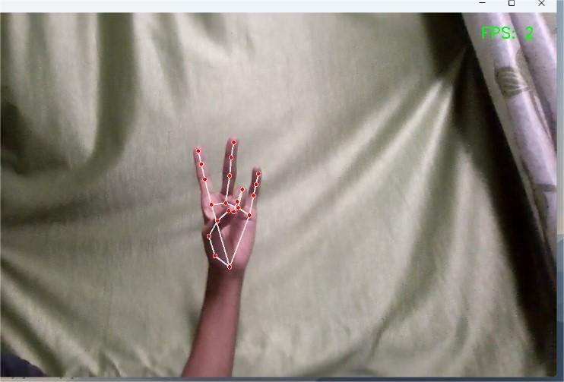

Fig.4.3 Mouse left button press

* Simulate a right mouse button press.

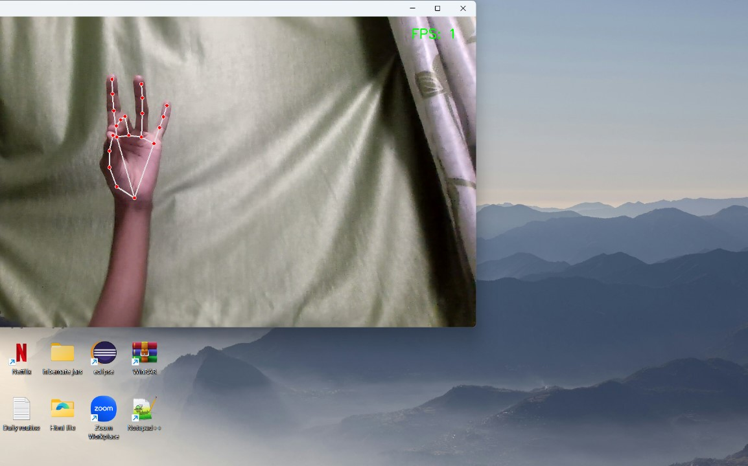

Fig.4.4 Right click (thumb tip, middle finger tip)

* To obtain information regarding the current calendar date and clock time.

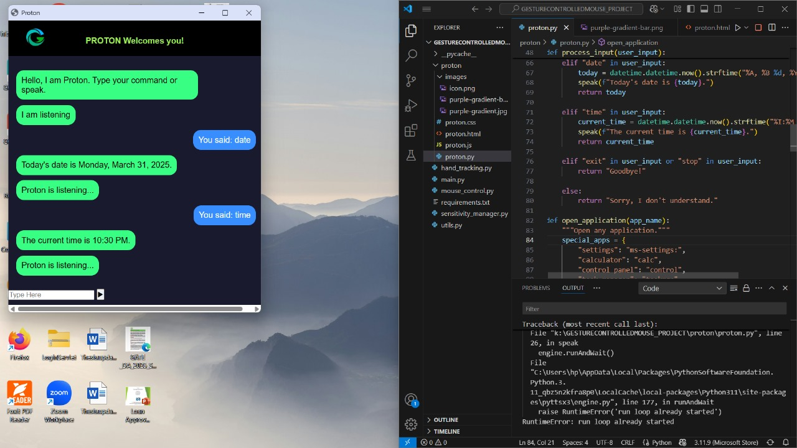

Fig.4.5 Current calendar day and hour, or System clock display, or Time and calendar information.

* Access the internet and initiate a search query or Browse the web to find specific information or Launch an online search using a web browser.

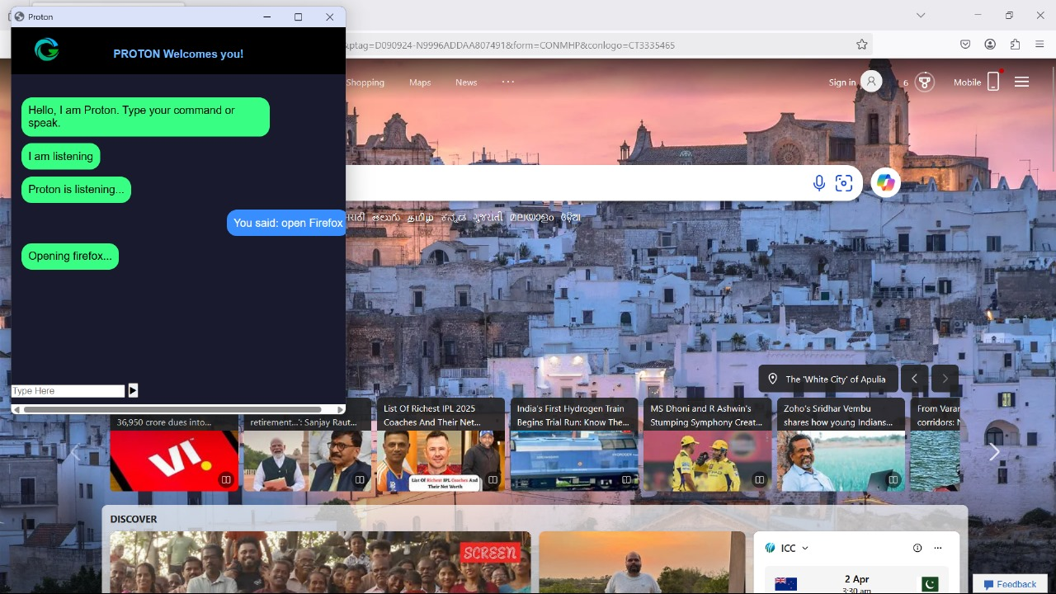

Fig.4.6 Voice Assistant Commands

* Terminate the voice-activated AI assistant or End the conversational interface session.

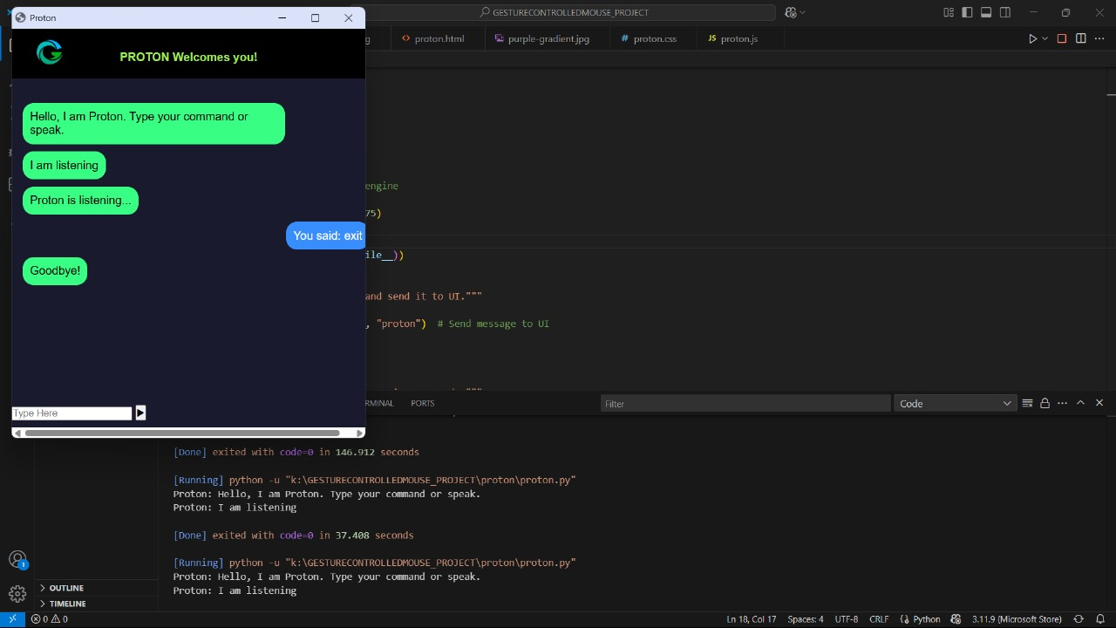

Fig.4.7 Ended the session

V. CONCLUSION

the Gesture Controlled Virtual Mouse project has achieved a groundbreaking fusion of computer vision and machine learning, yielding an innovative, hands-free interface for digital devices. By harnessing OpenCV and gesture recognition capabilities, the system enables users to control a virtual mouse with precise hand gestures, thereby introducing a new paradigm of user experience and accessibility. This pioneering project underscores the vast potential of gesture-based interfaces in revolutionising human-computer interaction, with far-reaching implications for gaming, healthcare, and education. Characterised by its robust design and adaptability, the Gesture Controlled Virtual Mouse project unlocks new avenues for innovation and research in gesture recognition and virtual interfaces, paving the way for a more intuitive, immersive, and seamless technological experience.

VI. REFRENCES

1. Pandey, A. Chauhan and A. Gupta, "Voice Based Sign Language Detection for Dumb People Communication Using Machine Learning", Journal of Pharmaceutical Negative Results*,* pp. 22-30, 2023.
2. V. Srivastava, A. Khaparde, A. Kothari and V. Deshmukh, "NLP-Based AI-Powered Sanskrit Voice Bot*",*Artificial Intelligence Applications and Reconfigurable Architectures, pp. 95-124, 2023.
3. S. Kambhamettu, M. Vimal Cruz, S. Anitha, S. Sibi Chakkaravarthy and K. Nandeesh Kumar, "Brain–Computer Interface-Assisted Automated Wheelchair Control Management–Cerebro: A BCI Application", Brain-Computer Interface: Using Deep Learning Applications, pp. 205-229, 2023

.

1. M. Jindal, E. Bajal and S. Sharma, "A Comparative Analysis of Established Techniques and Their Applications in the Field of Gesture Detection", Machine Learning Algorithms and Applications in Engineering*,* pp. 73, 2023*.*
2. Pawan R Zadgonkar, Abhishek R Waghate, Sakshi S Nivalkar, Pooja A Kondvilkar, Mrunmayee Hatiskar, “Vision: The Desktop Voice Assistant”, ISSN: 2320-2882, Vol. 12, Issue 4, April 2024.
3. Prithvi J, S Shree Lakshmi, Suraj Nair and Sohan R Kumar, “Gesture Controlled Virtual Mouse with Voice Automation”, ISSN: 2278-0181, Vol. 12 Issue 04, April-2023.
4. Kasar, M., Kavimandan, P., Suryawanshi, T., & Abbad, S. (2024). AI-based real-time hand gesture-controlled virtual mouse. Australian Journal of Electrical and Electronics Engineering, 1-10.
5. Singh, J., Goel, Y., Jain, S., & Yadav, S. (2023). Virtual mouse and assistant: A technological revolution of artificial intelligence. arXiv preprint arXiv:2303.06309.
6. Yadav, K. S., Anish Monsley, K., & Laskar, R. H. (2023). Gesture objects detection and tracking for virtual text entry keyboard interface. Multimedia Tools and Applications, 82(4), 5317- 5342.
7. Shankar, A., Bondia, A., Rani, R., Jaiswal, G., & Sharma, A. (2024, January). Gesture Controlled Virtual Mouse and Finger Air Writing. In 2024 14th International Conference on Cloud Computing, Data Science & Engineering (Confluence) (pp. 370-375). IEEE.
8. K. H. Shibly, S. Kumar Dey, M. A. Islam, and S. Iftekhar Showrav, “Design and development of hand gesture based virtual mouse,” in Proceedings of the 2024 1st International Conference on Advances in Science, Engineering and Robotics Technology (ICASERT), pp. 1–5,
9. Virtual Mouse Using Hand Gesture and Voice Assistant Khushi Patel, Snehal Solaunde, Shivani Bhong, and Sairabanu Pansare ISSN: 2349-6002 2024 IJIRT.
10. Shriram, S., B. Nagaraj, J. Jaya, S. Shankar, and P. Ajay.
11. 2023. “Deep Learning-Based Real-Time AI Virtual
12. Mouse System Using Computer Vision to Avoid
13. COVID-19 Spread.”
14. Shriram, S., B. Nagaraj, J. Jaya, S. Shankar, and P. Ajay.
15. 2023. “Deep Learning-Based Real-Time AI Virtual
16. Mouse System Using Computer Vision to Avoid
17. COVID-19 Spread.