**BLOOD DONOR FINDER SYSTEM**

**Priyanka Raising,** **Shubhangi Patil,** **Prof. Vardan Gupta**

Department of Computer Science and Engineering, Thakur Shiv Kumar Singh Memorial Engineering College Burhanpur(MP.)

**ABSTRACT**

The search donor donor system is an innovative online application to optimize the link between the blood donors and real recipients. Securing users to register as donors or beneficiaries and provide critical information such as blood Include location services, advanced search filters, notifications and real managers, Allow recipients to publish urgent blood claims that immediately communicated to potential donors. Including an administration panel facilitates user data management, verification and database. The additional characteristics of the story and realize holidays in santeseni also will fill the platform, with the potential integration with hospitals. After all, the tame of the blood donor replies to the pressure needed as soon as possible Access to blood, especially in urgent cases, contribute significant significant to save life.

**INTRODUCTION**

The Blood Donor Finder System is a web or mobile-based application designed to streamline the process of connecting blood donors with recipients in real-time. It allows users to register as donors or recipients, providing essential details like blood group, location, and contact information. The system leverages location-based services to find nearby donors and includes features like advanced search filters, real-time notifications, and request management. Recipients can post urgent blood requests, and donors are alerted immediately through notifications, enabling prompt assistance. The platform also includes an admin panel for managing user data, verifying donor authenticity, and maintaining the database. With additional features such as donation history tracking, awareness campaigns, and potential integration with hospitals, this system aims to save lives by ensuring the timely availability of blood during emergencies. The Blood Donor Finder System is a web-based or mobile application designed to bridge the gap between blood donors and those in need of blood. This system addresses the critical challenge of finding eligible blood donors quickly and efficiently, especially during emergencies. It streamlines the process of blood donation by connecting recipients to registered donors or blood banks in their vicinity.

**REQUIREMENT AND ANALYSIS**

1. **Architectural Requirements:** Architectural requirements explain what has to be done by identifying the necessary systems architecture of a system.
2. **Structural Requirements**: Structural requirements explain what has to be done by identifying the necessary structure of a system.
3. **Behavioural Requirements:** Behavioural requirements explain what has to be done by identifying the necessary behaviour of a system.
4. **Functional Requirements:** Functional requirements explain what has to be done by identifying the necessary task, action or activity that must be accomplished
5. **Non-functional Requirements:** Non-functional requirements are requirements that specify criteria that can be used to judge the operation of a system, rather than specific behaviour’s.

**PROBLEM DEFINITION**

A definition of the problem is a description of a problem of a problem that must be solved or condition to improve. Identifies the difference between the actual state (problem) and the desired state (intended) of a process or product. The first situation to solve a problem is to understand the problem, which one can do for a problem statement. Problems are widely used by business and organizations to make projects to improve the process. A simple and well -definite definition of the problem will be Is used by the project team to understand the problem and work on developing a solution. We also make management with a specific summary of the problem so that make appropriate appropriate decisions. As, it is important that the statement of the problem is clear and unwelcome. The process of determining the problem is often a group effort. Begins with interested parties, customers and / or users affected by the problem (if possible) and learn their Painpoints.

**LIMITATIONS**

* A blood donor finder system is a tool designed to connect people in need of blood with potential donors. Despite its usefulness, such systems have several limitations:
* Limited Donor Availability: Donors may be unavailable, have health issues, or be difficult to match for rare blood types.
* Geographic and Logistical Barriers: Distance and transport delays can prevent timely blood delivery.
* Data Accuracy Issues: Outdated or incorrect donor information and unverified health status can lead to errors.
* Technical Problems: Limited access, system downtime, and poor user interfaces can hinder usage.
* Privacy and Security Concerns: Risk of data breaches and lack of informed consent
* Awareness and Trust Issues: Limited awareness and mistrust can reduce participation.
* Emergency Challenges: Delays in matching donors and reliance on technology without backup plans can affect urgent situations.

**RESULT OUR PROJECT**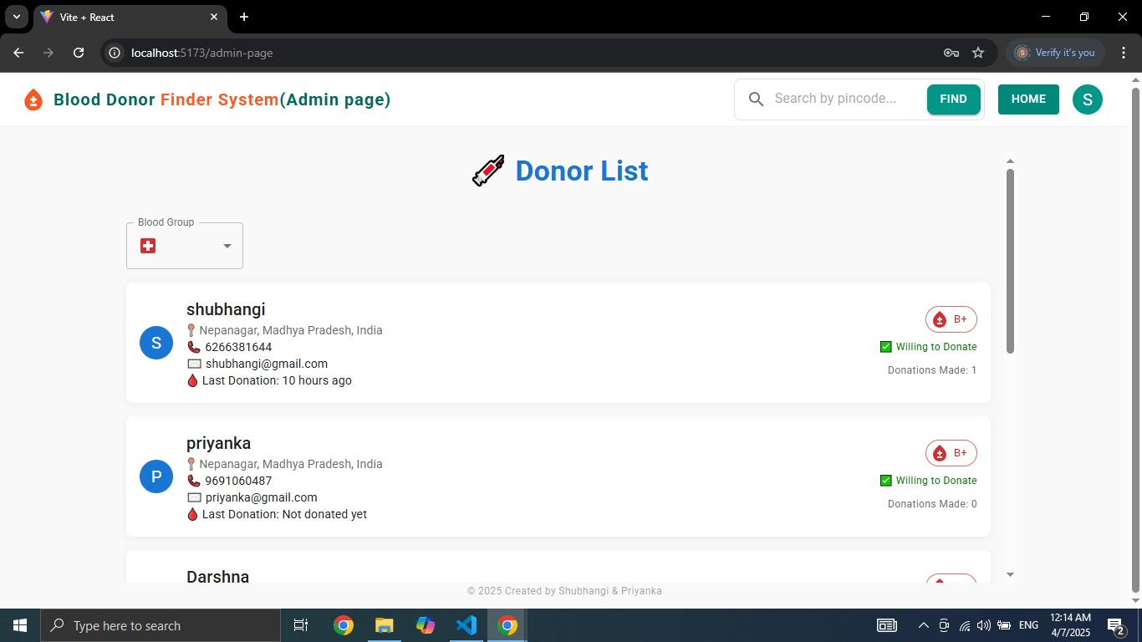

**Fig 1.1** A blood donor finder system

**FUTURE SCOPE**

❖ The future scope of blood donor finder systems includes several promising developments to improve their efficiency and effectiveness. Bal Reach: Expanding to create a worldwide donor network.

❖ AI & Machine Learning: Enhancing matching and demand prediction.

❖ Real-Time Tracking: Improving blood request and delivery tracking.

❖ Integration with Health Systems: Streamlining donation with hospitals.

❖ Better User Engagement: Boosting donor participation through awareness and incentives.

❖ Mobile & Wearable Integration: Tracking donor health and availability via apps and wearables.

❖ Blockchain for Security: Ensuring secure handling of donor data.

❖ Automation & Drone Delivery: Using drones for faster, emergency blood delivery.

**CONCLUSION**

A blood donor finder system is a valuable tool for connecting donors with patients in need, improving the efficiency and accessibility of blood donation. However, its effectiveness is limited by factors such as donor availability, geographic barriers, data accuracy, technical challenges, and privacy concerns. To enhance its impact, improvements are needed in system reliability, awareness, user trust, and logistical support. With better infrastructure, awareness campaigns, and technological advancements, such a system can play a crucial role in addressing blood shortages and saving lives.

**REFERENCE**

[1] John Duckett, HTML and CSS: Design and Build Websites, Wiley, 2011.

[2] Robin Nixon, Learning PHP, MySQL & JavaScript: With jQuery, CSS & HTML5, O'Reilly Media, 2018.

[3] Elmasri Ramez and Shamkant B. Navathe, Fundamentals of Database Systems, Seventh Edition, Pearson, 2015.

[4] Ethan Brown, Learning JavaScript: JavaScript Essentials for Modern Application Development, O'Reilly Media, 2016.

[5] Brad Traversy, MERN Stack Front To Back: Full Stack React, Redux, Node.js & MongoDB, 2018.

[6] Alex Banks and Eve Porcello, Learning React: Modern Patterns for Developing React Applications, Second Edition, O'Reilly Media, 2020.

[7] Adam D. Scott, JavaScript Everywhere: Building Cross-Platform Applications with GraphQL, React, React Native, and Electron, O'Reilly Media, 2020.

[8] Valentin Bojinov, Mastering MongoDB 6.x: Develop Modern, Fast, and Scalable Applications with MongoDB, Packt Publishing, 2021.

[9] Saeed Zarinfam, Pro Express.js: Master Express.js, Apress, 2014.

[10] MD Saiful Islam, "A Secure and Scalable Approach for Blood Donor Applications Using MERN Stack," IEEE Journal on Web Application Development, 2022.

[11] Christopher Pitt, Modern Web Development with Node.js and MongoDB, Apress, 2019.