# A STUDY ON CUSTOMER PERCEPTION TOWARD JAYAMM MILK PRODUCT

**________________________________________________________**

# ABSTRACT

##### This product is a high-quality dairy beverage derived from fresh cow's milk, designed to provide essential nutrients in a convenient and delicious form. Rich in calcium, protein, and vitamins such as A, D, and B12, it supports bone health, muscle growth, and overall well-being. Produced under hygienic conditions and subjected to rigorous quality control measures, the milk is pasteurized to ensure safety while preserving its natural taste and nutritional value. Whether consumed directly, used in cooking, or added to beverages, this milk product offers a wholesome and nutritious addition to a balanced diet.

##### 

# INTRODUCTION

About Dairy IndustryIndia is the highest milk producer and ranks first position in the world contributing24.64% of global milk production in the year 2021-22. The milk production of Indiahas registered 58% increase during the last nine years i.e., during the year 2014-15and 2022-23 and increased to 230.58 Mn Tonnes in the year 2022-23. The milkproduction has increased at CAGR 5.85% over the past 9 years. The top 5 milk-producing states are: Rajasthan (15.05%), Uttar Pradesh (14.93%), Madhya Pradesh (8.6%), Gujarat (7.56%) and Andhra Pradesh (6.97%). Theytogether contribute 53.11% of total Milk production in the country. India's Export of Dairy products was 67,572.99 MT to the world for the worth$284.65 Mn during the year 2022-23The market growth in Dairy requires support of significant infrastructure investmentacross processing, chilling, logistics, cattle feed etc. Further, lucrative untappedopportunities exist in areas such as value-added dairy products, organic/farm freshmilk and exports. To facilitate the infrastructure growth, Central/ State Governmentshave released various incentives to attract investments in this sector. Animal Husbandry Infrastructure Development fund (AHIDF). AHIDF is one of the flagshipschemes by DAHD, Government of India whereby INR 15,000 Cr fund has beensetup for offering financial support to set up new units or expand existing units inareas of dairy processing & related value addition infrastructure, meat processing &related value addition infrastructure and Animal Feed Plant. Milk and milk products are some of our oldest and best-known natural foods. Inbaking Milk and milk products are used fresh, condensed, powdered, skimmed, orwhole. The great bulk, weight, and perishability of fresh milk plus the expense ofrefrigeration makes it a relatively high-cost ingredient, and for this reason, mostmodern bakeries use non-fat powdered milk or buttermilk powder.fn3Dairy products or milk products, also known as lactic, are food products madefrom (or containing) milk. The most common dairy animals are cow, waterbuffalo, nanny goat, and ewe. Dairy products include common grocery store foodaround the world such as yogurt, cheese, milk and butter. A facility that producesdairy products is a dairy. Milk products are consumed worldwide to varyingdegrees. Some people avoid some or all dairy products because of lactoseintolerance, veganism, or other health reasons or beliefs. There is no such unequivocal position regarding the effect of milk and dairy fat onhuman health. Currently controversy has emerged about the benefits compared withharms of dairy fat, including concerns over long-termeffect

# OBJECTIVES

•To study customer perception towards quality of Jayam Milk Products Pvt.Ltd

•To understand various features affecting the purchase of milk products.

•To find out customer perception towards Quality, Taste, Variety, Availability Packaging, Marketing assistance, store assistance, Brand awarness.

•To find out most preferred milk product.

# SCOPE OF THE STUDY

•We have started this project to know about the costumer perception of jayam milk product pvt Ltd located at Madhavaram, chennai.

•we have attained a lot of information which includes taste preferences, quantity and quality

•In this project we also took efforts to know about their consumer behavior and the quality of the milk

•This study was restricted to the consumers buying the products from Jayam milk products in Madhavaram area during the evening hours.

# REVIEW OF LITERATURE

•Shilpashree (2021) Developing wellbeing cognizance and familiarity with solid nourishment have expanded buyer interest for dairy items. The current review evaluated the buyer inclination for various dairy items accessible at University retail outlets in Chennai. One hundred respondents who purchased dairy items were picked utilizing an orderly irregular examining system from every University retail outlet in Chennai. Hence, at whatever point the item is accessible, shoppers are prepared to take which is a roundabout way shows that there is consistent interest for the dairy results of University. It grants the need to upgrade the creation of value and assortment dairy products. Hence, in emerging nations like India, where the per capita pay is on the ascent, there will be an unmistakable expansion sought after for an assortment of dairy items. This sort of study on purchaser inclination for dairy items ought to be rehashed at different time spans to comprehend the changing example and style on taste and inclination for quality credits of dairy items to make changes in the dairy creation framework the further handling innovations.

•Nedumaran & M. (2020) Dairy Farming has dependably been the foundation of the Indian monetary framework through the strategies for giving the milk to the entire society. Dairy progress straightforwardly \influences destitution destruction since it makes the milk as per the prerequisite. The reception on the developing part, paying little brain to whether positive or negative, will have a multiplier wave all things considered economy. Moreover, the connected division like agribusiness, creature improvement, and dairy is imperative in working on over every imperative in working on over every single monetary state of typical India (Bimbo et al., 2017). There is a need for practical and adjusted progress of developing and coordinated parts to keep up the environmental evening out. From our first preparation onwards, facilitators have offered the required uniting division for the cash-related improvement of the country division. Suppose proposals given above are sought after by the Tamilnadu Co-employable Milk Producers' Association Limited. In that case, it can supply better quality milk with different brands and milk things to the purchasers around Tamilnadu.

•Mounika et al., (2020) Since ancient times, Indians have consumed desi milk, also known as A2 milk. When people realized the benefits of A2 milk, the concept of A2 milk resurfaced, and the market for A2 milk expanded rapidly. Around ten A2 milk businesses have emerged in Hyderabad city during the previous five years. As result, the study focused on consumer purchasing behavior, awareness, and preference for A2 milk in Hyderabad, Telangana state, from January to March 2020. The 120 buyers were drawn randomly from portioned areas of selected enterprises in the review area. The data was examined using rates, the Chi-square test, and element inquiry methodologies. According to the study, the majority of the consumers are accomplished, medium-aged persons with an annual income of more than eight lakh. Children in the household were significant purchasers of A2 milk. The majority of the customers consumed A2 milk for one year and relied on house conveyance for their regular A2 milk procurement.

•Singh and Singh (2020) This paper portrays the contextual investigation of the dairy helpful, AMUL, in western India, which has fostered a fruitful business model in the enormous arising economy. It was mindful that India turned into the world's biggest milk maker through its creative practices. The paper draws different bits of knowledge from AMUL's experience that can be helpful to cooperatives throughout the planet, just as to organizations engaged with carrying on with work in wide developing business sectors like India. Therefore, organizations that arrange to target huge lacking business sectors or expect to exploit a broad yet restricted provider base will, in any case, benefit. Amul centers around Advertising, quality, and client care, making it a leading brand in the dairy industry. Competitors like mother dairy center on accessibility. This way, they draw in just existing clients and limit their caught market.

# RESEARCH METHODOLOGY

Achieving accuracy in any research requires in depth study regarding the subject. As the prime objective of the project is to know buying behaviour of consumers regarding milk with the existing competitors in the market and the impact on milk product. The research methodology adopted is basically based on primary data via which the most recent and accurate piece of first hand information could be collected. Secondary data has been used to support primary data wherever needed.Research type used in this projects was descriptive study, since data was collected from the respondent through questionnaire. So as to determine there opinion on service based on the plot price, ambience etc.Here the researcher used convenience sampling techniques to draw the samples for the purpose of studying the customers perception towards jayam milk product.Target geographic area was Madhavaram, Chennai.For this geographical area we asked closed ended questions.The period during which questionnaires were filled was two weeks.Finally the collected data and information was analyzed and compiled to arrive at the conclusion.The sample size for this study is taken as 101.

**AGE Of THE RESPONDENTS**

|  | Frequency | percent |
| --- | --- | --- |
| 1to2 | 2 | 1.9 |
| 15to30 | 75 | 74.25 |
| 30to45 | 16 | 15.9 |
| 45 above | 8 | 8 |
| Total | 101 | 100 |

**INTERPRETATION**: The above table shows that 2% of the respondents belongs to1to15 age group, 75% of respondents belongs to 15 to 30 age group, 16% of the respondents belongs 30 to 45 age group, 8% of the respondents belongs to 45 above age group.

**INFERENCE**: Majority of the respondents belongs to 15 to 30 age group.

## AGE OF THE RESPONDENTS

101 Response

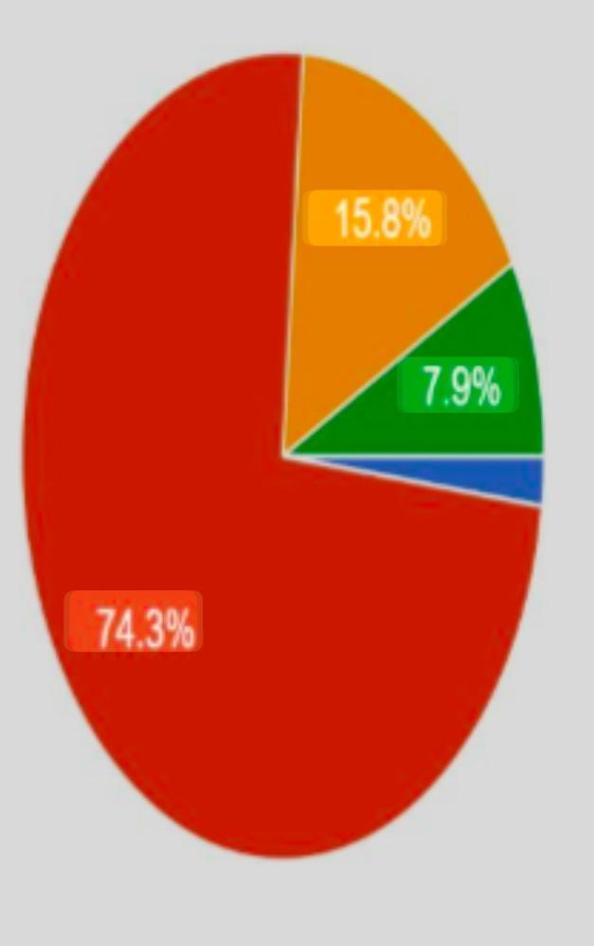 • 1to15

• 15 to30

• 30 to 45

• 45 above

## INTERPRETATION

42% are first rank,23% are second rank,23% are third rank, 4% are fourth rank,4% are fifth rank price of the ranking.31% are first rank,30% are second rank,28% are third rank,3% are fourth rank,4% are fifth rank quality of the ranking.35% are first rank, 24% are second rank,28% are third rank,6% are fourth rank,3% are fifth rank availability of the ranking.35% are first rank,24% are second rank,28% are third rank,6% are fourth rank,3% fifth rank are taste of the ranking.35% are first rank, 26% are second rank,.24% are third rank,6% are fourth rank,5% are fifth rank variety of the ranking.

## INFERENCE

Majority of the respondents first ranking of the price, Majority of the respondents second ranking of the quality, Majority of the respondents third ranking of the quality, Majority of the respondents fourth ranking of the availability, Majority of the respondents fifth ranking of the taste.

## Why you want purchase jayam milk products rank the factor

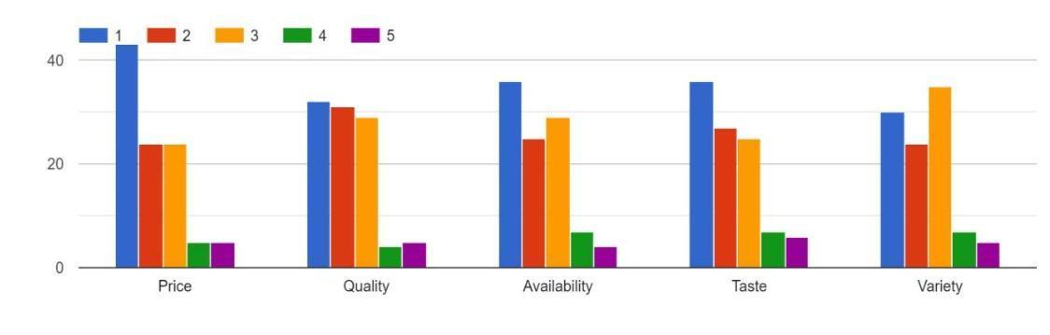

# FINDING

Majority of the respondents belongs to 15 to 30 age group. Majority of the respondents belong to the female. Majority of the respondents belongs to milkMajority of respondents belongs to near.Majority of the respondents belong to 500ml and 1 liter.Majority of the respondents belongs to affordable price.Majority of the respondents are highly influence with quality of milk, Majority of the respondents are Moderate influence with packaging, Majority of the respondents are least influence variety of the Milk Product, Majority of the respondents are influence Brand awareness of the Milk product. Majority of the respondents first ranking of the price, Majority of the respondents second ranking of the quality, Majority of the respondents third ranking of the quality, Majority of the respondents fourth ranking of the availability, Majority of the respondents fifth ranking of the taste.Majority of the respondents yes of this brand.Majority of the respondents are daily. Majority of the respondents monthly or weekly.Major of the respondents are through friends. Major of the respondents are through friends. Majority of the respondents are not change the brand to another milk product. From the above table, it is found that Majority of the consumer are highly influence with the taste, least influence with the brand awareness.From the above table, it is found that majority of the consumer are ranked first of the price, less consumer are ranked fifth of the variety.

# SUGGESTION

The milk powder very less people can use so improve the quality and taste of the milk product The above 45 age group very less buying the milk product interact with that kind of age group.The brand need more advertisement to reach the people In the basis of questionnaire more number of people are willing to change the milk product so they brand should improve the quality. And they can sell the product in affordable price so that people afford it easily

# CONCLUSION

Consumer perception is one of the relevant factors that a company should consider in order to run the business profitably. It has a great influence in attracting new customers and retaining existing customers. The study reveals that while purchasing for dairy products consumers look for price, quality, availability, variety, taste, variety rather then texture, validity and convenience. The major challenge is to make the milk affordable to all with all the necessary characteristics.From the survey it is evident that jayam milk trying to fulfills the customer's expectation.

# REFERENCE

•Dror, D. K., and Allen, L. H. (2014) "Dairy product intake in children and adolescents in developed countries: rends, nutritional contribution, and a review of association with health outcomes," Nutrition Reviews, \Vol. 72, No. 2, pp. 68-81. E- ISSN 1753-4887, ISSN 0029-6643.

• Mounika, V., Kumar, B., Seema,.., & Supriya, K. (2020). "Study on Consumer Buying Behavior, Awareness and Preference for A2 Milk in Hyderabad", India. Asian Journal Of Agricultural Extension, Economics & Sociology, Volume 38, Issue 9, 21-29

•P. Jayakumar and S. Loganathan (2015), "A Study On Consumer Preference of Milk at Edamalaippattipudur in Tiruchirappalli District," Intercontinental Journal of Marketing Research Review, ISSN:2321-0346, Volume 3, Issue 7, July 2015

•Sugrova, M. (2018). "Consumer Behaviour on the Market of Dairy Products: Case Study of Slovak Seniors. "International Scientific Days 2018. Towards Productive, Sustainable And Resilient Global Agriculture And Food Systems: Proceedings.

•Bhavya Bhanu, P.V, A. Serma Saravana Pandian, P. Vinothini, and S.K. Mathanghi (2017), "Analysing the Consumer Preference for Dairy Products in Trivandrum City, India," International Journal of Science,

•Samoggia, A. (2016) "Healthy Food: Determinants of price knowledge of functional dairy products," Journal of Food Products Marketing, Vol. 22, No. pp. 905-929. E-ISSN 1540-4102, ISSN 1045-4446

•Assan, N. (2017) "Milk and milk products consumption pattern, preferences and purchase behavior in communal areas of the Eastern Cape Province in South Africa," Scientific Journal of Animal Science, Vol. 6, No. 5, pp. 407-427. E-ISSN 1525-3163, ISSN 0021-8812

•Davis, J., Gallego, G., and Topaloglu, H. (2014) "Assortment Optimization under Variants of the Nested Logit Model," Operations Research, Vol. 62, No. 2, pp. 250-273. E-ISSN 1526-5463, ISSN 0030-364X

•Weaver, C. M. (2014) "How sound is the science behind the dietary recommendations for dairy?", The American Journal of Clinical Nutrition, Vol. 99, No. 5, pp. 1217-1222

•Klaudia Kurajdova and Janka Táborecka-Petrovicova (2015), "Literature Review on Factors Influencing Milk Purchase Behaviour," International Review of Management and Marketing, Vol. 5, No. 1, 2015, pp.9-25, ISSN: 2146-4405.

•Abhishek Singh and Ajay Singh (2020), "Consumer Behavior and Comparative Analysis of AMUL products". International Journal of Scientific Research in Engineering and Management, Volume 4, Issue 1, 1-9.

•Ahmadi Kaliji, S., Mojaverian, S. M., Amirnejad, \H., & Canavari, M. (2019). "Factors affecting consumers' dairy products preferences. "AGRIS on-line Papers in Economics and Informatics, 11(665-2019-4000), 3-11.