##### **Food-Delivery Website**

##### **Krishnali Mahajan, Rituja Pachpande,** **Prof. Raj Kumar Verma**

Department of Computer Science and Engineering, Thakur Shivkumar Singh Memorial Engineering College, Burhanpur(M.P.)

**ABSTRACT**

project presents the development of a This food delivery website aimed at providing users with a seamless and efficient platform for ordering food online. The system connects local restaurants with customers, allowing users to browse menus, place orders, make payments, and track deliveries in real-time. The website is designed with a user-friendly interface to enhance the customer experience, incorporating features such as restaurant filtering, search functionality, order history, and user ratings. The platform is developed using the MERN stack (MongoDB, Express.js, React.js, and Node.js), ensuring a scalable and responsive web application. The backend manages restaurant data, user authentication, order processing, and real-time updates, while the frontend provides an interactive and dynamic user interface. This project not only simplifies food ordering for users but also supports restaurants in expanding their reach and managing orders more efficiently.

**INTRODUCTION**

Online shopping is a way of buying food and other household necessities using a web-based s hopping service. There are two basic methods that people can use to purchase these items on line. One is to order them from a local grocery store that participates in online shopping. A customer can then arrange for a home delivery directly from the store, or he can pick up his order at the store once an employee has assembled it. Another common practice is to order groceries from a large company, such as Amazon or Net grocery that will ship the items to one’s home.

Online markets have been a thing that has come to stay with the society of today since most financial transactions can be attained online. Internet access has vastly grown across the world today and has given rise to interconnectivity even to the remotest areas in the world. This gen early means it is possible to be at any location and reach any other location in the world without stepping a foot out of your premises.

**OBJECTIVE OF PROJECT:**

There are some basic objectives of the Food Delivery Website: To develop a user-friendly online platform for purchasing groceries and household essentials.

1. To enable customers to browse products, view details, and place orders from the comfort of their homes.
2. To implement user registration and authentication for personalized experiences and data security.
3. To maintain an inventory management system for real-time stock updates and efficient supply chain handling.
4. To provide an admin dashboard for managing products, orders, users, and overall operations.
5. To allow users to track their orders and receive timely notifications.
6. To reduce the time and effort involved in traditional grocery shopping.
7. To support promotional features such as discounts, coupon codes, and featured items. 8. To analyze customer behavior and order history for better service and marketing strategies.

**APPLICATIONS**

* Convenience for Consumers:

- Product Availability.

- 12 hours Accessibility.

- Convenience for Consumers.

* + Personalized Shopping Experience:

-Subscription Services.

- Recommendations.

- Customer Recommendation.

**RESULT**

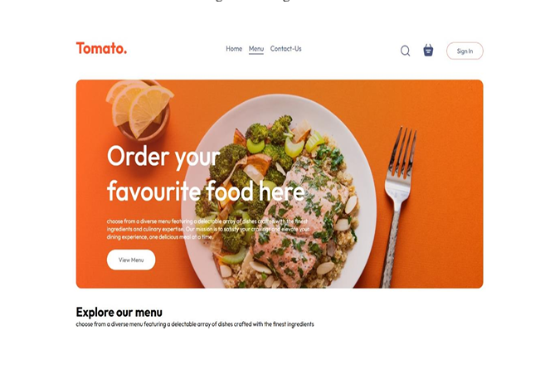

**Fig 1.1 Home page of Food-Delivery Website**

**LIMITATIONS**

• **Delivery Issues:** Delivery fees, especially for small orders or express delivery, can make the service less affordable for some consumers.

• **Limited Delivery Areas**: Some online grocery services only cover specific geographic areas, meaning customers in rural or less populated regions may have limited access to the service.

• **Perishable Goods:** Fresh produce, meat, dairy, and other perishable items can be damaged or spoiled during shipping.

• **Quality Control:** Customers may feel less confident about the quality of products they cannot physically inspect before purchasing.

• **Price Variability:** Prices of certain items can fluctuate frequently, and there might be hidden fees like delivery charges, service fees.

• Internet Dependency Users must have a stable internet connection to access and use the platform.

• Technical Glitches Bugs, crashes, or server downtime may affect the shopping experience.

• Security Concerns Although secure systems are implemented, there’s always a risk of data breaches or payment fraud.

• Competition from Established Platforms Competing with major players (like Amazon Fresh, Big Basket, etc.) can be difficult without strong marketing or unique features.

**CONCLUSION**

The rise of online grocery stores marks a significant shift in how consumers shop for everyday essentials. As technology advances and consumer preferences evolve, online grocery shopping has become an increasingly popular and convenient choice, offering timesaving benefits, a wide range of products, and personalized shopping experiences. With the growing demand for convenience, speed, and sustainability, online grocery stores are expected to continue to expand and innovate. The future of online grocery stores is bright, with technology, convenience, sustainability, and customer experience at the core of their continued growth.

**FUTURE SCOPE**

Same-Day and One-Hour Delivery: The demand for faster delivery options, especially for fresh produce and perishables, will drive online stores to expand their same-day and even one-hour delivery services.

• **Real-Time Tracking and Communication**: Real-time tracking will become more sophisticated, allowing customers to track their groceries' journey from warehouse to doorstep. •**Global Market Reach:** As internet penetration increases worldwide, online grocery stores will expand into new markets, particularly in developing countries. Loyalty and Rewards Programs: Online grocery stores will increasingly implement loyalty programs that reward customers for repeat purchases, sharing referrals.

**REFERENCES**

* React.js **Documentation:**

• Official React.js documentation used for understanding components, state management, hooks, and routing.

• Reference: <https://reactjs.org/docs/getting-started.html>

* Node.js **Documentation:**

• Official documentation for building backend servers, handling HTTP requests, and integrating with MongoDB.

• Reference: <https://nodejs.org/en/docs/>

* MongoDB **Documentation:**

• MongoDB documentation was used to understand how to integrate MongoDB with the backend, CRUD operations, and the use of Mongoose.

• Reference: <https://www.mongodb.com/docs/>

* Express.js **Documentation:**

• Express.js framework documentation was referred for creating the backend API, routing, and handling middleware. • Reference: <https://expressjs.com/en/starter/installing.html>

* Chakra UI **Documentation:**

• Chakra UI documentation helped in using pre-built React components to design the user interface. • Reference: <https://chakra-ui.com/docs/getting-started>

* Tailwind CSS **Documentation:**

• Tailwind CSS documentation was referred to for creating responsive and customizable styles in the frontend. • Reference: <https://tailwindcss.com/docs>

* Font Awesome Icons **Documentation:**

• Font Awesome documentation used to incorporate icons such as FaBars, FaSearch, and others for the app’s navigation. • Reference: <https://fontawesome.com/>

* React Router **Documentation:**

• React Router documentation used to implement routing for navigating between pages like home, about, contact, etc.

• Reference: <https://reactrouter.com/>

* JWT **Authentication:**

• Used JWT (JSON Web Token) for handling user authentication and sessions.

• Reference: <https://jwt.io/introduction/>

* Google **Fonts for Typography:**

• Google Fonts used to enhance the typography of the website.

• Reference: https://fonts.google.com/