TSGI Website

**Komal Mahajan, Pratiksha Chandode, Vaishnavi Choudhary, Prof. Pragati Lokhande**

### Department Of Computer Science & Engineering

**Thakur Shivkumar Singh Memorial Engineering College, Burhanpur**(M.P.)

**ABSTRACT**

The TSGI Website serves as the official digital portal for the Thakur Shivkumarsingh Memorial Group of Institution (TSGI), facilitating access to vital information for various stakeholders, including prospective students, current members, and interested individuals. This research paper examines the website's design, emphasizing its simplicity and accessibility, which enhances user experience through intuitive navigation and regularly updated content. It provides an overview of the institution's academic offerings, departments, faculty, and admission processes, reflecting TSGI's commitment to holistic education and academic excellence. The website not only acts as an essential resource for information but also fosters a sense of community by connecting users with the institution's vision and ongoing activities.

### **INTRODUCTION**

* 1. **MOTIVATION:**

The TSGI Website project was initiated to digitalize and streamline the communication, information, and services offered by the college. With increasing dependence on technology, having an online presence for educational institutions is crucial for better interaction with students, staff, and external stakeholders.

###### **OBJECTIVE OF PROJECT:**

The primary objective of the TSGI Website is to provide an efficient and user-friendly platform where students, faculty, and visitors can access relevant information such as announcements, academic calendars, course materials, and contact details.

###### **APPLICATION & SCOPE:**

* Students for academic resources and updates.
* Faculty for sharing notices and course content.
* Visitors for general college information.
* Administrative staff for managing and updating content.

###### **LIMITATIONS:**

* Initial version may not include full mobile responsiveness.
* Limited automation in content update; manual intervention required.
* User-specific dashboards not implemented in this version.

###### **SUMMARY:**

The introduction of the TSGI Website project serves as a introduction . This chapter highlights the motivation, goals, scope, and limitations of the TSGI Website. It sets the stage for the following detailed discussions on methodology and implementation.

**RESULT**

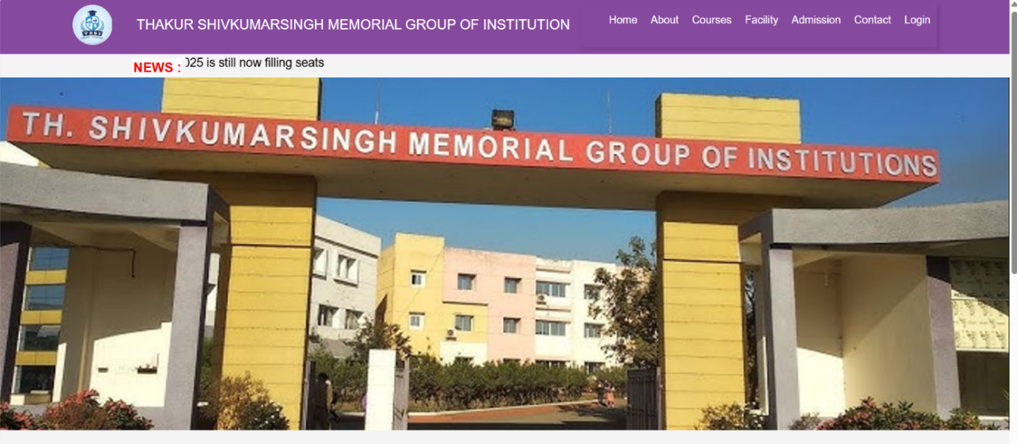

Fig 1.1 Home Page I of Our Website

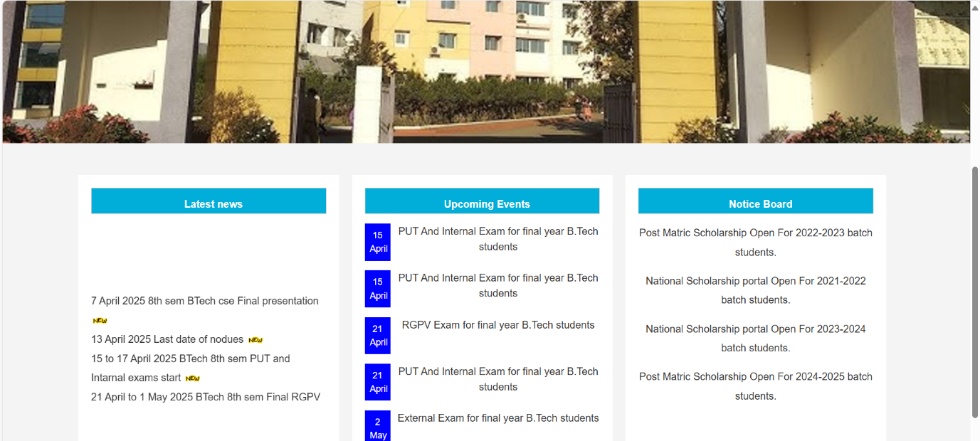

Fig 1.1 Home Page II of Our Website

**CONCLUSION**

The TSGI Website successfully provides a platform for college communication and information sharing. A comprehensive website should provide detailed information about admissions, financial aid, academic requirements, campus life, and other relevant details. It fulfills core requirements and is scalable. It helps establish credibility, demonstrating the college's commitment to quality education and effective administration. Moreover, a user-friendly website enhances accessibility.

**FUTURE SCOPE**

* Add mobile app version.
* Implement student and faculty dashboards.
* Automate updates using admin CMS.

**REFRENCES**

1. **Java Programming**

Utilized for developing the backend functionality of the platform, ensuring scalability and robustness.

Resource: [Oracle Java Documentation](https://docs.oracle.com/en/java/)

1. **Spring Boot Framework**

Framework used for building the backend APIs and managing application configurations.  
Resource: [Spring Boot Documentation](https://spring.io/projects/spring-boot)

1. **MySQL Database**

Database system employed for managing user and event data efficiently.

Resource: [MySQL Reference Manual](https://dev.mysql.com/doc/)

1. **HTML5, CSS3, and JavaScript**

Core technologies used for designing and implementing the responsive frontend of PVK Eventstar.

Resources:

* + [HTML5 Tutorial](https://www.w3schools.com/html/)
  + [CSS3 Tutorial](https://www.w3schools.com/css/)
  + [JavaScript Guide](https://developer.mozilla.org/en-US/docs/Web/JavaScript)

1. **Bootstrap Framework**

Used to enhance the website's responsiveness and ensure a consistent user experience across devices.

Resource: [Bootstrap Official Site](https://getbootstrap.com/)

1. **Tomcat or Equivalent Application Server**

For deploying the application during development and testing phases.

Resource: [Apache Tomcat Documentation](https://tomcat.apache.org/)

1. **IDE for Development**

Development environment used for coding and debugging the project. Examples include IntelliJ IDEA, Eclipse, or Visual Studio Code.

Resource: [JetBrains IntelliJ IDEA](https://www.jetbrains.com/idea/)

1. **W3C Standards**

Referenced for ensuring adherence to web development standards and best practices.

Resource: [World Wide Web Consortium (W3C)](https://www.w3.org/)

1. **Google Material Design Guidelines**

Used as inspiration for creating a visually appealing and intuitive UI.

Resource: [Material Design Guidelines](https://material.io/design)

1. **User Feedback and Local Research**

Incorporated insights from potential users and local event planning needs to create a tailored solution.

1. **W3C Standards**

Referenced for ensuring adherence to web development standards and best practices.

Resource: [World Wide Web Consortium (W3C)](https://www.w3.org/)

1. **Google Material Design Guidelines**

Used as inspiration for creating a visually appealing and intuitive UI.

Resource: [Material Design Guidelines](https://material.io/design)

1. **User Feedback and Local Research**

Incorporated insights from potential users and local event planning needs to create a tailored solution.