# Developing a Real-Time Inventory Tracking System for Mini Magic Mart Utilizing IoT Technologies

##### **Akansha Shankpal, Anjali Gaikwad, Gayatri Paraskar,** **Prof. Vikas Kumar Yadav**

Department of Computer Science and Engineering, Thakur Shiv Kumar Singh Memorial Engineering College Burhanpur (M.P.)

**ABSTRACT**

Fresh produce is an essential component of daily nutrition, requiring efficient distribution to maintain quality and reduce waste. This research examines the operational dynamics of a grocery shop specializing in fruits, vegetables, and dairy products. Key aspects explored include supply chain management, inventory control, refrigeration techniques, and customer preferences. The study also analyzes challenges such as seasonal availability, perishability, and pricing strategies in a competitive market. Additionally, the role of technology in improving operational efficiency, digital payments, and online delivery services is discussed. The findings provide insights into optimizing business sustainability and ensuring high-quality fresh products for consumers.

***Index Terms***- Grocery shopping, Food retail, Supermarket, Household supplier, Consumer behavior

**Introduction**

Shops that sell fruits, vegetables, and dairy products play a crucial role in providing fresh and nutritious food to consumers. These establishments ensure the availability of essential perishable items

In this approach, all the researched information about grocery shopping—such as consumer preferences, shopping frequency,

that require proper handling, storage, and distribution to maintain their quality. Unlike general grocery stores, these outlets focus on farm-fresh produce and dairy, often sourced directly from farmers and local suppliers. Efficient management of such businesses is vital for reducing food waste and meeting customer demand.

On the React-based frontend, real-time simulation results were visualized using dynamic charts and dashboards. These visualizations display how factors such as pricing, discounts, and product availability affect consumer purchasing behavior.

**IDENTIFY, RESEARCH AND COLLECT IDEA**

The primary objective is to explore grocery shopping behaviour’s, consumer preferences, and the factors influencing purchasing decisions. The initial steps include:

1. Reviewing existing studies and reports on consumer grocery shopping habits.
2. Conducting online research for up-to-date trends and technologies in the retail sector.
3. Familiarizing with retail-specific terminology.
4. Analysing consumer feedback, reviews, and online purchasing patterns.

**OUR STUDIES AND FINDINGS**

## choice of store, and budget patterns—is combined and presented in the form of a detailed research paper. A.

## **Bits and Pieces together**

Prior studies on grocery shopping trends and consumer behavior were analyzed to form the foundation of this research. These insights were then consolidated to identify patterns and preferences in consumer choices.

***Jump Start***

## Throughout the research process, guidance was sought from peers, mentors, and faculty members. Their feedback helped to

## refine objectives and improve the structure and depth of the study.

## A**. Use of Simulation software**

Simulation tools were utilized to model customer behavior and purchasing patterns. These tools, integrated with the MERN (MongoDB, Express.js, React, Node.js) stack, allow real-time forecasting and scenario analysis.

## **B. Results and Findings**

The study highlights several insights:

* **Consumer Preferences:** Consumers prioritize freshness, pricing, and convenience when choosing where and how to shop.
* **Shopping Frequency:** Most consumers prefer weekly shopping trips but shift to online platforms during busy schedules or adverse weather.
* **Budget Behaviour:** Price sensitivity influences brand loyalty and purchase volume.
* **Technology Use:** Digital payments and app-based shopping have become increasingly popular.

The integration of technology into grocery management has led to improved stock control, reduced waste, and enhanced customer experience.

**LIMITATIONS**

• Delivery Issues: Delivery fees, especially for small orders or express delivery, can make the service less affordable for some consumers.

• Limited Delivery Areas: Some online grocery services only cover specific geographic areas, meaning customers in rural or less populated regions may have limited access to the service.

• Perishable Goods: Fresh produce, meat, dairy, and other perishable items can be damaged or spoiled during shipping.

• Quality Control: Customers may feel less confident about the quality of products they cannot physically inspect before purchasing.

• Price Variability: Prices of certain items can fluctuate frequently, and there might be hidden fees like delivery charges, service fees.

• Internet Dependency Users must have a stable internet connection to access and use the platform.

• Technical Glitches Bugs, crashes, or server downtime may affect the shopping experience.

• Security Concerns Although secure systems are implemented, there’s always a risk of data breaches or payment fraud.

• Competition from Established Platforms Competing with major players (like Amazon Fresh, Big Basket, etc.) can be difficult without **strong marketing or unique features.**

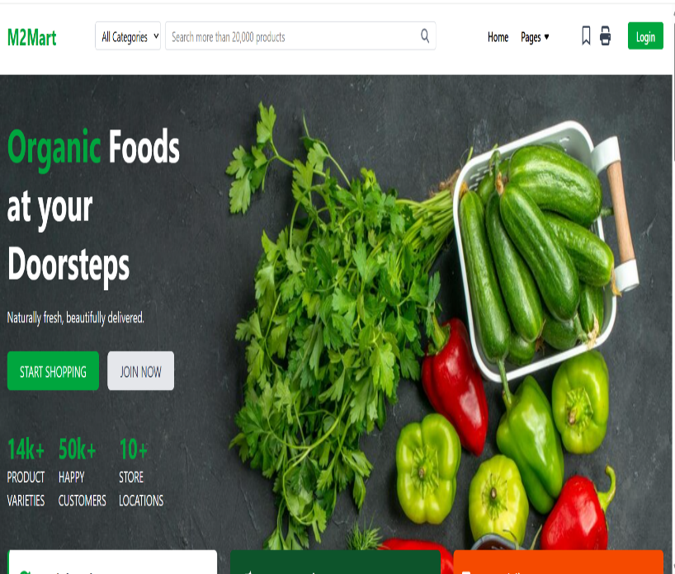**RESULT**

Fig 1.1 Snapshot With Description

**IMPROVEMENT AS PER REVIEWER COMMENTS**

In this section, we address the constructive feedback provided by the reviewers to enhance the overall quality and effectiveness of the grocery shopping project. Based on the suggestions, several improvements were made to ensure that the project is more user-friendly, efficient, and aligned with current trends in grocery shopping.

This completes the entire process required for widespread of research work on open front. Generally all International Journals are governed by an Intellectual body and they select the most suitable paper for publishing after a thorough analysis of submitted paper. Selected paper get published (online and printed) in their periodicals and get indexed by number of sources.

**FUTURE SCOPE**

* Same-Day and One-Hour Delivery: The demand for faster delivery options, especially for fresh produce and perishables, will drive online stores to expand their same-day and even one-hour delivery services.
* Real-Time Tracking and Communication: Real-time tracking will become more sophisticated, allowing customers to track their groceries' journey from warehouse to doorstep.
* Global Market Reach: As internet penetration increases worldwide, online grocery stores will expand into new markets, particularly in developing countries.
* Loyalty and Rewards Programs: Online grocery stores will increasingly implement loyalty programs that reward customers for repeat purchases, sharing referrals.

**CONCLUSION**

This research provides valuable insights into the evolving consumer behaviors within the grocery retail sector. With the rapid growth of online shopping platforms and the integration of digital technologies, customer expectations have shifted significantly. Today’s consumers not only seek convenience but also demand greater variety, faster delivery, personalized shopping experiences, and seamless payment options Moreover, the increasing popularity of mobile applications, digital wallets, and AI-powered recommendations has transformed the way people interact with grocery stores—both physical and virtual. Retailers are now required to go beyond traditional models and embrace data-driven approaches to anticipate demand, manage inventory more efficiently, and deliver tailored promotions based on individual preferences. In conclusion, businesses that proactively adapt to these emerging trends by leveraging technology, understanding customer insights, and streamlining their supply chain operations will be better positioned to thrive in an increasingly competitive and digital-first marketplace.

**Acknowledgment**

I deeply grateful to all those who contributed to the successful completion of this research. We extend our sincere thanks to our academic advisors and mentors for their valuable guidance, constructive feedback, and continuous encouragement throughout the study. Their insights were instrumental in shaping the direction and scope of this research. Lastly, we appreciate the support from our institution, Thakur Shiv Kumar Singh Memorial Engineering College, for providing a conducive research environment and the necessary infrastructure to carry out this work. This research stands as a reflection of collective effort, shared knowledge, and continuous learning.

**References**

* Sharma, R., & Verma, N. (2021). Design of a Web-Based Inventory and Order Management System for Perishable Goods. International Journal of Retail and Distribution Technology, 18(4), 112–120.
* React.js Documentation:

Official React.js documentation used for understanding components, state management, hooks, and routing. Reference: https://reactjs.org/docs/getting-started.html

* Node.js Documentation:

Official documentation for building backend servers, handling HTTP requests, and integrating with MongoDB. Reference: https://nodejs.org/en/docs/

* MongoDB Documentation:

MongoDB documentation was used to understand how to integrate MongoDB with the backend, CRUD operations, and the use of Mongoose.

Reference: <https://www.mongodb.com/docs/>

* Express.js Documentation:

Express.js framework documentation was referred for creating the backend API, routing, and handling middleware.

Reference: https://expressjs.com/en/starter/installing.htm

* Chakra UI Documentation:

Chakra UI documentation helped in using pre-built React components to design the user interface.

Reference: https://chakra-ui.com/docs/getting-started

* Tailwind CSS Documentation:

Tailwind CSS documentation was referred to for creating responsive and customizable styles in the frontend.

Reference: <https://tailwindcss.com/docs>

* Font Awesome Icons Documentation:

Font Awesome documentation used to incorporate icons such as FaBars, FaSearch, and others for the app’s navigation.

Reference: <https://fontawesome.com/>

* React Router Documentation:

React Router documentation used to implement routing for navigating between pages like home, about, contact, etc. Reference: <https://reactrouter.com/>

* JWT Authentication:

Used JWT (JSON Web Token) for handling user authentication and sessions.

Reference: https://jwt.io/introduction/

* Google Fonts for Typography:

Google Fonts used to enhance the typography of the website. Reference: <https://fonts.google.com/>