Annapurna Food Management Application for NGOs, Android Based

Mr. Chinmay Vispute Mr. Mit Patel Mr. Viraj Bhavsar Miss. P.M. Takate.

**Department of Information Technology**

**MET Institute of Technology, Polytechnic, Bhujbal Knowledge City,**

**Nashik-422003**

**Department of Information Technology**

**MET Institute of Technology, Polytechnic,**

**Bhujbal Knowledge City, Nashik-422003**

**Department of Information Technology**

**MET Institute of Technology, Polytechnic,**

**Bhujbal Knowledge City, Nashik-422003**

**Department of Information Technology**

**ET Institute of Technology, Polytechnic, Bhujbal Knowledge City,**

**Nashik-422003**

chinmayvispute58@gmail.com mitp21122005@gmail.com bhavsarviraj53@gmail.com [pallavit_iot@bkc.met.edu](mailto:pallavit_iot@bkc.met.edu)

***Abstract* - *Food waste is becoming a growing source of worry, owing to its detrimental influence on the economy and agricultural business. According to research, households in Finland appear to be the largest producers of food waste, with some of this due to food being discarded because it has expired. Food waste has become a major issue today. It has become a severe concern in our society in recent years, affecting both the poor and the rich countries, even the Food and Agriculture Organization (FAO) estimates that over half of all food produced will never be consumed. By squandering food, we waste the "time and energy" that was used to make it, as well as our "natural resources" which could have been used in a more efficient and sustainable manner. Waste also has a significant financial impact and has an influence on the environment, including overall greenhouse gas emissions. This application- based project assists in the collection of food from contributors and distribution to those in need. This is the project's fundamental and key goal.***

***Keywords*** *— Application, Donor, Receiver, NGOs, Food Waste, Waste Management.*

# Introduction

The primary aim of this project is to gather excess or leftover food from contributors which could include hotels, restaurants, wedding halls, and other similar establishments and distribute it to the less fortunate through NGOs or other similar organizations. They will then collect any leftover or excess food from the above-mentioned locations and distribute it to those in need. This application based food waste management can help collect leftover food from hotels, restaurants, wedding halls, social, political, and religious events and distribute it to people in need. NGOs that are assisting underprivileged communities in their fight against hunger and malnutrition can use this application to request excess/left-over food from eateries. The NGOs can collect the food from the venue for distribution after the request is approved.

This app-based tool for food waste management will

assist donors in reducing food waste and assisting in the feeding of the poor and needy. If we were to talk about some of the goals of the system, some of these are:

* Collection of leftovers from Marriage halls/ home food/ restaurant chains etc
* Helpful to users: which could include social welfare organizations/individual users (we focus on individual user’s in our system)
* Individual users here can be foreigners, for travelers or bachelors in search of food.
* For food wastage management
* Covering the SDG: Zero Hunger.

# Literature Review

1. This paper describes a web-based application that assists in collecting excess food/leftovers from donors and distributing them to those who are in need. This web-based application for food waste management has four modules: administration, donor, non-governmental organization and physical delivery system. This web-based application is functional and responsive to users, with proper database retrieval. In addition, there is a help menu provided to all users that is handled by the administrator. As a result, the website depicted in this article has a variety of features for the efficient consumption of waste food by those in need.
2. The complex reasons behind why nearly one- third of all food produced for human consumption is wasted are evident throughout the food supply chain, from production to consumption.
3. While there are many practical strategies which have been discussed to reduce food loss and waste (i.e., improving storage facilities, starting food waste awareness. Campaigns)

truly put an end to food waste, citizens of the world must organize to reshape and rebuild local and global food systems in a way that builds food sovereignty, respects nature, nurtures health and wellbeing of people, and ensures the right to food for all people in a sustainable and resilient manner.

1. The paper focuses on analyzing food waste that might exist in a particular country by focusing on three factors directly related to restaurants as either managers or owners and an actor. The analysis was supported using the Triple Bottom Line Framework, a Positional Analysis ideology and the EU Waste Framework Directive. For the actors, the generation of food waste was significant at the customer level, but was also influenced by the service provided by the restaurants.
2. In a world of finite natural resources and rapid population increase, we owe it to future generations to take steps to reduce FLW. Food surpluses that are still fit for human use and nutritious should be reclaimed and redistributed to the most vulnerable persons if this is not practicable. As a result, this document promotes enterprises to give food, which may aid in the reduction of poverty and hunger. Food surplus redistribution is becoming more common and food businesses may be encouraged to give more food if incentive agreements are implemented.

# Methodology/Experimental

The requirements that our system has, the workflow of our projects and the working is given below:

* 1. ***Requirement Analysis:***

The application for food donation acts as an interface between the users who are looking for a channel to give the excess food without wasting it. It enables us to donate the excess food by notifying nearby users with the details of the food that is available.

Technical Requirements-

* + - A Java Database connected to Database Management System.
    - Java
    - Java - To create the GUI part for the application for taking user inputs like Login credentials, Adding product for donation etc.
    - A Java Database connected to Database Management System. After accepting the inputs they are stored in database management system.
  1. ***Workflow***

**Start:** After building the gradle and installing the apk the application is launched successfully.

**User:** After starting the app firstly the user is to be authenticated.

**Register:** If the user has installed and launched the app for the first time then he need to Sign Up first by registering his/her details as follows:

1. Name
2. Email ID
3. Password

**Login:** If the user already exists (already signed up) then he/she can just simply login just by entering users login credentials as:

1. Name
2. Password

**Successful Login:** After successful login the user is directed to Dashboard

**Product:** The user has two options after directing to product page:

1. Add a new Product(Act as a Donor)
2. Existing Product (Act as a receiver and request for the food product from dashboard)

**Add a new Product (User acting as a Donor):** If user wants to donate the food product then he/she can simply just fill the required details of the product along with the image and can add the food item to Dashboard.

**Existing Product (User acting as a receiver and requesting for the food product from dashboard):** To request a required food product the User who is acting as food receiver can request food item to donor through the chat window.

* 1. ***Flowchart***

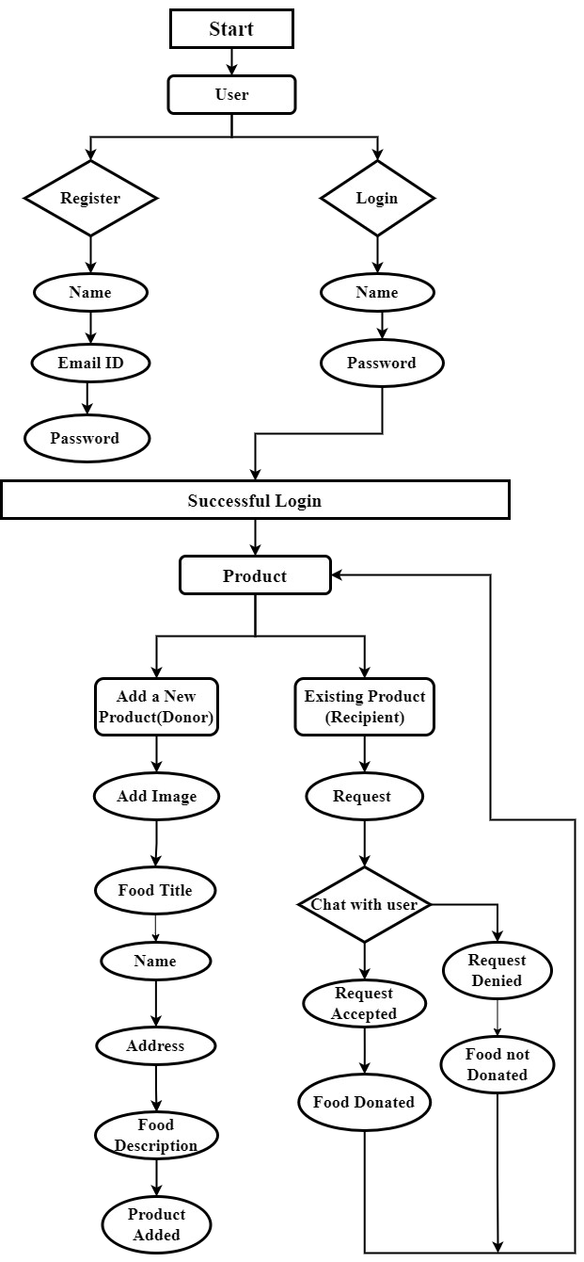

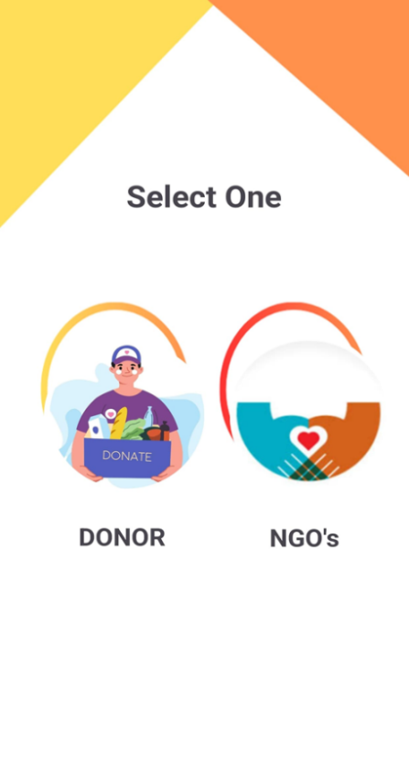

# Results and Discussions

Our goal was to create a waste-free food system by building an easy-to-use application which we have successfully achieved. Our system first requires a sign-in from the user or donor, after which authentication is required for logging in. Once logged in, the donor can fill in details of the food item to be donated and put it up for donation which would then be accepted by any genuine receiver who might be in need. We have even built a simple and efficient user interface using Android Studio as can be seen in the images below.



***3.Donor and Ngo’s Page***

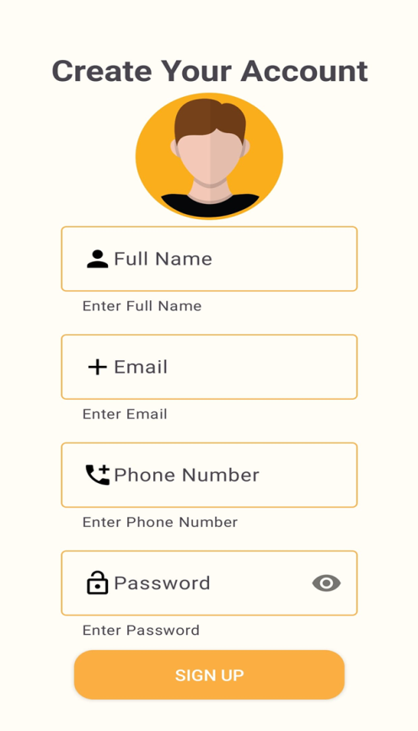

***1.Splash Activity***

***2. Signup Page***

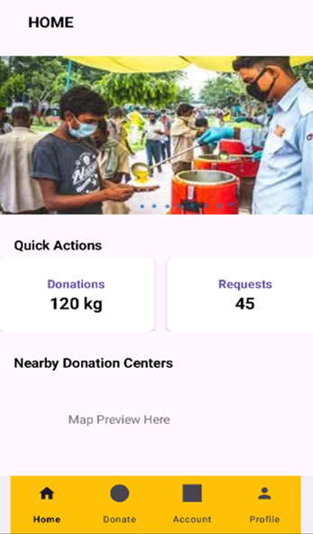

# Future Scope

The system that we have built can further include a link between the donor and the receiver. This link can basically be a person or an organization who would volunteer to deliver the food from the source to the target destination. Hence, this can even make use of the “real-time” location of the users (which can be done through the google location API) in order to locate precisely.

# Conclusion

Preventing food waste should be the primary goal. When this isn't practicable, however, food surpluses, which are still edible and nutritious, should be retrieved and redistributed to the most vulnerable who are at risk. Encouragement of stores and enterprises to give food could aid in the reduction of poverty and hunger. Food surplus redistribution is becoming more common, and food manufacturers and many shops are taking part willing to make a donation Donors and beneficiaries, however, may face legal and operational obstacles.

# III. Acknowledgment

Thanks to our project guide Prof. Swati Jadhav Ma’am and our VIT College who gave valuable time, support and effort for the project. Also, Thanks to R. Uma , S. Ranjith, I. Kaja Mohaidheen,

S. R. Dharaneesh, Kennard, Nicole, J. L. A. Monzon

Santos, Myriam ANNETTE who provided insight through their research papers that greatly assisted this project.

**IV. Reference**

1. R. Uma, S. Ranjith, I. Kaja Mohaidheen, S. R. Dharaneesh, 2022, Web – based Application for Food Waste Management, INTERNATIONAL JOURNAL OF ENGINEERING RESEARCH & TECHNOLOGY

(IJERT) Volume 11, Issue 05 (May 2022),

1. Kennard, Nicole. (2019). Food Waste Management. 10.1007/978-3-319-69626-3_86-1
2. J. L. A. Monzon Santos, ‘Food Waste Management
   * Perceptions, Decisions, and Actions: The case of Guatemala City Department Restaurants’, Dissertation, 2017.

***4. Home Page***

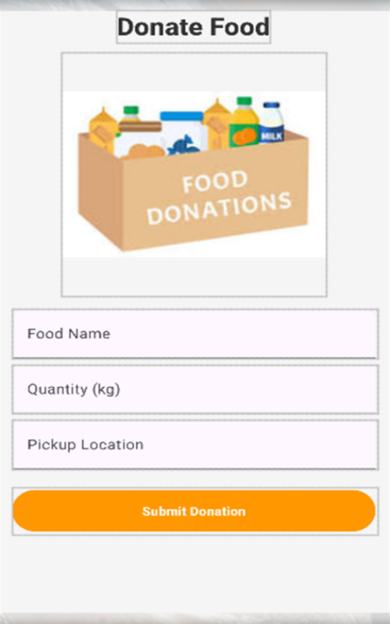

***5. Donation Page***

# 

1. Myriam ANNETTE International Consultant SAVE FOOD Initiative, Food and Agriculture Organization of the United Nations Regional Office for Europe and Central Asia (REU) Budapest – HUNGARY
2. Food Wastage Reduction:

-Sharad Bhardwaj, International Journal of Science and Research (IJSR)

1. Development of Leftover food management system using efficient hunger search techniques

-Naveen Kumar G N, Jeevith R.

1. Research Paper on Food Waste Management

-By Madiha Saba, Pooja , Dr. Priyadarshini. Patil

1. Food waste management innovations in the food service

-Martin-Rios, C., Demen-Meier, C., Gössling, S.

1. Waste to wealth — A novel approach for food waste management

-K. Jayalakshmi; S. Pavithra; C. Aarthi Publisher

1. Waste management initiatives in india

-By Dr. Raveesh Agarwal

1. Waste food management

-By Vimalkantdubey, Shweeta Singh