**Wavelet Transform and Neural Network-Based Fuzzy Logic Controller for Power Transformer Protection**

**Riddhi Wani1, Piyush Tupat2, Shrawani Talwar3, Prof. Harshada Raghuwanshi4,**

**Prof. Vikramsingh R. Parihar5**

1,2,3UG Students, Department of Computer Engineering, TCOER, Pune, Maharashtra, India

4 Assistant Professor, Department of Computer Engineering, TCOER, Pune, Maharashtra, India

5Assistant Professor, Department of Electrical Engineering, PRMCEAM, Amravati, Maharashtra, India

**ABSTRACT**

Wavelet transforms are fast and efficient means of analyzing transient voltage and current signals. Compare with fast Fourier transform, wavelet transform gives better results in analyzing signals containing sharp spikes. Differential protection schemes are widely used by electric companies to protect power equipments. Normally, various techniques are used in power transformer protection. This paper proposed novel control technique for transformer protection. This protection approach is based on extracting the fundamental components present in differential currents. This paper aims to prove that the Wavelet Transform is a reliable and computationally efficient tool for fault currents. The a neural network based fuzzy logic controller is used to design protection relay for transformer. The simulation is done by MATLAB/SIMULINK software and results are shown clearly in this paper.

**Keywords:** Fast Fourier transform, wavelet transform, artificial neural network and fuzzy logic controller

1. **INTRODUCTION**

Transformer is expensive primary plant equipment within a power system network which needs to be isolated quickly and reliably in the event of a fault. Utilities have a responsibility towards the consumer to provide reliable and continuous power in the network without causing a large blackout or cascade power failure. Inrush and fault currents consist of DC component and harmonics and it is a challenging task to estimate and eliminate DC component which occur during transients. Inrush current happening due to switching of a power transformer on no load may lead to resonance. A resonance is said to have occurred in the power system when there is a slow damping of inrush current. It has been observed that during inrush phenomenon, the magnitude of the inrush current depends on the switching angle and switching instance of the circuit breaker. In a typical normal operating scenario, the primary and secondary current of a power transformer maintains equilibrium but when an internal fault occurs, this balance is disturbed. The magnitude of the fault current depends upon zone of occurrence, the type of the fault (i.e. phase to phase, phase to earth etc), vector group of transformer (i.e. star-star, star-delta, delta-star). The magnitude of an inrush phenomenon is usually 10-15 times the normal [1-6].

**2. MAGNETIZING INRUSH CURRENT**

This occurrence of transient magnetizing inrush occurs in the primary side of transformer when it is switched on. This current appears as a internal fault and it is sensed as a differential current by the differential relay. The value of the first peak of magnetizing current may be as high as several times of the peak of the full load current. The magnitude and duration of magnetizing inrush current is influenced by many factors as described below [7].

* The input supply of voltage level.
* The instantaneous value of the voltage waveform at the moment of closing Circuit Breaker.
* The value of the residual magnetizing flux.
* Depends on the sign of the residual magnetizing flux.
* Type of iron laminations used in transformer core.
* The saturation of flux density in the core of transformer.
* The final impedance of the supply circuit.
* The size of the transformer.

The effect of the inrush current on the relay is false tripping the transformer without of any existing type of faults. From the principle of operation of the differential relay the relay compares the currents coming from both sides of the power transformer. As the inrush current flows through the primary side of the power transformer and therefore the differential current will have a significant value due to the existence of current in only one side. Thus the planning of relay is to recognize that this current is a normal phenomenon and not to trip due to this current.

**3. POWER QUALITY PROBLEMS DERIVED FROM MAGNITIZING INRUSH CURRENT**

From a power quality perspective, magnetizing inrush current introduces disturbances that can significantly affect system stability and operation. This inrush current, characterized by its non-sinusoidal waveform, gives rise to two primary types of power quality issues:

* Current Unbalance
* Harmonic Distortion

Each of these problems is described in detail below.

**3.1 Current Unbalance**

While current unbalance is not traditionally classified as a disturbance, it is an important indicator of asymmetrical conditions within a power system. In the case of transformer energization, the magnetizing inrush current often leads to unbalanced phase currents due to asymmetric saturation of the core. This results in varying current magnitudes in each phase during the initial cycles.

The occurrence of current unbalance, alongside the presence of the second harmonic component, can be effectively used to detect and analyze inrush events during transformer energization. These indicators are also essential for distinguishing between inrush current and internal transformer faults.

**3.2 Harmonic Distortion**

The magnetizing inrush current contains a broad spectrum of harmonic components due to the non-linear behavior of the transformer core during saturation. Although multiple harmonic orders may be present, only a few play a significant role in power quality issues. These include:

**I. DC or Offset Component:**

A DC component is typically present in all three phases during inrush, though its magnitude may vary. This component is primarily influenced by the residual magnetic flux in the core prior to energization and can result in waveform asymmetry.

**II. Second Harmonic:**

The second harmonic is consistently observed in the inrush current of all three phases. Its presence is a direct result of core saturation and is often used as a key diagnostic feature in transformer protection schemes.

**III. Third Harmonic:**

The third harmonic can appear with magnitudes comparable to the second harmonic. It arises due to symmetrical saturation of the transformer core and contributes to the distortion of the current waveform.

**IV. Higher-Order Harmonics:**

Although higher-order harmonics (beyond the third) are present during inrush events, their amplitudes are generally low and can often be neglected in power quality assessments.

**4. TECHNIQUES TO DISTINGUISH INRUSH AND FAULT CURRENT**

There are several ways of discriminating fault and inrush condition for protection purpose[9-10].

* Desensitization method is no longer being practised.
* Wave shape recognition methods are still relatively new and not widely practised.
* Harmonic based methods

These methods are widely practiced. The inrush current has a large harmonic component which is not present in fault currents. Inrush currents generate harmonics with second harmonic amplitudes as high as 65% of the fundamental. Thus SHR (second harmonic ratio) is used to discriminate inrush current from fault current such that, if SHR is less than threshold value then that

condition can be considered as fault and if SHR is more than threshold value then there is inrush current condition

· Using artificial intelligent technique

New techniques like artificial intelligent technique (fuzzy logic controller) can help to discriminate

between magnetization and fault conditions. Let us elaborate this technique and evaluate its advantages over others.

**5. THE FUZZY LOGIC CONTROLLER**

The concept of fuzzy logic was first introduced by Lotfi Zadeh and has since evolved into a powerful tool for controlling systems characterized by non-linearity, imprecision, and uncertainty. Fuzzy logic controllers (FLCs) have been successfully applied across various domains, particularly where conventional control strategies struggle to cope with dynamic or uncertain environments.

One of the most commonly used structures is the error-feedback-based fuzzy logic controller. Within this category, there are further variants such as the proportional-derivative (PD), proportional-integral (PI), and proportional-integral-derivative (PID) types of FLCs. These controllers mimic the behavior of classical control systems but enhance flexibility by incorporating linguistic rules and fuzzy reasoning, which allow for smoother transitions and more adaptable control logic.

The functioning of an FLC typically involves four key stages. The first is fuzzification, which is the process of converting crisp numerical input values into fuzzy sets. This allows the controller to interpret inputs in a way that reflects real-world vagueness or ambiguity, such as defining a temperature as "high" or "moderate" rather than assigning an exact number.

Next is the knowledge base, which includes both the data base and the rule base. The data base provides the necessary parameters and membership functions for fuzzification and defuzzification processes, while the rule base encapsulates expert knowledge in the form of "if-then" rules. These rules govern how the system responds under various conditions and represent the heart of the decision-making process in fuzzy logic control.

**Discrete Wavelet Transform (DWT)**

In the realm of signal processing for power system protection, especially differential protection of transformers, traditional techniques based on the Fast Fourier Transform (FFT) often fall short. These methods tend to overlook high-frequency transient components and are limited by their reliance on fixed windowing techniques, which can introduce time delays and reduce detection accuracy during fast-changing events.

By decomposing signals into orthogonal wavelets at various scales and positions, the DWT allows for multi-resolution analysis, providing a detailed representation of signal features at different frequencies and times. This makes it ideal for real-time fault detection, especially in systems where rapid and accurate decision-making is critical.

Wavelets are inherently suitable for analyzing non-stationary signals and have been widely used across fields such as audio processing, image compression, and biomedical signal analysis. In power systems, the application of DWT significantly enhances the ability to detect, classify, and respond to abnormalities with higher precision and reduced latency compared to traditional Fourier-based methods.



**Figure2:** Wavelet transform

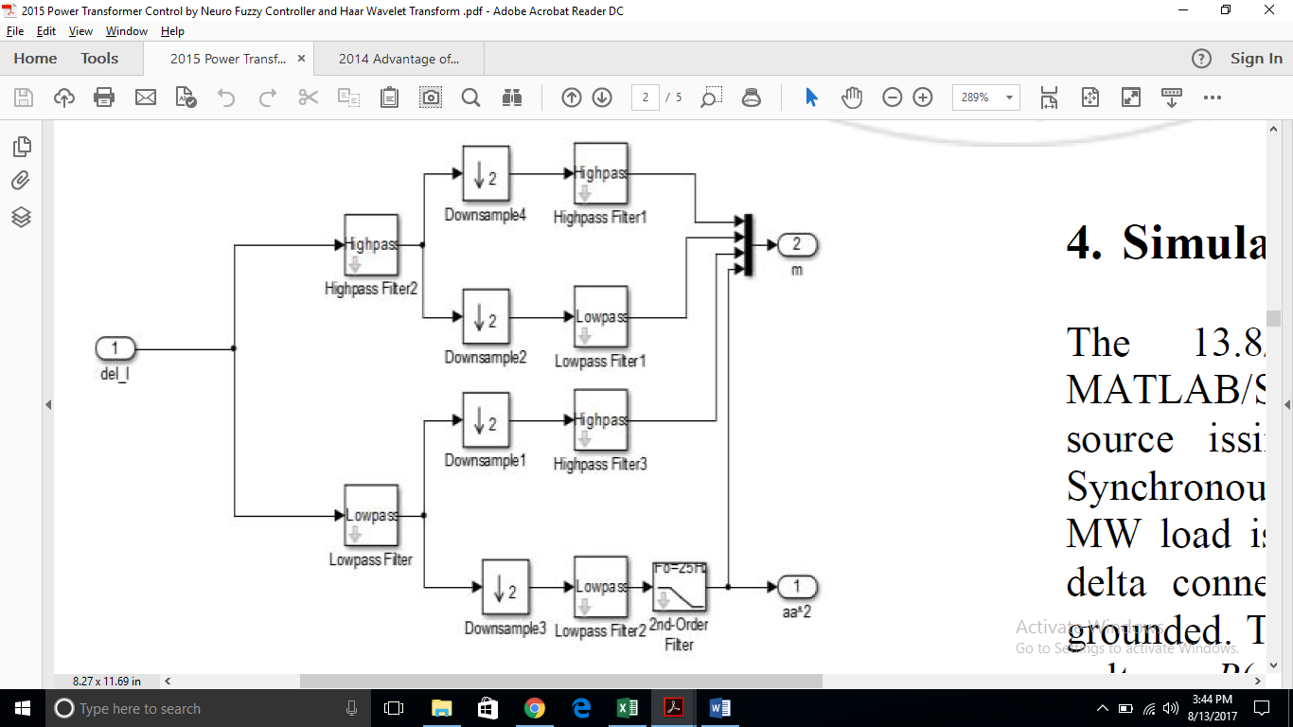

**Figure 3:** Simulink model of wavelet transform

**4. Simulation and Results** The 13.8/138V system is modeled by using MATLAB/SIMULINK software. As shown in Fig.5The source issimulated by an equivalent 50 Hz 30MVA Synchronousmachines with 500 MVA transformer and 50 MW load isconnected in parallel. A .8(13/138) kV star to delta connectedtransformer is employed with its neutral grounded. The generator *X/R*ratio is 7. The primary winding voltage *R*(*pu*) and *L*(*pu*)are 13.8 kV.0.0078 and 0.259 respectively, and secondarywinding voltage is *R*(*pu*) and *L*(*pu*) are 138 k.V 0.0078 and0.259 respectively. The load taken hereis 50 MW and 10 MVAR.

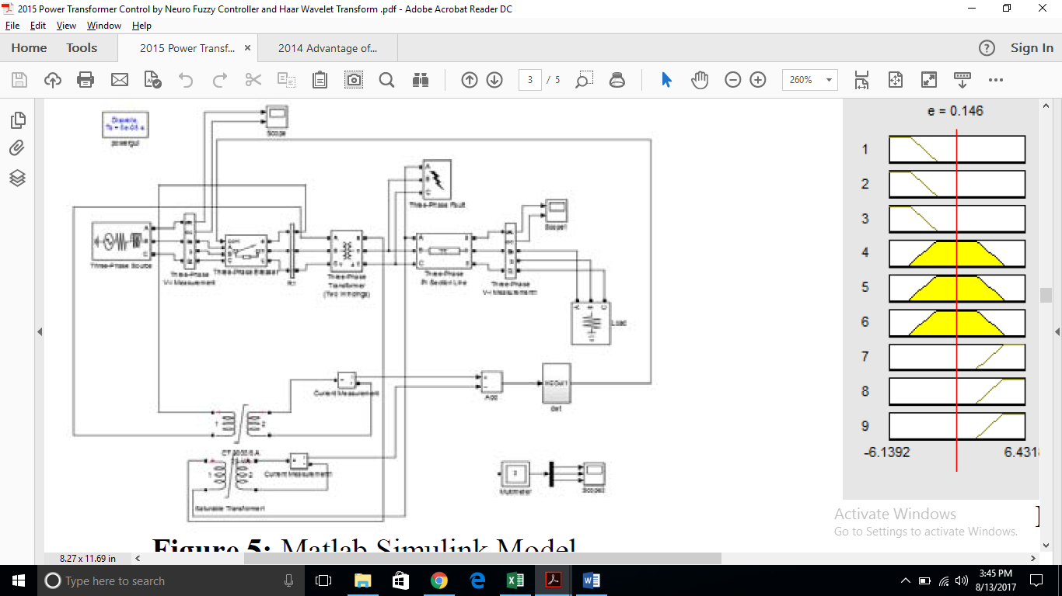

**Figure 5:** Matlab Simulink Model

**4.1 Simulation of Neuro fuzzy controller**

To identify the fault currents in transmission system various technique are used. The current in primary and secondary side of the transformer are measured by using current transformer. As shown in fig.3 From this differential current approximation and detailed coefficients were detected by discrete wavelet transform. From the approximation coeffitients relaying algorithm is derived by using Neuro fuzzy.



**Figure 6:** (a) Membership function of e



**Figure 7:** Rule viewer

**5. Results** The Voltage and current waveforms for various conditions (without fault, with fault and with tripping algorithm) are shown in the figures below. Fig.10(a) - (b) and Fig.11(a) – (b) represented Voltage and current waveforms under normal condition at no fault in a transmission line.



**Figure 10:** (a) Grid V under normal condition



**Figure 10:** (b) Grid I under normal condition



**Figure 11:** (a) The Load V under normal condition



**Figure 11:** (b) The Load I under normal condition

**6. CONCLUSION**

In the present work wavelet transform, fuzzy controller and Neuro fuzzy controller are used to protect power transformers from faults. The simulation results show that the protection system based on wavelet transform is suitable for relay protection for all types of fault. A simple decision making logic scheme using fuzzy logic ANFIS is presented for the developed technique for faults identification. The simulation waveforms show that the Neuro fuzzy based relays are tripping properly during the faulty condition. The extensive simulation results presented show that the proposed technique needs very simple input signals.

**REFERENCES**

1. M. F. M. Wafeek and C. P. Sekhar, "Power Transformer Control by Neuro Fuzzy Controller and Haar Wavelet Transform," International Journal of Science and Research (IJSR), vol. 5, no. 4, pp. 947–951, Apr. 2016. ​
2. C.-I. Chen, C.-K. Lan, Y.-C. Chen, C.-H. Chen, and Y.-R. Chang, "Wavelet Energy Fuzzy Neural Network-Based Fault Protection System for Microgrid," Energies, vol. 13, no. 4, p. 1007, Feb. 2020. ​
3. M. Gheisari, "Differential Protection of Power Transformer using Wavelet Transform," International Journal of Recent Technology and Engineering (IJRTE), vol. 8, no. 3, pp. 7627–7630, Sep. 2019. ​
4. O. Özgönenel, "Wavelet Based ANN Approach for Transformer Protection," International Journal of Computational Intelligence, vol. 2, no. 3, pp. 161–166, 2005. ​
5. C.-I. Chen, C.-K. Lan, Y.-C. Chen, C.-H. Chen, and Y.-R. Chang, "Wavelet Energy Fuzzy Neural Network-Based Fault Protection System for Microgrid," Energies, vol. 13, no. 4, p. 1007, Feb. 2020.
6. M. J. B. Reddy and D. K. Mohanta, "A wavelet-fuzzy combined approach for classification and location of transmission line faults," International Journal of Electrical Power & Energy Systems, vol. 29, no. 9, pp. 669–678, Nov. 2007.
7. Vikramsingh R. Parihar, Graph Theory Based Approach for Image Segmentation Using Wavelet Transform, International Journal of Image Processing (IJIP), Volume 8, Issue 5, pp 255-277, Sept 2014
8. Vikramsingh R. Parihar, Heartbeat and Temperature Monitoring System for Remote Patients using Arduino, International Journal of Advanced Engineering Research and Science (IJAERS), Volume 4, Issue 5, PP 55-58, May 2017
9. Vikramsingh R. Parihar, PC Controlled Electrical Line Cutting System, International Journal of Engineering Science and Computing (IJESC), Volume 7, Issue 5, pp 11380-11381, May 2017
10. Vikramsingh R. Parihar, Overview and an Approach to Develop a Four Quadrant Control System for DC Motors without using Microcontroller, International Journal of Engineering Science and Computing (IJESC), Volume 7, Issue 5, pp 11879-11881, May 2017
11. Vikramsingh R. Parihar, Image Analysis and Image Mining Techniques: A Review, Journal of Image Processing and Artificial Intelligence (MAT Journals), June 2017
12. Vikramsingh R. Parihar, Power Transformer Protection using Fuzzy Logic based Controller, International Journal of Engineering Research (IJER), Volume 6, Issue 7, pp 366-370, July 2017
13. Vikramsingh R. Parihar, Overview and an Approach to Real Time Face Detection and Recognition, International Advanced Research Journal in Science, Engineering and Technology (IARJSET), Volume 4, Issue 9, PP 39-46, Sept 2017
14. Vikramsingh R. Parihar, Neural Network and Fuzzy Logic Based Controller For Transformer Protection, International Journal of Current Engineering and Scientific Research (IJCESR), Volume 4, Issue 9, PP 33-38 , Sept 2017
15. Vikramsingh R. Parihar, A Novel Approach to Power Transformer Fault Protection using Artificial Neural Network, International Journal of Current Engineering and Scientific Research (IJCESR), Volume 4, Issue 9, PP 33-38, Sept 2017
16. Vikramsingh R. Parihar, Power Transformer Fault Protection using Artificial Neural Network, Journal of Electrical and Power System Engineering (MAT Journals), Volume 3, Issue 3, pp 1-5 , Sept 2017
17. Vikramsingh R. Parihar, Fuzzy Logic based Controller for Power Transformer Protection, Journal of Electrical and Power System Engineering (MAT Journals), Volume 3, Issue 3, pp 1-5 , Oct 2017
18. Vikramsingh R. Parihar, Real Time Face Detection and Recognition: Overview and Suggested Approach, Journal of Image Processing and Artificial Intelligence (MAT Journals), Volume 3, Issue 3, pp 1-6, Sept 2017
19. Vikramsingh R. Parihar, A Novel Approach to Real Time Face Detection and Recognition, International Journal of Computer Sciences and Engineering (IJCSE), Volume 5, Issue 9, pp 62-67, Sept 2017
20. Vikramsingh R. Parihar, Automatic Irrigation System Using Android Mobile: A Review, International Journal of Advanced Research in Computer and Communication Engineering (IJARCCE), Volume 6, Issue 9, pp 200-203, Oct 2017
21. Vikramsingh R. Parihar, Transmission Line Multiple Fault Detection: A Review and an Approach, International Journal of Current Engineering and Scientific Research (IJCESR), Volume 4, Issue 10 pp 1-7, Oct 2017
22. Vikramsingh R. Parihar, Regenerative Braking System for Energy Harvesting from Railways and Vehicles: A Review and an Approach, International Journal of Innovative Research in Electrical, Electronics, Instrumentation and Control Engineering (IJIREEICE), Volume 5, Issue 10, pp 18-25, Oct 2017
23. Vikramsingh R. Parihar, RFID Based Student Attendance Management System: A Review and an Approach, International Advanced Research Journal in Science, Engineering and Technology (IARJSET), Volume 4, Issue 9, pp 262-265, Sept 2017
24. Vikramsingh R. Parihar, Distance Protection Problem in Series-Compensated Transmission Lines, International Journal of Advanced Trends in Technology, Management and Applied Science (IJATTMAS), Volume 3, Issue 10, pp 44-48, Oct 2017
25. Vikramsingh R. Parihar, Series-Compensated Transmission Line Problem in Distance Protection, International Journal of Electrical, Electronics and Communication Engineering (IJEECE), Volume 3, Issue 10, pp 1-9, Oct 2017
26. Vikramsingh R. Parihar, Series Compensated Line Protection using Artificial Neural Network, International Advanced Research Journal in Science, Engineering and Technology (IARJSET), Volume 4, Issue 10, pp 102-111, Oct 2017
27. Vikramsingh R. Parihar, Protection Scheme of Fault Detection in High Voltage Transmission Line, International Journal of Advanced Trends in Technology, Management and Applied Science (IJATTMAS), Volume 3, Issue 11, pp 1-4, Nov 2017
28. Vikramsingh R. Parihar, IOT Based Communication Technology for High Voltage Transmission System, Journal of Electrical and Power System Engineering (MAT Journals), Volume 3, Issue 3, pp 1-6 , Nov 2017
29. Vikramsingh R. Parihar, Transmission Line Protection Analysis using STATCOM, International Journal of Advanced Trends in Technology, Management and Applied Science (IJATTMAS), Volume 3, Issue 11, pp 23-26, Nov 2017
30. Vikramsingh R. Parihar, A Review on Transmission Line Fault Detection Techniques, International Journal of Advanced Trends in Technology, Management and Applied Science (IJATTMAS), Volume 3, Issue 11, pp 27-32, Nov 2017
31. Vikramsingh R. Parihar, Transmission Line Protection using Distance Relays, International Journal of Electrical, Electronics and Communication Engineering (IJEECE), Volume 3, Issue 1, pp 1-15, Nov 2017
32. Vikramsingh R. Parihar,Protection of Power Transformers using Artificial Neural Network and Fuzzy logic, International Journal of Advanced Trends in Technology, Management and Applied Science (IJATTMAS), Volume 3, Issue 11, pp 72-79, Nov 2017
33. Vikramsingh R. Parihar, Control System Security: An Issue, Journal of Control System and Control Instrumentation (MAT Journals), Volume 3, Issue 3, pp 1-5 , Dec 2017
34. Vikramsingh R. Parihar, Resilient Designs of Control Systems Analysis and Review, Journal of Control System and Control Instrumentation (MAT Journals), Volume 3, Issue 3, pp 1-9 , Dec 2017
35. Vikramsingh R. Parihar,Industrial Control System Cyber Security: Review & Recommendations, Journal of Network Security Computer Networks (MAT Journals), Volume 3, Issue 3, pp 1-9 , Dec 2017
36. Vikramsingh R. Parihar,Operational Analysis of Infrared Gas Sensor, Journal of Instrumentation and Innovation Sciences (MAT Journals), Volume 4, Issue 1, pp 1-5 , Dec 2017
37. Vikramsingh R. Parihar, Automatic Fault Detection in Transmission Lines using GSM Technology, International Journal of Innovative Research in Electrical, Electronics, Instrumentation and Control Engineering (IJIREEICE), Volume 6, Issue 4, pp 90-95, April 2018
38. Vikramsingh R. Parihar, UPFC based distance relays for protection of transmission systems employing FACTS, International Journal of Advanced Engineering and Technology (IJAET), Volume 2, Issue 2, pp 4-7, May 2018
39. Vikramsingh R. Parihar, Power Substation Protection from Lightening Over voltages and Power Surges, International Journal of Innovative Research in Electrical, Electronics, Instrumentation and Control Engineering (IJIREEICE), Volume 6, Issue 6, pp 26-31, June 2018
40. Vikramsingh R. Parihar, An Overview of Transmission Line Fault Detection Techniques, International Journal of Innovative Research & Studies (IJIRS), Volume 8, Issue VII, pp 64-77, July-2018
41. Vikramsingh R. Parihar, Power Monitoring System Using Microcontroller for Optimum Power Utility in homes, Reinvention International: An International Journal of Thesis Projects and Dissertation, Volume 1, Issue 1, pp 96-112, Aug-2018
42. Vikramsingh R. Parihar, Automatic Wireless Health Monitoring System, Reinvention International: An International Journal of Thesis Projects and Dissertation, Volume 1, Issue 1, pp 84-95, Aug-2019
43. Vikramsingh R. Parihar, Overview and an Approach for QR-Code Based Messaging and File Sharing on Android Platform in View of Security, Proceedings of the IEEE 2017 International Conference on Computing Methodologies and Communication (ICCMC), July 2017
44. Vikramsingh R. Parihar, Line Trap and Artificial Intelligence Based Double Circuit Transmission Line Fault Classification, International Conference on Energy, Communication, Data Analytics and Soft Computing (ICECDS 2017), August 2017
45. Vikramsingh R. Parihar, Hybrid Power System with Integration of Wind, Battery and Solar PV System, IEEE International Conference on Power, Control, System and Instrumentation Engineering (ICPCSI), Sept 2017
46. Vikramsingh R. Parihar, A Novel System of Real Time Hand Tracking and Gesture Recognition, IEEE International Conference on Inventive Computing and Informatics (ICICI), Nov 2017.
47. Vikramsingh R. Parihar, Improving Power Quality of Induction Motors using Capacitor Bank, International Journal of Innovative Research in Electrical, Electronics, Instrumentation and Control Engineering (IJIREEICE), Volume 6, Issue 9, pp 37-45, Sept 2018
48. Vikramsingh R. Parihar, Power Generation from Exhaust Gases of Diesel Engines: An Overview and an Approach, International Advanced Research Journal in Science, Engineering and Technology (IARJSET), Volume 5, Issue 9, pp 66-74, Sept 2018
49. Vikramsingh R. Parihar, Power Quality Disturbance Eviction using SOM Neural Network, Journal of Recent Advances in Electronics and Communication Engineering, Volume 1, Issue 1, pp 1-15, Oct 2018
50. Vikramsingh R. Parihar, Optimized Neural Network Based Classifier for Effective Classification of Power Quality Disturbances, Journal of Recent Advances in Electronics and Communication Engineering, Volume 1, Issue 1, pp 16-31, Oct 2018
51. Vikramsingh R. Parihar, A Review and an Approach of Water Pollution Indication using Arduino Uno, International Journal of Advanced Engineering Research and Science (IJAERS), Volume 5, Issue 10, pp 160-167, Oct- 2018
52. Vikramsingh R. Parihar, A Review and an Approach of Flying Electric Generators as Alternate Source of Energy, International Journal of Advanced Engineering Research and Science (IJAERS), Volume 5, Issue 10, pp 173-178, Oct- 2018
53. Vikramsingh R. Parihar, Automatic Overhead Water Tank Cleaning System: A Review and an Approach, International Journal of Advanced Engineering Research and Science (IJAERS), Volume 5, Issue 10, pp 185-194, Oct- 2018
54. Vikramsingh R. Parihar, Transmission Line Symmetrical Faults Protection System, Journal of Recent Advances in Electronics and Communication Engineering, Volume 1, Issue 1, pp 32-37, Oct 2018
55. Vikramsingh Parihar, Hamid Reza Boveiri, "Research Directions and Future Trends in Medical Image Segmentation," ICSES Transactions on Image Processing and Pattern Recognition, vol. 5, no. 2, pp. 1-3, Jun. 2019.
56. Vikramsingh R. Parihar, Two Way Wireless Mesh Network Data Sharing between ESP8266 without Internet, International Journal of Advanced Research in Computer and Communication Engineering (IJARCCE), Volume 8, Issue 8, pp 23-28, Aug 2019
57. Vikramsingh Parihar, Hamid Reza Boveiri, Image Segmentation: A Guide to Image Mining. ICSES Transactions on Image Processing and Pattern Recognition (ITIPPR), ICSES, pp. 1-250, 2018. DOI: 10.31424/icses.itippr.2018.v4.n4
58. Altaf Shah, Vikram Parihar, "An Easy Approach to JAVA: Let's code"
59. Vikramsingh Parihar, Hamid Reza Boveiri, "A Survey and Comparative Analysis on Image Segmentation Techniques," in Image Segmentation: A Guide to Image Mining, 1st ed., ITIPPR: ICSES, 2018, pp. 1-15.
60. Vikramsingh Parihar, Roshani Nage, Atul Dahane, "A Novel Graph-based Image Mining Technique Using Weighted Substructure," in Image Segmentation: A Guide to Image Mining, 1st ed., ITIPPR: ICSES, 2018, pp. 16-25.
61. Vikramsingh Parihar, "Image Segmentation Based on Graph Theory and Threshold," in Image Segmentation: A Guide to Image Mining, 1st ed., ITIPPR: ICSES, 2018, pp. 61-82.
62. Vikramsingh Parihar, Roshani Nage, Atul Dahane, "A Review and Comparative Analysis on Image Mining Techniques ," in Image Segmentation: A Guide to Image Mining, 1st ed., ITIPPR: ICSES, 2018, pp. 51-60.
63. Ashish R. Varma, Surbhi S. Kashyap, Vikramsingh Parihar, "Challenges in Cloud Computing and Big Data, and their Solution using Hadoop", Innovation, Opportunities and Challenges in Big Data, Eureka Publications, pp 63-74, 2019, ISBN 978-81-938863-0-4
64. Ashish R. Varma, Surbhi S. Kashyap, Vikramsingh Parihar, "Design and Implementation of
65. Optimum Replica Management in HDFS", Innovation, Opportunities and Challenges in Big Data, Eureka Publications, pp 100-133, 2019, ISBN 978-81-938863-0-4
66. Ashish R. Varma, Surbhi S. Kashyap, Vikramsingh Parihar, "Novel Approach for Providing High
67. Storage Efficiency in HDFS", Innovation, Opportunities and Challenges in Big Data, Eureka Publications, pp 139-155, 2019, ISBN 978-81-938863-0-4
68. Ashish R. Varma, Surbhi S. Kashyap, Vikramsingh Parihar, "Study of Different Approaches used In Heterogeneous Cluster to provide Higher Access and Consistency for Big Data", Innovation, Opportunities and Challenges in Big Data, Eureka Publications, pp 173-190, 2019, ISBN 978-81-938863-0-4
69. Vikramsingh Parihar, Hamid Reza Boveiri, "A Survey and Comparative Analysis on Image Segmentation Techniques," in Image Segmentation: A Guide to Image Mining, 1st ed., ITIPPR: ICSES, 2018, pp. 1-15.
70. Vikramsingh Parihar, Roshani Nage, Atul Dahane, "A Novel Graph-based Image Mining Technique Using Weighted Substructure," in Image Segmentation: A Guide to Image Mining, 1st ed., ITIPPR: ICSES, 2018, pp. 16-25.
71. Vikramsingh Parihar, "Image Segmentation Based on Graph Theory and Threshold," in Image Segmentation: A Guide to Image Mining, 1st ed., ITIPPR: ICSES, 2018, pp. 61-82.
72. Vikramsingh Parihar, Roshani Nage, Atul Dahane, "A Review and Comparative Analysis on Image Mining Techniques ," in Image Segmentation: A Guide to Image Mining, 1st ed., ITIPPR: ICSES, 2018, pp. 51-60.
73. Vikramsingh R. Parihar, “Wireless Communication Technology using Li-Fi”, International Journal of Advanced Research in Computer and Communication Engineering (IJARCCE), Vol. 8, Issue 9, pp. 38-41. September 2019,
74. Vikramsingh R. Parihar, Solar Power Tracking Device using Embedded Systems, International Journal of Creative Research Thoughts (IJCRT), Volume 9, Issue 7, pp f388-f401, July 2021
75. Vikramsingh R. Parihar, Distance Calculation for Underground Cable Fault, International Journal of Creative Research Thoughts (IJCRT), Volume 9, Issue 7, pp f776-f796, July 2021
76. Vikramsingh R. Parihar, Minimizing Penalty in Industrial Power Factor by Engaging APFC Unit, International Journal of Computer Science (IJCS), Volume 10, Issue 2, pp 2936-2947, Aug 2022
77. Vikramsingh R. Parihar, AUTO SELECTION OF ANY AVAILABLE PHASE IN THREE PHASE SUPPLY SYSTEM, International Journal of Computer Science (IJCS), Volume 10, Issue 2, pp 2948-2960, Aug 2022
78. Vikramsingh R. Parihar, Repercussions of Anti Satellite Missile Tests Alternate ASAT Technologies and Preventive Techniques for Mitigation of Space Debris, International Journal of Scientific Research in Engineering and Management (IJSREM), Volume 8, Issue 4, pp 1-8, April 2024
79. Vikramsingh R. Parihar, Kidney Stone Prediction using Neural Network, Ajanta, Volume 13, Issue 2, April 2024
80. Vikramsingh R. Parihar, Roshani S. Nage, Harshada M. Raghuwanshi, Mohini G. Fuse, Dr. Soni A. Chaturvedi, "Power Transformer Faults: Analysis, Classification and Protection," Engineering World, vol. 6, pp. 215-224, 2024, DOI:10.37394/232025.2024.6.23
81. Vikramsingh R. Parihar, Rohan V. Thakur, Dr. Mohan B. Tasare, Harshada M. Raghuwanshi, Mohini G. Fuse, Dr. Soni A. Chaturvedi, "Inverter Coupled Energy Storage System for Soft-Restarting of Power System Dynamic Load," International Journal on Applied Physics and Engineering, vol. 3, pp. 52-58, 2024, DOI:10.37394/232030.2024.3.8
82. Vikramsingh R. Parihar, Aaditya P. Agarkar, Kaustubh S. Kalkonde, Harshada M. Raghuwanshi, Mohini G. Fuse, Dr. Soni A. Chaturvedi, "Series Active Power Filter for Power Quality Improvement," Engineering World, vol. 6, pp. 234-239, 2024, DOI:10.37394/232025.2024.6.25
83. Vikramsingh R. Parihar, Roshani S. Nage, Krunal S. Panpaliya, Yogesh P. Khadse, Kaustubh S. Kalkonde, Dr. Soni A. Chaturvedi, "Adaptive Approach for Power Oscillation Damping using STATCOM," Engineering World, vol. 6, pp. 225-233, 2024, DOI:10.37394/232025.2024.6.24
84. Aaditya P. Agarkar, Vishalsing V. Bais, Chetan R. Ingole, Amol. P. Bhagat, Vikramsingh R. Parihar, "Automatic UPI based Medicine Vending Machine using IOT", First International Conference on Multidisciplinary Research 2024 (FICMR 2024)