**Artificial Neural Network-Based Approach for Transformer Fault Detection and Inrush Current Discrimination Using Wavelet Coefficients**

**Sakshi Patil1, Shreyash Mali2, Adesh Tikande3, Prof. Harshada Raghuwanshi4,**

**Prof. Vikramsingh R. Parihar5**

1,2,3UG Students, Department of Computer Engineering, TCOER, Pune, Maharashtra, India

4 Assistant Professor, Department of Computer Engineering, TCOER, Pune, Maharashtra, India

5Assistant Professor, Department of Electrical Engineering, PRMCEAM, Amravati, Maharashtra, India

**ABSTRACT**

Transformer protection remains a critical concern in power systems, particularly due to the challenge of accurately and swiftly distinguishing magnetizing inrush currents from internal fault currents. To address this issue, artificial neural networks (ANNs) have been proposed and proven effective, offering a cost-efficient, reliable, and noninvasive solution for transformer monitoring and fault detection. This paper presents an innovative algorithm that utilizes statistical parameters derived from the detailed D1-level wavelet coefficients of the signal as inputs to the ANN. This method provides a novel, real-time approach for accurately differentiating between magnetizing inrush currents and inter-turn faults. Furthermore, the proposed ANN-based model extends its capability to identifying the fault location—determining whether the inter-turn fault resides in the primary or secondary winding of the transformer.

**Keywords:** Artificial Neural Network, Fault Detection, Inrush Current, Inter-turn Fault, Transformer Protection, Wavelet Coefficients, Wavelet Transform

1. **INTRODUCTION**

Power transformers are critical components in power systems, and their reliable protection is essential to prevent operational failures. Differential protection has long been the primary method employed for safeguarding power transformers. It relies on differential relays that detect internal faults by comparing current differences and are designed to block operations during magnetizing inrush conditions. However, a significant limitation of this method is its vulnerability to maloperation due to transient inrush currents, which commonly occur during transformer energization. These inrush currents often contain substantial second harmonic components.

Traditional digital differential protection techniques depend heavily on analyzing the harmonic content of the differential current. The common assumption is that the ratio of second harmonic to the fundamental component is higher during inrush conditions than during internal faults. Nonetheless, second harmonic components can also be present during internal faults, due to factors such as current transformer (CT) saturation, parallel capacitances, or isolated transformer sections. In some cases, the second harmonic magnitude during faults may exceed that observed during inrush, leading to misclassification by conventional harmonic restraint methods.

To address these limitations and improve reliability, various advanced techniques have been developed to distinguish inrush currents from internal fault currents. Given that both types of signals are non-stationary, wavelet transform-based signal processing has proven effective for analyzing and extracting distinguishing features. Although wavelet techniques offer superior time-frequency resolution, they typically require long data windows and are susceptible to noise interference.

For example, the method in [6] combines Wavelet Transform (WT) with Adaptive Neuro-Fuzzy Inference System (ANFIS) to discriminate between inrush and internal fault currents. However, because it relies on detail level 5 (D5) wavelet coefficients for pattern recognition, its performance degrades in noisy environments. Similarly, the technique in [5] differentiates inter-turn faults from magnetizing inrush conditions using peaks in the |D5| wavelet coefficients. Although this method eliminates the need for predefined threshold values, it still struggles in noisy conditions, especially when the precise switching instance is unclear.

Feedforward Neural Networks (FFNNs) [7–10] have also been applied to detect inrush conditions, but they face two primary challenges: the training process is time-consuming, and determining the optimal number of neurons to prevent overfitting or underfitting lacks a systematic approach. To mitigate these issues, Radial Basis Function Networks (RBFNs) [11] have been introduced. RBFNs offer a simpler structure and a more transparent learning process, making them suitable for this application.

Additionally, some approaches use harmonic content of differential current as input for fuzzy logic systems [6], [12], offering another path to improving transformer protection.

**2. ARTIFICIAL NEURAL NETWORK**

The use of Artificial Neural Networks (ANNs) for fault classification in power systems has garnered significant attention in recent years. Dr. Robert Hecht-Nielsen, a pioneer in the development of early neurocomputers, described an ANN as “a computing system made up of a number of simple, highly interconnected processing elements, which process information by their dynamic state response to external inputs.” Essentially, ANNs are designed to model complex patterns and relationships in data by simulating the way biological neural networks function. They are trained for specific tasks—such as pattern recognition or data classification—through a structured learning process that adjusts the internal parameters based on input-output mappings..

**2.1 ARCHITECTURE OF NEURAL NETWORKS**

Neural networks are typically structured in multiple layers, each comprising numerous interconnected processing units known as neurons or nodes. These layers include an input layer, one or more hidden layers, and an output layer. Each node within a layer applies an activation function to the weighted sum of its inputs, which determines the node’s output. The input layer receives the raw data and passes it through to the hidden layers, where the core computations occur via a network of weighted connections. These hidden layers extract features and identify patterns in the data. Finally, the processed information reaches the output layer, which produces the final result of the network, such as a classification or decision, as illustrated in the corresponding figure..



Figure 1: Architecture of ANN

**3. PROPOSED ALGORITHM**

In the proposed approach, a **Multilayer Perceptron (MLP)** neural network with two hidden neurons is employed to effectively distinguish between magnetizing inrush current and internal fault current in a power transformer. This neural model is trained to recognize patterns based on statistical features extracted from the current signals. The **trained weights**, representing long-term memory of the network, are utilized at the processor level to make real-time classification decisions regarding the nature of the disturbance.

The overall procedure for online detection and classification of transformer conditions using the proposed algorithm is illustrated in Figure [X]. The step-by-step implementation is described below:

* **Step 1:** One complete cycle of both primary and secondary current waveforms is captured using a real-time data acquisition system.
* **Step 2:** The **differential current** is computed using the relation:

Id=Ip−IsI_d = I_p - I_sId​=Ip​−Is​

where IpI_pIp​ is the primary current and IsI_sIs​ is the secondary current.

* **Step 3:** The **RMS value** of the differential current is calculated. If the RMS value is below a predefined threshold, the system concludes that no abnormal condition exists and returns to Step 1 for continued monitoring.
* **Step 4:** If the RMS value exceeds the threshold, the **Discrete Wavelet Transform (DWT)** of the differential current is computed to capture transient and non-stationary characteristics of the signal.
* **Step 5:** From the DWT, **statistical parameters** such as mean, standard deviation, skewness, and kurtosis are extracted from the first decomposition level (d1). These parameters provide a concise representation of the signal's behavior during the event.
* **Step 6:** The extracted parameters are then fed into the **Artificial Neural Network (ANN)** as input features. The ANN, trained on known cases of inrush and fault conditions, classifies the current disturbance accordingly.
* **Step 7:** If the ANN classifies the condition as an **internal fault**, a **trip signal** is issued to the circuit breaker to isolate the transformer. If the condition is identified as **inrush** or **healthy**, the system continues monitoring the differential current for any further disturbances.

This intelligent approach leverages the power of neural networks and wavelet-based signal analysis to ensure accurate and efficient discrimination between inrush and fault currents, thereby enhancing the reliability of transformer protection schemes.

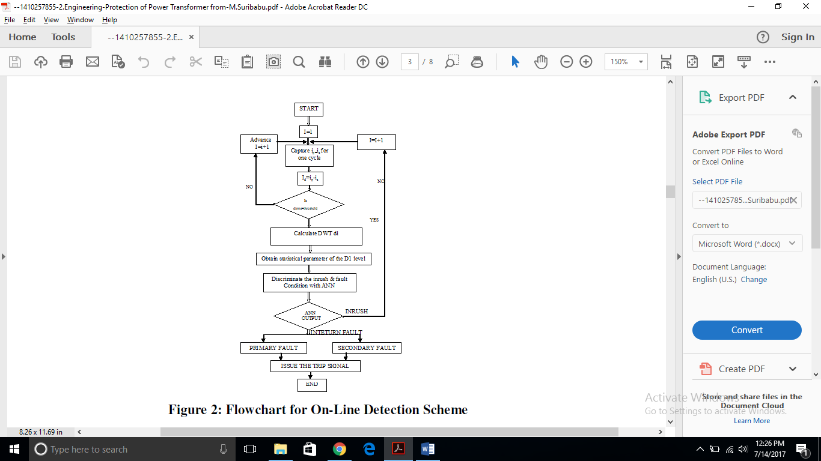

Figure 2: Flowchart for On-Line Detection Scheme

**4. SIMULATION RESULTS**

Neural networks possess the capability to execute massively parallel computations, which significantly enhances their processing speed and efficiency. Additionally, they exhibit fault tolerance, as information is distributed across the network's interconnected structure. This characteristic allows the system to continue functioning even if some nodes or connections are compromised.

In the context of control systems, the implementation of a Neural PI (Proportional-Integral) controller offers notable advantages over conventional PI controllers. Specifically, it reduces peak overshoot and ensures a faster settling time, thereby improving the dynamic performance of the system.

The following MATLAB script outlines the procedure to create and train a feedforward neural network using provided input (i) and output (o1) datasets:

% Load input and output datasets

load n

% Normalize input and output data

k1 = max(i');

k2 = max(o1');

P = i' / k1; % Normalized input

T = o1' / k2; % Normalized target output

% Define neural network architecture

net = newff(minmax(P), [5 1], {'tansig', 'purelin'});

% Set training parameters

net.trainParam.epochs = 200;

% Train the network

net = train(net, P, T);

% Simulate the network output

Y = sim(net, P);

% Plot the target and simulated outputs

plot(P, T, P, Y, 'o');

% Generate a Simulink block from the trained network

gensim(net, -1);



Figure 3: ANN M-File Program



Figure 4: Training Epochs of ANN

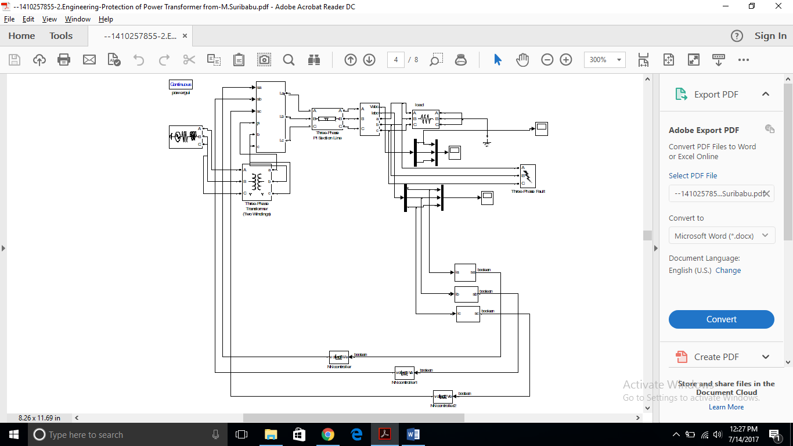

Figure 5: Simulation Model with ANN

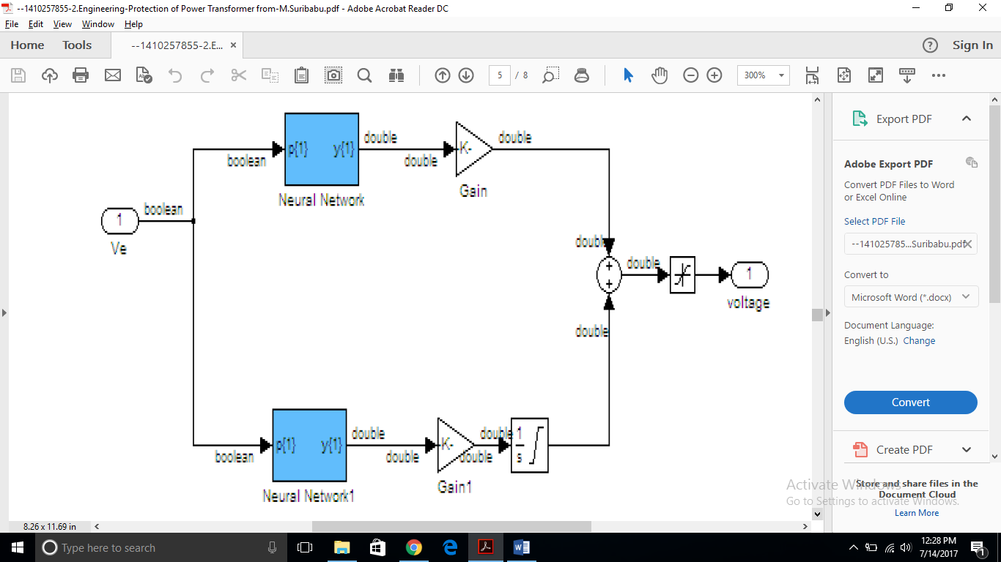

Figure 6: Subsystem Model of ANN



Figure 7: ANN output for internal fault current

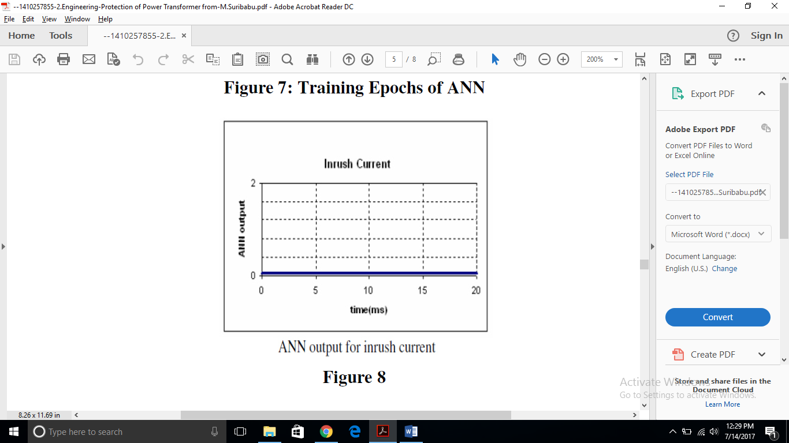

Figure 8: ANN output for inrush current

**5. CONCLUSIONS**

A new method is proposed to distinguish magnetizing inrush current from inter-turn faults in transformers using Wavelet Transform to extract time-frequency features from differential current signals. These features serve as inputs to an Artificial Neural Network (ANN), which accurately classifies the events in less than one cycle after initiation.

The method performs reliably under varying conditions such as fault angle, resistance, and system parameters. In case of misclassification, the new event data can be added to the training set, and the ANN retrained to improve accuracy and adaptability.

***REFERENCES***

1. S. M. S. Hosseinimoghadam, M. Dashtdar, and M. Dashtdar, “Improving the Differential Protection of Power Transformers Based on Clarke Transform and Fuzzy Systems,” J. Control Autom. Electr. Syst., vol. 33, pp. 610–624, 2022.
2. R. A. Prasojo, H. Gumilang, Suwarno, N. U. Maulidevi, and B. A. Soedjarno, “A Fuzzy Logic Model for Power Transformer Faults’ Severity Determination Based on Gas Level, Gas Rate, and Dissolved Gas Analysis Interpretation,” Energies, vol. 13, no. 4, p. 1009, 2020.
3. C. Nagarajan, G. Neelakrishnan, R. Janani, S. Maithili, and G. Ramya, “Investigation on Fault Analysis for Power Transformers Using Adaptive Differential Relay,” Asian J. Electr. Sci., vol. 11, no. 1, 2022.
4. Z. Babaei and M. Moradi, “Novel Method for Discrimination of Transformers Faults from Magnetizing Inrush Currents Using Wavelet Transform,” Iran J. Sci. Technol. Trans. Electr. Eng., vol. 45, pp. 803–813, 2021.
5. M. M. Marei, M. H. Nawir, and A. A. R. Altahir, “An Improved Technique for Power Transformer Protection Using Fuzzy Logic Protective Relaying,” Indones. J. Electr. Eng. Comput. Sci., vol. 22, no. 3, pp. 1754–1760, 2021.
6. B. Saravanan and A. Rathinam, “Inrush Blocking Scheme in Transformer Differential Protection,” Energy Procedia, vol. 117, pp. 1165–1171, 2017.
7. M. E. B. Elshaer, A. H. A. Badr, and H. E. Z. E. Rafei, “A New Fuzzy-Based Differential Protection Scheme for Power Transformers,” Electr. Power Syst. Res., vol. 199, p. 107472, 2021.
8. A. E. Ahad and A. Abu-Siada, “An Improved Transformer Differential Protection Based on Adaptive Fuzzy Logic System,” IEEE Trans. Power Deliv., vol. 35, no. 6, pp. 2601–2609, Dec. 2020.
9. Vikramsingh R. Parihar, Graph Theory Based Approach for Image Segmentation Using Wavelet Transform, International Journal of Image Processing (IJIP), Volume 8, Issue 5, pp 255-277, Sept 2014
10. Vikramsingh R. Parihar, Heartbeat and Temperature Monitoring System for Remote Patients using Arduino, International Journal of Advanced Engineering Research and Science (IJAERS), Volume 4, Issue 5, PP 55-58, May 2017
11. Vikramsingh R. Parihar, PC Controlled Electrical Line Cutting System, International Journal of Engineering Science and Computing (IJESC), Volume 7, Issue 5, pp 11380-11381, May 2017
12. Vikramsingh R. Parihar, Overview and an Approach to Develop a Four Quadrant Control System for DC Motors without using Microcontroller, International Journal of Engineering Science and Computing (IJESC), Volume 7, Issue 5, pp 11879-11881, May 2017
13. Vikramsingh R. Parihar, Image Analysis and Image Mining Techniques: A Review, Journal of Image Processing and Artificial Intelligence (MAT Journals), June 2017
14. Vikramsingh R. Parihar, Power Transformer Protection using Fuzzy Logic based Controller, International Journal of Engineering Research (IJER), Volume 6, Issue 7, pp 366-370, July 2017
15. Vikramsingh R. Parihar, Overview and an Approach to Real Time Face Detection and Recognition, International Advanced Research Journal in Science, Engineering and Technology (IARJSET), Volume 4, Issue 9, PP 39-46, Sept 2017
16. Vikramsingh R. Parihar, Neural Network and Fuzzy Logic Based Controller For Transformer Protection, International Journal of Current Engineering and Scientific Research (IJCESR), Volume 4, Issue 9, PP 33-38 , Sept 2017
17. Vikramsingh R. Parihar, A Novel Approach to Power Transformer Fault Protection using Artificial Neural Network, International Journal of Current Engineering and Scientific Research (IJCESR), Volume 4, Issue 9, PP 33-38, Sept 2017
18. Vikramsingh R. Parihar, Power Transformer Fault Protection using Artificial Neural Network, Journal of Electrical and Power System Engineering (MAT Journals), Volume 3, Issue 3, pp 1-5 , Sept 2017
19. Vikramsingh R. Parihar, Fuzzy Logic based Controller for Power Transformer Protection, Journal of Electrical and Power System Engineering (MAT Journals), Volume 3, Issue 3, pp 1-5 , Oct 2017
20. Vikramsingh R. Parihar, Real Time Face Detection and Recognition: Overview and Suggested Approach, Journal of Image Processing and Artificial Intelligence (MAT Journals), Volume 3, Issue 3, pp 1-6, Sept 2017
21. Vikramsingh R. Parihar, A Novel Approach to Real Time Face Detection and Recognition, International Journal of Computer Sciences and Engineering (IJCSE), Volume 5, Issue 9, pp 62-67, Sept 2017
22. Vikramsingh R. Parihar, Automatic Irrigation System Using Android Mobile: A Review, International Journal of Advanced Research in Computer and Communication Engineering (IJARCCE), Volume 6, Issue 9, pp 200-203, Oct 2017
23. Vikramsingh R. Parihar, Transmission Line Multiple Fault Detection: A Review and an Approach, International Journal of Current Engineering and Scientific Research (IJCESR), Volume 4, Issue 10 pp 1-7, Oct 2017
24. Vikramsingh R. Parihar, Regenerative Braking System for Energy Harvesting from Railways and Vehicles: A Review and an Approach, International Journal of Innovative Research in Electrical, Electronics, Instrumentation and Control Engineering (IJIREEICE), Volume 5, Issue 10, pp 18-25, Oct 2017
25. Vikramsingh R. Parihar, RFID Based Student Attendance Management System: A Review and an Approach, International Advanced Research Journal in Science, Engineering and Technology (IARJSET), Volume 4, Issue 9, pp 262-265, Sept 2017
26. Vikramsingh R. Parihar, Distance Protection Problem in Series-Compensated Transmission Lines, International Journal of Advanced Trends in Technology, Management and Applied Science (IJATTMAS), Volume 3, Issue 10, pp 44-48, Oct 2017
27. Vikramsingh R. Parihar, Series-Compensated Transmission Line Problem in Distance Protection, International Journal of Electrical, Electronics and Communication Engineering (IJEECE), Volume 3, Issue 10, pp 1-9, Oct 2017
28. Vikramsingh R. Parihar, Series Compensated Line Protection using Artificial Neural Network, International Advanced Research Journal in Science, Engineering and Technology (IARJSET), Volume 4, Issue 10, pp 102-111, Oct 2017
29. Vikramsingh R. Parihar, Protection Scheme of Fault Detection in High Voltage Transmission Line, International Journal of Advanced Trends in Technology, Management and Applied Science (IJATTMAS), Volume 3, Issue 11, pp 1-4, Nov 2017
30. Vikramsingh R. Parihar, IOT Based Communication Technology for High Voltage Transmission System, Journal of Electrical and Power System Engineering (MAT Journals), Volume 3, Issue 3, pp 1-6 , Nov 2017
31. Vikramsingh R. Parihar, Transmission Line Protection Analysis using STATCOM, International Journal of Advanced Trends in Technology, Management and Applied Science (IJATTMAS), Volume 3, Issue 11, pp 23-26, Nov 2017
32. Vikramsingh R. Parihar, A Review on Transmission Line Fault Detection Techniques, International Journal of Advanced Trends in Technology, Management and Applied Science (IJATTMAS), Volume 3, Issue 11, pp 27-32, Nov 2017
33. Vikramsingh R. Parihar, Transmission Line Protection using Distance Relays, International Journal of Electrical, Electronics and Communication Engineering (IJEECE), Volume 3, Issue 1, pp 1-15, Nov 2017
34. Vikramsingh R. Parihar,Protection of Power Transformers using Artificial Neural Network and Fuzzy logic, International Journal of Advanced Trends in Technology, Management and Applied Science (IJATTMAS), Volume 3, Issue 11, pp 72-79, Nov 2017
35. Vikramsingh R. Parihar, Control System Security: An Issue, Journal of Control System and Control Instrumentation (MAT Journals), Volume 3, Issue 3, pp 1-5 , Dec 2017
36. Vikramsingh R. Parihar, Resilient Designs of Control Systems Analysis and Review, Journal of Control System and Control Instrumentation (MAT Journals), Volume 3, Issue 3, pp 1-9 , Dec 2017
37. Vikramsingh R. Parihar,Industrial Control System Cyber Security: Review & Recommendations, Journal of Network Security Computer Networks (MAT Journals), Volume 3, Issue 3, pp 1-9 , Dec 2017
38. Vikramsingh R. Parihar,Operational Analysis of Infrared Gas Sensor, Journal of Instrumentation and Innovation Sciences (MAT Journals), Volume 4, Issue 1, pp 1-5 , Dec 2017
39. Vikramsingh R. Parihar, Automatic Fault Detection in Transmission Lines using GSM Technology, International Journal of Innovative Research in Electrical, Electronics, Instrumentation and Control Engineering (IJIREEICE), Volume 6, Issue 4, pp 90-95, April 2018
40. Vikramsingh R. Parihar, UPFC based distance relays for protection of transmission systems employing FACTS, International Journal of Advanced Engineering and Technology (IJAET), Volume 2, Issue 2, pp 4-7, May 2018
41. Vikramsingh R. Parihar, Power Substation Protection from Lightening Over voltages and Power Surges, International Journal of Innovative Research in Electrical, Electronics, Instrumentation and Control Engineering (IJIREEICE), Volume 6, Issue 6, pp 26-31, June 2018
42. Vikramsingh R. Parihar, An Overview of Transmission Line Fault Detection Techniques, International Journal of Innovative Research & Studies (IJIRS), Volume 8, Issue VII, pp 64-77, July-2018
43. Vikramsingh R. Parihar, Power Monitoring System Using Microcontroller for Optimum Power Utility in homes, Reinvention International: An International Journal of Thesis Projects and Dissertation, Volume 1, Issue 1, pp 96-112, Aug-2018
44. Vikramsingh R. Parihar, Automatic Wireless Health Monitoring System, Reinvention International: An International Journal of Thesis Projects and Dissertation, Volume 1, Issue 1, pp 84-95, Aug-2019
45. Vikramsingh R. Parihar, Overview and an Approach for QR-Code Based Messaging and File Sharing on Android Platform in View of Security, Proceedings of the IEEE 2017 International Conference on Computing Methodologies and Communication (ICCMC), July 2017
46. Vikramsingh R. Parihar, Line Trap and Artificial Intelligence Based Double Circuit Transmission Line Fault Classification, International Conference on Energy, Communication, Data Analytics and Soft Computing (ICECDS 2017), August 2017
47. Vikramsingh R. Parihar, Hybrid Power System with Integration of Wind, Battery and Solar PV System, IEEE International Conference on Power, Control, System and Instrumentation Engineering (ICPCSI), Sept 2017
48. Vikramsingh R. Parihar, A Novel System of Real Time Hand Tracking and Gesture Recognition, IEEE International Conference on Inventive Computing and Informatics (ICICI), Nov 2017.
49. Vikramsingh R. Parihar, Improving Power Quality of Induction Motors using Capacitor Bank, International Journal of Innovative Research in Electrical, Electronics, Instrumentation and Control Engineering (IJIREEICE), Volume 6, Issue 9, pp 37-45, Sept 2018
50. Vikramsingh R. Parihar, Power Generation from Exhaust Gases of Diesel Engines: An Overview and an Approach, International Advanced Research Journal in Science, Engineering and Technology (IARJSET), Volume 5, Issue 9, pp 66-74, Sept 2018
51. Vikramsingh R. Parihar, Power Quality Disturbance Eviction using SOM Neural Network, Journal of Recent Advances in Electronics and Communication Engineering, Volume 1, Issue 1, pp 1-15, Oct 2018
52. Vikramsingh R. Parihar, Optimized Neural Network Based Classifier for Effective Classification of Power Quality Disturbances, Journal of Recent Advances in Electronics and Communication Engineering, Volume 1, Issue 1, pp 16-31, Oct 2018
53. Vikramsingh R. Parihar, A Review and an Approach of Water Pollution Indication using Arduino Uno, International Journal of Advanced Engineering Research and Science (IJAERS), Volume 5, Issue 10, pp 160-167, Oct- 2018
54. Vikramsingh R. Parihar, A Review and an Approach of Flying Electric Generators as Alternate Source of Energy, International Journal of Advanced Engineering Research and Science (IJAERS), Volume 5, Issue 10, pp 173-178, Oct- 2018
55. Vikramsingh R. Parihar, Automatic Overhead Water Tank Cleaning System: A Review and an Approach, International Journal of Advanced Engineering Research and Science (IJAERS), Volume 5, Issue 10, pp 185-194, Oct- 2018
56. Vikramsingh R. Parihar, Transmission Line Symmetrical Faults Protection System, Journal of Recent Advances in Electronics and Communication Engineering, Volume 1, Issue 1, pp 32-37, Oct 2018
57. Vikramsingh Parihar, Hamid Reza Boveiri, "Research Directions and Future Trends in Medical Image Segmentation," ICSES Transactions on Image Processing and Pattern Recognition, vol. 5, no. 2, pp. 1-3, Jun. 2019.
58. Vikramsingh R. Parihar, Two Way Wireless Mesh Network Data Sharing between ESP8266 without Internet, International Journal of Advanced Research in Computer and Communication Engineering (IJARCCE), Volume 8, Issue 8, pp 23-28, Aug 2019
59. Vikramsingh Parihar, Hamid Reza Boveiri, Image Segmentation: A Guide to Image Mining. ICSES Transactions on Image Processing and Pattern Recognition (ITIPPR), ICSES, pp. 1-250, 2018. DOI: 10.31424/icses.itippr.2018.v4.n4
60. Altaf Shah, Vikram Parihar, "An Easy Approach to JAVA: Let's code"
61. Vikramsingh Parihar, Hamid Reza Boveiri, "A Survey and Comparative Analysis on Image Segmentation Techniques," in Image Segmentation: A Guide to Image Mining, 1st ed., ITIPPR: ICSES, 2018, pp. 1-15.
62. Vikramsingh Parihar, Roshani Nage, Atul Dahane, "A Novel Graph-based Image Mining Technique Using Weighted Substructure," in Image Segmentation: A Guide to Image Mining, 1st ed., ITIPPR: ICSES, 2018, pp. 16-25.
63. Vikramsingh Parihar, "Image Segmentation Based on Graph Theory and Threshold," in Image Segmentation: A Guide to Image Mining, 1st ed., ITIPPR: ICSES, 2018, pp. 61-82.
64. Vikramsingh Parihar, Roshani Nage, Atul Dahane, "A Review and Comparative Analysis on Image Mining Techniques ," in Image Segmentation: A Guide to Image Mining, 1st ed., ITIPPR: ICSES, 2018, pp. 51-60.
65. Ashish R. Varma, Surbhi S. Kashyap, Vikramsingh Parihar, "Challenges in Cloud Computing and Big Data, and their Solution using Hadoop", Innovation, Opportunities and Challenges in Big Data, Eureka Publications, pp 63-74, 2019, ISBN 978-81-938863-0-4
66. Ashish R. Varma, Surbhi S. Kashyap, Vikramsingh Parihar, "Design and Implementation of
67. Optimum Replica Management in HDFS", Innovation, Opportunities and Challenges in Big Data, Eureka Publications, pp 100-133, 2019, ISBN 978-81-938863-0-4
68. Ashish R. Varma, Surbhi S. Kashyap, Vikramsingh Parihar, "Novel Approach for Providing High
69. Storage Efficiency in HDFS", Innovation, Opportunities and Challenges in Big Data, Eureka Publications, pp 139-155, 2019, ISBN 978-81-938863-0-4
70. Ashish R. Varma, Surbhi S. Kashyap, Vikramsingh Parihar, "Study of Different Approaches used In Heterogeneous Cluster to provide Higher Access and Consistency for Big Data", Innovation, Opportunities and Challenges in Big Data, Eureka Publications, pp 173-190, 2019, ISBN 978-81-938863-0-4
71. Vikramsingh Parihar, Hamid Reza Boveiri, "A Survey and Comparative Analysis on Image Segmentation Techniques," in Image Segmentation: A Guide to Image Mining, 1st ed., ITIPPR: ICSES, 2018, pp. 1-15.
72. Vikramsingh Parihar, Roshani Nage, Atul Dahane, "A Novel Graph-based Image Mining Technique Using Weighted Substructure," in Image Segmentation: A Guide to Image Mining, 1st ed., ITIPPR: ICSES, 2018, pp. 16-25.
73. Vikramsingh Parihar, "Image Segmentation Based on Graph Theory and Threshold," in Image Segmentation: A Guide to Image Mining, 1st ed., ITIPPR: ICSES, 2018, pp. 61-82.
74. Vikramsingh Parihar, Roshani Nage, Atul Dahane, "A Review and Comparative Analysis on Image Mining Techniques ," in Image Segmentation: A Guide to Image Mining, 1st ed., ITIPPR: ICSES, 2018, pp. 51-60.
75. Vikramsingh R. Parihar, “Wireless Communication Technology using Li-Fi”, International Journal of Advanced Research in Computer and Communication Engineering (IJARCCE), Vol. 8, Issue 9, pp. 38-41. September 2019,
76. Vikramsingh R. Parihar, Solar Power Tracking Device using Embedded Systems, International Journal of Creative Research Thoughts (IJCRT), Volume 9, Issue 7, pp f388-f401, July 2021
77. Vikramsingh R. Parihar, Distance Calculation for Underground Cable Fault, International Journal of Creative Research Thoughts (IJCRT), Volume 9, Issue 7, pp f776-f796, July 2021
78. Vikramsingh R. Parihar, Minimizing Penalty in Industrial Power Factor by Engaging APFC Unit, International Journal of Computer Science (IJCS), Volume 10, Issue 2, pp 2936-2947, Aug 2022
79. Vikramsingh R. Parihar, AUTO SELECTION OF ANY AVAILABLE PHASE IN THREE PHASE SUPPLY SYSTEM, International Journal of Computer Science (IJCS), Volume 10, Issue 2, pp 2948-2960, Aug 2022
80. Vikramsingh R. Parihar, Repercussions of Anti Satellite Missile Tests Alternate ASAT Technologies and Preventive Techniques for Mitigation of Space Debris, International Journal of Scientific Research in Engineering and Management (IJSREM), Volume 8, Issue 4, pp 1-8, April 2024
81. Vikramsingh R. Parihar, Kidney Stone Prediction using Neural Network, Ajanta, Volume 13, Issue 2, April 2024
82. Vikramsingh R. Parihar, Roshani S. Nage, Harshada M. Raghuwanshi, Mohini G. Fuse, Dr. Soni A. Chaturvedi, "Power Transformer Faults: Analysis, Classification and Protection," Engineering World, vol. 6, pp. 215-224, 2024, DOI:10.37394/232025.2024.6.23
83. Vikramsingh R. Parihar, Rohan V. Thakur, Dr. Mohan B. Tasare, Harshada M. Raghuwanshi, Mohini G. Fuse, Dr. Soni A. Chaturvedi, "Inverter Coupled Energy Storage System for Soft-Restarting of Power System Dynamic Load," International Journal on Applied Physics and Engineering, vol. 3, pp. 52-58, 2024, DOI:10.37394/232030.2024.3.8
84. Vikramsingh R. Parihar, Aaditya P. Agarkar, Kaustubh S. Kalkonde, Harshada M. Raghuwanshi, Mohini G. Fuse, Dr. Soni A. Chaturvedi, "Series Active Power Filter for Power Quality Improvement," Engineering World, vol. 6, pp. 234-239, 2024, DOI:10.37394/232025.2024.6.25
85. Vikramsingh R. Parihar, Roshani S. Nage, Krunal S. Panpaliya, Yogesh P. Khadse, Kaustubh S. Kalkonde, Dr. Soni A. Chaturvedi, "Adaptive Approach for Power Oscillation Damping using STATCOM," Engineering World, vol. 6, pp. 225-233, 2024, DOI:10.37394/232025.2024.6.24
86. Aaditya P. Agarkar, Vishalsing V. Bais, Chetan R. Ingole, Amol. P. Bhagat, Vikramsingh R. Parihar, "Automatic UPI based Medicine Vending Machine using IOT", First International Conference on Multidisciplinary Research 2024 (FICMR 2024)