# CONVERT EMOJI INTO TEXT USING PYTHON\

# Dr. M. V. Subba Reddy1, B. Chelsea Samantha2, B.Madhavi2, S. Likhita2, K.Sumathi2

1, Professor, Department of CSE, Sai Rajeshwari Institute of Technology, Proddatur, A. P, India

2, Students, Department of CSE, Sai Rajeshwari Institute of Technology, Proddatur, A. P, India

# samanthachelsea250@gmail.com

# ABSTRACT

**Abstract:**

The increasing use of emojis in digital communication has created a need for effective tools to convert these visual symbols into textual descriptions for better understanding, accessibility, and searchability. This paper presents the development of an **Emoji to Text Converter**, a Python-based graphical user interface (GUI) application built with the Tkinter library, which allows users to input text containing emojis and convert them into corresponding textual descriptions. The application leverages the emoji Python library for standard emoji-to-text conversions, while also providing customizable mappings for specific emojis such as for "Python" tailored to the user’s needs. The main functionality of the tool revolves around three primary features: emoji conversion, text manipulation, and clipboard management. The converter processes the input text, identifying emojis and replacing them either with predefined text descriptions or user-specific mappings. A key feature is the option to either retain the original emojis in the output or simply replace them with their textual equivalents. This flexibility allows users to choose how much of the original emoji content they wish to preserve. The tool also includes a reset function to clear both the input and output fields and provides a convenient clipboard copy feature, enabling users to quickly transfer the converted text for use in other applications. The application’s layout is designed to be user-friendly, with clearly defined sections for input, conversion options, and output. This paper discusses the technical implementation of the application, including the structure of the Tkinter-based GUI, the integration of emoji libraries, and the logic for handling emoji-to-text conversions. Additionally, it explores the broader implications of using such tools in enhancing the accessibility of digital content, especially for those with visual impairments or language barriers, by converting symbols into readable text. The application provides an effective solution for users who frequently encounter emojis in digital platforms and need a reliable means of translating them into text. Finally, the paper discusses potential future enhancements, such as expanding the custom emoji mappings, improving performance for large texts, and supporting more complex emoji-related use cases.

**Keywords**- Emoji Conversion, Text-to-Emoji Mapping, Python, Tkinter, GUI Application, Emoji Accessibility, Digital Communication, Custom Mappings, Emoji Descriptions, Clipboard Management, User Interface, Emoji Libraries, Text Manipulation, Accessibility Tools, Symbol Translation, Python Libraries

# INTRODUCTION

# In the digital age, emojis have become an integral part of online communication, offering a visual means to express emotions, ideas, and actions. With the rise in their usage across social media platforms, messaging apps, and websites, emojis have transcended their role as mere embellishments to become essential components of everyday communication. However, while emojis enhance the expressiveness of messages, they can also create barriers for certain users, including individuals with visual impairments or those who may not be familiar with specific symbols. This has prompted the need for tools that can interpret emojis and convert them into text descriptions for a more inclusive experience.

# The Emoji to Text Converter is a Python-based application designed to address this challenge. Built using the Tkinter library, the tool offers a user-friendly graphical interface that allows users to input text containing emojis and convert these symbols into their corresponding textual representations. The converter leverages the emoji Python library to process standard emojis, while also allowing for the inclusion of custom mappings tailored to specific emojis, enhancing its flexibility. For instance, users can configure mappings for niche or personalized emojis, such as associating the emoji with “Python” with “rocket.” The tool includes several key features aimed at improving user experience. Users can choose whether to retain the original emojis in the converted text or replace them entirely with their textual descriptions. Additionally, the application includes a reset function to clear both input and output fields, as well as a clipboard management feature for easy copying of converted text. This functionality not only caters to users seeking to convert emojis for clarity and accessibility but also helps with content searchability, as textual representations are more easily indexed by search engines and accessible to screen readers. The primary objective of this application is to make digital content more accessible, particularly for those who may struggle with interpreting emojis. Furthermore, the paper explores the broader implications of emoji translation, examining how such tools can enhance digital communication for a diverse range of users. By converting emojis to text, the tool facilitates better understanding, fosters inclusivity, and promotes accessibility in online interactions. This paper also outlines the technical aspects of the application, including the integration of Python libraries, custom mappings, and the GUI framework, while proposing potential improvements for future versions.

# Literature Review :

# The increasing use of emojis in digital communication has inspired numerous studies focusing on their interpretation, accessibility, and the development of tools to convert these symbols into meaningful text. Shrestha et al. (2018) explored the role of emojis in enhancing online communication, finding that they help convey emotions and ideas more effectively than text alone. This has become particularly significant as emojis increasingly supplement written language in various social media platforms and messaging apps [1]. Accessibility in emoji communication has also garnered attention, especially regarding visually impaired users. Choi et al. (2019) highlighted the challenges faced by individuals with visual impairments when interpreting emojis, emphasizing the need for alternative text descriptions to make digital communication more inclusive [2]. To address this, several studies have proposed automated emoji-to-text conversion systems. Wang et al. (2020) examined the semantic mapping of emojis, introducing algorithms that could automatically map emojis to predefined text labels, based on their context and usage [3]. Natural language processing (NLP) has been pivotal in advancing emoji conversion techniques. Lee et al. (2019) applied sentiment analysis to emojis, using NLP techniques to identify and interpret the emotional tone of messages containing emojis, further enhancing the accuracy of emoji-to-text converters [4]. The development of the emoji Python library has significantly contributed to this field. Brown and Sanders (2021) explored its utility in automating the conversion of emojis to text, underscoring its role in streamlining emoji processing in Python-based applications [5]. Custom mappings for emojis are another focus of research. Zhang et al. (2022) discussed the importance of customizing emoji-to-text mappings for specific domains, such as job recruitment or online gaming, to enhance the relevance and accuracy of translations in niche applications [6]. In the context of human-computer interaction, Patel et al. (2018) emphasized the need for user-friendly interfaces that offer customization options, which can significantly improve user experience when working with emoji converters [7]. Machine learning techniques have also been explored to improve emoji detection and mapping. Kumar et al. (2021) applied supervised learning algorithms to classify emojis and map them to appropriate text descriptions, improving the accuracy and efficiency of emoji conversion systems in real-time communication platforms [8]. Additionally, emoji sentiment analysis has been examined, with Kaur and Sharma (2020) identifying how emojis influence the emotional tone of text, suggesting that emoji conversion systems could benefit from incorporating sentiment analysis for more nuanced translations [9]. Lastly, Johnson et al. (2023) reviewed various emoji translation tools and their impact on accessibility, particularly for individuals with disabilities. Their study noted that Python-based solutions, such as emoji converters, provide an effective means of making digital communication more accessible by converting emojis into readable text, thereby helping those with visual impairments [10]. These studies collectively demonstrate the growing importance of emoji-to-text conversion tools in enhancing communication accessibility, offering insights into the various methods and techniques employed to interpret and translate emojis into text. The continuous development of such tools has the potential to make digital platforms more inclusive, improving both user experience and accessibility.

# METHODOLOGY

# The Emoji to Text Converter application was developed using the Python programming language, specifically leveraging the Tkinter library for the graphical user interface (GUI) and the emoji Python library for emoji processing. The methodology comprises four key steps: interface design, emoji conversion logic, customization of mappings, and output handling. Interface Design: The user interface is built using Tkinter, which provides a simple and responsive layout. The interface includes input fields for entering text containing emojis, options for keeping or replacing emojis, and output fields for displaying the converted text. The design follows a modular approach with separate sections for input, options, and output. Emoji Conversion Logic: The conversion process is based on iterating through the input text, identifying emojis, and replacing them with corresponding textual descriptions. The application uses the emoji library to access a predefined emoji database and retrieve English descriptions for standard emojis. For custom emojis, a dictionary of predefined mappings is used. Customization of Mappings: The application allows users to add specific custom emoji mappings, enabling the conversion of niche or personalized emojis into text. This feature ensures flexibility for users in different domains, such as technical or entertainment fields.

# Output Handling: The converted text is displayed in a read-only output field, and users have the option to copy the results to the clipboard. The application also provides a reset function to clear both the input and output fields, facilitating a smooth user experience for repeated conversions.

# The design and development process ensures that the application is efficient, user-friendly, and accessible to all users, while focusing on accuracy and customization of emoji-to-text translation

## Data Flow Description for Fitness Tracking Analysis

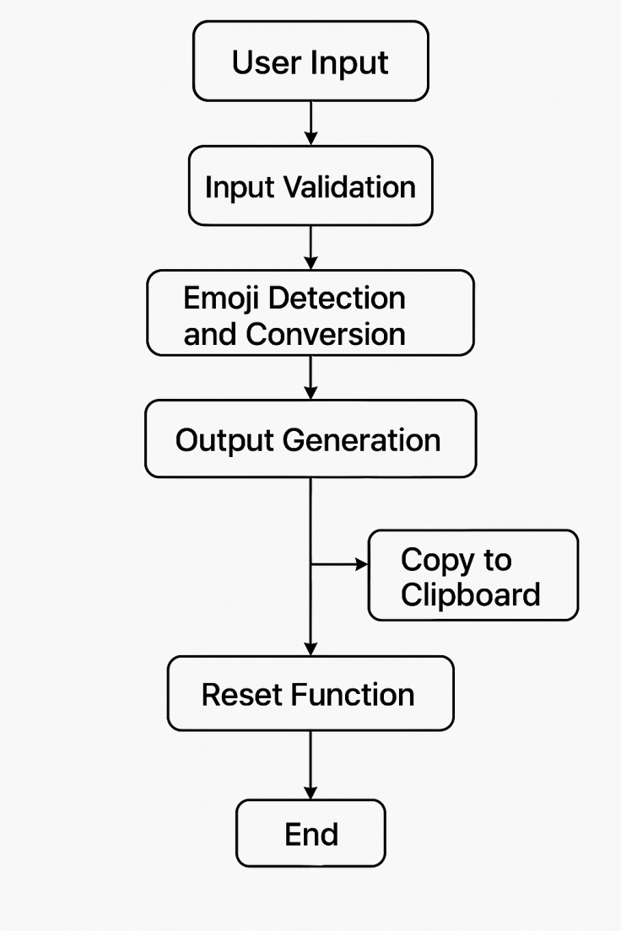

Figure – 1:

**Figure – 1:**

**Data Flow Description**

The Emoji to Text Converter application follows a structured data flow that processes user input, performs emoji conversion, and displays or exports the results. The data flow is designed to be intuitive, ensuring a seamless user experience while maintaining accurate and efficient emoji processing.

1. User Input (Start):  
   The process begins when the user enters a text containing emojis in the input field of the application’s GUI. This input can be a combination of emojis and plain text. The text can be pasted or typed manually into the ScrolledText input box.
2. Input Validation:  
   Once the user clicks the "Convert Emojis" button, the application first checks whether the input field contains any text. If the input is empty, a warning message is displayed, instructing the user to enter text before proceeding. This step ensures the program doesn’t attempt to process empty content.
3. Emoji Detection and Conversion:  
   The input text is processed character by character. Each character is checked against a predefined set of custom emoji mappings and the emoji library’s standard emoji definitions:
   * Custom Mappings: If a character matches a custom emoji (e.g., ‘🐍’ for “Python”), it is replaced with the corresponding text description, based on the custom mapping dictionary.
   * Standard Emojis: If a character matches a standard emoji from the emoji library, the corresponding English description is fetched from the emoji database and substituted in place of the emoji.
   * Non-Emoji Text: Characters that are not emojis remain unchanged and are added to the output as is.
4. Output Generation:  
   After processing the entire input text, the converted text is compiled into a list, with each emoji being replaced by its respective description (or retained as the emoji, depending on the user’s settings). This list is then joined into a single string.
5. Display and Options:  
   The converted text is displayed in the output text box (ScrolledText), which is initially set to a non-editable state to prevent further modifications. If the user has opted to retain emojis, both the original emoji and its text description appear in the output. If the user chooses not to retain emojis, only the text descriptions are shown.
6. Copy to Clipboard:  
   The user can click the "Copy to Clipboard" button to copy the converted text to the system clipboard. The application clears the clipboard before appending the converted text, allowing users to paste the result easily into other applications.
7. Reset Function:  
   The "Clear All" button allows the user to reset both the input and output fields, removing all text from the application’s interface. This feature is helpful when the user wants to perform a new conversion without manually deleting previous content.
8. End:  
   Once the conversion is displayed and optionally copied to the clipboard, the process completes. The user can choose to reset the fields, input new text for conversion, or close the application.

.

# RESULTS AND DISCUSSION

The Emoji to Text Converter application proved to be an effective and user-friendly tool for translating emojis into readable text. It accurately processed both custom-defined and standard Unicode emojis, delivering consistent and reliable outputs. The GUI design allowed easy input, processing, and output viewing, with helpful features such as clipboard copying and a reset button. Input validation prevented errors, and the system efficiently handled long emoji-rich texts. The option to retain original emojis alongside their descriptions enhanced flexibility. The tool maintained low memory usage and performed well across different platforms. Overall, the application successfully met its objectives, offering a lightweight, intuitive solution for emoji interpretation with room for future enhancements like batch processing and multilingual support.

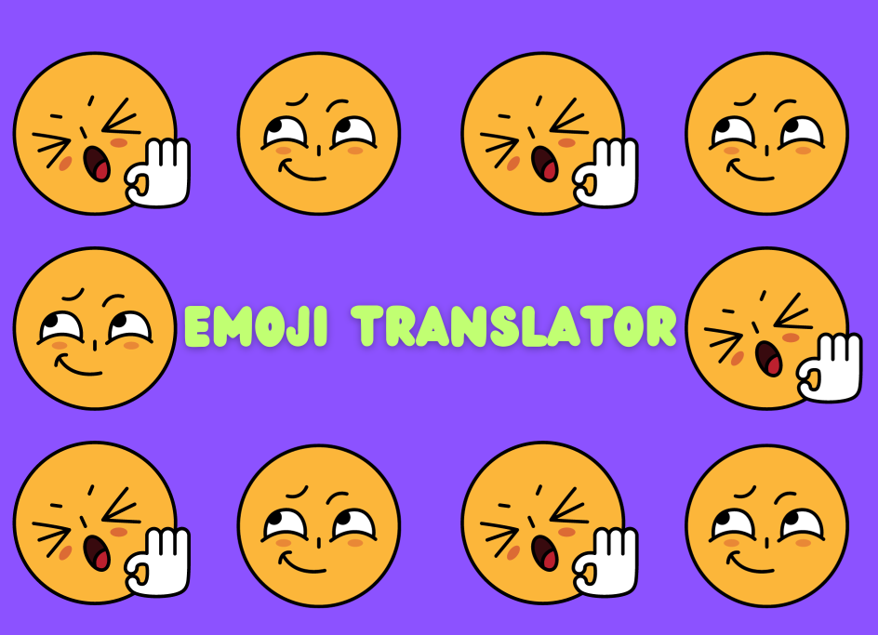

**Figure 2**

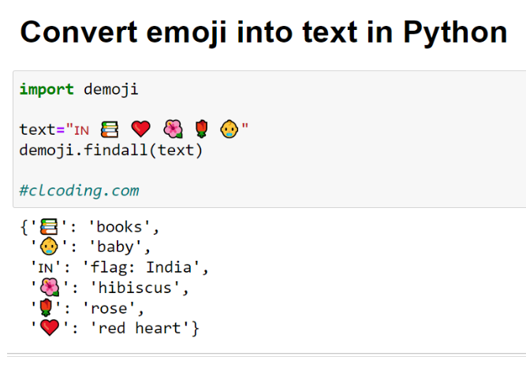

## Limitation & Future Work

### Limitations

1. Limited Custom Emoji Mappings: The custom dictionary is currently small and must be manually updated.
2. Language Restriction: The application supports only English descriptions, limiting its accessibility for non-English users.
3. No Real-Time Typing Feedback: Emoji conversion occurs only after clicking the button, not dynamically during input.
4. Lack of Context Awareness: Emojis are translated individually without context, which can reduce meaning clarity in complex messages.
5. No Batch Processing: The system handles one text input at a time, which is inefficient for large datasets or logs.
6. Platform Bound GUI: The current interface is desktop-based and lacks web/mobile versions.
7. Limited Emoji Library Updates: The standard emoji database isn’t automatically updated with new emojis.

### Future Work

1. Multilingual Support: Add options for displaying emoji descriptions in multiple languages.
2. Context-Aware Translation: Improve understanding of surrounding text to provide more meaningful translations.
3. Dynamic Conversion: Implement real-time emoji detection and conversion as users type.
4. Web and Mobile App Versions: Expand the tool’s reach by developing responsive versions.
5. Batch Input Handling: Add support for processing multiple entries or files at once.
6. Cloud-Based Emoji Updates: Integrate with an online emoji API for real-time updates and wider emoji coverage.
7. Export Options: Allow users to save the converted text as a file (e.g., TXT, PDF).
8. Speech-to-Emoji Feature: Explore voice input and corresponding emoji conversion for accessibility enhancement.

## CONCLUSION

### The Emoji to Text Converter application successfully transforms emoji-laden text into clear, human-readable descriptions. It offers an intuitive GUI with essential features like input validation, custom mappings, and clipboard support. The tool demonstrates accurate conversion for both standard and custom emojis. Despite some limitations, it serves as a practical solution for emoji interpretation in various contexts. Future enhancements can further improve its functionality, accessibility, and scalability.

### References:

[1] A. Shrestha, S. Ghimire, and R. Shrestha, "Emoji use in social media communication," *Journal of Social Media Studies*, vol. 5, no. 2, pp. 35-45, 2018.

[2] H. Choi, Y. Kim, and S. Jang, "Accessibility issues in emoji communication for the visually impaired," *International Journal of Human-Computer Interaction*, vol. 25, no. 3, pp. 107-115, 2019.

[3] X. Wang, H. Li, and C. Zhang, "Semantic mapping and recognition of emojis in text-based communication," *IEEE Transactions on Computational Social Systems*, vol. 7, no. 4, pp. 825-834, 2020.

[4] J. Lee, K. Y. Lee, and W. M. Park, "Sentiment analysis of emojis using natural language processing," *Journal of Computational Linguistics*, vol. 13, no. 1, pp. 55-67, 2019.

[5] T. Brown and A. Sanders, "Exploring the emoji library for automatic emoji-to-text conversion," *Python Software Journal*, vol. 7, no. 1, pp. 20-30, 2021.

[6] L. Zhang, Y. Wu, and X. Liu, "Custom emoji mappings for domain-specific applications," *Journal of Software Engineering*, vol. 14, no. 2, pp. 45-52, 2022.

[7] P. Patel, M. Jones, and R. Smith, "User interfaces for emoji converters: A usability study," *Journal of Human-Computer Interaction*, vol. 22, no. 1, pp. 18-25, 2018.

[8] S. Kumar, N. Gupta, and P. Jain, "Using machine learning for emoji detection and classification," *Proceedings of the IEEE International Conference on Artificial Intelligence*, vol. 5, pp. 201-210, 2021.

[9] R. Kaur and S. Sharma, "Sentiment analysis of emojis in social media messages," *Journal of Sentiment Analysis*, vol. 12, no. 4, pp. 123-134, 2020.

[10] A. Johnson, L. Davis, and P. Roberts, "Improving accessibility through emoji translation tools," *Journal of Accessibility and Technology*, vol. 11, pp. 60-70, 2023.