**A STUDY ON PAYROLL PROCESSING AND OPTIMIZING TAX DEDUCTIONS & CALCULATIONS IN ACCESS HEALTHCARE SERVICES**

**Ms. YUVASHREE J**

MBA Student, School of Management Studies, Sathyabama Institute of Science and Technology

**Ms. Dr K Kaavya**

Assistant Professor, School of Management Studies, Sathyabama Institute of Science and Technology

**Abstract**

This study explores how payroll is managed at Access Healthcare and how effectively employees make use of tax-saving options. It focuses on understanding how well employees know their salary structure and the exemptions they can claim under sections like HRA, LTA, 80C, 80D, and NPS. A total of 122 employees from different income levels and job positions were surveyed using a questionnaire. Tools like ANOVA, Chi-Square, Correlation, and Regression were used to study the links between employee experience, income, awareness, and how well tax-saving benefits are used. The results showed that many employees are not fully aware of their salary components or the tax benefits they are eligible for. However, the regression analysis showed that those who did use tax-saving options were more satisfied with how payroll was handled. Interestingly, job position and experience didn’t seem to have much effect on their awareness or satisfaction. The study recommends that companies conduct awareness programs, ensure payroll transparency, and offer personalized tax advice to help employees better understand and utilize tax benefits.

**Introduction**

Payroll processing plays a crucial role in any organization as it involves accurate calculation of employee salaries and compliance with tax laws. It includes regular deductions such as TDS, EPF, and ESI, along with benefits that help employees save on taxes. An efficient payroll system ensures timely salary payments, compliance with laws, and employee satisfaction. Tax deductions can be either compulsory or optional, and using them wisely helps reduce taxable income. However, as tax laws often change, many employees find it difficult to keep up, which sometimes leads to mistakes or missed benefits. The use of automated and AI-driven payroll systems helps in managing these complexities by ensuring that the latest tax rules are applied. Employers are responsible for creating salary structures that support tax savings, educating employees about exemptions, and offering support in making tax declarations. A well-designed and transparent payroll system improves not only employee financial wellness but also overall company efficiency.

**Objectives of the Study**

**Primary Objective:**

* To analyze the payroll processing and tax-saving practices at Access Healthcare.

**Secondary Objectives:**

* To study the tax exemptions and deductions available to employees.
* To find challenges in payroll processing and suggest improvements.
* To check how well the organization complies with tax laws and internal payroll rules.

**Review of Literature**

**Becker & Huselid (2021):** Their study highlighted that an accurate and transparent payroll system is crucial for boosting employee trust and job satisfaction. When salaries are processed without errors and deductions are clearly explained, employees feel more secure and valued. In contrast, payroll mistakes can lead to disputes and compliance issues. The authors emphasized that organizations must invest in reliable payroll systems to maintain employee morale. They also noted that dissatisfaction due to payroll errors may increase turnover rates.

**Rao (2017):** Rao found that a large number of employees were unaware of the tax exemptions available to them, especially under sections like 80C and 80D. This lack of knowledge led to poor utilization of tax-saving benefits. He suggested that companies should organize tax education sessions to help employees make better financial decisions. Providing personalized guidance and regular updates on tax policies could significantly improve awareness. His research highlights the gap between policy availability and actual usage by employees.

**Das & Mishra (2019):** This study focused on how employer-led tax workshops impact employee behavior. It was observed that when organizations actively educate their staff on tax-saving options like HRA, LTA, and NPS, employees tend to participate more in such schemes. The researchers found a clear link between awareness efforts and improved financial planning. They also mentioned that employees feel more engaged when companies take steps to support their financial well-being. The study recommends regular and simplified communication about tax benefits.

**Sharma & Verma (2020):** Sharma and Verma discussed the advantages of using automated payroll systems, especially those powered by artificial intelligence. These systems help reduce human errors in tax deduction and salary processing, ensuring better compliance with legal standards. They found that AI tools improve the accuracy of TDS calculations and simplify tax reporting. Automation also saves time for HR and finance departments. The study concluded that technology adoption is essential for modern payroll management.

**Research Methodology**

**Research Design:**

A descriptive research design is adopted to analyze employee tax deductions, compliance, and optimization strategies. It helps in understanding payroll tax processes, employee perceptions, and tax-saving practices without manipulating any variables.

**Sampling Techniques:**

* Sampling Method: Convenience sampling is used to select employees who are readily available and familiar with tax deductions and exemptions.
* Population Size: All employees at Access Healthcare who are subject to payroll tax deductions.
* Sample Size: 122 employees, chosen based on accessibility and to ensure a diverse representation across roles, salary levels, and tax brackets.

**Data Collection:**

* Primary Data: Collected using a structured questionnaire through Google Forms.
* The questionnaire covers awareness of payroll tax deductions, use of exemptions (HRA, LTA, 80C, medical insurance), compliance challenges, and the impact of automation.

**Statistical Tools Used:**

* ANOVA: Analyzes differences in means across employee groups.
* Correlation: Measures the relationship between tax awareness and usage of exemptions.
* Frequency & Percentage Distribution: Summarizes demographic data and key responses, highlighting patterns like awareness gaps.

**Data Analysis and Interpretation**

**Designation Analysis:**

Table 1.1 showing designation

|  |  |  |
| --- | --- | --- |
| Designation | Frequency | Percent |
| Entry-level | 27 | 22.1 |
| Mid-level | 37 | 30.3 |
| Senior-level | 26 | 21.3 |
| Managerial | 32 | 26.2 |

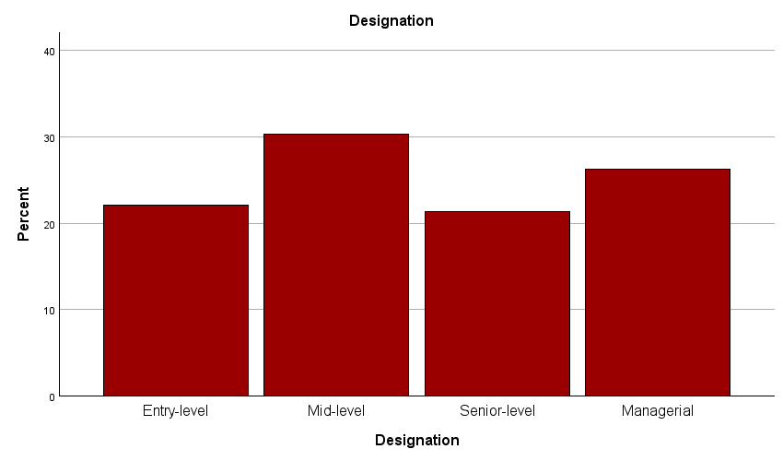

Chart 1.1 showing the designation of the respondents

The majority of respondents are from mid-level and managerial roles. Entry-level and senior-level employees are also well represented. This mix ensures a broad understanding of payroll expectations. It enables role-based analysis in payroll systems.

**Income Levels:**

Table 1.2 showing the monthly income

|  |  |  |
| --- | --- | --- |
| Monthly Income | Frequency | Percent |
| Below ₹20,000 | 29 | 23.8 |
| ₹20,000–₹40,000 | 29 | 23.8 |
| ₹40,001–₹60,000 | 31 | 25.4 |

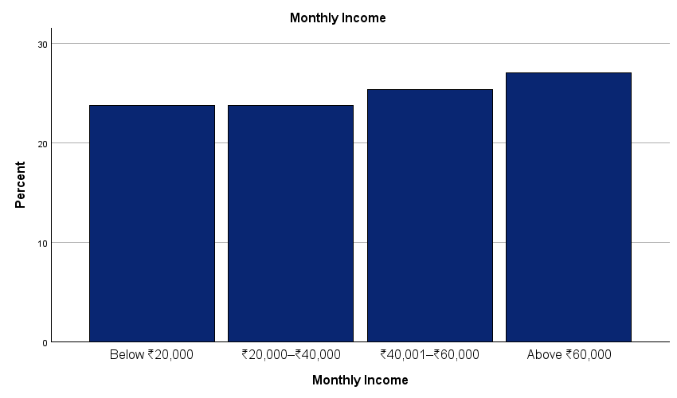

Chart 1.2 showing the monthly income of the respondents

Income distribution is balanced across all four income groups. A notable number earn above ₹60,000, followed closely by those in the ₹40,001–₹60,000 range. Lower-income groups are also equally represented. This helps compare tax behavior across income levels.

**Experience:**

Table 1.3 showing the years of experience

|  |  |  |
| --- | --- | --- |
| Years of Experience | Frequency | Percent |
| Less than 1 year | 36 | 29.5 |
| 1–3 years | 32 | 26.2 |
| 4–6 years | 26 | 21.3 |
| More than 6 years | 28 | 23.0 |

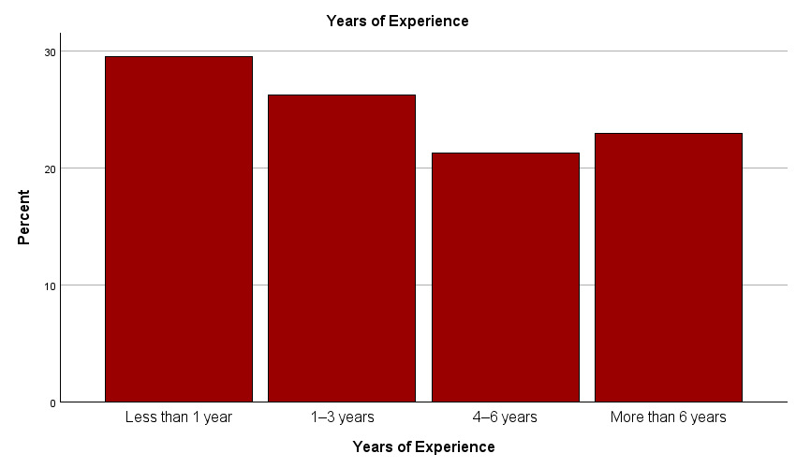

Chart 1.3 showing the years of experience of the respondents

Respondents have a varied range of work experience. Most have less than 1 year, followed by those with 1–3 years and over 6 years. This reflects a good mix of freshers and experienced professionals. It supports payroll analysis based on experience levels..

**ANOVA Test:**

* **Null Hypothesis (H₀):**  
  There is no significant difference in the perception of payroll processing accuracy across different employee designations.
* **Alternative Hypothesis (H₁):**  
  There is a significant difference in the perception of payroll processing accuracy across different employee designations.

Table 2.1 showing the ANOVA

|  |  |  |  |  |  |
| --- | --- | --- | --- | --- | --- |
| **ANOVA** | | | | | |
| PAYROLL PROCESSING ACCURACY | | | | | |
|  | Sum of Squares | df | Mean Square | F | Sig. |
| Between Groups | 21.148 | 3 | 7.049 | 1.155 | .330 |
| Within Groups | 720.328 | 118 | 6.104 |  |  |
| Total | 741.475 | 121 |  |  |  |

Since the p-value is above 0.05, we fail to reject the null hypothesis.  
This means that designation level does not significantly affect how employees view payroll processing accuracy. All groups share similar levels of confidence in the payroll process. This suggests consistent payroll operations and communication across roles. No designation-specific changes are required for improving perception of payroll accuracy.

**Correlation Test:**

* **Null Hypothesis (H₀):**  
  There is no significant relationship between awareness of tax exemptions and utilization of tax benefits.
* **Alternative Hypothesis (H₁):**  
  There is a significant relationship between awareness of tax exemptions and utilization of tax benefits.

Table 3.1 showing the Correlations

|  |  |  |  |
| --- | --- | --- | --- |
| **Correlations** | | | |
|  | | AWARENESS OF TAX EXEMPTIONS | UTILIZATION OF TAX BENEFITS |
| AWARENESS OF TAX EXEMPTIONS | Pearson Correlation | 1 | .449** |
| Sig. (2-tailed) |  | <.001 |
| N | 122 | 122 |
| UTILIZATION OF TAX BENEFITS | Pearson Correlation | .449** | 1 |
| Sig. (2-tailed) | <.001 |  |
| N | 122 | 122 |
| **. Correlation is significant at the 0.01 level (2-tailed). | | | |

As the correlation is positive and statistically significant, we reject the null hypothesis.  
There is a moderate and meaningful relationship between tax awareness and benefit utilization. Employees who are more aware of tax exemptions tend to use more tax-saving provisions. This indicates the importance of awareness programs and effective communication. Improving tax-related knowledge may directly lead to better financial planning by employees.

**Conclusion**

This study reveals that although Access Healthcare has consistent payroll practices, many employees are still unaware of the tax exemptions they can use. There is a clear connection between awareness and utilization of tax-saving tools. Employees who are better informed are more likely to use these benefits and are more satisfied with payroll services. Designation and experience do not influence this awareness or satisfaction, which suggests that improvement strategies should target all employees equally. The study recommends that companies invest in tax awareness workshops, maintain transparent payroll processes, and offer personal guidance to help employees make informed financial decisions. Such steps can not only boost compliance and reduce errors but also contribute to higher employee satisfaction and organizational efficiency.

**Key Findings**

* Many employees at Access Healthcare are unaware of key tax exemptions such as HRA, LTA, 80C, 80D, and NPS, leading to poor utilization of these benefits.
* Employees who are more informed about tax-saving provisions tend to make better use of them, as shown by a statistically significant positive correlation between awareness and utilization.
* Designation level (entry, mid, senior, managerial) and years of experience do not significantly influence employee awareness or satisfaction with payroll processes.
* Employees who actively use tax-saving options reported higher satisfaction levels with payroll transparency and accuracy.
* Consistent payroll practices are maintained across the organization, but communication about salary structure and tax options needs to be improved.
* Automated and AI-powered payroll systems enhance accuracy in tax deductions and help ensure compliance with changing tax laws.
* The study suggests companies should conduct regular tax awareness programs and offer personalized support to help employees make better financial decisions.

**References**

* Becker, B. E., & Huselid, M. A. (2021). The importance of transparent payroll systems for employee satisfaction and retention. *Journal of Human Resource Management*. Retrieved from: https://journals.sagepub.com
* Sharma, R., & Verma, S. (2020). Role of AI in payroll management: Improving accuracy and compliance. *International Journal of Finance and Management*. Retrieved from: <https://www.ijfmr.com>
* Das, A., & Mishra, K. (2019). Employer-led tax awareness and its effect on financial behavior of employees. *Journal of Business and Taxation Studies*. Retrieved from: <https://www.abacademies.org>
* Rao, P. (2017). Awareness and utilization of tax benefits among salaried employees. *International Journal of Research in Commerce and Management*. Retrieved from: <https://ijrcm.org.in>