**WEB BASED INVENTORY MANAGEMENT INFORMATION SYSTEM USING DATA COLLECTION TECHNIQUES**

**VETRISELVAN.M1,YOGAPRIYA.D M.E(Ph.D)2, Dr.M.BALAMURUGAN3**

*1Student, The Kavery Engineering College, M. Kalipatti, Tamil Nadu*

*2,3Assistant Professor, The Kavery Engineering College, M. Kalipatti, Tamil Nadu*

**ABSTRACT**

At Dynamic Inventory, we understand that the biggest challenge for business owners is not being able to full fill orders due to a miscalculation of inventory levels. Our inventory management web app allows efficiently track the exact web app stock and sales level of our products in real time. We offer a powerful, user-friendly inventory control web app designed specifically with small to midsize companies. There we specified admin side panel this will have the ability to track sales and available inventory. Our inventory management solution is cost-effective and solves many common problems that only expensive enterprise-level solutions have solved in the past. Need a state-of-the-art inventory management system for inventory control. Dynamic Inventory allows to efficiently track their inventory, products, purchase orders and sales orders.

**1. SYSTEM ANALYSIS**

**1.1 EXISTING SYSTEM**

In present non-computerized system all jobs are performed manually. All records of Customer, and Customers details are written and stored in paper format in a file. Prop writer maintains separate files for each new information. So managing them is very complex and has become an impossible task to be performed manually systematic way. Preparation of records on yearly basis becomes a tedious and time-consuming job still its authenticity is always debatable and can’t be verified easily. Time required for searching records of particular item is also difficult. Maintaining the records of each and every minute detail of every item is also very difficult. Any manual error can lead to wrong result. This system is unable to provide timely report information.

**1.1.1 LIMITATIONS OF EXISTING SYSTEM**

In present system each and every record is maintained in files, so there will be lot of redundancy in maintaining ‘Customer and Volunteer records. Also there is no security as all records are maintained in files.

Modification of one record causes changes to other records related to that record, so work becomes very critical, there are chances of data loss.

Storage of information is costly.

Require knowledge about the system searching any old record requires more time due to critical system of register, Present system is very time consuming.

A lot of paperwork is maintain.

Difficult in maintaining records, it is difficult to keep through registers for many years or months safely.

There are many chances of mistakes as all the data is handled manually.

**1.2 PROPOSED SYSTEM**

The proposed system is computerized and has been developed using advance language therefore it gives more facilities than present system. It provides quick access to any data. Features of project include aspects such as to make it so easy to use that the user will not dream of switching back to the original System. By user friendly we mean to make records available to the user at just the hit of a key stroke. To maintain records of Customers and Event, to maintain records of Customer, to maintain the transaction details. To add/update/search them from the database-all these features have been considered for the management of the system. Besides maintaining the data in the database the system also has the provision for printing various reports. The system helps reduce the paper work and provide an efficient environment that is user friendly to work in.

1.2.1 BENEFITS OF PROPOSED SYSTEM

Easy to manage all the daily transactions

Can generate required reports easily

Easy to manage historical data in a secure manner

Centralized database helps in avoiding conflicts

Easy to use GUI that does not requires specific training

2. SYSTEM DESIGN

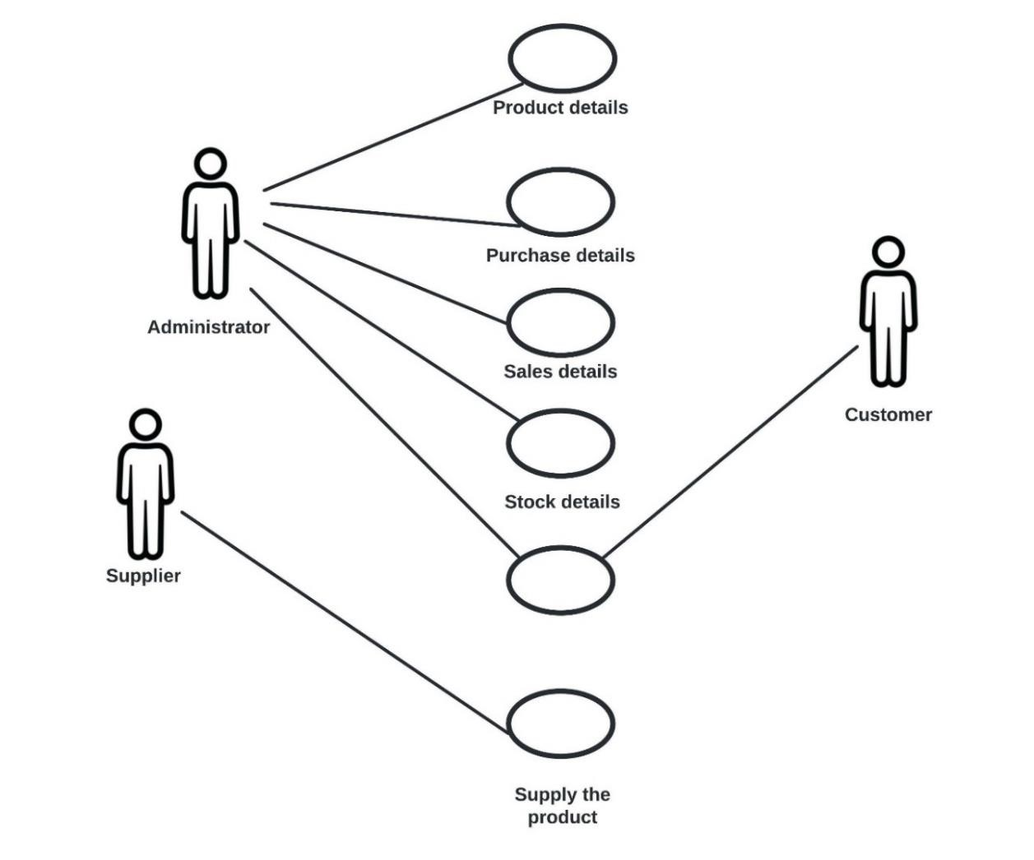

**3. PROJECT DESCRIPTION**

**3.1 MODULE DESIGN**

Inventory management information system using data collection techniquesuse Accounting Modules. These modules automate financial and accounting activities like accounts payable and receivable, procurement and third-party payments, and they categorize revenue.

**3.2 LIST OF MODULES**

User sign up and login module

User validation module

CRUD module

Data storage module

**3.2.1 USER SIGN UP&LOGIN MODULE**

The User sign up and login module help to create and design the perfect user registration forms and sending an email after successful registration using this module.

Here are the key features of the User Registration Form module –

Option to Register only with the Email field

Form Fields – Username, First Name, Last Name, Email, Password, Confirm Password

Submit Button customizations

Input field width option for all form fields

Send Email option after a successful registration • Success / Error message customizations

**3.2.2 USER VALIDATION MODULE**

The Validations module provides an easy out-of-the-box way to verify that the content of a message in your flow matches a given set of criteria. The main advantage this has over using is traceability, as filters all raise identical exceptions, making it hard for you to know where the exception was caused.

**3.2.3 CRUD MODULE**

CRUD technique, an acronym for Create, Read or Report, Update, and Delete technique is used for identifying use cases. Here, the analyst checks the data the needs to be processed by the system, and creates use cases that create, report on, update, and delete the data items.

**3.2.4 DATA STORAGE MODULE**

The Storage module minimize bottlenecks and repeated handlings. Managing of data can be updated directly from your warehouse to avoid repeatedly having to enter data.  **4. USER MANUAL**

**4.1 DASHBOARD**

A dashboard typically indicates items, which require urgent actions at the top of the page, moving into less important statistics at the bottom. Dashboard is a design to show important data in a more enhanced way.

A data dashboard is an information management tool used to track, analyse, and display key performance indicators, metrics, and data points. You can use a dashboard to monitor the overall health of your business, department, or a specific process.

Dashboards are customizable, too. You can build a dashboard that supports the specific needs of your users. If you are a founder or executive, your dashboard could display SaaS metrics.

A dashboard transforms the raw data into something human-readable. Instead of sifting through columns or rows in a spreadsheet, you can analyse your data in a table, line chart, bubble chart, or bar chart, just to name a few options.

Dashboards aggregate data from multiple data sources. A dashboard is not just about saving time, but seeing all of your data together in one place.

**4.2 UPDATES:**

Updating sales information is the most important step in the sales order processing process. It acts as an interface between Sales Order Processing and other modules, such as Inventory. In order to maintain the most accurate sales information, you can update your records in the sales order management system daily.

During sales update, the system overwrites the record with the invoice number and type of product and batch number.

**4.2.1 PRODUCT STOCK ALERT SYSTEM:**

This project is aimed at developing an alert system which notifies shop owners and managers of products/inventory which are about to expire. Faced with the challenges shop owners face with loses and health hazards brought about by expired products, the researcher aimed at developing a product/Inventory Expiration system that manages product expiration in a computerized manner. The Product expiration management system notifies/alerts the store manager on products expiring soon for prompt attention and decision.

**4.2.2 ALL DUE PURCHASES:**

All due purchase is the cost of buying inventory during a period for the purpose of sale in the ordinary course of the business. It is therefore a kind of expense and is hence included in the income statement within the cost of goods sold. Purchases may include buying of raw materials in the case of a manufacturing concern or finished goods in the case of a retail business

As purchase results in increase in the expense and decrease in assets of the entity, expense must be debited while assets must be credited. A purchase also results in increase in inventory, A purchase may be made on Cash or on Credit.

**4.2.3 LATEST UPDATES:**

Update is generally keeping some data or information up to date. Our Inventos will update about product stock, all due purchases and latest updates of our product. This will keep up to date about the product’s unit price, warehouse and so on.

**4.3 USER MANAGEMENT:**

User management software or user management system or staff management system give the ability for administrators to create and manage users or staff in system or software. In user management system admin can create or manage users and authenticate them to access limited section or modules

User management system can handle tasks, information, and granted access of company users. Any business where multiple users must have a user management system. User management system not only establishes a user’s authorization or access, it also serves as a repository of identities and, if done effectively, can be the valuable source of all identities for an organization. User management can help companies ensure that they are maintaining their userbased access, and helps with the transparency of user-based licenses. It allows you to manage permissions at the level of an individual user, and maintain the appropriate balance ofcollaboration and control. User management system is also responsible for access permission levels to each user for different tasks and modules.

**4.3.1 USER LIST:**

User Roles can be thought of as "permission groups" that define the access that certain users have in Asset Essentials. Asset Essentials Enterprise Administrators can add new user roles with varying permissions to the account. However, (CRM) this program provides various default User Roles that fall under categories called User Types. The User Type categories include Administrator, Full User, Request Only, Specialty, and Tracking Only. This User Type can be given access to everything in the account.

**4.4 PRODUCT:**

A Product is the item offered for sale. A product can be a service or an item. It can be physical or in virtual or cyber form. Every product is made at a cost and each is sold at a price. The price that can be charged depends on the market, the quality, the marketing and the segment that is targeted. A product needs to be relevant: the users must have an immediate use for it. A product needs to be functionally able to do what it is supposed to, and do it with a good quality. A product needs to be communicated: Users and potential users must know why they need to use it, what benefits they can derive from it, and what it does difference it does to their lives. Advertising and 'brand building' best do this.

A product needs a name: a name that people remember and relate to. A product with a name becomes a brand. It helps it stand out from the clutter of products and names.

A product should be adaptable: with trends, time and change in segments, the product should lend itself to adaptation to make it more relevant and maintain its revenue stream.

**4.4.1 CATEGORY LIST:**

A product category is a type of product or service. Product categories are typically created by a firm or industry organization to organize products. This can include a hierarchy of categories that resemble a tree structure. Alternatively, product categories can be a flat structure such as a list of product types.

**4.4.2 UNIT LIST:**

The unit sales number on a balance sheet represents the total sales of a product in a given period. This sales information is used to determine the price point that allows for the greatest profit per unit considering the actual cost of production. To stock analysts, unit sales are a valuable measure of a product's contribution to a company's balance sheet.

Unit sales appear on a company's income statement. They are examined over different accounting periods, such as monthly, quarterly, or yearly. Internally, company marketing executives might use this figure to help determine the right price point for a product.

**4.4.3 TAX LIST:**

Sales Tax is a form of tax paid to a governing body for the sale of goods and services. Sales tax is an indirect tax and is generally charged at the point of buy or exchange of certain taxable goods, charged as a percentage of the value of the product. (GST) The sales tax depends on the government in power and the individual policies enforced by it, generally being simple to calculate and collect. In simple terms, the sales tax is an extra amount of money paid while purchasing goods or services.

**4.4.4 PRODUCT LIST:**

Product list populated the Item Proposal with the products from Sales Order History, Product List and Promotions on a custom button click. On saving, the products in Item Proposal are copied to Products in Sales Order by standard functionality.

**4.5 PURCHASE:**

Purchase list will display the details of (PO), the purchases that have been done. This will include the details of supplier of the goods, their total amount and the amount that has been paid and also the due amount. This will also show you the warehouse i.e. from where the products were bought including the shipping cost.

4**.5.1 PURCHASE LIST:**

The purchase order worksheet in this template is linked to a customizable price list. This eliminates the need to manually enter the Item and Unit Price each time you create a new purchase order.

It is just a simple list containing the item description, Item and Unit Price. The Item Description is used to populate the drop-down box in the order form. (OMS) where the descriptions need to be unique because they are used in lookup functions for the Item and Unit Price columns.

**4.6 QUOTATION:**

Quotation list also known as quotes, sales quotes or sales quotations, (ABM) quotations are used to let a potential buyer know how much goods or services will cost before they commit to the purchase.

Our quotation page will display the details of the product’s quotes with its invoice number and name of the product.

**4.6.1 QUOTATION LIST:**

Many businesses, such as hairdressers, use a standardized price list that remains the same for every customer. Other businesses, such as painters and decorators, have to provide tailored prices for the specific products or services a customer wants to buy. This is usually done with an estimate or a quotation. Larger, more complicated projects are often priced on the basis of a detailed tender document drawn up by the customer.

This guide outlines how to present your prices to your customers. It tells you how to create a price list, describes the difference between a quotation and an estimate, details how to prepare quotations and estimates and describes how to price a tender for a contract.

Prepare a price list

The difference between a quotation and an estimate

Prepare a written estimate

Prepare a written quotation

Prepare a price for a tender

Win contracts at the right price

**4.7 SALES LIST:**

Sales list will display you the details of the particular product’s sales. The details of (POS) which will include invoice number, price, quantity and name of the product. The data also contains the name of the customer.

Sales list is reshaping the industry of sales. We're building a global network of Brand Ambassadors that work on a freelance basis. Brand Ambassadors with high ambitions and an interest for sales that feel they would perform much better if they where in charge of their own conditions. We work together with companies that provides innovative online solutions targeting the B2B segment, companies that for different reasons need help with expanding and selling their product.

Today Sales list in a one-man show consisting of me Fabian. My vision is to build a global sales network, empowering people to do what they love and give more people the chance to be at the right place. Sales list give people with high ambitions and an interest for sales the right conditions and tools to succeed. We know that a lot of people feel that they could perform so much better if they only where given the ability to decide their own conditions.

4.8 **EXPENSES:**

An expense is the cost of operations that a company incurs to generate revenue. As the popular saying goes, “it costs money to make money.”

Common expenses include payments to suppliers, employee wages, factory leases, and equipment depreciation. Businesses are allowed to write off tax-deductible expenses on their income tax returns to lower their taxable income and thus their tax liability. However, the Internal Revenue Service (IRS) has strict rules on which expenses businesses are allowed to claim as a deduction.

One of the main goals of company management teams is to maximize profits. This is achieved by boosting revenues while keeping expenses in check. Slashing costs can help companies to make even more money from sales. However, if expenses are cut too much it could also have a detrimental effect. For example, paying less on advertising reduces costs but also lowers the company’s visibility and ability to reach out to potential customers.

**4.9 STOCK TRANSFER:**

The stock and sales report for the companies will be collected from the stockist. The company executives will collect the hard copy of the stock and sales report directly from the stockist. This process will take considerable amount of time for stockist; more over this will also interrupt their daily business.

**4.9.1 STOCK LIST:**

A Stock list template helps one to catalogue the items and maintain the inventory details. They are extremely useful for any type of industry. They are very easy to maintain and help in knowing the items that are available and give an idea about items to be procured. They also help to crosscheck the physical inventory of various items and maintain the price of the items. They can also be considered as price list template.

**4.9.2 STOCK TRANSFER LIST:**

Stock transfer, contains stock list and stock transfer list as subpages. Stock list, a list of the stock issues admitted to dealings on an exchange. This also include the details such as invoice, price, quantity and some other basic data required. Stock Transfer is the act of moving goods from one part of the distribution chain to another. Stock transfer list, will shows you the details of this such as invoices, price etc.

People usually invest in stocks on various companies and corporate houses with a view of making a profit and to increase their wealth. While selling the stocks, they are required to fill in a form and sign it to transfer the ownership to the buyer. It is for this purpose that a Transfer Forms is used. The seller needs to fill in the details of the stock. The form also contains the clauses that guard this transaction.

**4.10 STOCK ADJUSTMENT:**

Stock Adjustment helps you decrease the goods you hold in stock; you can enter manual stock adjustments. It is generally used to write-off damaged stock, or to adjust quantities after a stock take. This page has a subpage named as return product list, which will shows you the details of the return products.

Stock Adjustment helps you decrease the goods you hold in stock; you can enter manual stock adjustments. (DSD) It is generally used to write-off damaged stock, or to adjust quantities after a stock take. The quantities entered for each product will be deducted from the available quantities.

Also, Stock Adjustment is used in Profit & Loss Report (P & L Report). “Total Stock Adjustment” amount is deducted from (P & L Report) and “Total Stock Recovered” amount is added to Profit & Loss Report.

**4.10.1 RETURN PRODUCT LIST:**

Return product list, which contains what are the products has returned yet, and this which have the specific page to show current and future returns.

**4.11 REPORT:**

Report page is a page where you can give a written account of something that one has observed, heard, done, or investigated. This page will let you to give a report about the product by filling the basic details of that product. This will also allow you to write a message about the product.

There are many ways to inform everyone about a specific thing, but the best way out there is by creating a report. A report has been known to effectively communicate the information, data, and research without the need of having extensive materials or resources. A simple feasibility report can completely convey a message.

**4.12 SETTINGS:**

You can customize certain aspects of your account, Now that you are on your Settings Page, you will be able to set your default settings for your account. Keep in mind when making changes, "Save" button to save your changes. We can edit the registered admin details totally and individually. Once the detail is edited and updated, it will update the new credentials in the database When you login the updated credentials it will welcomes you the dashboard page.

**4.13 RESULT:**

Performing all the operations is important, but those data and the data that have been modified after performing the specific operations is more important. Django is specially designed with its own database named as SQLite 3. The data will get stored in this database. Let us have a look on this with a snap shot of how this data gets stored .

**CONCLUSION**

Evolving web based inventory management system have created a need for digital data storage and quick result. It would be the secure web based application and which is provenance mechanisms. In this we have a created a web application for inventory management to avoid manual works records. Our intention is to digitalize the manual records to get to know about Sales, purchase, stock, live current status via web application. Which came to existence to become more effective helpful one. Unlike the as usual user interface where we used advanced UI technologies to show up more attractive. whether we were not sure about the data security. Anyway we chose good secure data storage web framework called as Django. Which is well to go with. I hope it will help to the many organizations to fulfil their needs.

**REFERENCES**

1. Pikulkaew Tangtisanon ,” Web Service Based Food Additive Inventory

Management with Forecasting System“. 3rd International Conference on Computer and Communication Systems.. 2018

2. Lingyun Wei. “Inventory Management in E-commerce Supply Chain with Lateral Transshipment and Quick Response”. 5th International Conference on Industrial Engineering and Applications, 2018

3. Wanthanee Prachuabsupakij, “ABC Classification in Spare Parts for

Inventory Management using Ensemble Techniques, 2018

4. Elvi Fetrina, “inventory management information system development”,

Department of Information System, Faculty of Science And Technology,2019

5. Fitra Lestari, Ulfah, “Inventory Management Information System in

Blood Transfusion Unit”, Department of Industrial Engineering, Universitas Islam Negeri Sultan Syarif Kasim Riau,2019