*IoT and AI-Based Plant Monitoring System for Optimized*

*Agricultural Management*

|  |  |  |
| --- | --- | --- |
|  |  |  |
| Prof. Mr. Deepak A. Kapgate dakapgate@gmail.com  Project Guide *Department of Electronics &*  *Communication Engineering*  *Priyadarshini College of Engineering , Nagpur* , *India*    Mr. Yash Jumale  Yashjumale32@gmail.com  Student  *Department of Electronics &*  *Communication Engineering*  *Priyadarshini College of Engineering , Nagpur* , *India* | Mr. Asmit Karode ashmitkarode2305@gmail.com  Student  *Department of Electronics &*  *Communication Engineering*  *Priyadarshini College of Engineering ,*  *Nagpur , India*    Mr. Samyak Sukhdeve  Samyaksukhdeve84@gmail.com  Student  *Department of Electronics &*  *Communication Engineering*  *Priyadarshini College of Engineering ,*  *Nagpur* , *India* | Mr. Samir Patil syampatil2002@gmail.com Student  *Department of Electronics &*  *Communication Engineering*  *Priyadarshini College of Engineering , Nagpur* , *India*          *,* |

***Abstract*— As we can see, only a select few gadgets, such as PCs and smartphones, are internet-connected in the modern error world. Internet of Things (IoT) and the internet have completely taken over today's world. All humans utilize the internet to fulfil basic needs. The network of actual items is known as the Internet of Things (IOT). It simply refers to the act of keeping an eye on a machine or physical object. It can also refer to the interconnection of physical objects that have been embedded with electronics, sensors, software, and network connectivity to enable them to provide better value and services by exchanging data with their creators. This project is envisioned as an IOT-based plant monitoring system. We employed a variety of modules in this project, including IOT, temperature, moisture, and humidity sensors.**

***Keywords—IOT, Humidity, Moisture, Monitoring, Temperature etc.***

I. INTRODUCTION

In order to preserve the ecological cycle and preserve the food chain's pyramid, plants are crucial. Every area of the human lifestyle has been altered and improved by the lightning-fast development of technology, especially the agriculture sector. Many these days like to continue using the internet while engaging in daily tasks like cooking, watching television, etc. The Internet of Things (IoT) and artificial intelligence are the main game-changers in the agriculture industry, though there are hundreds of other helpful technologies as well.

People suffer from hunger in developing nations like Asia and south-east Asia due to a lack of food. However, solely a lack of food supplies caused the deaths of close to 10 million people. Farmers still favour traditional technology over cutting-edge tools, which has resulted in a decrease in

|  |
| --- |
| XXX-X-XXXX-XXXX-X/XX/$XX.00 ©20XX IEEE |

food production. Some people wanted to cultivate in their gardens to supply the needs for regular meals. The identified problem can be resolved with the aid of IoT and AI technology.

Setting up cross-device connectivity over the internet is the idea underlying IoT technology. It is a sizable network that links people and various connected objects in order to gather

*Nagpur , India*

and share data. The sensors that are incorporated into connected devices are linked to IoT platforms, allowing access to the devices' data and application of various analytics to produce and show useful information from the data. An IoT-based solution for the plant monitoring system was suggested by the IoT and AI-based system. Temperature, humidity, and light intensity are the variables employed in this study. Moreover, data kept on a cloud server can be accessed via a smartphone. IoT-based solutions to categorise plant illnesses and track current conditions like air quality, soil moisture, pH, and temperature. The AI model is used to categorise the shape, texture, and colour aspects.

II. PROBLEM FORMULATION

The majority of people rely on agriculture, which is the backbone of our nation. Water scarcity is the fundamental problem in agriculture. Water is squandered because the resource is not utilised effectively. The irrigation process can be mechanised to get around this. Water waste will be decreased because to the application of the Internet of Things in this area. Sensors are used to measure the temperature, humidity, and light, and based on the results, additional processing can be done. We suggest a system that will use various sensors to record all the information about the soil and temperature. Using network infrastructure, IOT enables remote sensing or control of items. As a result, accuracy, financial gains, and efficiency increase while human intervention decreases. We will discuss the fundamental ideas of IOT as well as its potential in the future in this essay. This essay examines the use of IOT in daily life for various applications and provides a summary of IOT.

# III. OBJECTIVE

The main objective of this project was to design a small scale IOT based plant monitoring system with smart irrigation system using Solar Energy.

* All function work with AI based technology using IOT.
* Stored data in cloud server.
* It will well-organized way in order to prevent excess water loss and minimize the cost of labour.
* Use of solar energy and main power supply for unerupted power sources.
* Wireless camera will monitor the crops and also protect from theft.

# IV. LITERATURE SURVEY

In India, 35% of the land was effectively irrigated. And the monsoon provides water to about two thirds of the area. The use of irrigation increases agricultural output, decreases reliance on the monsoon, increases food security, and creates more employment opportunities in rural regions. Farmers are having issues with their irrigation system, namely how much water has to be supplied and when. Crop damage and water waste can occasionally result from overwatering. So, we must keep an approximate water level in the soil to prevent such harm.

***C. Verdouw et. al. 2019,*** In this study, plant roots are equipped with humidity, wetness, and temperature sensors. A gateway unit (ESP8266) manages sensor data and transmits it to an Android application. This application was created to estimate the values of temperature, humidity, and moisture sensors that were programmed into a microcontroller to regulate the amount of water.

1. ***A. Zamora-Izquierdo,*** ***et. al. 2019,*** A review article According to an IoT-based plant monitoring system[2], 35% of the land in India has reliable irrigation. Moreover, the monsoon provides water to around two thirds of the land. The use of irrigation increases agricultural output, decreases reliance on the monsoon, increases food security, and creates more employment opportunities in rural regions. Farmers are having issues with their irrigation system, namely how much water has to be supplied and when. Crop damage and water waste can occasionally result from overwatering. So, we must keep an approximate water level in the soil to prevent such harm.
2. ***Ahmed,*** ***et. al. 2018,*** A review article Prototyping is the initial phase in creating an Internet of Things (IoT) product, according to Internet of Things and Node MCU[3]. User interface, hardware devices such as sensors, actuators, and CPUs, backend software, and connection make up an IoT prototype. Prototyping is done using an IoT microcontroller unit (MCU) or development board. Low-power CPUs used in IoT microcontroller units (MCUs) or development boards allow for numerous programming environments, the firmware-based collection of data from sensors, and the transmission of raw or processed data to a local or cloud-based server. NodeMCU is a firmware for the ESP8266 wifi chip that is open source and based on the LUA programming language.

***Bhuvan Puri, et. al. 2020,*** Because they absorb carbon dioxide and release oxygen into the atmosphere, plants serve a crucial role in maintaining a healthy ecosystem. Nonetheless, it is necessary to give the needed monitoring and to preserve the right plant growth and health. An artificial intelligence (AI) and internet of things (IoT) based solution is suggested to monitor the plant's growth and health in order to allay these worries. This study shows how environmental sensors like the DHT 11 and soil moisture sensors can monitor plants in real-time. The machine learning models were used to real-time variables saved on a cloud server to forecast the growth of the plant.

The system's output is examined using statistical measures such the RMSE and MAE.

***Prathamesh Pawar , et. al. 2022,*** This essay examines the use of IOT in daily life for various applications and provides a quick primer on the technology. IOT makes a substantial contribution to cutting-edge farming techniques. So, we are attempting to show IOT with an automatic watering system. The approximate moisture level of the soil is monitored and maintained using an automatic watering system. The control unit is implemented using an Arduino UNO as a microcontroller. The system makes use of sensors to measure the approximate temperature, moisture content, and humidity of the soil: temperature, moisture, and humidity. This value enables the system to use the proper amount of water, preventing excessive or insufficient irrigation.

We have examined numerous earlier studies conducted in this area by various researchers. Using technology in agriculture is crucial for both improving output and minimising labour requirements.

# V. CONCEPT AND METHODOLOGY

## A. Block Diagram

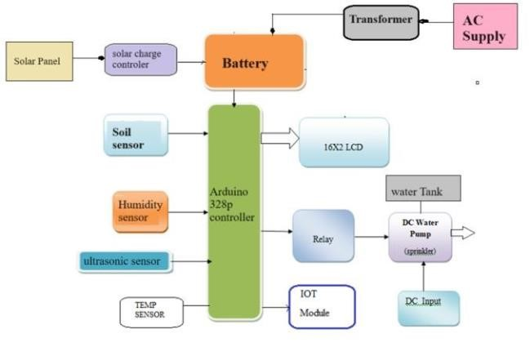

Fig.1. Block Diagram of system

## B. Working of system

• **Sensors:** In this study, three environmental parameters, including ambient temperature, humidity, and soil moisture, are monitored using two different types of sensors. Following is a discussion of the sensors:

1. **DHT11:** The DHT11 is a sensor that measures both humidity and temperature. The sensor has a specialised negative temperature coefficient for sensing temperature. This sensor has been factory pre-calibrated and is prepared to connect to any processing device. It is sufficient to measure the humidity and temperature in the ranges of 0% to 500°C and 20% to 90%, respectively.
2. **Soil Moisture Sensor:** To gauge the amount of moisture in the soil, soil moisture is utilised. This sensor has two metallic pads that serve as both a

variable resistor and a sensor probe. A portion of the water is carried by these two lengthy pads inside the soil. The amount of water affects the conductivity between the pads, the amount of resistance, and the voltage that leaves the sensor.

1. **Processing Unit**: Any type of IoT system's main component is the processing unit. It is used to gather data from the sensors, transform it into usable form, and then assist in transferring it to the cloud or other devices via Bluetooth or Wi-Fi. The primary processing component in this project is the ESP32, which aids in capturing sensor data before processing and sending it to Thingspeak cloud.
2. **IoT Cloud Server**: An open source IoT platform called Server offers an API that allows users to send, save, and retrieve data via the protocol. The multi sensor data logging, supplying GPS coordinates, and social network of objects are the major services offered by the server platform.
3. **Artificial Intelligence Models**: There are AI models used in this project.

**Evaluation Parameters**: In this project, performance evaluation of the models is performed using statistical methods.

VI. COMPONENTS REQUIREMENT

## • Arduino Uno (12v)

The Arduino Uno is an open-source microcontroller board based on the Microchip ATmega328P microcontroller and developed by Arduino.cc. The board is equipped with sets of digital and analog input/output (I/O) pins that may be interfaced to various expansion boards (shields) and other circuits.

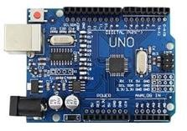

## • Solar Panel (10w)

Used for power generation form solar energy. Which is further stored in 12 V battery.

Solar Panel ( 10 W ) Power.

Solar Panel are devices which collect the light and convert it into electricity. The cells are wired in series, sealed between sheets of glass or plastic, and supported inside a metal frame. These frames are called solar modules or panels.

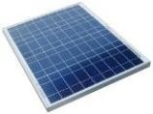

• ***Liquid Crystal Display (5v)*** LCD stands for Liquid Crystal Display. LCD is finding wide spread use replacing LEDs (seven segment LEDs or other multi segment LEDs) The ability to display numbers, characters and graphics. This is in contrast to LEDs, which are limited to numbers and a few characters.

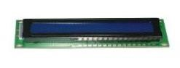

## • Solar MPPT charge controller (12v DC)

To get the most out of your solar panels, need a charge controller to charge your batteries efficiently. The most efficient type of charge controller is the maximum power point tracking or MPPT charge controller. Maximum Power Point Tracking is electronic tracking - usually digital. The charge controller looks at the output of the panels and compares it to the battery voltage. It then figures out what is the best power that the panel can put out to charge the battery.

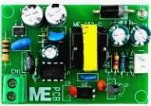

## • Moisture sensor

The sensor was constructed using two cylindrical galvanized metal probes. The probes were slotted firmly into a block of varnished with a spacing of four centimetres between them in the block. An insulated conducting wire was attached to each probe.

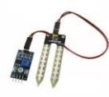

• ***Temperature and Humidity sensor***  **Thermo-hygrometer** is a device that gives you a measurement of the temperature and humidity of a place with one device. They prove to be very important in fields where temperature and humidity play an important role.

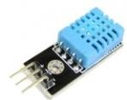

## • Ultrasonic Sensor

An ultrasonic sensor is an instrument that measures the distance to an object using ultrasonic sound waves. An ultrasonic sensor uses a transducer to send and receive ultrasonic pulses that relay back information about an object's proximity. Ultrasonic sensors emit short, highfrequency sound pulses at regular intervals. These propagate in the air at the velocity of sound.

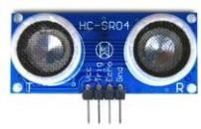

## • IOT Module (5V)

The Internet of Things (“IoT”) refers to the ability of everyday objects to connect to the Internet and to send and receive data. The ESP8266 WiFi Module is a self-contained SOC with integrated TCP/IP protocol stack that can give any microcontroller access to your WiFi network.

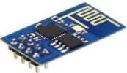

## • Relay Board (12v)

A relay is usually an electromechanical device that is actuated by an electrical current. The current flowing in one circuit causes the opening or closing of another circuit. Relays are like remote control switches and are used in many applications because of their relative simplicity, long life, and proven high reliability.

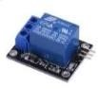

## • 12 v Battery

12 V , 2 Amp Battery is high power battery easily handle all the function.

Main things are to collect electrical energy from solar panel and provide to various components For running specific function.

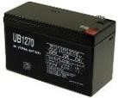

# VII. CIRCUIT DIAGRAM

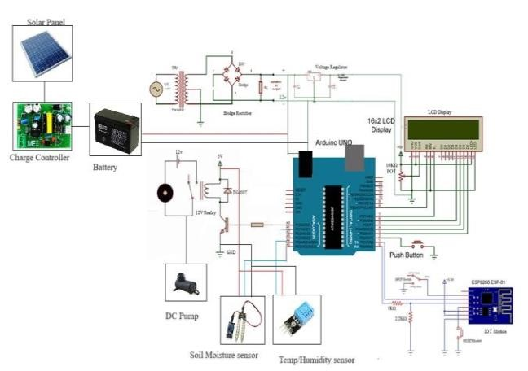

## Fig.2. Circuit Diagram

VIII. RESULTS & DISCUSSION

We can automate many different home appliances by establishing communication between them using the Internet of Things. Routine domestic duties can be automated to save time and to better organize a person's lifestyle. The goal of this project was to design a sensor-based circuit that makes use of the Internet of Things concept, monitors and analyses the data produced by the sensors, and alerts the user to changes in the conditions of the plant. This inexpensive plant monitoring device is mostly used for domestic use. Also, it is kind of an intriguing idea because the plant may request water and protection anytime it requires them. Results from the experiment are discussed in this section. The built module to collect data from sensors, process it, and register every value at a server cloud is shown in Figure 3.

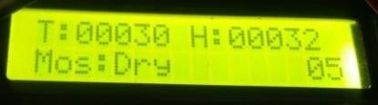

Fig. 3. Sensor Values shown on LCD display

Figure 4 shows the information entered into the server cloud. Three separate variables, including atmospheric temperature, humidity, and soil moisture, are used in this investigation. Figure 6 shows the deployed module in a realtime setting to gather data for additional analysis.

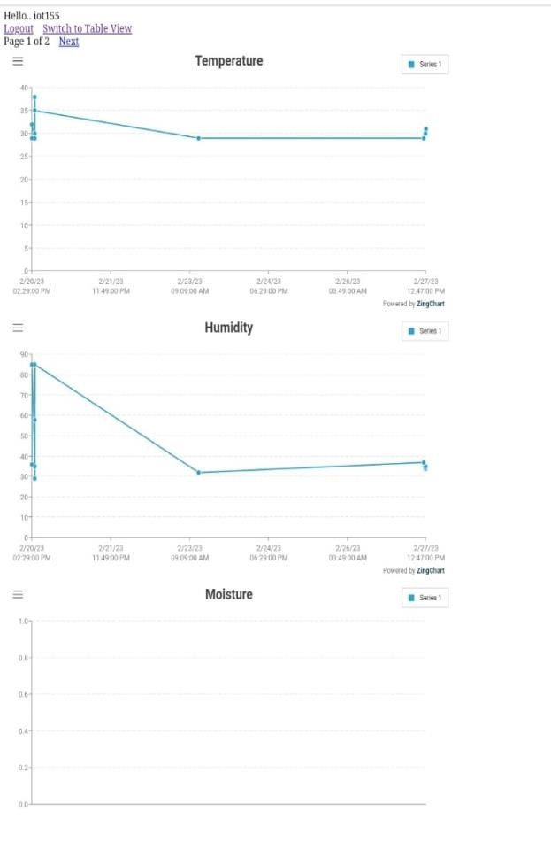

Fig.4. Collected Data at server cloud from different sensors.

Data is taken from the cloud of servers. putting preprocessing techniques to use to get rid of any useless or empty values. The dataset will be ready for dividing into train and test sets in the following step. The prepared dataset is subjected to two distinct modelling techniques, including ANN and SVM. The dataset, which is divided into an 80:20 train: test set ratio, is based on timeseries that include variables for air temperature, humidity, and soil moisture.

The RMSE and MAE values for the ANN and SVM, respectively, are 27.2188 and 42.1498 and 31.9681 and 34.9675 correspondingly.

A system to track temperature, humidity, and soil moisture levels was developed, and this project offers a chance to examine the current systems, their benefits and shortcomings. One of the activities that uses the most water is agriculture. One of the most time-efficient farming chores, irrigation can be automated by using the proposed system to switch depending on the health of the plants, or sensor values. This helps to avoid crop damage by preventing overwatering or underwatering of the soil. Via Front End Structure, the farm owner can keep an eye on the procedure online. By doing this task, it will be possible to save water and motor power for later use by reducing their waste. By this experiment, it can be inferred that the usage of IOT and automation may significantly advance farming.

# IX. ADVANTAGES

* The system is inexpensive in terms of hardware components and power consumption.
* The system helps in saving of water and electricity. It can be applied in large agricultural areas.
* The system helps the labour problem when there are no workers to work with and eliminate manpower. • The system can be switched to manual mode if required.
* It is convenient to all climatic conditions and all sorts of irrigation.
* Monitoring the levels of water source from remote places.

## X. APPLICATIONS

Irrigation can be completed on farms, orchards, farms etc. It is effective for a variety of crops. This application is useful for monitoring the patient. Software applications developed for this system can be used for domestic tasks such as tank storage. The system is operated automatically and manually • IoT Irrigation Control.

* Soil Nutrient Analysis.
* Smart Greenhouses.
* Precision Farming.
* Data Analytics.

## XI. CONCLUSION

A system to track temperature, humidity, and soil moisture level was developed, and this project offers a chance to examine the current systems, their benefits and shortcomings. One of the activities that uses the most water is agriculture. The suggested system can be used to automate irrigation by turning the motor on or off based on the health of the plants, or sensor values. Which is one of the farming operations that uses the least amount of time and prevents soil from being over or underirrigated, preventing crop damage. Via an android app, the farm owner may keep an eye on the procedure online.

Notwithstanding this project's limitations, it can be said that automation and the Internet of Things can significantly advance farming.

Plants are vital to our way of life because they support our ecological way of life. For them to live a healthy existence, it is essential to maintain their appropriate growth and a enough supply of water. In this study, an intelligent plant monitoring system that uses IoT and AI technology is created. Real-time measurements of three crucial factors, including the temperature, humidity, and wetness of the soil, are uploaded to a cloud server for additional analysis. In this work, two alternative machine learning models—ANN and SVM—were used. Two statistical measures, such as RMSE and MAE, are used to analyze machine learning models.

# REFERENCES

1. Bhuvan Puri, IoT and AI-based Plant Monitoring System, Vol. 04, No. 3 ,(2020), (135-142 ), International Journal of Machine Learning and Networked Collaborative Engineering, D.A.V. Institute of Engineering and Technology, Jalandhar, Punjab
2. Dr. Senthil Kumar M, Sneha K, Chidhambararajan B, RajaKumar M , IoT and AI-based Plant Monitoring

System, , Gorteria Journal, 2020, Pp: 185-190

1. Dr. Hetal Patel, Dr. Shailesh Khant, Dr. Atul Patel, Artificial Intelligence and IoT based Smart Irrigation system for Precision Farming, CHARUSAT, Changa, India Vol.12

No.10 (2021), 4462-4467

1. Athawale, S. V., Solanki, M., Sapkal, A., Gawande, A., & Chaudhari, S. (2020). An IoT-Based Smart Plant Monitoring System. In Smart Computing Paradigms: New

Progresses and Challenges (pp. 303-310). Springer,

Singapore.

1. Singh, R., Srivastava, S., & Mishra, R. (2020, February). AI and IoT Based Monitoring System for Increasing the Yield in Crop Production. In 2020 International Conference on Electrical and Electronics Engineering (ICE3) (pp. 301305).IEEE.
2. Kohli, A., Kohli, R., Singh, B., & Singh, J. (2020). Smart plant monitoring system using IoT technology. In Handbook of Research on the Internet of Things Applications in Robotics and Automation (pp. 318366). IGI Global.
3. Bin Sadli, M. D. D. (2019, April). An IoT-based Smart Garden with Weather Station System. In 2019 IEEE 9th

Symposium on Computer Applications & Industrial Electronics (ISCAIE) (pp. 38-43). IEEE.

1. Puri, V., Chandramouli, M., Van Le, C., & Hoa, T. H. (2020, March). Internet of Things and Fuzzy logic based hybrid approach for the Prediction of Smart Farming System. In 2020 International Conference on Computer Science, Engineering and Applications (ICCSEA) (pp. 1-5).

IEEE.

1. Siddagangaiah, S. (2016). A novel approach to IoTbased plant health monitoring system. Int. Res. J. Eng. Technol, 3(11), 880-886.
2. Tangworakitthaworn, P., Tengchaisri, V.,

Rungsuptaweekoon, K., & Samakit, T. (2018, July). A game-based learning system for plant monitoring based on IoT technology. In 2018 15th International Joint Conference on Computer Science and Software Engineering (JCSSE) (pp. 1-5). IEEE.

1. Ezhilazhahi, A. M., & Bhuvaneswari, P. T. V. (2017, May). IoT enabled plant soil moisture monitoring using wireless sensor networks. In 2017 Third International Conference on Sensing, Signal Processing and Security (ICSSS) (pp. 345-349). IEEE.
2. Pavel, M. I., Kamruzzaman, S. M., Hasan, S. S., & Sabuj, S. R. (2019, February). An IoT based plant health monitoring system implementing image processing. In 2019 IEEE 4th International Conference on Computer and Communication Systems (ICCCS) (pp. 299-303). IEEE.
3. Athawale, S. V., Solanki, M., Sapkal, A., Gawande, A., & Chaudhari, S. (2020). An IoT-Based Smart Plant Monitoring System. In Smart Computing Paradigms: New

Progresses and Challenges (pp. 303-310). Springer,

Singapore.

1. Singh, R., Srivastava, S., & Mishra, R. (2020,

February). AI and IoT Based Monitoring System for

Increasing the Yield in Crop Production. In 2020 International Conference on Electrical and Electronics Engineering (ICE3) (pp. 301-305). IEEE. [15] Ragavi, B., Pavithra, L., Sandhiyadevi, P., Mohanapriya, G. K., & Harikirubha, S. (2020, March). Smart Agriculture with AI Sensor by Using Agrobot. In 2020 Fourth International Conference on

Computing Methodologies and Communication (ICCMC)

(pp. 1-4). IEEE.

1. Bhanu, K. N., Jasmine, H. J., & Mahadevaswamy, H. S. (2020, June). Machine learning Implementation in

IoT based Intelligent System for Agriculture. In 2020 International Conference for Emerging Technology (INCET) (pp. 1-5). IEEE.

1. Walczak, S. (2019). Artificial neural networks. In Advanced Methodologies and Technologies in Artificial Intelligence, Computer Simulation, and Human-Computer Interaction (pp. 40-53). IGI Global.
2. Quek, S. G., Selvachandran, G., Munir, M., Mahmood, T., Ullah, K., Son, L. H., ... & Priyadarshini, I. (2019). Multi-attribute multi-perception decision-making based on generalized T-spherical fuzzy weighted aggregation operators on neutrosophic sets.

Mathematics, 7(9), 780.

1. Gholami, R., & Fakhari, N. (2017). Support vector machine: principles, parameters, and applications. In Handbook of Neural Computation (pp. 515-535). Academic

Press.

1. Martínez-Ramón, M., & Christodoulou, C. (2005). Support vector machines for antenna array processing and electromagnetics. Synthesis Lectures on Computational Electromagnetics, 1(1), 1-120.
2. Kecman, V., & Wang, L. (2005). Support vector machines: theory and applications.
3. Tuan, T. A., Long, H. V., Kumar, R., Priyadarshini, I., & Son, N. T. K. (2019). Performance evaluation of Botnet

DDoS attack detection using machine learning.

Evolutionary Intelligence, 1-12.

1. Gay, W. (2018). DHT11 sensor. In Advanced

Raspberry Pi (pp. 399-418). Apress, Berkeley, CA. [24] Singh, P., & Saikia, S. (2016, December). Arduinobased smart irrigation using water flow sensor, soil moisture sensor, temperature sensor and ESP8266 WiFi module. In 2016 IEEE Region 10 Humanitarian Technology

Conference (R10-HTC) (pp. 1-4). IEEE.

[25] Maureira, M. A. G., Oldenhof, D., & Teernstra, L. (2011). ThingSpeak–an API and Web Service for the Internet of Things. World Wide Web.