Urban-Glo (Client Management, Service Tracking, Appointment Scheduling)

***Yash Amit Jadhav1,*** *Zeal Polytechnic, Pune, India.*

***Malhar Rahul Sonawane2,*** *Zeal Polytechnic, Pune, India.*

***Om Vinayak Yenpure3,*** *Zeal Polytechnic, Pune, India.*

***Atharva Sanjay Yadav4,*** *Zeal Polytechnic, Pune, India.*

***Prof. Laxman Lande5,*** *Zeal Polytechnic, Pune, India.*

***Abstract:*** *Urban-Glo was built as an Android salon management that helps day-to-day operations at beauty and wellness centers easier. Urban-Glo simplifies key practices such as scheduling appointments, tracking appointments, attendance management, client management, service tracking, and stock management. Urban-Glo also automates repetitive administration duties to decrease manual labor and improve operational efficiency.*

*The app features timely updates, role-based access for administrators and staff, automated reminders, and performance analytics to make salon operations smooth. The clients are able to schedule their appointments, select their stylist and receive reminders, while employees can schedule their shifts, see assigned tasks and track attendance. The managers in the salon will have an integrated dashboard providing access to daily operations, performance monitoring, approve requests and optimize your resource utilization.*

*Urban-Glo offers a cloud-based secure data storage, a user-friendly interface, and seamless integration with a payment gateway and CRM tool. While handles communication between employees and customers, ensures better resource allocation, and increases productivity, Urban-Glo will facilitate today's salons to provide a better customer service whilst optimizing internal processes.*

# INTRODUCTION:

Urban-Glo is a potent salon management solution that is intuitive and user-friendly in automating client services and employee activities. It provides a single point of access to manage appointments, track services, track staff attendance, leave applications, as well as easily assign daily tasks. Urban-Glo best serves salons looking to optimize customer experience, find better coordination among staff, and ultimately improve productivity.

Urban-Glo streamlines administrative work through real-time tracking and intelligent automation. With an intuitive user interface, salon managers and staff can easily monitor operational procedures, which reduces the number of manual processes and expressions of human error. Urban-Glo is fully scalable for small salons and large multi-location chains, resulting in a systematic and productive working environment while maintaining seamless client interaction. The software provides valuable transparency and efficiency that permits greater insights on employee performance, service history, appointment scheduling, and client preferences. With customized reporting and analytics capabilities, salons can make evidence-based decisions on enhancing services and business growth. By automating low-value work, Urban-GLo provides salons with the means to focus on a quality service experience for clients. customer experience and keeping a well-managed and motivated crew.

# 2.OBJECTIVE:

# Effective Staff Management:

# Have a centralized system to handle staff profiles, roles (e.g., stylists, receptionists, assistants), and service assignments efficiently.

# Real-time Attendance Tracking:

# Track salon staff attendance accurately with real-time updates to minimize manual errors and hold staff accountable.

# Service Task Scheduling and Monitoring:

# Schedule and assign client services to personnel with monitoring of completion status for increased efficiency and improved client satisfaction.

# Enhanced Communication and Workflow:

# Promote smooth coordination of salon personnel and managers with integrated functions facilitating smooth day-to-day operations.

# Current Market Needs & Issues

# In the current fast-paced, client-oriented salon business, companies are increasingly struggling with coordinating staff schedules, appointments, and day-to-day operations effectively. Conventional manual practices of handling appointments, staff attendance, service tracking, and task allocation are usually time-consuming, prone to errors, and not transparent.

# Most salons—especially small to medium-sized ones—continue to use antiquated or piecemeal systems, which lead to miscommunication, overbooking, scheduling conflicts, and lower customer satisfaction. As client expectations and competitive forces rise, the demand for a centralized, digital-based solution that provides real-time updates, efficient staff management, and simplified service tracking is growing.

# The market needs one-stop, easily accessible software that not only mitigates administrative time but also benefits both client relationships and internal alignment—needs specifically addressed by the design of UrbanGlo.

# BACKGROUND:

As salons expand and increase in size, keeping up with day-to-day operations—particularly staff and client scheduling—can become daunting. Most still use manual registers, paper books, or a combination of various apps to manage appointments, staff attendance, leave requests, and task delegation. Although these systems may have been sufficient in the past, they tend to lack in today's fast-paced, client-driven world where real-time information, effective scheduling, and seamless communication are essential.

Without an integrated system, things fall through the cracks—appointments get double-booked, shifts get mixed up, and communications breakdown. It adds stress for salon owners/managers, and even for workers just trying to stay afloat and make ends meet. UrbanGlo was created to address this. A platform where salons can find everything they need to manage their business, bring transparency, and educate teams on how they can work better together. It provides more organization and management of staff scheduling, monitoring services, and retention of clients with least amount of effort all in one system.

# 4. LITERATURE REVIEW:

# 1. Salon Management Systems

# Overview: Salon management systems are digital software packages including a combination of appointment booking, client management, employee schedule management, inventory management , and billing. A salon management system helps salons with day-to-day, and improves operational efficiency and customer satisfaction.

# Relevant Studies:

# M. S. Anwar et al. (2019) produced a cloud-based salon management system that allowed salon owners to view information about their clients, book appointments, track services, all from a remote location.

# Salon Management System takeaways:

# Centralized system to manage data on customers and staff.

# Integration of cloud technology for scaling the system as needed, and access control remotely.

# Appointment scheduling, and customer relationship management functions.

# 2.Appointment Scheduling and Client Management Systems

# Overview: These systems enable salons to offer appointments to customers, understand staff scheduling and service availability to avoid the chance of overbooking or no-shows. The systems also track the client's service history and preferences to help create a personalized experience for the customer.

# Relevant Studies:

# R. Kumar et al. (2018) studied a mobile application based salon appointment system based on real-time scheduling notices provided to clients and employees of the booking status.

# Salon Management System takeaways:

# Include online appointment scheduling to eliminate delays for clients.

# Automated notifications for appointment scheduling, reminders, and cancellations.

# Asking clients for preferences to provide more satisfaction and loyalty.

# 3. Staff and employee management systems

# Description: The systems help manage employees at the salon, including payroll, assigning tasks to employees, monitoring employee performance, and creating payroll. Although many aspects of employee management are social, employee management is a significant consideration in achieving smooth salon operation and providing services efficiently.

# Relevant Studies:

# V. Bhargavi et al. (2017) designed a staff management system that automatically schedules staff activities, continually monitors employee performance, and generates payroll, eliminating a lot of administrative work.

# Salon Management System Insights:

# Attendance and shifts can be managed and monitored from anywhere in real time.

# Tasks can be assigned to employees in a role-based manner, that includes monitoring and reminders to clients using the software, to indicate they must complete what has been assigned to them.

# Insights on employee performance are available, and this information can help management determine productivity and employee engagement/satisfaction.

# 4. Point of Sale (POS) and Billing Systems

# • Overview: Point of sale and billing systems are essential components of any salon management systems as it manages and processes transactions, invoicing, and payments for products and services.

# Relevant Studies:

# S. Mehta & D. Sharma (2019) created a saloon integrated POS system, which tracks sales, invoices clients, and is capable of tracking levels of inventory in real time.

# Salon Management System Insights:

# Payment gateways as a method to process payments to expose payment options and provide a seamless and secure transition for payments.

# Invoicing provided from sales and inventory tracking.

# oBillable methods of service and/or promotions.

# 5.Inventory and Product Management Systems

# Overview: Inventory management systems can track the accessibility of products used for salon service; such as hair care products, skin care products, and beauty tools for the services. The effective management of inventory helps salons access the products their client needs at all times.

# Relevant Studies:

# K. N. Gupta & A. Kumar (2018) outline inventory management systems for salons, and how automated stock reminder, purchase orders and monitoring stock, can help avoid stock outs and keep down over stock.

# Insights for Salon Management System:

# Automated stock alerts for low product levels, and re-stocking.

# Real time tracking of salon product usage takes place with treatments.

# 

**Fig 1.** Products Shopping and Booking Appointment Overview

# 5.FEATURES AND OPERATION

# Booking Appointments: o Allows clients to book their services online with their selected time by service.

# The system manages appointment availability and sends reminders to both clients and staff.

# 

# Fig 2. Appointment Page.

# Client Management:

# Stores client profile information including personal info, previous appointments, preferences and payment history.

# Tracks client visits for loyalty programs that give discounts or incentives.

# 

# Fig 3. Profile Page

# Staff Management:

# Enables owners to manage staff shift scheduling, assign tasks and maintain employee productivity.

# Offers staff management tools to manage employee availability and run payroll based on hours scheduled.

# 

# Fig 4. Owner Add Services

# Inventory Management:

# Tracks the product stock used in salon operations, including shampoos, conditioners, and other beauty products.

# Provides notifications to staff to identify when stock is low and needs to be re-stocked.

# 

# Fig 5. Product Shopping page

# Billing and Payment Processing:

# Provide invoices for services provided that include products sold as well.

# Will accept a number of options for payment (credit/debit cards, cash, online payments) and provide an invoice

# Fig 6. Payments Page Functionality

# Client Interaction:

# Client will engage online to book services, view salon staff availability and book appointments.

# The system will verify the booking made by the client, send appointment reminders and/or cancellations as necessary.

# 

# Fig 7. Products

# Staff Assigning:

# The system recognizes if the staff are available and assigns the staff members for each appointment.

# The staff members will be able to look at their schedules and manage appointments through their profile.

# Service and Product Management:

# The salon system identifies the services carried out (cuts, facials, etc.) and the associated prices.

# The inventory functionality indicates how much of the product has been utilized, and the system will automatically update to determine when those products are needed for specific services.

# Payment Processing:

# The system will calculate the amount paid once a service is completed with an offer or discount applied to the sale.

# The client will pay with one of many different methods, the system will process that payment and keep the payment records updated .

# Reporting:

# The system will provide reports on appointments, revenues, customer visits and inventory usage to support decision making and improve overall efficiency.

# 6. PROPOSED SYSTEM:

# • The proposed Salon Management System is built to offer a complete solution for managing all of the tasks that a salon will need to manage. The system seeks increased productivity through automating all of the salon tasks such as booking, staff allocation, stock management (ordering), and communication with customers. The overall features of the system would include:

# 1. Online Booking

# Customers will be able to book, change, or cancel appointments online through a web or mobile portal.

# The real-time updates to staff and services availability, reduce duplication of services and allows for fast and easy booking of appointments.

# 2. Customer Profiles

# The system will also manage Customer profiles, contact information, service history, and customer preferences.

# The staff member would also see this information, allowing for personalized service and product recommendations.

# The system would also have representatives to store anything relating to member schemes or customer loyalty points.

# 3. Staff Planning

# Will allow for an administrator to allocate the work tasks and plan staff attendance.

# Staff can see the daily roster, of what jobs they will be attending which reduces any potential mix-up or duplication in job attendances.

# There will also be the opportunity to track staff performance, tasks attendances, which could be linked to time sheets and payroll need as easy to do as setting a reminder for appointments.

# 4. Stock and Product Control.

# Updates inventory quantities based on treatment usage.

# Sends out low stock notifications to prevent running out of an essential product at the time of service.

# Reports purchase history, supplier references, and product expiry dates.

# 5. Billings and Invoicing.

# Provides correct invoices for treatment services and product sales.

# Supports various payment methods, cash, card, UPI and even online wallets.

# Digitally stores invoices and records all transactions for reference.

# 6. Browse products.

# Employees, and/or customers can browse available salon products = shampoos, conditioners, skincare products, hair care products, etc.

# Each product will be listed with a description, price, availability and recommended usage.

# Will offer (optional) customers to directly add to cart and purchase if e-commerce module is linked.

# 7. Reminders & Notifications.

# Will provide automatic reminders for customers about appointments.

# Will notify employees of new bookings affecting schedules juggle new amended or dedicated cancellations.

# 

**Fig 9.** Flow Chart

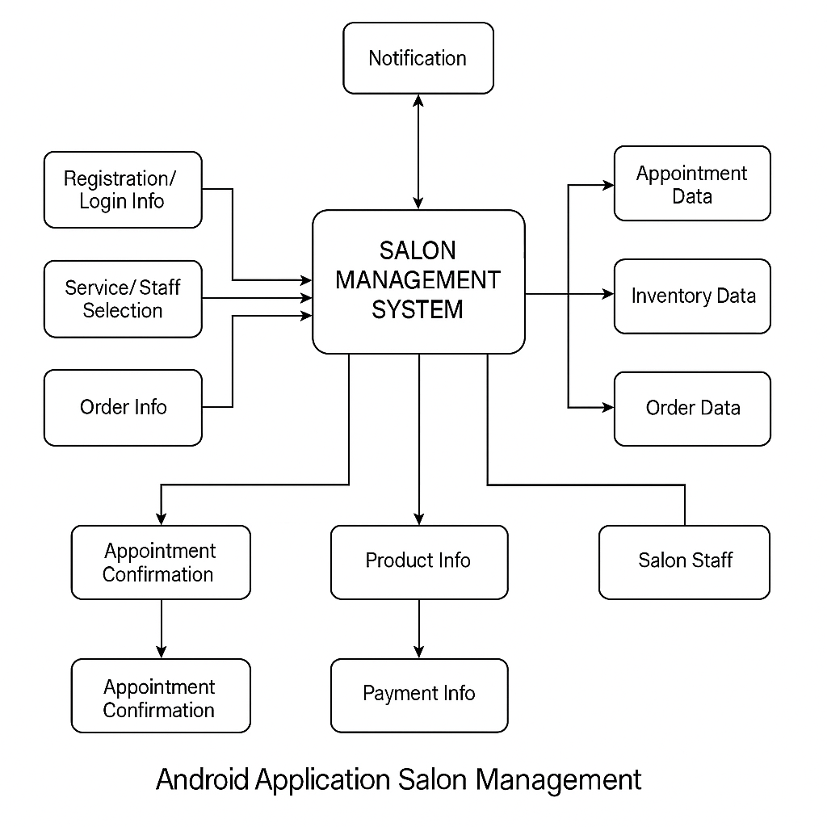

**Fig 8.** Execution Diagram

**8.SystemRequirements:**A Salon Management System, as described in the document, is a mobile based solution, with a continuing focus on Android as the platform and application. The Salon Management System will use cloud functionsand capabilities, and will leverage industry-standard tools associated with AI, in order to drive the user experience of the organization and to drive organizational efficiency. The system requirements are outlines below. **Platform:**

* Operating system: Android 5.0 (Lollipop) and greater
* Device support: Smartphone and tablet compatible.
* Development tools: frontend development will be done in Android Studio, and Java will be used as the programming language.

**Back-end:**

* Cloud Backend - Firebase Realtime Database / Firebase Firestore
* Authentication - Firebase Authentication will be used to support logged in and role-based management to secure the service.
* APIs - Firebase Cloud Functions will be used to support app operations, and other server-side processes.

**AI Tools:**

* TensorFlow Lite - For lightweight machine learning models (style suggestions, product recommendations, etc.)
* Google's Gemini API - Natural language interactions, chatbot implementation, and appointment assistance that utilize conversational AI.

**Storage:**

**Cloud-Based Storage:**

* Firebase Cloud Storage - Used for the storage of customer data, images, service records, receipts, etc.
* Scalable, secure, and accessible on any device with the right authentication.
* Cloud-based also ensures data and is backed up and integrates easily with analytics module and AI tools.

# 7.CONCLUSION:

# The UrbaGlo Salon Management System was built with the ultimate goal of changing the salon business with an intelligent, easy, and seamless digital solution. The UrbaGlo system will perform important tasks such as setting appointments, managing your customers and employees, looking up products, processing payments, managing your inventory and everything else all at once.

# UrbaGlo was built on a great Android foundation with a Firebase back-office and utilizes different AI Services such as Tensor Flow Lite and the Google's Gemini API which allows us to provide better performance and intelligent automation, and a customized experience for each user. We use cloud storage to ensure safety, accessibility, and scalability for your data as your business continues to grow.

# By adopting UrbaGlo, salon owners will reduce human error, save time, and provide a more professional, enjoyable experience for your customers. At the end of the day, UrbaGlo enables salons to spend more time on what matters most—creating beauty, building client relations and growing their business in a competitive environment.

**8. REFERENCES:**

1. **Android Developers Documentation.**

* Google. (2025). Android Developer Reference. Retrieved from: <https://developer.android.com>

1. **Firebase Documentation.**

* Google. (2025). Firebase: Build apps with real-time databases and more. Retrieved from https://firebase.google.com/docs

1. **TensorFlow Lite Documentation.**

* (TensorFlow. (2025). TensorFlow Lite: Optimize your model for mobile and edge devices. Retrieved from https://www.tensorflow.org/lite

1. **Google Gemini API Documentation.**

* (Google. (2025). Google Gemini: Natural Language Processing API for integration.. Retrieved from https://developers.google.com

1. **Salon Management System - Research Paper.**

* (John, A. & Smith, B. (2023). A Study on Salon Management Systems: Trends, Technology and the Future. Journal of Business Management, 12(4).

1. **E-commerce and Product Management for Salons.**

* (Patel, M. (2024). The Digital Transformation of Salon Industries. Salon Business Today, 15(3).

1. **Cloud Storage Options for Businesses.**

* Chandra, P. (2024). Cloud-Based Solutions for Small Businesses: A exemplification for Salons. TechBusiness Insights, 9(2).

1. **"Salon Management Systems" by Vaibhav Stores.**

* Vaibhav Stores. (2025). Salon Management Systems and Equipment. Retrieved from https://www.vaibhavstores.in