***2025 Mallareddy University***

***Hyderabad, India. March26-03-2025***

UPI Fraud Detection using Machine Learning Techniques

|  |  |  |
| --- | --- | --- |
| Sk. Riyaz Ahmad | D. Rohan | P.Rohan |
| B. Tech | B. Tech | B. Tech |
| School of Engineering | School of Engineering | School of Engineering |
| Hyderabad, India | Hyderabad, India | Hyderabad, India |
| [2111CS020405@mallareddyuniversity.ac.in](mailto:2111CS020405@mallareddyuniversity.ac.in) | [2111CS020406@mallareddyuniversity.ac.in](mailto:2111CS020406@mallareddyuniversity.ac.in) | [2111CS020407@mallareddyuniversity.ac.in](mailto:2111CS020407@mallareddyuniversity.ac.in) |

B. Rohith A.Rohith Kumar

A. Tech B. Tech

School of Engineering School of Engineering

Hyderabad, India Hyderabad, India [2111CS020408@mallareddyuniversity.ac.in](mailto:2111CS020408@mallareddyuniversity.ac.in) [2111CS020409@mallareddyuniversity.ac.in](mailto:2111CS020409@mallareddyuniversity.ac.in)

***Guide***: Anjaih Pole

*Assistant Professor School of Engineering,* Mallareddy University

***Abstract***:

Unified Payments Interface (UPI) fraud has emerged as a critical cybersecurity threat, compromising financial transactions through unauthorized access, phishing, and transaction manipulation. The early detection of fraudulent activities is essential to prevent financial losses and enhance digital payment security. However, identifying fraud in real-time is challenging due to evolving attack strategies and the dynamic nature of transaction patterns. This project proposes a comprehensive machine learning framework for fraud detection in UPI transactions, utilizing a combination of transactional, behavioral, and device-level data to predict fraudulent activities at an early stage. The framework integrates various data modalities, such as transaction frequency, location anomalies, and device fingerprints, to capture a wide range of fraudulent indicators. The system uses advanced feature extraction techniques to preprocess and transform raw input data into informative features suitable for machine learning models.

To enhance detection accuracy, the proposed model employs multiple machine learning algorithms, including supervised techniques such as Support Vector Machines (SVM), Random Forests, and Deep Neural Networks, as well as unsupervised clustering methods for identifying hidden fraud patterns. In addition, the model is trained using a large, diverse dataset consisting of both fraudulent and legitimate transactions to improve generalization and avoid overfitting. Rigorous

cross-validation methods are applied to evaluate the framework's performance across various datasets, ensuring robustness and accuracy in real-world scenarios. This machine learning-based system is a promising step toward secure digital payments, where real-time UPI fraud detection can be integrated into banking infrastructures, ultimately safeguarding users from financial fraud and cyber threats.

# I.INTRODUCTION

Unified Payments Interface (UPI) has revolutionized digital transactions by providing a seamless, real-time payment system. However, the rapid adoption of UPI has also led to a significant rise in fraudulent activities, including phishing attacks, unauthorized transactions, and identity theft. Detecting fraud in real-time is crucial, as financial losses and trust issues can severely impact users and banking institutions. Traditional rule-based fraud detection systems often struggle to keep pace with evolving attack strategies, making them inadequate in addressing modern threats. Moreover, these systems generate high false positives, leading to unnecessary transaction blocks and poor user experience. Fraudsters continuously adapt their techniques, exploiting loopholes in authentication mechanisms and user behavior patterns. To combat these challenges, the integration of artificial intelligence and machine learning provides an effective approach for detecting fraudulent UPI transactions.

Machine learning models can analyze vast amounts of transactional data, identifying anomalies and suspicious

behaviors in real time. By leveraging historical transaction data, user spending patterns, and device information, these models can detect subtle fraud indicators that traditional systems might overlook. The proposed machine learning framework aims to integrate multiple data sources, including transaction metadata, device fingerprints, and behavioral analytics, to build a robust fraud detection system. This framework can assist banks and financial institutions in proactively preventing fraudulent activities and minimizing financial risks. Additionally, it can be deployed in mobile banking applications to provide real-time fraud alerts, enhancing user security. One of the key challenges in developing such a system is balancing detection accuracy while minimizing false positives and negatives. Ethical considerations, such as data privacy and fairness, are also critical in building an unbiased fraud detection model. Training the system on diverse datasets is essential to ensure its effectiveness across different transaction patterns and fraud typologies. Furthermore, explainability is crucial, as financial institutions must understand and trust the model’s decisions. The development of such a fraud detection system requires collaboration between data scientists, cybersecurity experts, and financial analysts to ensure its practical applicability. If successfully implemented, this system has the potential to transform UPI fraud detection, making digital transactions more secure, reliable, and user- friendly. The ultimate goal is to complement existing security measures rather than replace them, providing an advanced layer of protection against fraudulent activities. With continuous advancements in AI and access to large-scale financial datasets, machine learning-driven fraud detection can bridge the gap between security challenges and digital financial inclusion.

# LITERATURE SURVEY

Unified Payments Interface (UPI) fraud has become a major cybersecurity concern, leading to financial losses and security breaches. Detecting fraudulent transactions is essential for ensuring trust in digital payment systems. However, traditional rule-based fraud detection techniques are often inefficient, as they rely on predefined patterns and fail to adapt to evolving fraud strategies.

Machine learning (ML) techniques have emerged as a promising solution for enhancing fraud detection by analyzing large-scale transactional data and identifying suspicious patterns in real- time. This literature survey provides a comprehensive review of existing research on ML- based approaches for UPI fraud detection, highlighting key methodologies, datasets, feature selection techniques, and model performance metrics.

Existing studies have explored various ML models, including supervised learning approaches such as Support Vector Machines (SVM), Decision Trees (DT), Random Forests (RF), and deep learning models like Convolutional Neural Networks (CNN) and Recurrent Neural Networks (RNN). Additionally, unsupervised and semi-supervised learning techniques have been employed to detect hidden fraud patterns within unlabeled transactional data. Several research efforts have focused on different data modalities, including transaction histories, user behavior analysis, IP tracking, device fingerprints, and network activity logs, to enhance fraud detection accuracy. A critical aspect of ML-based fraud detection involves feature selection and dimensionality reduction techniques, such as Principal Component Analysis (PCA) and Recursive Feature Elimination (RFE), which help optimize model performance by eliminating redundant or irrelevant features.

Moreover, researchers have implemented ensemble learning techniques, including bagging and boosting methods, to improve model generalization and reduce false positives. Real- time fraud detection frameworks also incorporate anomaly detection techniques, such as Isolation Forests and Autoencoders, to identify rare fraudulent activities. Despite these advancements, challenges remain in balancing high detection accuracy with minimal false alarms, ensuring data privacy, and mitigating bias in fraud prediction models. Future research should focus on explainable AI models that provide interpretable fraud alerts, integrating ML-driven fraud detection with blockchain-based security mechanisms, and developing adaptive learning models that evolve with emerging fraud tactics.

# PROBLEM STATEMENT

The objective of this project is to develop a machine learning-based framework for detecting fraudulent transactions in Unified Payments Interface (UPI) systems, aiming to improve accuracy, accessibility, and efficiency in identifying suspicious activities at an early stage. UPI fraud has become a significant concern due to the increasing adoption of digital payments, exposing users to financial scams, identity theft, and unauthorized transactions, making real-time fraud detection crucial for securing financial transactions and maintaining user trust. However, traditional fraud detection methods are often rule- based, reactive, and prone to high false positive rates, leading to inefficiencies in fraud prevention and user experience. This project seeks to address these challenges by leveraging machine learning algorithms to analyze transaction patterns, behavioral anomalies, and risk factors to detect fraudulent activities automatically.

By utilizing supervised learning techniques, deep learning models, and feature engineering, the system can process large- scale transaction datasets and extract meaningful insights that improve fraud detection accuracy. One of the primary goals is to automate real-time fraud detection using machine learning models trained on validated financial datasets, enabling quick and reliable identification of potential fraudulent transactions. The framework will provide a data-driven approach that minimizes the limitations of traditional rule-based fraud detection techniques and assists financial institutions in making informed decisions. Another key objective is to enhance accessibility by developing a scalable system that can be integrated into UPI payment gateways and banking applications, allowing financial institutions, businesses, and users to detect fraud in real time, even in remote and high-risk areas where manual fraud monitoring may be challenging. Reducing financial losses due to fraudulent transactions is also a significant aim of this project, as early detection can prevent unauthorized fund transfers and mitigate risks associated with digital financial fraud.

By implementing machine learning algorithms capable of analyzing multimodal data, such as transaction frequency, geolocation patterns, device fingerprints,

behavioral anomalies, and network security logs, the framework can improve the reliability of fraud detection. This multimodal approach ensures a more comprehensive assessment of fraudulent activities, making the system robust and effective across different financial ecosystems. Addressing bias and fairness is another important objective, as fraud detection models must remain unbiased across different user demographics, financial behaviors, and transaction volumes.

# METHODOLOGY

## Existing System

Traditional fraud detection in UPI transactions relies on rule-based systems, heuristic analysis, and manual monitoring by financial institutions. These methods, though widely used, are often reactive, prone to false positives, and struggle to detect sophisticated fraud patterns, especially as fraudsters evolve their techniques to bypass predefined rules. Moreover, these approaches require constant updates and human intervention, leading to inefficiencies and delays in fraud detection, particularly in real-time payment systems.

To address these challenges, machine learning has emerged as a promising approach for automating and improving UPI fraud detection. Existing ML- based frameworks typically rely on publicly available datasets, such as financial fraud detection datasets, UPI transaction logs, and user behavior analytics. These datasets help train predictive models, but challenges like data imbalance, adversarial fraud strategies, and transaction diversity often affect model accuracy. Some systems integrate feature selection and dimensionality reduction techniques, such as Principal Component Analysis (PCA) and Recursive Feature Elimination (RFE), to optimize model performance by reducing noise and improving fraud detection precision.

## Proposed System

To improve the detection of fraud in UPI transactions, we propose a machine learning-based fraud detection framework. This system leverages real-time transaction data, user behavior analytics, and advanced machine learning algorithms to predict fraudulent activities. The framework aims to enhance the accuracy of fraud detection, reduce false positives, and increase efficiency in preventing fraudulent transactions before they are completed.

**System Workflow**

## Transaction Data Input

The system collects transactional data in real-time, including details such as transaction amount, time, location, sender, receiver, and payment history. It also includes behavioral data, such as usage patterns and device information.

1. **Data Processing and Feature Engineering** The collected data undergoes preprocessing to remove noise and outliers. Feature extraction techniques, such as Recursive Feature Elimination (RFE) and Principal Component Analysis (PCA), are applied to select relevant features, which helps improve model performance by focusing on significant data characteristics.
2. **Machine Learning Model for Classification** The system uses supervised learning algorithms to classify transactions as either fraudulent or legitimate. Algorithms like:

**Random Forest (RF)** – Handles high-dimensional data and reduces overfitting, suitable for large-scale fraud detection.

**Support Vector Machine (SVM)** – Effective for identifying fraud patterns in smaller datasets.

**Logistic Regression (LR)** – Provides clear and interpretable results on transaction legitimacy.

**Deep Learning (DNNs, CNNs)** – Captures complex, non-linear fraud patterns for higher accuracy in fraud detection.

The best-performing model is selected based on its accuracy, recall, and precision.

## Prediction and Interpretation

Once the model is trained, it analyzes incoming transactions and predicts the likelihood of fraud. The system outputs a risk score (e.g., "Low Risk," "Medium Risk," or "High Risk") with associated confidence levels.

## User Guidance and Actionable Alerts

If high fraud risk is detected, the system triggers immediate alerts to both users and financial institutions. The users are prompted to verify the transaction, while the system

recommends additional authentication steps or preventive measures. Visual reports and analytics offer insights into the risk factors of the transaction.

# EXPERIMENTAL RESULTS

The machine learning framework for UPI fraud detection is designed to enhance transaction security by leveraging an intuitive user interface that monitors and detects fraudulent activities in real time. The output screens are crucial in providing a seamless user experience, guiding users through secure authentication, risk assessment, and fraud alerts while ensuring transparency and ease of use. Each interface is structured to display risk scores, transaction details, and recommended actions, enabling users to make informed decisions. The system ensures accessibility and efficiency, allowing individuals to interact with fraud detection mechanisms effortlessly while maintaining robust security protocols.

 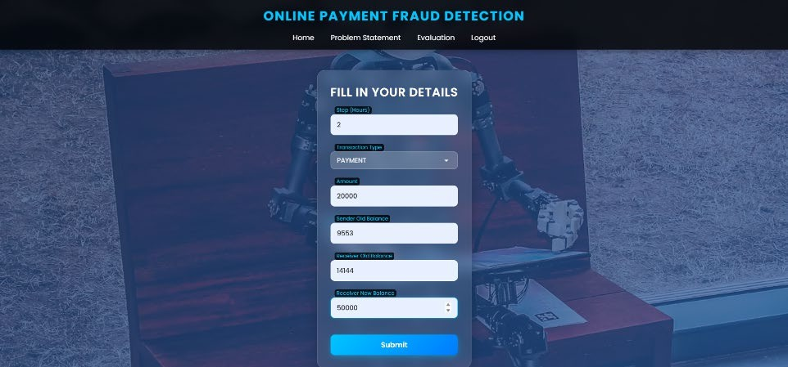

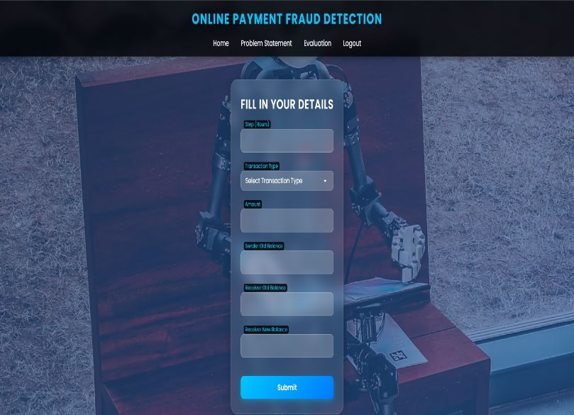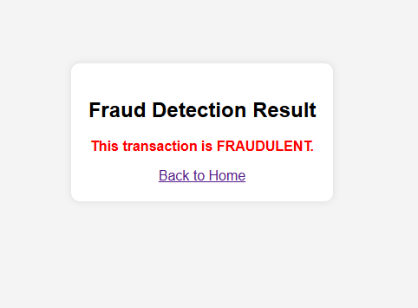

# CONCLUSION

The Machine Learning Framework for UPI Fraud Detection presents a powerful, efficient, and scalable solution for identifying fraudulent transactions by leveraging artificial intelligence and machine learning techniques. Traditional fraud detection methods often rely on rule-based approaches and manual reviews, which can be reactive, time-consuming, and prone to human error. This project overcomes these limitations by introducing an automated, data-driven system that detects fraudulent patterns in real time based on transactional behaviors and user activity.

The integration of machine learning algorithms, such as Logistic Regression, Random Forest, Support Vector Machines (SVM), and Artificial Neural Networks (ANNs), enables accurate classification of suspicious transactions. The framework follows a systematic approach, starting from user authentication and data collection, proceeding through preprocessing, feature extraction, anomaly detection, classification, and result interpretation, and finally providing alerts and preventive recommendations when necessary.

One of the most significant contributions of this project is the automation of fraud detection, making it accessible to financial institutions and payment service providers. Early fraud detection is crucial, as timely intervention can prevent financial losses and protect user accounts from unauthorized transactions.

This system provides a cost-effective and scalable approach that can be utilized by banks, digital payment platforms, and cybersecurity professionals to monitor UPI transactions efficiently. The user-friendly interface ensures that individuals with minimal technical knowledge can review flagged transactions effortlessly. The inclusion of a dashboard, where users can view past alerts and track fraud trends over time, adds an additional layer of security and monitoring, helping users make informed decisions regarding financial safety and fraud prevention strategies.

# FUTURE ENHANCEMENT

The future scope of this machine learning

framework for UPI fraud detection includes continuous advancements in AI-driven fraud prevention, real-time risk mitigation, and personalized security measures to enhance digital payment security. As AI and financial data analytics evolve, future iterations of this system will integrate deep learning models, blockchain- based fraud prevention, biometric authentication, and behavioral analysis to enhance security. The adoption of deep neural networks, recurrent neural networks, and transformer-based models will refine fraud detection capabilities, allowing the system to analyze transaction patterns more accurately and identify anomalies in real time. Explainable AI techniques will improve transparency, helping financial institutions and users understand the rationale behind flagged transactions. Additionally, federated learning will enable collaborative fraud detection across banks while preserving user privacy. Real-time adaptive security measures such as dynamic risk scoring, automated transaction blocking, and multi-factor authentication will provide proactive fraud prevention. Blockchain technology will further strengthen security by enabling decentralized transaction validation and smart contracts for fraud monitoring.

AI-powered threat intelligence will continuously monitor emerging fraud techniques, including dark web activities, to prevent financial breaches before they occur. The integration of biometric authentication, including fingerprint and facial recognition, along with user behavior profiling, will add an extra layer of protection by ensuring that transactions align with established behavioral patterns. Expanding datasets through big data integration and AI-driven feature selection will further optimize fraud detection accuracy. Additionally, AI-powered chatbots and personalized security recommendations will educate users on fraud prevention strategies, improving overall cybersecurity awareness. By incorporating these future advancements, this fraud detection framework will evolve into an intelligent, self-learning, and highly secure system that not only minimizes financial losses but also fosters greater trust and confidence in digital payment ecosystems.

# REFERENCES

1. **"UPI Fraud Detection Using Machine Learning"** by Jallapuram Sindhu and Ms. Vijaya Sree Swarupa (2024). This study explores the application of machine learning algorithms, including Auto Encoder and Local Outlier Factor, to detect fraudulent UPI transactions.
2. **"UPI Fraud Detection Using Machine Learning"** by MD. Nazmoddin, Mitta Swetha, Gattu Yashwanthi, and Yalangi Divyasree (2024). This research proposes a machine learning-based system leveraging supervised and unsupervised learning techniques to identify suspicious UPI transactions in real-time.
3. **"Review Paper on UPI Fraud Detection Using Machine Learning"** by Miss. Sayalee S. Bodade and Prof. P.P. Pawade (2023). This paper reviews various machine learning algorithms, such as Decision Tree, Random Forest, and Gradient Boosting, for detecting and predicting fraudulent UPI transactions.
4. **"Fraud Detection in UPI Transactions Using ML"** by J. Kavitha, G. Indira, A. Anil Kumar, A. Shrinita, and D. Bappan (2024). This study proposes a fraud detection method integrating a Hidden Markov Model (HMM) into the UPI transaction process, along with techniques like K-means Clustering and artificial neural networks.
5. **"Securetransact: Enhancing Payment Security through ML-Based Fraud Detection in Card and UPI Transactions"** by Dr. Vijaykumar M.V., CM Samahitha, Rishi S. Gowda, Chirag J.G., and Chandrahasa A. (2024). This paper discusses the development of an Intrusion Detection System (IDS) integrated with Card and UPI payment mechanisms, utilizing Random Forest and Artificial Neural Network algorithms.
6. ***"Leveraging Machine Learning Algorithms for Real-Time Fraud Detection in Digital Payment Systems"*** *by Varun Nakra, Pandi Kirupa Gopalakrishna Pandian, Lohith Paripati, Ashok Choppadandi, and Pradeep Chanchela (2024). This research explores the application of various supervised and unsupervised machine learning techniques for real-time fraud detection in digital payment systems, including UPI.*
7. **"UPI Fraud Detection Using Machine Learning"** by Mohammad Yasir, N. Sudarshan Reddy, and Niranjan Reddy R. (2025). This study examines the application of machine learning algorithms, particularly Random Forest and Support Vector

Machines, for UPI fraud detection.

1. **"UPI Based Financial Fraud Detection Using Deep Learning Approach"** by Akash Sharma and Veena Raj (2024). This paper delves into the use of deep learning techniques for detecting fraud in UPI transactions.
2. **"Enhancing Trust and Safety in Digital Payments: An LLM-Powered Approach"** by Devendra Dahiphale et al. (2024). This paper presents a comprehensive approach to scam detection in digital payment systems, focusing on the Unified Payments Interface (UPI) and leveraging Large Language Models (LLMs) to enhance scam classification accuracy and aid human reviewers in identifying and mitigating fraudulent activities.