**I-Smart Glasses**

*K. S. Jadhav (Gide)*

1.Sushant Kharat(Member)Information Technology SVCP, Pune

2.Sahil Gurav(Member)Information Technology SVCP, Pune

------------------------------------------------------------------------------------------------------------------------------------------

**Abstract**

Conventional assistive technologies do not usually offer the ability to interact in real time, meaning that users must switch between several devices to complete a given task. This paper proposes an ingenious solution- smart glasses integrated object detection, sign language recognition, and TTS technology as one wearable device. The system improves real-time environmental awareness and communication for people with disabilities using cutting-edge AI models, sensor fusion and mechatronic processing applied on embedded devices. These practical implementations illustrate how the proposed solution provides greater accessibility and autonomy for people with visual impairments, speech or hearing disabilities, and mobility challenges.

**Key Words —** Smart glass, object recognition, sign language interpretation, Text-to-Speech, Assistive Technology, Artificial Intelligence, computer vision, Access.

1. **INTRODUCTION**

Wearable assistive technologies have evolved rapidly over the last decade and opened new avenues for improving the lives of people with disabilities.

However, many of the solutions available are single-functioning: one device helps a visually impaired user navigate, another facilitates communication for individuals with speech or hearing impairments, and another gives access to real-time information. This fragmentation leads to switching between multiple devices, which lowers convenience and usability

In an effort to solve this problem, this paper presents an integrated smart glasses system that brings together three key functionalities:

**1.Object Detection:** Real-time object identification along with distance approximation by AI-powered computer vision.

**2.Sign Language Recognition:** Deep learning model with ability to read hand gestures in the interpretation of sign language.

**3.Text-to-Speech Conversion :** A speech synthesis engine that turns text information into voice output as naturally sounding.

All these functions will be encapsulated into one device, compact, lightweight, and userfriendly, making it wearable. Thus, the accessibility, independence, and safety for users are considerably increased.

**[2] LITERATURE SURVEY**

**1. Real-Time Object Detection on Edge Devices for Assistive Vision**Authors: J. Redmon, S. Divvala, R. Girshick, A. Farhadi  
Journal: IEEE Conference on Computer Vision and Pattern Recognition (CVPR)  
Year: 2016

Summary: This work introduced YOLO (You Only Look Once), a deep learning model for real-time object detection. The model’s ability to detect multiple objects in a single pass makes it ideal for embedded devices like smart glasses, where speed and efficiency are critical. Its integration in assistive vision systems has enabled real-time awareness for visually impaired users.[**arxiv.org/abs/1506.02640**](https://arxiv.org/abs/1506.02640)

**2. Hand Gesture Recognition for Sign Language Using Deep Learning**Authors: D. Li, C. Rodriguez, X. Yu  
Journal: arXiv Preprint  
Year: 2019  
Summary: This research focuses on word-level sign language recognition using deep learning from video sequences. It serves as a foundation for sign language interpretation systems by recognizing static and dynamic gestures through neural networks. This approach supports communication for hearing-impaired individuals through smart glasses.  
[arxiv.org/abs/1910.11006](https://arxiv.org/abs/1910.11006)

**3. A Survey on Wearable Assistive Devices for the Blind**

Authors: T. Pan, J. Wang, L. Zhang Journal: IEEE Access  
Year:2021  
Summary: This survey highlights various wearable assistive technologies, including navigation aids and vision enhancement tools. The paper emphasizes the need for compact, multifunctional systems capable of supporting daily tasks for visually impaired users—strengthening the relevance of integrated smart glasses.

[ieeexplore.ieee.org/document/9444870](https://ieeexplore.ieee.org/document/9444870)

**4. Vision-Based Approach to Sign Language Recognition**Authors: A. Kumar, M. Bhosale, S. Patil  
Journal: International Journal of Advances in Applied Sciences  
Year:2022  
Summary: This paper presents a computer vision approach to interpreting sign language using convolutional neural networks. It emphasizes low-cost and accessible solutions using embedded systems, aligning closely with the hardware limitations and goals of smart glasses for inclusive communication.

**5. Speech Synthesis and TTS Applications in Assistive Systems**Authors: R. Vemulapalli, M. Al-Akaidi  
Journal: International Journal of Speech Technology  
Year: 2020  
Summary: This study investigates text-to-speech technologies for assistive communication. It examines speech rate, clarity, and language adaptation, highlighting the importance of personalized voice outputs in wearable systems. The findings support the use of TTS modules in AI-powered smart glasses to deliver real-time feedback.

**[3] METHODOLOGY**

The proposed **I-Smart Glasses for Object Detection, Sign Language Recognition, and Text-to-Speech** follow a structured methodology that integrates camera-based visual input, real-time AI processing, and speech synthesis. The system combines hardware integration, model inference, real-time data processing, and audio output to assist users with visual or hearing impairments. The methodology is divided into hardware design, AI model integration, gesture interpretation, and audio feedback.

**3.1 System Architecture**

The system architecture consists of the following main components:

* **Raspberry Pi (4 Model B)** – Acts as the central processing unit for image processing, gesture recognition, and audio output.
* **Raspberry Pi Camera Module** – Captures real-time visual input for both object detection and hand gesture recognition.
* **TensorFlow Lite Models** – Lightweight AI models deployed on the Pi for object detection and sign recognition.
* **OpenCV** – Handles image acquisition, pre-processing, and ROI extraction from video frames.
* **pyttsx3/espeak** – Python-based TTS engine used to convert recognized objects or gestures into speech.
* **3.5mm Audio Jack** – Connects to headphones or mini speaker for real-time audible output.
* **Python-based Control Script** – Manages the AI processing pipeline, model inference, and triggers TTS output based on results.

**3.2 Hardware Design and Integration**

The hardware design is assembled in the following stages:

1. **Glasses Frame Integration**
   * The Raspberry Pi board is mounted on one side of a lightweight glasses frame.
   * The Pi Camera is positioned near the front to align with the user's line of sight.
2. **Visual Input Capture**
   * The camera continuously streams video, which is processed frame-by-frame for object or gesture detection.
3. **Model Inference and Classification**
   * The TensorFlow Lite models are used for classifying objects in view or interpreting sign language gestures.
   * A confidence score threshold is used to determine the final prediction.
4. **Audio Output Integration**
   * Once a valid object or gesture is detected, the corresponding label is converted into speech using the pyttsx3 engine.
   * Audio output is delivered via the Raspberry Pi’s 3.5mm jack or USB sound device.

**3.3 Working Procedure**

The complete system follows a sequential process:

**Step 1: Input Capture**

* The Pi Camera captures continuous video input.
* Frames are extracted and passed to the image processing pipeline.

**Step 2: Detection & Recognition**

* **Object Detection**: If the frame contains common objects, YOLO-tuned TFLite models detect and classify them.
* **Sign Recognition**: If a hand is detected, the frame is processed for gesture recognition using a trained CNN.
* The highest-confidence result is selected for output.

**Step 3: Text-to-Speech Output**

* Based on the classified result, a corresponding description (e.g., "bottle", "thank you") is passed to the TTS engine.
* Speech is generated and played through the speaker in real time.

**Step 4: System Monitoring (Optional UI)**

* If needed, logs of detected objects and gestures can be sent to a remote dashboard or mobile app via Wi-Fi (optional feature).
* Useful for logging usage patterns or performance feedback.

**[4] BLOCK DIAGRAM**

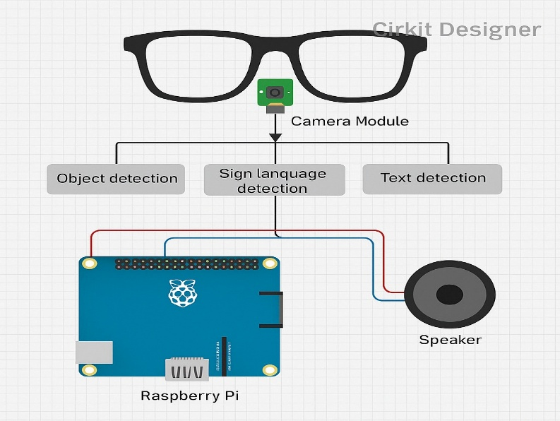

**[5] ALGORITHM & PROTOCOL**

The system’s decision-making logic is implemented using the following algorithms:

### Image Capture : The Raspberry Pi camera continuously captures live video frames.

### Data Processing : Each frame is analyzed using:

### Object Detection Model (e.g., YOLO-TFLite)

### Sign Language Recognition Model (if a hand is detected)

### Result Extraction : The most confident prediction (object or sign) is selected.

### Text-to-Speech Conversion : The detected result is converted into speech using TTS engine (pyttsx3 or espeak).

### Audio Output : The speech is played via a connected laptop speaker or external speaker.

### Advantages

### Real-time object detection improves environmental awareness for visually impaired users.

* Integrated sign language recognition enables better communication for hearing-impaired individuals.
* Hands-free operation enhances mobility and ease of use in daily life.
* Text-to-speech output offers immediate audio feedback without the need for external assistance.

**Limitations**

### Implementing more small components require more time.

### Processing power limitations on small embedded devices.

### The challenge stays in making it wearable.

### Speech output may be affected by background noise

### [6] Results

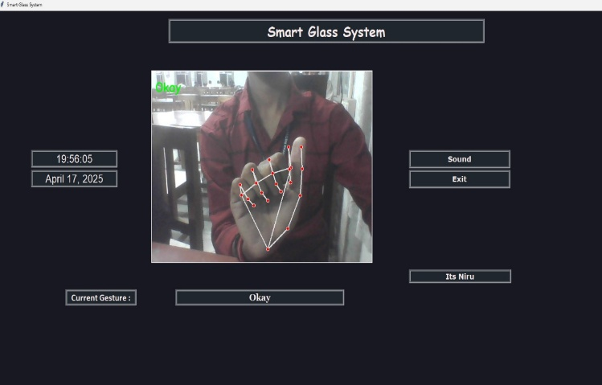

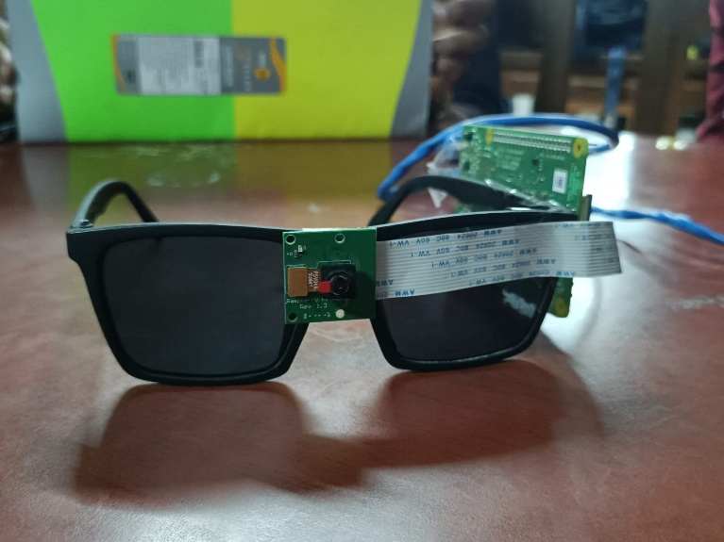

### [7] CONCLUSION AND FUTURE SCOPE

The proposed **AI-Smart Glasses** system enhances real-time awareness and communication by integrating **object detection**, **sign language recognition**, and **text-to-speech** in a single wearable device. Using a **Raspberry Pi** and **camera**, the system captures live video, processes it with AI models, and converts results into speech through an onboard speaker. It supports optional monitoring via MQTT and Python UI. This compact and cost-effective solution reduces dependence on multiple devices and promotes independent use for people with visual or hearing impairments.

### [8] REFERENCES

1. J. Redmon, S. Divvala, R. Girshick, and A. Farhadi, 2016, “You Only Look Once: Unified, Real-Time Object Detection,” *IEEE Conference on Computer Vision and Pattern Recognition (CVPR)*. [Online]. Available: <https://arxiv.org/abs/1506.02640>
2. D. Li, C. Rodriguez, and X. Yu, 2019, "Word-Level Deep Sign Language Recognition from Video," arXiv preprint. [Online]. Available: <https://arxiv.org/abs/1910.11006>
3. A. Al-Hammadi, M. A. Jamil, and S. A. Al-Rahbi, 2020, "Hand Gesture Recognition for Sign Language Using 3DCNN," IEEE Access, vol. 8, pp. 79491–79509. [Online]. Available: [https://ieeexplore.ieee.org/document/c Authors: T. Pan, J. Wang, L. Zhang Journal: IEEE Access 9099065](https://ieeexplore.ieee.org/document/c%20Authors:%20T.%20Pan,%20J.%20Wang,%20L.%20Zhang%20Journal:%20IEEE%20Access%209099065)

[4] T. Pan, J. Wang, and L. Zhang, 2021, “A Survey on

Wearable Assistive Devices for the Blind,” IEEE Access, vol.

9, pp. 15012–15030. [Online]. Available:

https://ieeexplore.ieee.org/document/9444870

.

|  |  |
| --- | --- |
|  |  |
|  |  |