**Formulation Design and Optimization of Transdermal Drug Delivery System for Gliclazide**

Jaybhaye Kiran Shivanand1*, Dr. Rakesh K. Jatav1, Ms. Chetana malvia1

1- School of Pharmacy, Dr. APJ Abdul Kalam University, Indore MP

**Abstract** Transdermal systems are ideally suited for diseases that demand chronic treatment. Hence, an anti-diabetic agent of both therapeutic and prophylactic usage has been subjected to transdermal investigation. Gliclazide, a second-generation hypoglycemic agent, faces problems like its poor solubility, poor oral bioavailability with large individual variation and extensive metabolism. In the present work, transdermal matrix-type patches were prepared by film casting techniques on mercury using polymers like HPMC, Eudragit RL-100, and chitosan. Also an attempt was made to increase the permeation rate of drug by preparing an inclusion complex with hydroxypropyl β-cyclodextrin (HP β-CD). The possibility of a synergistic effect of chemical penetration enhancers (CPE) (propylene glycol and oleic acid) on the transdermal transport of the drug was also studied. Folding endurance was found to be high in patches containing higher amount of the Eudragit. There was increase in tensile strength with an increase in Eudragit in the polymer blend. In vitro drug release profile indicates that the drug release is sustained with increasing the amount of Eudragit in patches. The patches containing inclusion complex of drug showed higher permeation flux compared with patches containing plain drug. The result of the synergistic effect indicates that the HP β- CD in conjunction with other CPE showed a higher permeation flux.

Key Words : Chitosan, Metabolism, Synergistic Effect.

**Introduction:** - Transdermal Drug Delivery System (TDDS) denotes directing drug molecules across the skin into the systemic circulation. TDDS imposes limited alternatives for formulators in delivering diverse active moieties because to its stringent adherence to selection criteria, which include low molecular weight, short half-life, high permeability, optimal oil/water partitioning behavior, and low melting point. The compounds deemed most appropriate for transdermal delivery align with Lipinski's rule of five, which correlates the chemical characteristics of pharmacological entities with their pharmacokinetic qualities. According to the Rule of five, enhanced drug permeability is associated with a low molecular weight entity (<500 Da), which should not possess more than 5 hydrogen bond donors, 10 hydrogen bond acceptors, or a log P value above 5. Typically, tiny lipophilic moieties are deemed appropriate for transdermal drug administration, while some small molecular weight hydrophilic compounds can also penetrate the epidermal barrier via the transappendageal pathway. High molecular weight substances, such as proteins and peptides, are challenging to administer transdermally due to the skin's barrier function. This is due to a tight junction formed by a trans membrane protein, tight junction-associated adhesion molecules, plaque proteins, and marvel proteins linked to active filaments of the cytoskeleton in the epidermis, illustrating the complexity of skin structure that limits the penetration of high molecular weight drugs.

**Diabetes mellitus** is one of the four primary illnesses that pose a significant risk to the health of people living in every region of the world. Type 2 Diabetes Mellitus (T2DM) is a chronic metabolic disorder characterized by insulin resistance, impaired insulin secretion, and hyperglycemia. It is one of the most prevalent non-communicable diseases globally, with millions of individuals affected.

**Gliclazide** is one of the commonly prescribed oral hypoglycemic agents for the management of T2DM. Gliclazide is a second-generation sulfonylurea that stimulates insulin secretion by binding to pancreatic beta cells.

The anti-hyperglycemic drug known as gliclazide is classed as a category II medication. The average plasma half-life is between two and three hours, and due to hepatic metabolism, only forty percent of the medicine that is taken orally is able to make its way into the systemic circulation.

**Rationale for the study**

The treatment of Type 2 Diabetes Mellitus (T2DM) requires long-term and consistent administration of oral hypoglycemic agents such as Gliclazide, a second-generation sulfonylurea widely used to control blood glucose levels. However, oral administration of Gliclazide is associated with several limitations, including hepatic first-pass metabolism, fluctuations in plasma drug concentrations, and gastrointestinal side effects, which can reduce patient compliance and therapeutic efficacy.

To address these challenges, transdermal drug delivery systems (TDDS) offer a promising alternative for the sustained and controlled release of Gliclazide. TDDS bypasses the first- pass metabolism, provides continuous drug release, and enhances patient compliance by reducing the need for frequent dosing. Furthermore, transdermal patches can maintain stable plasma drug concentrations, minimizing the risk of hypoglycemia and other side effects commonly seen with oral Gliclazide.

**MATERIALS AND METHODS:**

Table No. 1 : Material used

|  |  |  |  |
| --- | --- | --- | --- |
| **Excipients/Materials** | **Supplier/Source** | **Location** | **Type** |
| Gliclazide | Dr. Reddy’s  Laboratories | Hyderabad,  India | Active Ingredient |
| Eudragit L100 | Corel Pharma Chem  Ltd. | India | Polymer |
| Eudragit S100 | Corel Pharma Chem  Ltd. | India | Polymer |
| Ethyl Cellulose | Colorcon Asia Pvt.  Ltd. | India | Polymer |
| PEG 400 | CDH Pvt. Ltd. | New Delhi,  India | Plasticizer |
| Mercury | CDH Pvt. Ltd. | New Delhi,  India | Analytical Reagent |
| Glycerol | Loba Chemie | Mumbai, India | Plasticizer |
| Polyethylene Glycol | Himedia Laboratories | Mumbai, India | Plasticizer |
| Dimethyl Sulfoxide  (DMSO) | SRL | Mumbai, India | Permeation  Enhancer |
| Ethanol | Merck | India | Solvent |
| Chloroform | Thomas Baker | Mumbai, India | Solvent |

**Procedure for Solvent Casting Method**

Transdermal drug delivery films were prepared by solvent casting method. Eudragit L100, HPMCK4M and HPMCK15M were weighed in requisite ratios and they were then dissolved in dichloromethane and ethanol as solvent using magnetic stirrer. Gliclazide (36mg), Propylene glycol and Tween 80 was added to the above dispersion under continuous stirring. The uniform dispersion was poured in the Petri plate. The rate of evaporation of solvent was controlled by inverting cut funnel over the films. After 24h, the dried films were taken out and stored in desiccators.

**RESULTS AND DISCUSSION**

**Table No. 2 :** Quantities for Eudragit-Based TDDS Patches

|  |  |  |  |  |
| --- | --- | --- | --- | --- |
| Ingredients | GEL1 | GEL2 | GES1 | GES2 |
| Drug (mg) | 10-15 | 15-20 | 10-12 | 15-18 |
| Eudragit L100 (mg) | 300 | 250 | 200 | 150 |
| Eudragit S100 (mg) | 100 | 150 | 150 | 200 |
| Ethyl Cellulose (mg) | 50 | 40 | 60 | 50 |
| Methanol (ml) | 5 | 7 | 6 | 8 |
| Ethanol (ml) | 3 | 4 | 3.5 | 4.5 |
| Propylene Glycol (ml) | 1.5 | 2 | 1.8 | 2.2 |
| Chloroform (ml) | 5 | 6 | 5 | 6.5 |
| Water (ml) | 10 | 12 | 8 | 10 |

The drug release profile of transdermal patches depends significantly on the polymer ratio, ethyl cellulose content, plasticizer, and solvent choice. The polymers Eudragit L100 and Eudragit S100 play a crucial role in controlling the drug release rate based on the pH environment. Eudragit L100 dissolves at pH 6.0, making it suitable for faster drug release in slightly acidic environments, such as the upper gastrointestinal tract. In contrast, Eudragit S100 dissolves at pH 7.0, which causes a delayed and more sustained release in neutral to alkaline environments, like the lower gastrointestinal tract. A higher proportion of Eudragit L100 leads to faster drug release, while a higher Eudragit S100 content results in a more controlled, sustained release.

**Evaluation of Gliclazide Transdermal films**

Physical appearance: All the Transdermal films were visually inspected for color, clarity, flexibility.

Flatness: All the Transdermal films was found to be flat without any foams.

The prepared Gliclazide Transdermal films were evaluated by physical methods such as Physical appearance, Flatness, Weight variation, Thickness, Folding endurance, Drug content, Moisture uptake and Moisture content and all the results were found to be within the pharmacopeial limits.

**Table No. 3:** Thickness and Folding Endurance

|  |  |  |
| --- | --- | --- |
| **Formulation** | **Thickness (mm)** | **Folding endurance** |
| Blank 1 | 0.3569 | 120 |
| GEL1 | 0.3520 | 125 |
| GEL2 | 0.3470 | 127 |
| GES1 | 0.3496 | 124 |
| GES2 | 0.3460 | 130 |
| Batch 1 | 0.3517 | 132 |
| Batch 2 | 0.3478 | 140 |
| Batch 3 | 0.3437 | 137 |
| Batch 4 | 0.3503 | 134 |

Among the tested formulations, Batch 2 showed the highest folding endurance of 140, suggesting it possesses the best mechanical strength and flexibility. This could be attributed to an optimized combination of polymers and plasticizers. Similarly, Batch 1 and Batch 4 also demonstrated good folding endurance values of 132 and 134, respectively, indicating robust mechanical properties suitable for handling and application.

**Drug content**

The drug content values in the table range from 45% to 101.7%, indicating the efficiency of drug incorporation across different formulations. GEL1, GEL2, GES1, and GES2 show moderate drug content values ranging from 57.5% to 67.5%, suggesting partial drug incorporation depending on the formulation components.

**Table No. 4 :** Drug content

|  |  |
| --- | --- |
| Formulation | Drug content (%) |
| GEL1 | 65 |
| GEL2 | 57.5 |
| GES1 | 60 |
| GES2 | 67.5 |
| Batch 1 | 92.5 |
| Batch 2 | 101.7 |
| Batch 3 | 85 |
| Batch 4 | 55 |

**Table No 4**: Moisture uptake and Moisture content

|  |  |  |
| --- | --- | --- |
| **Formulation** | **Moisture uptake (%)** | **Moisture content (%)** |
| Blank 1 | 15.63 | 5.66 |
| GEL1 | 11.73 | 4.87 |
| GEL2 | 19.65 | 12.67 |
| GES1 | 9.42 | 3.43 |
| GES2 | 10.87 | 4.72 |
| Batch 1 | 16.44 | 6.62 |
| Batch 2 | 13.08 | 6.17 |
| Batch 3 | 20.63 | 7.94 |
| Batch 4 | 15.73 | 6.55 |

**Table No. 5** : Batch Formulations for HPMC-Based Gliclazide TDDS Patch

|  |  |  |  |  |
| --- | --- | --- | --- | --- |
| **Ingredients** | **Batch 1** | **Batch 2** | **Batch 3** | **Batch 4** |
| Gliclazide (mg) | 36 | 36 | 36 | 36 |
| HPMC K4M (mg) | 150 | 100 | 50 | 75 |
| HPMC K15M (mg) | 50 | 100 | 150 | 125 |
| Dichloromethane (ml) | 5 | 6 | 5.5 | 6.5 |
| Ethanol (ml) | 3 | 4 | 3.5 | 4.5 |
| Propylene Glycol (ml) | 1.5 | 2 | 1.8 | 2.2 |
| Tween 80 (ml) | 0.5 | 0.7 | 0.6 | 0.8 |

Weighed the requisite amounts of HPMC K4M and HPMC K15M. Dissolved the weighed polymers in a mixture of dichloromethane and ethanol. The ratio of 5:3 (DCM:ethanol) was used. Stirred the solution on a magnetic stirrer for 30-45 minutes until the polymers are fully dissolved.

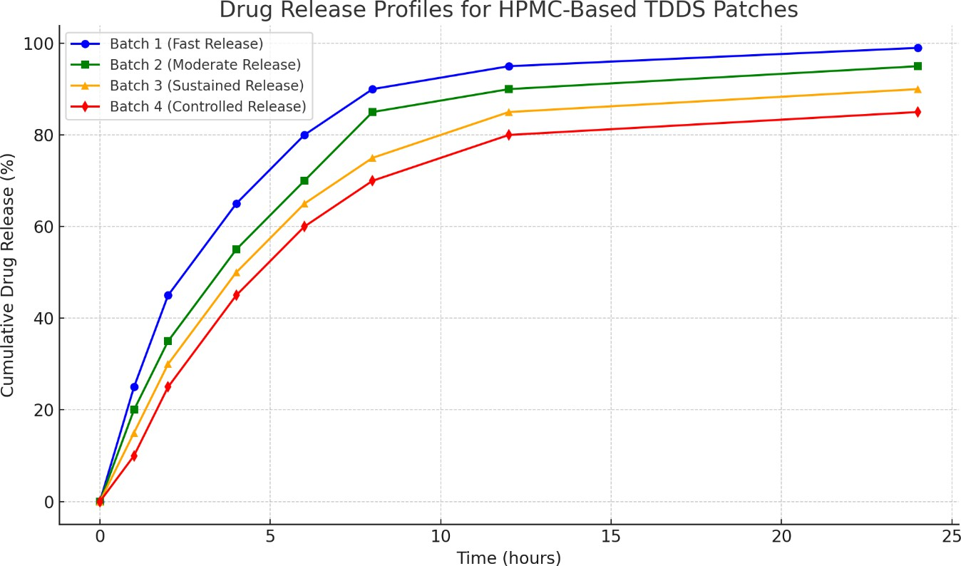**Fig. 1 :** Drug Realese Profile for HPMC – Based TDDS pathes

**Conclusion:**

In order to assist continuous monitoring and regulated release of medications, innovative transdermal patches and wearable devices have been devised. This is especially helpful in the case of chronic illnesses such as diabetes.

# REFERENCES

* Awasthi, R. and Kulkarni, G.T., 2014. Development of novel gastroretentive drug delivery system of gliclazide: Hollow beads. *Drug development and industrial pharmacy*, *40*(3), pp.398-408.
* Awasthi, R. and T Kulkarni, G., 2012. Development of novel gastroretentive floating particulate drug delivery system of gliclazide. *Current drug delivery*, *9*(5), pp.437- 451.
* Babu, V.R., 2018. Design and characterisation of transdermal film of gliclazide for the type-ii diabetes. *Asian Journal of Pharmaceutical Research and Development*, pp.20- 26.
* Barakat, N.S. and Almurshedi, A.S., 2011. Design and development of gliclazide- loaded chitosan microparticles for oral sustained drug delivery: in-vitro/in-vivo evaluation. *Journal of Pharmacy and Pharmacology*, *63*(2), pp.169-178.
* Bhatt DC, Dhake AS, Khar RK, Mishra DN. Development and in-vitro evaluation of transdermal matrix films of metoprolol tartrate. Yakugaku Zasshi 2008;1325-31.
* Elsayed, E.W., El-Ashmawy, A.A., Mursi, N.M. and Emara, L.H., 2023. Biorelevant dissolution testing of numerically optimized multiparticulate drug delivery systems of gliclazide. *drugs*, *7*, p.10.
* Kamath, H. and Sivakumar, A., 2017. Microemulsion based formulation as drug delivery system for gliclazide. *Int J Pharm Edu Res*, *51*(4S), pp.571-579.
* Morgan, T.M., O’Sullivan, H.J.M., Reed, B.L., and Fainin, B.C. Transdermal delivery of estradiol in postmenopausal women with a novel topical aerosol. *J. Pharm. Sci.* **87**, 1226–1228 (1998).
* Mukherjee B, Kanupriya, Mahapatra S, Das S, Patra B. Sorbitan monolaurate 20 as a potential skin permeation enhancer in transdermal patches. The J App Res 2005;1:96- 108.
* Mutalik S, Udupa N, Glibenclamide transdermal patches: Physicochemical, pharmacodynamic, and pharmacokinetic evaluations. J Pharm Sci ;93:1577-94.
* Nasr, M., Almawash, S., Al Saqr, A., Bazeed, A.Y., Saber, S. and Elagamy, H.I., 2021. Bioavailability and antidiabetic activity of gliclazide-loaded cubosomal nanoparticles. *Pharmaceuticals*, *14*(8), p.786.
* Sharna, A., Kara, M., Smith, F.R., Krishnan, T.R. Transdermal drug delivery using electoporation I. Factors influencing in vitro delivery of terazosin HCl in hairless rats. *J. Pharm. Sci.* **89**, 528–535 (2000).
* Shinde, A.J., Shinde, A.L. and More, H.N., 2010. Design and evaluation of transdermal drug delivery system of gliclazide. *Asian Journal of Pharmaceutics (AJP)*, *4*(2).
* Swarbrick, J. and Boylan, J.C., Eds. *Encyclopedia of Pharmaceutical Technology, 2*nd *ed.* New York: Marcel Dekker, Inc. 2002, pp. 1573–1587.
* Tamizharasi S, Dubey A, Rathi V, Rathi JC. Development and characterization of niosomal drug delivery of gliclazide. Journal of Young pharmacists. 2009;1(3):205.
* Tanwar YS, Chauhan CS, Sharma A. Development and evaluation of carvedilol transdermal patches. Acta Pharm 2007;57:151-9.
* Ubaidulla U, Reddy MV, Ruckmani K, Ahmad FJ, Khar RK. Transdermal therapeutic system of carvedilol: Effect of hydrophilic and hydrophobic matrix on in vitro and in vivo characteristics. AAPS PharmSciTech ;8:2.
* Wankhade, V., Tapar, K., Pande, S. and Bobade, N., 2010. Design and evaluation of self-nanoemulsifying drug delivery systems (SNEDDS) for Gliclazide. *Der Pharm Lett*, *2*(4), pp.132-143.
* Zhou, B., Liu, S., Yin, H., Qi, M., Hong, M. and Ren, G.B., 2021. Development of gliclazide ionic liquid and the transdermal patches: An effective and noninvasive sustained release formulation to achieve hypoglycemic effects. *European Journal of Pharmaceutical Sciences*, *164*, p.105915.