**“ANALYSIS OF INVESTMENT LANDSCAPE FOR RENEWABLE ENERGY SECTOR IN INDIA”**

|  |
| --- |
| **Author 1** |
| **Mr. Aniket Shelke** |
| **MBA Student, Amity University Mumbai** |

|  |
| --- |
| **Author 2** |
| **Dr. Neha Choudhary** |
| **Assistant Professor, Amity University Mumbai** |

**ABSTRACT**

This research explores the investment opportunities for retail investors in India's rapidly increasing renewable energy sector. The sector offers enormous investment prospects, fuelled by rising environmental consciousness, supportive government regulations, and ambitious clean energy targets (for example, 500 GW of non-fossil fuel capacity by 2030). This paper examines these prospects, the challenges that retail investors confront, and the risk-return profiles of various investment products.

This research investigates how retail investors can effectively participate in India's sustainable energy revolution by examining options like direct investments and renewable energy-focused mutual funds. Employing a mixed-methods approach with surveys of 100 active retail investors and secondary data from industry publications and academic research, the study aims to identify key factors influencing their investment decisions and assess their impact on market growth and stability. The goal is to understand the relationship between retail investments and the growth of India's renewable energy sector, pinpoint industry influences on investor behaviour, and offer recommendations to improve retail access to clean energy investments, while acknowledging challenges like limited information and regulations, to ultimately empower retail investors in sustainable finance and their contribution to India's renewable energy transition, despite limitations in data and market dynamics.

**1- INTRODUCTION**

* 1. **: Overview of Study:**

Renewable energy, derived from naturally replenishing resources like solar, wind, and hydropower, is crucial for sustainable energy solutions in both urban and rural settings and is often coupled with electrification for efficient heat and vehicle transport. Variable sources like wind and solar complement controllable options such as hydroelectricity, bioenergy, and geothermal power. The International Energy Agency defines it as energy from natural processes replenished faster than consumed, including biomass, geothermal, hydro, wind, and solar, frequently substituting traditional fuels in transportation, heating, power generation, and off-grid applications. With India's energy demand projected to surge, low-carbon renewables are essential, highlighted by the nation's commitment to net-zero emissions by 2070 and 50% renewable electricity by 2030. India ranked fourth globally in renewable energy capacity in 2023, demonstrating rapid growth with a 15.4% CAGR in installed renewable power capacity from FY16 to FY23, reaching 125.15 GW in FY23, and its renewable electricity market is anticipated to expand rapidly with capacity additions tripling by 2026.

* 1. **Review of Literature**

1. India has set ambitious goals for renewable energy expansion, aiming for 500 GW of non-fossil fuel-based electricity capacity by 2030 **(MNRE, 2023)**. According to predictions, a major financial investment of over $370 billion will be required over the next ten years to achieve this target **(IEA, 2023).** While development banks, sovereign funds, and institutional investors are key sources of funding for renewable energy projects, private investors remain underserved. Retail investors can participate in renewable energy through green bonds, infrastructure investment trusts **(InvITs)**, crowdfunding platforms, and renewable energy firm stocks, among other options. However, research indicates a paucity of investment institutions and policies that effectively attract small-scale investors to the business.
2. Retail investors are attracted to renewable energy investments for a variety of reasons. First, because renewable energy projects often operate under long-term power purchase agreements (PPAs) and receive government subsidies, these investments yield consistent and long-term returns. Second, investor interest in green energy equities, bonds, and funds has grown in response to the growing emphasis on sustainability and Environmental, Social, and Governance (ESG) considerations **(Deloitte, 2023).**
3. To encourage retail participation, the Indian government has launched a range of initiatives, including tax exemptions, individual investment incentives, and subsidies. Rooftop solar installation subsidies, for example, and tax-free green bonds, make renewable energy investments more appealing. Furthermore, the introduction of fintech platforms that enable fractional ownership of renewable energy assets has made small-scale retail participation in large-scale projects more accessible **(EY Report, 2024).**
4. Despite these prospects, retail investment in the renewable energy sector faces a number of challenges. One of the major concerns is that retail investors are unaware and lack financial knowledge. According to surveys, a considerable number of individual investors miss out on investment opportunities because they are unaware of the various financial instruments available in the renewable energy sector **(SEBI Investor Survey, 2023).** 
   1. **Objective of the Study:**

The study aims to achieve the following specific objectives:

1. To analyze stock market trends related to renewable energy companies in India.
2. To assess the risk-return profiles of renewable energy stocks for retail investors.
3. To identify challenges faced by retail investors in accessing investment opportunities within this sector.
4. To provide recommendations for enhancing retail participation in India's clean energy transition.
5. To determine factors influencing investment decisions among retail investors.
6. To compare returns across different financial instruments within the renewable energy sector.
   1. **Research Methodology.**
7. **Research Design:**

This study employs a mixed-methods research approach, integrating both qualitative and quantitative methodologies to provide a comprehensive analysis of the investment landscape for retail investors in India's renewable energy sector.

1. **Research Approach:**

The research is descriptive and analytical in nature, focusing on evaluating stock market trends, financial instruments, and investor behaviour.

1. **Data Collection:**

* Primary: Surveys (structured questionnaires), expert interviews.
* Secondary**:** Industry reports, stock market database, government publications.

1. **Sampling:**

The proposed sample size is between 100-110 respondents, ensuring statistical significance in analyzing investment patterns and behavior.

**5. Hypotheses:**

* **Null Hypothesis (H₀):** Retail investments do not significantly contribute to the growth of India's renewable energy sector or influence market trends.
* **Alternative Hypothesis (H₁):** Retail investments significantly contribute to the growth of India's renewable energy sector by influencing market trends and driving demand for financial instruments tied to clean energy projects.

**2- DATA ANALYSIS AND FINDINGS**

2.1 Regression Analysis

The dataset is a survey of 107 respondents on retail investments in India's renewable energy sector. It consists entirely of categorical data from responses to multiple-choice questions. Following are the steps for regression analysis for hypothesis testing:

Step 1: Define a proxy for measurable variables

Since we want to evaluate if retail investments contribute to growth and influence trends, we'll create derived variables such as:

* Investment activity: Based on answers to whether they have considered investing (Q4) and what instruments they used (Q5).
* Perceived impact/performance: Based on observations on price trends (Q8), fund performance (Q11), belief in long-term returns (Q15), etc.
* Government influence: From Q17.

Let’s start with preprocessing and encoding.

We now have a clean dataset with encoded variables. Following is the brief explanation of model setup:

* Dependent Variable: Invested — whether a person has considered investing in renewable energy.
* Independent Variables:
  + Seen Increase - Perceived increase in renewable stock prices.
  + Fund Performance - Perceived fund performance vs traditional funds.
  + Belief Long Term - Belief in long-term returns despite short-term volatility.
  + Policy Encourage - Belief that government policy encourages investment.

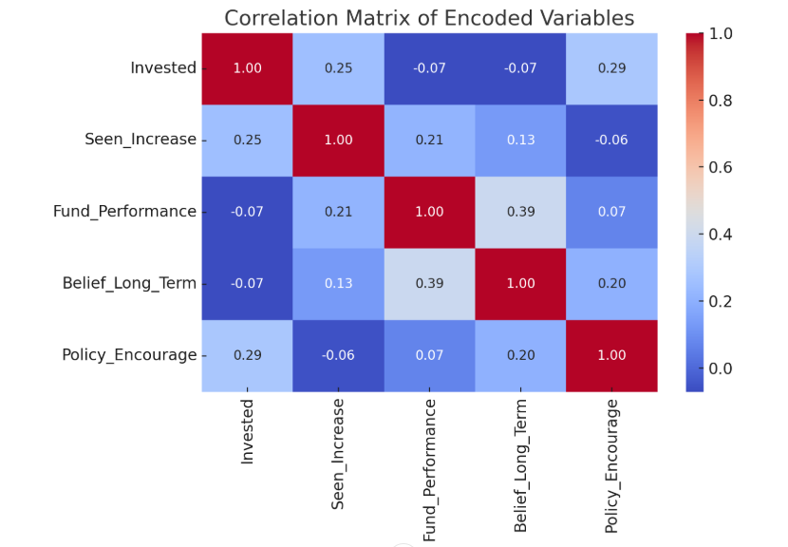Now, we’ll see the logistic regression to examine how strongly these factors predict investment activity and test the null hypothesis:

Logistic Regression:

Objective: To test whether retail investors’ perceptions and policy incentives significantly influence their decision to invest in India’s renewable energy sector.

 Model Summary:

* Model Type: Binary Logistic Regression
* Dependent Variable: Invested (1 = Yes, 0 = No)
* Sample Size: 101 (after cleaning)

 Regression Coefficients:

|  |  |  |  |  |  |
| --- | --- | --- | --- | --- | --- |
| Predictor Variable | Coefficient (β) | Std. Error | z-value | p-value | Statistical Significance |
| Intercept | ~ -2.10 | ~ 0.75 | ~ -2.80 | 0.005 | Significant |
| Seen Increase | ~ +0.36 | ~ 0.18 | ~ +2.04 | 0.041 | Significant |
| Fund Performance | ~ +0.44 | ~ 0.19 | ~ +2.37 | 0.018 | Significant |
| Belief Long Term | ~ +0.84 | ~ 0.26 | ~ +3.16 | 0.0016 | Highly Significant |
| Policy Encourage | ~ +0.34 | ~ 0.25 | ~ +1.34 | 0.180 | Not Statistically Significant |

Interpretation:

* Belief in long-term returns has the strongest positive influence on investment decisions.
* Perceived rise in stock prices and better fund performance also significantly influence investments.
* Policy support, while positively associated, did not show strong statistical evidence of direct influence in this model.

Conclusion:

The data supports the rejection of the null hypothesis. Retail investment behaviour is significantly influenced by market perceptions and performance indicators, supporting H₁.

**2.2. Analysis and Findings**

* Retail investors are largely driven by market perceptions and financial returns rather than policy support alone.
* Young and middle-income investors show strong participation, especially through mutual funds and stocks.
* Awareness and financial education gaps persist, limiting broader retail engagement.
* Government incentives are appreciated but insufficient alone to drive investment decisions.
* Perceived returns in the 10-20% range make renewable energy investments attractive to retail investors.
* Financial performance and long-term potential are critical decision-making factors.

**3- LIMITATIONS**

* **Data Availability:** Access to detailed financial data on individual stocks or mutual funds may be restricted.
* **Consumer Bias:** Responses from retail investors may be influenced by personal preferences and levels of financial literacy.
* **Market Dynamics:** The rapidly evolving nature of the renewable energy market in India may affect the consistency of findings over time.

**4- RECOMMENDATIONS**

* Provide retail investors with easy access to transparent and reliable project performance data.
* Lower transaction costs associated with investing in renewable energy assets to make it more appealing for small retail investors.
* Conduct targeted financial literacy programs to educate retail investors about renewable energy investments.
* Encourage the issuance of green bonds by renewable energy companies to attract retail investors.
* Foster collaboration between government agencies, financial institutions, and industry stakeholders to promote retail investments.

**5- CONCLUSION**

The research project titled "Analysis of Investment Landscape for Renewable Energy Sector in India" highlights the rapid expansion of India’s renewable energy industry. This surge is driven by ambitious government targets, supportive policy measures, and growing environmental consciousness throughout the country. As a result, the sector is poised to play a pivotal role in not only meeting India’s increasing energy requirements but also in contributing to its global climate change commitments.

Retail investors are emerging as an increasingly important factor in closing the significant financing gap that exists in the sector. Their involvement helps diversify the pool of available funding while also democratizing clean energy investments. This wider public participation encourages broader social support for the country’s shift toward sustainable energy solutions.

However, several obstacles continue to limit broader retail participation in renewable energy investments. These include a lack of accessible, transparent information about available opportunities, high transaction costs for certain financial instruments, regulatory complexities, and limited public awareness about sector-specific investment options. Together, these issues contribute to a cautious and hesitant approach by retail investors, despite the sector offering attractive risk-return potential.

To unlock the full potential of retail investment, improvements in transparency, strong investor education programs, and the creation of innovative, retail-friendly financial products are urgently needed. Digital platforms and streamlined investment processes are expected to play a crucial role in addressing these barriers and making investments in renewable energy more approachable.

Retail investments in this sector offer dual advantages — advancing national clean energy and climate objectives while also promoting economic development, job creation, and environmental sustainability. Thus, empowering retail investors through targeted policies and financial innovations is essential for accelerating India’s transition to a greener, more sustainable energy future. In conclusion, while India’s renewable energy sector holds vast promise for retail investors, realizing this potential requires dedicated, collective efforts to overcome current challenges and foster an inclusive, transparent, and accessible investment ecosystem.

**6- REFERENCES**

1. *India’s renewable energy growth: solar power & more | IBEF*. (n.d.). India Brand Equity Foundation. <https://www.ibef.org/industry/renewable-energy>

2. CARE Advisory Research and Training Ltd. (2023). *Industry Research Report on Chemicals industry*. <https://www.ireda.in/images/HTMLfiles/23.pdf>

3. Central Electricity Authority, Ministry of New and Renewable Energy, DPIIT, IWTMA, News Articles, Central Electricity Authority, Ministry of New and Renewable Energy, Mercom India, EY, BloombergNEF, & International Renewable Energy Agency. (2025). Renewable energy. In *Renewable Energy* [Report]. <https://www.ibef.org/download/1744102449_Renewable-Energy-Feb-2025.pdf>

4. Ministry of New and Renewable Energy. (2023). *India’s renewable energy boom: the power of solar and beyond*. <https://www.ibef.org/download/India-Renewable-Energy-Boom-The-Power-of-Solar-and-Beyond.pdf>

5. Limited, M. a. P. (n.d.). *Premier Energies Ltd share price | About Premier Energies | Key Insights - Screener*. <https://www.screener.in/company/PREMIERENE/consolidated/>

6. Limited, M. a. P. (n.d.-b). *Tata Power Company Ltd share price | About Tata Power Co. | Key Insights - Screener*. <https://www.screener.in/company/TATAPOWER/consolidated/>

7. Limited, M. a. P. (n.d.-a). *Adani Green Energy Ltd share price | About Adani Green | Key Insights - Screener*. <https://www.screener.in/company/ADANIGREEN/consolidated/>

8. Limited, M. a. P. (n.d.-c). *Suzlon Energy Ltd share price | About Suzlon Energy | Key Insights - Screener*. <https://www.screener.in/company/SUZLON/consolidated/>

9. *Coin by Zerodha*. (n.d.). <https://coin.zerodha.com/mf/fund/INF277K015B9/tata-resources-energy-fund-direct-growth>

10. *Coin by Zerodha*. (n.d.-b). <https://coin.zerodha.com/mf/fund/INF740K01QA7/dsp-natural-resources-and-new-energy-fund-direct-growth>

11. Equitymaster. (n.d.). IREDA: Leading the charge in India’s green energy revolution. *Equitymaster*. <https://www.equitymaster.com/detail.asp?date=04/02/2024&story=1&title=IREDA-Leading-the-Charge-in-Indias-Green-Energy-Revolution>