**Wireless Communication RFID-Based Smart Attendance System**

**Dr. Kashmira. N. Kasat1, Dr. Vinit. P. Kharkar2, Shubham R. Rathod3,**

**Shantanu G. Gavhale4, Sarthark M. Chikate5**

1Assistant Professor, Department of Electronics & Telecommunication Engineering, Prof Ram Meghe College of Engineering and Management, Amravati (Maharashtra), India.

23456Third Year Student, Department of Electronics & Telecommunication Engineering, Prof Ram Meghe College of Engineering and Management, Amravati (Maharashtra), India.

**ABSTRACT**

We have implemented the RFID based Attendance system [Projectsusig8051Microcontroller](https://www.electronicshub.org/8051-microcontroller-projects-engineering-students/) . Attendance in colleges is generally paper based which may sometimes cause errors. Taking attendance manually consumes more time. So, the proposed attendance system uses RFID technology to take attendance.In this system, each student is issued an RFID tag. Controlling unit is in the institute. Whenever the card is placed near the reader, it will take the attendance. This mini-project presents the design and implementation of an RFID-Based Smart Attendance System to automate attendance tracking using Radio Frequency Identification (RFID) technology. The system consists of an RFID reader (RC522), RFID tags, a microcontroller (Arduino/Raspberry Pi), and a database to store attendance records. When a user scans their RFID tag, the system verifies the unique ID and marks attendance in real-time. This project enhances accuracy, eliminates manual errors, and prevents proxy attendance. The proposed system is cost- effective, easy to implement, and suitable for schools, offices, and secured environments.

**Keywords:** AT89C51 Programming Board, AT89C51 Microcontroller, 16 x 2 LCD display, EM-18 RFID Reader module ,RFID Tags or cards, Connecting wires

# INTRODUCTION

Attendance tracking is a crucial task in educational institutions, offices, and secured environment**s** to monitor the presence of individuals. Traditional attendance methods, such as manual registers and biometric systems, have several drawbacks, including time consumption, human errors, and the possibility of proxy attendance. To address these challenges, Radio Frequency Identification (RFID) technolog**y** provides **a** contactless, automated, and efficient

solution **f**or tracking attendance.in very little amount of time. The RFID- based attendance system using the 8051 microcontroller automates attendance marking by using RFID tags and an RFID reader (RC522 or EM- 18**)**. Each person is assigned a unique RFID tag, which is scanned by the RFID reade**r** when they enter a premises. The 8051 microcontroller processes the scanned tag ID, verifies it against a **pre-stored** database, and records attendance. An LCD display is used to provide real-time feedback, confirming the attendance status of the individual. The system may also store attendance records in EEPROM or an external database for further processing.

The RFID-based attendance system using 8051 can be applied in schools, colleges, corporate offices, factories, and secured facilities**.** The system can be enhanced by integrating cloud storage, GSM modules for SMS notifications, and IoT- based monitoring **to** provide better accessibility and security.

# METHODOLOGY

This section outlines the step-by-step process followed in the design and implementation of the RFID-Based Smart Attendance System, which utilizes wireless communication technologies for real-time attendance tracking and data management.

**2.1 System Design and Architecture:**

* **RFID Tags:** Passive RFID cards assigned to each student or employee.
* **RFID Reader:** A fixed device installed at the entrance or attendance point, capable of reading RFID tags within a specific range.
* **Microcontroller (e.g., Arduino/ESP32):** Interfaces with the RFID reader and processes tag data.
* **Wireless Communication Module (e.g., Wi-Fi, Bluetooth):** Transmits data to a central database or cloud server.
* **Database/Cloud Storage:** Stores attendance records for retrieval and analysis
* **User Interface (Web or Mobile App):** Allows administrators or users to view attendance logs and generate reports.
  1. **Hardware Implementation:**
* RFID Tag Registration**:** Each RFID tag is registered in the system’s database with a unique identifier linked to a user profile.
* Integration of RFID Reader and Microcontroller**:** The RFID reader is connected to a microcontroller unit (MCU), which reads tag data and processes it in real time.
* Wireless Module Setup**:** A Wi-Fi or Bluetooth module (such as ESP8266, ESP32) is used to enable wireless communication between the microcontroller and the remote server.

**2.3 Software Development:**

* **Firmware for Microcontroller:** Embedded C or Arduino IDE is used to program the microcontroller to read RFID data and send it wirelessly.
* Backend System: A server-side application (e.g., PHP, Node.js, or Firebase functions) receives data from the device, validates it, and stores it in a structured database (e.g., MySQL, Firebase Realtime DB).
* **Fronted Interface:** A responsive web or mobile app is developed for users to log in and view attendance history, send alerts, or download reports.

**2.4 Data Flow and Operation:**

* When an individual taps their RFID card on the reader, the unique ID is captured.
* The server checks the ID against the database and logs the timestamp.
* The microcontroller processes the ID and sends it via the wireless communication module to the server.
* A confirmation message may be sent back to the user interface, indicating successful attendance marking.
  1. **Security and Validation:**
* Authentication: Only registered RFID tags are allowed; unrecognized tags are logged separately for review.
* Data Encryption**:** Communication between devices and the server is secured using encryption protocols such as HTTPS or MQTT with TLS.
* Fault Tolerance**:** Local storage is used as a fallback in case of network failure, with automatic sync once the connection is restored.
  1. **Testing and Evaluation:**
* Accuracy of RFID tag detection
* Range and reliability of wireless communication
* Latency in attendance recording
* System scalability and user-friendliness

# COMPONENTS

**3.1 AT89C51 Microcontroller :**

The [**AT89C51**](https://www.ovaga.com/series/at89c51)is a member of the 8051 microcontroller family, featuring 4 KB of on-chip Flash memory, 128 bytes of RAM, and 32 programmable I/O lines. With its compact instruction set and efficient architecture, the AT89C51 provides reliable processing for real-time applications. It is fully compatible with standard 8051 tools and development platforms, ensuring ease of integration and development.

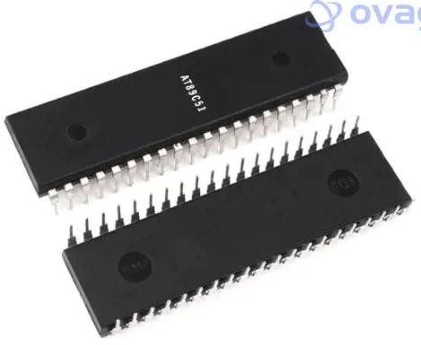

**Fig 1.** . AT89C51 Microcontroller:

The AT89C51 is built around an 8-bit CPU core, featuring 4 KB of Flash program memory and 128 bytes of RAM for efficient data storage and processing. The microcontroller supports a 16-bit timer/counter, a full-duplex UART, and a configurable interrupt system. It also includes 32 I/O pins, divided into four 8-bit ports, offering flexible interfacing options for peripherals and sensors.

* 8051-Compatible Architecture**:** Fully compatible with the 8051 instruction set, enabling easy migration of existing designs.
* 4 KB Flash Memory:Provides ample storage for program code in small to medium-sized applications.
* 128 Bytes RAM**:** Suitable for temporary data storage and real-time processing tasks.
* 32 Programmable I/O Lines**:** Flexible I/O pins for interfacing with peripherals, sensors, and other devices.
* Integrated Peripherals**:** Includes two 16-bit timers/counters, a full-duplex UART, and an interrupt

controller.

**3.2 AT89C51 Programming Board:**

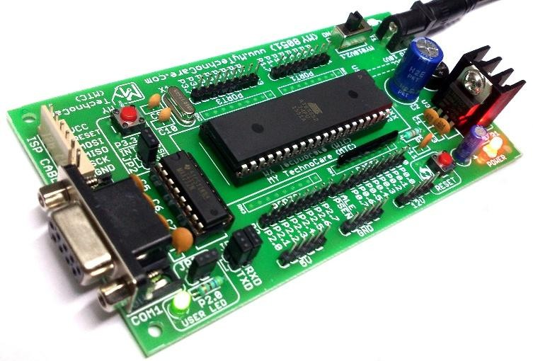The AT89C51 programming boardis a development board designed for programming and testing AT89C51microcontrollers, which belong to the 8051 familyof microcontrollers. Here’s a breakdown of its features, components, and how it works:

**Fig 2.** AT89C51 Programming Board

**Features of the AT89C51 Programming Board**:

1. Microcontroller:
   * Supports AT89C51, AT89S51, AT89S52,

AT89C52, AT89C205**1** (depends on the board version).

1. Power Supply**:**
   * Typically operates on 5V DC.
   * Some versions have onboard voltage regulators**.**
2. Clock Circuit:
   * Uses a crystal oscillator (usually 11.0592 MHz) **for** stable timing operations.
3. Reset Circuit**:**
   * Push-button reset switch with a capacitor and resistor network.
4. Programming Interface**:**
   * Supports **ISP (**In-System Programming**)** for models like AT89S51/AT89S52.
   * Parallel Programming for AT89C51 (requires an external programmer).
5. I/O Expansion:
   * 40-pin DIP socket for microcontroller insertion.
   * Port headers for easy access to GPIO pins.
6. Peripherals Support:
   * LEDs, switches, and buzzers for simple interfacing.
   * UART (RS232) interfac**e** for serial communication (via MAX232 IC).
7. EEPROM and Memory:
   * Supports external EEPROM or RAM if needed.

**3.3EM-18 RFID Reader Module:**

The EM-18 RFID Reader Module is a popular RFID (Radio Frequency Identification) reader used for reading 125 kHz RFID tags. It is widely used in access control, attendance systems, security systems, and automation projects.

**Features of the EM-18 RFID Reader Module:**

* Operating Frequency: 125 kHz
* Reading Distance: 5 – 10 cm **(**depends on tag type)
* Communication Interface**:**
  + UART (Serial, 9600 bps by default)
  + Wiegand (some versions)
* Power Supply: 5V DC (Consumes ~50mA)
* Output Format: 12-digit unique ID in hexadecimal format
* Antenna: Built-in PCB antenna
* 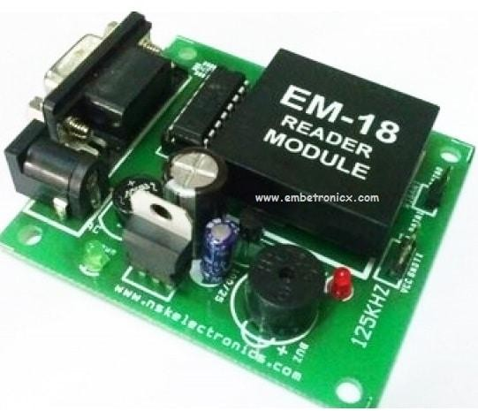Compact Size: 3.2 cm × 3.2 cm × 1

**Fig 3.** EM-18 RFID Reader Module

Application of EM-RFID Reader Module:

* Access Control Systems (Door locks, Security gates)
* Attendance Systems (Office, School, College)
* Library Management Systems
* Automated Toll Collection
* Smart Payment Systems
* Inventory Management
* Animal Tracking (with RFID embedded tags)

**3.4** **16x2 LCD Display:**

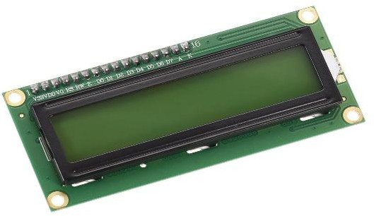A 16x2 LCD Display is a 16-character per line, 2- line alphanumeric display widely used in embedded systems, electronics, and automation projects. It operates on 5V DC and is controlled using the HD44780 controller, which supports both 4-bit and 8-bit parallel communication.

**Fig 4.** 16x2 LCD Display

**Features of 16x2 LCD Display:**

* 16 characters × 2 lines **(**Total 32 characters**).**
* HD44780 controller-based **(**Industry-standard interface).
* 5x8 dot matrix per character **(**with cursor support**).**
* Adjustable contrast **(**via a 10kΩ potentiometer**).**
* Supports both 4-bit and 8-bit modes **(**flexible for microcontrollers).
* LED Backlight (Optional; typically White/Blue/Green).
* Low power consumption (1-2mA, excluding backlight).
* Operating voltage: 5V DC**.**

# BLOCK DIAGRAM:

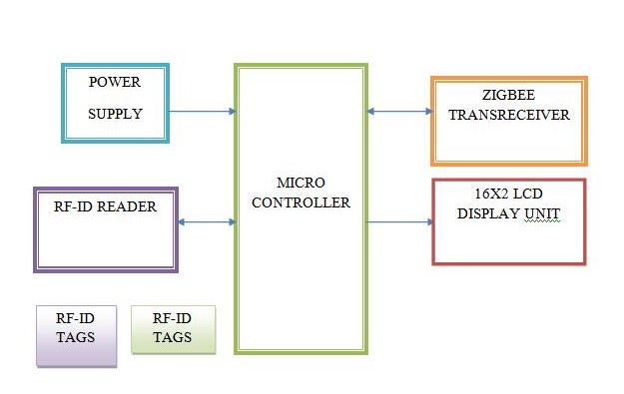

### **1. Power Supply:**

* **Function**: Provides regulated DC power (typically 5V) to all components.
* **Includes:**
  + Step-down transformer (if AC input),
  + Bridge rectifier (AC to DC),
  + Voltage regulator (e.g., 7805 for 5V output).
* **Importance:** Ensures stable operation of microcontroller, RFID reader, LCD, etc.

### **2. RF-ID Tags:**

* **Type**: Passive RFID cards/tags.
* **Function:** Each tag contains a unique identification number.
* **Operation**: When brought near the reader, it transmits its ID using radio frequency (typically 125 kHz or 13.56 MHz).

### **3. RF-ID Reader:**

* **Function**: Reads the ID from RFID tags when they are within range.
* **Operation**:
  + Activates the tag using an electromagnetic field.
  + Receives the tag’s ID.
  + Sends the ID to the microcontroller via serial communication (UART).
* **Example Module**: EM-18 (125 kHz RFID reader).

### **4. Microcontroller:**

* **Role:** Core processing unit of the system.
* **Responsibilities:**
  + Receives RFID tag data.
  + Compares it with stored data (predefined valid IDs).
  + Controls outputs (LCD, Zigbee module).
  + Makes attendance decisions (e.g., mark entry, deny access).
* **Typical MCU:** AT89C51, ATmega328P, or similar.

### **5. 16x2 LCD Display Unit:**

* **Function**: Provides visual feedback to the user.
* **Displays**:
  + Prompts like “Scan your ID”
  + Attendance status: “Welcome [Name]” or “Invalid ID”
* **Connected to:** Microcontroller via data and control pins.

**FLOW CHART :**

* 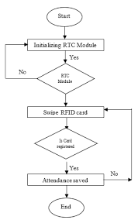

1. **Start**

* The system is powered on and begins execution.

1. **Initializing RTC Module**

* The microcontroller attempts to initialize the RTC module (e.g., DS1307 or DS3231), which keeps track of the current date and time.
* This step is crucial for recording time-stamped attendance.

1. **RTC Module Ready?**

* If the RTC module is not responding or fails to initialize, the system loops back and tries again.
* If successful, it moves to the next step.

1. **swipe RFID Card**

* The system waits for an RFID tag to be brought near the RFID reader.
* Upon detection, it reads the tag’s unique ID.

1. **is Card Registered?**

* The system checks whether the read ID matches any of the pre-registered card IDs stored in memory (EEPROM, microcontroller flash, or external database).
* If the ID is not recognized, the system returns to the card scan step.

**6.Attendance Saved**

* If the card is valid, the system:
* Marks attendance,
* Stores the card ID, date, and time (from RTC) in memory or sends it to a server.
* Once saved, the system either ends the process or returns to idle mode, depending on design.

**7.End**

* This may represent the end of one attendance cycle, after which the system continues running for the next user.

# C:\Users\patel com\Downloads\RFID-based-Attendance-System-Image-5-760x440.jpgRESULT

# CONCLUSION:

# The RFID-based attendance system automates attendance marking, reducing errors and saving time. It provides secure and accurate identification using unique RFID tags. The system is cost-effective, easy to use, and scalable, making it ideal for schools, offices, and security applications. It can be further enhanced with database integration and wireless connectivity for advanced features.

# REFERENCES:

* Muhammad Ali Mazidi– Author of *"8051 Microcontroller and Embedded Systems,"* a widely used book for learning 8051 programming.
* Raj Kamal– Author of *"Embedded Systems: Architecture, Programming, and Design,"* covering RFID-based automation.
* Kenneth J. Ayala– Known for his book *"The 8051 Microcontroller,"* which explains hardware and software aspects of 8051.
* Daniel M. Dobkin– Expert in RFID technology and author of *"The RF in RFID: Passive UHF RFID in Practice."*