**Sea Oil Separator**

*Tushar Bhamre 1, Rohidas Bobade 2,*

*Sanket Dengale3,*

*,Prof: R.C Lokhande 4*

*JSPM’s Rajarshi Shahu College of Engineering, Polytechnic, Tathawade*

*Dept. Of Mechanical Engineering, Pune, India*

**ABSTRACT:**

This paper deals with the separation of oil and water to find out the better solution for oil recovery from the water surface mixture Empress Oil spill to produce oil free water. Also, it deals with the fabrication of mechanical equipment to separate oil from the water. Oil and water separator is mechanical equipment, which is used in the environment pollution control from oil spillage. Oil separator helps in removing the oily from the mixing surface leaked water. By removing the oil from industry mixture water, it becomes free of oil pollution. This is mainly due to acrylic material used in the oil separator. This oil separator can be used in the effluent treatment plant. This paper consists of construction, fabrication details, assembly, working and applications of oil and water separator. There is the different method to remove the oil form the water but disc type oil skimmer is mostly used.

***KEYWORDS***

*Oil Skimmers, Crude oil, Oil pollution, spills Disk and Belt skimmers*

**INTRODUCTION:**

Oil skimming is basically sticking of oil to some material which is inserted in it. This action can be effectively used as oil can stick to the material but not the other impurities in it. Hence by this principle, Oil can be separated from its containments as well as it can be separated when it is containment. Oil skimmers are effectively used in various industries for the sake of separation of the coolants especially from water. Although designs vary, all oil skimmers rely on specific gravity, surface tension and a moving medium to remove floating oil from a fluid's surface. Floating or sinking oil and grease cling to skimming media more readily than water, and water has little affinity for the media. This allows skimming media in the shape of a belt, disk, drum, etc. to pass through a fluid surface to pick up oil and grease with very little water. This oily material is subsequently removed from the media with wiper blades or pinch rollers. Oil skimmers are simple, dependable and effective tools for removing oil, grease and other hydrocarbons from water. Often, a skimmer by itself can achieve the desired level of water purity. In more demanding situations, skimming is a cost-effective means of removing most of the oil before using more complicated and costly treatments such as coalesces, membrane filters and chemical processes.

Now, in industries, to separate oil from other things like coolant and water, we use oil skimmers. There are various methods for this, of which disk type oil skimmer is one of the majorly used. This is because of its simple working and very high efficiency of around 90-95%.

**PROBLEM STATEMENT**

Recently in Mumbai, there occurred 2 cases of sever oil spill near sea shore affecting most of the aquatic life of the area. Also fishing and tourism were affected by this spillage. The environmental effects of such oil spills are not negligible as this is a global problem now days. Every year, there is 100 million US gallons of oil spill. This is equal to 100 large size gymnasium halls. The numbers though could not tell the actual harm caused to the environment by such oil spill as it is in numerous. So there is need of an effective way to clean this oil from the surface without actually wasting it.

**METYHODOLOGY:**

Basic science and engineering concepts used in development of project

1. Specific gravity

Specific Gravity: Most hydrocarbons have a lower specific gravity than water. Without agitation, oil separates from the water and floats to the surface. These oils are known as LNAPL's, Light Non-Aqueous Phase Liquid. Oils (and other compounds) that sink in water have a higher specific gravity and are known as DNAPL's, Dense Non-Aqueous Phase Liquid.

2. Surface Tension and Affinity

Surface Tension and Affinity: Normally, oil bonds more tightly to itself and other materials than to water. This affinity and differences in surface tension between oil and water, cause oils to adhere to a skimming medium.

3. Cohesive and Adhesive forces

Cohesive Forces:

Cohesive forces are the intermolecular forces (such as those from hydrogen bonding and Van der Waals forces) which cause a tendency in liquids to resist separation. These attractive forces exist between molecules of the same substance. For instance, rain falls in droplets, rather than a fine mist, because water has strong cohesion which pulls its molecules tightly together, forming droplets. This force tends to unite molecules of a liquid, gathering them into relatively large clusters due to the molecules' dislike for its surrounding.

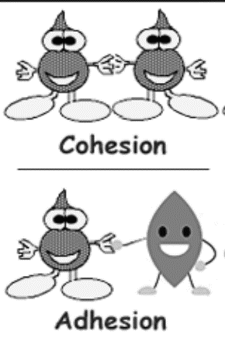

Cohesive Forces

**Effects of Cohesive and Adhesive Forces:**

When liquid is placed on a smooth surface, the relative strengths of the cohesive and adhesive forces acting on that liquid determine the shape it will take. The fig. below shows the same.

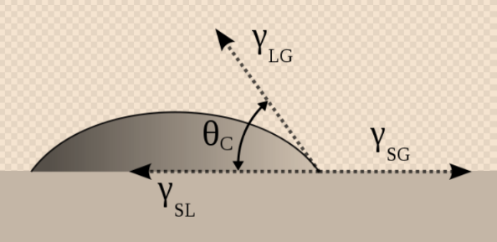Relative strengths

If the adhesive forces between a liquid and a surface are stronger, they will pull the liquid down, causing it to wet the surface. However, if they cohesive forces among the liquid itself are stronger, they will resist such adhesion and cause the liquid to retain a spherical shape and bead the surface.

4. Contact angle

The contact angle is the angle, conventionally measured through the liquid, where a liquid/vapour interface meets a solid surface. It quantifies the wettability of a solid surface by a liquid via the Young equation. A given system of solid, liquid, and vapour at a given temperature and pressure has a unique equilibrium contact angle.

Contact angle is a primary parameter which indicates whether given liquid can wet the solid surface or not.

5. Concept of Surface energy

Surface energy quantifies the disruption of intermolecular bonds that occur when a surface is created. In the physics of solids, surfaces must be intrinsically less energetically favourable than the bulk of a material (the molecules on the surface have more energy compared with the molecules in the bulk of the material), otherwise there would be a driving force for surfaces to be created, removing the bulk of the material (like sublimation). The surface energy may therefore be defined as the excess energy at the surface of a material compared to the bulk. For a liquid, the surface tension (force per unit length) and the surface energy density are identical. The unit surface energy of a material would therefore be half of its energy of cohesion. This amount of surface energy plays very important role in the adhesion phenomenon.

Working of the Solar based Drum type oil spill recovery System.

1. It is a method which can be used for the purpose of recovering oil from the water surface when it is spilled in a water body due to accidents or leakage. The basic principle used in this method is that oil has greater affinity towards some materials rather than water. Hence, when came in to the contact with such material, oil sticks to its surface and hence can be removed off from the surface of water.

2. Now, consider drum skimmers. A drum skimmer consists of a metal drum coated with PVC (polymer of vinyl chloride) material which has capability to attract oil, & is mounted on the shaft which is rotating with the adequate low speed. The wheel is dipped in oil water mixture with the depth of 1/4th to 1/3rd of diameter (which should be slightly greater than that of the oil thickness above water). Now when the wheel is rotated, the oil sticks to the coated material and is carried upwards. Here care is taken that centrifugal force generated is less than the adhesive force acting on the oil. The oil lifted by wheel is removed by the oil removing mechanism provided at the other end which is collected in the collector.

3. It possible to use the same mechanism for removing oil from sea water. But with modifications and with some advancements. The sample design of prototype of the concept is as shown in the figure above.

It consists of a rubber tube and driving mechanism mounted on the small floater which is equipped with the blades for guiding motion of the small setup. Now those setups can be programmed so as to guide

**CAD DRAWING:**

**Procedure**

The entire model has been designed with the help of designing software solid works.

With the help of colour feature the colours are given to the entire model.

**SOLID MODELING**

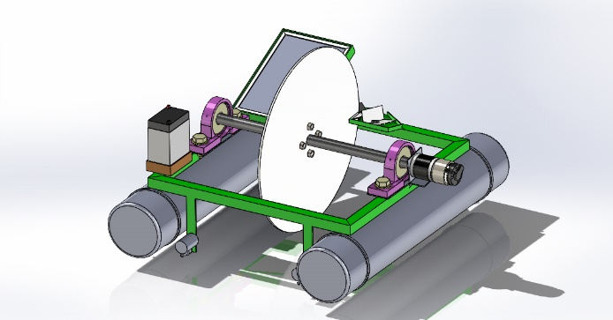

**RESULTS & OBSERVATIONS:**

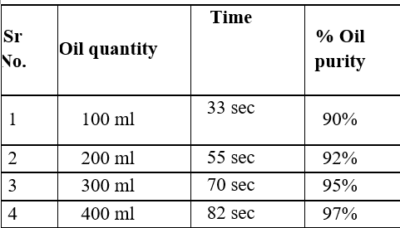

**Observations**

1. The system is restricted to recovery of low-density oils (i.e., oil which floats on water).

2. The rotation speed of the skimming element is restricted as it is inversely proportional to the efficiency of system.

3. The system gives it maximum efficiency in standstill water.

4. The oil collector capacity is limited due to weight increment reasons.

5. The system can give high efficiency only in small scale oil spill cases.

6. The width of Disc is limited due weight increment reasons.

**CONCLUSION:**

Solar based, disc type, oil spill recovery system is easy, effective, and economical and environ friendly system to tackle the global crisis of the oil spill. It has many advantages over present day technologies to clean spilled water. It can effectively clean the water surface recovering most of the oil back in usable form. The system can be automated and run-on solar system making it greatly capable to survive on its own. Hence lots of human efforts are eliminated and hence oil spill can get faster and efficient response. The hazardous effects of oil spill are thus effectively reduced. Hence, solar based, disc type, oil spill recovery system promises to be an important tool against global crisis of oil spill.

**REFERENCES:**

[1]website:http://response.restoration.noaa.gov/oil-and-chemical-spills/oil-spills/how-oil-spills-affect-fish-and-whales.html

[2]1.Mr.DhondeDiapkPanditrao,Mr.GadhePruthvirajJalindar,Mr.PadolKiranBalasaheb,Mr.PawarChetanTusahiram, Dr. Dongare.A.D. (2016) Sea oil separator with disc and bellt skimmer ISSN-2321-0613

[3]Suraj Nair,KajolKamble, SayaliShewale, Sanjay Lohar Design & Fabrication of Disc Type Oil Skimmer (2017) 2395-1052

[4]SumonKhandakar,Md.NasiqulIslam,

Robiul Islam Rubel, Sk. Suzauddin Yusuf Construction of an economic blanket belt oil skimmer (2017) 115-122

[5]Hydrodynamic Seperator Unit For Removal And Recovery Oil From Wastewater, Mohamed Ahmed Mahmoud (2016) ISSN 2157-7463

[6] Zhang Yindong, Zhang Xingming Li Wenhua The Improvement Of Oil-Water Separation Technology In Oil Spill Mechanical Recovery 2014 Research Gate.

.