**A Review of QR Code Attendance Systems for Real-Time Student Tracking and Data Integration in Educational Institutions**

Ashwini Yadav 1

1 Department of Master of Computer Application, J D College of Engineering and Management

Khandala ,Borgaon Phata , Kalmeshwar Road ,Nagpur ,India-441501   
[ashwinjyadav122@gmail.com](mailto:ayushfulzele2002@gmail.com)

Prof. Aman Singh2

2 Department of Master of Computer Application, J D College of Engineering and Management

Khandala ,Borgaon Phata , Kalmeshwar Road ,Nagpur ,India-441501   
acsingh@jdcoem.ac.in

**Abstract:** In higher education, there’s a strong link between student attendance and academic success. Yet, many institutions still use outdated, manual methods to track attendance, which is particularly cumbersome for large classes. Manual recording can lead to errors, missed entries, and significant administrative overhead. Recognizing these challenges, we've designed a smart attendance system that utilizes QR code technology. This innovative system not only simplifies the process of recording attendance for lectures and exercises across various courses but also ensures efficiency and accuracy. By scanning a QR code, students can instantly mark their presence, and all data is securely stored for easy access and analysis. This approach reduces the administrative burden on educators and provides real-time insights into attendance patterns, helping institutions to better support their students.

Moreover, this system offers an additional layer of security and transparency. Each QR code is unique to the student and the specific class session, minimizing the risk of fraudulent attendance marking. The system can also integrate with existing student management systems, allowing for seamless data synchronization and comprehensive reporting. This ensures that attendance records are accurate and up-to-date, providing valuable data for both educators and administrators.

By adopting this smart attendance system, educational institutions can enhance their administrative processes and improve the overall learning experience. Accurate attendance tracking can help identify students who may need additional support, ensuring timely intervention and fostering a more supportive educational environment. This technological advancement not only streamlines operations but also underscores the institution's commitment to leveraging modern solutions for better academic outcomes.

**Keywords:** QR Code Technology, Attendance Management, Real-time Tracking, AI, Administrative Efficiency

## Introduction

In the fast-paced world we live in today, there is a growing necessity to complete tasks swiftly, acquire new knowledge, and achieve high results as efficiently as possible. This is particularly evident in education and the business sector, where effective management systems are crucial for overseeing learning and work processes. In light of these needs, we identified a gap in university-level student attendance management and proposed an online system to fill it. Consistent attendance is a fundamental requirement in educational institutions. Students who do not meet attendance standards risk losing the opportunity to take exams, and excessive absences can result in being barred from final exams. The traditional, manual methods of recording attendance are prone to errors and inefficiencies. To address these issues, we developed a web-based system that is responsive on mobile devices, tablets, and computers. This system ensures data security and allows for quick access to attendance records for entire classes or individual students, with automatic report generation by professors. Our internet-based attendance system seeks to modernize the conventional attendance marking methods by providing a smarter, more efficient solution. Each student and professor is assigned a unique QR code, which they scan at the beginning of each class to confirm their attendance. This system records all relevant data, ensuring accurate and reliable tracking of lecture attendance.

## Need and scope of study

Ensuring accurate and efficient attendance tracking is crucial in the realm of higher education. Traditional methods, which often involve manual recording, are prone to errors and inefficiencies, particularly in large classrooms. These shortcomings can affect administrative processes and the overall educational experience. Hence, there is a pressing need for a modern, automated solution that can streamline attendance management.

This study focuses on the development and implementation of a QR-based attendance system. Utilizing QR code technology offers a straightforward and secure method for tracking student attendance. Each student and instructor is assigned a unique QR code that is scanned at the beginning of each class session, ensuring that attendance data is recorded accurately and in real-time. This system not only reduces administrative burden but also minimizes the risk of errors associated with manual attendance recording.

The scope of this study includes designing the QR-based system architecture, developing the necessary software, and evaluating its effectiveness in various educational settings. It aims to explore the advantages of using QR codes for attendance tracking, such as increased accuracy, efficiency, and data security. Additionally, the study will address potential challenges, such as system scalability and integration with existing educational infrastructure. By providing a comprehensive framework, this research seeks to offer valuable insights that can enhance attendance management practices and improve overall academic outcomes.

## Objective

* + - **Enhance Attendance Accuracy**: To improve the precision of student attendance records through automated QR code scanning.
    - **Increase Administrative Efficiency:** To streamline the process of recording and managing attendance, reducing the workload on educators and administrative staff.
    - **Ensure Data Security:** To protect attendance data from tampering or loss by using secure, encrypted storage methods.
    - **Reduce Errors:** To minimize the errors associated with manual attendance recording and data entry.
    - **Improve Student Accountability**: To foster a sense of responsibility among students by implementing a reliable attendance tracking system.

## System Design

**System Components :**

* **QR Code Generator: Generates unique QR codes for each session or individual.**
* **Scanner Interface: Allows students to scan codes via a mobile app or web interface.**
* **Database (MySQL): Stores student information, attendance records, and session details.**
* **Admin Interface: For educators and administrators to manage sessions, track attendance, and access reports.**

**System Workflow :**

* **QR Code Generation: Each class session or student is assigned a unique QR code.**
* **Attendance Marking: Students scan the QR code via a mobile device, marking attendance.**
* **Data Storage & Validation: The system logs attendance details, time-stamping and validating entries in the database.**
* **Report Generation: Attendance data is processed and displayed for tracking and analysis**

**Key Functionalities:**

* **Real-Time Updates: Immediate attendance recording upon scan.**
* **Security: Unique QR codes reduce fraud, ensuring secure attendance.**
* **Data Integration: Seamlessly integrates with student management systems for synchronized records.**

## 1.5 Modules

## Scan QR Code :

To mark their attendance, students will open the QR Code Attendance System on their devices. They will then use the application to scan their personalized QR code, which is displayed on the screen. This action will register their presence for the class session, ensuring that their attendance is accurately recorded and securely stored in the system.

## Record Attendance

Once the QR code is successfully scanned by the student, the system promptly registers their attendance for that particular class session. This automated process ensures that attendance records are updated in real-time, reducing the likelihood of manual errors and simplifying the tracking process for educators.

1. **View Attendance Records:**

Administrators have comprehensive access to manage and review detailed attendance records through the system. This includes information such as the names of students, the specific courses they are enrolled in, their assigned sections, and the exact times they logged their attendance. With this centralized system, administrators can efficiently oversee attendance data, ensuring it is accurate and up-to-date. This functionality aids in identifying patterns, addressing any irregularities promptly, and ensuring compliance with attendance policies.

1. **Add and Manage Students:**

Administrators have the capability to efficiently manage student information within the system. They can effortlessly add new students by inputting necessary details through a user-friendly interface. Additionally, if there are changes to a student's information—such as updates to their personal details or adjustments to their course enrollment—administrators can easily modify these records. This seamless process ensures that all student data remains current and accurate, facilitating better management and oversight of student attendance and participation.

1. **Generate QR Codes:**

Administrators can efficiently generate QR codes for newly enrolled students using the provided interface. These unique QR codes are then linked to the individual profiles of the students, ensuring that each code corresponds accurately to a specific student. This process facilitates seamless attendance tracking, as students will use their assigned QR codes to mark their presence in class. By integrating QR code generation into the system, we enhance the ease of managing student attendance while maintaining the integrity and accuracy of attendance records

* 1. **Architecture Diagram**

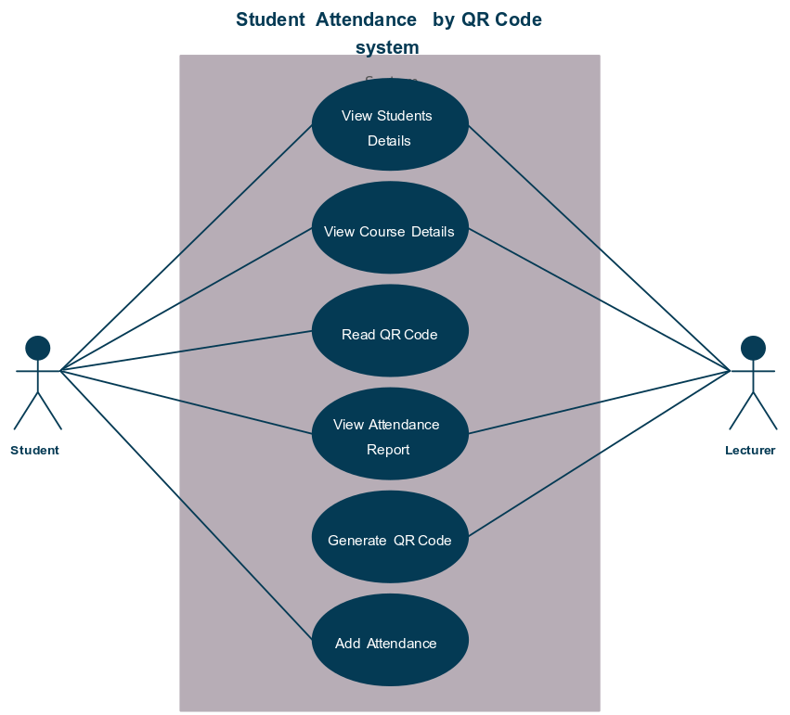

# Conclusion:

In an era where technological advancements drive efficiency, our QR-based attendance system emerges as a crucial innovation in higher education. Traditional manual attendance methods, fraught with errors and administrative burdens, are increasingly inadequate in managing large classrooms. By adopting QR code technology, we not only modernize the process but also ensure accuracy and ease of use.

This system addresses key challenges such as data security, error minimization, and real-time attendance tracking. Each student and professor is assigned a unique QR code, facilitating seamless and reliable attendance recording. The automation of attendance management not only reduces administrative workload but also provides valuable insights into attendance patterns, enabling timely interventions to support student success.

Furthermore, the integration of this system with existing educational infrastructure underscores its scalability and adaptability. It offers a user-friendly interface and maintains compliance with educational standards, making it a robust solution for institutions seeking to enhance their administrative processes.

Overall, the QR-based attendance system represents a significant step forward in leveraging technology to improve educational outcomes, ensuring that the management of student attendance is both efficient and secure.

# References:

1. R. D. Bacuna and B. G. Dadiz, "eSAM: Atendance System Using QR Codes in Romblon State University-Cajidiocan Campus", *2022 International Conference for Advancement in Technology (ICONAT). IEEE*, 2022
2. S. Shaban et al., "Developing a student attendance app using QR codes: educational and practical considerations", *International Journal of Technology Enhanced Learning 13.1*, pp. 92-106, 2021.
3. R. Mo et al., "Quick Response codes for virtual learner evaluation of teaching and attendance monitoring", *Canadian Medical Education Journal/Revue canadienne de I'education medicale 12.3*, pp. 169-170, 2021.
4. M. Singh, R. Yadav, P. Mishra, P. Jain and P. K. Aggarwal, "Enhancing Data Security through RSA Algorithm", *Proceedings of Innovations in Clean Energy technologies (ICET -2023)*, 2023.
5. Shubham Mishra, Chandan Kumar, Ahmad Ali and Jeevan Bala, "Online Attendance Monitoring System Using QR Code (OAMS)", *2021 2nd International Conference on Intelligent Engineering and Management (ICIEM)*.